A Psychedelic Airport for Time Travelers
Storyboard + Animation Prompt Package

Core premise: a lone traveler passes through a surreal airport where fish function as aircraft, waiting rooms split time, luggage has memory, and every terminal belongs to a different decade.

Final order
- 1. The Skywhale Airport (H - giant yellow skywhale)
- 2. Lost Baggage Check-In (F - luggage hall)
- 3. Departures Concourse (A - red ceiling departures hall)
- 4. Gate Delay / Duplicate Selves (J - pink waiting room with duplicate selves)
- 5. Boarding Platform (D - circular portal platform)
- 6. Zero-Gravity Transfer (G - levitation beside pink terminal)
- 7. Golden Fish Flight (I - riding the yellow fish)
- 8. Holding Pattern Runway (E - runway table / tarmac limbo)
- 9. Cloud Orchard Layover (C - cloud orchard layover)
- 10. Pink Rotunda Arrival (B - pink rotunda arrival)

Narration draft
There are airports for cities, airports for countries, and one airport for lost decades.
Beneath the skywhale, she arrives carrying a single bag.
At check-in, they weigh her luggage, her memories, and the years she has not yet unpacked.
In the departures hall, fish move overhead and the clock refuses ordinary time.
At the gate, she meets another version of herself already waiting.
When boarding begins, the runway opens like a memory.
Somewhere between gate and sky, gravity stops insisting.
A golden fish carries her between decades.
They do not arrive. They circle. Every decade has its own weather.
In the layover orchard, even the clouds are waiting for someone.
At last she enters a vast terminal where fish drift through the ceiling like constellations.
She has arrived in another decade, carrying one bag, one body, and more time than she left with.

Suno.ai style notes
Create a spoken-word cinematic voiceover and music bed for a surreal retro animation called "A Psychedelic Airport for Time Travelers." The voice should feel warm, intimate, poetic, and calm: a curious narrator from a lost 1970s airport film, not a movie-trailer voice. Delivery should be measured, slightly dreamy, emotionally sincere, with spacious pauses between lines. Avoid hype, parody, pop belting, and overacting.
Music style: retro-futurist ambient lounge-jazz with analog tape warmth. 72-84 BPM. Soft airport chimes through tape delay, brushed drums, vibraphone, mellow electric piano, upright bass, warm analog synth pads, subtle theremin, distant trumpet, watery bubbles, reel-to-reel hiss, and gentle vinyl crackle. Whimsical but eerie, light-hearted but emotionally meaningful. The music should feel like an old airline brochure discovered in a dream.
Mix notes: voiceover must be clear and forward. Keep music airy and cinematic underneath. No big EDM drop, no aggressive drums, no modern pop sheen, no lyrics other than the spoken narration.

Storyboard overview - Act I: Entry and Boarding
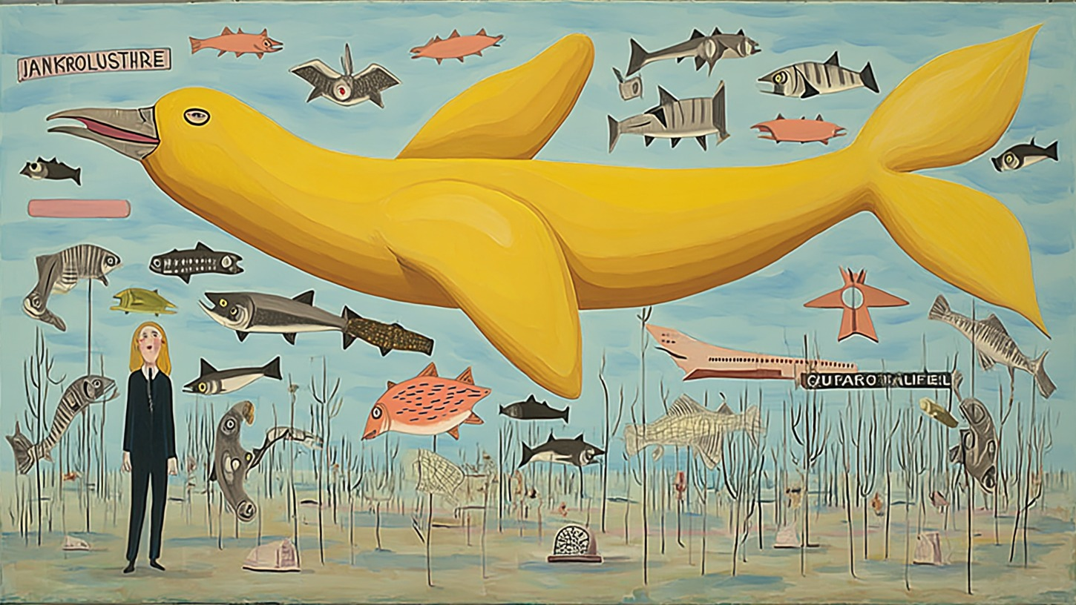 | 1. The Skywhale Airport  Beat: A lone traveler arrives beneath a colossal yellow fish-aircraft, tiny against a field of poles, markers, smaller fish, and impossible runway signs.  Purpose: Establish the airport as a mythic place where fish are aircraft and time travel is routine.  Motion: Slow push-in from wide exterior.  Audio: Wide outdoor terminal ambience, distant propellers, low analog synth, gull-like fish calls, faint runway radio static, soft tape hiss.
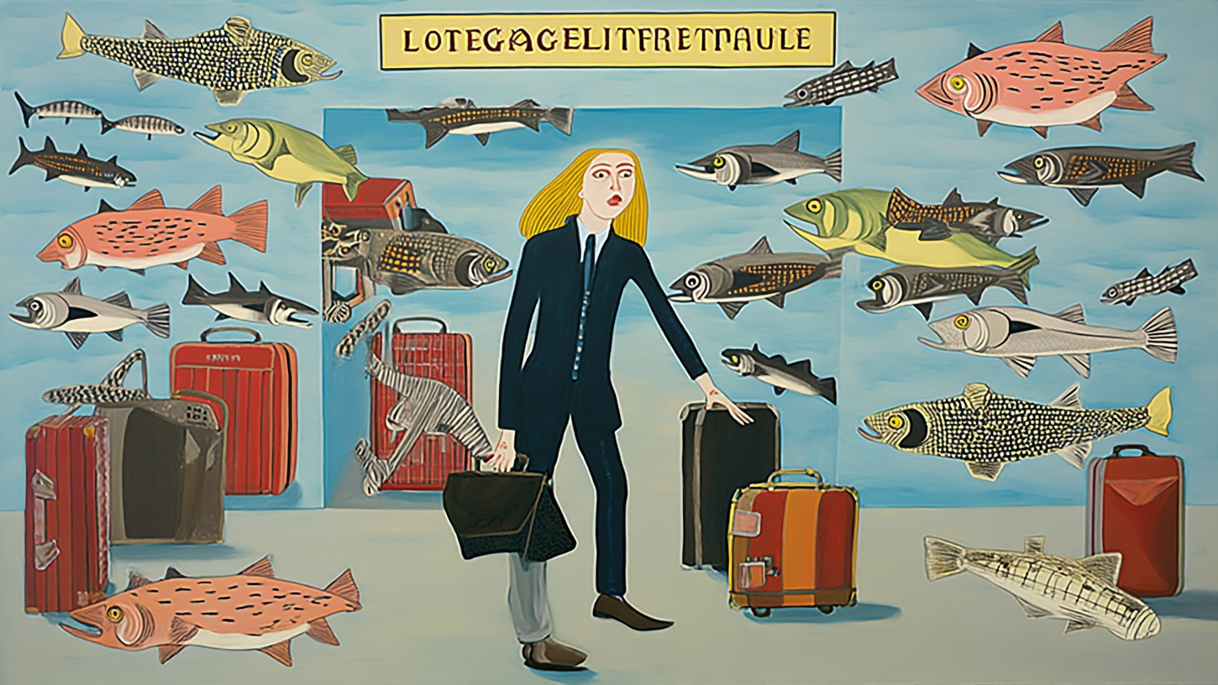 | 2. Lost Baggage Check-In  Beat: The traveler enters a hall where luggage, fish, and identity blur. Suitcases look inspected by fish; signage feels like language from a delayed timeline.  Purpose: Ground the dream in a familiar airport ritual: check-in and baggage.  Motion: Slow pan across suitcases and fish.  Audio: Suitcase wheels, clerk stamp rhythm, muffled intercom, soft aquatic hum, fluorescent buzz, tape flutter.
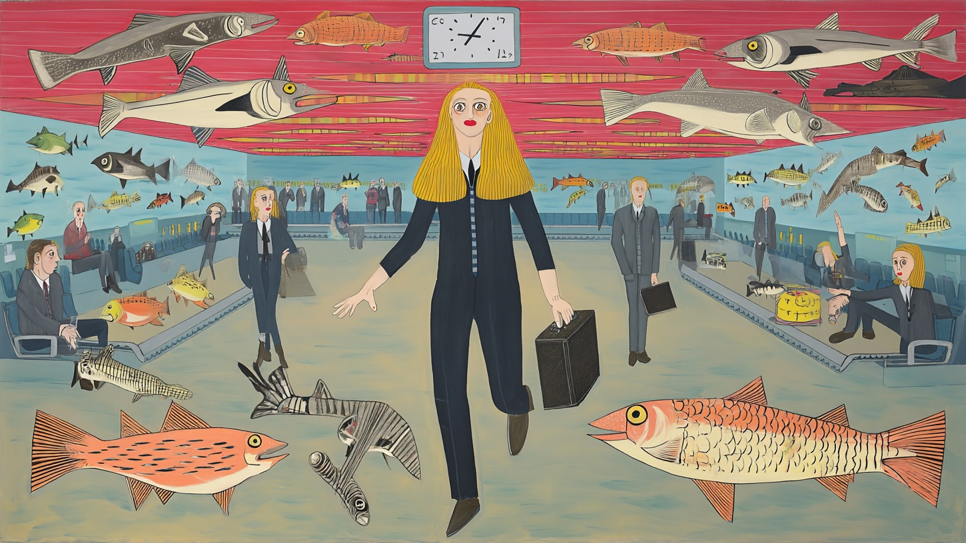 | 3. Departures Concourse  Beat: She crosses a red-ceilinged departures hall under drifting fish, clocks, benches, and passengers waiting for flights through time.  Purpose: Reveal the airport in full operation. The traveler is now inside the moving system.  Motion: Slow forward dolly toward the traveler.  Audio: Boarding announcements, terminal murmur, analog chimes, ticking clock, soft watery engine wash.
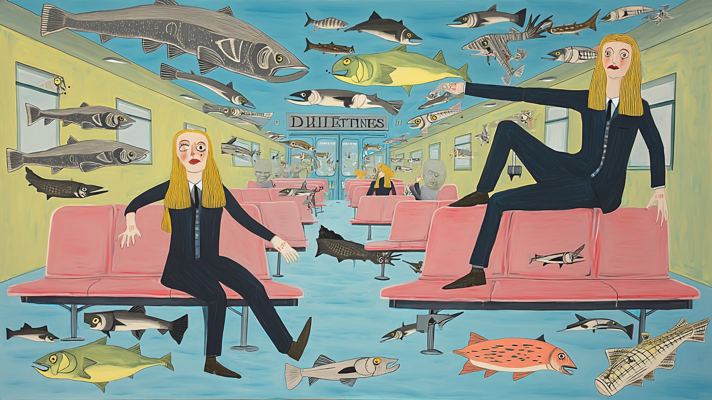 | 4. Gate Delay / Duplicate Selves  Beat: In a pink gate lounge, the traveler appears twice: one self waits, another lounges above. Fish drift through the corridor like slow thoughts.  Purpose: Make the time-travel premise emotional and undeniable: delay creates multiple versions of the traveler.  Motion: Nearly still.  Audio: HVAC hum, delayed chimes, seat squeak, quiet terminal ambience, tape flutter, distant reversed announcement.
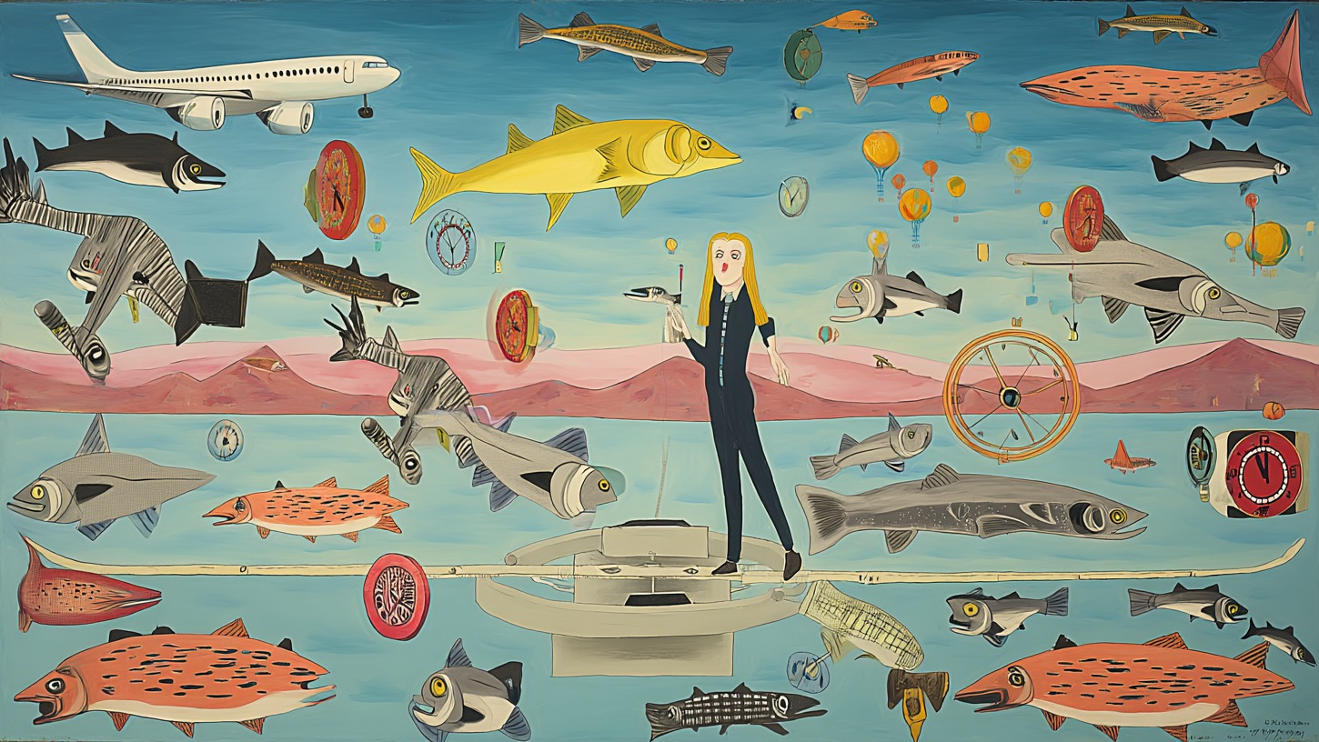 | 5. Boarding Platform  Beat: The traveler stands on a circular platform surrounded by fish, tokens, clocks, planes, and hot-air route markers. Boarding is less a gate than an activation ritual.  Purpose: The formal threshold. The terminal turns into a route-map machine.  Motion: Platform hums and slowly rotates.  Audio: Activation tone, radar beeps, route-map ticks, soft bass swell, distant voice calling a gate number.

Storyboard overview - Act II: Transit and Arrival
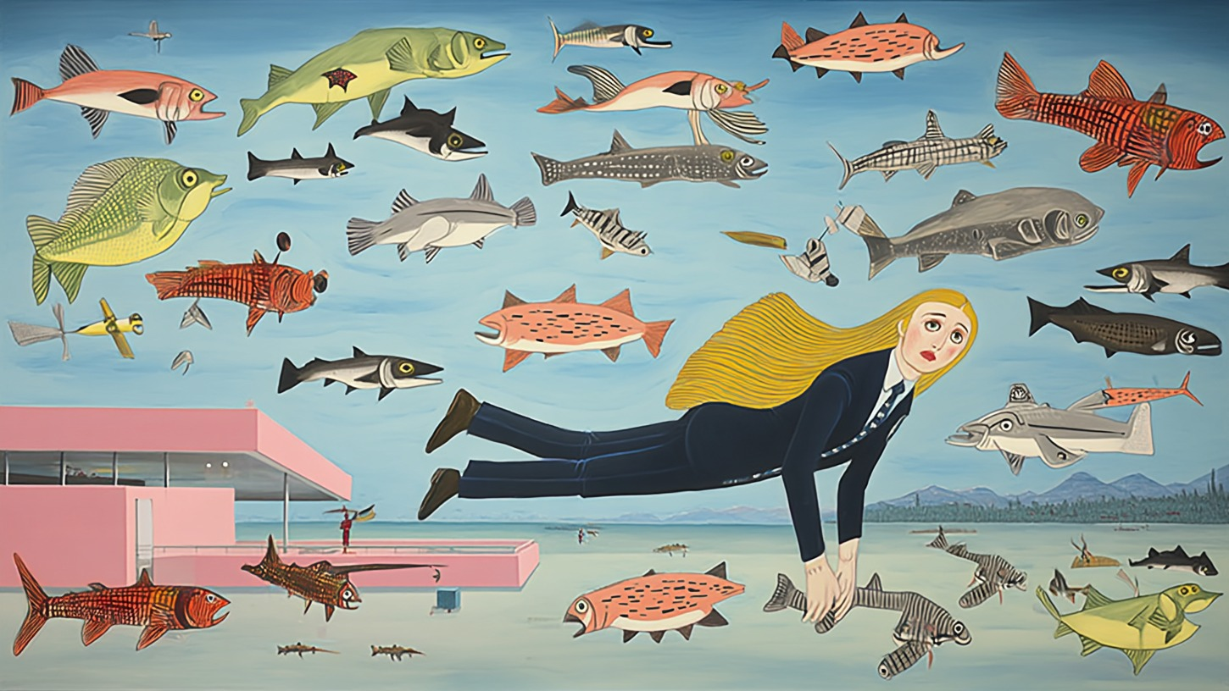 | 6. Zero-Gravity Transfer  Beat: The traveler floats sideways beside a pink modernist terminal as fish traffic thickens around her. Gravity has stopped insisting.  Purpose: The journey begins physically: she leaves ordinary ground.  Motion: She drifts slowly horizontally, hair and tie trailing.  Audio: Air whoosh, underwater bubbles, chime stretch, soft pressure drop, low synth lift.
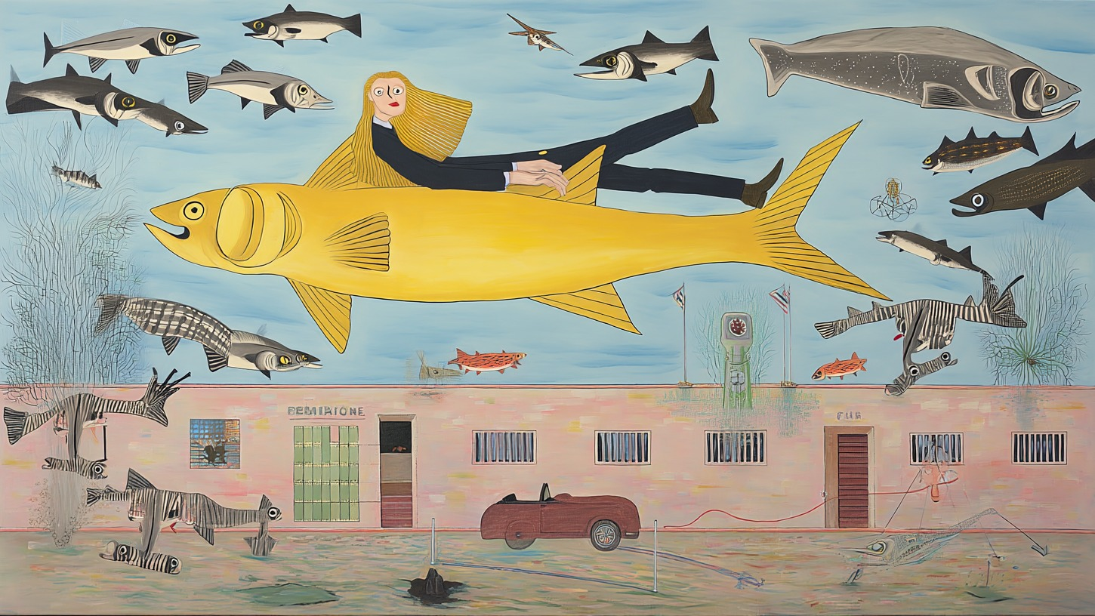 | 7. Golden Fish Flight  Beat: The traveler rides a giant yellow fish across the sky above a low terminal building and a parked car, surrounded by escorting fish.  Purpose: The main in-flight hero image: she accepts the living aircraft.  Motion: Broad lateral glide.  Audio: Air rush, oceanic engine hum, distant trumpet, soft rhythmic pulse, wind over scales.
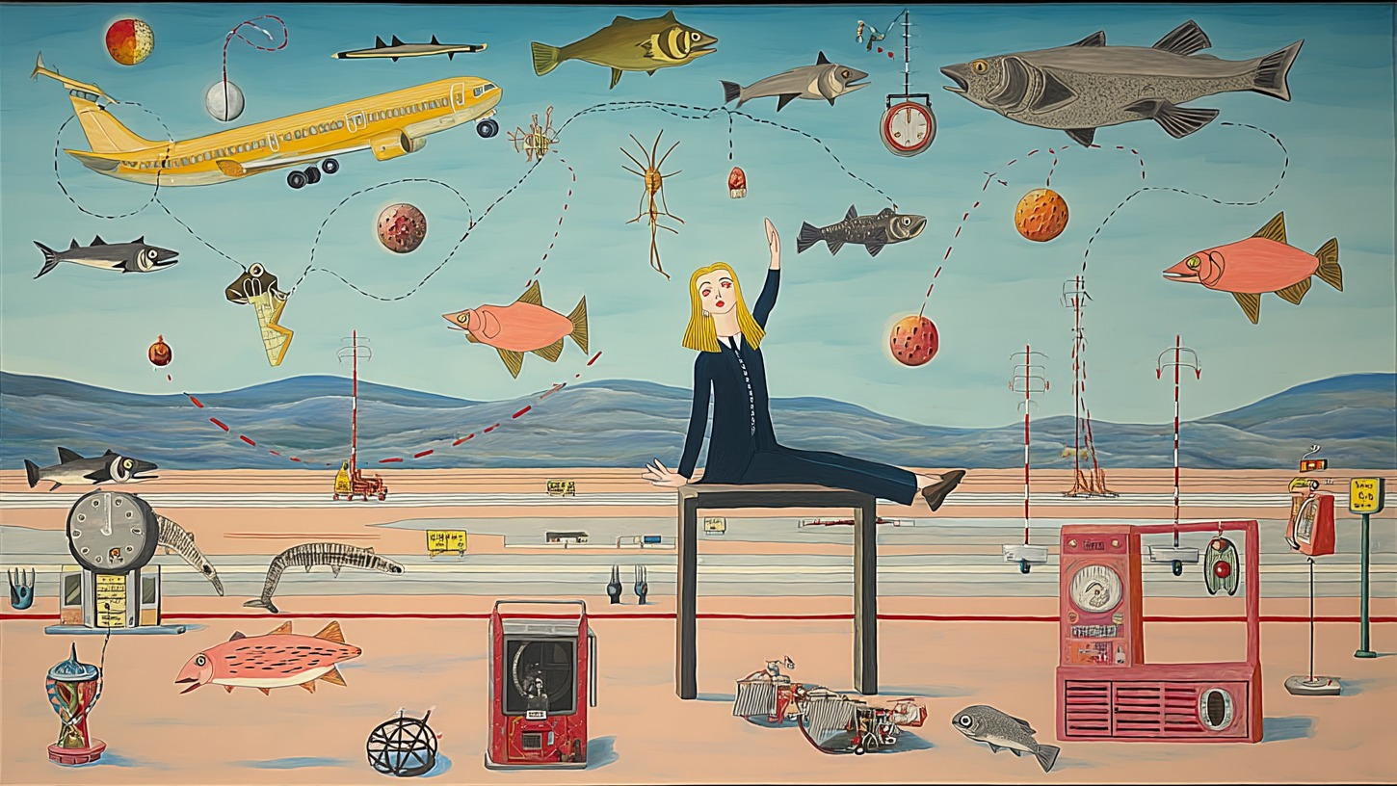 | 8. Holding Pattern Runway  Beat: The traveler sits on a tall table over a runway zone filled with clocks, route lines, tower markers, red signal machines, planes, and fish.  Purpose: A pause inside transit: time circles before choosing a destination.  Motion: Route lines slowly draw themselves through the sky.  Audio: Tower radio static, clock ticks, runway wind, red machine hum, distant landing gear thump.
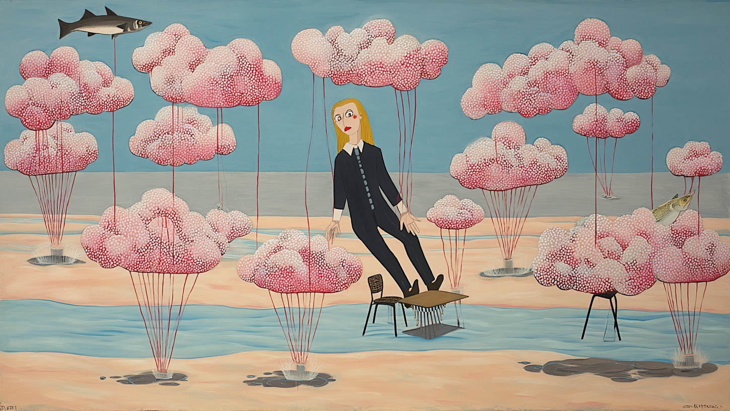 | 9. Cloud Orchard Layover  Beat: She rests among pink cloud-trees, chairs, and shallow water, suspended in a gentle layover garden between versions of life.  Purpose: Emotional decompression before arrival. The airport becomes soft.  Motion: Cloud trees breathe and bob.  Audio: Airy synth chord, soft bells, water lap, marsh wind, distant chime, quiet breath.
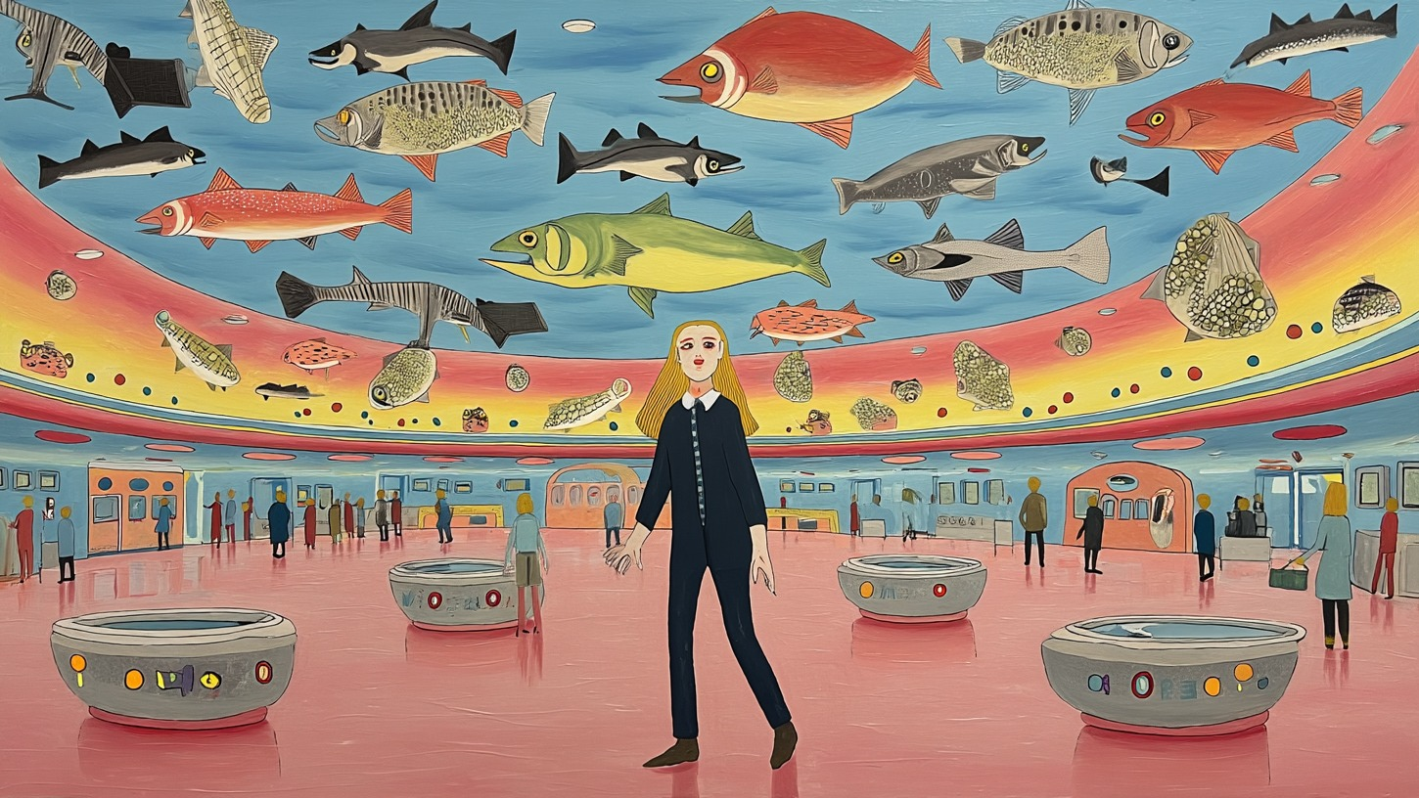 | 10. Pink Rotunda Arrival  Beat: She enters a vast pink terminal beneath a curved ceiling of fish-aircraft and soft circular baggage pods. The airport has become spacious, ordered, and serene.  Purpose: Final destination: the traveler arrives in another decade.  Motion: Slow pull-back or reveal.  Audio: Arrival chime, open terminal reverb, warm synth pad, distant footsteps, gentle final chord.

1. The Skywhale Airport

Image code: H - giant yellow skywhale
Story beat: A lone traveler arrives beneath a colossal yellow fish-aircraft, tiny against a field of poles, markers, smaller fish, and impossible runway signs.
Story purpose: Establish the airport as a mythic place where fish are aircraft and time travel is routine.
Emotional function: Wonder, scale, orientation.
Motion direction: Slow push-in from wide exterior. Giant yellow skywhale drifts almost imperceptibly. Small fish cross in layered parallax. Reeds and marker poles tremble in a soft terminal wind.
Audio direction: Wide outdoor terminal ambience, distant propellers, low analog synth, gull-like fish calls, faint runway radio static, soft tape hiss.
Transition into next scene: Cut or dissolve into the luggage hall as the skywhale shadow passes over the frame.
Optional voiceover line: There are airports for cities, airports for countries, and one airport for lost decades.

Veo 3.1 image-to-video prompt - 8 seconds
Animate the provided keyframe as the opening exterior of a surreal retro hand-painted short film called A Psychedelic Airport for Time Travelers. A colossal yellow fish-aircraft hangs over a flooded field of runway markers while a lone blonde traveler stands below. Preserve the exact gouache-like painted texture, delicate ink outlines, pastel palette, and 1960s-1970s psychedelic airport futurism. Use a slow cinematic push-in. The yellow skywhale drifts slightly, smaller fish glide like aircraft, reeds and poles tremble gently, and the air feels charged with departure. No modern digital effects, no readable text additions, no subtitles, no watermark. Audio: wide outdoor terminal wind, distant propeller flutter, low analog synth drone, faint runway radio static, gull-like fish calls, and soft reel-to-reel tape hiss.

Text-to-image / regeneration prompt
A mythic exterior establishing shot of a psychedelic airport for time travelers: a gigantic smooth yellow fish-aircraft floats across a pale blue sky above a flooded runway field of thin marker poles, strange airport signs, small fish-aircraft, skeletal luggage creatures, and a tiny blonde traveler in a dark suit standing below with a suitcase. Surreal hand-painted retro illustration, 1960s-1970s airport futurism, pastel blue and dusty yellow palette, gouache texture, delicate ink outlines, whimsical but eerie, widescreen, no text except optional abstract unreadable airport signage, no watermark.

Team edit notes

2. Lost Baggage Check-In

Image code: F - luggage hall
Story beat: The traveler enters a hall where luggage, fish, and identity blur. Suitcases look inspected by fish; signage feels like language from a delayed timeline.
Story purpose: Ground the dream in a familiar airport ritual: check-in and baggage.
Emotional function: Entry into the system, low-key unease.
Motion direction: Slow pan across suitcases and fish. The traveler shifts weight. Bags nudge slightly as if alive. Fish drift through the baggage zone in inspection patterns.
Audio direction: Suitcase wheels, clerk stamp rhythm, muffled intercom, soft aquatic hum, fluorescent buzz, tape flutter.
Transition into next scene: A chime pulls her forward into the main departures concourse.
Optional voiceover line: At check-in, they weighed my luggage, my memories, and the years I was still carrying.

Veo 3.1 image-to-video prompt - 8 seconds
Animate the provided keyframe as the lost-baggage check-in hall of a surreal time-travel airport. The blonde traveler stands with suitcases while fish-aircraft drift through the room like baggage inspectors. Preserve the hand-painted retro illustration style, pastel airport palette, paper texture, wonky signage, and dreamlike composition. Use a slow observational pan from luggage to traveler. Suitcases subtly breathe or nudge, fish swim through the terminal air, and the traveler turns her head slightly as if called to the next counter. Keep motion restrained and uncanny. No subtitles, no watermark. Audio: suitcase wheels rolling on tile, rubber baggage-belt hum, soft passport stamps, muffled invented-language intercom, watery ambience, faint analog synth pad, tape hiss.

Text-to-image / regeneration prompt
A surreal lost-baggage check-in hall inside a psychedelic airport for time travelers. A blonde woman in a dark navy suit stands with black and red suitcases while fish float overhead and around the luggage like aircraft and customs inspectors. Retro counters, strange baggage portals, pale blue walls, awkward dream signage, and piles of suitcases create a bureaucratic dream terminal. Hand-painted 1960s-1970s psychedelic illustration, gouache texture, delicate ink outlines, pastel airport colors, whimsical and eerie, widescreen, optional clear sign reading LOST BAGGAGE, no watermark.

Team edit notes

3. Departures Concourse

Image code: A - red ceiling departures hall
Story beat: She crosses a red-ceilinged departures hall under drifting fish, clocks, benches, and passengers waiting for flights through time.
Story purpose: Reveal the airport in full operation. The traveler is now inside the moving system.
Emotional function: Anticipation and forward motion.
Motion direction: Slow forward dolly toward the traveler. Fish glide overhead. The clock twitches out of sequence. Background passengers move in looped micro-gestures.
Audio direction: Boarding announcements, terminal murmur, analog chimes, ticking clock, soft watery engine wash.
Transition into next scene: The crowd sound stretches into a delay, carrying us into the waiting room where time splits.
Optional voiceover line: All departures here happen twice: once in the body, and once in time.

Veo 3.1 image-to-video prompt - 8 seconds
Animate the provided keyframe as the main departures concourse of a psychedelic time-travel airport. A blonde traveler in a dark suit walks forward holding a briefcase under a red-striped ceiling crowded with fish-aircraft and a strange clock. Preserve the original hand-painted gouache style, pastel blue walls, red ceiling, delicate ink lines, vintage airline-brochure surrealism, and 1970s retro-futurist mood. Use a slow forward dolly. Fish glide above like planes, the clock hand stutters out of sequence, passengers perform tiny waiting-room loops, and the traveler moves calmly through the center aisle. No modern digital polish, no subtitles, no watermark. Audio: tape-delayed airport chimes, murmuring passengers, distant invented-language boarding announcements, ticking clock irregularities, low analog synth, watery engine ambience.

Text-to-image / regeneration prompt
A grand surreal departures concourse in a psychedelic airport for time travelers. A blonde woman in a dark navy suit walks down the center aisle carrying a black briefcase. Overhead, a red striped ceiling is filled with large fish-aircraft, clocks, and route symbols. Passengers wait on benches along both sides while fish drift through the terminal air. Hand-painted retro psychedelic airport illustration, 1960s-1970s airline futurism, pastel blue walls, dusty red ceiling, delicate ink outlines, gouache texture, widescreen, no watermark.

Team edit notes

4. Gate Delay / Duplicate Selves

Image code: J - pink waiting room with duplicate selves
Story beat: In a pink gate lounge, the traveler appears twice: one self waits, another lounges above. Fish drift through the corridor like slow thoughts.
Story purpose: Make the time-travel premise emotional and undeniable: delay creates multiple versions of the traveler.
Emotional function: Uncanny recognition, playful temporal slippage.
Motion direction: Nearly still. One version of the traveler blinks; the other shifts a hand or foot. Fish pass between them in soft parallax.
Audio direction: HVAC hum, delayed chimes, seat squeak, quiet terminal ambience, tape flutter, distant reversed announcement.
Transition into next scene: A gate tone sounds. Both selves look toward an unseen boarding signal.
Optional voiceover line: At the gate, I met the version of me who had already been waiting.

Veo 3.1 image-to-video prompt - 8 seconds
Animate the provided keyframe as a pink waiting-room gate inside a surreal time airport. Two versions of the same blonde traveler appear in the lounge, one seated lower and one perched higher on the pink chairs, while fish-aircraft drift through the corridor. Preserve the hand-painted retro illustration style, pale yellow walls, pink seats, blue floor, paper texture, and eerie comic timing. Keep the scene almost still and uncanny. One traveler blinks or shifts slightly while the other version moves a hand or foot; fish pass between the duplicates in gentle parallax. No subtitles, no watermark. Audio: soft HVAC hum, delayed boarding chime, vinyl crackle, pink vinyl seat squeak, muffled reversed intercom, faint lounge-jazz chord.

Text-to-image / regeneration prompt
A surreal pink airport gate lounge where time delay has created two versions of the same blonde woman in a dark navy suit. One version sits on pink terminal seats, another lounges higher on the seats, both calm and slightly uncanny. Fish-aircraft drift through the corridor above and below the chairs. Retro terminal hallway, pale yellow walls, blue floor, strange unreadable gate sign in the distance. Hand-painted 1960s-1970s psychedelic airport illustration, gouache texture, delicate ink outlines, whimsical but eerie, widescreen, no watermark.

Team edit notes

5. Boarding Platform

Image code: D - circular portal platform
Story beat: The traveler stands on a circular platform surrounded by fish, tokens, clocks, planes, and hot-air route markers. Boarding is less a gate than an activation ritual.
Story purpose: The formal threshold. The terminal turns into a route-map machine.
Emotional function: Threshold, ignition, invitation.
Motion direction: Platform hums and slowly rotates. Clock-coins spin. Balloons drift upward. Fish form circular traffic routes around her.
Audio direction: Activation tone, radar beeps, route-map ticks, soft bass swell, distant voice calling a gate number.
Transition into next scene: The platform lift becomes weightlessness outside the terminal.
Optional voiceover line: When my number was called, the runway opened like a memory.

Veo 3.1 image-to-video prompt - 8 seconds
Animate the provided keyframe as the boarding platform of a psychedelic airport for time travelers. The blonde traveler stands on a circular mechanical platform surrounded by fish-aircraft, a real airplane, balloons, clocks, route tokens, and soft pink mountains. Preserve the surreal hand-painted style, pastel blue sky, gouache texture, thin ink outlines, and retro-futurist airport mood. Use a slow circular camera drift. The platform hums and rotates slightly, clock-like discs spin, balloons rise, fish arrange into looping flight paths, and the traveler braces gently as if boarding a living route. No subtitles, no watermark. Audio: analog activation tone, radar pings, mechanical platform hum, soft bass swell, distant airport announcement, little clock ticks through tape delay.

Text-to-image / regeneration prompt
A circular boarding platform in a psychedelic airport for time travelers. A blonde woman in a dark suit stands on a pale mechanical disc surrounded by fish-aircraft, an airplane, drifting balloons, floating red clock-coins, route markers, and distant pink hills. The scene feels like a gate, runway, and time machine combined. Hand-painted 1960s-1970s retro airport futurism, pastel blue and pink palette, gouache texture, delicate ink outlines, ceremonial and strange, widescreen, no watermark.

Team edit notes

6. Zero-Gravity Transfer

Image code: G - levitation beside pink terminal
Story beat: The traveler floats sideways beside a pink modernist terminal as fish traffic thickens around her. Gravity has stopped insisting.
Story purpose: The journey begins physically: she leaves ordinary ground.
Emotional function: Release, lift-off, surrender.
Motion direction: She drifts slowly horizontally, hair and tie trailing. Fish pass in front and behind. The terminal slides away beneath her.
Audio direction: Air whoosh, underwater bubbles, chime stretch, soft pressure drop, low synth lift.
Transition into next scene: A giant yellow fish slides into frame and becomes the transport.
Optional voiceover line: Somewhere between gate and sky, gravity stopped insisting.

Veo 3.1 image-to-video prompt - 8 seconds
Animate the provided keyframe as the zero-gravity transfer out of the time airport. A blonde traveler in a dark navy suit floats horizontally beside a pink modernist terminal building while fish-aircraft surround her in the pale blue sky. Preserve the hand-painted gouache illustration, delicate ink outlines, pastel palette, and 1970s surreal airport tone. Use a gentle left-to-right floating camera move. The traveler drifts weightlessly, hair and tie slowly trailing, fish pass in front and behind her with parallax, and the pink terminal recedes below. No subtitles, no watermark. Audio: air pressure drop, soft underwater bubbles, stretched airport chime, quiet whoosh, low analog synth rising, distant tape-warped trumpet echo.

Text-to-image / regeneration prompt
A blonde woman in a dark navy suit floats horizontally in zero gravity outside a pink modernist airport terminal, surrounded by many fish-aircraft in a pale blue sky. Her long yellow hair and tie trail behind her as the terminal falls away below. The mood is gentle lift-off from a psychedelic time-travel airport. Hand-painted 1960s-1970s surreal illustration, pastel blue and pink, gouache texture, delicate ink outlines, whimsical and dreamlike, widescreen, no watermark.

Team edit notes

7. Golden Fish Flight

Image code: I - riding the yellow fish
Story beat: The traveler rides a giant yellow fish across the sky above a low terminal building and a parked car, surrounded by escorting fish.
Story purpose: The main in-flight hero image: she accepts the living aircraft.
Emotional function: Freedom, absurd majesty, trust.
Motion direction: Broad lateral glide. The yellow fish moves like a slow aircraft. Background building and ground drift underneath. Escort fish keep formation.
Audio direction: Air rush, oceanic engine hum, distant trumpet, soft rhythmic pulse, wind over scales.
Transition into next scene: Flight slows into a holding pattern over the runway system.
Optional voiceover line: The aircraft was alive, and for a while I was part of its dreaming.

Veo 3.1 image-to-video prompt - 8 seconds
Animate the provided keyframe as the main in-flight sequence of a psychedelic time-airport journey. The blonde traveler rides on the back of a huge yellow fish-aircraft above a low terminal building and parked car while many escort fish glide around her. Preserve the exact hand-painted retro illustration style, pale blue sky, pink building, gouache texture, ink outlines, and whimsical 1970s airline dream logic. Use a majestic lateral tracking shot. The yellow fish glides steadily like a living airplane, the traveler remains calm, escort fish keep loose formation, and the ground slowly drifts below. No subtitles, no watermark. Audio: soft rush of air, oceanic engine hum, wind over scales, distant mellow trumpet, analog bass pulse, light tape hiss.

Text-to-image / regeneration prompt
A heroic in-flight image from a psychedelic airport for time travelers: a blonde woman in a dark navy suit rides on the back of a gigantic yellow fish-aircraft above a low pink airport building and a small parked car. Many smaller fish-aircraft escort them across a pale blue sky. Hand-painted retro 1960s-1970s psychedelic airline illustration, gouache texture, delicate ink outlines, whimsical and inspirational, widescreen, no text, no watermark.

Team edit notes

8. Holding Pattern Runway

Image code: E - runway table / tarmac limbo
Story beat: The traveler sits on a tall table over a runway zone filled with clocks, route lines, tower markers, red signal machines, planes, and fish.
Story purpose: A pause inside transit: time circles before choosing a destination.
Emotional function: Suspension, reflection, mid-flight limbo.
Motion direction: Route lines slowly draw themselves through the sky. Fish and planes trace holding patterns. The traveler remains mostly still, listening.
Audio direction: Tower radio static, clock ticks, runway wind, red machine hum, distant landing gear thump.
Transition into next scene: The holding pattern softens into pink cloud trees.
Optional voiceover line: We did not arrive. We circled. Every decade has its own weather.

Veo 3.1 image-to-video prompt - 8 seconds
Animate the provided keyframe as a surreal holding-pattern runway between decades. The blonde traveler sits on a tall black table on a runway-like plain while fish, a yellow airplane, clocks, route lines, antenna towers, and red signal machines float around her. Preserve the hand-painted gouache style, pastel desert-runway palette, delicate ink outlines, and retro airport control-room logic. Use a slow patient camera push-in. Dotted route lines draw themselves through the sky, fish and planes trace lazy loops, signal towers blink, and the traveler remains still in mid-transit. No subtitles, no watermark. Audio: runway wind, analog tower radio static, irregular clock ticks, red machine hum, distant landing-gear clunk, soft synth drone.

Text-to-image / regeneration prompt
A surreal runway holding pattern between decades. A blonde woman in a dark navy suit sits on a tall black table in the middle of a pastel runway landscape. Around her float fish-aircraft, a yellow passenger plane, clocks, dotted route lines, antenna towers, red signal machines, strange baggage objects, and distant blue mountains. Hand-painted 1960s-1970s psychedelic airport futurism, gouache texture, delicate ink outlines, reflective and suspended mood, widescreen, no watermark.

Team edit notes

9. Cloud Orchard Layover

Image code: C - cloud orchard layover
Story beat: She rests among pink cloud-trees, chairs, and shallow water, suspended in a gentle layover garden between versions of life.
Story purpose: Emotional decompression before arrival. The airport becomes soft.
Emotional function: Calm, tenderness, restoration.
Motion direction: Cloud trees breathe and bob. The chair hovers slightly. Water ripples slowly. One fish passes high above like a distant shuttle.
Audio direction: Airy synth chord, soft bells, water lap, marsh wind, distant chime, quiet breath.
Transition into next scene: A final arrival chime opens the grand rotunda.
Optional voiceover line: In the layover orchard, even the clouds were waiting for someone.

Veo 3.1 image-to-video prompt - 8 seconds
Animate the provided keyframe as the soft layover orchard inside a psychedelic airport for time travelers. The blonde traveler rests among pink cloud-trees, chairs, shallow water, and a pale blue horizon. Preserve the dreamy hand-painted gouache texture, delicate ink outlines, pastel pink and blue palette, and gentle retro-surreal airport mood. Use a slow floating camera drift. The pink cloud-trees breathe and bob, thin red stems sway, water ripples softly, the chair hovers slightly, and a small fish glides high above like a distant shuttle. No subtitles, no watermark. Audio: airy analog synth chord, soft bell tones, shallow water lap, marsh wind, distant airport chime, warm tape hiss.

Text-to-image / regeneration prompt
A soft layover orchard in a psychedelic airport for time travelers. A blonde woman in a dark navy suit rests and floats gently among pink cloud-trees growing from shallow water, with sparse chairs and pale blue horizon. The scene is calm, restorative, and surreal, like a waiting garden between decades. Hand-painted 1960s-1970s retro illustration, gouache texture, delicate ink outlines, dusty pink and pale blue palette, widescreen, no text, no watermark.

Team edit notes

10. Pink Rotunda Arrival

Image code: B - pink rotunda arrival
Story beat: She enters a vast pink terminal beneath a curved ceiling of fish-aircraft and soft circular baggage pods. The airport has become spacious, ordered, and serene.
Story purpose: Final destination: the traveler arrives in another decade.
Emotional function: Completion, wonder, peaceful arrival.
Motion direction: Slow pull-back or reveal. Fish glide in huge arcs overhead. Baggage pods pulse. Distant travelers settle into the space.
Audio direction: Arrival chime, open terminal reverb, warm synth pad, distant footsteps, gentle final chord.
Transition into next scene: End on stillness, or fade to cream/pink with tape hiss.
Optional voiceover line: I arrived in another decade carrying one bag, one body, and more time than I left with.

Veo 3.1 image-to-video prompt - 8 seconds
Animate the provided keyframe as the final arrival terminal of A Psychedelic Airport for Time Travelers. The blonde traveler stands in a vast pink rotunda with circular baggage pods and a huge curved ceiling filled with fish-aircraft moving like constellations. Preserve the hand-painted retro illustration, gouache texture, delicate ink outlines, pastel pink floor, blue ceiling, and 1970s airline-brochure futurism. Use a slow elegant pull-back to reveal the full terminal. Fish glide in broad arcs overhead, baggage pods pulse softly, distant travelers make tiny settling movements, and the protagonist pauses in peaceful arrival. No subtitles, no watermark. Audio: soft landing chime, spacious terminal reverb, warm analog synth pad, distant footsteps, gentle final chord, tape hiss fading out.

Text-to-image / regeneration prompt
A vast pink arrival rotunda inside a psychedelic airport for time travelers. A blonde woman in a dark navy suit stands calmly in the center beneath a huge curved ceiling filled with fish-aircraft swimming like constellations. Circular baggage pods sit on the glossy pink floor, distant travelers wait and walk, pastel blue ceiling and retro terminal walls surround the scene. Hand-painted 1960s-1970s airport futurism, gouache texture, delicate ink outlines, serene final arrival mood, widescreen, optional small sign reading ARRIVALS, no watermark.

Team edit notes

Appendix: Veo 3.1 prompt dump

Scene 1 - The Skywhale Airport
Animate the provided keyframe as the opening exterior of a surreal retro hand-painted short film called A Psychedelic Airport for Time Travelers. A colossal yellow fish-aircraft hangs over a flooded field of runway markers while a lone blonde traveler stands below. Preserve the exact gouache-like painted texture, delicate ink outlines, pastel palette, and 1960s-1970s psychedelic airport futurism. Use a slow cinematic push-in. The yellow skywhale drifts slightly, smaller fish glide like aircraft, reeds and poles tremble gently, and the air feels charged with departure. No modern digital effects, no readable text additions, no subtitles, no watermark. Audio: wide outdoor terminal wind, distant propeller flutter, low analog synth drone, faint runway radio static, gull-like fish calls, and soft reel-to-reel tape hiss.

Scene 2 - Lost Baggage Check-In
Animate the provided keyframe as the lost-baggage check-in hall of a surreal time-travel airport. The blonde traveler stands with suitcases while fish-aircraft drift through the room like baggage inspectors. Preserve the hand-painted retro illustration style, pastel airport palette, paper texture, wonky signage, and dreamlike composition. Use a slow observational pan from luggage to traveler. Suitcases subtly breathe or nudge, fish swim through the terminal air, and the traveler turns her head slightly as if called to the next counter. Keep motion restrained and uncanny. No subtitles, no watermark. Audio: suitcase wheels rolling on tile, rubber baggage-belt hum, soft passport stamps, muffled invented-language intercom, watery ambience, faint analog synth pad, tape hiss.

Scene 3 - Departures Concourse
Animate the provided keyframe as the main departures concourse of a psychedelic time-travel airport. A blonde traveler in a dark suit walks forward holding a briefcase under a red-striped ceiling crowded with fish-aircraft and a strange clock. Preserve the original hand-painted gouache style, pastel blue walls, red ceiling, delicate ink lines, vintage airline-brochure surrealism, and 1970s retro-futurist mood. Use a slow forward dolly. Fish glide above like planes, the clock hand stutters out of sequence, passengers perform tiny waiting-room loops, and the traveler moves calmly through the center aisle. No modern digital polish, no subtitles, no watermark. Audio: tape-delayed airport chimes, murmuring passengers, distant invented-language boarding announcements, ticking clock irregularities, low analog synth, watery engine ambience.

Scene 4 - Gate Delay / Duplicate Selves
Animate the provided keyframe as a pink waiting-room gate inside a surreal time airport. Two versions of the same blonde traveler appear in the lounge, one seated lower and one perched higher on the pink chairs, while fish-aircraft drift through the corridor. Preserve the hand-painted retro illustration style, pale yellow walls, pink seats, blue floor, paper texture, and eerie comic timing. Keep the scene almost still and uncanny. One traveler blinks or shifts slightly while the other version moves a hand or foot; fish pass between the duplicates in gentle parallax. No subtitles, no watermark. Audio: soft HVAC hum, delayed boarding chime, vinyl crackle, pink vinyl seat squeak, muffled reversed intercom, faint lounge-jazz chord.

Scene 5 - Boarding Platform
Animate the provided keyframe as the boarding platform of a psychedelic airport for time travelers. The blonde traveler stands on a circular mechanical platform surrounded by fish-aircraft, a real airplane, balloons, clocks, route tokens, and soft pink mountains. Preserve the surreal hand-painted style, pastel blue sky, gouache texture, thin ink outlines, and retro-futurist airport mood. Use a slow circular camera drift. The platform hums and rotates slightly, clock-like discs spin, balloons rise, fish arrange into looping flight paths, and the traveler braces gently as if boarding a living route. No subtitles, no watermark. Audio: analog activation tone, radar pings, mechanical platform hum, soft bass swell, distant airport announcement, little clock ticks through tape delay.

Scene 6 - Zero-Gravity Transfer
Animate the provided keyframe as the zero-gravity transfer out of the time airport. A blonde traveler in a dark navy suit floats horizontally beside a pink modernist terminal building while fish-aircraft surround her in the pale blue sky. Preserve the hand-painted gouache illustration, delicate ink outlines, pastel palette, and 1970s surreal airport tone. Use a gentle left-to-right floating camera move. The traveler drifts weightlessly, hair and tie slowly trailing, fish pass in front and behind her with parallax, and the pink terminal recedes below. No subtitles, no watermark. Audio: air pressure drop, soft underwater bubbles, stretched airport chime, quiet whoosh, low analog synth rising, distant tape-warped trumpet echo.

Scene 7 - Golden Fish Flight
Animate the provided keyframe as the main in-flight sequence of a psychedelic time-airport journey. The blonde traveler rides on the back of a huge yellow fish-aircraft above a low terminal building and parked car while many escort fish glide around her. Preserve the exact hand-painted retro illustration style, pale blue sky, pink building, gouache texture, ink outlines, and whimsical 1970s airline dream logic. Use a majestic lateral tracking shot. The yellow fish glides steadily like a living airplane, the traveler remains calm, escort fish keep loose formation, and the ground slowly drifts below. No subtitles, no watermark. Audio: soft rush of air, oceanic engine hum, wind over scales, distant mellow trumpet, analog bass pulse, light tape hiss.

Scene 8 - Holding Pattern Runway
Animate the provided keyframe as a surreal holding-pattern runway between decades. The blonde traveler sits on a tall black table on a runway-like plain while fish, a yellow airplane, clocks, route lines, antenna towers, and red signal machines float around her. Preserve the hand-painted gouache style, pastel desert-runway palette, delicate ink outlines, and retro airport control-room logic. Use a slow patient camera push-in. Dotted route lines draw themselves through the sky, fish and planes trace lazy loops, signal towers blink, and the traveler remains still in mid-transit. No subtitles, no watermark. Audio: runway wind, analog tower radio static, irregular clock ticks, red machine hum, distant landing-gear clunk, soft synth drone.

Scene 9 - Cloud Orchard Layover
Animate the provided keyframe as the soft layover orchard inside a psychedelic airport for time travelers. The blonde traveler rests among pink cloud-trees, chairs, shallow water, and a pale blue horizon. Preserve the dreamy hand-painted gouache texture, delicate ink outlines, pastel pink and blue palette, and gentle retro-surreal airport mood. Use a slow floating camera drift. The pink cloud-trees breathe and bob, thin red stems sway, water ripples softly, the chair hovers slightly, and a small fish glides high above like a distant shuttle. No subtitles, no watermark. Audio: airy analog synth chord, soft bell tones, shallow water lap, marsh wind, distant airport chime, warm tape hiss.

Scene 10 - Pink Rotunda Arrival
Animate the provided keyframe as the final arrival terminal of A Psychedelic Airport for Time Travelers. The blonde traveler stands in a vast pink rotunda with circular baggage pods and a huge curved ceiling filled with fish-aircraft moving like constellations. Preserve the hand-painted retro illustration, gouache texture, delicate ink outlines, pastel pink floor, blue ceiling, and 1970s airline-brochure futurism. Use a slow elegant pull-back to reveal the full terminal. Fish glide in broad arcs overhead, baggage pods pulse softly, distant travelers make tiny settling movements, and the protagonist pauses in peaceful arrival. No subtitles, no watermark. Audio: soft landing chime, spacious terminal reverb, warm analog synth pad, distant footsteps, gentle final chord, tape hiss fading out.

