# 蛋壳创意前端笔试题

## 请写出下列题目的运行结果是什么?

### 1.

function(){  
 var a = b = 3;  
})();  
  
console.log("a defined? " + (typeof a !== 'undefined'));  
console.log("b defined? " + (typeof b !== 'undefined'));

### 2.

var myObject = {  
 foo: "bar",  
 func: function() {  
 var self = this;  
 console.log("outer func: this.foo = " + this.foo);  
 console.log("outer func: self.foo = " + self.foo);  
 (function() {  
 console.log("inner func: this.foo = " + this.foo);  
 console.log("inner func: self.foo = " + self.foo);  
 }());  
 }  
};  
myObject.func();

### 3.

(function() {  
 console.log(1);   
 setTimeout(function(){console.log(2)}, 1000);   
 setTimeout(function(){console.log(3)}, 0);   
 console.log(4);  
})();

### 4.

for (var i = 0; i < 5; i++) {  
 setTimeout(function() { console.log(i); }, i * 1000 );  
}

## CSS

### 1.如图，如果header已知高度,如何使content的高度铺满?如果未知header高度又该如何调整呢？

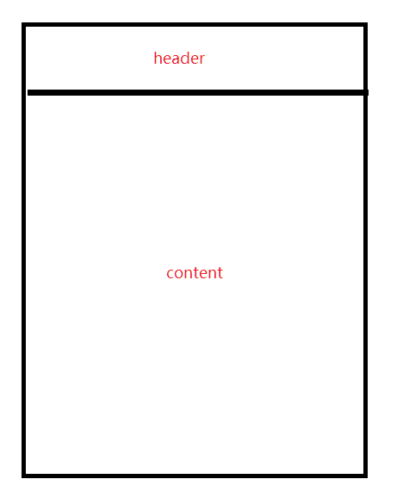

css1

<html>  
 html,  
 body{  
 height:100%;  
 width:100%;  
 }  
 <body>  
 <div class="header">  
 </div>  
 <div class="content">  
 </div>   
 </body>  
</html>

### 2.快速实现水平居中和垂直居中的方式？(写出伪代码即可)