The Logistics System:
A Key Element of Contraceptive Security Planning

A logistics system provides excellent customer service by fulfilling the six “rights”: ensuring that the right goods, in the right quantities, in the right condition, are delivered to the right place, at the right time, for the right cost.

Logistics Cycle

Over the years, experts have developed a logistics cycle that describes the activities of a logistics system. The logistics cycle comprises the following:

- The logistics management information system (LMIS), which is at the heart of the cycle;
- Quality monitoring, which is a continuing activity throughout the cycle; and
- Policies and adaptability, which constitute the logistics environment.

Each activity in the logistics cycle must contribute to excellence in customer service. Logistics management includes several activities that support the six rights.

The logistics cycle (JSI/DEVILVER Web site, 2005) emphasizes the interdependence of the various activities (see Figure 1). For example, product selection is based on serving customers. What would happen if, for medical reasons, customers refused to use a particular product? Logistics managers would need to reconsider their earlier decision and order products more acceptable to the customer. The decision would, in turn, affect procurement and storage, which are two other activities in the logistics cycle.

Figure 1. The Main Activities in the Logistics Cycle

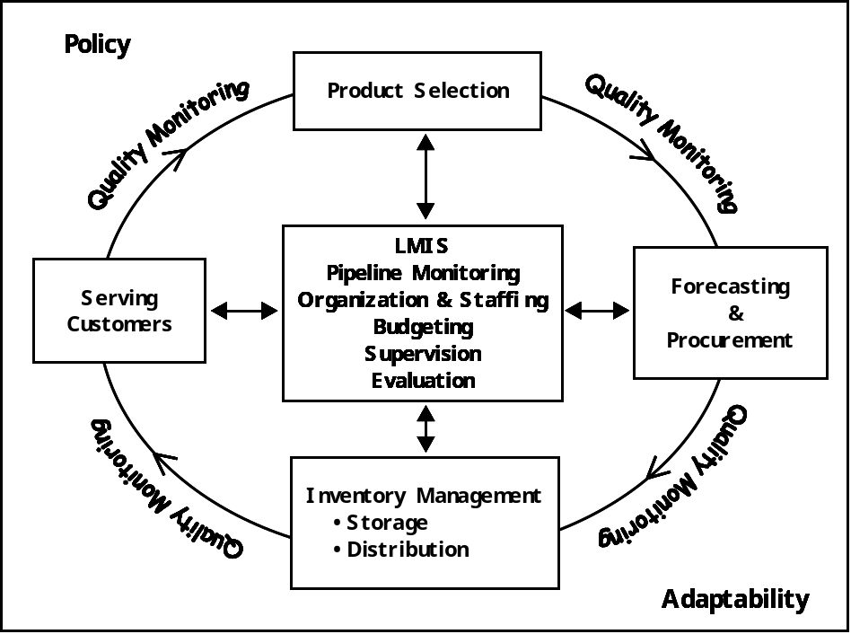

Serving customers. Each person who works in logistics must remember that he or she selects, procures, stores, or distributes products to meet customer needs. For example, a storekeeper does not store drugs simply for the purpose of storing them; he or she stores and provides products for customers as needed. For some items, customers may be willing to accept a substitute when the first choice is not available. Yet, a family planning client may not want to switch to pills if an injectable contraceptive is not available. While a retail business may fulfill most but not all of the six rights and still provide acceptable customer service, a health system must fulfill all six rights.

Product selection. In any logistics system, product selection is crucial. In a health logistics system, product selection may be the responsibility of a national formulary and therapeutics committee, pharmaceutical board, board of physicians, or other government-appointed group. Most countries have developed lists of essential drugs based on World Health Organization recommendations. The designated board’s ability to select specific products is influenced by other elements of the logistics cycle. The most important of these elements is the budget available to purchase the chosen products. For example, boards often choose generic drugs over name brands, which are often more expensive.

Many programs supplement the development of essential drug lists (products deemed most cost-effective in treating priority health issues) with programs to promote rational drug use. Rational drug use efforts aim to help prescribers choose the right product for each health problem and in the correct quantity.

Forecasting and procurement. After product selection, managers of the logistics cycle must determine and procure the quantity required of each product. The forecasting process focuses on estimating the quantities of the specific commodities that will be needed for a specified time period. The Procurement of Contraceptive Commodities Fact Sheet describes the procurement process.

Inventory management: storage and distribution. After an item is procured and received, it must be stored until the customer needs it. Almost all organizations store a quantity of stock for future needs. Determining how much stock should be stored is an important decision. Resource-poor countries face a particular challenge in providing appropriate storage and ensuring limited waste and losses during storage and distribution.

Logistics management information system. Information should drive the logistics cycle. Without information, the logistics system would not be able to run smoothly. Managers gather information about each activity in the system and analyze that information to coordinate future actions. For example, they gather information about inventory levels and consumption in order to know how much more of a product to procure.

A logistics system operates successfully only if well-trained and efficient staff members place orders, move boxes, and provide clients with goods. Health programs must be organized to provide the appropriate resources (for example, supervisory authority and technical knowledge) to ensure that all logistics activities are carried out properly. Organization and staffing are therefore important parts of the cycle. Logistics staff must make the six rights a top priority if a logistics system is to work properly.

- Budgeting affects product selection, the quantity of procured products, the amount of storage space available, and the number of staff working in logistics. Logistics activities must receive sufficient funding in the budget if the system is to operate effectively.

- Supervision of the logistics system ensures that the system runs smoothly and is able to anticipate needed changes. Effective supervision helps avoid problems or resolves them quickly before they escalate into crises.

- Evaluation of the logistics system can help demonstrate the impact of the system on other elements.

Quality monitoring. The logistics cycle depicted above shows that quality monitoring occurs between each activity of the logistics cycle. Referring not only to the quality of the product but also to the quality of the logistics cycle, quality monitoring is important for the following reasons:

- To monitor the quality of procurement decisions. For example, a manager selected Noristerat, an injectable contraceptive, as the most medically appropriate product for the health system. During forecasting and procurement, the manager learns that a donor cannot supply Noristerat, but will supply Depo-Provera, another injectable contraceptive. When reviewing the medical literature about the appropriateness of Noristerat, the manager realizes that Depo-Provera is equally appropriate and decides to offer that product instead.

- To monitor procured products. A program’s procurement request should include specifications that manufacturers are to follow (e.g., the requirement that the expiration date must be printed on each cycle of oral contraceptives). After procuring items, a logistics manager must also monitor quality before products enter the distribution system. The manufacturer often carries out quality monitoring, but the family planning program manager or pharmaceutical board may also require independent testing. Some programs also conduct quality-monitoring procedures to ensure adherence to procurement specifications (such as potency tests for drugs). One simple quality assurance technique is to check the labeling and packaging of arriving shipments to make sure that labels and packaging match required specifications.

- To monitor quality while products are stored and distributed (but before they reach customers). Products should be in the right condition when they are made available to customers. In preparing Ghana’s National Contraceptive Security Strategy, 2004 to 2010, the MOH and its partners pointed out that, within the public health system, outlets for distributing contraceptives are located mainly in local outlets and with midwives who are poorly equipped for proper storage and distribution.

- To follow up quality monitoring even after products are distributed to customers. Feedback should be collected on how customers feel about the quality of products they receive and whether they are satisfied with the service they receive. Quality monitoring of both product and service is critical to the success of efforts to promote the use of products—contraceptives, vaccines, or other essential drugs. The results of monitoring customer satisfaction can be used to inform decisionmakers about what products to select in the next procurement cycle.

The Logistics Environment: Policies and Adaptability

In addition to the components of the logistics cycle, two outside forces—policies and adaptability—have a strong influence on the logistics system.

Government regulations and procedures affect all elements of the logistics system. Many governments have set forth policies that guide the selection of medical products, how items are procured, when items are distributed, where and how items are stored, and the quantities customers can receive (often called dispensing protocols). Logistics managers should stay abreast of government policies and carry them out as specified. If logistics staff encounter problems with operating policies, they should bring the problems to the attention of logistics managers, who should discuss matters with the appropriate authorities or with contraceptive security committees in the event of the need for advocacy or policy dialogue.

Adaptability is the logistics system’s ability to obtain internal or external resources that are necessary to address changes in demand. Logistics managers often depend on a larger system, such as the government, to provide inputs. When managers do not control inputs, adaptability becomes more challenging. Money is one of the most important resources in a logistics system. For example, as demand increases, the logistics system needs more money to pay for fuel for extra deliveries, hire new warehouse workers, and train clinic personnel. The logistics system’s ability to meet these needs—its adaptability—will have an impact on its ability to meet customer needs.

A good logistics system can prevent stockouts and build customer trust. A woman walking a long distance to a clinic wants to obtain the reproductive health product of her choice, in good condition, in the quantity needed, and at the price she can afford. The woman who travels far and cannot obtain the product of choice is a disappointed customer. As stated, the logistics system should procure, store, and distribute products that meet customer needs.

