Raymond Walugembe 2021-B071-21417, Ssekate Victor Moses 2021-B071-21238

GROUP ONE  LUBAGA CAMPUS

DIGITAL lIBRARY MANAGEMENT SYSTEM

DIGITAL LIBRARY MANAGEMENT SYSTEM

1. CASE STUDY

In the current system, there is a Library branch which has various copies of books, and a table of book loans. A borrower can borrow any number of books as long as the copies are available. Each book has a given number of copies and these are the maximum number of loans that can be lent out.

The system has tables of the book author and the publisher. To identify the borrower, there is a Card_No. as the Primary key which is reflected as a Foreign key in the Book_Loans table. The Book copies and Book Loans tables are related to the Library branch using the Branch_ID key. The Book loans table and the Book copies table are related to the Books table using the Book_ID key. The Publisher table is related to the Book table using the Book_ID key which is a good representation of data consistence.

Below is the current system’s relational diagram.

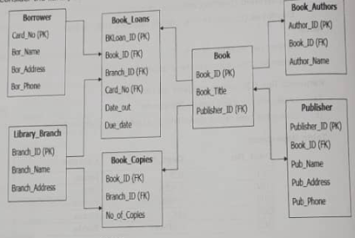

BUSINESS PROCESSES THAT NEED RE-DESIGNING

With the current system, there is no identification of the institution under which the library branch exists. This does not limit the borrowers and the library users which makes it hard to track the library’s resource usage.

The current system doesn’t have a report table to show the usage data and transactions made in the library system.

The current system doesn’t show the transaction made by the borrower. This ignores the penalties that are supposed to happen in case of loss or damage to the books.

The system doesn’t show the entity-relationship multiplicities.

1. The proposed Library management system database keeps track of the readers with the following considerations.

* The system keeps track of the university which comprises of the university_name, campus_name, location, address, student_id, branch_id and contact.
* The system contains students tables which in includes the stud_ID, stud_name, gender, contact and stud_email.
* This library shows the book_category, working hours, branch_id and branch_name, branch_address.
* Borrower consists of the borrowing_id, book_id, stud_id, date_out, Due_date, book_name.
* Report presents the report_id, trans_id, borrower_id, report_date
* Books identifies the book_id, bk_name, publisher_name, author_name, pub_date
* Transaction presents the trans_id, trans_name, borrower_id
* Book_copies contain book_id, branch_id, numbers_of_copies.
* Librarian contains of librarian_id, librarian_contact, librarian_name, branch_id.

ENTITY-RELATIONSHIP DIAGRAM OF PROPOSED SYSTEM.