CS4287 – Neural Computing
Assignment 1:
Fruit Classification Using a CNN
Group 5 - Colin Walsh, Luke Scanlon and Evelyn Sadlier

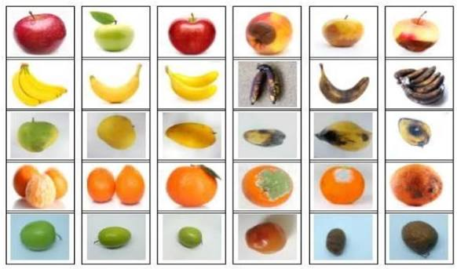

ii. Table of Contents

- The Dataset
This is the dataset we have chosen to work with:
https://github.com/fruits-360/fruits-360-100x100
- It contains fruit images for training an image-classification model.

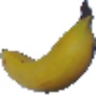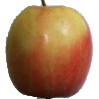
These are example images taken from the dataset. There are multiple angles and classifications for each fruit, for example here are a few of the banana pictures:
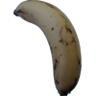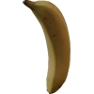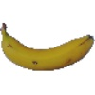

- These are the properties of our dataset:
Total number of images: 196522.
Training set size: 147416 images.
Test set size: 49106 images.
Number of classes: 274 (fruits, vegetables, nuts, seeds and mushrooms).
Image size: 100x100 pixels.

- We have decided to resize our images from 100x100 to 32x32. This is to reduce computational cost and training time while retaining enough visual information for the CNN to distinguish between the fruit classes.
The data is split into training and testing data, which we will honor by only using training data for model development and test data for final evaluation.

