Systems & Signals 414 10 April 2021

Walt Deyzel: 21750793

Question 1:

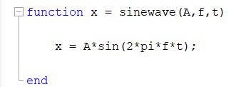

## Sine graph: A=2; f=50 Hz; t = 5 cycles

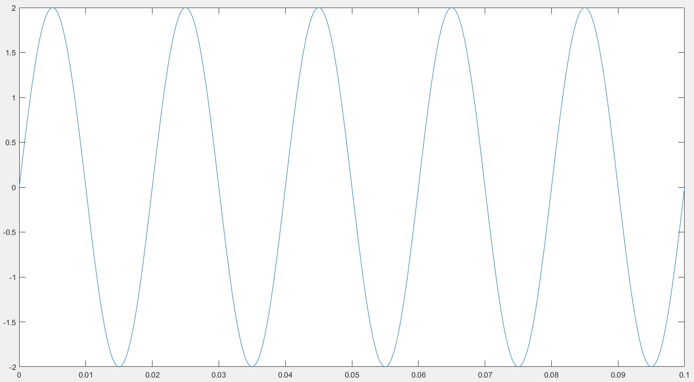

The sine signal above has a period of 0.01 which matches the period of the intended generated signal and the amplitude is 2 as expected.

**Question 2**:

## **Sampling a sine wave at fs=2000 Hz, of different frequencies (0-2100 Hz) and plotting 39 samples.**

### 300 Hz

### 200 Hz

### 100 Hz

### 0 Hz

|  |  |  |  |
| --- | --- | --- | --- |
|  |  |  |  |
|  |  |  |  |
|  |  |  |  |
|  |  |  |  |
|  |  |  |  |
|  |  |  | Time axis. |

**Question 2: Continued.**

The sampling frequency is 2000 Hz while the frequency of the sin wave increases from 0 Hz to 2100Hz. In the beginning the signal is oversampled because the fs is much greater then 2xf. As the frequency of the signal increases the period decreases but the sample frequency stays the same. Which means every period has fewer samples. At 1kHz and 2kHz a sample is taken at every instant the sine signal is at zero amplitude resulting in a flat line. Up until 1kHz the discrete signal can accurately represent the actual signal because the sample frequency is greater than twice the signal frequency. From 1kHz onwards the accuracy of the discrete signal is very bad because the sample frequency is less than twice the signal frequency (Nyquist).

**Question 3:**

### Sine wave with frequency 900 Hz sampled at 2000 Hz unscaled axis.

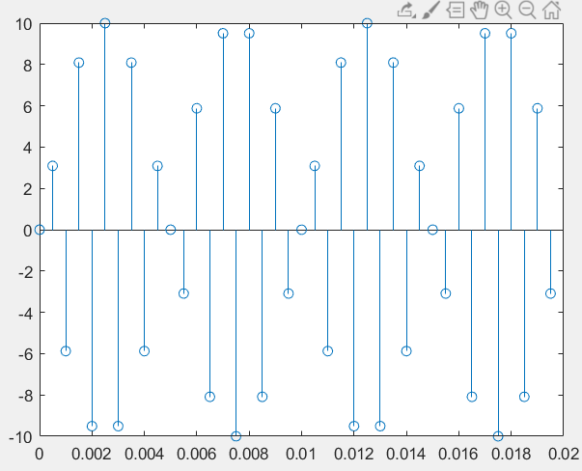

The sampled signal might look incorrect, but it is not. The sample frequency is greater than 2x the signal frequency, so the Nyquist criteria is met. Plotting the sampled signal over the continuous signal (see next graph below) one can see that how little information is used to capture and represent the signal.

### Sine wave with frequency 900 Hz sampled at 2000 Hz

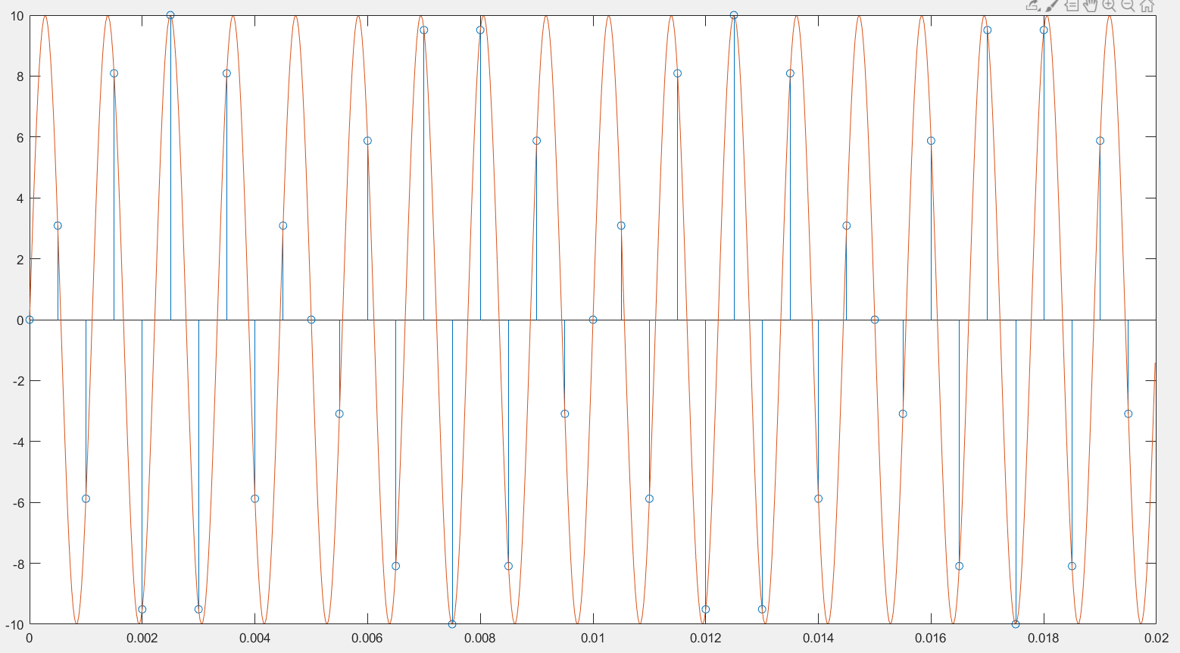

Question 4:

$$y=10\sin\left(2π\left(100\right)t\right)+ 10\sin\left(2π\left(2100\right)t\right)$$

#### Y sampled at 2000 Hz

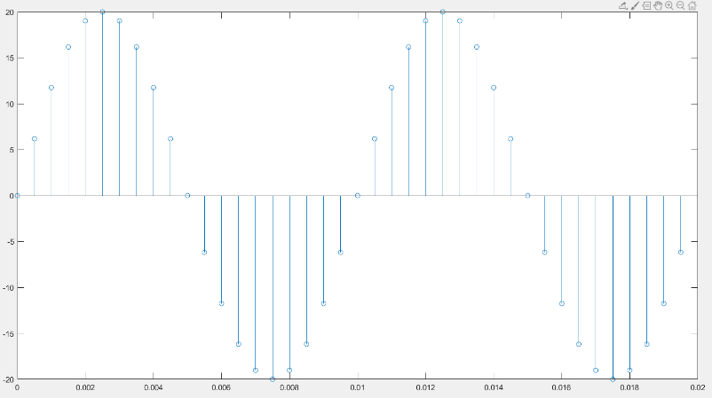

A

### Y continuous sampled at 2000 Hz

### Y continuous

|  |  |
| --- | --- |
| B | C |
| D | As you can see on **graph** **A** the sampled signal is a 100Hz sine signal with amplitude 20.  The graph on D illustrates the fact by dividing the amplitude of the sampled signal by two and plotting the 100 Hz signal. They match perfectly.  This means sampling at 2000 Hz does not capture the 2100Hz signal’s information. And therfore cannot reconstruct the signal perfectly from its samples. Nyquist criteria not met. |

### All 3 signals plotted but not superimposed.

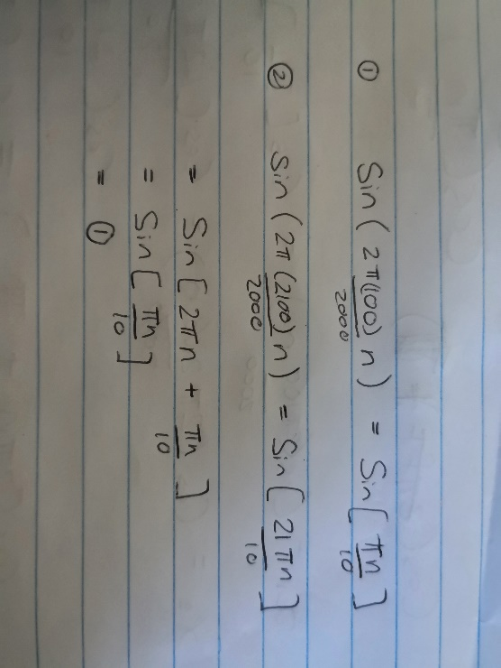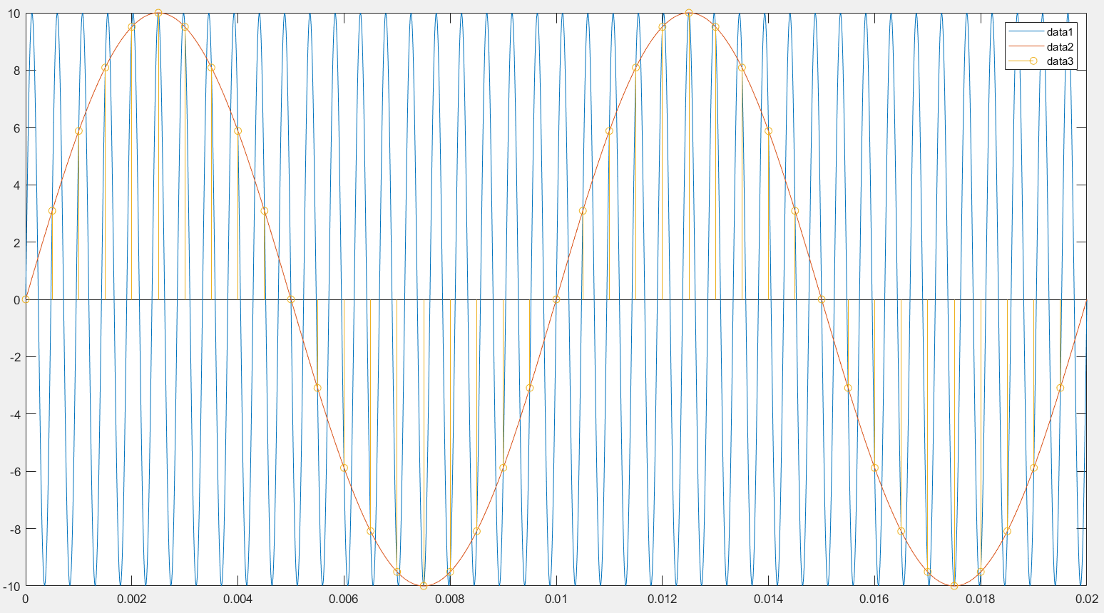

As you can see in the figure above the 2100 Hz sine wave is sampled exactly as a 100Hz sine wave.

**Question 5:**

$$f_{ω}= \frac{f}{f_{s}}= \frac{100}{2000} ; \frac{2100}{2000}$$

$$T_{p}=\frac{1}{f}$$

The 900 Hz signal has a period of 0.001 seconds. The 100 Hz signal has a period of 0.01 seconds.

Assuming a sample frequency of 2000Hz because the question does not specify any.

For 100Hz -> T = 0.01 seconds and the sampling period is 0.0005 seconds. $N_{p} =\frac{0.01}{0.0005}=20=\frac{1}{fω_{100Hz}}$ and for 900Hz -> T = 0.0111 seconds and the sampling period is 0.0005 seconds. $N_{p} =\frac{0.0111}{0.0005}=3=\frac{1}{fω_{2100Hz}}$; rounded to 0 decimal places.

For Ω = 900 = 2πf; ->f=143.239 Hz -> T = 0.00698 seconds. $f_{ω}= \frac{143.239}{2000}≈0.0715→N_{p}=14$

$$x\left[n+N_{p}\right]=x[n]$$

$$\sin{[nT]}=\sin\left[nT+N_{p}\right]→\sin\left[\frac{900}{2000}*14\right]≈0=sin⁡[0]$$