Systems & Signals 414 Prac4 12 May 2021

Walt Deyzel: 21750793

|  |
| --- |
| Q1.a) Z-Plane & |
|  |
|  |

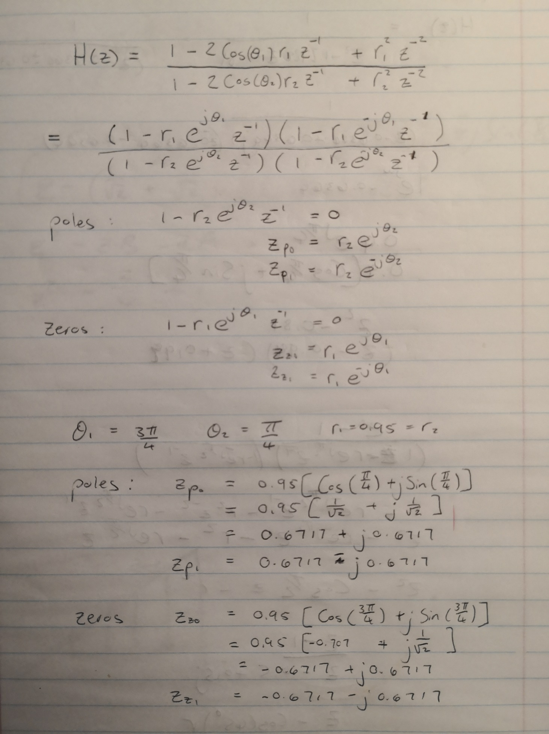

|  |
| --- |
| Q1.b) Frequency & Phase Response of H: varying |
|  |
| **Observations:** |
| When we change the value of **R1** we are changing the distance of the zeros are from the unit circle but keeping the angle it makes with the real axis constant. The effect that has on the frequency response can be seen in the graphs above. At R1 = 0 there are two spikes arount 0.3 and 1.7 rad/sample and a steady decay to zero. As R1 increases the steady decay slows down and a small bump starts to apear between 0.7-1.3 rad/sample circled in orange. |
| Impulse Response of H: varying |
|  |
| **Observations:** |
| Only observation I can make is that the amplitude of the impulse response changes ever so slightly due to the phase shift of the signal. |
| Frequency & Phase Response of H: varying |
|  |
| **Observation:** |
| When we change the value of R2 we are changing the distance the poles are from the unit circle but keeping the angle it makes with the real axis constant. The effect that has on the frequency response can be seen in the graphs above. At R2 = 0 there is a fat lobes centered arount 0.3 and 1.7 rad/sample that decays to zero with a small bump between 0.7-1.3 rad/sample. As R2 increases the decay of the fat lobe becomes faster and a sharper spike starts to appear indicated by the orange arrow. As soon as the poles leave the unit circle the sharp spikes changes to small spikes on the fat lobes. The slope of the phase graph near the edges becomes steaper as indicated by the green arrows. |
| Impulse Response of H: varying |
|  |
| **Observation:** |
| When the poles leave the unit circle the system becomes unstable. This can be seen in the graph where R2=1.05. When the poles are within the unit circle the system is stable on the impulse response dies out quickly. When R2=1 the system is marginally unstable for its impulse response won’t die out, but it will not increase either. There is a minor phase shift between the graphs. |
| Frequency & Phase Response of H: varying |
|  |
| **Observation:** |
| When we change the value of we are changing the angle the zeros makes with the real axis but keeping the distance to the origin constant. With the bump in the middle is very wide and morphs into the spikes on either side of it. As increases the middle lobe becomes narrower and the decays from the spike peaks becomes faster. Also there is a 2π phase shift between = 0 and = 0.5π. |
| Impulse Response of H: varying |
|  |
| **Observation:** |
| The amplitude of the impulse response changes slightly as increases due to the slight phase shift as theta changes. There is a 2π phase shift as increaases. |
| Frequency & Phase Response of H: varying |
|  |
| **Observation:** |
| When we change the value of we are changing the angle the poles makes with the real axis but keeping the distance to the origin constant. With the tips of the spikes sit at the end of beginning and end of the graph indicated by the yellow arrow. As increases the tips of the spikes move closer and closer to the middle until they merge. The green arrows show how the phase graph changes due to |
| Impulse Response of H: varying |
|  |
| **Observation:** |
| It is also clear from the graph above the effect has on the phase. All the impulse responses are stable for it does not shoot of to infinity. Except when = π the signal keeps oscillating and is not stable. |
| Sinusoidal response of H: varying |
|  |
| **Observation:** |
| No noticeable observation. |

|  |
| --- |
| Q2.a.1) Bandpass Filter frequency response. |
|  |
| ZPlane |
|  |