ODT TEMPLATE ENGINE / LEARN · L06

Images
Choose who owns the image structure: LibreOffice can author a position, or PHP can generate an image element.

Template-owned position
LibreOffice authored this frame; PHP replaces its image resource.
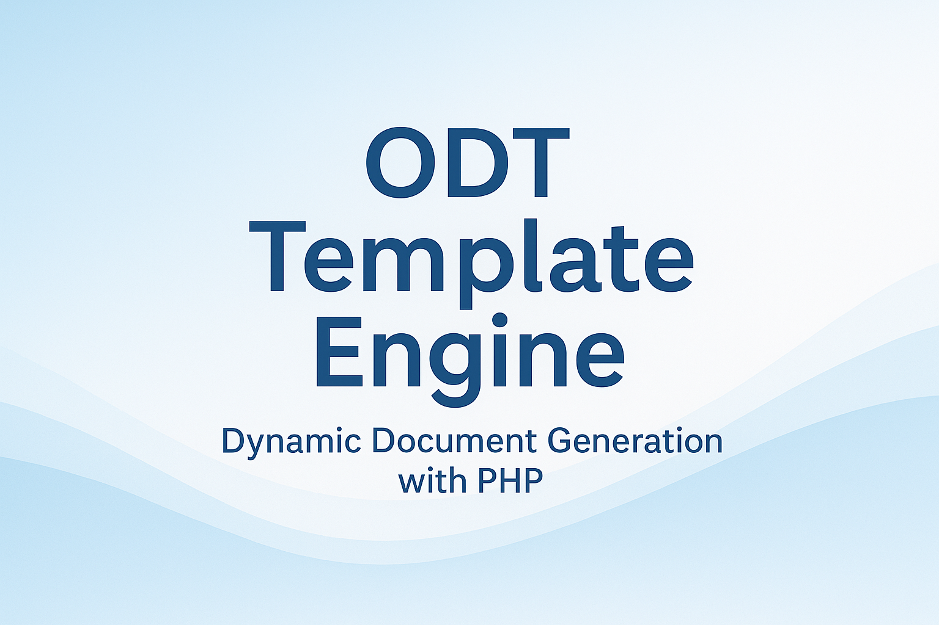

PHP-generated image element
This insertion point is template-authored; PHP supplies a new native frame and image.
{{generated_image}}
replaceImageByName() replaces image content in an existing named frame. ImageElement creates a frame as part of a generated ODT subtree.

