Asteria Demo Foundation
SAMPLE DOCUMENT · FICTIONAL ORGANIZATION AND DATA
Annual Performance Report 2026
Pathways 360 Demo Program
January–December 2026 · Final Report · 31 January 2027

This document is a demonstration sample created for the ODT Template Engine. All organizations, programs, persons, figures and report data shown in this document are fictional and are used solely for demonstration purposes.
01 Executive Summary
Bridgeway Skills supported 272 participants across three delivery locations during 2027, combining coaching, practical learning, and employer contact.
The updated report retains the authored professional structure while changing the report identity, results, activities, and management reading through native targets.
Completion reached 89%, and 71% of participants progressed into employment or further training.

272  Participants | 89%  Completion rate | 71%  Positive outcomes | 47  Employer partners

KEY FINDING
Participants receiving coordinated coaching and employer-facing support showed the strongest progression.

Management reading
The 2027 results point to the value of linking practical learning with earlier employer contact and targeted confidence-building support.
02 Program Overview & Delivery
Bridgeway Skills combined individual guidance, practical workshops, and employer-facing activity to support progression across three fictional delivery locations.

Reporting period  January–December 2027 | Locations  3 locations | Delivery team  14 people | Employer partners  47 partners

Program Objectives
- Improve employment readiness and training opportunities.
- Strengthen vocational and digital skills.
- Connect participants with employers.
- Support progression into employment or further training.

Activities Delivered
Activity | Delivered | Participants
Mentoring clinics | 980 | 210
Digital practice labs | 72 | 198
Employer roundtables | 12 | 110
Sector visits | 9 | 96
Peer learning circles | 28 | 144
Progression workshops | 34 | 173

Delivery observation
The expanded activity mix increased opportunities for participants to practise skills in different settings.
Employer-facing activity remained concentrated around practical preparation and progression conversations.
03 Performance & Outcomes
Performance against targets
Indicator | Target | Actual | Status
Participants enrolled | 260 | 272 | Achieved
Program completion | 82% | 89% | Above target
Employment/training outcome | 65% | 71% | Above target
Employer partners | 40 | 47 | Above target

Participant outcomes
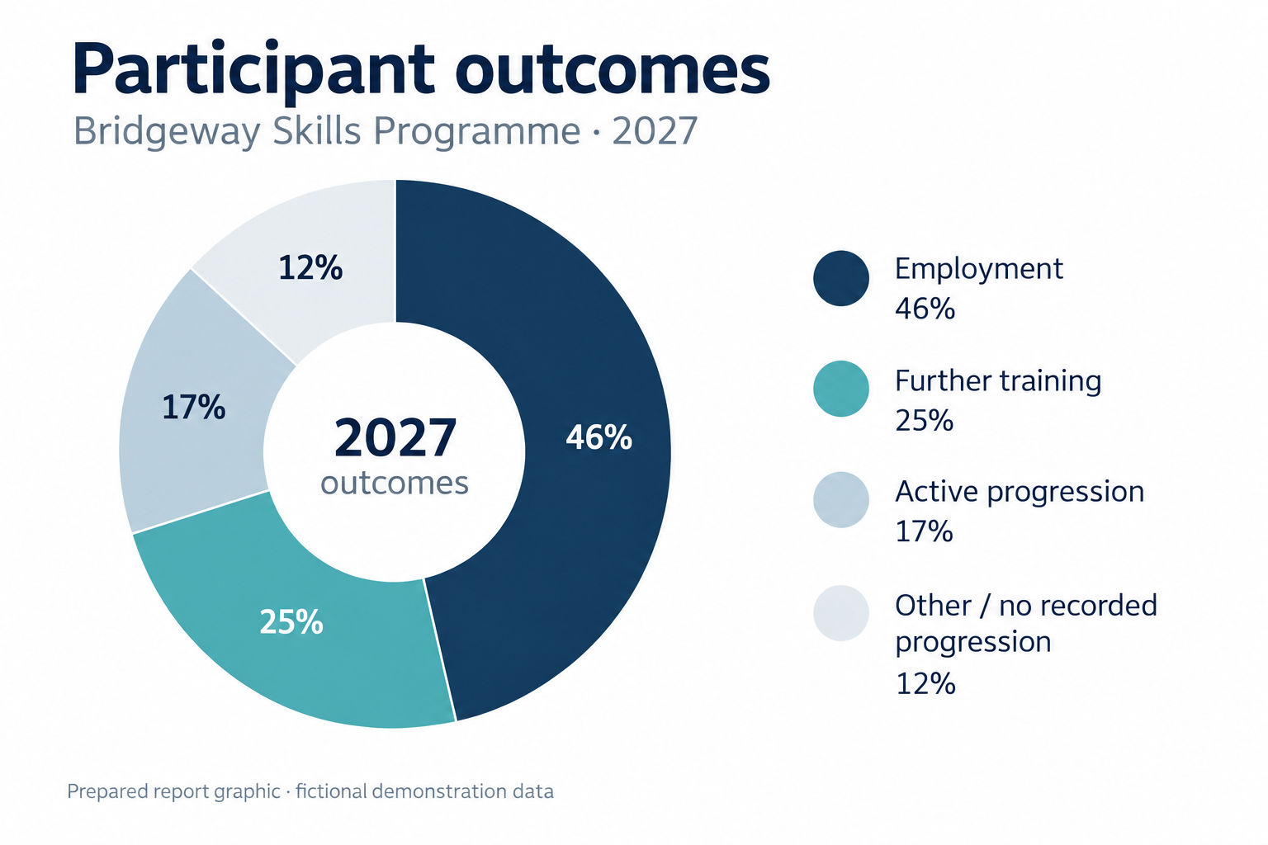
Participant outcomes · 2027
Employment and further-training outcomes together accounted for 71% of recorded progression, with active progression representing a further 17%.
04 Findings & Analysis
1. Integrated support produced stronger outcomes
Participants who received both individual coaching and employer-facing support showed the clearest progression through the program.
This pattern supports maintaining a connected delivery journey rather than treating activities as separate interventions.

2. Digital confidence remains uneven
Digital practice improved confidence for many participants, but starting points and preferred learning routes remained varied.
Targeted practice should therefore remain part of ordinary delivery instead of being reserved for a single specialist session.
PROGRAM INSIGHT
Employer engagement proved most effective when Employer engagement proved most effective when employers became involved before the formal recruitment stage rather than only receiving completed candidate profiles.
Challenges
- Irregular attendance among a small participant group.
- Varying levels of digital literacy.
- Limited placement opportunities in some occupational areas.

Management implication
The response should remain selective: protect flexible attendance support, build digital practice into ordinary delivery, and focus employer development where progression opportunities are most constrained.
05 Recommendations & Outlook
Recommendations
- Expand employer involvement by bringing partners into program design and preparation earlier. This should align practice opportunities with realistic recruitment expectations and make employer-facing activity more purposeful.
- Strengthen targeted digital support for participants with lower initial confidence. Additional guided practice should help participants apply digital skills with greater confidence in vocational contexts.
- Improve outcome tracking so longer-term progression can be understood more consistently. A clearer view after completion would help distinguish immediate results from sustained movement into work or training.
- Create more peer-learning opportunities around sector-specific practice and confidence building. Shared practice can reinforce capability and reduce isolation for participants working toward similar goals.

Outlook 2028
The next reporting period should consolidate the stronger activity model while extending purposeful employer contact and practical digital support.
A clearer follow-up view will help Meridian distinguish immediate completion from sustained progression into employment or further training.
Demonstration report · fictional organization and data

