Welcome to the Project Report 📘
This document was automatically generated from HTML content using the OdtTemplateEngine. It demonstrates key features such as styling, structure, and media embedding.

Core Features
Supported elements include:
- Styled text with colors, italics, underlining, and highlighting
- Text can be removed or annotated with subscripts and superscripts
- Clickable hyperlinks to external resources
- Local image embedding from your project files
- Remote image loading from the web
- Embedded base64 images (if enabled)
- Structured lists with nested items

Project Structure
- Introduction
  - Goals of the project
  - Initial approach and planning
- Analysis
  - Data Collection
  - Evaluation
    - Strengths
    - Weaknesses
- Conclusion

Image Showcase
Embedded local image:

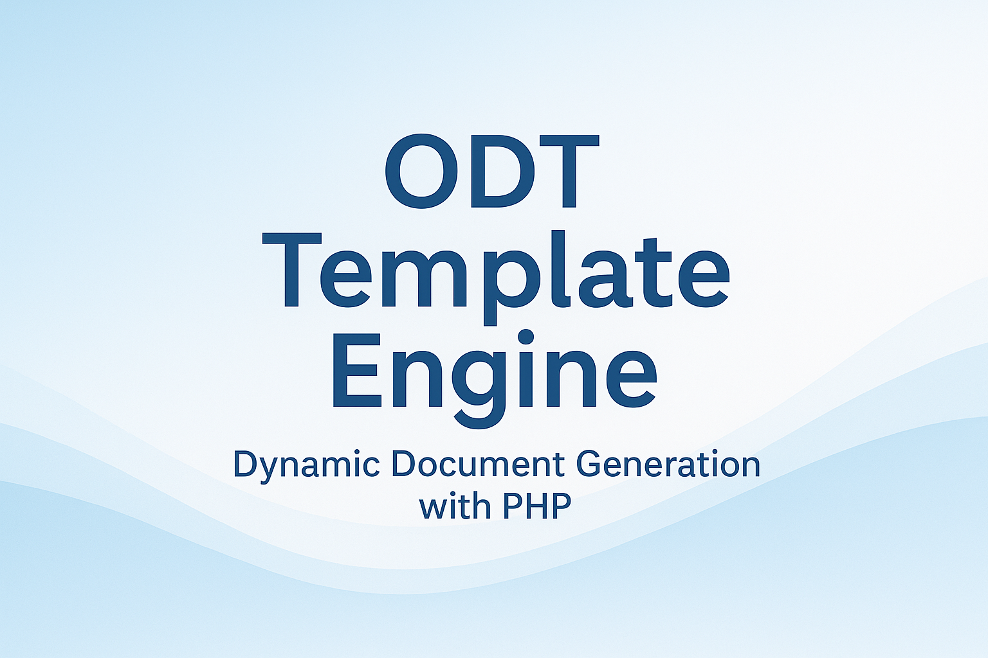
Remote image (web-hosted):

Base64-encoded image (small placeholder):

Contact
For questions, reach us at: contact@example.com
© 2025 OdtTemplateEngine — Automatically generated with ❤️.

