Welcome to OdtTemplateEngine 🌟
This is a dynamic document generated using HTML structures.

Features
Our engine supports:
- Paragraphs with different colors and styles
- Links to external websites
- Internal anchors like Contact Section
- Local images embedded directly from the project

Gallery
Here is an embedded image:

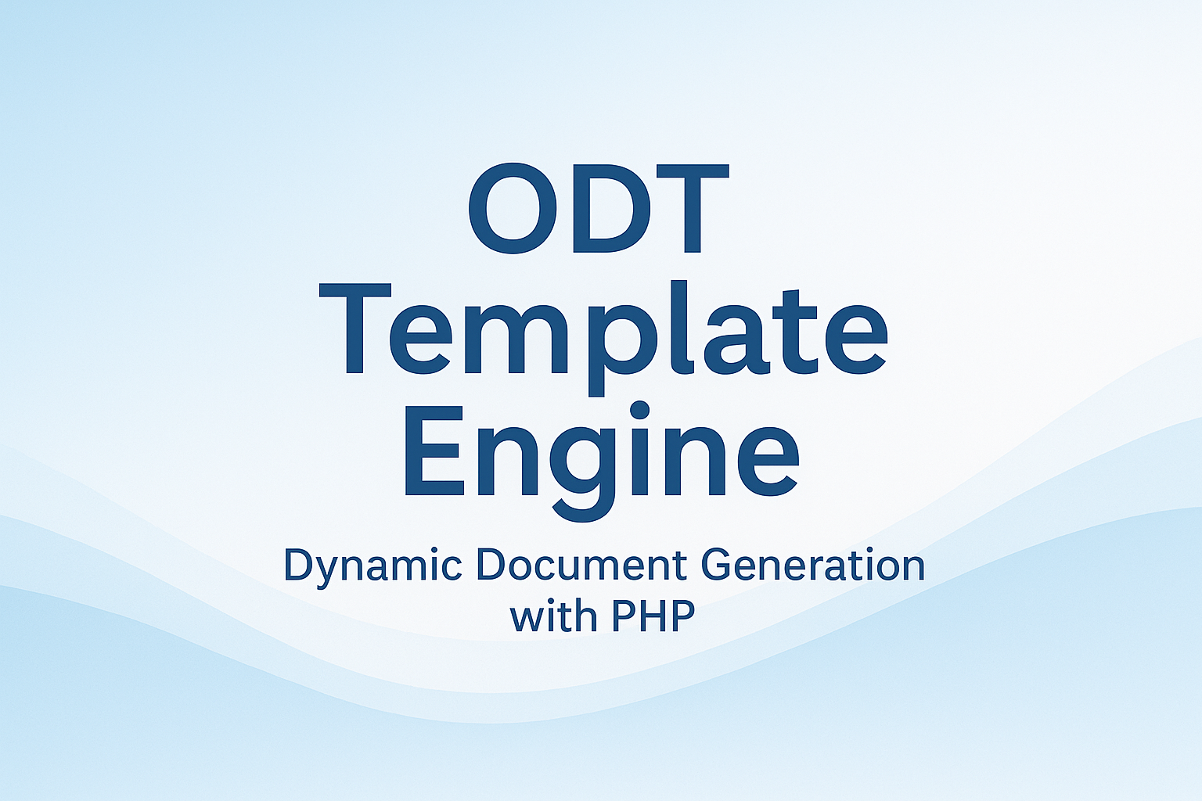

Contact
You can reach us at: contact@example.com
© 2025 OdtTemplateEngine - All rights reserved.

