Biomechanics Toolbox Documentation (v0.1)
Program and Help written by Walt Menke

Table of Contents
License 1
License Information 1
License Agreement 1
Program Description 2
Purpose 2
Hardware and Software 2
Data Format Requirements 2
Main Menu 3
Function - Script Gen 6
Function - EMG (under construction) 8
Function - Batch 9
Function - Normalize 12
Function - Event Pick (under construction) 13
Function - Event Compile (under construction) 15
Function - Quality Check 16
Function – Ensemble 18
Function – SPM (under construction) 21
Example File Descriptions 25
Suggested Citations 26
SPM1D 26
SciencePlots 26
Biomechanics Toolbox 26

License

License Information
The Biomechanics Toolbox is free but copyright software, distributed under the terms of the GNU General Public License as published by the Free Software Foundation (version 3). Further details on “copyleft” can be found at http://www.gnu.org/copyleft/. In particular, Biomechanics Toolbox is supplied as is. No formal support or maintenance is provided or implied.
Additionally, this program utilizes the spm1d package which is covered under the same GNU General Public License 3.0 with Copyright (C) 2021-2022 Todd Pataky; further license information can be found at https://spm1d.org/Downloads.html.

License Agreement
Copyright 2023, Walter Menke
This file is part of the Biomechanics Toolbox.
Biomechanics Toolbox is free software: you can redistribute it and/or modify it under the terms of the GNU General Public License as published by the Free Software Foundation, either version 3 of the License, or (at your option) any later version.
Biomechanics Toolbox is distributed in the hope that it will be useful, but WITHOUT ANY WARRANTY; without even the implied warranty of MERCHANTABILITY or FITNESS FOR A PARTICULAR PURPOSE. See the GNU General Public License for more details.
You should have received a copy of the GNU General Public License along with Biomechanics Toolbox. If not, see <https://www.gnu.org/licenses/>.

Program Description

Purpose
The field of biomechanics is usually plagued with time consuming data processing on account of the vast amount of data collected in labs (motion capture, kinetics, electromyography, etc.). Frequently, there are no packaged options for gathering data into usable batches, performing quality checks, determining useful discrete time series events, and producing publication ready figures. The purpose of the Biomechanics Toolbox is to facilitate a more efficient workflow for processing biomechanics data and preparing it for presentation in abstracts and manuscripts. Significant efforts have been made to provide numerous and descriptive error messages to the user to prevent frustration and time lost to troubleshooting. The program has been designed to allow users to generate Visual 3D scripts for each subject and condition, filter and process EMG data, batch process V3D output text files, normalize batch outputs for graphing, select only desired variables for discrete event picking, compile events, check data quality, create publication level ensemble graphs, and perform Statistical Parametric Mapping analyses.

Hardware and Software
Package requirements for this program can be found in the “ToolboxRequirements.txt” file included with the application download. The matplotlib modification package “SciencePlots” is not strictly necessary as it requires a local LaTeX installation to be used. Plotting functionality will only be changed minimally without it installed; the effect will only be seen when generating ensemble curves. The program was originally written in Python v3.11.6 (64-bit) on Windows 11 in Visual Studio Code v1.84.2. The default application window size is 750x800 pixels, but some visualization functions create a window of 1100x1100 pixels. The OS package in Python has been used to in effort to allow MacOS and Linux functionality, but functionality is not guaranteed outside of Windows 11.

Data Format Requirements
This program was written with certain file naming conventions and data structures in mind. Specifically, it is highly encouraged to utilize a consistent naming scheme in the format of ‘S1C1T1,’ where S corresponds to the subject number, C corresponds to the condition (gait, cycling, stair climb, etc), and T corresponds to the trial number. Once the Batch function has been used, for example, this program will recognize how many components (X, Y, Z) have been exported, but it is recommended to export all three components for biomechanics data. Given the ability for the user to select which specific variables to perform event picking on, there is no downside to having all three components present in the data. Be sure that single component variables (Joint Work, ROM, etc) are not included in the files you would like to process with this program. Those variables should be in a separate file. Variable names should be named along the lines of “HipAngle” and “KneePower” because some functionality is tied to finding upper- and lowercase letters to insert whitespace.
It is strongly advised that you do not export two components for one variable and three components for another in the same output file. This is likely to result in abnormal program behavior. Additionally, script files using the V3D ‘Export_Data_to_ASCII’ pipeline command should ideally export a file for each condition and side individually. For example, a file ‘S1C3_Right_Vars.txt” would be a good name to save all C3 data for S1. Combining multiple sides of conditions per output file is not advised as this may make your experience with later functions in the program more difficult. The Quality Check and Event Picking functions will become considerably more cumbersome as a result. More specific formats and structures are explained along with relevant function sections.

Main Menu
The Main Menu of the program is shown below in Figure 1, and it consists of a small overview of the program’s purpose, functionality, and some required packages. The toolbar consists of ‘Options’, ‘Functions’, and ‘Help’ entries whose sub-entries are displayed in Figures 2, 3, and 4, respectively.
Throughout the program, in general, input buttons will be green, output buttons will be blue, and function execute buttons will be orange.
Figure 1:Main Menu image of the Biomechanics Toolbox with no tabs open.
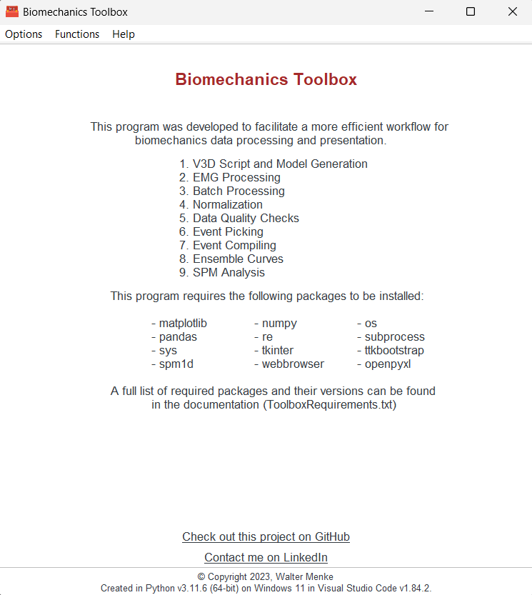
The toolbar within the main window provides three dropdown menus: Options, Functions, and Help (Figure 2,3, and 4, respectively). The Options menu has six sub-entries that are explained here.
Save Tab Params: This option saves the currently selected tab’s entries and parameters to a txt file in a location specified by the user. This includes the tab name, strings, checkboxes, lists, etc.
Load Tab Params: This option loads saved tab parameters into the tab as specified in the Save Tab Params output file.
Close Current Tab: Closes the currently selected tab.
Close All Tabs: Closes all open tabs and returns the user to the main menu.
Restart: Restarts the program.
Exit: Safely exits the program.
Figure 2: The Options toolbar entry expanded to show the four sub-entries.
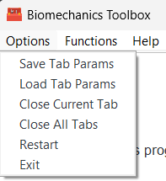
The Functions toolbar entry expanded to show the various functions available in the program are seen in Figure 3. The options are described in greater detail in the next section of the documentation.
Figure 3: The Functions toolbar entry expanded to show the nine sub-entries.
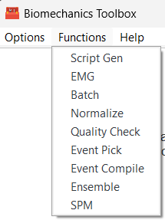
Figure 4 shows the Help toolbar entry expanded which has a single entry to open this documentation.
Figure 4: The Help toolbar entry expanded to show the Toolbox Documentation sub-entry.
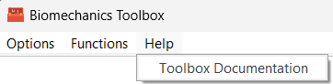
The program supports the ability to have multiple tabs (each containing a function) open at one time and these tabs are clickable once opened (Figure 5).
Figure 5: Image showing the selectable multi-tab functionality of the toolbox.
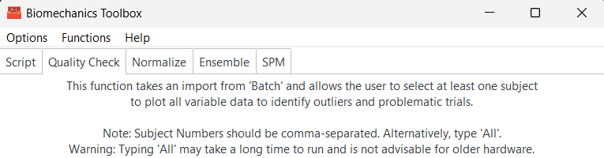
The following sections describe each of the available toolbox functions, their appearance, inputs required, and outputs produced for the functions. Descriptions of the variable type expected in each tab are also presented.

Function - Script Gen
This function provides the ability to input a template V3D pipeline, V3D model file, and a Height-Weight table to produce scripts and models for all subjects with specific heights and weights applied.
Figure 6: A view of the Script tab without entries.
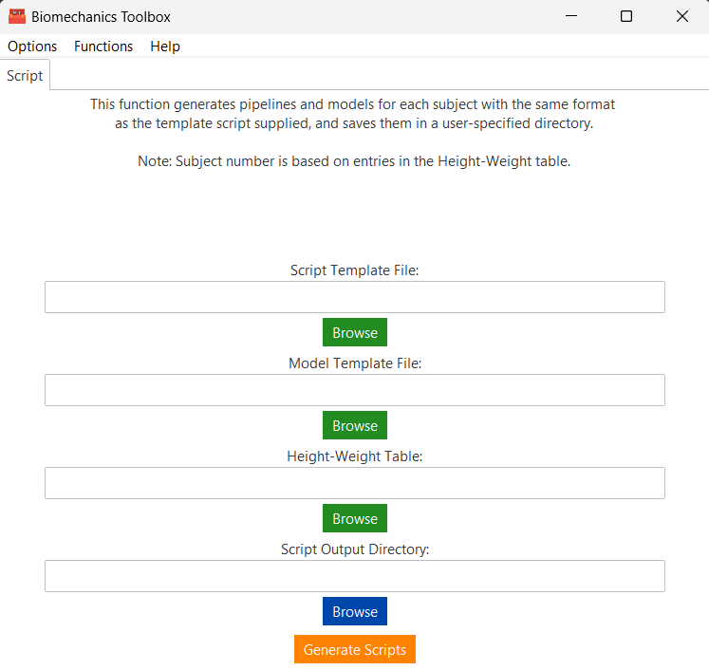
Inputs
Script Template File (string): Specify the full path to the Visual 3D pipeline file (.v3s) you would like to duplicate for multiple subject numbers. Be sure that ‘S1’ is referenced throughout the template script as the program searches specifically for ‘S1’ to replace with your subject numbers. This script should contain pipeline commands for ALL conditions of each subject.
Model Template File (string): Specify the full path to the Visual 3D model file (.mdh) you would like to duplicate for multiple subject numbers. As specified above, ‘S1’ should referenced within the template model file. The toolbox simply replaces the heights and weights between subjects by searching for /METRIC_NAME=Mass (or Height) followed by /METRIC_VALUE=(some float value).
Height-Weight Table (string): Specify the full path to an Excel file (.xlsx) that contains a layout as specified below (Figure 7). Mass should be entered in kilograms and Height should be entered in meters.
Figure 7: Height-Weight Table layout.
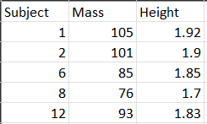

Script Output Directory (string): Specify the full path to the directory you would like the Scripts and Models to be placed. The program will generate a ‘Models’ and ‘Scripts’ folder in the directory if they do not already exist to store the respective files (Figure 8).
Outputs
The function outputs can be seen in the three figures below (Figure 9, 10). The number of files generated depends on the length of the subject column in the Height-Weight table.
Figure 8: Models and Scripts folders generated by the toolbox.
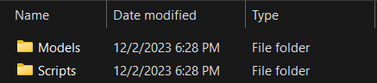
Figure 9: Contents of the Scripts and Models folders according to the Figure 7 Height-Weight table.
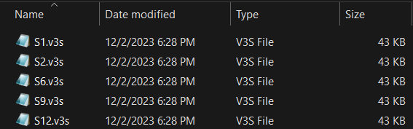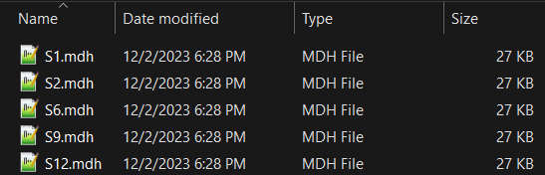

Function - EMG (not available)
This function will allow for electromyography (EMG) data to be filtered, normalized and optionally graphed if desired.
Inputs, Outputs
Example

Function - Batch
This function creates a text file output that contains the compiled data for all subjects for a particular condition that is specified by the user.
Figure 10: A view of the Batch tab without entries.
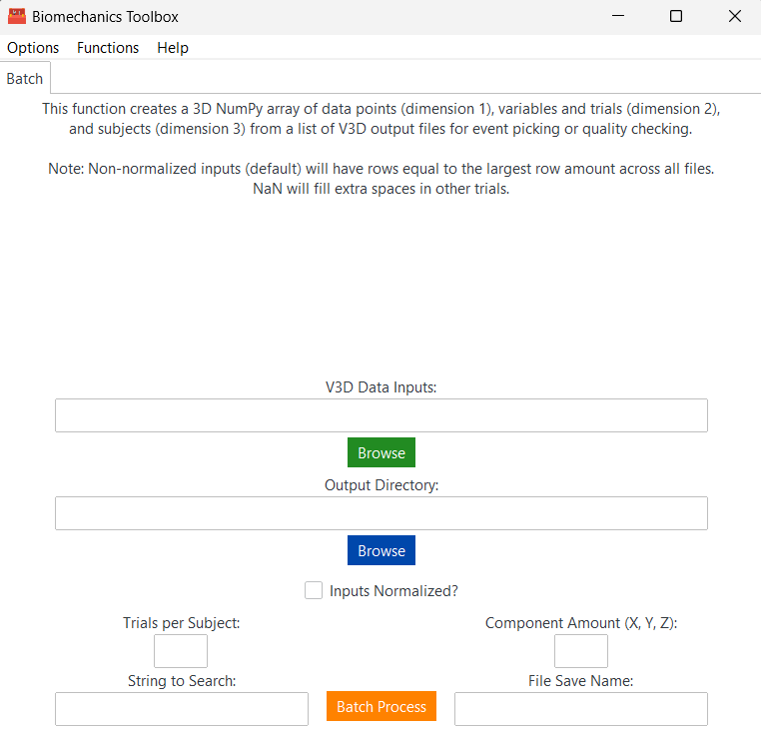
Inputs
V3D Data Inputs (string): Specify the full path to the directory you have saved all V3D text output files of interest. All output files of interest for all subjects should be in this directory (Figure 12).
Output Directory (string): Specify the full path to the directory you would like your batched data to be saved to.
Inputs Normalized (True/False): A checkbox denoting if the input data are normalized to 101 data points.
Trials Per Subject (integer): A single integer that denotes the number of trials that are contained within each file in the V3D Data Inputs directory.
Component Amount (comma-separated list): A Boolean list describing the presence or absence of X, Y, and/or Z components. For example, to specify that X and Z components are present, you should enter ‘1,0,1.’ It is recommended to always export all components for this program.
String to Search (string): Specify a string that is a partial pattern match to select files from the folder you would like to compile. For example, if your folder contains files named as shown in Figure 12, the entry option here could be ‘_walk.txt’ to select all related files. This string should be specific enough to exclude other files present if they are not currently of interest.
File Save Name (string): Specify the filename you would like the output to be saved to. Do not add a file extension, as the default extension is .TXT.

Figure 11: A view of the Batch tab with all entry boxes filled.
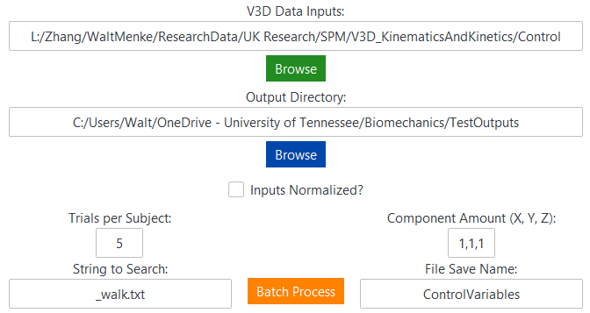
Figure 12: An example setup of a folder to search for the Batch function.
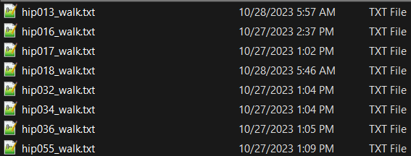
Outputs
The Batch function returns a text file with three lines of metadata followed by a flattened 3-dimensional array containing the observations (rows), trials and variables (columns), and subjects (slices). The first few lines of an output from this function can be seen in Figure 13. The first line (101 135 8) is metadata about the Rows X Columns X Slices of the original array and is used to reshape the array in later functions. The second row is a list of strings that are the variables present in all of the files. The program checks to ensure each input file has the same number of columns. In Figure 12, ‘RightAnkleAngle’ is seen repeated three times. The purpose of this is to have a string for each component present in row three, which has (1,1,1), indicating that X, Y, and Z are present. If this entry was (1,0,1), then ‘RightAnkleAngle’ would only be repeated once. In this example, the data were normalized before processing, but for non-normalized data the rows count will correspond to the largest number of rows for a trial across all subjects and ‘nan’ will fill all other empty spaces.
Figure 13: An example output from the Batch function.
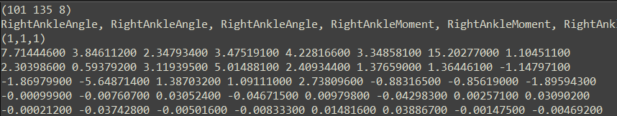

Function - Normalize
This function allows for the normalization of a file produced by the Batch function. In cases when normalized data are not exported from V3D, this should be used to allow for ensemble curve generation.
Figure 14: A view of the Normalize tab without entries.
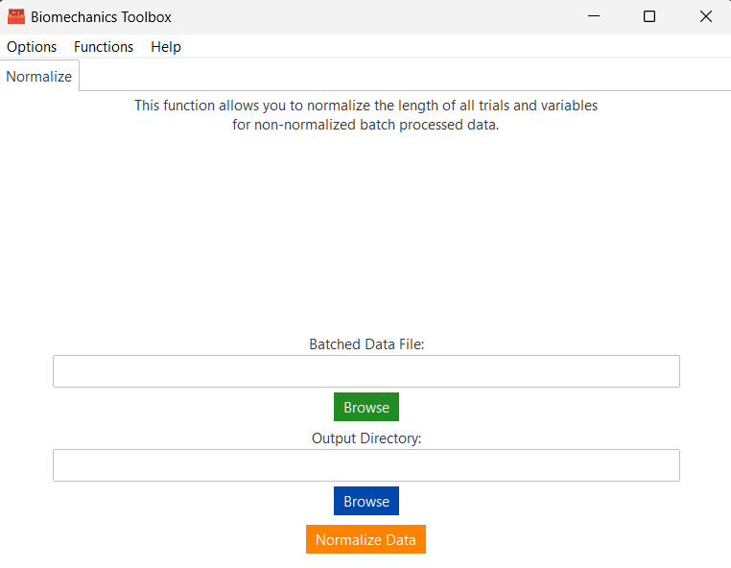
Inputs
Batched Data File (string): Specify the full path to a text file that was produced by the Batch function previously. Raw V3D outputs will not work here, the file must be produced by the Batch function.
Output Directory (string): Specify the full path to save the normalized text file. The filename will be the same as the input file with ‘_Normalized” appended to the end.

Figure 15: A view of the Normalize tab with both entry boxes filled.
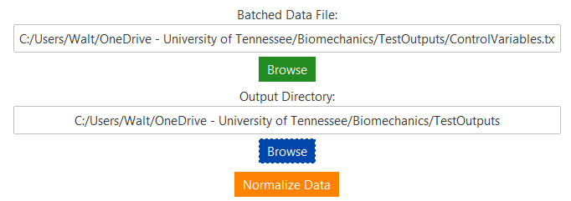
Outputs
A file with the same format as the output from the Batch function will be produced, except the row data will now be 101. Columns and slice amount will not be changed.

Function - Event Pick (in progress)
This function is designed to allow the user to assess, remove, and replace local maxima and minima from variables of interest. It allows the user to import a file produced by the Batch function and select a single subject to process.
Figure 16: A view of the Event Picking tab without entries.
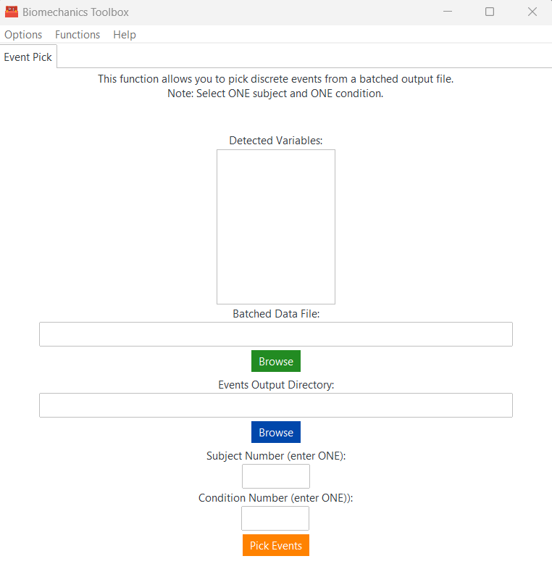
Figure 17: A view of the Event Picking window with a randomly generated curve.
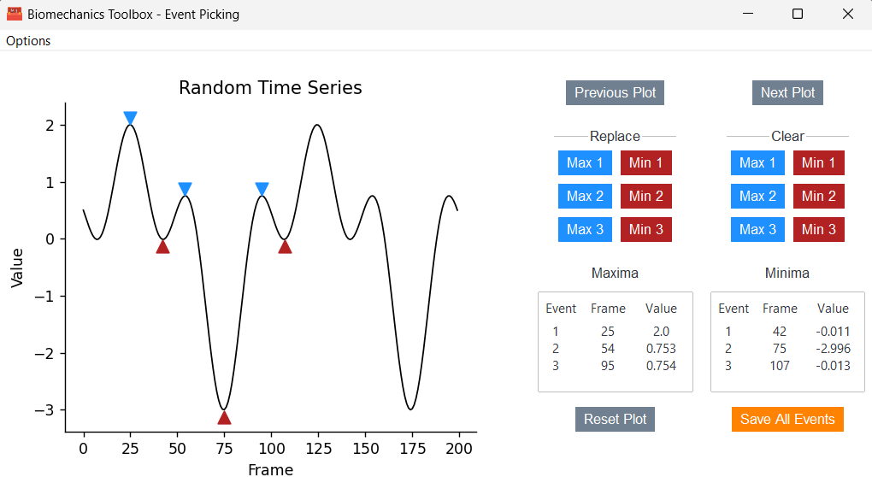
Figure 18: The Event Picking window with Max 2 moved and Min 3 cleared.
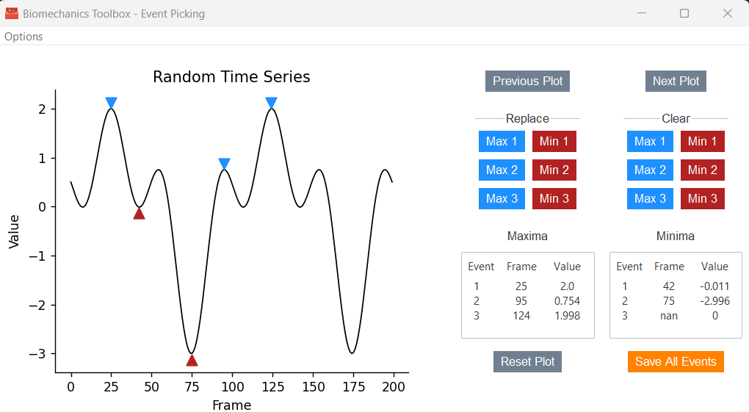
Figure 19: The Options toolbar expanded within the Event Picking window.
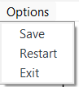

Inputs, Outputs

Function - Event Compile (not available)
Inputs, Outputs
Example

Function - Quality Check
This function allows the user to assess the visual quality of a Batch function output file for outliers, marker label issues, or errors in processing among trials of the same variables. One or more subjects at a time can be investigated for a single condition.
Figure 20: A view of the Quality Check tab without entries.
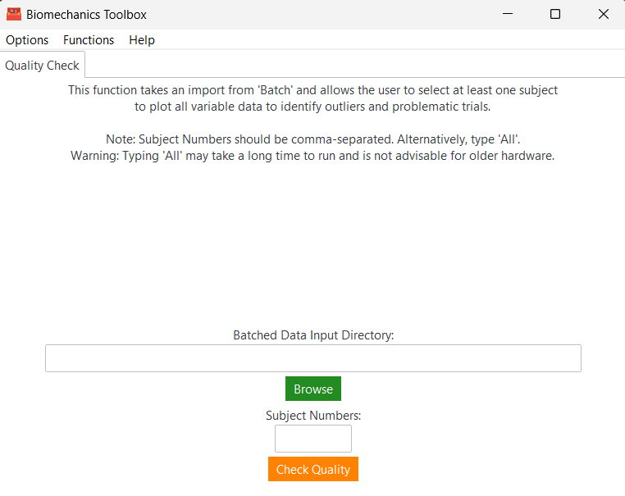
Inputs
Batched Data Input Directory (string): Specify the full path to a file produced by the Batch function. This should ideally be the variables for a single condition.
Subject Numbers (comma-separated list): Specify the number of subjects you’d like to assess separated by commas without whitespaces in between. Alternatively, you may enter ‘All’ if you would like to produce the quality check graphs for each subject in the input file.
Figure 21: A view of the Quality Check tab with both entries.
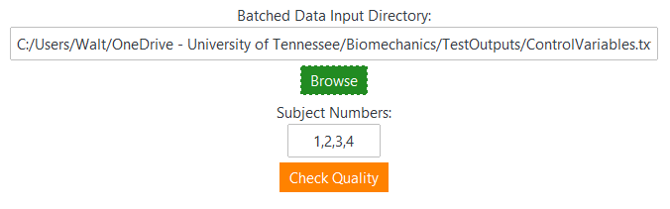
Figure 21 shows the Quality Checking window that appears after ‘Check Quality’ successfully executes. Please note that if you type ‘All’ for the Subject Numbers entry it will take some time to produce the plots. In the bottom right and left corners of the window the Next and Previous buttons will progress you through the quality checks. The Subject number is displayed in the title as the order in which the subject is in the file. For example, if the input file has true subject numbers 3,4,6,8 then this window will display Subject Number 1 for your true subject number 3. This function produces 3x3 plots of the variables in the input file and the Page number is displayed in the title. A file with 27 variables will have three pages per subject (9 variables X 3 pages).
Figure 22:A view of the Quality Checking window with sample data.
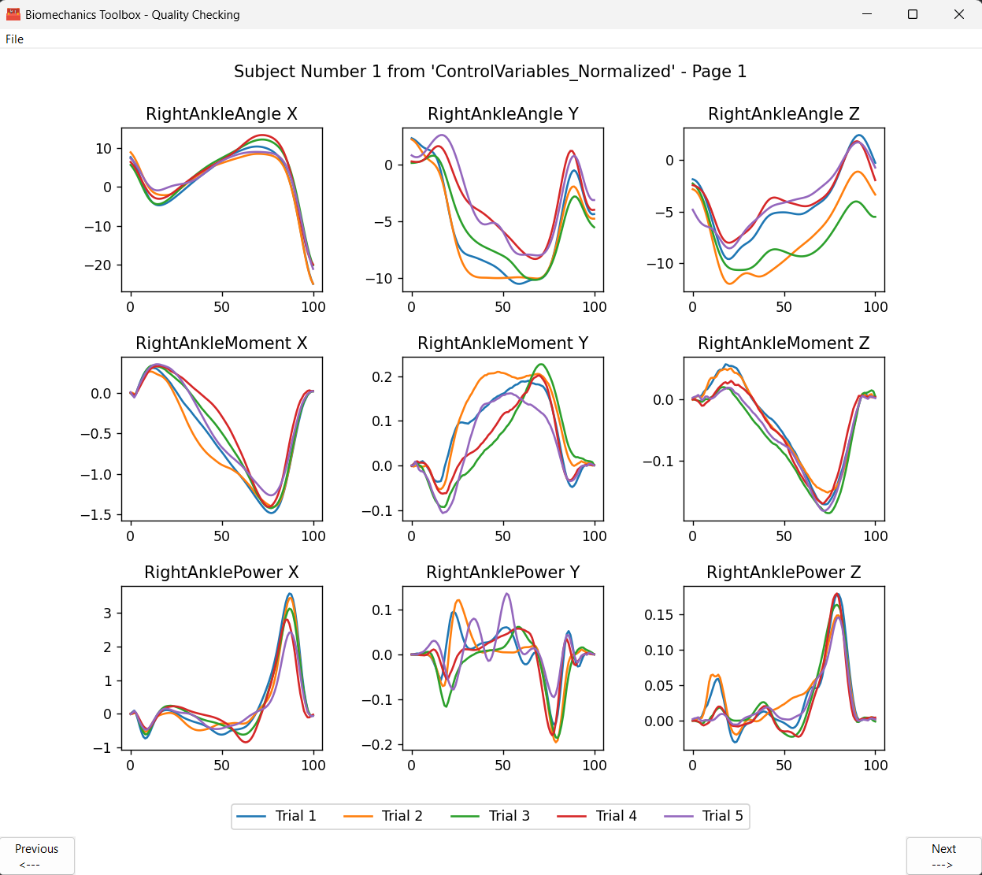
Figure 22 shows the options for saving quality check plots. ‘Save Current’ will save the current plot as one of the following filetypes: PDF, JPG, PNG, or .TIF. ‘Save All’ will save every quality check plot produced into a single PDF file.
Figure 23: The Quality Check toolbar with sub-entries options.
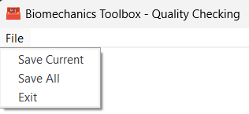
Outputs
No outputs are automatically generated for the Quality Check function. As stated above, images of individual or all the quality check plots can be saved.

Function – Ensemble
This function takes a user specified Batch function output that is normalized and produces publication quality ensemble plot(s) of one group with user specified axes, colors, and .TIFF dots per inch (DPI) specifications.
Figure 19: A view of the Ensemble tab without entries.
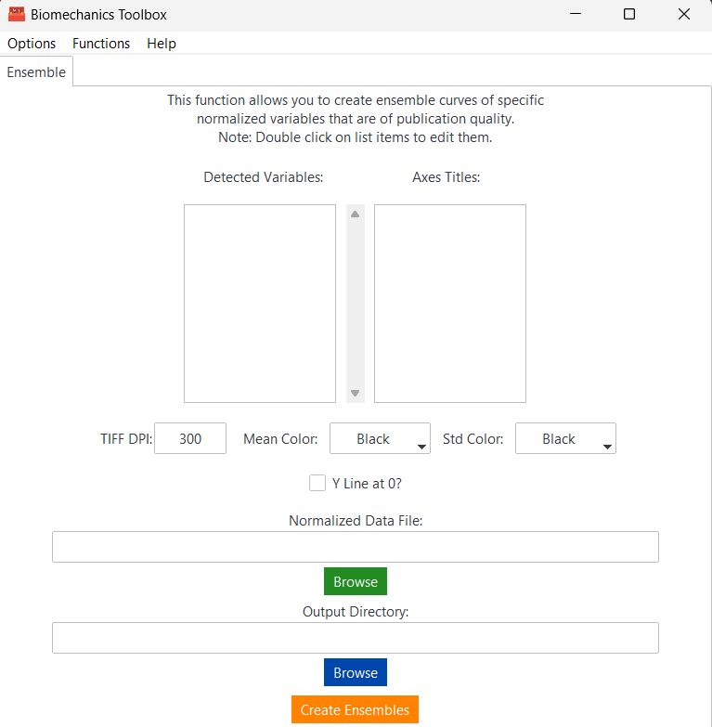
Inputs
Normalized Data File (string): Specify the full path to a normalized file of data that follows the format of the Batch function output. This function does not accept non-normalized data.
Output Directory (string): Specify the full path to the output ensemble image(s).
Detected Variables: This is automatically generated from the input file once it has been selected. It displays each detected variable and allows the user to double-click on an entry to change the variable name to their liking (Figure 21). This entry will be the ensemble plot title. The variables you would like to plot must be selected before pressing the ‘Create Ensembles’ button (Figure 22).
Axes Titles: This is automatically generated according to the length of the Detected Variables. The order of the variables is numbered in parentheses so the user can match variables with their respective axes. Double-clicking on the axes titles allows the user to specify the X and Y axis titles, separated by a comma. The axes do not need to be selected to create ensemble plots.
TIFF DPI (integer): Specify an integer for the dots per inch you would like the ensemble plot(s) to be saved at. The default value is 300 as this is frequently the minimum accepted by journals.
Mean Color: The desired mean line color for the ensemble plots. It is recommended to leave it as black.
Std Color: The desired standard deviation shading color for the ensemble plots. It is recommended to leave it as black because this will become opaque (alpha = 0.2).
Y Line at 0: A checkbox to specify if you would like a black, dotted reference line at y=0 across the ensemble plots. It is important to note that this should only be checked if you are sure that y=0 is within the plot bounds.

Figure 20: A view of the Ensemble tab with entries filled.
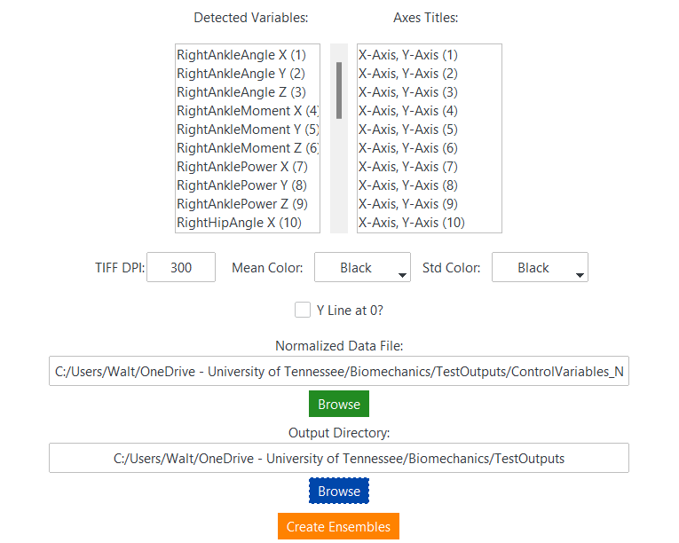

Figure 21: Result of double clicking on a variable entry in the list box for renaming.
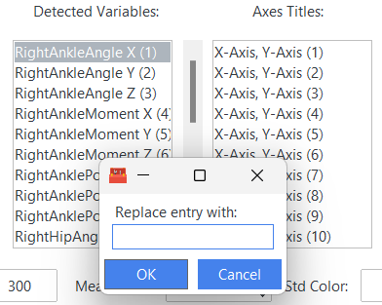
Figure 22: Example usage of multiple variable selection after renaming variables and axes.
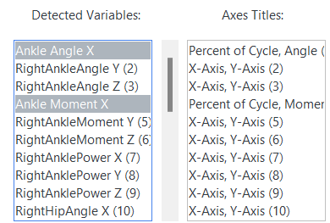
Outputs
Figure 23 displays two separate ensemble plots that were generated from the options as shown in Figure 22. The user defined the X axis label, Y axis label, and the plot title. The legend entries are Mean and Std Dev by default.
Figure 23: Example outputs of an ensemble curve from Figure 22.

Function – SPM (in progress)
This function is under construction but will eventually allow for multiple types of statistical parametric mapping (SPM) analyses to be carried out. Testing for 1, 2, and 3 groups are currently planned (Figures 27, 28, and 29, respectively). Currently, only 2 group two-sample t tests are available. It is important to note that data inputs for this function must be normalized to the same length.
Figure 24: A view of the SPM tab without selecting a Group number.
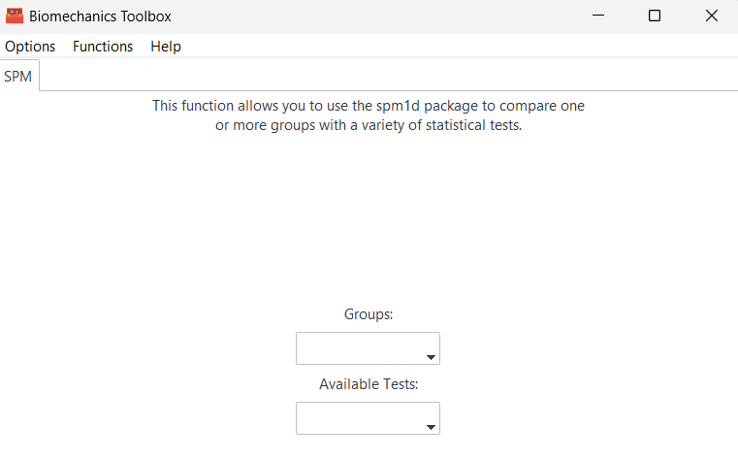
Figure 25: A view of the SPM tab with Group set to 2 and the resulting entry and button generation.
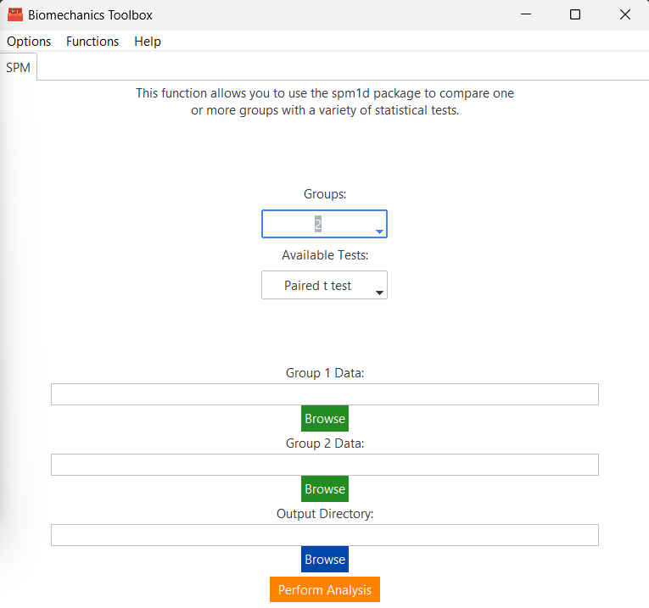
Figure 26: Group selection options from 1-3.
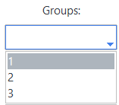
Figure 27: The test option when 1 Group is selected.
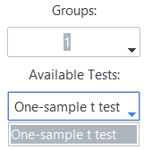
Figure 28: The test options when 2 Groups are selected.
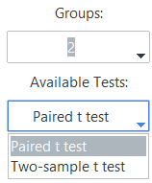
Figure 29: The test options when 3 Groups are selected.
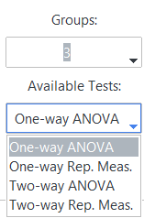
Figure 30: The additional child window of the SPM tab when a Group number has been selected.
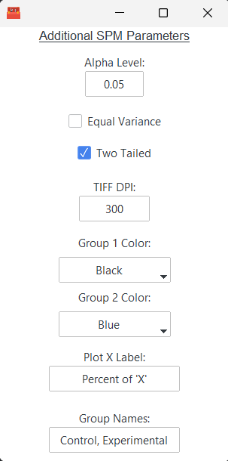
Inputs
Groups: Select an option from 1 to 3 corresponding to the group amount you would like to compare.
Available Tests: Select an option from the available tests. These options will change depending on the number of groups selected (Figures 27, 28, and 29).
Group ‘X’ Data: Specify the full path to the Batch function output file for group number “X.” The number of generated entries for groups will adjust based on Group selection.
Alpha Level: The desired significance level for SPM analyses.
Equal Variance: Whether or not to assume equal variances in the input data. Default is False (unchecked), equal variance is not assumed.
Two Tailed: Whether or not to conduct a two tailed SPM analysis. Default is True (checked).
TIFF DPI: Specify an integer for the dots per inch you would like the ensemble plot(s) to be saved at. The default value is 300 as this is frequently the minimum accepted by journals.
Group ‘X’ Color: Select the color for the mean line and shaded standard deviation area for each group number “X.” The number of generated entries for groups will adjust based on Group selection.
Plot X Label: Specify a plot X label to set for all SPM outputs. SPM data must be the same length and therefore, ‘Percent of X’ is the default entry.
Group Names:
Figure 24: A view of the filled entries for a 2 Group paired t-test SPM analysis.
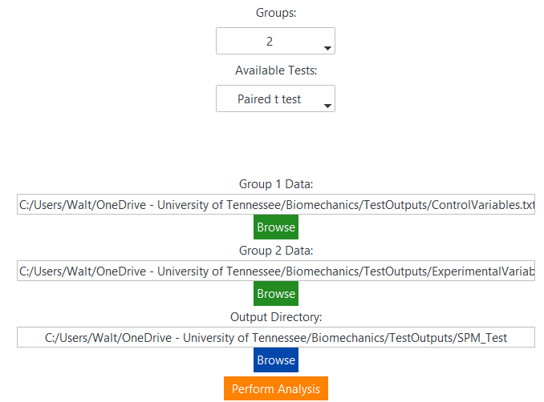
Outputs
The SPM function will automatically conduct the chosen SPM test for all variables in the data input file(s). A .TIFF file will be generated for each variable in the file and a PDF of all SPM outputs will additionally be generated.
Figure 25: An example output from the entries in Figure 23.
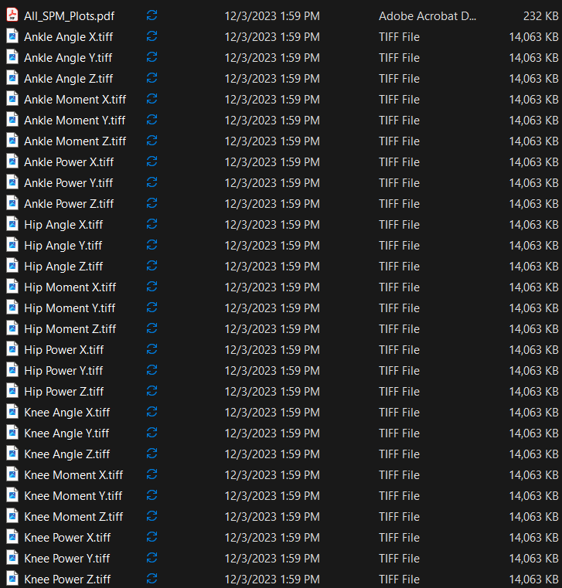
Figure 26: An individual SPM analysis graph (Knee Moment Z.tiff) produced by the SPM tab.

Example File Descriptions

Suggested Citations
You are not under any obligation to cite software/code used within the Biomechanics Toolbox or the program itself. However, this section provides a handful of recommended citations if you would like to use them.

SPM1D
Pataky TC. One-dimensional statistical parametric mapping in Python. Comput Methods Biomech Biomed Engin. 2012;15(3):295-301. doi:10.1080/10255842.2010.527837

SciencePlots
John Garrett, Echedey Luis, H.-H. Peng, Tim Cera, gobinathj, Josh Borrow, Mehmet Keçeci, et al. “Garrettj403/scienceplots: 2.1.1”. Zenodo, November 25, 2023. https://doi.org/10.5281/zenodo.10206719.

Biomechanics Toolbox
(TBD)

