# Mapping x to z (General)

The z is latent variable, sample from probability distribution, normally normal distribution. is transformative function, invertible (or *bijective*)

After *change of variables*, probability density function (pdf) given a data-point will be:

Jacobian matrix is a triangular matrix

# GLOW

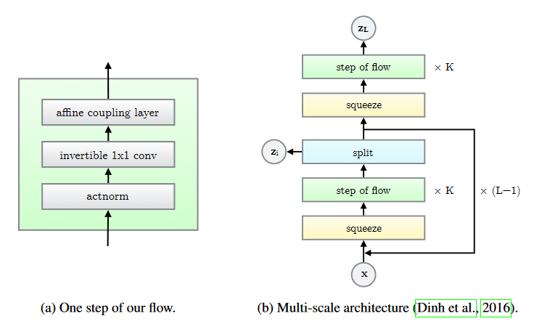

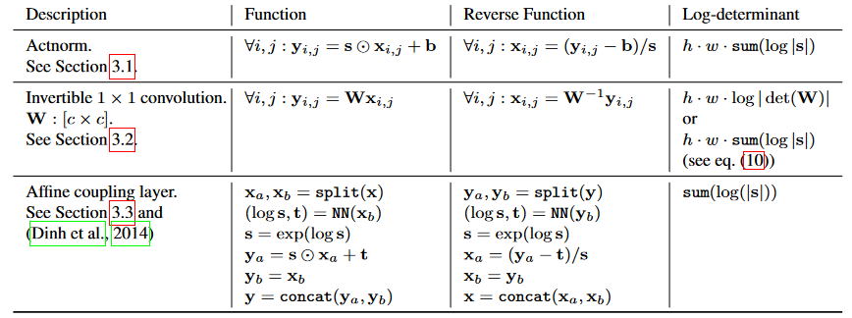

# Loss (Bits per dimension)

n_pixel = *image_size* * *image_size* * 3

    loss = -log(*n_bins*) * n_pixel *# loss considering noise inputted.*

    loss = loss + *logdet* + *log_p*

loss = (-loss / (log(2) * n_pixel)).mean()

# Reversible ViT

Mangalam_Reversible_Vision_Transformers_CVPR_2022_paper

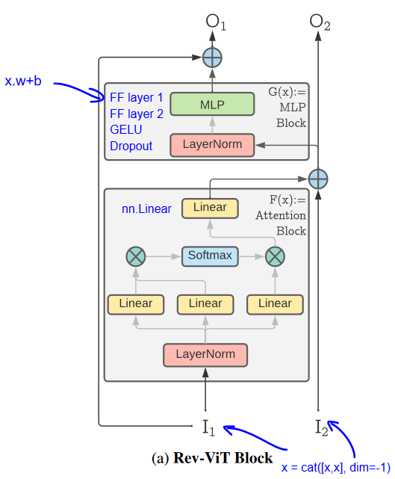

# Idea

Image to image:

Image to audio:

Structure change:



Rev ViT Block

Problem:



~~No way to calculate~~

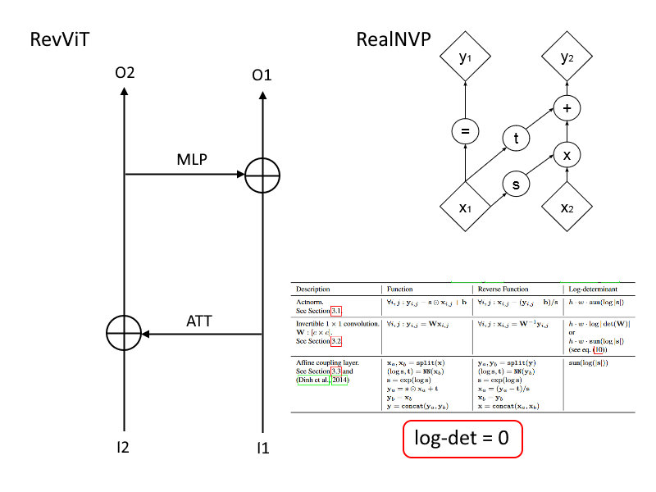

An additive coupling layer is a special case with s = 1 and a log-determinant of 0