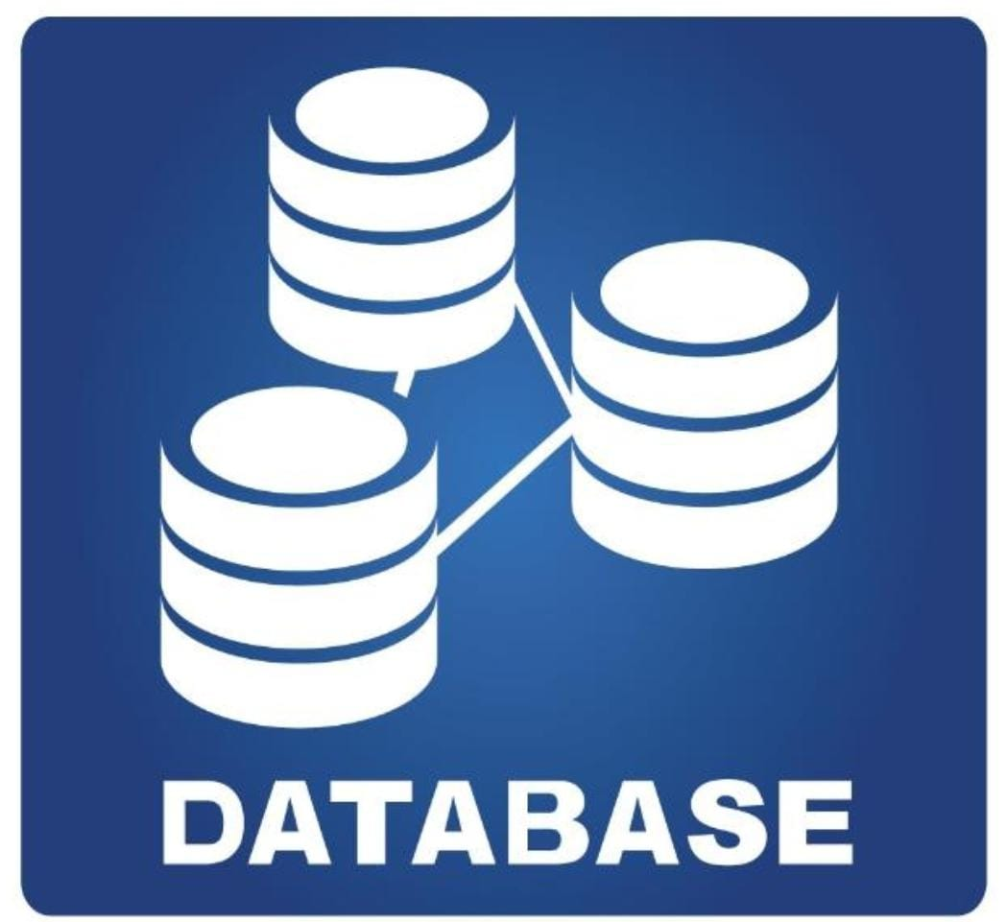
CMPG321- Project Phase 1
L Mathipa 38283077(Group leader)
S Magudu 39374459
NS Mdlovu 45610525
JM Maswanganyi 35056940
WM Nkadimeng 44092199
 | 8/26/25 | Project assignment

Table of Contents
- Executive Summary .................................................................................. 3
- Requirements Definition Approach ............................................................ 3
- Data Analysis Approach
- Stakeholders Involved
- Literature and Benchmarking Review
- Business Requirements .............................................................................3
- High-Level Business Objectives .................................................................4
- Analytical and Information Requirements ...................................................4
- Preliminary Source System Analysis ...........................................................4
- Overview of Provided Data Files
- Identified Structures, Relationships, and Hierarchies
- Preliminary Success Criteria .......................................................................5
- Conceptual NoSQL Design .........................................................................5
- Proposed Collections and Structures
- Justification for NoSQL Approach
- SQL vs NoSQL Comparison
- AI Usage Log ..............................................................................................5

- Executive Summary
ClearVue Ltd. currently lacks the ability to generate accurate and timely sales performance reports due to its reliance on legacy systems such as MS Access. These systems cannot effectively accommodate the company’s unique financial year structure, which runs from the last Saturday of a month to the last Friday of the following month, nor can they support the scalability required for future supplier-focused analytics.

This report proposes the development of a modern NoSQL-based Business Intelligence (BI) system. By leveraging NoSQL technology, the solution will support flexible time-based reporting, real-time data streaming, and hierarchical data management while providing an interactive BI dashboard for management. The system is expected to enhance decision-making, ensure scalability, and demonstrate superiority over traditional SQL systems in terms of flexibility and adaptability.

- Requirements Definition Approach
The requirements for this system were defined through a combination of:

- Analysis of Provided Data Files: Seventeen datasets (~20MB) were examined, including customer, payment, sales, and product information. Relationships, hierarchies, and data types were identified.

- Business Needs Assessment: ClearVue’s executive management and CSIS Department defined reporting needs aligned with their financial year and strategic shift toward supplier analytics.

- Benchmarking & Literature Review: Research on SQL vs NoSQL BI solutions was conducted. SQL systems (e.g., MS Access) were found to be rigid, while NoSQL (e.g., MongoDB) offered superior handling of semi-structured data and scalability.

- Stakeholder Consultation: Key stakeholders include senior management (strategic decision-makers), sales managers (operational reporting), IT teams (system integration), and executives (long-term supplier analytics).

- Business Requirements
The system must:
- Generate time-based sales reports (daily, weekly, monthly, quarterly, annual) aligned with ClearVue’s financial calendar.
- Support hierarchical product and supplier analytics.
- Enable real-time monitoring of payment transactions.
- Provide dashboards and visualization tools for decision-making.
- Ensure scalability and flexibility to accommodate new data sources and supplier-focused analytics.
- Deliver faster and more reliable queries than MS Access.

- High-Level Business Objectives
- Improve Decision-Making: Deliver timely, accurate, and visually intuitive reports to managers.
- Enable Scalability: Prepare for future supplier-centric data and new data formats.
- Enhance Competitiveness: Use analytics to identify sales trends and supplier performance.
- Replace Legacy Systems: Transition from MS Access to a modern, flexible NoSQL-based environment.
- Support Strategic Growth: Build a BI foundation capable of handling expanding data volumes.

- Analytical and Information Requirements
The BI system should support the following reports and metrics:
- Daily Sales by Region and Product Category.
- Weekly and Monthly Sales Trends (aligned to the financial month).
- Quarterly Product Performance and seasonal trends.
- Annual Sales Comparison by customer, region, and supplier.
- Supplier Contribution Analysis: sales volumes, profitability, and discounts.
- Real-Time Payment Monitoring: streaming analytics to detect delays or irregularities.

- Preliminary Source System Analysis
The 17 provided data files form the foundation for the BI system. Initial analysis reveals:
- Customer Data: Includes demographic, geographic, and account details.

- Sales Transactions & Payment Headers/Lines: Contain invoice, payment, and product-level details, enabling transaction-level analysis.

- Products & Brands: Hierarchical structures exist (brand → product line → product).

- Suppliers: Represent future expansion needs, linking supplier → brand → product.
The datasets are currently in flat tabular structures with relational characteristics. However, their hierarchical and evolving nature (e.g., product categories, customer attributes) makes them well-suited for a NoSQL document-based model.

- Preliminary Success Criteria
Success of the NoSQL BI implementation will be measured by:
- Query Performance: Reports generated faster than MS Access queries.
- User Satisfaction: Positive feedback from management and sales teams using dashboards.
- Scalability: Ability to incorporate supplier data and new data types without major redesign.
- Accuracy: Correct alignment of reports with the company’s unique financial calendar.
- Real-Time Insights: Effective integration of streaming data for payments.

- Conceptual NoSQL Design
A document-oriented model (MongoDB) is proposed. The design includes the following collections:
- Customers { CustomerID, Name, Region, Accounts, ContactDetails }
- Products { ProductID, Name, Brand, CategoryHierarchy, SupplierID }
- Suppliers {SupplierID, SupplierName, ContactDetails, ProductsSupplied[]}
- SalesTransactions {TransactionID, CustomerID, ProductID, Date, Quantity,
TotalAmount, PaymentDetails{}}
- Payments { PaymentID, TransactionID, PaymentDate, Method, Amount }
Justification:
- SQL Approach: Requires multiple joins (Customers ↔ Orders ↔ Payments ↔ Products), making queries complex and performance heavy.
- NoSQL Approach: Embedding product, supplier, and payment details in a single transaction document allows for fast retrieval and flexibility.
- Scalability: NoSQL schema can easily adapt when new supplier or customer attributes are added, unlike rigid SQL schemas.
- Real-Time Streaming: MongoDB integrates well with Apache Kafka, supporting live payment feeds.

- AI Usage Log
- Prompting: AI was used to structure the preliminary report template, draft business requirements, and propose a conceptual NoSQL schema.
- Validation: AI outputs were cross-checked against the ClearVue RFP requirements and known NoSQL design practices.
- Refinement: Generated drafts were critically evaluated, with manual adjustments to emphasize ClearVue’s unique financial year and supplier-focused strategy.
- Improvement: AI-generated schema designs were adapted to better reflect hierarchical supplier-product relationships and real-time data needs.

