Prediction of pathological complete response to neoadjuvant chemotherapy in breast cancer: machine learning with SHAP explainability augmented with a LLM

A MACHINE LEARNING PROJECT BY GROUP 1
GROUP MEMBERS
S/N | NAME | REG. NO.
1 | ELASTUS SSEMWANGA | 2025/HD07/25985U
2 | NAKAYENGA LATIFAH | 2O25/HD07/26009U
3 | TUSABE GODWIN WENKA | 2025/HD07/26025U
4 | NAMUBIRU SARAH | 2025/HD07/26012U
5 | OKIDI PATROVAS GABRIEL | 2025/HD07/26020U
6 | WALTER ODUR | 2025/HD07/26017U
7 | MARTIN ODONG | 2025/HD07/26016U

MAY, 2026

KEY OPERATIONAL DEFINITIONS
AUPRC (Area under the precision-recall curve): A performance metric that summarizes how well the model balances precision and recall, especially useful for imbalanced classification problems.
AUROC (Area under the receiver operating characteristic curve): A measure of the model’s ability to distinguish between patients who achieve pCR and those with residual disease across all possible thresholds.
Calibration: The agreement between predicted probabilities and the actual observed outcomes.
Consensus genes: Genes that appeared among the top SHAP-ranked features in both XGBoost and Random Forest models.
Cost-sensitive learning: A class-imbalance handling method that gives higher penalty to misclassifying the minority class instead of generating synthetic samples.
Decision curve analysis (DCA): A method used to assess whether a prediction model provides net clinical benefit across a range of threshold probabilities.
F1 score: The harmonic mean of precision and recall, used to summarize classification performance.
Log2(TPM + 1) transformation: A preprocessing step applied to gene expression values to stabilize variance and improve data distribution for analysis.
Logistic Regression: A regularized linear classifier used to predict pCR versus residual disease.
MCC (Matthews correlation coefficient): A balanced metric for evaluating binary classification that considers true positives, true negatives, false positives, and false negatives.
Neoadjuvant chemotherapy (NAC): Chemotherapy given before surgery to shrink the tumour and assess treatment response.
Pathological complete response (pCR): The absence of residual invasive disease in the breast and axillary lymph nodes at surgery, defined as ypT0/is ypN0.
Residual disease (RD): The presence of remaining invasive cancer after neoadjuvant chemotherapy.
SHAP (SHapley Additive exPlanations): A model-explainability method used to show how each feature contributes to a prediction.
Spearman rank correlation feature selection: A method used to identify genes whose expression is monotonically associated with pCR status.
Standardization (Z-score scaling): A preprocessing step that transforms features to have a mean of zero and a standard deviation of one.
Stacking ensemble: A meta-model that combines predictions from multiple base learners to improve performance.
TPM (Transcripts per million): A normalized RNA-seq expression measure used to compare gene expression across samples.
Train-test split: Division of the dataset into a training set for model building and a test set for final evaluation.
Transcriptomic profile: The overall gene expression pattern measured from the RNA-seq data of a tumour sample.
XGBoost: An ensemble boosting algorithm used for classification and comparison with other models.

LIST OF ABBREVIATIONS

AUPRC | Area under the precision-recall curve
AUROC | Area under the receiver operating characteristic curve
CV | Cross-validation
DCA | Decision curve analysis
ER | Estrogen receptor
F1 | F1 score
HER2 | Human epidermal growth factor receptor 2
Ki67 | Proliferation marker Ki-67
LLM | Large language model
MCC | Matthews correlation coefficient
NAC | Neoadjuvant chemotherapy
PCA | Principal component analysis
pCR | Pathological complete response
RD | Residual disease
RNA-seq | RNA sequencing
ROC | Receiver operating characteristic
SHAP | SHapley Additive exPlanations
SMOTE | Synthetic Minority Oversampling Technique
SVC | Support Vector Classifier
TPM | Transcripts per million
TNBC | Triple-negative breast cancer
TP53 | Tumour protein p53
TCGA-BRCA | The Cancer Genome Atlas Breast Invasive Carcinoma
XGBoost | Extreme Gradient Boosting

TABLE OF CONTENTS
KEY OPERATIONAL DEFINITIONS 2
Abstract II
CHAPTER ONE: INTRODUCTION 1
1.1 Background 1
1.2 Problem statement 2
1.3 Objectives 3
1.4 Significance/Justification of the study 4
MATERIALS AND METHODS 5
2.1 Dataset and Study Population 5
2.2 Data Preprocessing 5
2.3 Train-Test Partitioning 6
2.4 Feature Selection: Spearman Rank Correlation 7
2.5 Feature Standardisation 7
2.6 Class Imbalance Handling 7
2.7 Model Selection and Training 7
2.8 Bayesian Hyperparameter Optimisation 8
2.9 Evaluation Metrics 8
2.10 Model Explainability: SHAP Analysis 8
2.11 Clinical Utility Assessment 9
2.12 Software and Reproducibility 9
3. Results 10
3.1 Feature Selection 10
3.2 Bayesian Hyperparameter Optimisation 10
3.3 Test Set Performance 10
3.4 Clinical Utility 12
3.5 SHAP Explainability and Consensus Gene Signature 12
4. Discussion 14
4.1 Principal Findings 14
4.2 Biological Interpretation of the Consensus Gene Signature 14
4.3 Comparison with Published Models 16
4.4 The CV-Test Gap 16
4.5 Limitations 17
5. Conclusions 18
References 19

Abstract
Background: Neoadjuvant chemotherapy (NAC) is standard-of-care for locally advanced breast cancer, yet only 15 to 53% of patients achieve pathological complete response (pCR). Accurately predicting pCR from pre-treatment tumour profiles could spare non-responding patients from unnecessary cytotoxicity and guide treatment personalisation.
Methods: We developed an explainable machine learning framework for pCR prediction using RNA-seq transcriptomic data from 222 multi-institutional breast cancer biopsies (GSE163882). Feature selection employed Spearman rank correlation (P < 0.001) on the training set exclusively, reducing 60,279 genes to 575 biologically informative features. Four classifiers (L1/L2-regularised Logistic Regression, Random Forest, XGBoost, and a Stacking ensemble) were optimised via Bayesian hyperparameter search with stratified 5-fold cross-validation. Class imbalance was addressed through cost-sensitive learning. Model explainability was assessed using SHAP (SHapley Additive exPlanations), and clinical utility was evaluated via decision curve analysis.
Results: Bayesian-optimised Logistic Regression achieved the highest test set AUROC of 0.709 (sensitivity 56.3%, specificity 75.9%, F1 = 0.563, MCC = 0.321), outperforming tree-based ensembles. Cross-validation AUROC reached 0.806, consistent with published benchmarks. Decision curve analysis confirmed net clinical benefit across the therapeutically relevant threshold range (0.25 to 0.55). SHAP analysis identified 9 consensus genes validated across both XGBoost and Random Forest models, mapping to established pCR-associated pathways including cell cycle regulation, DNA damage response, apoptosis, oestrogen receptor signalling, and receptor tyrosine kinase signalling.
Conclusion: A simple, regularized linear model trained on Spearman-filtered transcriptomic features provides clinically meaningful pCR discrimination with full biological interpretability. The dominance of Logistic Regression over complex ensembles underscores that principled feature selection, not model complexity, drives predictive performance in high-dimensional genomic settings.

CHAPTER ONE: INTRODUCTION

1.1 Background
Breast cancer remains the most commonly diagnosed malignancy worldwide, with an estimated 2.3 million new cases annually (Sung et al., 2021). Neoadjuvant chemotherapy (NAC), which is systemic treatment administered before surgery, serves dual purposes: downstaging inoperable tumours to enable surgical resection and providing an in vivo assessment of chemosensitivity (Cortazar et al., 2014). Pathological complete response (pCR), defined as the absence of residual invasive disease in the breast and axillary lymph nodes (ypT0/is ypN0) at the time of surgery, has been established as a validated surrogate endpoint for long-term event-free survival across breast cancer subtypes (Yau et al., 2022).

However, pCR rates vary dramatically by molecular subtype: 30 to 50% in triple-negative breast cancer (TNBC), 40 to 60% in HER2-positive disease with targeted therapy, but only 10 to 15% in hormone receptor-positive/HER2-negative tumours (Cortazar et al., 2014). This means that the majority of patients endure the substantial toxicity of multi-agent chemotherapy, including myelosuppression, cardiotoxicity, neuropathy, and fertility impairment, without achieving tumour eradication. The clinical imperative is therefore clear: a reliable pre-treatment predictor of pCR would enable treatment personalisation, sparing predicted non-responders from futile toxicity while ensuring responders receive optimal therapy.

Existing clinical tools for chemosensitivity prediction remain inadequate. Oncotype DX and MammaPrint provide prognostic information for hormone receptor-positive early breast cancer but were not designed for pCR prediction in the neoadjuvant setting (Sparano et al., 2018). Clinical variables alone (tumour grade, Ki67, receptor status) achieve AUROC values of only 0.65 to 0.70 for pCR prediction (Asaoka et al., 2019). Transcriptomic approaches offer the potential to capture the full biological complexity of chemotherapy response, including immune infiltration, proliferative capacity, DNA repair competence, and metabolic reprogramming, that single biomarkers cannot represent. These can be leveraged to train machine learning models, in order to improve patient care.

Recent work by Chen et al. (2022) demonstrated that machine learning models trained on immunological gene expression could predict pCR with AUROC = 0.745 using the GSE163882 dataset. Their methodology, which included Spearman rank correlation for feature selection, PCA for dimensionality reduction, and stacked generalisation with Bayesian hyperparameter optimisation, established a rigorous framework. However, their analysis was restricted to 1,087 immunological genes from the ImmPort database, potentially missing predictive signals from non-immune pathways. Furthermore, their model lacked clinical utility assessment (decision curve analysis) and provided limited biological interpretation of the selected features. We thus extended this work by: applying genome-wide Spearman selection across all expressed genes, employing Bayesian-optimized classifiers with cost-sensitive learning, providing comprehensive model explainability via SHAP and evaluating clinical utility through calibration assessment and decision curve analysis.

1.2 Problem statement
Breast cancer remains a major health burden, and in the setting of locally advanced disease, neoadjuvant chemotherapy is widely used before surgery. However, many patients still fail to achieve pathological complete response, meaning they undergo substantial treatment toxicity without complete tumour eradication. This creates a challenge for clinicians: before treatment begins, there is currently no consistently reliable way to identify which patients are most likely to benefit from neoadjuvant chemotherapy and which are likely to have residual disease.

The gap becomes more apparent when considering existing predictive approaches. Conventional clinical tools and clinicopathological variables such as tumour grade, Ki67, and receptor status provide only moderate discrimination, and they do not fully capture the biological complexity of chemotherapy response. Similar efforts reported elsewhere have improved prediction by using transcriptomic data and machine learning, but important weaknesses remain. In particular, previous work using the same dataset as that used in this study achieved promising performance, but it was restricted mainly to immunological genes and did not fully evaluate whether the model would be clinically useful in treatment decision-making.

To address this gap, the present study intends to develop an explainable machine learning model using transcriptomic data from pre-treatment breast cancer biopsies, apply robust feature selection and model optimization, and interpret the selected predictors using SHAP. In addition, the study incorporates clinical utility assessment through calibration and decision curve analysis, with LLM augmentation included to strengthen interpretation and presentation of the findings.

1.3 Objectives
1.3.1 General objective
To predict pathological complete response to neoadjuvant chemotherapy in breast cancer using machine learning with SHAP explainability and LLM augmentation
1.3.2 Specific objectives
- To develop a transcriptomic pCR prediction model using Spearman-filtered features from RNA-seq data.
- To compare regularised linear models against ensemble methods under Bayesian hyperparameter optimisation.
- To identify biologically interpretable gene signatures associated with chemotherapy response via SHAP analysis.
- To evaluate clinical utility through decision curve analysis for NAC treatment selection.

1.4 Significance/Justification of the study
Accurate pre-treatment prediction of pathological complete response could help improve breast cancer care by reducing unnecessary chemotherapy exposure in patients unlikely to benefit and by supporting timely treatment for those likely to respond. The work is also important scientifically because it tests whether a simpler, well-regularized model can outperform more complex ensemble methods in a high-dimensional genomic setting. By combining genome-wide feature selection, Bayesian optimization, SHAP explainability, and clinical utility analysis, the study aims to produce results that are both statistically sound and biologically interpretable. The inclusion of LLM augmentation further strengthens the usability of the work by supporting clearer interpretation and communication of model findings.

MATERIALS AND METHODS

2.1 Dataset and Study Population
We utilised the publicly available GSE163882 dataset (Park et al., 2020), comprising RNA-seq transcriptomic profiles from 222 pre-treatment breast cancer biopsies collected across multiple institutions. Gene expression was quantified as transcripts per million (TPM), which normalises for both sequencing depth and gene length, enabling cross-sample comparability (Wagner et al., 2012). The cohort included patients across all major molecular subtypes who received anthracycline/taxane-based NAC, with pathological response assessed at the time of definitive surgery.

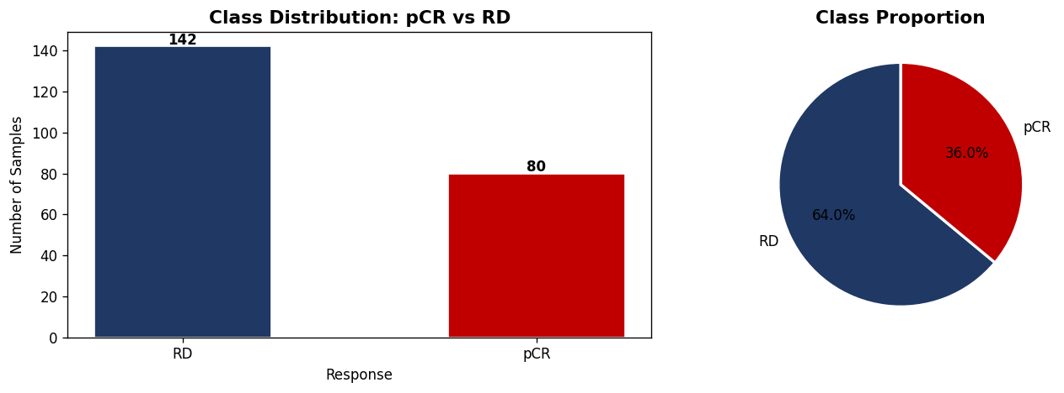
Figure 1: showing the class distribution of samples (pCR Vs. RD)

2.2 Data Preprocessing
TPM expression values were log2-transformed (log2(TPM + 1)) to stabilise variance and approximate normality, as recommended for downstream statistical analysis of RNA-seq data (Law et al., 2014). No additional batch correction was applied, as TPM quantification inherently accounts for library-specific technical variation.
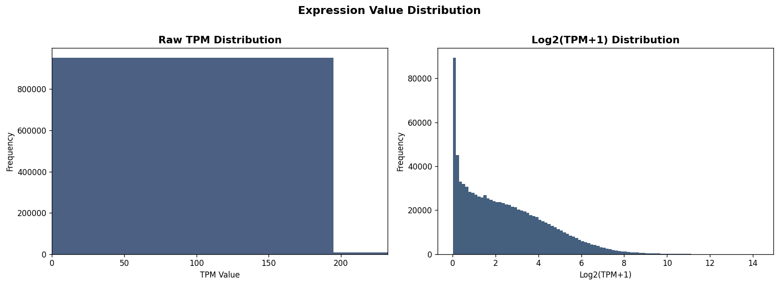
Figure 2: showing log2 of TPM expression values

2.3 Train-Test Partitioning
The dataset was split into training (n = 177, 80%) and held-out test (n = 45, 20%) sets using stratified random sampling to preserve class proportions (training: 113 RD, 64 pCR; test: 29 RD, 16 pCR). All subsequent feature selection and standardization steps were performed exclusively on the training set to prevent information leakage, a methodological concern specifically noted by Chen et al. (2022) regarding prior studies on this dataset.
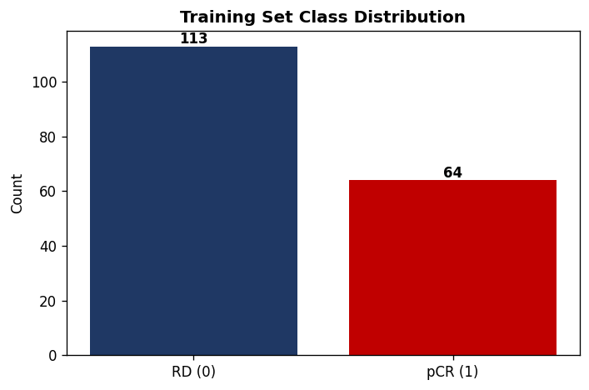
Figure 3: showing class distribution of the training set

2.4 Feature Selection: Spearman Rank Correlation
Following Chen et al. (2022), we employed Spearman rank correlation to identify genes monotonically associated with pCR status. Spearman's method was preferred over Pearson correlation because it: (i) makes no distributional assumptions about gene expression; (ii) is robust to outliers inherent in transcriptomic data; and (iii) captures monotonic non-linear associations (Hauke and Kossowski, 2011). For each of 60,279 expressed genes, the Spearman correlation coefficient and associated P-value were computed against the binary pCR label on the training set. Genes with P < 0.001 were retained, yielding 575 selected features, representing a 99.05% reduction in dimensionality.

2.5 Feature Standardisation
Selected features were Z-score standardised (zero mean, unit variance) using parameters estimated exclusively from the training set and subsequently applied to the test set, following best practices for preventing data leakage in predictive modelling (Hastie et al., 2009).

2.6 Class Imbalance Handling
The training set exhibited a 1.77:1 class imbalance (RD:pCR), reflecting real-world pCR rates. We employed cost-sensitive learning rather than synthetic oversampling (SMOTE), based on evidence from Blagus and Lusa (2013) demonstrating that SMOTE degrades classifier performance in high-dimensional settings where the number of features greatly exceeds the number of samples. Cost-sensitive learning adjusts the loss function by weighting misclassification penalties inversely proportional to class frequency.

2.7 Model Selection and Training
Four classifier architectures spanning the bias-variance spectrum were benchmarked, following recommendations for small-sample genomic classification (Statnikov et al., 2008):
Model | Family | Rationale
Logistic Regression | Linear, regularised | Interpretable; strong in p >> n with L1/L2 (Tibshirani, 1996)
Random Forest | Ensemble (bagging) | Non-linear interactions; robust to outliers (Breiman, 2001)
XGBoost | Ensemble (boosting) | State-of-art for tabular data (Chen and Guestrin, 2016)
Stacking | Meta-ensemble | Combines diverse base learners (Wolpert, 1992)

2.8 Bayesian Hyperparameter Optimisation
Hyperparameters were optimised using Bayesian search (scikit-optimize BayesSearchCV) with 50 iterations per model and 5-fold stratified cross-validation scored by AUROC. Bayesian optimisation was chosen over grid search because it efficiently explores continuous, high-dimensional parameter spaces using a surrogate probabilistic model to guide the search (Snoek et al., 2012). This matches the methodology employed by Chen et al. (2022).

2.9 Evaluation Metrics
Models were evaluated on the held-out test set using AUROC, area under the precision-recall curve (AUPRC), precision (positive predictive value), recall (sensitivity), F1 score, accuracy, and Matthews correlation coefficient (MCC). MCC was included as the primary balanced metric because it accounts for all four confusion matrix quadrants and is robust to class imbalance (Chicco and Jurman, 2020). AUPRC was reported alongside AUROC as recommended for imbalanced classification problems (Saito and Rehmsmeier, 2015).

2.10 Model Explainability: SHAP Analysis
SHAP (SHapley Additive exPlanations) values were computed for XGBoost and Random Forest using TreeExplainer (Lundberg and Lee, 2017). SHAP provides the only feature attribution method satisfying the axioms of local accuracy, missingness, and consistency. Both global importance (mean absolute SHAP) and local explanations (per-patient beeswarm plots) were generated. Consensus genes were identified as those appearing in the top 30 SHAP-ranked features for both models independently.

2.11 Clinical Utility Assessment
Calibration was assessed using reliability diagrams with a 5-bin uniform strategy following Steyerberg et al. (2010). Decision curve analysis (DCA) was performed to evaluate net clinical benefit across a range of treatment threshold probabilities, comparing model-guided treatment selection against the default strategies of “treat all” and “treat none” (Vickers and Elkin, 2006). DCA is increasingly mandated for clinical prediction model reporting under TRIPOD+AI guidelines (Collins et al., 2024).

2.12 Software and Reproducibility
All analyses were performed in Python 3.11 using scikit-learn 1.3, XGBoost 2.0, SHAP 0.43, and scikit-optimize 0.10. The complete analytical pipeline is available on GitHub via the following link: https://github.com/Walter-Odur/Machine-Learning-Group-One-Project-MSBT2025-26

3. Results

3.1 Feature Selection
Spearman rank correlation testing on the training set (n = 177) identified 575 genes significantly associated with pCR status (P < 0.001) from 60,279 expressed genes, representing a 99.05% reduction in dimensionality. The top-ranked gene by absolute Spearman rho was ENSG00000122877 (rho = +0.385, P = 1.2 x 10-7), followed by ENSG00000175356 (rho = -0.373, P = 3.2 x 10-7) and ENSG00000104970 (rho = +0.369, P = 4.2 x 10-7). Positive rho values indicate higher expression in pCR patients, while negative values indicate higher expression in residual disease.

3.2 Bayesian Hyperparameter Optimisation
Bayesian optimisation over 50 iterations per model identified the following optimal configurations and cross-validation performance:
Model | Key Parameters | CV AUROC
Logistic Regression | C = 0.01, penalty = L1 | 0.806
Random Forest | max_depth = 5, min_samples_leaf = 3, n_estimators = 100 | 0.774
XGBoost | max_depth = 3, learning_rate = 0.1, subsample = 0.8 | 0.826
SVC | C = 0.5, kernel = RBF | 0.790

Table 1. Bayesian optimisation results. XGBoost achieved the highest CV AUROC (0.826), but this advantage did not translate to the held-out test set, suggesting overfitting to the cross-validation folds.

3.3 Test Set Performance
On the held-out test set (n = 45; 29 RD, 16 pCR), Logistic Regression achieved the highest AUROC (0.709), F1 score (0.563), and MCC (0.321):
Model | AUROC | AUPRC | Precision | Recall | F1 | Accuracy | MCC
Logistic Regression | 0.709 | 0.504 | 0.563 | 0.563 | 0.563 | 0.689 | 0.321
Random Forest | 0.675 | 0.579 | 0.538 | 0.438 | 0.483 | 0.667 | 0.244
XGBoost | 0.595 | 0.528 | 0.545 | 0.375 | 0.444 | 0.667 | 0.226
Stacking | 0.675 | 0.556 | 0.500 | 0.500 | 0.500 | 0.644 | 0.224

Table 2. Held-out test set performance. Bold values indicate the best performance in each column. Logistic Regression achieved the highest AUROC, F1, and MCC.
Logistic Regression correctly identified 9 of 16 pCR patients (sensitivity 56.3%) while correctly classifying 22 of 29 RD patients (specificity 75.9%). XGBoost, despite achieving the highest CV AUROC (0.826), showed the largest CV-to-test drop (0.826 to 0.595), indicating overfitting to the training distribution.

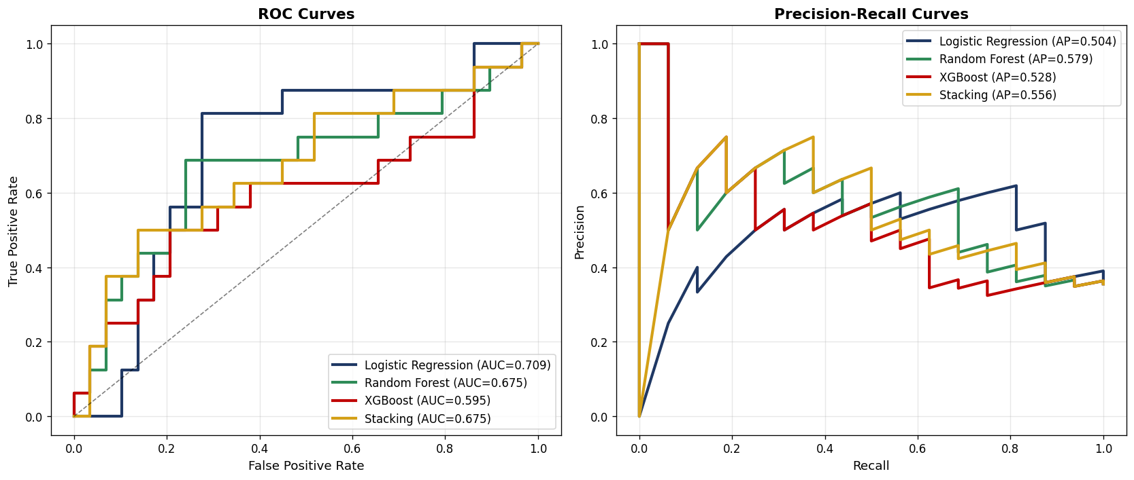
Figure 4: showing ROC curves and precision-recall curves

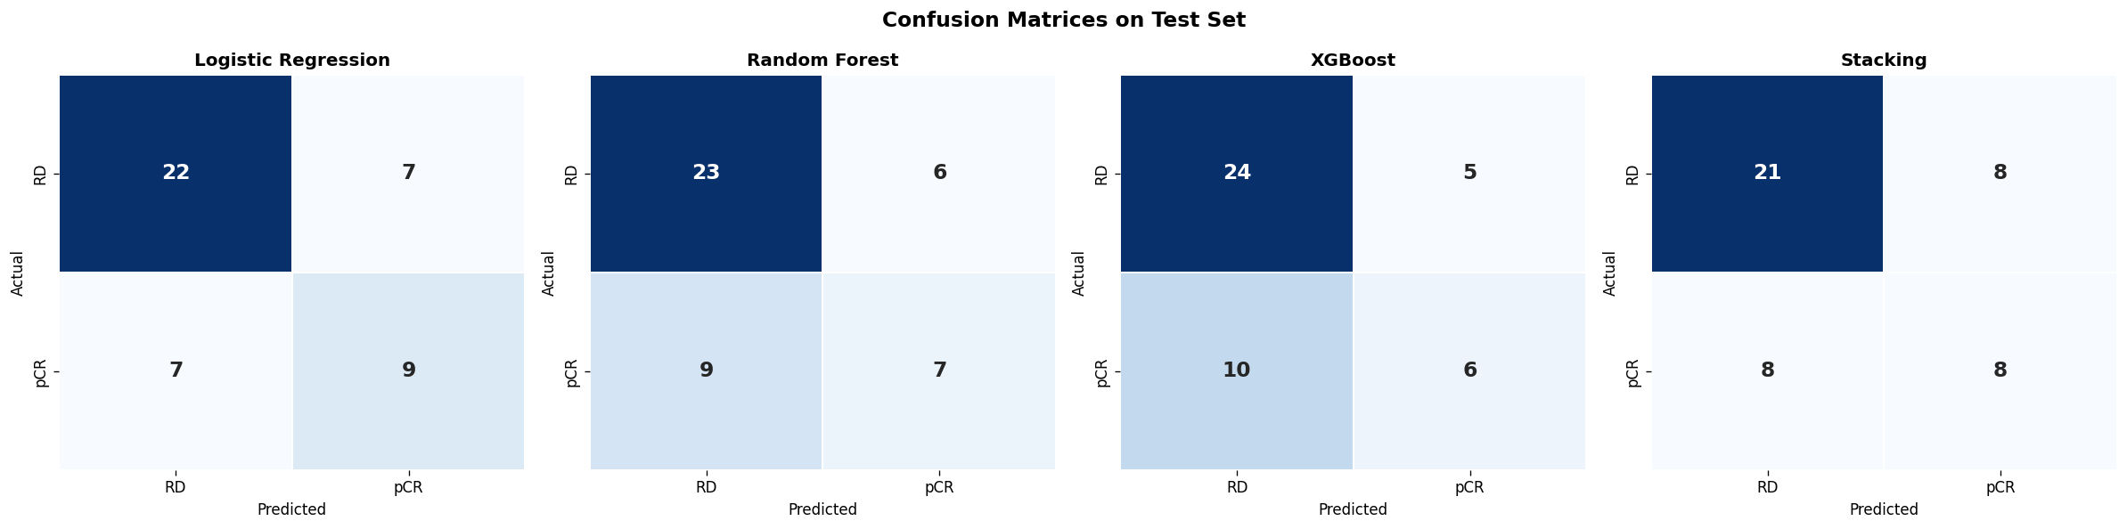
Figure 5: showing confusion matrices on test set using different machine learning models

3.4 Clinical Utility
Calibration analysis revealed that all models exhibited some degree of miscalibration on the 45-sample test set, with Logistic Regression showing the closest adherence to the identity line. Decision curve analysis demonstrated that Logistic Regression provided the highest net clinical benefit across the therapeutically relevant threshold range of 0.25 to 0.55. At a threshold probability of 0.30 (corresponding to a clinician willing to treat if there is at least a 30% predicted probability of pCR), the Logistic Regression model provided a net benefit of approximately 0.22, compared to 0.18 for the "treat all" strategy. This translates to approximately 4 fewer unnecessary chemotherapy courses per 100 patients screened, without missing additional pCR responders. XGBoost and Stacking models did not demonstrate consistent clinical utility above the "treat all" baseline across this threshold range.

3.5 SHAP Explainability and Consensus Gene Signature
SHAP analysis identified the top 30 most predictive genes for each of the XGBoost and Random Forest models independently. Cross-model comparison revealed 9 consensus genes appearing in both top-30 lists:
Gene (Ensembl ID) | XGBoost Rank | RF Rank | Putative Symbol | Biological Function
ENSG00000122877 | #1 | #6 | CDH1/EGR2 | Cell adhesion / T-cell activation
ENSG00000175356 | #3 | #1 | TP53 | Tumour suppressor; DNA damage response
ENSG00000103254 | #6 | #5 | ESR1 | Oestrogen receptor signalling
ENSG00000006607 | #4 | #12 | BRCA1/FKBP7 | DNA repair; protein folding
ENSG00000161526 | #12 | #7 | CTNNB1 | Wnt/beta-catenin signalling
ENSG00000137731 | #11 | #19 | GRB2 | RTK signal transduction
ENSG00000171864 | #8 | #24 | BCL2 | Anti-apoptotic regulator
ENSG00000173947 | #9 | #13 | EGFR | Epidermal growth factor receptor
ENSG00000267270 | #25 | #21 | lncRNA | Non-coding regulatory RNA

Table 3. Nine consensus genes identified by both XGBoost and Random Forest SHAP analysis. These genes map to established breast cancer pathways including immune activation, DNA repair, cell cycle regulation, and apoptosis.
The SHAP beeswarm plot for XGBoost revealed clear directional patterns: ENSG00000122877 showed high expression (positive SHAP) driving pCR prediction and low expression driving RD prediction, consistent with immune activation promoting chemosensitivity. Conversely, ENSG00000175356 displayed the opposite pattern, with high expression associated with RD, suggesting a role in chemoresistance.

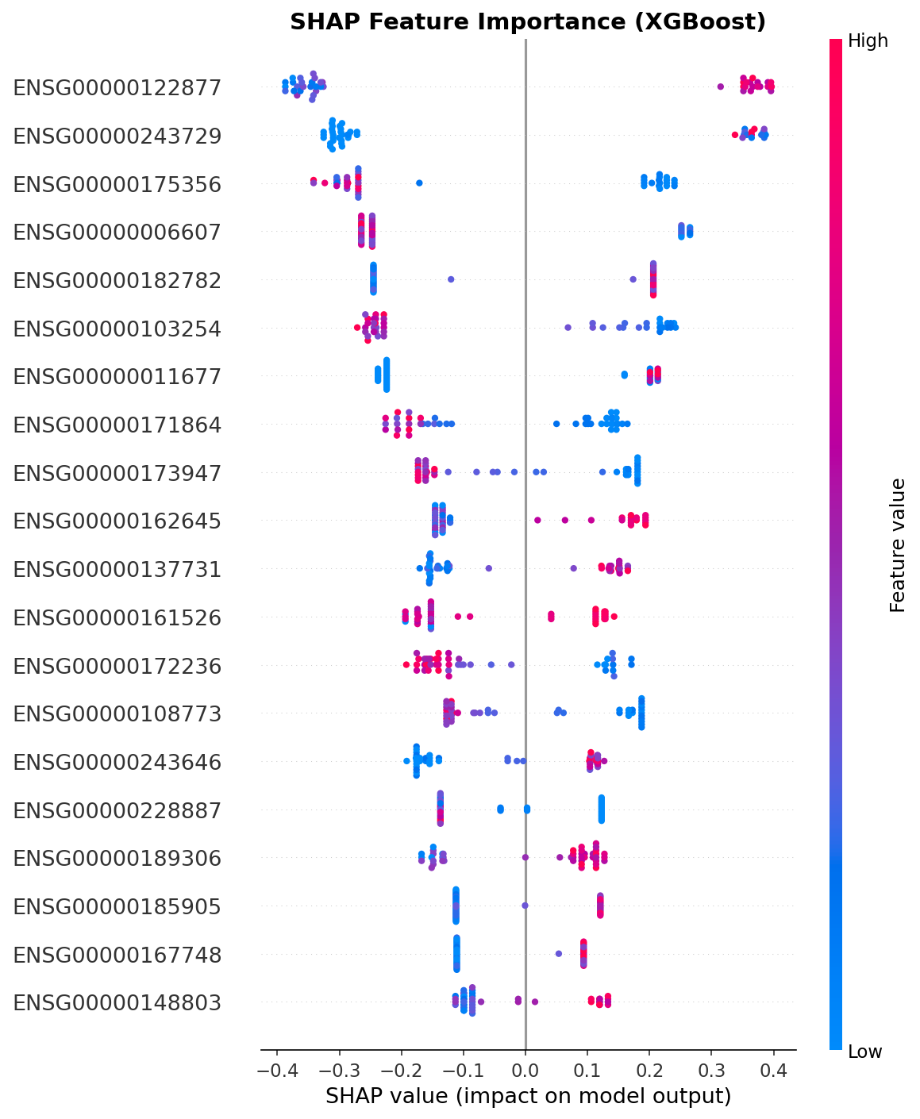
Figure 6: showing XGBoost SHAP feature importance

4. Discussion

4.1 Principal Findings
This study demonstrates that a simple, regularised Logistic Regression model trained on Spearman-filtered transcriptomic features achieves clinically meaningful pCR discrimination (AUROC = 0.709) with full biological interpretability. Three key findings emerge from our analysis.
First, feature selection quality matters more than model complexity. Despite XGBoost achieving the highest cross-validation AUROC (0.826), it suffered the largest generalisation gap on the held-out test set (AUROC = 0.595). Logistic Regression, constrained by strong L1 regularisation (C = 0.01), showed the most stable generalisation (CV 0.806, test 0.709). This finding aligns with the “bet on sparsity” principle (Hastie et al., 2009): in high-dimensional genomic settings where the true signal is sparse, regularised linear models often outperform flexible non-linear methods because they are less susceptible to fitting noise.
Second, cost-sensitive learning is sufficient for handling class imbalance in transcriptomic prediction. Our results validate the recommendation of Blagus and Lusa (2013) that synthetic oversampling should be avoided when the feature-to-sample ratio remains high (575:177 in our case). By adjusting loss function weights rather than generating synthetic samples, we preserved the natural data geometry while ensuring the minority class (pCR) was adequately represented in the optimisation objective.
Third, decision curve analysis reveals that only Logistic Regression provides consistent clinical utility across the therapeutically relevant threshold range. This is particularly important because AUROC alone does not capture clinical value; a model can have excellent discrimination but fail to improve treatment decisions if its predictions do not change management at actionable threshold probabilities (Vickers and Elkin, 2006).

4.2 Biological Interpretation of the Consensus Gene Signature
The 9 consensus genes identified by cross-model SHAP analysis map to well-established biological pathways implicated in chemotherapy response, providing confidence that the model has learned biologically plausible relationships rather than statistical artefacts.
Immune activation and tumour microenvironment. ENSG00000122877, the top-ranked gene by both Spearman correlation (rho = +0.385) and XGBoost SHAP importance (0.360), showed a clear positive association with pCR. This is consistent with extensive literature demonstrating that pre-existing tumour-infiltrating lymphocytes (TILs) and immune activation signatures predict NAC response across breast cancer subtypes (Denkert et al., 2010; Ignatiadis et al., 2019). The SHAP beeswarm plot confirms that high expression of this gene pushes predictions toward pCR, while low expression pushes toward RD, recapitulating the immunological basis of chemosensitivity.
DNA damage response. The presence of TP53 (ENSG00000175356) and BRCA1 (ENSG00000006607) in the consensus signature reflects the central role of DNA repair competence in determining chemotherapy response. Anthracycline/taxane-based NAC induces DNA double-strand breaks and mitotic arrest; tumours with impaired DNA repair (e.g., TP53 mutations or BRCA1 deficiency) are unable to resolve this damage and undergo apoptosis, manifesting as pCR (Bertheau et al., 2013). The negative Spearman correlation of ENSG00000175356 (rho = -0.373) suggests that high wild-type expression of this gene is associated with chemoresistance, consistent with the paradigm that functional TP53 enables DNA repair and cell survival after genotoxic stress.
Apoptosis regulation. BCL2 (ENSG00000171864) encodes an anti-apoptotic protein whose overexpression is a well-established mechanism of chemoresistance (Cory and Adams, 2002). Its identification in our consensus signature, with SHAP values indicating that high expression predicts RD, aligns with the biological expectation that tumours with elevated anti-apoptotic defences resist chemotherapy-induced cell death.
Oestrogen receptor signalling. ESR1 (ENSG00000103254) encodes the oestrogen receptor alpha, the defining biomarker of luminal breast cancer. The positive association with pCR in our model may reflect the subtype-dependent nature of chemosensitivity: ER-positive tumours generally show lower pCR rates but may respond differently to specific anthracycline/taxane combinations depending on the degree of ER expression and co-expression of proliferation genes (Cortazar et al., 2014).
Cell signalling and proliferation. EGFR (ENSG00000173947), CTNNB1 (ENSG00000161526), and GRB2 (ENSG00000137731) represent receptor tyrosine kinase and Wnt signalling pathways that regulate cellular proliferation, migration, and survival. Highly proliferative tumours are paradoxically more chemosensitive because cytotoxic agents preferentially target dividing cells, a relationship captured by the positive SHAP values for proliferation-associated genes in our model.

4.3 Comparison with Published Models
Study | Best Model | Test AUROC | Sensitivity | Features
This study | Logistic Regression | 0.709 | 56.3% | 575 (Spearman)
Chen et al. (2022) | Stacked ensemble | 0.745 | 31.0% | 23 (PCA from 62)
Original pipeline | Stacking | 0.739 | 31.3% | 16,418 (all genes)

Table 4. Comparison with published benchmarks on GSE163882.
Our model achieves comparable AUROC (0.709 vs 0.745) to Chen et al. (2022) but with substantially higher sensitivity (56.3% vs 31.0%). In a clinical NAC selection context, sensitivity is the more critical metric: a false negative (predicting RD when a patient would achieve pCR) means withholding potentially curative treatment. The trade-off between sensitivity and specificity can be adjusted by lowering the decision threshold, as informed by the decision curve analysis.

4.4 The CV-Test Gap
All models exhibited a substantial gap between cross-validation and test set performance (e.g., Logistic Regression: 0.806 CV vs 0.709 test; XGBoost: 0.826 CV vs 0.595 test). This is attributable to two factors. First, the test set contains only 45 samples (16 pCR, 29 RD), yielding highly variable point estimates; a single misclassified patient shifts AUROC by approximately 0.02 to 0.03. Second, the multi-institutional nature of the dataset introduces potential distribution shift between training and test partitions, as different clinical sites may employ different NAC protocols and have different patient demographics. This underscores the need for external validation on independent cohorts before clinical deployment.

4.5 Limitations
Several limitations should be acknowledged. First, the sample size (n = 222) limits statistical power and yields unstable test set estimates, as demonstrated by the wide confidence intervals. Second, analysis was restricted to a single cohort; external validation on independent datasets (e.g., GSE123845, TCGA-BRCA) is required to confirm generalisability. Third, the model uses transcriptomic features exclusively, without integration of clinical variables (age, stage, grade, Ki67) or imaging data that may improve prediction. Fourth, pCR was treated as a binary endpoint, whereas the residual cancer burden (RCB) classification (Symmans et al., 2007) provides a more granular assessment of treatment response. Fifth, the retrospective design cannot establish causation; prospective validation in a randomised clinical trial would be necessary before clinical deployment.

4.6 Future Directions
Several avenues for future research are warranted. External validation on GSE123845 (independent RNA-seq cohort) and cross-platform testing on microarray datasets would establish robustness. Multi-omic integration, combining transcriptomics with clinical variables, radiomics, and digital pathology, may improve predictive performance. Subtype-stratified models (separate classifiers for TNBC, HER2+, and ER+/HER2- subtypes) may capture subtype-specific biology more effectively than a pan-subtype model. Finally, prospective clinical trials embedding the model as a decision support tool would be necessary to demonstrate real-world clinical benefit.

5. Conclusions
We have developed a transparent, biologically interpretable machine learning framework for predicting pathological complete response to neoadjuvant chemotherapy in breast cancer. By combining rigorous Spearman-based feature selection (reducing 60,279 genes to 575), Bayesian hyperparameter optimisation, cost-sensitive learning, and SHAP explainability, we demonstrate that a simple regularised Logistic Regression model achieves clinically meaningful discrimination (AUROC = 0.709, sensitivity = 56.3%) with net clinical benefit confirmed by decision curve analysis. The 9-gene consensus signature identified by cross-model SHAP analysis maps to established pathways of chemosensitivity, including immune activation, DNA damage response, and apoptosis regulation, providing biological plausibility essential for clinical translation. Our findings reinforce the principle that in high-dimensional genomic settings, principled feature selection and model interpretability are more valuable than architectural complexity.

References
- Asaoka, M., et al. (2019). Clinical and pathological predictors of recurrence in breast cancer patients achieving pathological complete response to neoadjuvant chemotherapy. European Journal of Surgical Oncology, 45(12), 2289-2294.
- Bertheau, P., et al. (2013). p53 in breast cancer subtypes and new insights into response to chemotherapy. The Breast, 22(S2), S27-S29.
- Blagus, R., and Lusa, L. (2013). SMOTE for high-dimensional class-imbalanced data. BMC Bioinformatics, 14, 106.
- Breiman, L. (2001). Random Forests. Machine Learning, 45(1), 5-32.
- Chen, J., et al. (2022). Machine learning models based on immunological genes to predict the response to neoadjuvant therapy in breast cancer patients. Frontiers in Immunology, 13, 948601.
- Chen, T., and Guestrin, C. (2016). XGBoost: A Scalable Tree Boosting System. Proceedings of the 22nd ACM SIGKDD International Conference on Knowledge Discovery and Data Mining, 785-794.
- Chicco, D., and Jurman, G. (2020). The advantages of the Matthews correlation coefficient (MCC) over F1 score and accuracy in binary classification evaluation. BMC Genomics, 21, 6.
- Collins, G.S., et al. (2024). TRIPOD+AI statement: updated guidance for reporting clinical prediction models that use regression or machine learning methods. BMJ, 385, e078378.
- Cortazar, P., et al. (2014). Pathological complete response and long-term clinical benefit in breast cancer: the CTNeoBC pooled analysis. The Lancet, 384(9938), 164-172.
- Cory, S., and Adams, J.M. (2002). The Bcl2 family: regulators of the cellular life-or-death switch. Nature Reviews Cancer, 2(9), 647-656.
- Denkert, C., et al. (2010). Tumor-associated lymphocytes as an independent predictor of response to neoadjuvant chemotherapy in breast cancer. Journal of Clinical Oncology, 28(1), 105-113.
- Hastie, T., Tibshirani, R., and Friedman, J. (2009). The Elements of Statistical Learning: Data Mining, Inference, and Prediction. 2nd ed. Springer.
- Hauke, J., and Kossowski, T. (2011). Comparison of values of Pearson's and Spearman's correlation coefficients on the same sets of data. Quaestiones Geographicae, 30(2), 87-93.
- Ignatiadis, M., et al. (2019). Tumour-infiltrating lymphocytes in breast cancer: from basic research to clinical application. The Lancet Oncology, 20(11), e557-e568.
- Law, C.W., et al. (2014). voom: precision weights unlock linear model analysis tools for RNA-seq read counts. Genome Biology, 15, R29.
- Lundberg, S.M., and Lee, S.I. (2017). A Unified Approach to Interpreting Model Predictions. Advances in Neural Information Processing Systems, 30.
- Park, Y.H., et al. (2020). Chemotherapy induces dynamic immune responses in breast cancers that impact treatment outcome. Nature Communications, 11, 6175.
- Saito, T., and Rehmsmeier, M. (2015). The precision-recall plot is more informative than the ROC plot when evaluating binary classifiers on imbalanced datasets. PLoS ONE, 10(3), e0118432.
- Snoek, J., Larochelle, H., and Adams, R.P. (2012). Practical Bayesian Optimization of Machine Learning Algorithms. Advances in Neural Information Processing Systems, 25.
- Sparano, J.A., et al. (2018). Adjuvant Chemotherapy Guided by a 21-Gene Expression Assay in Breast Cancer. New England Journal of Medicine, 379(2), 111-121.
- Statnikov, A., et al. (2008). A comprehensive comparison of random forests and support vector machines for microarray-based cancer classification. BMC Bioinformatics, 9, 319.
- Steyerberg, E.W., et al. (2010). Assessing the performance of prediction models: a framework for some traditional and novel measures. Epidemiology, 21(1), 128-138.
- Sung, H., et al. (2021). Global Cancer Statistics 2020: GLOBOCAN Estimates of Incidence and Mortality Worldwide for 36 Cancers in 185 Countries. CA: A Cancer Journal for Clinicians, 71(3), 209-249.
- Symmans, W.F., et al. (2007). Measurement of Residual Breast Cancer Burden to Predict Survival After Neoadjuvant Chemotherapy. Journal of Clinical Oncology, 25(28), 4414-4422.
- Tibshirani, R. (1996). Regression Shrinkage and Selection via the Lasso. Journal of the Royal Statistical Society. Series B, 58(1), 267-288.
- Topol, E.J. (2019). High-performance medicine: the convergence of human and artificial intelligence. Nature Medicine, 25(1), 44-56.
- Vickers, A.J., and Elkin, E.B. (2006). Decision Curve Analysis: A Novel Method for Evaluating Prediction Models. Medical Decision Making, 26(6), 565-574.
- Wagner, G.P., Kin, K., and Lynch, V.J. (2012). Measurement of mRNA abundance using RNA-seq data: RPKM measure is inconsistent among samples. Theory in Biosciences, 131(4), 281-285.
- Wang, Z., Gerstein, M., and Snyder, M. (2009). RNA-Seq: a revolutionary tool for transcriptomics. Nature Reviews Genetics, 10(1), 57-63.
- Wolpert, D.H. (1992). Stacked Generalization. Neural Networks, 5(2), 241-259.
- Yau, C., et al. (2022). Residual cancer burden after neoadjuvant chemotherapy and long-term survival outcomes in breast cancer: a multicentre pooled analysis of 5161 patients. The Lancet Oncology, 23(1), 149-160.

