**Programming Project Report**

Walter Dane

010699415

**Problem Statement:**

The goal of this programming assignment was to draw 4 different types of charts with data values scaled to the window size. There were two programs. A c++ program that asked the user for an input data file that contains 10 y-values and what kind of chart they would like to create. These values were then scaled and associated with a sequence of graphics commands based on the chart type, which were then written to an output file. The output file was then used as the input file to the second program: an OpenGl program that draws the chart onto the screen. No error handling was required for this project.

**Design:**

The major design task was to work out what sequence of graphics commands were needed. In addition, scale factors were needed to convert the raw data values into coordinates that can be seen on the chart. Each raw data value was multiplied by a scale factor, and there were unique functions for each chart type for both the c++ program and OpenGl program.

**Implementation:**

There was no sample code given for the first program, so the code for this program was implemented from the ground up. First, I started with writing the necessary code to ask the user to enter their data file and then ask what type of chart they would like to create. I then read in the data file and stored the y-value points in a vector of “points”. I then iterated of these y-values to figure out the minimum and maximum value so I could calculate the scale factor. Next, I implemented a sequence of if-commands that called the necessary functions based on the chart type to output the draw commands to a file. These functions also did the necessary scaling.

For the second program, I pulled the commands from the output file of the second program and called the appropriate OpenGl commands to display the chart on the screen.

**Testing:**

To demonstrate the correctness of the program, I ran the program four times with the data.txt file provided to us to generate four sequences of output commands which saved these commands in four data files. I then ran the OpenGl program four times to generate images of these charts. The four charts are shown on the following page in figure 1.

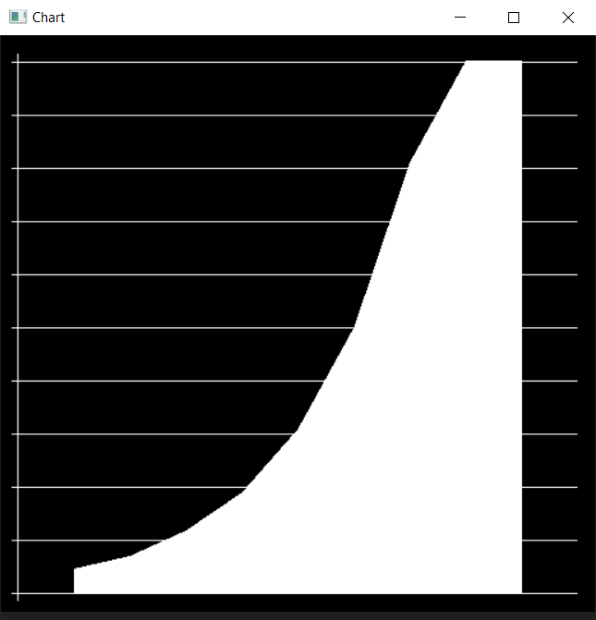

Figure 1: The point, line, column, and area chart generated by the OpenGl program.

**Conclusions:**

The overall result of a programming project was a success. Next time, I will probably start on the project earlier because I have formal languages due tonight. The project took approximately 10 hours to complete.