**PwC Switzerland**

**Power BI Virtual Case Experience**

1. **Call Centre Trends (Visualising customer and agent behaviour)**

**+ Background information:**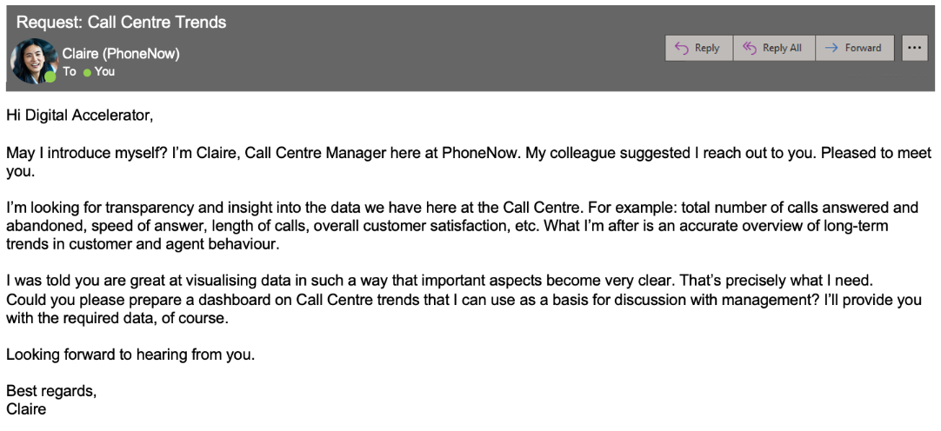

**+ Task:**

Create a dashboard in Power BI for Claire that reflects all relevant Key Performance Indicators (KPIs) and metrics in the dataset.

**KPIs include**:

* Overall customer satisfaction
* Overall calls answered/abandoned
* Calls by time
* Average speed of answer
* Agent’s performance quadrant -> average handle time (talk duration) vs calls answered
  1. **Customer Retention (Customer demographics and insights)**

**+ Background information:**

* Customers in the telecom industry are hard-earned: we don’t want to lose them.
* The retention department is here to get customers back in case of termination.
* Currently, we get in touch after they have terminated the contract, but this is reactionary: it would be better to know in advance who is at risk.
* We  have done customer analysis with Excel: it has always ended in a dead-end.
* We would like to know more about our customers: visualised clearly so that it’s self-explanatory for our management.

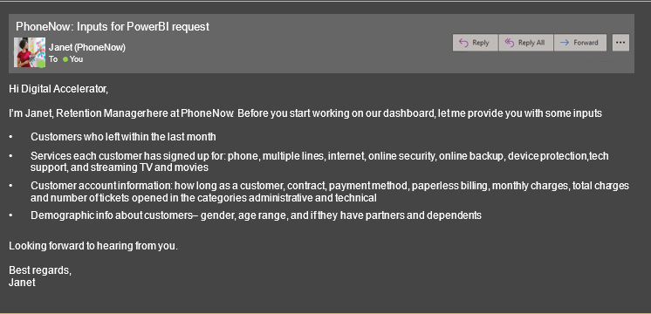

**+ Task:**

1. Define proper KPIs
2. Create a dashboard for the retention manager reflecting the KPIs
   1. **Diversity & Inclusion (gender balance in the executive suite)**

**+ Background information:**

Human Resources at our telecom client is highly into diversity and inclusion. They’ve been working hard to improve gender balance at the executive management level.

**+ Task:**

Define relevant KPIs in hiring, promotion, performance and turnover, and create a visualisation.

**Define proper KPIs:**

* # of men
* # of women
* # of leavers
* % employees promoted (FY21)
* % of women promoted
* % of hires men
* % of hires women
* % turnover
* Average performance rating: men
* Average Performance rating: women