（2）Vehicles

Transportation energy consumption: 6 kg H2 supports a cruise distance of 690 km

Daily travel distances: 50±5 km (Vehicle 1), 40±4 km (Vehicle 2), 30±3 km (Vehicle 3)

Vehicle parking schedules (1 for parking near buildings, 0 for leaving buildings):

Vehicle 1 (left: weekdays + right: weekends):

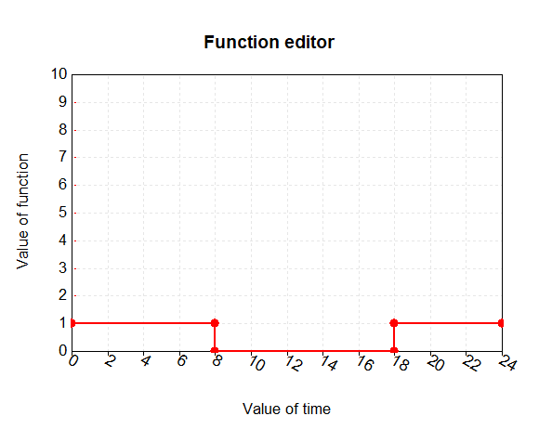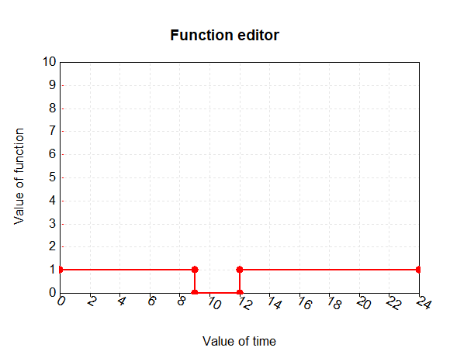

Vehicle 2 (left: weekdays + right: weekends):

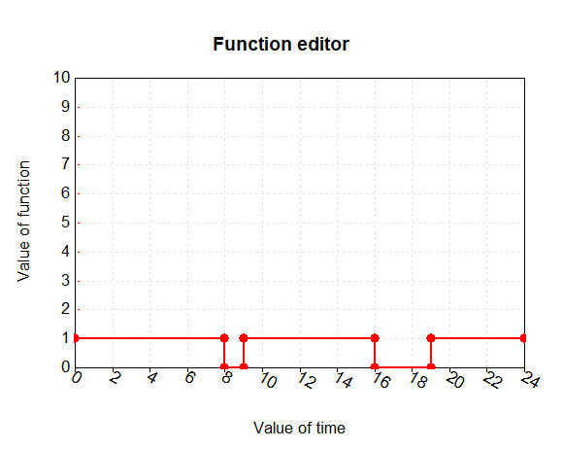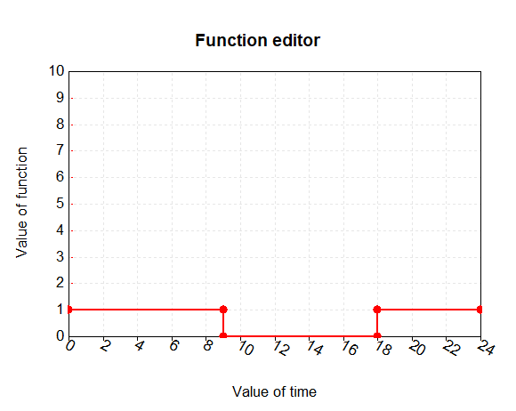

Vehicle 3 (left: weekdays + right: weekends):

 

(3) FC

Parameters:

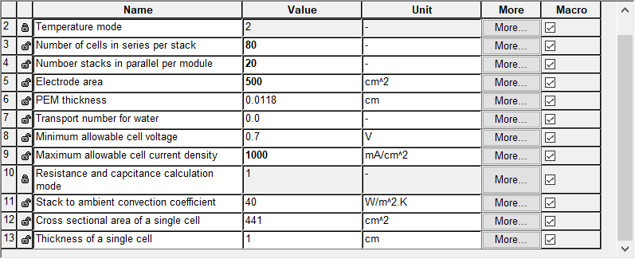

Variables:

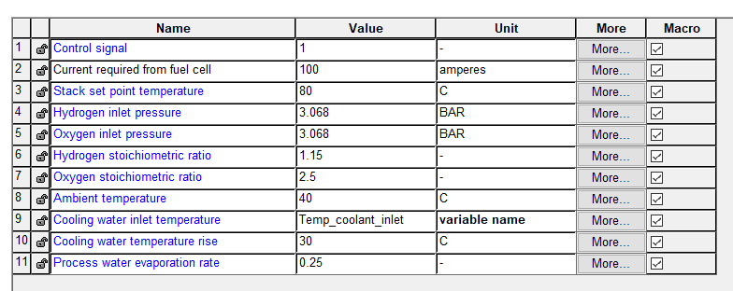

(4) H2 tanks

Parameters:

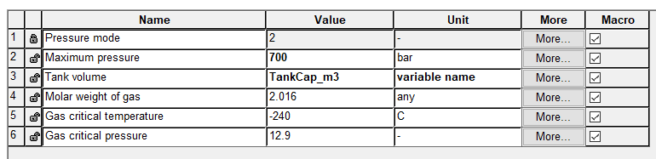

Variables:

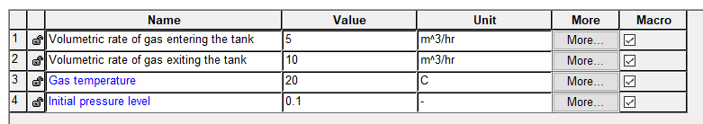

(5) H2 station

Designed daily charging amount: 100~800 kg H2

Hourly charging amount: 10±5 ~ 80±40 kg H2/h

Onsite-renewable-produce H2 storage capacity: 1000 kg (assumed)