Archiving, Loading and converting ARCPAD Tracklogs

Introduction
This applet was designed for use whilst trail walking. Whilst walking, the ArcPad tracklog was used to collect data with no need for continual user input. At the end of each walk the tracklog was archived, leaving the user with a clear tracklog ready to go again. For review purposes, the archived tracklog’s were selectively reloaded into the map, and cloned to the Tracks layer and annotated for future reference. The Tracks layer was used as a summary of all walks.
This zip package includes an ArcPad applet that has three tools:
- Archive the contents of the ArcPad Tracklog to a point shapefile
- Load a tracklog archive to the current map and make the layer editable
- Clone the points contained in the tracklog archive and create a single line feature from these points into an editable line layer
Also included is a sample line layer (Tracks) that can be used with the clone tool. When lines are cloned into this layer they will be symbolised with a circle at the start point, arrows pointing the direction of travel along the line and end with a square point.
You can use this sample as is, or modify for your own needs. The applet will work on Windows and Windows Mobile and with versions of ArcPad from version 6 and above.

ArcPad Tracklog
This applet relies on the user’s knowledge of, and ability to use, to ArcPad tracklog. For more detailed information on the ArcPad Tracklog refer to the ArcPad User guide. To summarize, the tracklog:
- is a point shapefile with special symbology in ArcPad – a heavy red line
- will collect features only when two conditions are met, the GPS must be active and the GPS Tracklog function must be enabled
- file can be added to a map like any other layer (but will display as points not the magic red line, and no re-projection)
- is captured continuously in background whilst you collect own point, line and polygon features
- even when the visibility of the is off, captures data
- has its own configuration options in the layer properties dialog (accessed via the Table of Contents)
- is different to the GPS Log (this GPS log is a different file and collects the actual strings of data supplied by the GPS. This file is for hardware troubleshooting)

The APPLet
The enclosed applet contains just three custom tools. To view the tools, copy the files Tracklog.vbs and Tracklog.apa – supplied with this readme - to the folder C:\Users\Public\Documents\ArcPad\Applets.
When you next launch ArcPad you will see an extra toolbar with the footprint symbol appear.
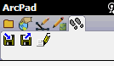
- The Archive tool  will
  - Turn of the GPS if it is on
  - Moves contents of the Tracklog shapefile to another shapefile that has the name Tracklog_hhmmss_dd_mm_yyyy
  - If the GPS was previously on, turn the GPS and Tracklog on.
- The Load tool  will
  - Launch the add layer dialog for user to add the desired tracklog archive layer
  - Make this layer editable
- The Clone tool  will
  - Check that an editable point layer and editable line layer exists in the current map
  - Clone the points contained in the tracklog archive and create a single line feature from these points into the editable line layer

How to use this Applet
Start by collecting a tracklog. The tracklog is represented as thick red line in the ArcPad map, here is an example:
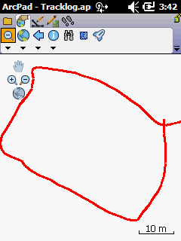
Once you have completed collecting the tracklog, use the Archive tool to move the contents to another file. When you tap the archive button you will see the button highlight momentarily, and once the move is finished, the tool will return to normal and you will see that the solid red line that represented the tracklog, will be gone from your map. Either immediately or sometime later when you are reviewing your archived tracklogs, use the Load tool to add the archived layer to your map. Once loaded, you will see the individual point features that made up the tracklog, display on the map. The previous example will look like this:
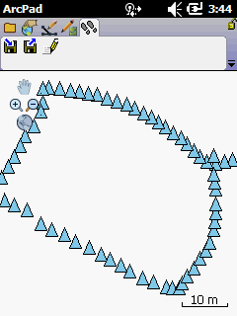
To convert these point features into a single line feature, tap the Clone tool. Again, you will initially see the tool highlight momentarily (to signify that the operation in processing). Once complete, a line will appear on the map along with the point features. You may need to remove the tracklog archive (or at least change the visibility of the layer) to be able to see the line. The previous example will now look like this:
