Listo para web. Negrillas aplicadas y las tres imagenes incrustadas abajo, cada una en su posicion. La cuarta (screenshot del dashboard) no se genero: ver la nota al final.
Bloqueo antes de subir: el enlace al case study de Goldwynn devuelve 410 Gone, la pagina fue borrada del sitio. Se elimino del texto. El CTA a /get-started/ sigue en 301 a la homepage.

SEO Meta
Meta Title: Centralized Leasing: The Complete Guide (2026) [45 chars]
Meta Description: What is centralized leasing, who benefits most, and how to implement it without losing the personal touch. Data-backed guide for multifamily operators. [153 chars]
Slug: /resources/centralized-leasing/ Author: Carlos Leal

Centralized Leasing: What It Is, Who It Works For, and How to Get It Right
Centralized leasing is a model where one team handles leasing for multiple properties from a single hub, replacing the traditional setup of on-site agents at each building. For multifamily operators managing portfolios across several locations, it cuts redundant roles, speeds up response times, and creates a consistent renter experience across every property.
The term “central leasing” is often used interchangeably with “centralized leasing.” Both describe the same operational shift: moving leasing activity away from individual properties and into a shared team that serves the entire portfolio.

Why operators are centralising now
The economics of on-site leasing are getting harder to justify. According to the 2025 NMHC 50 Report, the 50 largest apartment managers in the U.S. now oversee 24% of the nation’s apartment stock, with Greystar alone managing over 946,000 units. At that scale, the pressure to reduce per-unit operating costs pushes operators toward shared-services models. Centralisation is one of the highest-impact moves available because leasing is both labour-intensive and repetitive across properties.
At the NAA Apartmentalize 2024 session “Democratizing Centralization for Large and Small Firms”, panellists from Bozzuto, Veritas Investments, and Canopy Analytics concluded that centralisation is not only possible for any firm regardless of size, but vital to its success. Sunny Junjea, CEO of Canopy Analytics, noted that operators who centralise can “cross-reference properties to find [prospects] the right home” rather than losing leads to competitors when a single community does not fit.
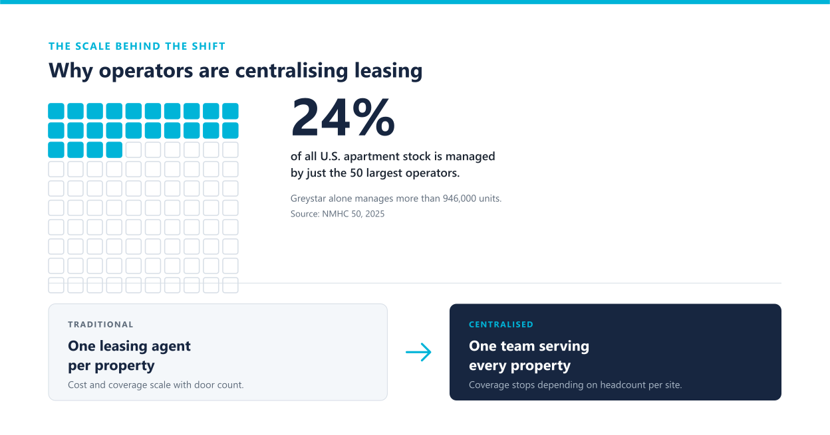
Alt text: Infographic showing that the top 50 U.S. apartment managers oversee 24 percent of all apartments, illustrating the scale driving centralised leasing adoption

What centralised leasing actually looks like
In a centralised model, prospective renters interact with a leasing hub rather than an on-site agent. The hub handles:
- Inquiry response — phone, chat, and email inquiries answered from one team, often with AI-assisted tools that maintain a 100% response rate
- Tour scheduling — self-guided or virtual tours coordinated centrally, with automated confirmations and reminders to reduce no-shows
- Application processing — tenant screening run through a single pipeline with consistent criteria across all properties
- Lease execution — digital lease generation and eSignature from one platform
The on-site team’s role shifts from leasing to resident experience: handling move-ins, maintenance coordination, and renewals. As Lucretia Kumah, SVP at Bozzuto, described at the NAA session, this lets staff focus on “improving the living experience and retaining residents” rather than chasing new leads.

Who centralised leasing is for
Centralised leasing works best for operators with scale and geographic spread. Based on the patterns discussed at NAA’s Apartmentalize 2024 centralisation session and Grace Hill’s analysis of multifamily centralisation, portfolios that benefit most share three characteristics:
- Multiple communities under one owner or manager — centralisation creates value when there are at least 3 to 5 properties to consolidate, because the shared team needs enough lead volume to justify dedicated staffing
- High lead volume relative to on-site capacity — if on-site agents are missing calls or taking more than 24 hours to respond, a central team absorbs the overflow
- Inconsistent leasing experience across properties — if each site runs its own process, centralisation standardises everything from screening criteria to lease terms
Operators with a single property or very small portfolios (under 50 units) typically find that the overhead of building a centralised team outweighs the efficiency gains.

How to implement centralised leasing without losing the personal touch
The most common objection operators raise is that renters want a local, personal experience. The NAA session panellists reported the opposite: renters want fast, consistent answers, regardless of who provides them. Veritas Investments found that when they showed prospects eight properties, the prospect rarely selected the initial one they inquired about, proving that a centralised team with cross-portfolio knowledge actually serves prospects better than a single-site agent.

Step 1: Audit your current leasing workflow
Map every touchpoint from first inquiry to signed lease at each property. Identify where leads drop off, where response times lag, and where the process varies between sites.

Step 2: Define what stays on-site vs. what centralises
Leasing activity centralises (inquiry response, tour scheduling, applications, screening). Resident-facing activity stays on-site (move-in, maintenance, renewals). The line is clearer than most operators expect.

Step 3: Choose your technology stack
A centralised model requires a platform that unifies listings, leads, communications, and applications in one place. The most effective setups include:
- Listing syndication to marketplaces, so all properties publish from one dashboard
- AI-powered inquiry response, to maintain 100% response rate across the portfolio
- Automated tour scheduling with confirmation and reminder workflows
- Integrated tenant screening with consistent criteria across all properties
- Digital lease generation and eSignature

Step 4: Staff the hub and train on portfolio-wide SOP
The central team needs to know every property’s unique selling points, pricing, and policies. Create a property playbook for each community so agents can speak knowledgeably about any unit in the portfolio.

Step 5: Measure and iterate
Track the metrics that matter (see the measurement section below) and adjust staffing, scripts, and technology quarterly.
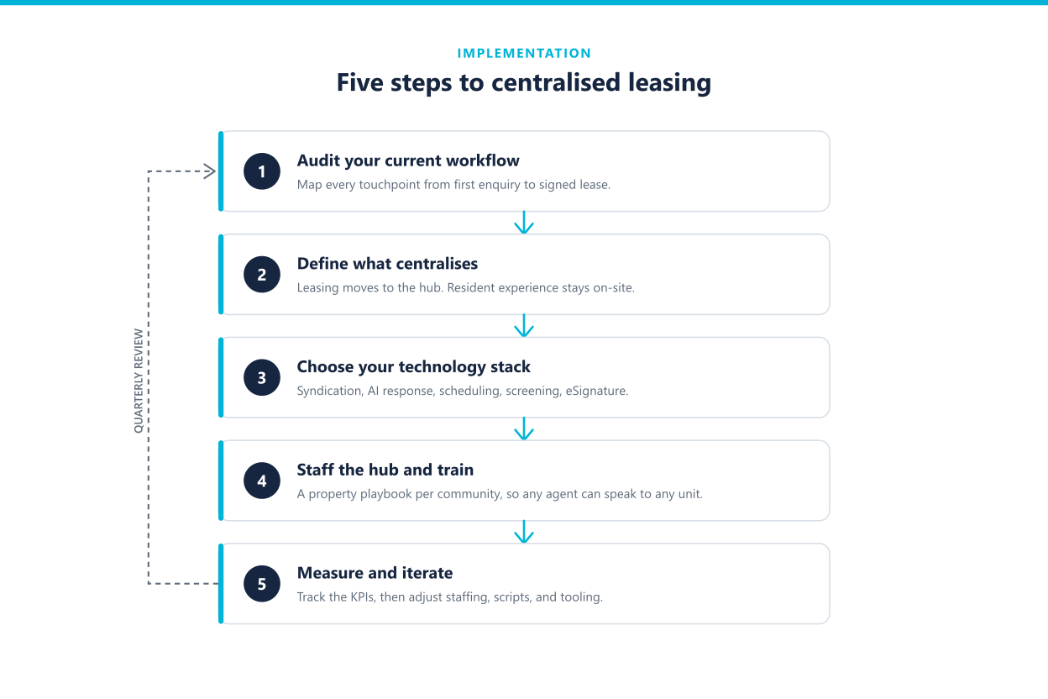
Alt text: Five-step process flowchart for implementing centralised leasing: audit, define scope, choose technology, staff and train, measure and iterate

Measuring centralised leasing performance
The metrics below reflect standard leasing KPIs tracked by multifamily operators. This framework draws from benchmarks published in the NMHC research library and operational data discussed at NAA Apartmentalize 2024, where panellists reported that centralised operations drove delinquencies down by as much as 11% and pushed retention rates to around 62%, well above the industry average.
Metric | What it measures | Why it matters for centralised teams
Lead-to-tour rate | % of inquiries that convert to scheduled tours | Centralised teams should outperform on-site agents here because they respond faster and can cross-sell across properties
Tour-to-application rate | % of tours that result in a submitted application | Self-guided and virtual tours coordinated centrally can increase this by reducing scheduling friction
Application-to-lease rate | % of applications that convert to signed leases | Consistent screening criteria across properties reduces drop-off from inconsistent standards
Average response time | Minutes from first inquiry to first response | The single most important metric. AI-assisted teams can hit under 1 minute; manual teams should target under 5 minutes
Cost per lease | Total leasing cost divided by leases signed | Centralisation should reduce this by eliminating redundant roles across properties
Lease-up velocity | Days from listing to signed lease per unit | Track trend over time; centralised teams with syndication typically show faster lease-up
Retention rate | % of residents who renew their lease | NAA data shows centralised operations reaching 62% retention, above the industry average

Centralised leasing in practice

Tricap Residential Group (industry case)
Tricap Residential Group, a Canadian multifamily operator, centralised their leasing operations across their portfolio using virtual tours and a shared leasing team. Suzanne Hopson, EVP at Tricap, reported that centralisation allowed the company to “keep teams aligned and informed” while reducing the operational overhead of staffing leasing agents at every property. The key: Tricap paired centralisation with technology rather than simply removing on-site staff.

Aquilini Investment Group (Leasey.AI client)
Aquilini Investment Group, one of Western Canada’s largest private investment groups, adopted Leasey.AI to centralise their leasing workflow. Robyn Lockhart from Aquilini reported:
“Leasey has made a big difference for our leasing process. Scheduling showings used to be a major challenge, especially with no-shows, but we’re now seeing far more people actually attend our tours. In just a few months, we’ve already signed several leases through Leasey, and the platform has kept our team consistently busy. Overall, we’ve seen huge improvements on our leasing flow.”
Robyn Lockhart, Aquilini Investment Group
This is particularly significant because Aquilini operates at institutional scale, the same segment where centralisation delivers the most value.

Goldwynn Residences (Leasey.AI client)
Goldwynn Residences, a multifamily operator, centralised their leasing operations through Leasey.AI. Carlos Torrubia, Director of Marketing at Goldwynn, noted:
“The team was extremely responsive to our questions, training was thorough and covered all key areas, and setting up showings by property was quick and convenient. The platform itself is very intuitive and easy to use.”
Carlos Torrubia, Director of Marketing, Goldwynn Residences
Goldwynn’s experience highlights a critical success factor for centralisation: onboarding speed. If the technology takes weeks to set up per property, the ROI timeline stretches. Goldwynn was operational across properties quickly because the platform handled per-property configuration natively.
Enlace eliminado. El doc original enlazaba al case study de Goldwynn. Esa URL devuelve 410 Gone: la pagina fue borrada. El parrafo funciona sin el enlace.
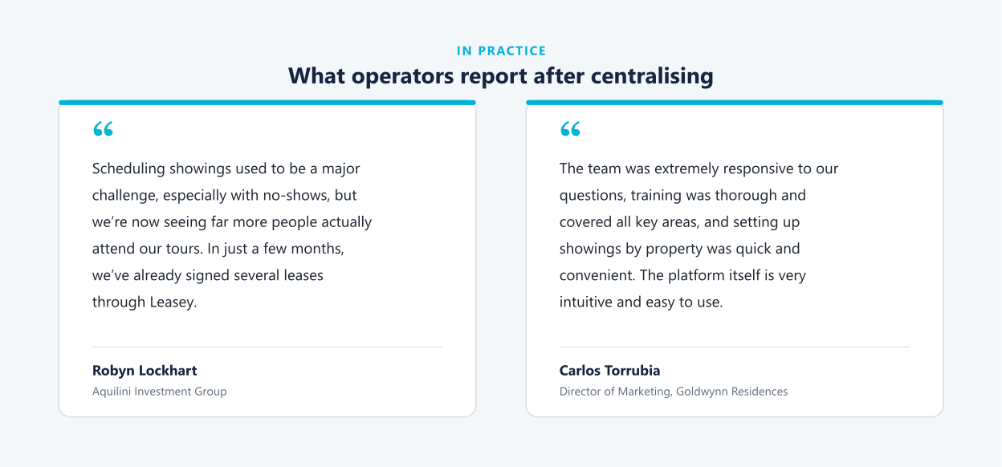
Alt text: Client testimonials from Aquilini Investment Group and Goldwynn Residences about centralising leasing operations with Leasey.AI

Where Leasey.AI fits
Leasey.AI is built for centralised leasing. The platform syndicates listings to 48+ marketplaces from one dashboard, and Liza, the AI leasing agent, handles phone and chat inquiries 24/7 with a 100% response rate. Tenant screening, tour scheduling, and digital lease execution run through a single pipeline.
Leasey.AI sits on top of the PMS you already use, whether that is Yardi, Buildium, or Rent Manager. It does not replace your property management system; it automates the leasing layer that sits above it.
For operators evaluating centralisation, the platform eliminates the most common technology gap: the need to stitch together separate tools for syndication, lead response, screening, and lease execution. As Justin Rogers from The Rockingham Group put it:
“Leasey.AI has been extremely helpful in managing our rental units, from lead handling to scheduling showings. We’re saving hours every week on showing coordination while also filtering out unqualified applicants.”
Justin Rogers, The Rockingham Group
CTA pendiente. El doc apunta a /get-started/, que devuelve 301 a la homepage. No publicar ese enlace hasta decidir el CTA canonico.

Sobre las imagenes
Las tres estan incrustadas arriba, cada una en su posicion. Se entregan tambien como archivos sueltos en SVG, PNG y WebP.
Formato recomendado para la web: SVG. Son diagramas, asi que el vector se ve nitido en cualquier tamano sin versiones @2x, pesa entre 4 y 14 KB frente a unos 100 KB del WebP, y el texto sigue siendo texto seleccionable e indexable. Si WordPress no acepta SVG sin plugin, estan los PNG y WebP a 2400px.
La cuarta imagen no se genero, y es a proposito. Pide un screenshot del dashboard de Leasey.AI con el pipeline multi-propiedad y las metricas de respuesta. Se puede dibujar algo que parezca ese dashboard, pero seria un producto inventado presentado como captura real: numeros que nadie midio y una interfaz que quiza no se ve asi. Esa imagen tiene que salir del producto. Es de las cuatro la que menos tiempo toma: abrir la plataforma, capturar, recortar.
Las tres que si se hicieron son diagramas conceptuales: no afirman nada sobre la interfaz, solo ilustran datos que ya estan en el texto y con fuente.

Verificacion de enlaces
Limpias (200, sin redirect): los 6 interlinks del cluster (operational-benefits, key-roles, impact-leasing-agents, improving-tenant-experience, risk-management, y el blog the-future-of-your-rental-business).
Rotas: /resources/testimonials/how-goldwynn-.../ da 410 Gone; la version sin /testimonials/ tambien da 410; /case-studies/ da 410; /get-started/ da 301 a la homepage.
Ojo con esto: la URL de Goldwynn sigue apareciendo en el sitemap aunque devuelve 410, asi que el sitio le esta sirviendo una pagina muerta a Google. Conviene avisarlo aparte, no es solo este documento.

