Your temporary usage period for IBM SPSS Statistics will expire in 10 days.

GET
FILE='C:\Program Files\IBM\SPSS\Statistics\Subscription\Samples\English\demo.sav'.
DATASET NAME DataSet1 WINDOW=FRONT.
FREQUENCIES VARIABLES=age marital income
/STATISTICS=STDDEV
/ORDER=ANALYSIS.

Frequencies

Notes
Output Created |  | 04-SEP-2017 23:50:29
Comments
Input | Data | C:\Program Files\IBM\SPSS\Statistics\Subscription\Samples\English\demo.sav
Input | Active Dataset | DataSet1
Input | Filter | <none>
Input | Weight | <none>
Input | Split File | <none>
Input | N of Rows in Working Data File | 6400
Missing Value Handling | Definition of Missing | User-defined missing values are treated as missing.
Missing Value Handling | Cases Used | Statistics are based on all cases with valid data.
Syntax |  | FREQUENCIES VARIABLES=age marital income  /STATISTICS=STDDEV  /ORDER=ANALYSIS.
Resources | Processor Time | 00:00:00.11
Resources | Elapsed Time | 00:00:00.32

[DataSet1] C:\Program Files\IBM\SPSS\Statistics\Subscription\Samples\English\demo.sav

Statistics
 |  | Age in years | Marital status | Household income in thousands
N | Valid | 6400 | 6400 | 6400
N | Missing | 0 | 0 | 0
Std. Deviation |  | 12.290 | .500 | 78.71856

Frequency Table

Age in years
 |  | Frequency | Percent | Valid Percent | Cumulative Percent
Valid | 18 | 13 | .2 | .2 | .2
Valid | 19 | 42 | .7 | .7 | .9
Valid | 20 | 54 | .8 | .8 | 1.7
Valid | 21 | 57 | .9 | .9 | 2.6
Valid | 22 | 65 | 1.0 | 1.0 | 3.6
Valid | 23 | 69 | 1.1 | 1.1 | 4.7
Valid | 24 | 111 | 1.7 | 1.7 | 6.4
Valid | 25 | 121 | 1.9 | 1.9 | 8.3
Valid | 26 | 138 | 2.2 | 2.2 | 10.5
Valid | 27 | 114 | 1.8 | 1.8 | 12.3
Valid | 28 | 162 | 2.5 | 2.5 | 14.8
Valid | 29 | 156 | 2.4 | 2.4 | 17.2
Valid | 30 | 168 | 2.6 | 2.6 | 19.8
Valid | 31 | 172 | 2.7 | 2.7 | 22.5
Valid | 32 | 156 | 2.4 | 2.4 | 25.0
Valid | 33 | 163 | 2.5 | 2.5 | 27.5
Valid | 34 | 189 | 3.0 | 3.0 | 30.5
Valid | 35 | 180 | 2.8 | 2.8 | 33.3
Valid | 36 | 187 | 2.9 | 2.9 | 36.2
Valid | 37 | 202 | 3.2 | 3.2 | 39.4
Valid | 38 | 188 | 2.9 | 2.9 | 42.3
Valid | 39 | 214 | 3.3 | 3.3 | 45.6
Valid | 40 | 181 | 2.8 | 2.8 | 48.5
Valid | 41 | 175 | 2.7 | 2.7 | 51.2
Valid | 42 | 195 | 3.0 | 3.0 | 54.3
Valid | 43 | 166 | 2.6 | 2.6 | 56.8
Valid | 44 | 157 | 2.5 | 2.5 | 59.3
Valid | 45 | 185 | 2.9 | 2.9 | 62.2
Valid | 46 | 143 | 2.2 | 2.2 | 64.4
Valid | 47 | 177 | 2.8 | 2.8 | 67.2
Valid | 48 | 157 | 2.5 | 2.5 | 69.6
Valid | 49 | 153 | 2.4 | 2.4 | 72.0
Valid | 50 | 141 | 2.2 | 2.2 | 74.2
Valid | 51 | 153 | 2.4 | 2.4 | 76.6
Valid | 52 | 128 | 2.0 | 2.0 | 78.6
Valid | 53 | 123 | 1.9 | 1.9 | 80.5
Valid | 54 | 136 | 2.1 | 2.1 | 82.7
Valid | 55 | 110 | 1.7 | 1.7 | 84.4
Valid | 56 | 107 | 1.7 | 1.7 | 86.1
Valid | 57 | 103 | 1.6 | 1.6 | 87.7
Valid | 58 | 81 | 1.3 | 1.3 | 88.9
Valid | 59 | 88 | 1.4 | 1.4 | 90.3
Valid | 60 | 65 | 1.0 | 1.0 | 91.3
Valid | 61 | 92 | 1.4 | 1.4 | 92.8
Valid | 62 | 60 | .9 | .9 | 93.7
Valid | 63 | 65 | 1.0 | 1.0 | 94.7
Valid | 64 | 49 | .8 | .8 | 95.5
Valid | 65 | 55 | .9 | .9 | 96.3
Valid | 66 | 60 | .9 | .9 | 97.3
Valid | 67 | 35 | .5 | .5 | 97.8
Valid | 68 | 19 | .3 | .3 | 98.1
Valid | 69 | 24 | .4 | .4 | 98.5
Valid | 70 | 27 | .4 | .4 | 98.9
Valid | 71 | 23 | .4 | .4 | 99.3
Valid | 72 | 14 | .2 | .2 | 99.5
Valid | 73 | 15 | .2 | .2 | 99.7
Valid | 74 | 9 | .1 | .1 | 99.9
Valid | 75 | 4 | .1 | .1 | 99.9
Valid | 76 | 3 | .0 | .0 | 100.0
Valid | 77 | 1 | .0 | .0 | 100.0
Valid | Total | 6400 | 100.0 | 100.0

Marital status
 |  | Frequency | Percent | Valid Percent | Cumulative Percent
Valid | Unmarried | 3224 | 50.4 | 50.4 | 50.4
Valid | Married | 3176 | 49.6 | 49.6 | 100.0
Valid | Total | 6400 | 100.0 | 100.0

BAYES REGRESSION age BY inccat gender
/CRITERIA CILEVEL=95
/DESIGN FACTORS=inccat gender
/INFERENCE ANALYSIS=POSTERIOR
/PRIOR TYPE=REFERENCE
/PLOT INTERCEPT=FALSE ERRORVAR=FALSE BAYESPRED=FALSE.

Bayesian Regression

Notes
Output Created |  | 05-SEP-2017 01:28:15
Comments
Input | Data | C:\Program Files\IBM\SPSS\Statistics\Subscription\Samples\English\demo.sav
Input | Active Dataset | DataSet1
Input | Filter | <none>
Input | Weight | <none>
Input | Split File | <none>
Input | N of Rows in Working Data File | 6400
Missing Value Handling | Definition of Missing | User-defined missing values are treated as missing.
Missing Value Handling | Cases Used | Only cases with valid data for all analysis variables are used in computing any statistics.
Weight Handling |  | not applicable
Syntax |  | BAYES REGRESSION age BY inccat gender  /CRITERIA CILEVEL=95  /DESIGN FACTORS=inccat gender  /INFERENCE ANALYSIS=POSTERIOR  /PRIOR TYPE=REFERENCE  /PLOT INTERCEPT=FALSE ERRORVAR=FALSE BAYESPRED=FALSE.
Resources | Processor Time | 00:00:00.17
Resources | Elapsed Time | 00:00:00.58

ANOVA^{a,b}
Source | Sum of Squares | df | Mean Square | F | Sig.
Regression | 129393.691 | 4 | 32348.423 | 247.136 | .000
Residual | 837061.337 | 6395 | 130.893
Total | 966455.027 | 6399

a. Dependent Variable: Age in years
b. Model: (Intercept), Income category in thousands, Gender

Bayesian Estimates of Coefficients^{a,b,c}
Parameter | Posterior |  |  | 95% Credible Interval
Parameter | Mode | Mean | Variance | Lower Bound | Upper Bound
(Intercept) | 49.217 | 49.217 | .096 | 48.611 | 49.823
Income category in thousands = Under $25 | -11.164 | -11.164 | .188 | -12.014 | -10.315
Income category in thousands = $25 - $49 | -10.116 | -10.116 | .131 | -10.825 | -9.406
Income category in thousands = $50 - $74 | -5.992 | -5.992 | .193 | -6.853 | -5.131
Income category in thousands = $75+ | .^{d} | .^{d} | .^{d} | .^{d} | .^{d}
Gender = Female | -.579 | -.579 | .082 | -1.140 | -.018
Gender = Male | .^{d} | .^{d} | .^{d} | .^{d} | .^{d}

a. Dependent Variable: Age in years
b. Model: (Intercept), Income category in thousands, Gender
c. Assume standard reference priors.
d. This parameter is redundant. Posterior statistics are not calculated.

Bayesian Estimates of Error Varianceª
Parameter | Posterior |  |  | 95% Credible Interval
Parameter | Mode | Mean | Variance | Lower Bound | Upper Bound
Error variance | 130.852 | 130.934 | 5.365 | 126.472 | 135.551

a. Assume standard reference priors.

Notes
Output Created |  | 05-SEP-2017 01:51:25
Comments
Input | Data | C:\Program Files\IBM\SPSS\Statistics\Subscription\Samples\English\demo.sav
Input | Active Dataset | DataSet1
Input | Filter | <none>
Input | Weight | <none>
Input | Split File | <none>
Input | N of Rows in Working Data File | 6400
Syntax |  | GGRAPH  /GRAPHDATASET NAME="graphdataset" VARIABLES=age inccat MISSING=LISTWISE REPORTMISSING=NO  /GRAPHSPEC SOURCE=INLINE.  BEGIN GPL  SOURCE: s=userSource(id("graphdataset"))  DATA: age=col(source(s), name("age"))  DATA: inccat=col(source(s), name("inccat"), unit.category())  GUIDE: axis(dim(1), label("Age in years"))  GUIDE: axis(dim(2), label("Income category in thousands"))  GUIDE: text.title(label("Simple Line of Income category in thousands by Age in years"))  SCALE: cat(dim(2), include("1.00", "2.00", "3.00", "4.00"))  ELEMENT: line(position(age*inccat), missing.interpolate())  END GPL.
Resources | Processor Time | 00:00:05.56
Resources | Elapsed Time | 00:00:04.25

Notes
Output Created |  | 05-SEP-2017 01:52:33
Comments
Input | Data | C:\Program Files\IBM\SPSS\Statistics\Subscription\Samples\English\demo.sav
Input | Active Dataset | DataSet1
Input | Filter | <none>
Input | Weight | <none>
Input | Split File | <none>
Input | N of Rows in Working Data File | 6400
Syntax |  | GGRAPH  /GRAPHDATASET NAME="graphdataset" VARIABLES=age inccat MISSING=LISTWISE REPORTMISSING=NO  /GRAPHSPEC SOURCE=INLINE.  BEGIN GPL  SOURCE: s=userSource(id("graphdataset"))  DATA: age=col(source(s), name("age"))  DATA: inccat=col(source(s), name("inccat"), unit.category())  GUIDE: axis(dim(1), label("Age in years"))  GUIDE: axis(dim(2), label("Income category in thousands"))  GUIDE: text.title(label("Simple Line of Income category in thousands by Age in years"))  SCALE: cat(dim(2), include("1.00", "2.00", "3.00", "4.00"))  ELEMENT: line(position(age*inccat), missing.wings())  END GPL.
Resources | Processor Time | 00:00:00.97
Resources | Elapsed Time | 00:00:01.09

Notes
Output Created |  | 05-SEP-2017 01:53:15
Comments
Input | Data | C:\Program Files\IBM\SPSS\Statistics\Subscription\Samples\English\demo.sav
Input | Active Dataset | DataSet1
Input | Filter | <none>
Input | Weight | <none>
Input | Split File | <none>
Input | N of Rows in Working Data File | 6400
Syntax |  | GGRAPH  /GRAPHDATASET NAME="graphdataset" VARIABLES=age inccat MISSING=LISTWISE REPORTMISSING=NO  /GRAPHSPEC SOURCE=INLINE.  BEGIN GPL  SOURCE: s=userSource(id("graphdataset"))  DATA: age=col(source(s), name("age"))  DATA: inccat=col(source(s), name("inccat"), unit.category())  GUIDE: axis(dim(1), label("Age in years"))  GUIDE: axis(dim(2), label("Income category in thousands"))  GUIDE: text.title(label("Simple Line of Income category in thousands by Age in years"))  SCALE: cat(dim(2), include("1.00", "2.00", "3.00", "4.00"))  ELEMENT: line(position(age*inccat), missing.wings())  END GPL.
Resources | Processor Time | 00:00:00.91
Resources | Elapsed Time | 00:00:01.11

Notes
Output Created |  | 05-SEP-2017 01:54:05
Comments
Input | Data | C:\Program Files\IBM\SPSS\Statistics\Subscription\Samples\English\demo.sav
Input | Active Dataset | DataSet1
Input | Filter | <none>
Input | Weight | <none>
Input | Split File | <none>
Input | N of Rows in Working Data File | 6400
Syntax |  | GGRAPH  /GRAPHDATASET NAME="graphdataset" VARIABLES=age marital MISSING=LISTWISE REPORTMISSING=NO  /GRAPHSPEC SOURCE=INLINE.  BEGIN GPL  SOURCE: s=userSource(id("graphdataset"))  DATA: age=col(source(s), name("age"))  DATA: marital=col(source(s), name("marital"))  GUIDE: axis(dim(1), label("Age in years"))  GUIDE: axis(dim(2), label("Marital status"))  GUIDE: text.title(label("Simple Histogram of Marital status by Age in years"))  ELEMENT: interval(position(age*marital), shape.interior(shape.square))  END GPL.
Resources | Processor Time | 00:00:01.62
Resources | Elapsed Time | 00:00:01.16

Notes
Output Created |  | 05-SEP-2017 01:54:50
Comments
Input | Data | C:\Program Files\IBM\SPSS\Statistics\Subscription\Samples\English\demo.sav
Input | Active Dataset | DataSet1
Input | Filter | <none>
Input | Weight | <none>
Input | Split File | <none>
Input | N of Rows in Working Data File | 6400
Syntax |  | GGRAPH  /GRAPHDATASET NAME="graphdataset" VARIABLES=age marital MISSING=LISTWISE REPORTMISSING=NO  /GRAPHSPEC SOURCE=INLINE  /FITLINE TOTAL=NO.  BEGIN GPL  SOURCE: s=userSource(id("graphdataset"))  DATA: age=col(source(s), name("age"))  DATA: marital=col(source(s), name("marital"))  GUIDE: axis(dim(1), label("Age in years"))  GUIDE: axis(dim(2), label("Marital status"))  GUIDE: text.title(label("Simple Scatter of Marital status by Age in years"))  ELEMENT: point(position(age*marital))  END GPL.
Resources | Processor Time | 00:00:00.72
Resources | Elapsed Time | 00:00:01.22

Notes
Output Created |  | 05-SEP-2017 01:56:17
Comments
Input | Data | C:\Program Files\IBM\SPSS\Statistics\Subscription\Samples\English\demo.sav
Input | Active Dataset | DataSet1
Input | Filter | <none>
Input | Weight | <none>
Input | Split File | <none>
Input | N of Rows in Working Data File | 6400
Syntax |  | GGRAPH  /GRAPHDATASET NAME="graphdataset" VARIABLES=inccat age MISSING=LISTWISE REPORTMISSING=NO  /GRAPHSPEC SOURCE=INLINE  /FITLINE TOTAL=NO.  BEGIN GPL  SOURCE: s=userSource(id("graphdataset"))  DATA: inccat=col(source(s), name("inccat"), unit.category())  DATA: age=col(source(s), name("age"))  GUIDE: axis(dim(1), label("Income category in thousands"))  GUIDE: axis(dim(2), label("Age in years"))  GUIDE: text.title(label("Simple Scatter of Age in years by Income category in thousands"))  SCALE: cat(dim(1), include("1.00", "2.00", "3.00", "4.00"))  SCALE: linear(dim(2), include(0))  ELEMENT: point(position(inccat*age))  END GPL.
Resources | Processor Time | 00:00:00.80
Resources | Elapsed Time | 00:00:01.19

* Chart Builder.
GGRAPH
/GRAPHDATASET NAME="graphdataset" VARIABLES=inccat carcat MISSING=LISTWISE REPORTMISSING=NO
/GRAPHSPEC SOURCE=INLINE.
BEGIN GPL
SOURCE: s=userSource(id("graphdataset"))
DATA: inccat=col(source(s), name("inccat"), unit.category())
DATA: carcat=col(source(s), name("carcat"), unit.category())
GUIDE: axis(dim(1), label("Income category in thousands"))
GUIDE: axis(dim(2), label("Primary vehicle price category"))
GUIDE: text.title(label("Simple Histogram of Primary vehicle price category by Income category ",
"in thousands"))
SCALE: cat(dim(1), include("1.00", "2.00", "3.00", "4.00"))
SCALE: cat(dim(2), include("1.00", "2.00", "3.00"))
ELEMENT: interval(position(inccat*carcat), shape.interior(shape.square))
END GPL.

GGraph

Notes
Output Created |  | 05-SEP-2017 02:00:03
Comments
Input | Data | C:\Program Files\IBM\SPSS\Statistics\Subscription\Samples\English\demo.sav
Input | Active Dataset | DataSet1
Input | Filter | <none>
Input | Weight | <none>
Input | Split File | <none>
Input | N of Rows in Working Data File | 6400
Syntax |  | GGRAPH  /GRAPHDATASET NAME="graphdataset" VARIABLES=inccat carcat MISSING=LISTWISE REPORTMISSING=NO  /GRAPHSPEC SOURCE=INLINE.  BEGIN GPL  SOURCE: s=userSource(id("graphdataset"))  DATA: inccat=col(source(s), name("inccat"), unit.category())  DATA: carcat=col(source(s), name("carcat"), unit.category())  GUIDE: axis(dim(1), label("Income category in thousands"))  GUIDE: axis(dim(2), label("Primary vehicle price category"))  GUIDE: text.title(label("Simple Histogram of Primary vehicle price category by Income category ",  "in thousands"))  SCALE: cat(dim(1), include("1.00", "2.00", "3.00", "4.00"))  SCALE: cat(dim(2), include("1.00", "2.00", "3.00"))  ELEMENT: interval(position(inccat*carcat), shape.interior(shape.square))  END GPL.
Resources | Processor Time | 00:00:00.72
Resources | Elapsed Time | 00:00:00.74

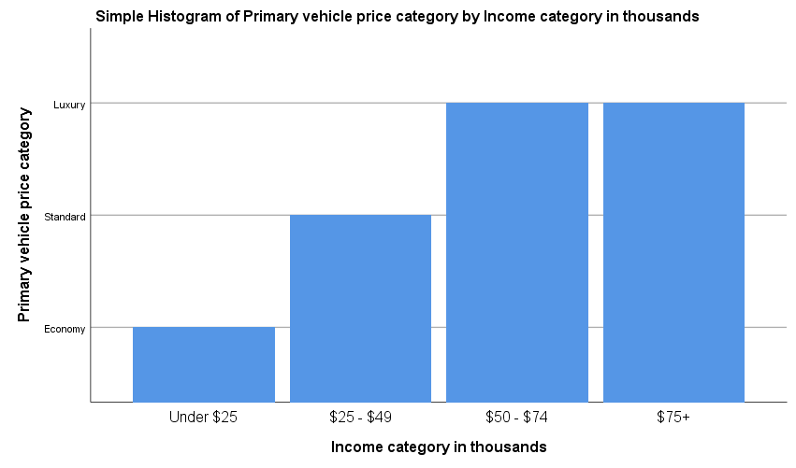

Notes
Output Created |  | 05-SEP-2017 02:02:58
Comments
Input | Data | C:\Program Files\IBM\SPSS\Statistics\Subscription\Samples\English\demo.sav
Input | Active Dataset | DataSet1
Input | Filter | <none>
Input | Weight | <none>
Input | Split File | <none>
Input | N of Rows in Working Data File | 6400
Syntax |  | GGRAPH  /GRAPHDATASET NAME="graphdataset" VARIABLES=gender jobsat MISSING=LISTWISE REPORTMISSING=NO  /GRAPHSPEC SOURCE=INLINE.  BEGIN GPL  SOURCE: s=userSource(id("graphdataset"))  DATA: gender=col(source(s), name("gender"), unit.category())  DATA: jobsat=col(source(s), name("jobsat"))  GUIDE: axis(dim(1), label("Gender"))  GUIDE: axis(dim(2), label("Job satisfaction"))  GUIDE: text.title(label("Simple Histogram of Job satisfaction by Gender"))  SCALE: cat(dim(1), include("f", "m"))  SCALE: linear(dim(2), include(0))  ELEMENT: interval(position(gender*jobsat), shape.interior(shape.square))  END GPL.
Resources | Processor Time | 00:00:00.78
Resources | Elapsed Time | 00:00:00.85

Notes
Output Created |  | 05-SEP-2017 02:04:24
Comments
Input | Data | C:\Program Files\IBM\SPSS\Statistics\Subscription\Samples\English\demo.sav
Input | Active Dataset | DataSet1
Input | Filter | <none>
Input | Weight | <none>
Input | Split File | <none>
Input | N of Rows in Working Data File | 6400
Syntax |  | GGRAPH  /GRAPHDATASET NAME="graphdataset" VARIABLES=age jobsat MISSING=LISTWISE REPORTMISSING=NO  /GRAPHSPEC SOURCE=INLINE.  BEGIN GPL  SOURCE: s=userSource(id("graphdataset"))  DATA: age=col(source(s), name("age"))  DATA: jobsat=col(source(s), name("jobsat"))  GUIDE: axis(dim(1), label("Age in years"))  GUIDE: axis(dim(2), label("Job satisfaction"))  GUIDE: text.title(label("Simple Line of Job satisfaction by Age in years"))  ELEMENT: line(position(age*jobsat), missing.wings())  END GPL.
Resources | Processor Time | 00:00:00.64
Resources | Elapsed Time | 00:00:00.69

Notes
Output Created |  | 05-SEP-2017 02:04:56
Comments
Input | Data | C:\Program Files\IBM\SPSS\Statistics\Subscription\Samples\English\demo.sav
Input | Active Dataset | DataSet1
Input | Filter | <none>
Input | Weight | <none>
Input | Split File | <none>
Input | N of Rows in Working Data File | 6400
Syntax |  | GGRAPH  /GRAPHDATASET NAME="graphdataset" VARIABLES=age jobsat MISSING=LISTWISE REPORTMISSING=NO  /GRAPHSPEC SOURCE=INLINE.  BEGIN GPL  SOURCE: s=userSource(id("graphdataset"))  DATA: age=col(source(s), name("age"))  DATA: jobsat=col(source(s), name("jobsat"))  GUIDE: axis(dim(1), label("Age in years"))  GUIDE: axis(dim(2), label("Job satisfaction"))  GUIDE: text.title(label("Simple Line of Job satisfaction by Age in years"))  ELEMENT: line(position(age*jobsat), missing.wings())  END GPL.
Resources | Processor Time | 00:00:00.66
Resources | Elapsed Time | 00:00:00.88

Notes
Output Created |  | 05-SEP-2017 02:05:55
Comments
Input | Data | C:\Program Files\IBM\SPSS\Statistics\Subscription\Samples\English\demo.sav
Input | Active Dataset | DataSet1
Input | Filter | <none>
Input | Weight | <none>
Input | Split File | <none>
Input | N of Rows in Working Data File | 6400
Syntax |  | GGRAPH  /GRAPHDATASET NAME="graphdataset" VARIABLES=car age MISSING=LISTWISE REPORTMISSING=NO  /GRAPHSPEC SOURCE=INLINE.  BEGIN GPL  SOURCE: s=userSource(id("graphdataset"))  DATA: car=col(source(s), name("car"))  DATA: age=col(source(s), name("age"))  GUIDE: axis(dim(1), label("Price of primary vehicle"))  GUIDE: axis(dim(2), label("Age in years"))  GUIDE: text.title(label("Simple Line of Age in years by Price of primary vehicle"))  ELEMENT: line(position(car*age), missing.wings())  END GPL.
Resources | Processor Time | 00:00:00.70
Resources | Elapsed Time | 00:00:00.73

Notes
Output Created |  | 05-SEP-2017 02:06:50
Comments
Input | Data | C:\Program Files\IBM\SPSS\Statistics\Subscription\Samples\English\demo.sav
Input | Active Dataset | DataSet1
Input | Filter | <none>
Input | Weight | <none>
Input | Split File | <none>
Input | N of Rows in Working Data File | 6400
Syntax |  | GGRAPH  /GRAPHDATASET NAME="graphdataset" VARIABLES=car age MISSING=LISTWISE REPORTMISSING=NO  /GRAPHSPEC SOURCE=INLINE.  BEGIN GPL  SOURCE: s=userSource(id("graphdataset"))  DATA: car=col(source(s), name("car"))  DATA: age=col(source(s), name("age"))  GUIDE: axis(dim(1), label("Price of primary vehicle"))  GUIDE: axis(dim(2), label("Age in years"))  GUIDE: text.title(label("Simple Line of Age in years by Price of primary vehicle"))  ELEMENT: line(position(car*age), missing.wings())  END GPL.
Resources | Processor Time | 00:00:00.64
Resources | Elapsed Time | 00:00:00.87

* Chart Builder.
GGRAPH
/GRAPHDATASET NAME="graphdataset" VARIABLES=car age MISSING=LISTWISE REPORTMISSING=NO
/GRAPHSPEC SOURCE=INLINE
/FITLINE TOTAL=NO.
BEGIN GPL
SOURCE: s=userSource(id("graphdataset"))
DATA: car=col(source(s), name("car"))
DATA: age=col(source(s), name("age"))
GUIDE: axis(dim(1), label("Price of primary vehicle"))
GUIDE: axis(dim(2), label("Age in years"))
GUIDE: text.title(label("Simple Scatter of Age in years by Price of primary vehicle"))
ELEMENT: point(position(car*age))
END GPL.

GGraph

Notes
Output Created |  | 05-SEP-2017 02:07:29
Comments
Input | Data | C:\Program Files\IBM\SPSS\Statistics\Subscription\Samples\English\demo.sav
Input | Active Dataset | DataSet1
Input | Filter | <none>
Input | Weight | <none>
Input | Split File | <none>
Input | N of Rows in Working Data File | 6400
Syntax |  | GGRAPH  /GRAPHDATASET NAME="graphdataset" VARIABLES=car age MISSING=LISTWISE REPORTMISSING=NO  /GRAPHSPEC SOURCE=INLINE  /FITLINE TOTAL=NO.  BEGIN GPL  SOURCE: s=userSource(id("graphdataset"))  DATA: car=col(source(s), name("car"))  DATA: age=col(source(s), name("age"))  GUIDE: axis(dim(1), label("Price of primary vehicle"))  GUIDE: axis(dim(2), label("Age in years"))  GUIDE: text.title(label("Simple Scatter of Age in years by Price of primary vehicle"))  ELEMENT: point(position(car*age))  END GPL.
Resources | Processor Time | 00:00:00.66
Resources | Elapsed Time | 00:00:00.70

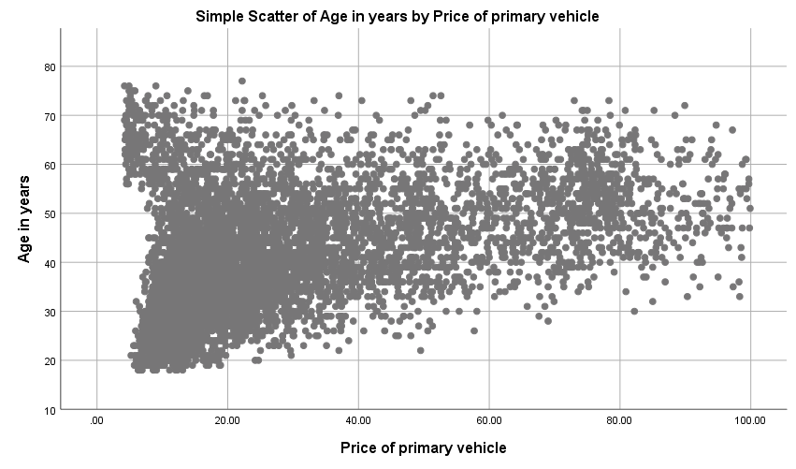

* Chart Builder.
GGRAPH
/GRAPHDATASET NAME="graphdataset" VARIABLES=inccat age MISSING=LISTWISE REPORTMISSING=NO
/GRAPHSPEC SOURCE=INLINE.
BEGIN GPL
SOURCE: s=userSource(id("graphdataset"))
DATA: inccat=col(source(s), name("inccat"), unit.category())
DATA: age=col(source(s), name("age"))
COORD: polar.theta(startAngle(0))
GUIDE: axis(dim(1), null())
GUIDE: legend(aesthetic(aesthetic.color.interior), label("Income category in thousands"))
GUIDE: text.title(label("Pie Chart of Age in years by Income category in thousands"))
SCALE: linear(dim(1), dataMinimum(), dataMaximum())
SCALE: cat(aesthetic(aesthetic.color.interior), include("1.00", "2.00", "3.00", "4.00"))
ELEMENT: interval.stack(position(summary.percent(age))), color.interior(inccat))
END GPL.

GGraph

Notes
Output Created |  | 05-SEP-2017 02:09:12
Comments
Input | Data | C:\Program Files\IBM\SPSS\Statistics\Subscription\Samples\English\demo.sav
Input | Active Dataset | DataSet1
Input | Filter | <none>
Input | Weight | <none>
Input | Split File | <none>
Input | N of Rows in Working Data File | 6400
Syntax |  | GGRAPH  /GRAPHDATASET NAME="graphdataset" VARIABLES=inccat age MISSING=LISTWISE REPORTMISSING=NO  /GRAPHSPEC SOURCE=INLINE.  BEGIN GPL  SOURCE: s=userSource(id("graphdataset"))  DATA: inccat=col(source(s), name("inccat"), unit.category())  DATA: age=col(source(s), name("age"))  COORD: polar.theta(startAngle(0))  GUIDE: axis(dim(1), null())  GUIDE: legend(aesthetic(aesthetic.color.interior), label("Income category in thousands"))  GUIDE: text.title(label("Pie Chart of Age in years by Income category in thousands"))  SCALE: linear(dim(1), dataMinimum(), dataMaximum())  SCALE: cat(aesthetic(aesthetic.color.interior), include("1.00", "2.00", "3.00", "4.00"))  ELEMENT: interval.stack(position(summary.percent(age))), color.interior(inccat))  END GPL.
Resources | Processor Time | 00:00:00.77
Resources | Elapsed Time | 00:00:00.83

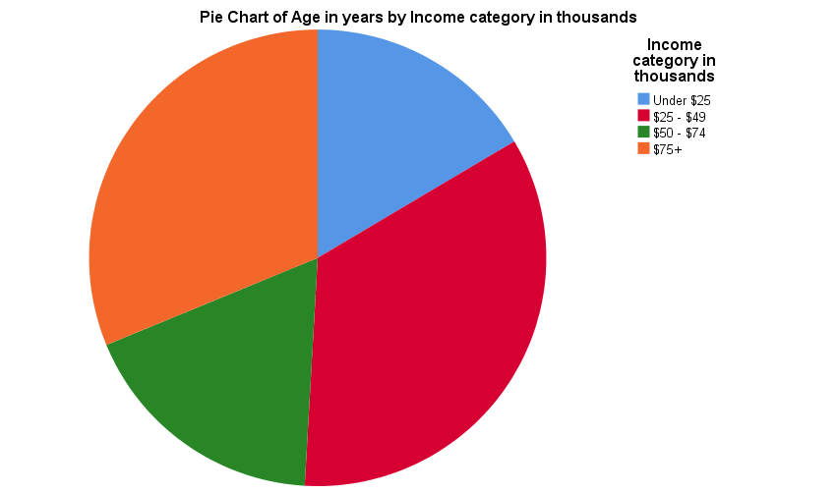

Notes
Output Created |  | 05-SEP-2017 02:26:35
Comments
Input | Data | C:\Program Files\IBM\SPSS\Statistics\Subscription\Samples\English\demo.sav
Input | Active Dataset | DataSet1
Input | Filter | <none>
Input | Weight | <none>
Input | Split File | <none>
Input | N of Rows in Working Data File | 6400
Syntax |  | GGRAPH  /GRAPHDATASET NAME="graphdataset" VARIABLES=inccat age MISSING=LISTWISE REPORTMISSING=NO  /GRAPHSPEC SOURCE=INLINE.  BEGIN GPL  SOURCE: s=userSource(id("graphdataset"))  DATA: inccat=col(source(s), name("inccat"), unit.category())  DATA: age=col(source(s), name("age"))  COORD: polar.theta(startAngle(0))  GUIDE: axis(dim(1), null())  GUIDE: legend(aesthetic(aesthetic.color.interior), label("Income category in thousands"))  GUIDE: text.title(label("Pie Chart of Age in years by Income category in thousands"))  SCALE: linear(dim(1), dataMinimum(), dataMaximum())  SCALE: cat(aesthetic(aesthetic.color.interior), include("1.00", "2.00", "3.00", "4.00"))  ELEMENT: interval.stack(position(summary.percent(age))), color.interior(inccat))  END GPL.
Resources | Processor Time | 00:00:00.67
Resources | Elapsed Time | 00:00:00.88

Notes
Output Created |  | 05-SEP-2017 02:27:54
Comments
Input | Data | C:\Program Files\IBM\SPSS\Statistics\Subscription\Samples\English\demo.sav
Input | Active Dataset | DataSet1
Input | Filter | <none>
Input | Weight | <none>
Input | Split File | <none>
Input | N of Rows in Working Data File | 6400
Syntax |  | GGRAPH  /GRAPHDATASET NAME="graphdataset" VARIABLES=inccat MEAN(age)[name="MEAN_age"] ed MISSING=LISTWISE  REPORTMISSING=NO  /GRAPHSPEC SOURCE=INLINE.  BEGIN GPL  SOURCE: s=userSource(id("graphdataset"))  DATA: inccat=col(source(s), name("inccat"), unit.category())  DATA: MEAN_age=col(source(s), name("MEAN_age"))  DATA: ed=col(source(s), name("ed"))  COORD: rect(dim(1,2,3))  GUIDE: axis(dim(1), label("Level of education"))  GUIDE: axis(dim(2), label("Income category in thousands"))  GUIDE: axis(dim(3), label("Mean Age in years"))  GUIDE: text.title(label("Simple 3-D Bar Mean of Age in years by Income category in thousands ",  "by Level of education"))  SCALE: cat(dim(2), include("1.00", "2.00", "3.00", "4.00"))  SCALE: linear(dim(3), include(0))  SCALE: linear(dim(1), include(0))  ELEMENT: interval(position(ed*inccat*MEAN_age), shape.interior(shape.square))  END GPL.
Resources | Processor Time | 00:00:00.67
Resources | Elapsed Time | 00:00:00.83

Notes
Output Created |  | 05-SEP-2017 02:31:14
Comments
Input | Data | C:\Program Files\IBM\SPSS\Statistics\Subscription\Samples\English\demo.sav
Input | Active Dataset | DataSet1
Input | Filter | <none>
Input | Weight | <none>
Input | Split File | <none>
Input | N of Rows in Working Data File | 6400
Syntax |  | GGRAPH  /GRAPHDATASET NAME="graphdataset" VARIABLES=inccat MEAN(ed)[name="MEAN_ed"] ed MISSING=LISTWISE  REPORTMISSING=NO  /GRAPHSPEC SOURCE=INLINE.  BEGIN GPL  SOURCE: s=userSource(id("graphdataset"))  DATA: inccat=col(source(s), name("inccat"), unit.category())  DATA: MEAN_ed=col(source(s), name("MEAN_ed"))  DATA: ed=col(source(s), name("ed"))  COORD: rect(dim(1,2,3))  GUIDE: axis(dim(1), label("Level of education"))  GUIDE: axis(dim(2), label("Income category in thousands"))  GUIDE: axis(dim(3), label("Mean Level of education"))  GUIDE: text.title(label("Simple 3-D Bar Mean of Level of education by Income category in ",  "thousands by Level of education"))  SCALE: cat(dim(2), include("1.00", "2.00", "3.00", "4.00"))  SCALE: linear(dim(3), include(0))  SCALE: linear(dim(1), include(0))  ELEMENT: interval(position(ed*inccat*MEAN_ed), shape.interior(shape.square))  END GPL.
Resources | Processor Time | 00:00:00.72
Resources | Elapsed Time | 00:00:00.84

Notes
Output Created |  | 05-SEP-2017 02:32:15
Comments
Input | Data | C:\Program Files\IBM\SPSS\Statistics\Subscription\Samples\English\demo.sav
Input | Active Dataset | DataSet1
Input | Filter | <none>
Input | Weight | <none>
Input | Split File | <none>
Input | N of Rows in Working Data File | 6400
Syntax |  | GGRAPH  /GRAPHDATASET NAME="graphdataset" VARIABLES=inccat MEAN(ed)[name="MEAN_ed"] age MISSING=LISTWISE  REPORTMISSING=NO  /GRAPHSPEC SOURCE=INLINE.  BEGIN GPL  SOURCE: s=userSource(id("graphdataset"))  DATA: inccat=col(source(s), name("inccat"), unit.category())  DATA: MEAN_ed=col(source(s), name("MEAN_ed"))  DATA: age=col(source(s), name("age"))  COORD: rect(dim(1,2,3))  GUIDE: axis(dim(1), label("Age in years"))  GUIDE: axis(dim(2), label("Income category in thousands"))  GUIDE: axis(dim(3), label("Mean Level of education"))  GUIDE: text.title(label("Simple 3-D Bar Mean of Level of education by Income category in ",  "thousands by Age in years"))  SCALE: cat(dim(2), include("1.00", "2.00", "3.00", "4.00"))  SCALE: linear(dim(3), include(0))  SCALE: linear(dim(1), include(0))  ELEMENT: interval(position(age*inccat*MEAN_ed), shape.interior(shape.square))  END GPL.
Resources | Processor Time | 00:00:00.66
Resources | Elapsed Time | 00:00:00.75

* Chart Builder.
GGRAPH
/GRAPHDATASET NAME="graphdataset" VARIABLES=inccat MEAN(age)[name="MEAN_age"] ed MISSING=LISTWISE
REPORTMISSING=NO
/GRAPHSPEC SOURCE=INLINE.
BEGIN GPL
SOURCE: s=userSource(id("graphdataset"))
DATA: inccat=col(source(s), name("inccat"), unit.category())
DATA: MEAN_age=col(source(s), name("MEAN_age"))
DATA: ed=col(source(s), name("ed"))
COORD: rect(dim(1,2,3))
GUIDE: axis(dim(1), label("Level of education"))
GUIDE: axis(dim(2), label("Income category in thousands"))
GUIDE: axis(dim(3), label("Mean Age in years"))
GUIDE: text.title(label("Simple 3-D Bar Mean of Age in years by Income category in thousands ",
"by Level of education"))
SCALE: cat(dim(2), include("1.00", "2.00", "3.00", "4.00"))
SCALE: linear(dim(3), include(0))
SCALE: linear(dim(1), include(0))
ELEMENT: interval(position(ed*inccat*MEAN_age), shape.interior(shape.square))
END GPL.

GGraph

Notes
Output Created |  | 05-SEP-2017 02:33:21
Comments
Input | Data | C:\Program Files\IBM\SPSS\Statistics\Subscription\Samples\English\demo.sav
Input | Active Dataset | DataSet1
Input | Filter | <none>
Input | Weight | <none>
Input | Split File | <none>
Input | N of Rows in Working Data File | 6400
Syntax |  | GGRAPH  /GRAPHDATASET NAME="graphdataset" VARIABLES=inccat MEAN(age)[name="MEAN_age"] ed MISSING=LISTWISE  REPORTMISSING=NO  /GRAPHSPEC SOURCE=INLINE.  BEGIN GPL  SOURCE: s=userSource(id("graphdataset"))  DATA: inccat=col(source(s), name("inccat"), unit.category())  DATA: MEAN_age=col(source(s), name("MEAN_age"))  DATA: ed=col(source(s), name("ed"))  COORD: rect(dim(1,2,3))  GUIDE: axis(dim(1), label("Level of education"))  GUIDE: axis(dim(2), label("Income category in thousands"))  GUIDE: axis(dim(3), label("Mean Age in years"))  GUIDE: text.title(label("Simple 3-D Bar Mean of Age in years by Income category in thousands ",  "by Level of education"))  SCALE: cat(dim(2), include("1.00", "2.00", "3.00", "4.00"))  SCALE: linear(dim(3), include(0))  SCALE: linear(dim(1), include(0))  ELEMENT: interval(position(ed*inccat*MEAN_age), shape.interior(shape.square))  END GPL.
Resources | Processor Time | 00:00:00.69
Resources | Elapsed Time | 00:00:01.03

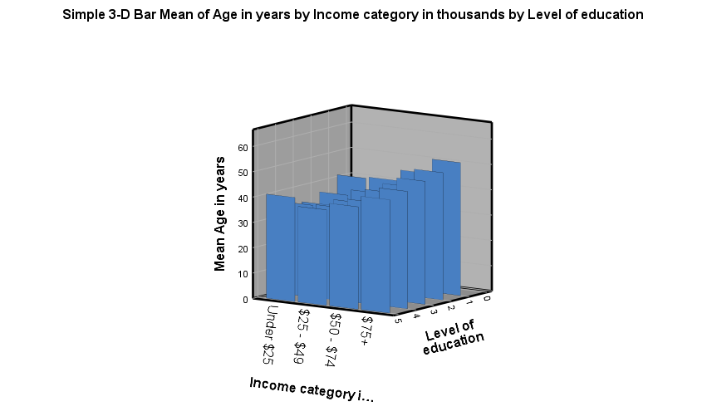

Notes
Output Created |  | 05-SEP-2017 03:08:53
Comments
Input | Data | C:\Program Files\IBM\SPSS\Statistics\Subscription\Samples\English\demo.sav
Input | Active Dataset | DataSet1
Input | Filter | <none>
Input | Weight | <none>
Input | Split File | <none>
Input | N of Rows in Working Data File | 6400
Syntax |  | GGRAPH  /GRAPHDATASET NAME="graphdataset" VARIABLES=age MAXIMUM(owntv)[name="MAXIMUM_owntv"]  MINIMUM(ownfax)[name="MINIMUM_ownfax"] MEAN(news)[name="MEAN_news"] MISSING=LISTWISE  REPORTMISSING=NO  /GRAPHSPEC SOURCE=INLINE.  BEGIN GPL  SOURCE: s=userSource(id("graphdataset"))  DATA: age=col(source(s), name("age"))  DATA: MAXIMUM_owntv=col(source(s), name("MAXIMUM_owntv"))  DATA: MINIMUM_ownfax=col(source(s), name("MINIMUM_ownfax"))  DATA: MEAN_news=col(source(s), name("MEAN_news"))  GUIDE: axis(dim(1), label("Age in years"))  GUIDE: axis(dim(2), label("Maximum(Owns TV), Minimum(Owns fax machine), Mean(Newspaper ",  "subscription)"))  GUIDE: text.title(label("High-Low-Close Maximum of Owns TV,Minimum of Owns fax machine,Mean of ",  "Newspaper subscription..."))  ELEMENT: interval(position(region.spread.range(age*(MINIMUM_ownfax+MAXIMUM_owntv))),  shape(shape.ibeam))  ELEMENT: point(position(age*MEAN_news), shape(shape.circle))  END GPL.
Resources | Processor Time | 00:00:00.64
Resources | Elapsed Time | 00:00:00.75

GGRAPH
/GRAPHDATASET NAME="graphdataset"
VARIABLES=inccat[LEVEL=ordinal] empcat[LEVEL=ordinal] age[LEVEL=scale]
MISSING=LISTWISE REPORTMISSING=NO
/GRAPHSPEC SOURCE=VIZTEMPLATE(NAME="Heat Map"[LOCATION=LOCAL]
MAPPING( "color"="age"[DATASET="graphdataset"] "columns"="inccat"[DATASET="graphdataset"]
"rows"="empcat"[DATASET="graphdataset"]))
VIZSTYLESHEET="Traditional"[LOCATION=LOCAL]
LABEL='HEAT MAP: inccat-empcat-age'
DEFAULTTEMPLATE=NO.

GGraph

Notes
Output Created |  | 05-SEP-2017 03:43:50
Comments
Input | Data | C:\Program Files\IBM\SPSS\Statistics\Subscription\Samples\English\demo.sav
Input | Active Dataset | DataSet1
Input | Filter | <none>
Input | Weight | <none>
Input | Split File | <none>
Input | N of Rows in Working Data File | 6400
Syntax |  | GGRAPH  /GRAPHDATASET NAME="graphdataset"  VARIABLES=inccat[LEVEL=ordinal] empcat[LEVEL=ordinal] age[LEVEL=scale]  MISSING=LISTWISE REPORTMISSING=NO  /GRAPHSPEC SOURCE=VIZTEMPLATE(NAME="Heat Map"[LOCATION=LOCAL]  MAPPING( "color"="age"[DATASET="graphdataset"] "columns"="inccat"[DATASET="graphdataset"]  "rows"="empcat"[DATASET="graphdataset"]))  VIZSTYLESHEET="Traditional"[LOCATION=LOCAL]  LABEL='HEAT MAP: inccat-empcat-age'  DEFAULTTEMPLATE=NO.
Resources | Processor Time | 00:00:03.91
Resources | Elapsed Time | 00:00:03.32

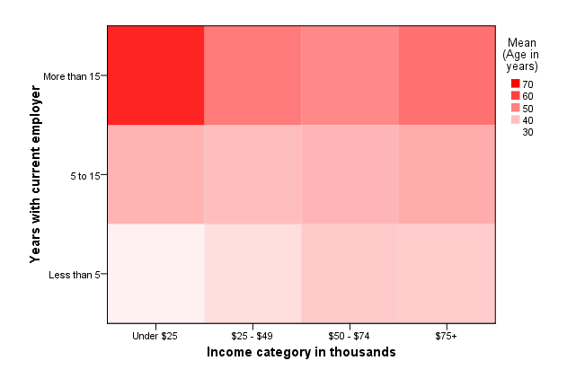

CORRELATIONS
/VARIABLES=age marital ed
/PRINT=TWOTAIL NOSIG
/MISSING=PAIRWISE.

Correlations

Notes
Output Created |  | 05-SEP-2017 03:50:40
Comments
Input | Data | C:\Program Files\IBM\SPSS\Statistics\Subscription\Samples\English\demo.sav
Input | Active Dataset | DataSet1
Input | Filter | <none>
Input | Weight | <none>
Input | Split File | <none>
Input | N of Rows in Working Data File | 6400
Missing Value Handling | Definition of Missing | User-defined missing values are treated as missing.
Missing Value Handling | Cases Used | Statistics for each pair of variables are based on all the cases with valid data for that pair.
Syntax |  | CORRELATIONS  /VARIABLES=age marital ed  /PRINT=TWOTAIL NOSIG  /MISSING=PAIRWISE.
Resources | Processor Time | 00:00:00.03
Resources | Elapsed Time | 00:00:00.12

Correlations
 |  | Age in years | Marital status | Level of education
Age in years | Pearson Correlation | 1 | .003 | -.126**
Age in years | Sig. (2-tailed) |  | .812 | .000
Age in years | N | 6400 | 6400 | 6400
Marital status | Pearson Correlation | .003 | 1 | -.030*
Marital status | Sig. (2-tailed) | .812 |  | .016
Marital status | N | 6400 | 6400 | 6400
Level of education | Pearson Correlation | -.126** | -.030* | 1
Level of education | Sig. (2-tailed) | .000 | .016
Level of education | N | 6400 | 6400 | 6400

**. Correlation is significant at the 0.01 level (2-tailed).
*. Correlation is significant at the 0.05 level (2-tailed).

CORRELATIONS
/VARIABLES=inccat ed internet
/PRINT=TWOTAIL NOSIG
/MISSING=PAIRWISE.

Correlations

Notes
Output Created |  | 05-SEP-2017 03:52:18
Comments
Input | Data | C:\Program Files\IBM\SPSS\Statistics\Subscription\Samples\English\demo.sav
Input | Active Dataset | DataSet1
Input | Filter | <none>
Input | Weight | <none>
Input | Split File | <none>
Input | N of Rows in Working Data File | 6400
Missing Value Handling | Definition of Missing | User-defined missing values are treated as missing.
Missing Value Handling | Cases Used | Statistics for each pair of variables are based on all the cases with valid data for that pair.
Syntax |  | CORRELATIONS  /VARIABLES=inccat ed internet  /PRINT=TWOTAIL NOSIG  /MISSING=PAIRWISE.
Resources | Processor Time | 00:00:00.05
Resources | Elapsed Time | 00:00:00.12

Correlations
 |  | Income category in thousands | Level of education | Internet
Income category in thousands | Pearson Correlation | 1 | .110** | .030*
Income category in thousands | Sig. (2-tailed) |  | .000 | .020
Income category in thousands | N | 6400 | 6400 | 6145
Level of education | Pearson Correlation | .110** | 1 | .339**
Level of education | Sig. (2-tailed) | .000 |  | .000
Level of education | N | 6400 | 6400 | 6145
Internet | Pearson Correlation | .030* | .339** | 1
Internet | Sig. (2-tailed) | .020 | .000
Internet | N | 6145 | 6145 | 6145

**. Correlation is significant at the 0.01 level (2-tailed).
*. Correlation is significant at the 0.05 level (2-tailed).

REGRESSION
/MISSING LISTWISE
/STATISTICS COEFF OUTS R ANOVA
/CRITERIA=PIN(.05) POUT(.10)
/NOORIGIN
/DEPENDENT retire
/METHOD=ENTER age news owntv ownvcr.

Regression

Notes
Output Created |  | 05-SEP-2017 03:58:43
Comments
Input | Data | C:\Program Files\IBM\SPSS\Statistics\Subscription\Samples\English\demo.sav
Input | Active Dataset | DataSet1
Input | Filter | <none>
Input | Weight | <none>
Input | Split File | <none>
Input | N of Rows in Working Data File | 6400
Missing Value Handling | Definition of Missing | User-defined missing values are treated as missing.
Missing Value Handling | Cases Used | Statistics are based on cases with no missing values for any variable used.
Syntax |  | REGRESSION  /MISSING LISTWISE  /STATISTICS COEFF OUTS R ANOVA  /CRITERIA=PIN(.05) POUT(.10)  /NOORIGIN  /DEPENDENT retire  /METHOD=ENTER age news owntv ownvcr.
Resources | Processor Time | 00:00:00.08
Resources | Elapsed Time | 00:00:00.13
Resources | Memory Required | 5040 bytes
Resources | Additional Memory Required for Residual Plots | 0 bytes

Variables Entered/Removedª
Model | Variables Entered | Variables Removed | Method
1 | Owns VCR, Age in years, Newspaper subscription, Owns TV^{b} | . | Enter

a. Dependent Variable: Retired
b. All requested variables entered.

Model Summary
Model | R | R Square | Adjusted R Square | Std. Error of the Estimate
1 | .473ª | .224 | .224 | .189

a. Predictors: (Constant), Owns VCR, Age in years, Newspaper subscription, Owns TV

ANOVAª
Model |  | Sum of Squares | df | Mean Square | F | Sig.
1 | Regression | 65.703 | 4 | 16.426 | 461.774 | .000^{b}
1 | Residual | 227.475 | 6395 | .036
1 | Total | 293.178 | 6399

a. Dependent Variable: Retired
b. Predictors: (Constant), Owns VCR, Age in years, Newspaper subscription, Owns TV

Coefficientsª
Model |  | Unstandardized Coefficients |  | Standardized Coefficients | t | Sig.
 |  | B | Std. Error | Beta | t | Sig.
1 | (Constant) | .154 | .026 |  | 5.871 | .000
1 | Age in years | .007 | .000 | .427 | 37.408 | .000
1 | Newspaper subscription | -.004 | .005 | -.009 | -.794 | .427
1 | Owns TV | -.265 | .025 | -.122 | -10.461 | .000
1 | Owns VCR | -.161 | .013 | -.147 | -12.492 | .000

a. Dependent Variable: Retired

