Cross-chain Center Manual
1. System Start-up
- Open the status page (the default vote list interface)
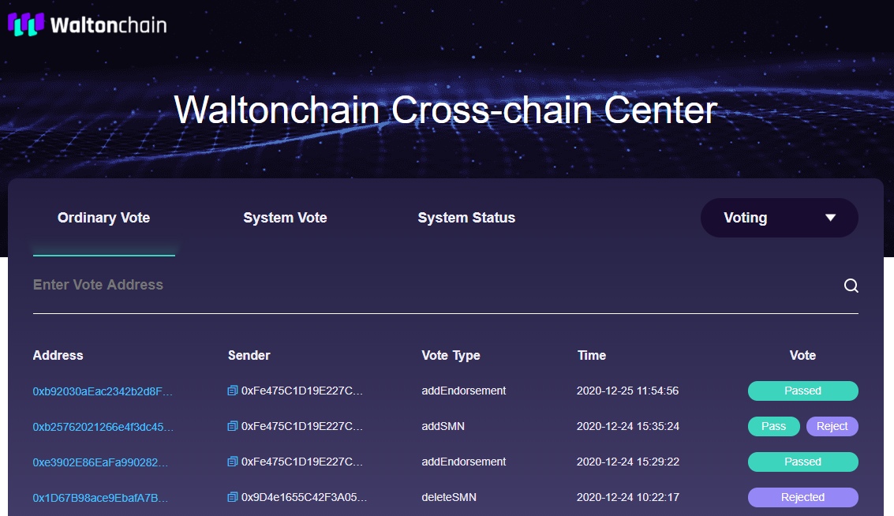
- Select a type in the drop-down menu
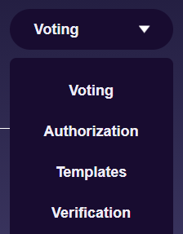
- When the MetaMask window pops up, press Next to proceed
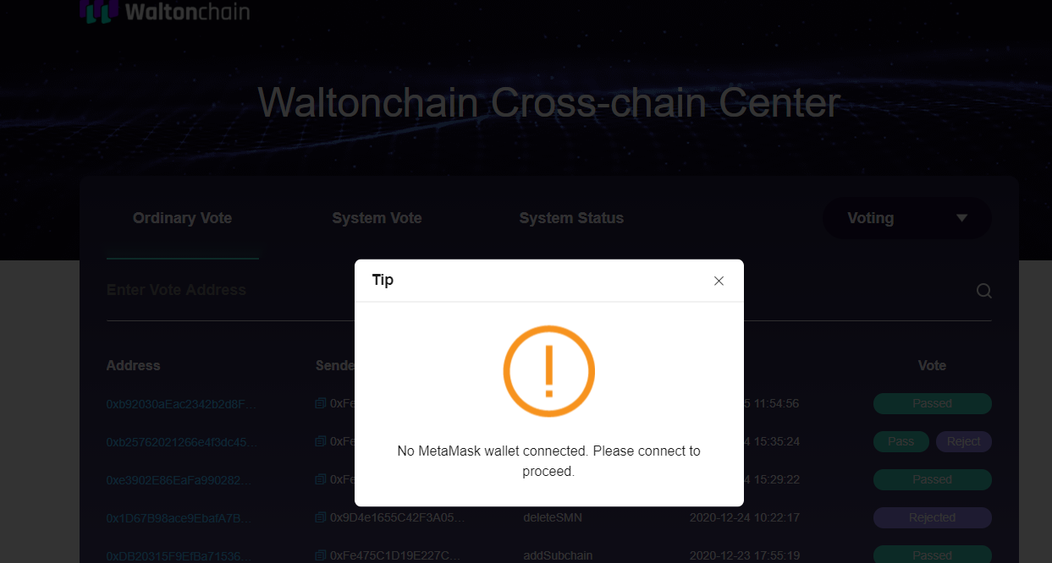
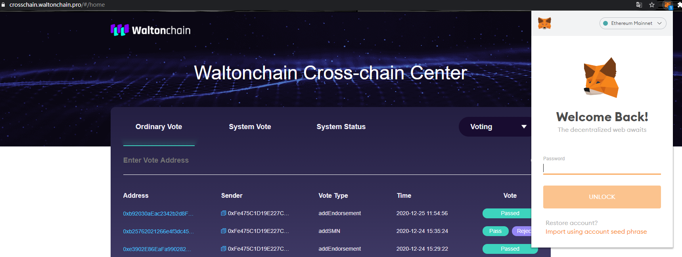
- Go to System Vote and press Pass / Reject to vote
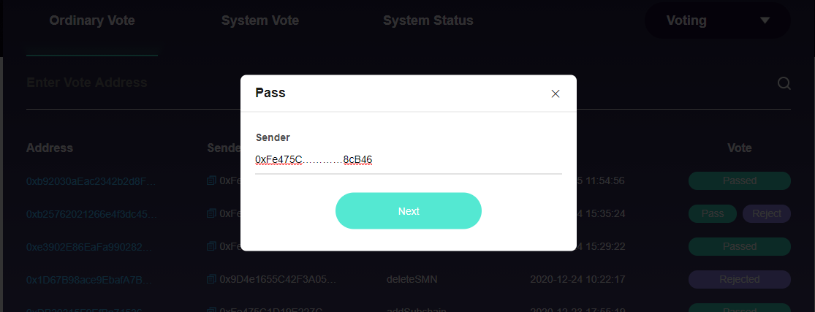
Address verification will happen next. Only JMN / SMN have the right to vote.
2. System Vote (normally available only to JMN / SMN)
- Go to System Vote
- Press the respective button in the Vote column to vote
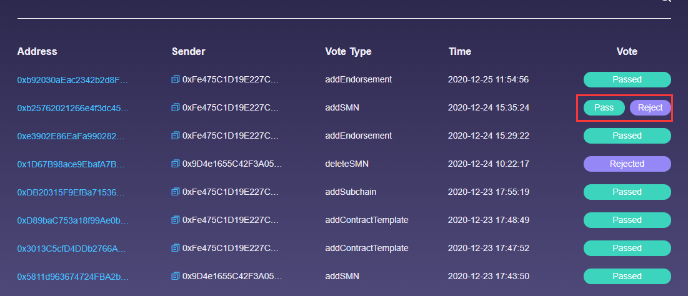
- Provide the sender address in the pop-up window and press Next
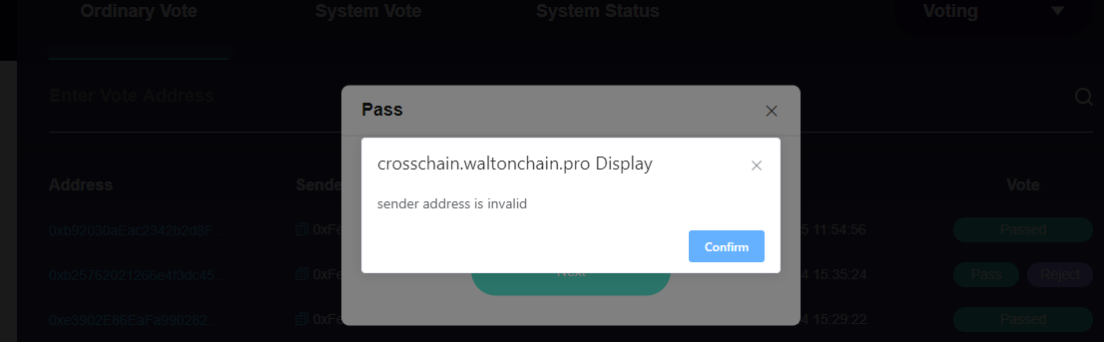
The system will verify your address
- When verification is successful, a MetaMask window will pop up for confirmation, press Next to continue
3. Ordinary Vote
Voting on some events has two stages: Pass and Approve
- Enter the voting interface
- Press the respective button in the Vote column to vote
- Provide the sender address in the pop-up window and press Next
- a MetaMask window will pop up for confirmation, press Next to continue

4. Authorization Management
Permissions include operations on JMN and SMN
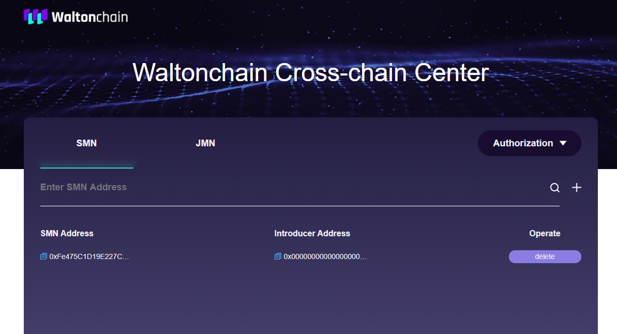
1. View
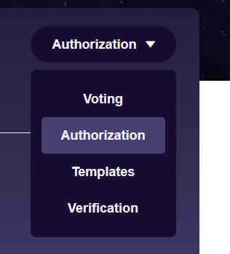
- Enter the Authorization page to see the JMN list and SMN list
2. Add
- Press Add, fill in the approval information in the pop-up window and press Next
- a MetaMask window will pop up for confirmation, press Next to continue
- the proposal becomes effective after it passes the ordinary vote
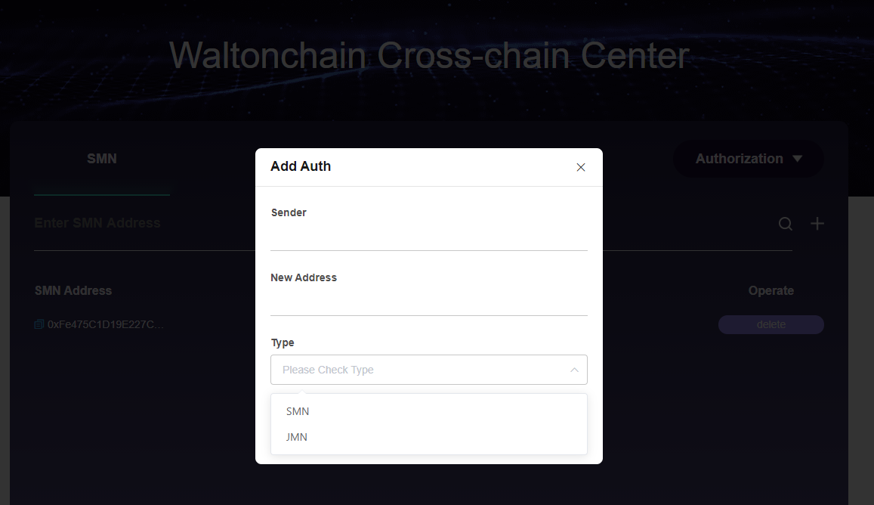
3. Delete
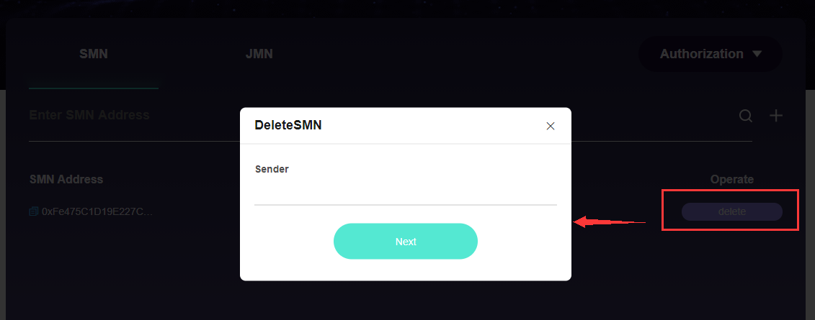
- Press Delete, fill in the approval information in the pop-up window and press Next
- a MetaMask window will pop up for confirmation, press Next to continue
- the proposal becomes effective after it passes the ordinary vote
5. Template Management
Endorsement contract templates serve as examples for deploying endorsement contracts on the parent chain and link endorsement contract with task contracts (if any)
1. View
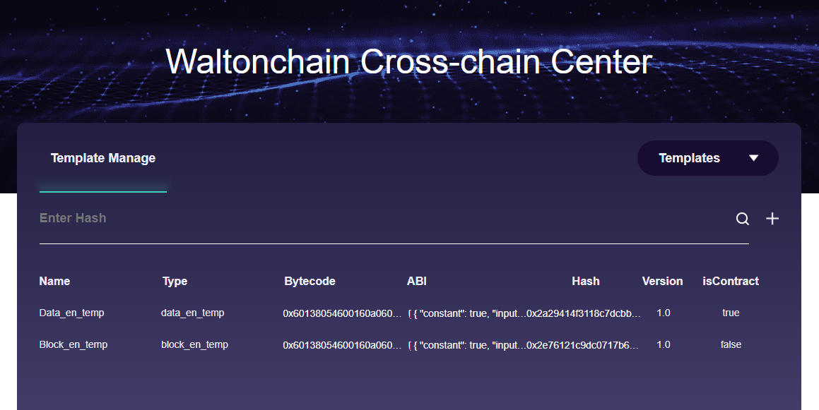
- Open Templates to see the template list
2. Add
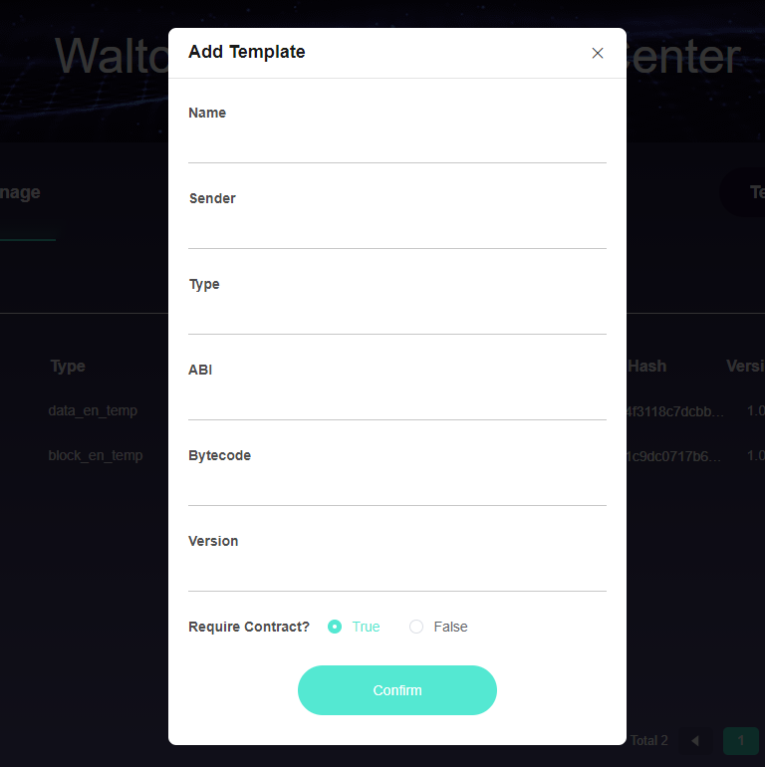
- Press the plus icon on the right, fill in the contract template information in the pop-up window and press Next
- a MetaMask window will pop up for confirmation, press Next to continue
- the proposal becomes effective after it passes the ordinary vote
6. Child Chain Verification System
1. View
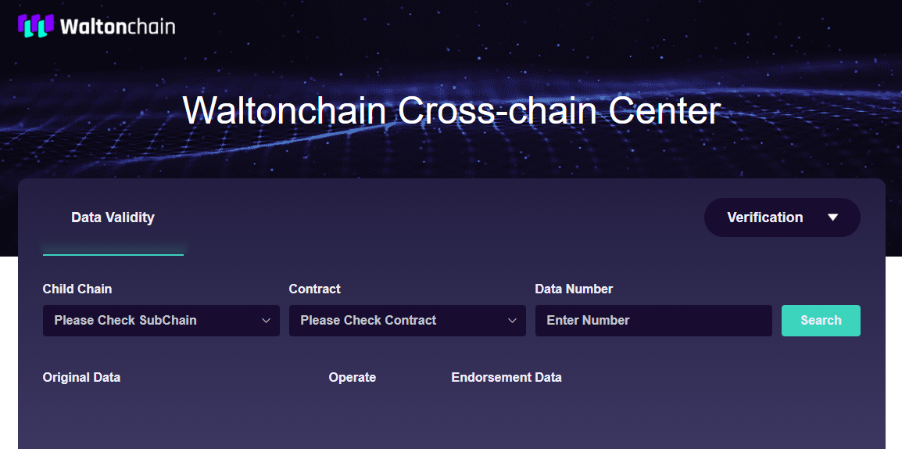
2. Select the Child Chain, Contract and Data Number
- Press Search to see the data list
3. You can verify data entries
- Find a data entry
- Press Verify in the Operate column to see whether the verification result is Success of Fail

Child Chain List
1. Search
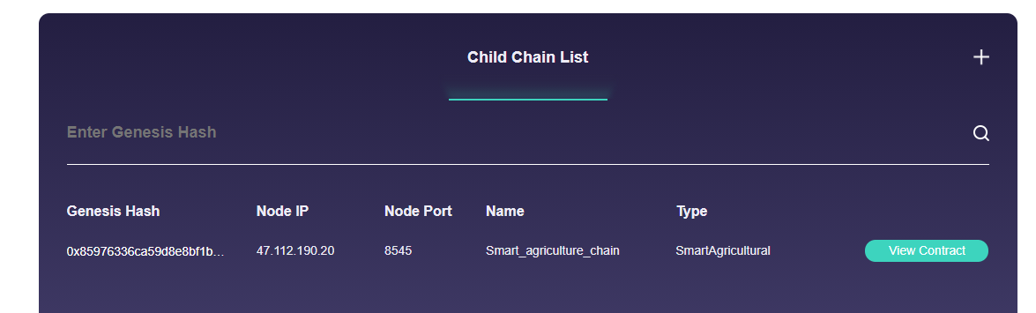
You can view the genesis data
- Select a child chain in the Child Chain List
- Press View Contract next to a child chain to see its respective contracts
2. Verification
View the source endorsement data
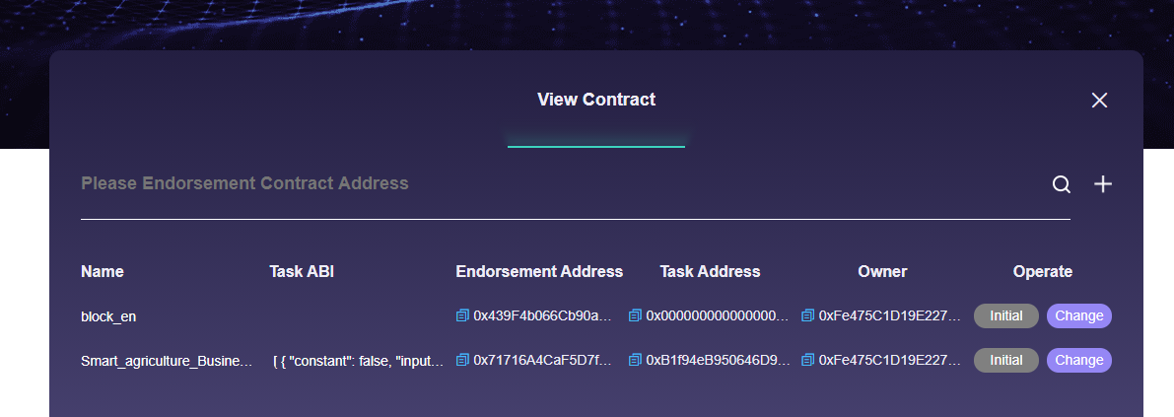
- You can see Name, Task ABI, Endorsement Address, Owner Address etc. of the child chain
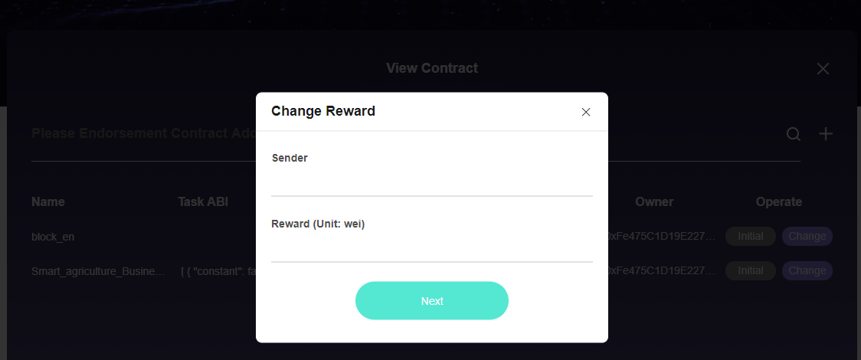
JMN and SMN addresses can edit information.
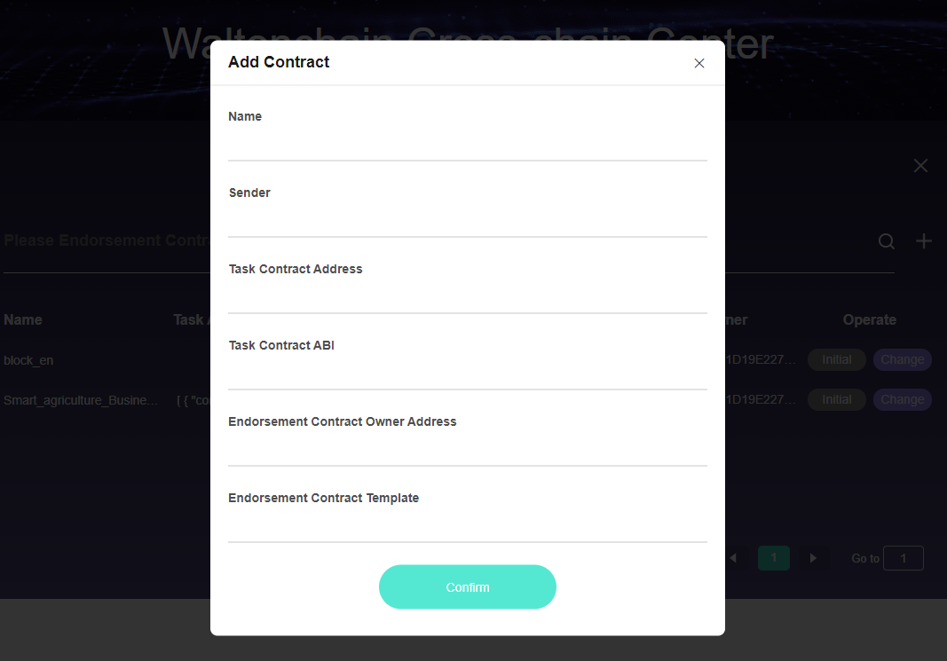
JMN / SMN can add contracts to a child chain. A MetaMask window will pop up for confirmation.

