# RoastNSizzle Financial Report covering Sept - Oct

The business operated at a financial loss of KES (92,470) for the period of Oct 10 to Nov 10, which is a far wider loss than the KES (74,502) recorded in the prior period.

This loss can be attributed to increased new non business expenses involving vehicle maintenance,new car tires and entertainment expenditure which added a cumulative total of KES 15,355 of new expenses.

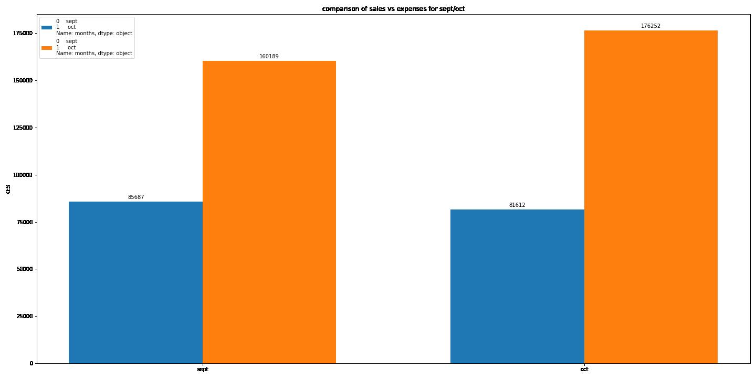

**Orange bars denote Expenses whilst blue bars denote sales**

Recurrent expenditure also increased especially for Fuel,spices,potatoes,labour,packaging and cooking oil which each rose by 67%,62%,52%,543%,45% and 49% respectively.The sharp increase in labour costs (543%) can be directly attributed to the addition of an extra to assist with day to day labour activities,while the (52%) increase in potatoes costs can be directly attributed to increased market prices for the commodity.

The increased costs in some recurrent expenditure items was offset by decreases in some recurrent items including riders,pork,groceries,facebook advertising and buns by 33%,16%,23%,40% and 5% respectively with the reductions in rider costs (33%) being attributed to a new pricing model involving using a flat per km rate (set at 15 KES per km) and adding a multiplier to that of 1.5x resulting in us using a demand based model that is far more beneficial for both parties involved. The reductions in pork (16%),buns (6%) and groceries (23%) can be attributed to us sourcing from cheaper producers on a per unit cost basis, with the decrease in facebook ads (40%) attributed to reduced ad and content creation spending overall.

The decrease in revenue can directly be attributed to reduced marketing spend,thus resulting in fewer client acquisitions than the previous month. On a lighter note we observed an increase in customer reorders from our existing client base with the majority of our sales coming from less than 30% of our established customer base as can be observed from the graphs below.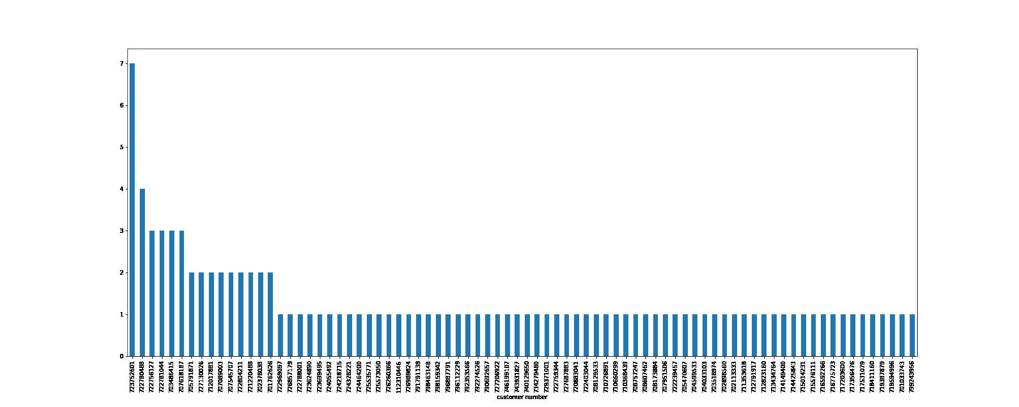

**Month 2 individual customer orders sorted by frequency**

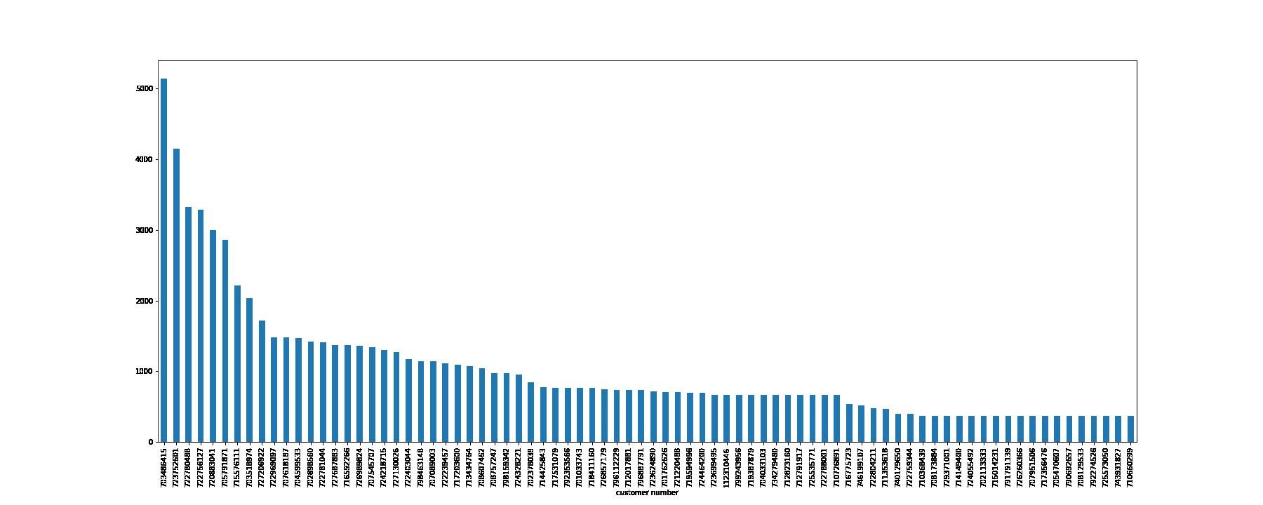

**Month 2 individual customer spend sorted by total spend**