URDF USING ROS2

1. Introduction
This report discusses the application of a URDF (Unified Robot Description Format) model of a robotic system in real-world scenarios. The model is built using ROS2 Foxy and visualized in RVIZ. URDF is a widely used format for describing the physical structure and dynamics of robots, and it enables simulation, visualization, and control in a consistent manner.

2. Overview of the Robot Model
The URDF model includes:
- A detailed description of the robot's links and joints.
- Sensor and actuator definitions.
- Integration with ROS2 for simulation and control.
The model is visualized in RVIZ, which provides a real-time 3D view of the robot and its environment.

3. Real-World Applications
The robot described in this model can be applied in the following real-world scenarios:
- Industrial Automation: The robot can be used in assembly lines for tasks such as picking, placing, and sorting components.
- Healthcare: The model can be adapted for use in robotic surgery or assistive devices for elderly care.
- Search and Rescue: The robot can be deployed in disaster scenarios to navigate through complex environments and locate survivors.
- Agriculture: The robot can be used for precision farming, such as planting, monitoring crops, and harvesting.

4. ROS2 Foxy Integration
ROS2 Foxy provides a robust framework for building and testing robotic systems. The URDF model is used RVIZ for visualization. This integration allows developers to test the robot's behavior in a simulated environment before deployment in real-world scenarios.

Process

Creating base link (Chasis)
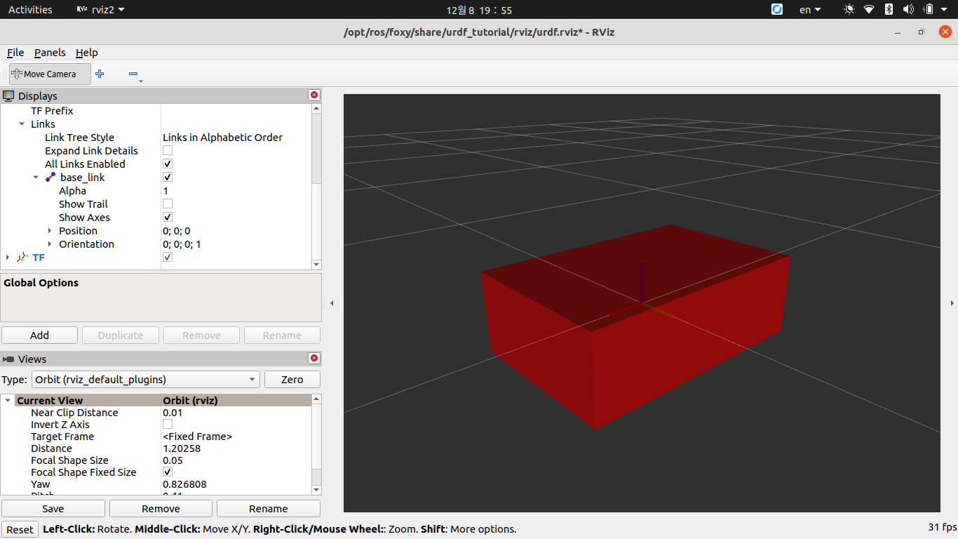
Commands
ros2 launch urdf_tutorial display.launch.py model:=/home/wambura/Desktop/Robotics/urdf/my_robot.urdf

Adding Lidar

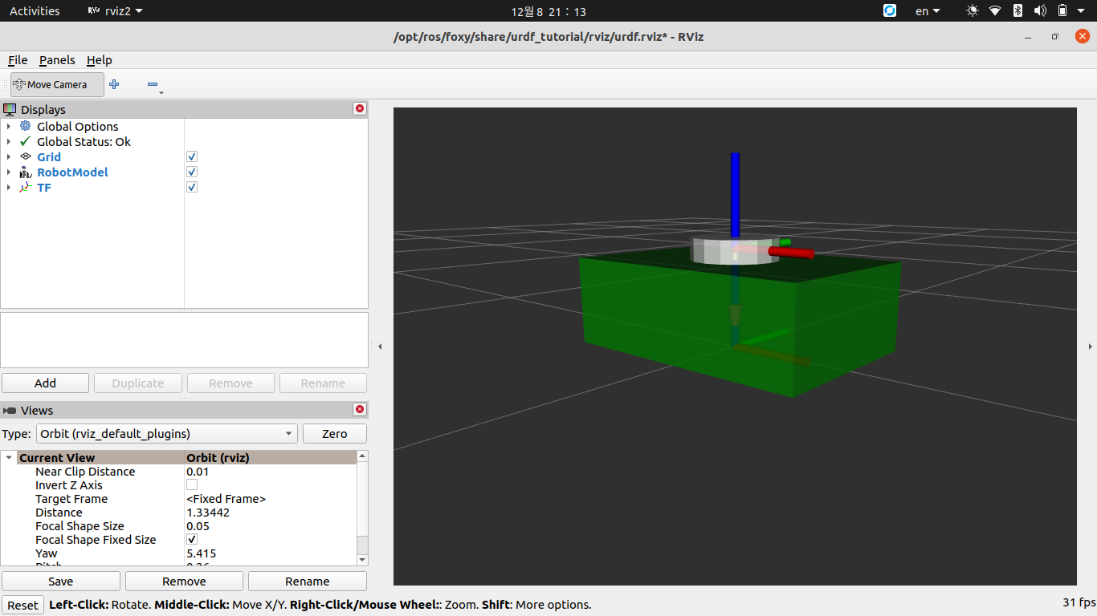

code
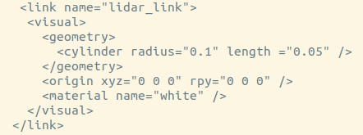

Joints
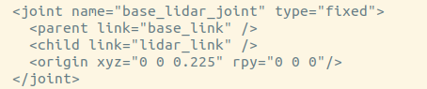

Visualizing frames
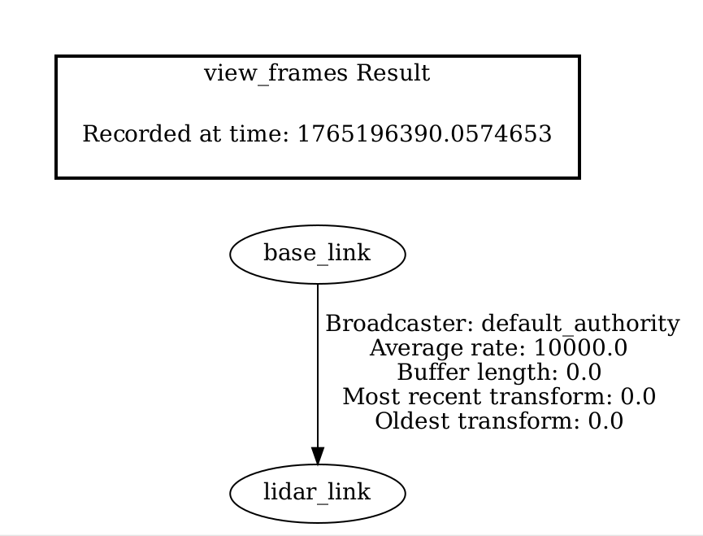
Commands
ros2 run tf2_tools view_frames.py

Adding wheels

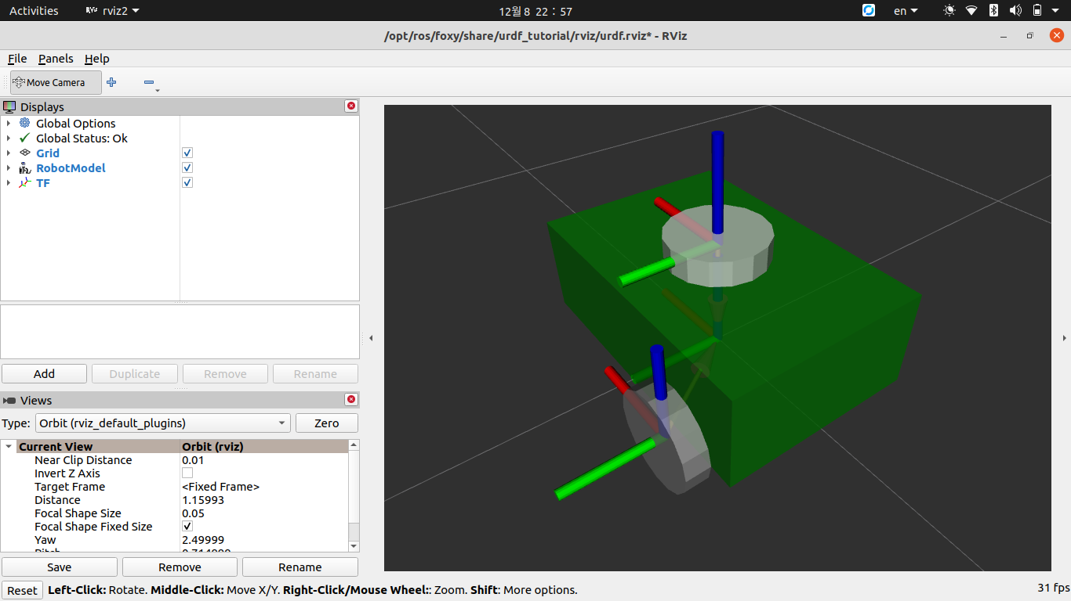
code

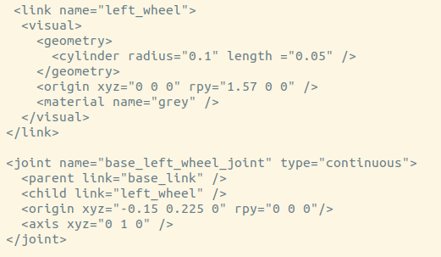

Adding caster wheel

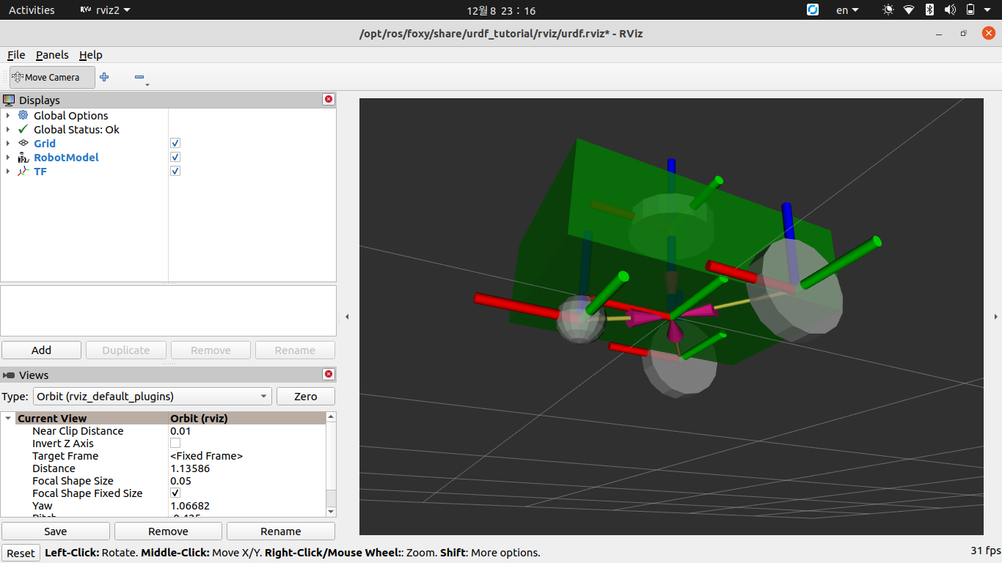
Code

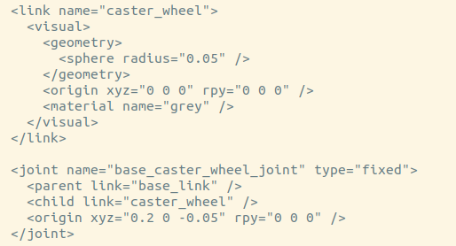

5. Challenges and Considerations
- Sensor Integration: Real-world robots require accurate sensor data, such as LIDAR, cameras, and IMUs.
- Actuator Control: Precise control of the robot's joints is essential for accurate movement and task execution.
- Power and Mobility: The robot must be designed to operate efficiently in real-world environments, which may require advanced power systems and mobility solutions.

6. Conclusion
The URDF-based robot model described in this report demonstrates the potential of ROS2 and RVIZ in simulating and visualizing robotic systems. With proper integration of sensors, actuators, and control systems, this model can be adapted for a wide range of real-world applications.

