Deployment, Testing & Development Log – J123456

Assessment 1

Deployment information
cPanel URL

Git Hub Link
https://github.com/Wameesha-thilakasiri/sea_bubbles

Miro Login
https://miro.com/app/live-embed/uXjVGJJ4PeA=/?embedMode=view_only_without_ui&moveToViewport=1536%2C-674%2C2457%2C1228&embedId=210000600274

UX & Designs

UX & Designs, Heuristics and Web Standards
The website developed is Sea Bubbles, a pirate-themed seaside guest house designed to attract tourists, families, and adventure-seeking travelers. The visual theme combines deep ocean blue backgrounds with gold accent colors to reflect a maritime and treasure-inspired aesthetic. This color scheme was selected to create strong contrast between background and text, improving readability and accessibility while reinforcing the thematic identity.
Initial planning was carried out using Miro wireframes for the Home, About & Gallery, and Contact pages. These wireframes established page hierarchy, navigation placement and content structure before development began. A consistent top navigation bar was used across all pages to support usability and predictability, following the consistency and standards heuristic described by Nielsen’s usability principles.
The layout design follows established UX principles including:
- Consistency and familiarity – identical navigation and footer across pages help users understand how to move through the site.
- Visibility of system status – interactive elements such as buttons and links use hover effects to provide feedback.
- Recognition rather than recall – clear headings and labelled sections allow users to quickly understand page content without needing instructions.
- Aesthetic and minimalist design – pages avoid unnecessary clutter, focusing on essential information and imagery.
The Home page uses a large hero image to create visual impact and guide user attention, supporting the principle of visual hierarchy. The About page includes a responsive gallery grid which displays accommodation images clearly across different screen sizes, improving accessibility and mobile usability. The Contact page places the enquiry form above the map location to prioritize user interaction and task completion.
The website structure and code follow W3C web standards through the use of semantic HTML elements (header, nav, main, section, footer), external CSS styling, and accessibility features such as alt text for images and labelled form inputs. Validation tools confirmed that the HTML, CSS and accessibility checks passed without errors, demonstrating compliance with WCAG Level A accessibility requirements.
Assets used in the project include AI-generated guest house images created using Microsoft Copilot for educational purposes, and an embedded Google Maps location to demonstrate geographical context. All external assets and tools have been referenced in APA 7th format in the references section.
Overall, the design decisions ensure the website is visually appealing, easy to navigate, accessible to users, and aligned with recognized UX theory and modern web design standards.
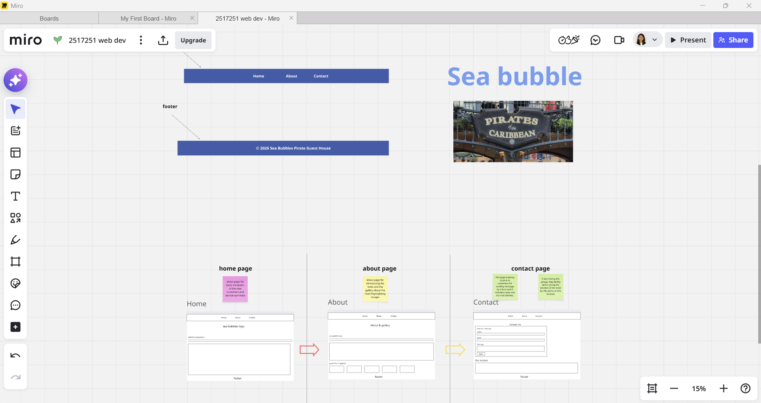
Figure 1: Miro Planning Board

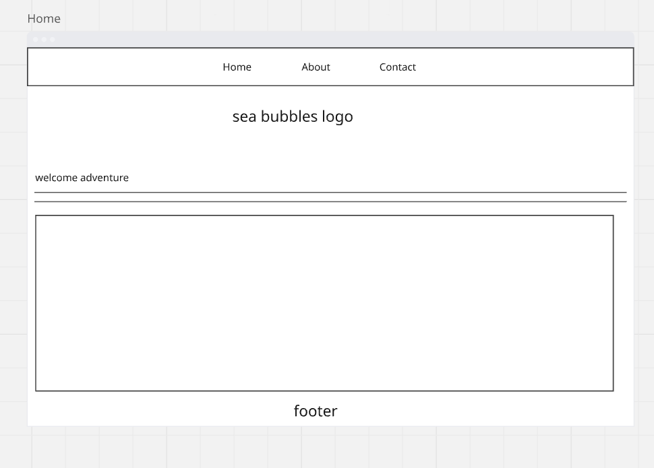
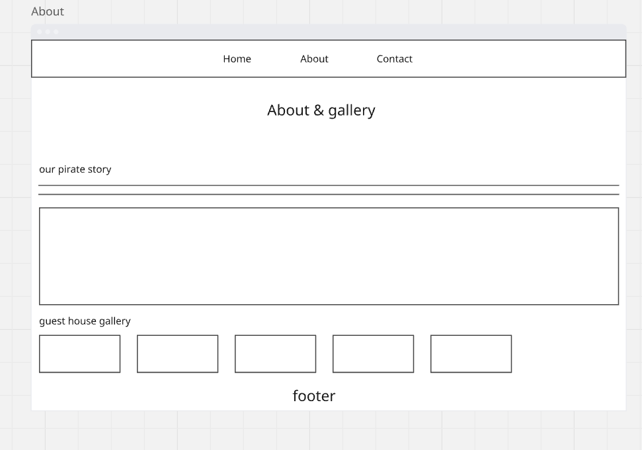
Figure 2: Home Page Wireframe

Figure 3: About Page Wireframe
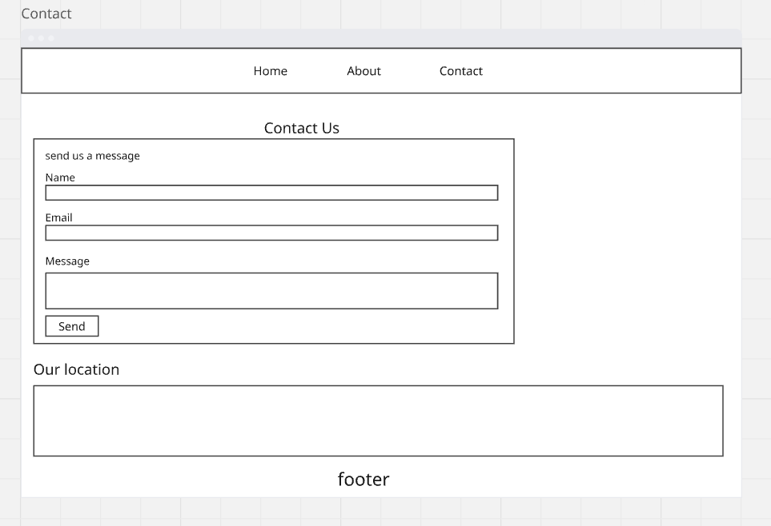
Figure 4: Contact Page Wireframe

Sprints

Sprint 1

Cycle Overview
In Sprint 1, I focused on setting up everything needed for the project.
I installed Visual Studio 2022, created my project folders in OneDrive, and set up a private GitHub repository.
I also added my tutor as a collaborator.
After that, I created a Miro board to collect my ideas and started thinking about the theme and layout of my pirate-themed guest house website.
I also looked at WCAG accessibility guidelines and basic UX principles so I could design the site in a user-friendly way.

Things Working Well
• Visual Studio installed and worked without issues.
• Miro board helped me organize ideas clearly.
• I was able to decide on my website theme early

Things That Could be Improved
• GitHub repository created and but didn’t linked successfully
• Trying to add tutor to repository.
• I should plan my time better for research and setup
• I could write down links and passwords earlier to stay organized
• I need to explore more website examples before deciding layouts

Testing
I checked that Visual Studio opened correctly and saved files properly. I confirmed that GitHub syncing worked and that my tutor had access. I also tested saving files in OneDrive to make sure backups were working.
Backlog Items | Completed/Not Complete
Install visual studio.  Create git hub repository  add tutor collaborator  create Miro board  research UX & WCAG  Finalised detailed layouts | Completed  Not completed  Not completed  Completed  Completed  Completed

Sprint 2

Cycle Overview
During Sprint 2, I started designing the website structure. I created wireframes for my three pages: Home, About/Gallery, and Contact. I also created a UML Use Case diagram to show how users would interact with the website. I selected colours, fonts, and a pirate-style theme to match the guest house idea. I generated themed images and saved them in my project folder. At the same time, I researched HTML and CSS on W3Schools to prepare for building the pages.

Things Working Well
• Wireframes helped me clearly see the page layouts
• I successfully chose colors and fonts for the theme
• Images were created and saved correctly

Things That Could be Improved
• Some layout ideas changed later during coding
• I could label my wireframes more clearly
• I should double-check color contrast earlier for accessibility

Testing
I reviewed my wireframes against UX principles and checked that my colour choices were readable. I also confirmed that all images were saved correctly and ready to use.
Backlog Items | Completed/Not Complete
Create wireframes.  choose color themes  generate images  research html /css | completed  completed  completed  completed

Sprint 3

Cycle Overview
In Sprint 3, I began developing the website using HTML and CSS. I created the three pages and added a navigation bar, header, and footer so that the design stayed consistent across the whole site. I applied the pirate-style colours and fonts and added my images and text content. I worked on each page step by step to make sure the structure and layout matched my wireframes.

Things Working Well
• All three pages were created successfully
• Navigation links worked correctly
• The layout stayed consistent across pages
• Images displayed properly
• The theme looked visually clear and attractive

Things That Could be Improved
• Some spacing and alignment needed adjusting
• Image sizes could be optimized for faster loading
• I had to correct a few small layout mistakes

Testing
I tested the navigation links between pages, checked that images loaded correctly, and reviewed the layout in different browser window sizes to ensure consistency.
Backlog Items | Completed/Not Complete
Create HTML pages  Add CSS styling  Add navigation  Insert images/content  Improve responsiveness | completed  completed  completed  completed  not complete

Sprint 4

Cycle Overview
During Sprint 4, I added JavaScript and tested how the website worked. I created a contact form with validation and embedded a Google Map to show the location. I then tested the website using usability principles and checked that all links, images, and features worked properly. I also used validators to check for HTML and CSS errors and fixed any problems I found.

Things Working Well
• Contact form validation worked correctly
• Map embedded successfully
• Navigation and images functioned properly
• Testing helped identify small issues early

Things That Could be Improved
• I needed to fix a small frame validation warning in CSS
• Accessibility could still be improved slightly.
• Form messages could be clearer for users

Testing
I tested the contact form, checked navigation links, validated HTML and CSS, and reviewed accessibility issues. After fixing errors, I retested the pages to confirm they worked correctly.
Backlog Items | Completed/Not Complete
Add JavaScript validation  Embed map  Run validators  fix validation errors  accessibility improvements | Completed  Completed  Completed  Completed  Completed

Sprint 5

Cycle Overview
In Sprint 5, I completed the final testing and prepared everything for submission. I refined the layout, checked the website again for errors, and validated the HTML and CSS successfully. I then deployed the website to the test server using cPanel and tested the live version to make sure everything worked online. Finally, I updated my development log, added links, and prepared the project for submission.

Things Working Well
• Website deployed successfully to the server
• All pages worked correctly online
• Validation passed successfully
• Documentation completed

Things That Could be Improved
• Images could be compressed further for performance
• More user feedback testing could be done
• Accessibility testing could be expanded

Testing
I tested the live website, checked navigation and images, reran validators, and confirmed the contact form worked correctly after deployment.
Backlog Items | Completed/Not Complete
Final texting  fix layout issues | Completed  Completed

Testing
My website https://123456.win.studentwebserver.co.uk
Create your own test cases and use the validators.
Test Case | Outcome | Recommendations | Date
Nav Bar | PASS | No action needed. Navigation works consistently across all pages | 19/02/26
Home Page Link | PASS | Page loads well. Could optimise images slightly for faster loading. | 19/02/26
Contact Page | PASS | Page loads correctly and form functions as expected. No further action required. | 19/02/16
Buy Button | FAIL | Buy button was not included in the design. Feature removed from requirements as booking is via contact form instead. | 19/02/26
HTML Validator | FAIL | Initial errors fixed (iframe width moved to CSS, minor tag corrections). Now validates successfully. | 21/02/26
CSS Validator | PASS | No significant issues found. Styling validated successfully. | 21/02/26
Accessibility Validator | PASS | Added alt text to images and ensured form labels are clear. Minor contrast improvements made. | 22/02/25

References W3Schools. (n.d.). HTML tutorial. Retrieved February 22, 2026, from https://www.w3schools.com/html/
W3Schools. (n.d.). CSS tutorial. Retrieved February 22, 2026, from https://www.w3schools.com/css/
W3Schools. (n.d.). JavaScript tutorial. Retrieved February 22, 2026, from https://www.w3schools.com/js/
Google. (n.d.). Google Maps. Retrieved February 22, 2026, from https://maps.google.com/
World Wide Web Consortium (W3C). (n.d.). Web Content Accessibility Guidelines (WCAG) Overview. Retrieved February 22, 2026, from https://www.w3.org/WAI/standards-guidelines/wcag/
Nielsen Norman Group. (n.d.). 10 usability heuristics for user interface design. Retrieved February 22, 2026, from https://www.nngroup.com/articles/ten-usability-heuristics/
Microsoft. (n.d.). Visual Studio documentation. Retrieved February 22, 2026, from https://learn.microsoft.com/visualstudio/
GitHub, Inc. (n.d.). GitHub documentation. Retrieved February 22, 2026, from https://docs.github.com/
Microsoft. (2024). Microsoft Copilot. AI-generated images and assistance used in this project.

