‘I acknowledge that this work is my own. I used Perplexity Pro( https://www.perplexity.ai/ ) to assist with summarizing my initial notes, refining the structure of my report and proofreading my final draft. The optimization modelling, analysis, and conclusions presented are my own.’
• Perplexity Pro
• https://www.perplexity.ai/
• Used to summarize the initial notes and create a presentable structure while also proofreading.
• The work was completely done by me.

Wamiq Chishti
Student Number 259586881
Word count – 2056
MN50750 - Optimisation & Spreadsheet Modelling
Coursework Assignment II - Building a Decision Support System for the Great Western Railway.

SUMMARY
Great Western Railway (GWR) faces significant operational challenges due to fluctuating passenger demand during peak events such as festivals, sporting matches, and holidays. To address this, HoptimaL Consulting has developed a Decision Support System designed to optimize train allocation across the GWR network.
This report outlines the development and functionality of the Decision Support System, which utilizes the Ford-Fulkerson algorithm to calculate the maximum flow of trains between any two stations in the network. The system was tested across five distinct route scenarios, successfully identifying capacity bottlenecks and optimal train frequencies. While the tool successfully models the 34 major stations and 88 rail segments, the report also highlights current limitations specifically regarding the user interface and proposes future enhancements to transform this prototype into a fully deployable mobile application.
BACKGROUND
Railway operators like GWR face sudden spikes in passenger demand at predictable events (sports matches, festivals, holiday weekends) and unpredictable ones (disruptions, special charters). Managing these spikes requires fast decisions about how many trains can be sent from one station to another and which track segments will carry those trains without exceeding capacity. The coursework brief provided a reduced GWR network of 34 major stations and 88 directed rail segments, with capacities for each segment; the task was to build a simple tool that uses that network to compute maximum routable trains between any chosen origin and destination. The tool’s objective is to support route managers with clear, actionable numbers and to highlight the network segments that create constraints.

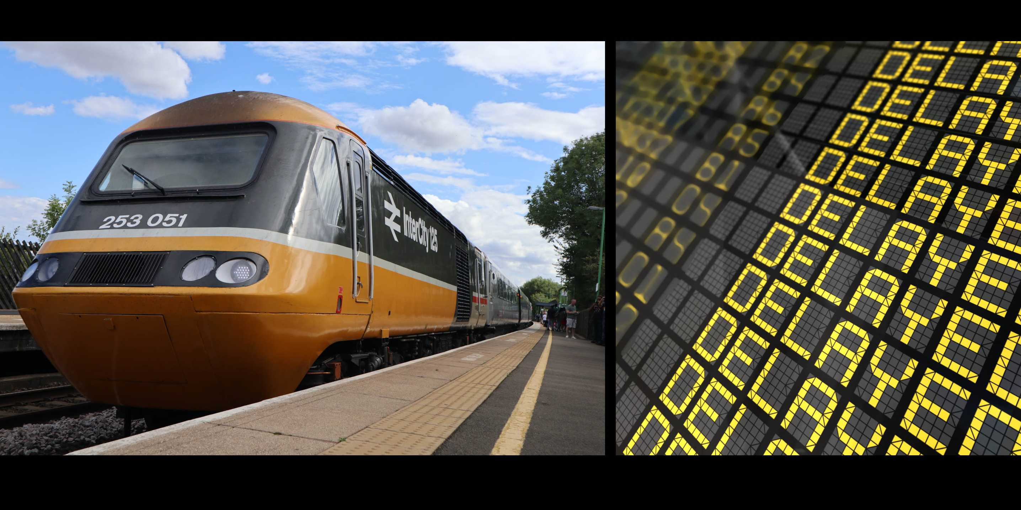
DECISION SUPPORT SYSTEM
The Decision support system or DSS is built within Excel, and it uses the Visual Basic Calculation or VBA to perform the complex calculations while making sure that the front end remains accessible to a non-technical audience. The system focuses on a reduced network of 34 major stations and 88 directional rail segments.
USER INTERFACE
The interface was designed with simplicity in mind, allowing quick inputs and resetting of data.
- Input Mechanism: Users interact primarily with the "Stations" sheet. Here, the user defines the journey by inputting the Origin Station ID and the Destination Station ID.

- Data Management: A Reset function allows the user to clear previous simulations instantly, ensuring no data overlaps between trials. The Reset Data button clears all flows from the previous run and restores residual capacities to their original values, so the user can immediately test a new origin–destination pair without reloading the entire workbook. The Clear Results button removes the previous trial's output from the Optimal flows sheet.

- Output Display: Results are generated on the Optimal flows sheet. This dashboard presents a clear list of every rail segment involved in the solution, the number of trains (flow) assigned to that segment, and the segment's maximum capacity.

USABILITY/HOW TO USE

- Open the Application: Launch the EXCEL file.
- Identify Stations: Consult the "Stations" list to find the ID numbers for the desired start and end points (e.g., Southampton Central is 26, Brighton is 31).
- Input Route: Enter these IDs into the designated cells on the "Stations" sheet (F2, F3).
- Load The Network: Press the “load data” button, a message box will confirm that station and rail segment data has been loaded into the system.
- Run Simulation: Click the "Run Algorithm" button. The system processes the network logic in the background.
- View Detailed Results: Click OK on the message box and switch to the “Optimal flows” sheet to view the maximum number of trains that can be scheduled and the specific path they should take.
- Reset For Next Trial: To run a new origin destination pair, click the "Clear data" button on the Stations sheet. This clears all previous flows and residual capacities in memory, preparing the model for a fresh calculation without affecting the base network data. Click “Reset Data” to clear flows and prepare the model for a fresh run. Enter new ID’s in F2 and F3.

LOGIC BEHIND THE MODEL
To solve this problem, we implemented the FORD-FAULKERSON algorithm. This is a model that is used in operations research to determine the maximum flow in a flow network.

The Algorithm in Practice
The algorithm works by iteratively finding a valid path from the Origin to the Destination that still has unused capacity.
- It searches for a path where every segment has at least 1 unit of spare capacity.
- If a path is found, it sends the maximum possible number of trains down that path (limited by the bottleneck segment with the lowest capacity).
- It updates the residual capacity (remaining space) of those segments.
- It repeats the search until no more paths can be found.
- The sum of flows sent across all paths is the Maximum Flow.
This ensures that the solution provided to GWR is mathematically proven to be the highest possible throughput the infrastructure can support.

TRIAL RESULTS
To validate the tool and demonstrate its value to GWR, five distinct trials were conducted using different Origin-Destination pairs. These scenarios cover various regions of the GWR network to test robustness.
Trial 1: The South Coast Route
- Origin: Southampton Central (ID: 26)
- Destination: Brighton (ID: 31)
- Context: A high-traffic route often used by holidaymakers and commuters along the coast.
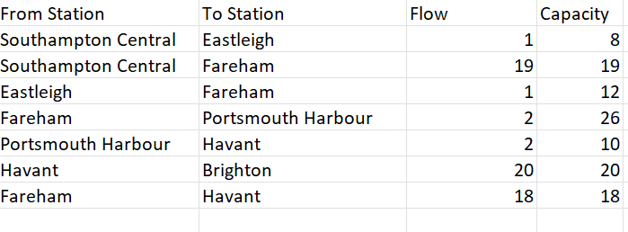
Table 1- SOUTHAMPTON CENTRAL TO BRIGHTON
- Total Max Flow: 20 Trains per day.
- Insight: The link between Havant and Brighton is fully saturated. To increase services to Brighton, GWR would need to upgrade the physical track capacity on this specific final leg.
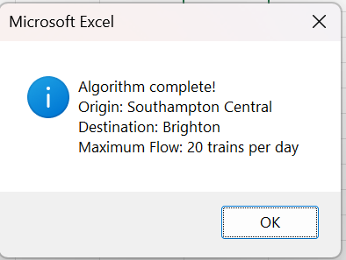
Figure 1: Southampton Central to Brighton Max Flow

Trial 2: Swansea to Bristol Temple Meads
- Origin: Swansea (ID: 1)
- Destination: Bristol Temple Meads (ID: 5)
- Maximum Flow: 20 trains per day.
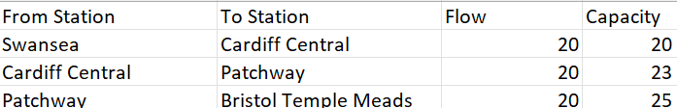
Table 2- SWANSEA TO BRISTOL TEMPLE MEADS

Analysis: This trial represents a heavy-duty mainline flow.
The bottleneck is identified immediately at the start of the journey: the Swansea to Cardiff Central segment. Even though later segments like Patchway to Bristol Temple Meads have a capacity of 25, the entire route is limited by the 20 train capacity at the Welsh origin.
For GWR, this highlights that adding more carriages or tracks near Bristol will not increase Swansea originating capacity unless the Swansea to Cardiff leg is upgraded.

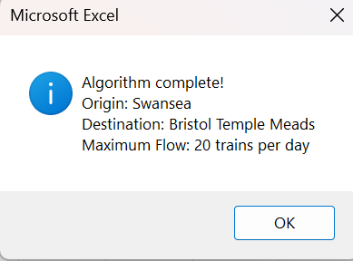
Figure 2: Max flow from Swansea to Bristol Temple Meads

Trial 3: Plymouth to Exeter St Davids
- Origin: Plymouth (ID: 21)
- Destination: Exeter St Davids (ID: 18)
- Maximum Flow: 27 trains per day.
Analysis: In the Southwest peninsula, the network is more linear. The system finds that the bottleneck is the final leg into Exeter St Davids, which can only handle 27 trains per day. Although Plymouth can send 28 trains to Newton Abbot, the 27-train limit into Exeter dictates the result
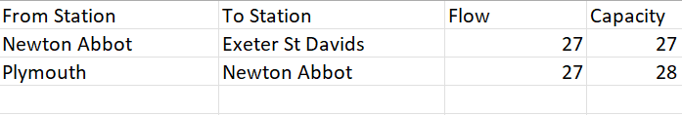
Table 3- PLYMOUTH TO EXETER ST DAVIDS

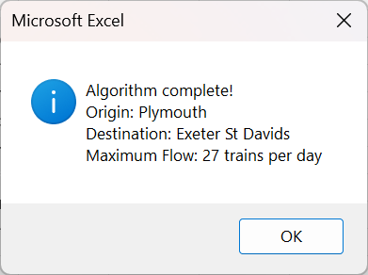
Figure 3: Plymouth to Exeter St Davids Max Flow

Trial 4: Reading to London Paddington
- Origin: Reading (ID: 15)
- Destination: London Paddington (ID: 16)
- Calculated Maximum Flow: 56 trains per day.
Analysis: This trial tests the highest-capacity segment in the model. The tool confirms a direct maximum flow of 56. This scenario is simple but validates that the Decision support system can scale to high put commuter links without error.
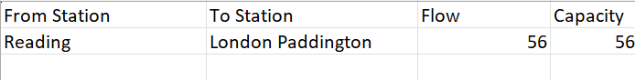
Table 4-READING TO LONDON PADDINGTON

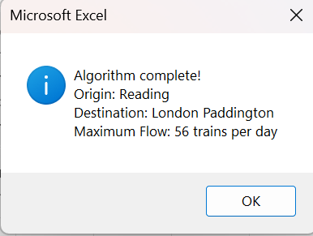
Figure 4: Reading to London Paddington Max Flow

Trial 5: Bath Spa to Oxford
- Origin: Bath Spa (ID: 6)
- Destination: Oxford (ID: 12)
- Maximum Flow: 51 trains per day.
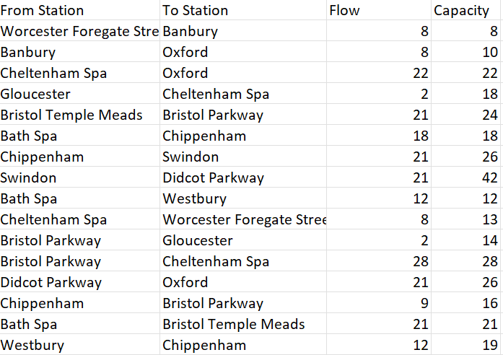
Table 5- BATH SPA TO OXFORD

Analysis: This is the most complex scenario, demonstrating the DSS's power to coordinate multiple overlapping paths. To reach Oxford, the system uses three primary "arteries":
- Directly through Chippenham and Swindon.
- Routing south through Westbury and then back up.
- Routing west into Bristol Temple Meads and Bristol Parkway before heading north.
The tool manages to push 51 trains by utilizing nearly every available track in the Wiltshire and Gloucestershire area. Notably, the Bath Spa to Bristol Temple Meads segment is saturated at (21/21), as is the Bath Spa to Chippenham segment (18/18).
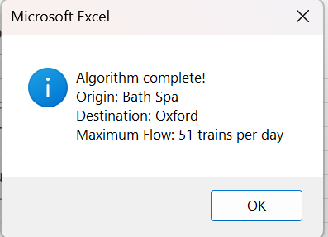
Figure 5: Bath Spa to Oxford Max flow

Business Case: Evaluation and Recommendations

Strengths of the Approach
- Precision and Optimization: Unlike manual scheduling, which may overlook complex secondary paths (like the "Bath to Oxford" bypass through Westbury), the DSS ensures that every unit of capacity is utilized.
- Transparency for Stakeholders: By displaying the "Flow" next to "Capacity" for every segment, the tool provides immediate visual evidence to route managers of why they cannot schedule more trains. This is essential for justifying service limitations to the public or the CEO.
- Adaptability: The inclusion of data storage and reset functions means this is not a static report, but a living tool. If a landslide closes the line near Exeter (reducing capacity to 0), a manager can update the spreadsheet and re-solve the network in seconds.
Assumptions Made
To create a functional pilot, several simplifying assumptions were necessary:
- Uniform Train Types: The model assumes all trains are identical. It does not distinguish between a 10-carriage high-speed train and a 2-carriage regional shuttle, though both occupy capacity differently.
- Directional Independence: While the network has 88 segments (44 in each direction), the model assumes that flow in one direction does not affect the capacity of the opposing direction.
- Time-Agnoticism: The Capacity is treated as a daily total. It does not account for the timing of trains; it assumes if a path is available at some point in the day, it can be used, ignoring the complexities of platform occupancy or peak-hour scheduling.
Limitations and Risks

- The ID Barrier: Currently, the system requires Node IDs (1-34). For a mobile app or a busy manager, this is a friction point. Future versions should include a name-based lookup system.
- Absence of Cost/Profitability: The Ford Fulkerson algorithm only maximizes volume. It might suggest a route that is 200 miles long just to fit one extra train, which might be financially ruinous or logistically impossible for crew scheduling.
- Network: The 34 station model is an excellent pilot but excludes hundreds of smaller stations. Expanding the network could significantly increase the Num Links variable, potentially slowing down the calculation if not managed efficiently.

Recommendations for Great Western Railway
The development of this Decision Support System (DSS) provides a foundation for more agile and data-driven scheduling. To move from the current pilot phase to a fully operational deployment, the following recommendations are proposed:
- Targeted Bottleneck Management: GWR should use the DSS outputs from Trial 1 (South Coast) and Trial 3 (Bath to Oxford) to identify saturation points. For instance, since the Havant to Brighton link is a recurring bottleneck, management should prioritize this specific segment for maintenance schedules during off-peak hours to ensure 100% reliability during peak demand spikes.
- Event Based Contingency Planning: Before major events route managers should run the DSS. As shown in the Bath Spa to Oxford trial, the model can identify non-obvious southern or western loops that can absorb overflow when the primary direct lines are at capacity.
- Capacity Expansion: GWR should use data to prioritize capital expenditure. Infrastructure upgrades should be focused exclusively on segments that consistently show saturation across multiple trials (e.g., Swansea to Cardiff). Expanding capacity for segments that already have high saturation is an inefficient use of capital.
- Dynamic Maintenance Scheduling: By integrating this tool with real-time maintenance logs, GWR can simulate the "Network Impact" of closing a specific track. If the DSS shows that a specific closure reduces the total network flow by more than 30%, the maintenance should be rescheduled.

Conclusion
The Decision Support System developed for Great Western Railway successfully fulfills the core requirement, providing a reliable, mathematically sound calculation of maximum network flow. The trials conducted ranging from the 20 train bottleneck between Swansea and Cardiff to the 56 train commuter flow into London demonstrate that the tool is ready for pilot use by GWR route managers.
For Mrs. Railsworth and HoptimaL Consulting, this tool is of high value as it demonstrates how complex algorithms can be packaged into accessible formats. Moving forward, integrating these results with cost-benefit analysis and a more refined user interface will transform this spreadsheet from a planning aid into a critical piece of GWR’s operational infrastructure.

