SuiteStay Singapore
Identifying the Premium Business Travel Gap in Singapore's Short-Stay Accommodation Market
Analytics in Practice | University of Bath | April 2026

Executive Summary
Singapore received 3.4 million business and MICE visitors in 2023, representing 25% of all international arrivals. Despite this strong demand, the premium Airbnb short-stay market fails to serve corporate travellers in three critical ways: 47% of premium entire-home listings impose minimum stays that exclude the typical three to five night trip, large portfolio operators dominate supply and generate persistent noise and cleanliness complaints, and only 37.8% of premium listings offer self check-in. Premium listings record just 14.2% estimated annual occupancy against a 76% hotel benchmark, pointing to unmet demand rather than low supply.
SuiteStay Singapore proposes a professionally managed entire-home service targeting high-income solo business travellers in Singapore's CBD corridor, priced at SGD 200–350 per night. The service guarantees one to five night flexible bookings, verified soundproofing, hotel-grade cleaning, a dedicated workspace, and 24-hour smart-lock check-in across every unit — directly addressing each failure point identified in the data.

1. Introduction
Singapore is Asia Pacific's leading business travel destination, hosting 3.4 million business and MICE visitors in 2023, anchored by high-profile recurring events including the Formula 1 Grand Prix, the Singapore Fintech Festival, and major regional corporate gatherings (STB, 2023). Figure 1 illustrates the scale of this demand relative to leisure and other visitor segments.
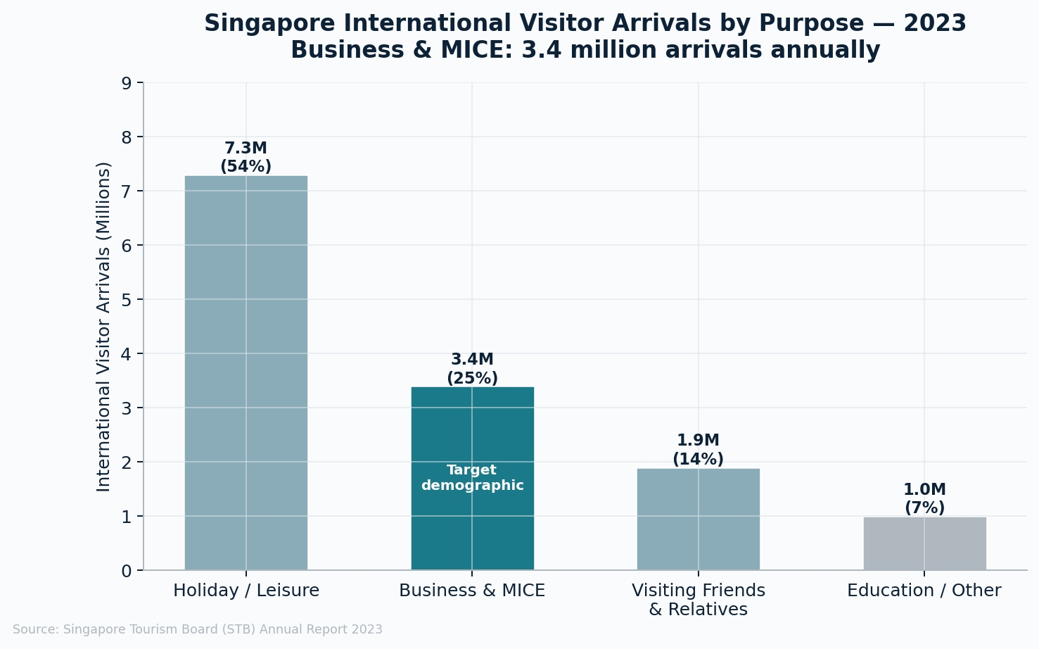
Figure 1: Singapore international visitor arrivals by purpose, 2023. Source: Singapore Tourism Board Annual Report 2023.
Existing accommodation options leave a clear gap for this segment. Hotels provide consistency and short stays but lack apartment-scale space. Serviced apartments offer quality but require long minimum stays. Airbnb appears to bridge the two, but the data in this report shows that much of its premium supply is inaccessible or unsuitable for corporate travel. The purpose of this report is to quantify that gap and set out a targeted service response.

2. Empathy Map
The target user, Marcus Chen, is a high-income regional sales director who visits Singapore four to six times annually for three to five nights. He says he needs reliable WiFi, a proper desk, and seamless late-night check-in. He thinks Airbnb is a gamble, and that he would pay more for certainty because accommodation failure carries professional consequences. He reads reviews carefully, prioritises CBD proximity, and needs flexible cancellation as business schedules shift.
His core pains are noise, inconsistent cleanliness, long minimum stay requirements, and volume-managed properties that underdeliver on quality. His gains are straightforward: one to five night availability, guaranteed operational standards, and frictionless arrival at any hour without coordinating with a host.

3. Analysis
This analysis uses Inside Airbnb Singapore data covering 3,693 listings, 12-month calendar availability, and 8,768 reviews from premium entire-home listings. Premium listings are entire homes priced at SGD 150 or above per night. Occupancy is estimated from availability data and should be treated as indicative.

3.1 Price structure
Figure 2 shows that 91% of entire-home listings sit at or above SGD 150 per night, clustering most heavily in the SGD 200–300 band. There is no meaningful budget segment in this market, validating a premium pricing strategy for any new entrant.
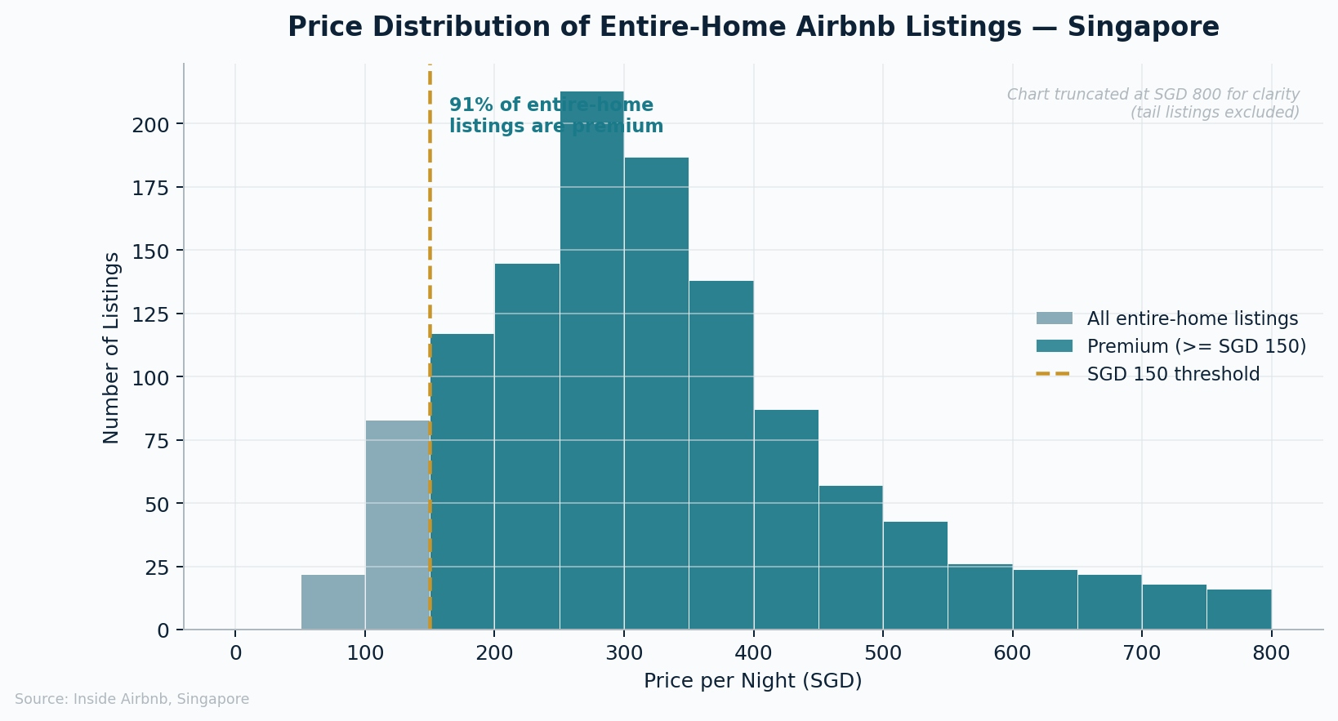
Figure 2: Price distribution of entire-home listings. Source: Inside Airbnb, Singapore.

3.2 Minimum stay gap
Figure 3 shows 44% of premium entire-home listings require a minimum stay of 90+ nights, with 47% overall blocking the typical corporate trip. Critically, this problem is invisible in review data: guests turned away by minimum stay rules never book and therefore never review, so the dataset hides rejected demand rather than reflecting it.
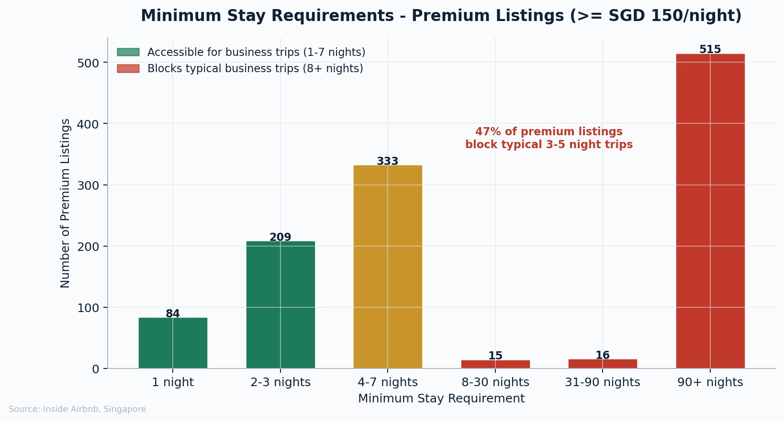
Figure 3: Minimum stay requirements, premium entire-home listings. Source: Inside Airbnb, Singapore.

3.3 Host concentration
Figure 4 shows that operators controlling ten or more listings account for 79.9% of premium supply. This portfolio-driven structure prioritises volume over individual guest experience, which explains the recurring operational complaints documented in Section 3.7.
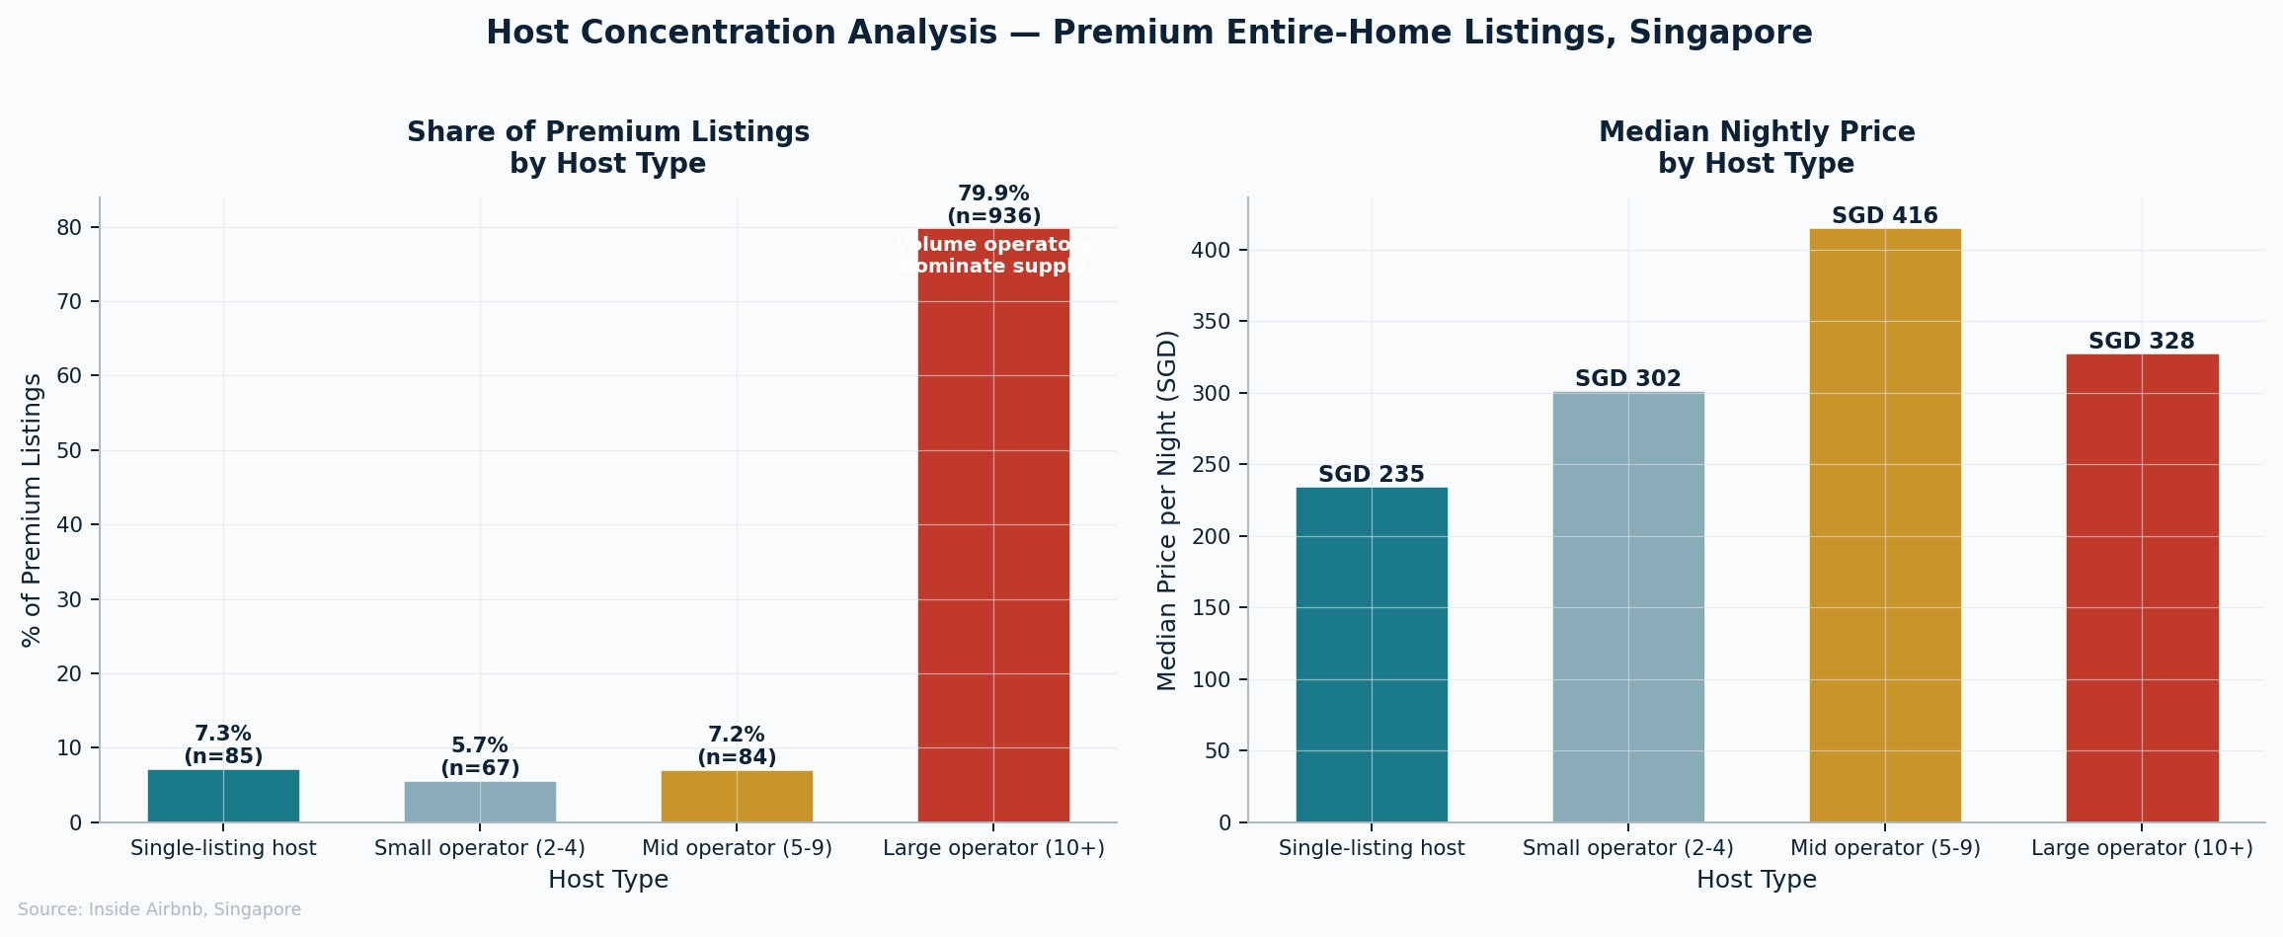
Figure 4: Host concentration analysis. Source: Inside Airbnb, Singapore.

3.4 Occupancy performance
Premium listings record an estimated 14.2% annual occupancy against a 76% hotel benchmark (STB, 2023), as shown in Figure 5. Figure 6 confirms that price alone does not drive occupancy; a visible cluster of 58 listings in the SGD 200–350 range achieves 40%+ occupancy, identifying the proven high-performance pricing zone.
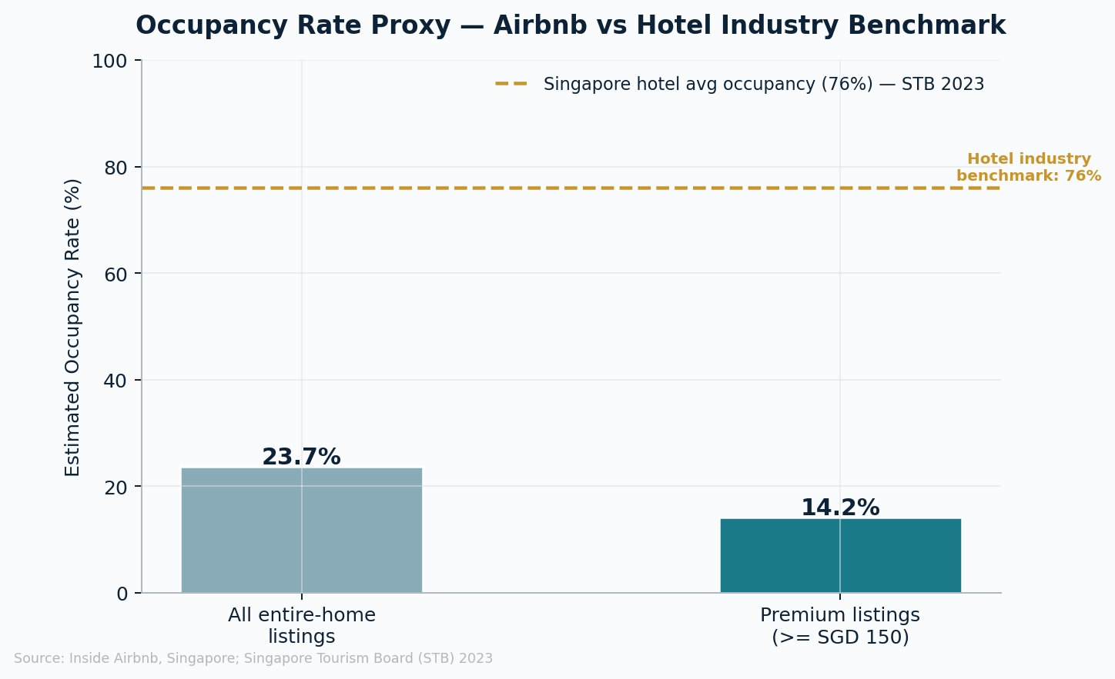
Figure 5: Occupancy proxy vs hotel benchmark. Source: Inside Airbnb, Singapore; STB 2023.
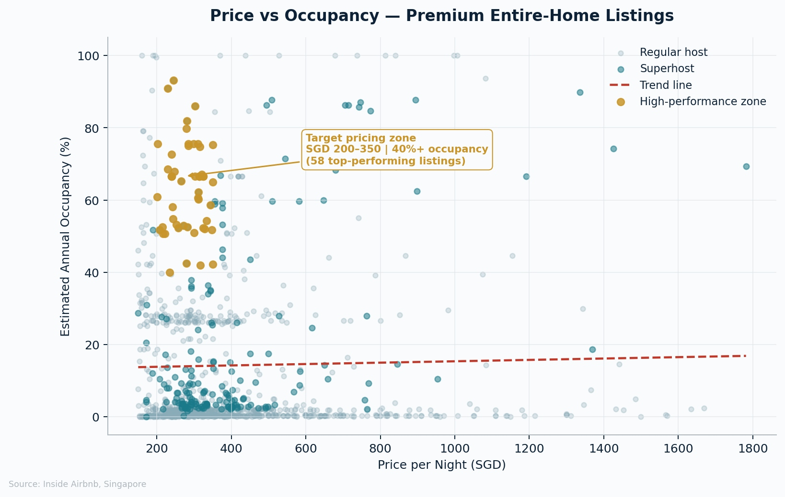
Figure 6: Price vs occupancy — high performers cluster at SGD 200–350. Source: Inside Airbnb.

3.5 Demand patterns
Figure 7 shows September occupancy spiking to 61.6% around the F1 Grand Prix, with October remaining elevated before softening through winter. Figure 8 shows only a 0.6 percentage point gap between weekday and weekend occupancy — far below the 20–30 point weekend premium typical of leisure markets — confirming that premium demand in Singapore is business-led, not leisure-led.
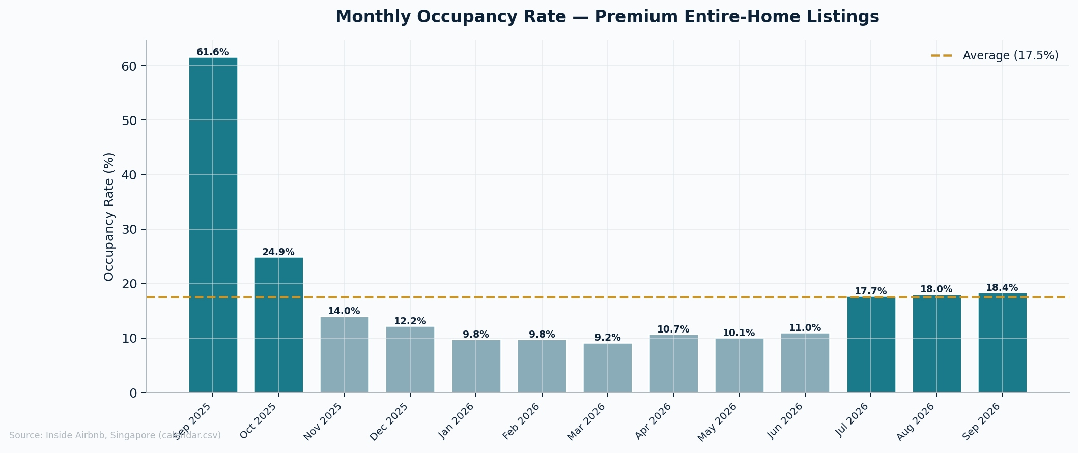
Figure 7: Monthly occupancy rate, premium entire-home listings. Source: Inside Airbnb, Singapore.
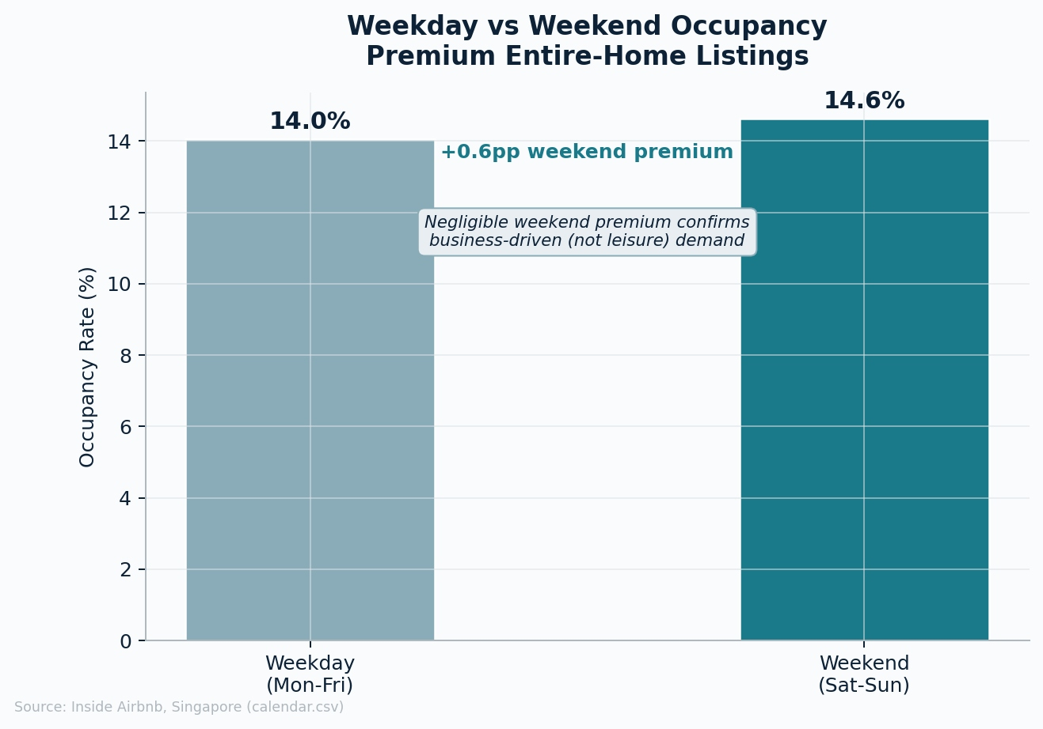
Figure 8: Weekday vs weekend occupancy. Source: Inside Airbnb, Singapore.

3.6 Geography
Premium listings cluster tightly in the CBD corridor. Figure 9 shows River Valley leads on listing count, followed by Novena, Orchard, Downtown Core, Outram, and Rochor. Figure 10 confirms the spatial concentration visually, supporting a focused CBD-first portfolio launch.
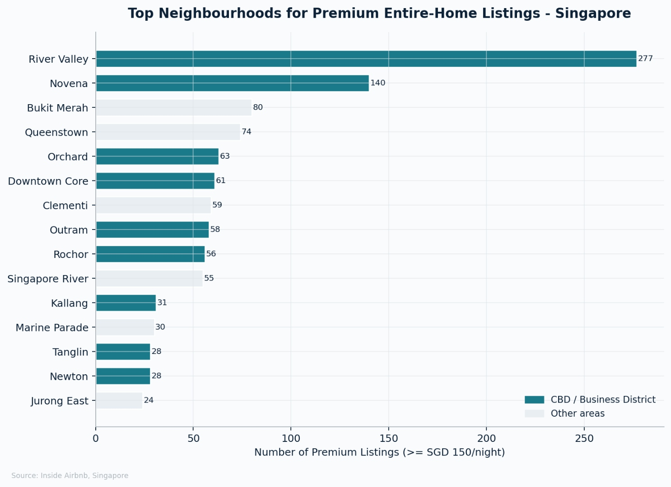
Figure 9: Top neighbourhoods by premium listing count. Source: Inside Airbnb, Singapore.
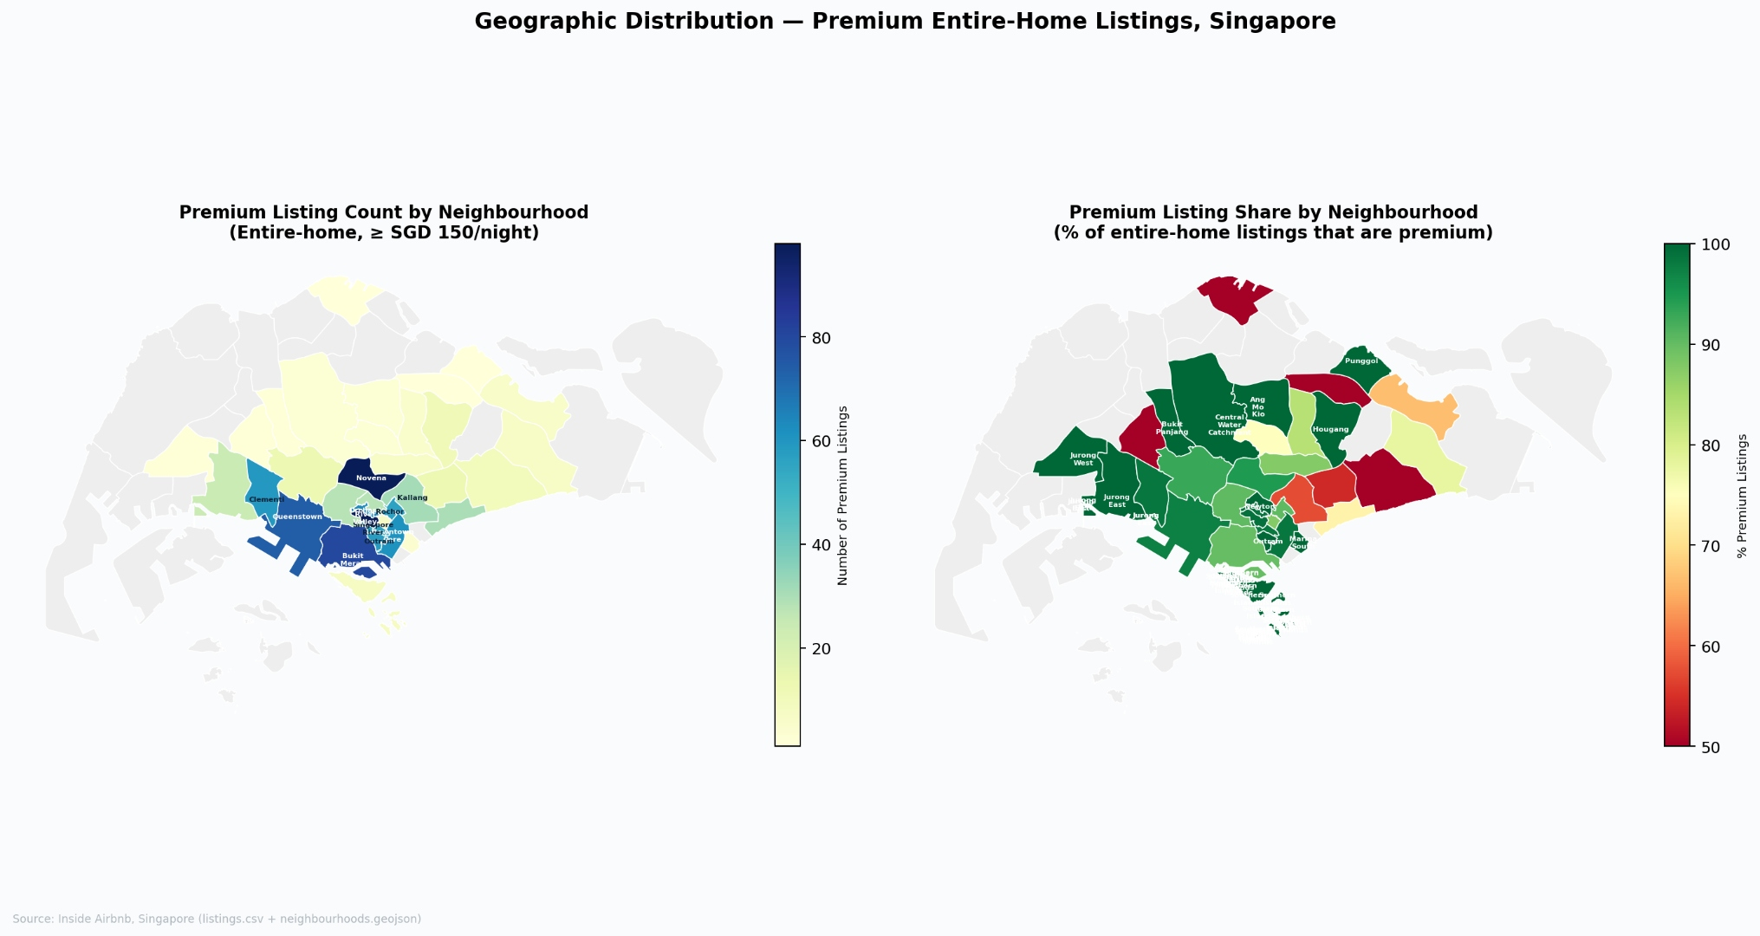
Figure 10: Geographic distribution of premium listings. Source: Inside Airbnb, Singapore.

3.7 Reviews and amenity gaps
Figure 11 shows location dominates positive feedback (43%), with communication, cleanliness, and comfort following. Amenities are praised in only 7.3% of reviews and check-in in just 1.8%, showing business-critical features are not currently meeting expectations. Figure 12 shows noise leads complaints (3.3% of reviews), followed by cleanliness issues and maintenance failures — each one a direct service risk for a business traveller.
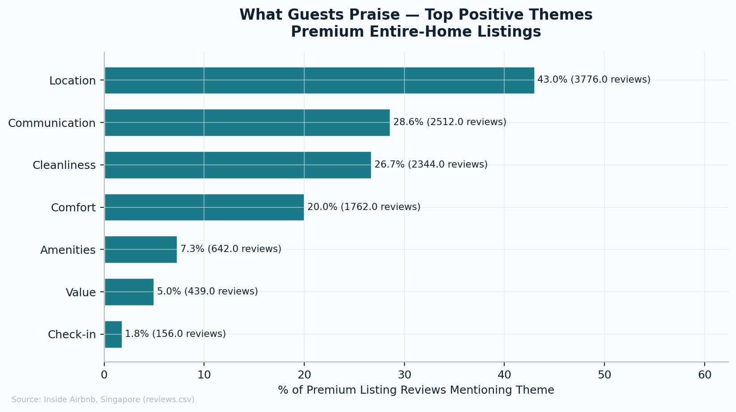
Figure 11: Top positive review themes. Source: Inside Airbnb, Singapore.
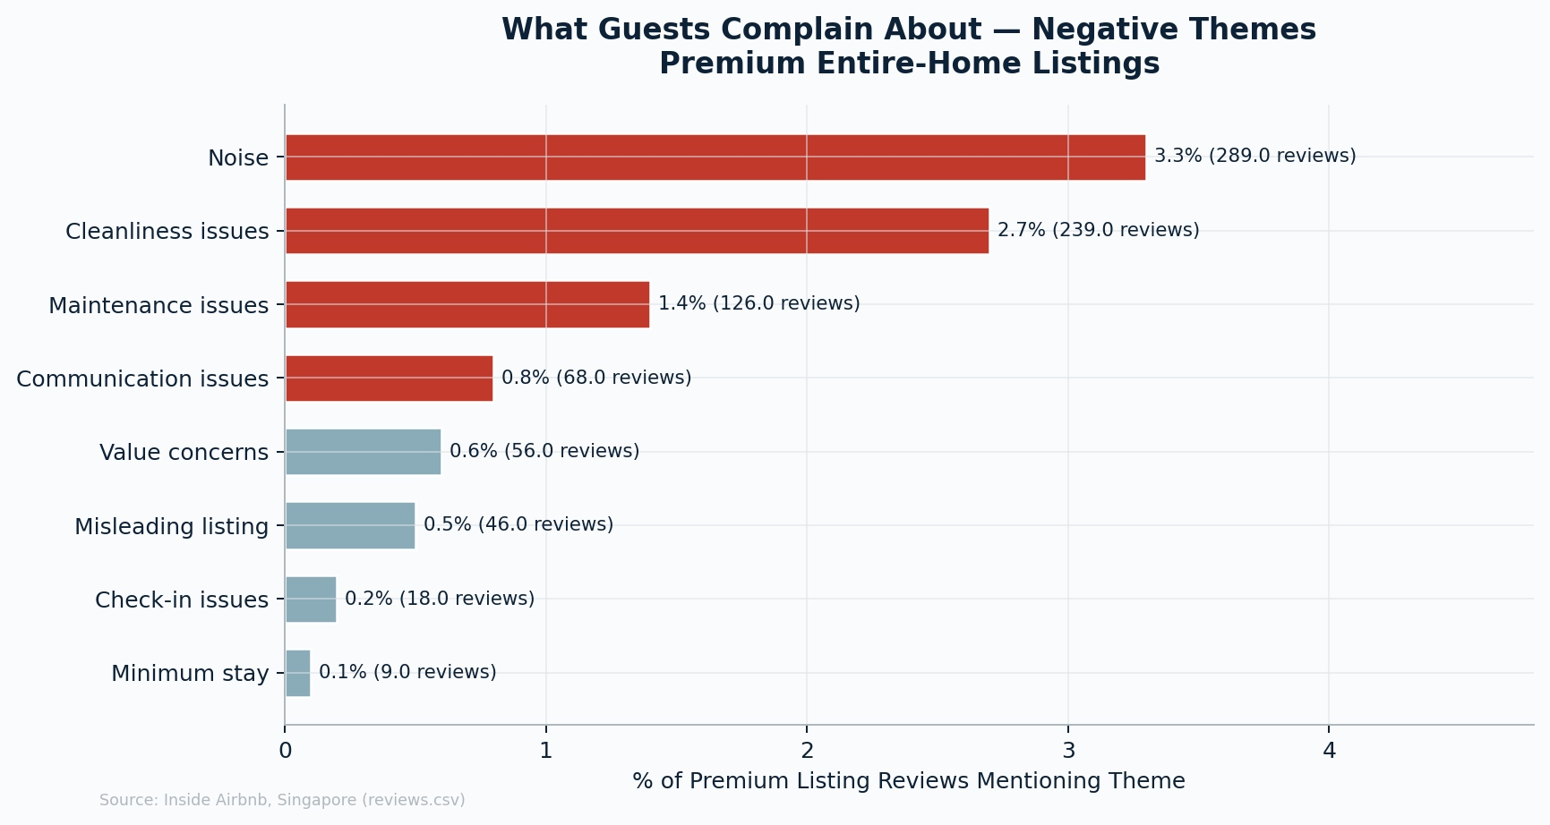
Figure 12: Top negative review themes. Source: Inside Airbnb, Singapore.
Figure 13 confirms the operational gap: self check-in is available in only 37.8% of premium listings, and 24-hour check-in in just 0.3%. The market offers premium pricing without premium business usability.
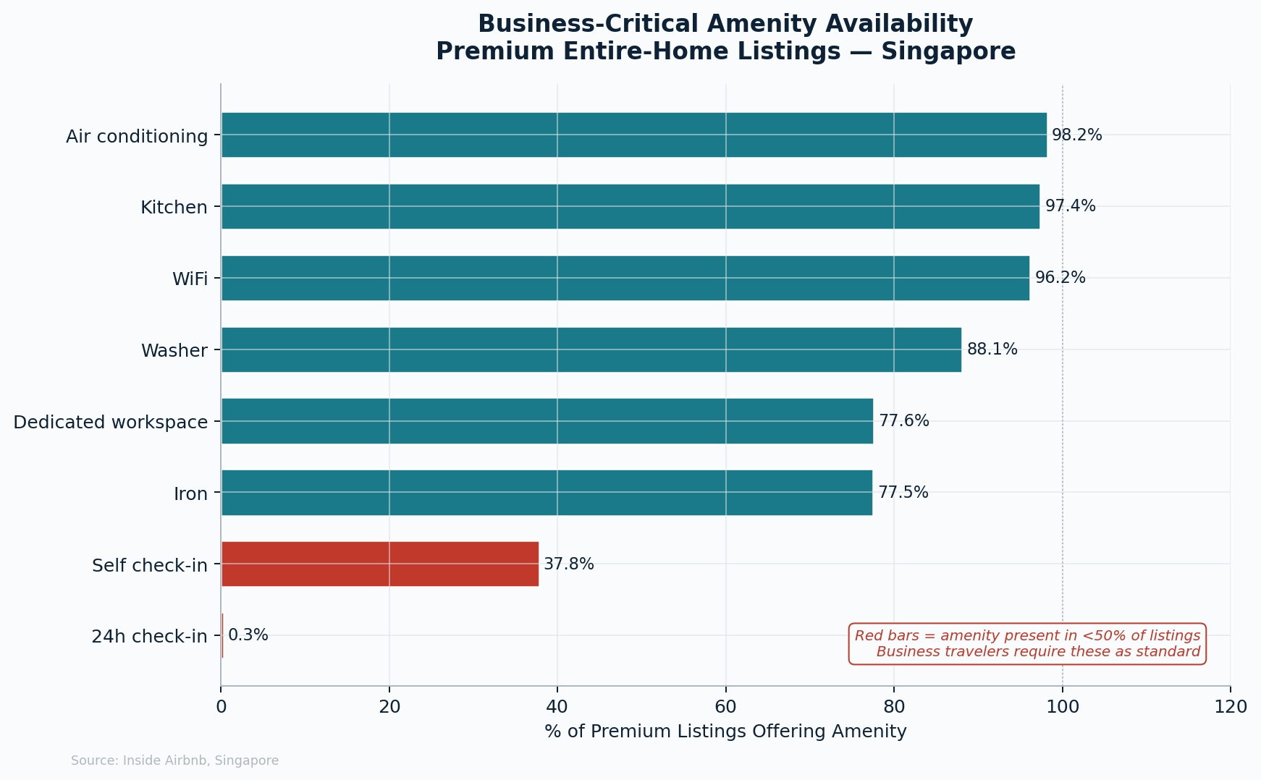
Figure 13: Business-critical amenity availability. Source: Inside Airbnb, Singapore.

4. Service Proposition
SuiteStay Singapore would offer entire-home CBD apartments at SGD 200–350 per night, aligned with the proven high-performance zone. The core promise is certainty: one to five night availability, verified soundproofing, hotel-grade cleaning, a dedicated workspace, and smart-lock self check-in across every property. The launch portfolio would concentrate on River Valley, Orchard, and Downtown Core. Pricing would flex upward for the September–October event peak, while corporate rate agreements would stabilise revenue through quieter months. The competitive advantage is not lower price but higher usability — removing every friction point that prevents premium supply from serving business demand.

5. Conclusion
A quantified market gap exists in Singapore's premium short-stay sector. Demand is large and recurrent, but a substantial share of premium Airbnb supply is blocked by minimum stays, weakened by service inconsistency, and missing the operational features business travellers treat as essential. A focused professionally managed service can compete not by being cheaper but by being more usable and purpose-built for the corporate segment.
Occupancy estimates are proxy-based and the review sentiment analysis uses keyword tagging, so conclusions should be treated as directionally strong rather than precisely measured. Future work should include primary research with business travellers to validate willingness to pay and a full financial model incorporating regulatory and operational costs.

References
Civil Aviation Authority of Singapore (2024) Annual Report 2023/24. Singapore: CAAS. Available at: https://www.caas.gov.sg (Accessed: 10 April 2026).
Global Business Travel Association (2023) Asia Pacific Business Travel Index 2023. Washington, DC: GBTA. Available at: https://www.gbta.org (Accessed: 9 April 2026).
Inside Airbnb (2025) Singapore Dataset [Online]. Available at: http://insideairbnb.com/get-the-data/ (Accessed: 6 April 2026).
Singapore Tourism Board (2023) Annual Report on Tourism Statistics 2023. Singapore: STB. Available at: https://www.stb.gov.sg (Accessed: 8 April 2026).
Singapore Tourism Board (2024) Singapore Tourism Industry Conference 2024: MICE Sector Review. Singapore: STB. Available at: https://www.stb.gov.sg (Accessed: 9 April 2026).
Urban Redevelopment Authority (2024) Short-Term Accommodation: Regulatory Framework. Singapore: URA. Available at: https://www.ura.gov.sg (Accessed: 10 April 2026).

