# Project: Analyzing a Market Test

Complete each section. When you are ready, save your file as a PDF document and submit it [here](https://classroom.udacity.com/nanodegrees/nd008/parts/11a7bf4c-2b69-47f3-9aec-108ce847f855/project).

## Step 1: Plan Your Analysis

*To perform the correct analysis, you will need to prepare a data set. (500 word limit)*

*Answer the following questions to help you plan out your analysis:*

1. What is the performance metric you’ll use to evaluate the results of your test?

Gross margin will be the metric used to evaluate the results of the test. The impact predicted to profitability should be enough to justify the increased budget in marketing: at least 18% increase in profit growth compared to the comparative period while compared to the control stores; also known as incremental lift. In our date profit is represented by the gross_margin variable.

1. What is the test period?

The test period is 12 weeks between 29th April 2016 and 21st July 2016

1. At what level (day, week, month, etc.) should the data be aggregated?

The data should be aggregated on a weekly level.

## Step 2: Clean Up Your Data

*In this step, you should prepare the data for steps 3 and 4. You should aggregate the transaction data to the appropriate level and filter on the appropriate data ranges. You can assume that there is no missing, incomplete, duplicate, or dirty data. You’re ready to move on to the next step when you have weekly transaction data for all stores.*

## Step 3: Match Treatment and Control Units

*In this step, you should create the trend and seasonality variables, and use them along with you other control variable(s) to match two control units to each treatment unit. Note: Calculate the number of transactions per store per week to calculate trend and seasonality.*

*Apart from trend and seasonality...*

1. What control variables should be considered? Note: Only consider variables in the RoundRoastersStore file.

Sq_ft and Avg Monthly Sales

1. What is the correlation between each potential control variable and your performance metric?

The correlation between Sq_Ft and Gross Margin as shown below is -0.019345 and that between AvgMonthSales and Gross Margin is 0.790358

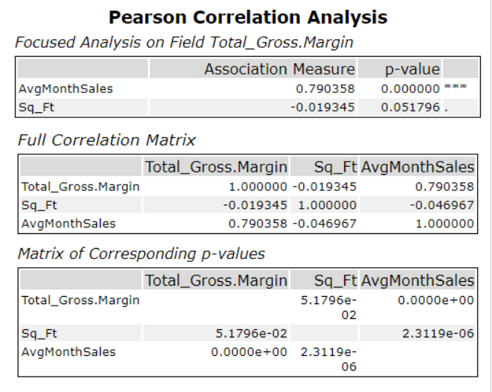

1. What control variables will you use to match treatment and control stores?

I will use the AvgMonthSales variable as it has high positive correlation with the performance metric and p-value which is much less that 0 which makes it statistically significant to match the treatment and control stores.

1. Please fill out the table below with your treatment and control stores pairs:

|  |  |  |
| --- | --- | --- |
| Treatment Store | Control Store 1 | Control Store 2 |
| 1664 | 7162 | 8112 |
| 1675 | 1580 | 1807 |
| 1696 | 1964 | 1863 |
| 1700 | 2014 | 1630 |
| 1712 | 8162 | 7434 |
| 2288 | 9081 | 2568 |
| 2293 | 12219 | 9524 |
| 2301 | 3102 | 9238 |
| 2322 | 2409 | 3235 |
| 2341 | 12536 | 2383 |

## Step 4: Analysis and Writeup

*Conduct your A/B analysis and create a short report outlining your results and recommendations. (250 words limit)*

*Answer these questions. Be sure to include visualizations from your analysis:*

1. What is your recommendation - Should the company roll out the updated menu to all stores?

Yes, the company should roll out the updated menu to all stores. The overall lift for the new Menu Launch is 40.7% and the higher than the threshold of 18%

1. What is the lift from the new menu for West and Central regions (include statistical significance)?

The lift from the new menu for the west region is 37.9% whereas that from the Central region is 5.9%

West:

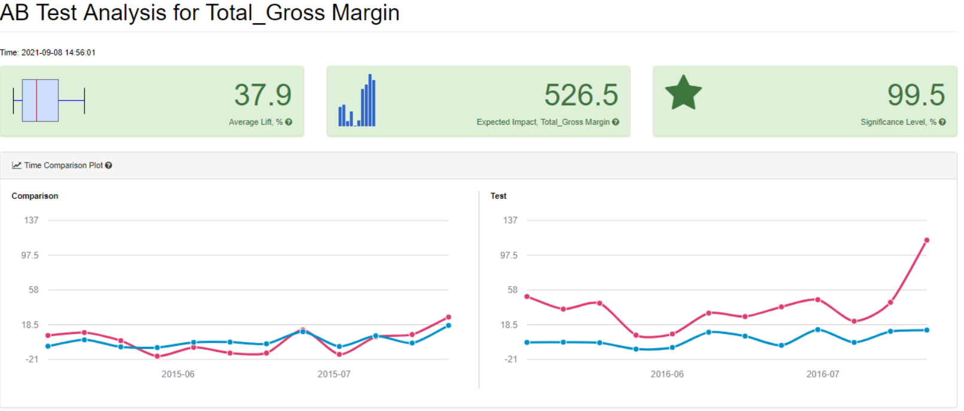

Central:

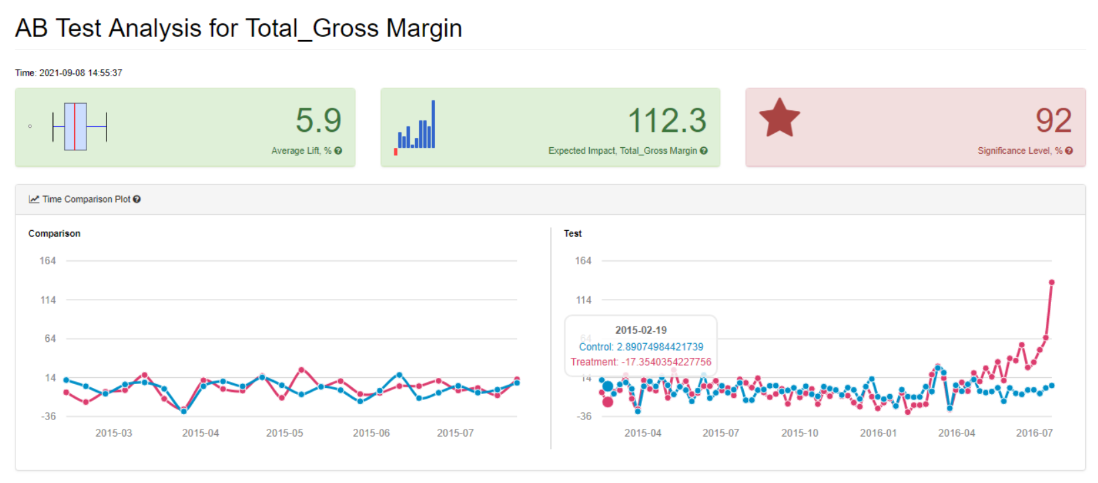

1. What is the lift from the new menu overall? The lift for the new menu overall is 40.7%

