
UNIVERSITY OF MPUMALANGA
School of Computing and Mathematical Sciences
SOFTWARE DESIGN DOCUMENT
UMP Smart-Dine
Campus cafeteria pre-ordering system
Eat smart. Study more.

 | Document reference | UMPSD-SDD-001
 | Version | 1.0
 | Date of issue | 18 September 2026
 | Classification | Confidential
 | Authors | Tebogo Maremane (231112009)  Tshegofatso Masete (220477868)  Wamkelwe Mkhabela (230822770)
 | Mentor and approver | Mr C. Ndlovu
 | Supersedes | No earlier issue. Reconciles with UMPSD-SRS-001 v1.0 (10 August 2026).
 | Contact | 231112009@ump.ac.za · +27 13 002 0255

DOCUMENT CONTROL
Approval
Responsibility | Name | Signature | Date
Examiner
Internal moderator
External moderator
Approver | Mr C. Ndlovu
Distribution
Organisation | Representative | Purpose
School of Computing and Mathematical Sciences | Mr C. Ndlovu | Assessment and approval
UMP Campus Cafeteria Services | To be confirmed | Stakeholder review
Development team | Maremane, Masete, Mkhabela | Implementation reference
How to read this document
Requirement tags in the form REQ-n and business rule tags in the form BR-n refer to UMPSD-SRS-001 version 1.0. Table 28 traces every one of them to the component that satisfies it. Database identifiers, file names and code identifiers appear in a monospaced typeface, for example menu_items and reserve_stock(). Migration numbers refer to the files under supabase/migrations in the source repository.
The design described here is the design as built at the date of issue, not a proposal. Clause 2.4 records every place where it has moved on from the Software Requirements Specification, including five status tags in that document that were wrong when it was issued.

TABLE OF CONTENTS
1.0 INTRODUCTION 7
1.1 Purpose 7
1.2 Scope 7
1.3 Overview 7
1.4 Reference Material 8
1.5 Definitions and Acronyms 8
2.0 SYSTEM OVERVIEW 10
2.1 The problem the design answers 10
2.2 What the system does 11
2.3 Operating context 12
2.4 Changes since the Software Requirements Specification 12
3.0 SYSTEM ARCHITECTURE 14
3.1 Architectural Design 14
3.1.1 How the subsystems collaborate 15
3.2 Decomposition Description 15
3.2.1 Package structure 16
3.2.2 Object model 17
3.2.3 Interface specifications 18
3.2.4 Sequence: concurrent stock reservation 19
3.2.5 Sequence: card checkout and settlement 21
3.2.6 Order state machine 22
3.2.7 Data flow 22
3.3 Design Rationale 24
3.3.1 A relational database rather than a document store 24
3.3.2 The database enforces the rules, not the client 25
3.3.3 The cart is a database table 25
3.3.4 Money is integer cents 25
3.3.5 The application never touches a card number 26
3.3.6 Alternatives considered and not taken 26
4.0 DATA DESIGN 27
4.1 Data Description 27
4.1.1 Entity relationships 27
4.1.2 Storage design 28
4.2 Data Dictionary 28
4.2.1 cafeterias 28
4.2.2 menu_items 29
4.2.3 notifications 29
4.2.4 order_items 29
4.2.5 orders 30
4.2.6 payments 30
4.2.7 profiles 30
4.2.8 staff_cafeterias 31
4.2.9 stock_reservations 31
4.2.10 Enumerated types 31
4.2.11 Database functions 32
4.2.12 Row level security policies 32
5.0 COMPONENT DESIGN 34
5.1 reserve_stock 34
5.2 release_stock 34
5.3 release_expired_reservations 35
5.4 place_order 35
5.5 advance_order 36
5.6 cancel_order 37
5.7 lookup_login_email 37
5.8 complete_profile and the immutability guard 38
5.9 applyPaymentResult 38
5.10 Webhook signature verification 39
5.11 CartController 39
5.12 AuthGate 40
5.13 AppError.from 41
5.14 Money.format 41
5.15 MenuSearchDelegate 41
6.0 HUMAN INTERFACE DESIGN 43
6.1 Overview of User Interface 43
6.1.1 What a student does 43
6.1.2 What a staff member does 43
6.1.3 Rules that hold on every screen 43
6.2 Screen Images 44
6.3 Screen Objects and Actions 46
6.4 Data entry design and field limits 47
6.5 Error prevention, trapping and recovery 48
6.5.1 Prevention before the user acts 49
6.5.2 What happens when the user does something unexpected 49
6.5.3 Recovery 50
6.6 User interface checklist compliance 50
6.6.1 Colours 51
6.6.2 Content 51
6.6.3 Images 51
6.6.4 Instructions 52
6.6.5 Navigation 52
6.6.6 Usability 52
6.6.7 Accessibility, beyond the checklist 53
7.0 REQUIREMENTS MATRIX 54
8.0 APPENDICES 59
Appendix A. Fault-proof plan 59
Appendix B. Error message reference 60
Appendix C. Outstanding design items 61
Appendix D. Deployment prerequisites and verification 61
Appendix E. Document control 62

LIST OF FIGURES
Figure 1 Use case diagram. Four actors, twenty use cases and the system boundary of version 1.0. 11
Figure 2 System architecture. Two Flutter interfaces compiled from one code base, a repository layer, and the hosted Supabase platform with its five services. The Paystack secret key never leaves the Edge Function environment. 14
Figure 3 Subsystem decomposition into packages and their dependencies. Every arrow points downward; no layer calls the layer above it. 16
Figure 4 Domain class diagram. Ten model types, five repositories, one controller and the enumerations that type them. 17
Figure 5 Two students contend for the last unit of an item. Exactly one succeeds, and the other is told why. 19
Figure 6 Card checkout. The order is created first so an amount exists server side, then the gateway is initialised, and the outcome arrives by either of two paths that share one idempotent handler. 21
Figure 7 The order lifecycle. Forward-only, with cancellation permitted from two states and a guard on every transition. 22
Figure 8 Data flow diagram, level 0. The system as one process with its four external entities. 23
Figure 9 Data flow diagram, level 1. Nine processes and nine data stores. Processes 3.0, 4.0, 6.0 and 9.0 reach their stores only through database functions. 24
Figure 10 Entity relationship diagram. Nine tables plus the authentication service's own user table, in crow's foot notation, as defined by migrations 0001 to 0007. 27
Figure 11 Student interface: Home with the live menu grid, My Cart with checkout, and the order confirmation screen. 44
Figure 12 Staff Dashboard: the Live Queue, menu management, and the menu item editor. 45
Figure 13 Screen navigation map. Every route in the application, with the role branch that decides which half a user ever sees. 46
Figure 14 Fault containment. Four independent barriers, where each class of failure is caught, and what the user is told. 49

LIST OF TABLES
Table 1 Definitions and acronyms used in this document. 8
Table 2 Changes since UMPSD-SRS-001 version 1.0. 12
Table 3 Subsystem responsibilities. 14
Table 4 Repository interface specifications. 18
Table 5 Design alternatives and why they were rejected. 26
Table 6 Physical storage design. 28
Table 7 cafeterias. 28
Table 8 menu_items. 29
Table 9 notifications. 29
Table 10 order_items. 29
Table 11 orders. 30
Table 12 payments. 30
Table 13 profiles. 30
Table 14 staff_cafeterias. 31
Table 15 stock_reservations. 31
Table 16 PostgreSQL enumerated types and their Dart counterparts. 31
Table 17 Database functions. 32
Table 18 Row level security policies. 32
Table 19 Screen objects and their actions. 46
Table 20 Data entry limits and validation. 47
Table 21 Unexpected user actions and the system response. 50
Table 22 Checklist section 1.1, colours. 51
Table 23 Checklist section 1.2, content. 51
Table 24 Checklist section 1.3, images. 51
Table 25 Checklist section 1.4, instructions. 52
Table 26 Checklist section 1.5, navigation. 52
Table 27 Checklist section 1.6, usability. 52
Table 28 Requirements traceability matrix. 54
Table 29 Business rule traceability. 57
Table 30 Failure modes and responses. 59
Table 31 Error codes and the messages they produce. 60
Table 32 Outstanding items. 61
Table 33 Version history. 62

1.0 INTRODUCTION

1.1 Purpose
This Software Design Document describes the architecture and system design of UMP Smart-Dine, a campus cafeteria pre-ordering system built for the University of Mpumalanga. It translates the requirements recorded in UMPSD-SRS-001 into a description of the components, interfaces and data structures that the implementation is built from, and it is detailed enough that a programmer who has never seen the code could rebuild the system from it.
The document has three audiences. The project approver and the external moderator will read it to judge whether the design is sound and whether the delivered software matches what was specified. The three developers use clause 3 through clause 6 as the working reference for what goes where. Anyone testing the system uses clause 5, clause 6 and clause 7 to derive test cases, because those clauses state what each component is supposed to do and which requirement it satisfies.
The design described here is the design as built, not a proposal. Every function signature, table name, colour value and validation rule in this document was read out of the source repository at the date of issue. Where the code and the specification disagree, clause 2.4 says so plainly rather than quietly taking one side.

1.2 Scope
UMP Smart-Dine moves the cafeteria menu, the stock position and the payment step onto a student's phone. A student opens the application, sees which outlets are trading and what each one still has in stock, builds an order, pays by card or chooses to pay cash at the counter, and collects the order against a six-character reference without joining the ordering queue. On the other side of the counter, cafeteria staff maintain their own menu, open and close the outlet for orders, publish notices, and work a live queue of incoming orders through four states.
The system covers the two operating flows agreed in the Software Project Plan. Instant pickup is an order placed for immediate collection. Pre-order is the same flow used ahead of time, and the two are the same code path because stock is held from the moment an item enters the cart in both cases. There is no separate scheduling mechanism, which is a deliberate simplification recorded in clause 3.3.
The goals the design is measured against are these. Two students who tap Add on the last remaining unit of an item must not both succeed. A change a staff member makes on the dashboard must appear on a student's device without either party refreshing. The stock count shown to a student must agree with the value in the database. A student must be able to complete an order on Android or iOS without the application terminating. Money must never drift by a rounding error.
Several things are outside the scope of version 1.0 and are not designed for here. The system does not deliver food anywhere; collection is at the counter. It does not manage procurement, supplier orders or cafeteria accounting. It does not integrate with the University's student records system, so a student number captured at registration is stored but never verified against an authoritative source. It holds no wallet, no balance and no credit. It carries no allergen or nutritional data, and REQ-103 forbids the interface from implying that it does.

1.3 Overview
The document follows the structure of the IEEE 1016 based template supplied with the assignment. Clause 2 gives the system overview and records where the delivered system has moved on from the Software Requirements Specification. Clause 3 is the architecture: the subsystem structure, the decomposition into packages, objects and message sequences, and the reasoning behind the choices that shaped it. Clause 4 covers data, from the relational schema down to a column by column data dictionary. Clause 5 takes each component in turn and gives its algorithm in pseudocode. Clause 6 covers the human interface, including the data entry limits, the error prevention design and a point by point response to the user interface checklist attached to the marking rubric. Clause 7 is the requirements traceability matrix. Clause 8 holds the appendices, including the fault-proof plan.
A reader with limited time should read clause 2, look at Figure 2 and Figure 10, then read clause 3.3 and clause 5.1. Those five pieces carry the design decisions that everything else follows from.

1.4 Reference Material
The following were used as sources for this design.
- IEEE Std 1016-2009, IEEE Standard for Information Technology, Systems Design, Software Design Descriptions. Institute of Electrical and Electronics Engineers.
- IEEE Std 830-1998, IEEE Recommended Practice for Software Requirements Specifications.
- Maremane T., Masete T., Mkhabela W. Software Requirements Specification: UMP Smart-Dine, document reference UMPSD-SRS-001 version 1.0, 10 August 2026. The requirement tags REQ-1 to REQ-131 used throughout this document are defined there.
- Maremane T., Masete T., Mkhabela W. Software Project Plan: UMP Smart-Dine. University of Mpumalanga, School of Computing and Mathematical Sciences, 2026.
- Flutter SDK documentation, version 3.11, and the Dart language specification. Google.
- Supabase platform documentation covering PostgREST, GoTrue, Realtime, Storage and Edge Functions.
- PostgreSQL 15 documentation, in particular the chapters on transaction isolation, row locking and row security policies.
- Paystack API reference, transaction initialisation, transaction verification and webhook signature validation.
- Payment Card Industry Data Security Standard version 4.0, PCI Security Standards Council, 2022.
- Protection of Personal Information Act 4 of 2013, Republic of South Africa.
- Web Content Accessibility Guidelines 2.1 Level AA, World Wide Web Consortium, 2018.
- UMP Smart-Dine source repository, main branch, together with the seven migration files under supabase/migrations and the three Edge Functions under supabase/functions.

1.5 Definitions and Acronyms
Terms defined in the Software Requirements Specification are not repeated here. The following are used in this document and are either new or carry a narrower meaning in a design context.
Table 1. Definitions and acronyms used in this document.
Term | Definition
Atomic operation | A database operation that either completes in full or has no effect, with no intermediate state visible to another session. Clause 5.1 depends on this property.
Collection reference | The six-character code issued at checkout and matched against the staff queue at the counter. Held in orders.collection_ref.
Edge Function | A Deno process that Supabase runs on its own infrastructure in response to an HTTP request. The system uses three, all of them for payment.
Idempotency key | A value that lets the same operation be applied twice without changing the result the second time. The system uses payments.provider_reference for this.
Optimistic update | Changing what is on screen before the server confirms the write, then reverting if it fails. Used by the trading status control.
PDL | Program design language. The structured pseudocode used in clause 5.
Predicated UPDATE | An UPDATE whose WHERE clause carries the condition that decides whether the write is legal, so the check and the write are one statement. The core of clause 5.1.
Reservation | A row in stock_reservations. Stock that has left the menu count but has not yet been sold. A reservation with a null order_id is a cart line; one with an order_id belongs to an order.
RLS | Row level security. PostgreSQL's mechanism for deciding which rows a given role may read or write.
RPC | Remote procedure call. In this system, a PostgREST call to a PostgreSQL function rather than to a table.
SECURITY DEFINER | A PostgreSQL function that runs with the privileges of its owner rather than its caller, so it can bypass row level security in a controlled way.
Service role | The Supabase credential that bypasses row level security. Held only by the Edge Functions and never shipped to a device.
Subsystem | One of the five groupings in clause 3.1. A subsystem is a unit of responsibility, not a deployment unit.
WAL | Write-ahead log. The PostgreSQL transaction log that the Realtime component reads to detect changes worth pushing to subscribed clients.

2.0 SYSTEM OVERVIEW

2.1 The problem the design answers
The queue at a University of Mpumalanga cafeteria eats a meaningful part of a student's break, and there is no way to see from outside the building what is still in stock. A student walks to an outlet, finds that the pie they wanted has gone or that the queue runs past the door, and leaves without buying anything. The cafeteria loses the sale and the corridor carries the congestion.
Two facts about that situation shape almost every decision in this design. The first is that stock is a contended resource. Several students look at the same last unit of an item at the same moment, and the system is worth nothing if it tells two of them that they have it. The second is that the value of the product is entirely in the freshness of what it shows. A stock count that is thirty seconds stale is a lie that sends a student on a walk for nothing.
Those two facts are why the design puts a relational database with row level locking at the centre rather than a document store, and why every screen that shows stock is driven by a live subscription rather than a fetch on open.

2.2 What the system does
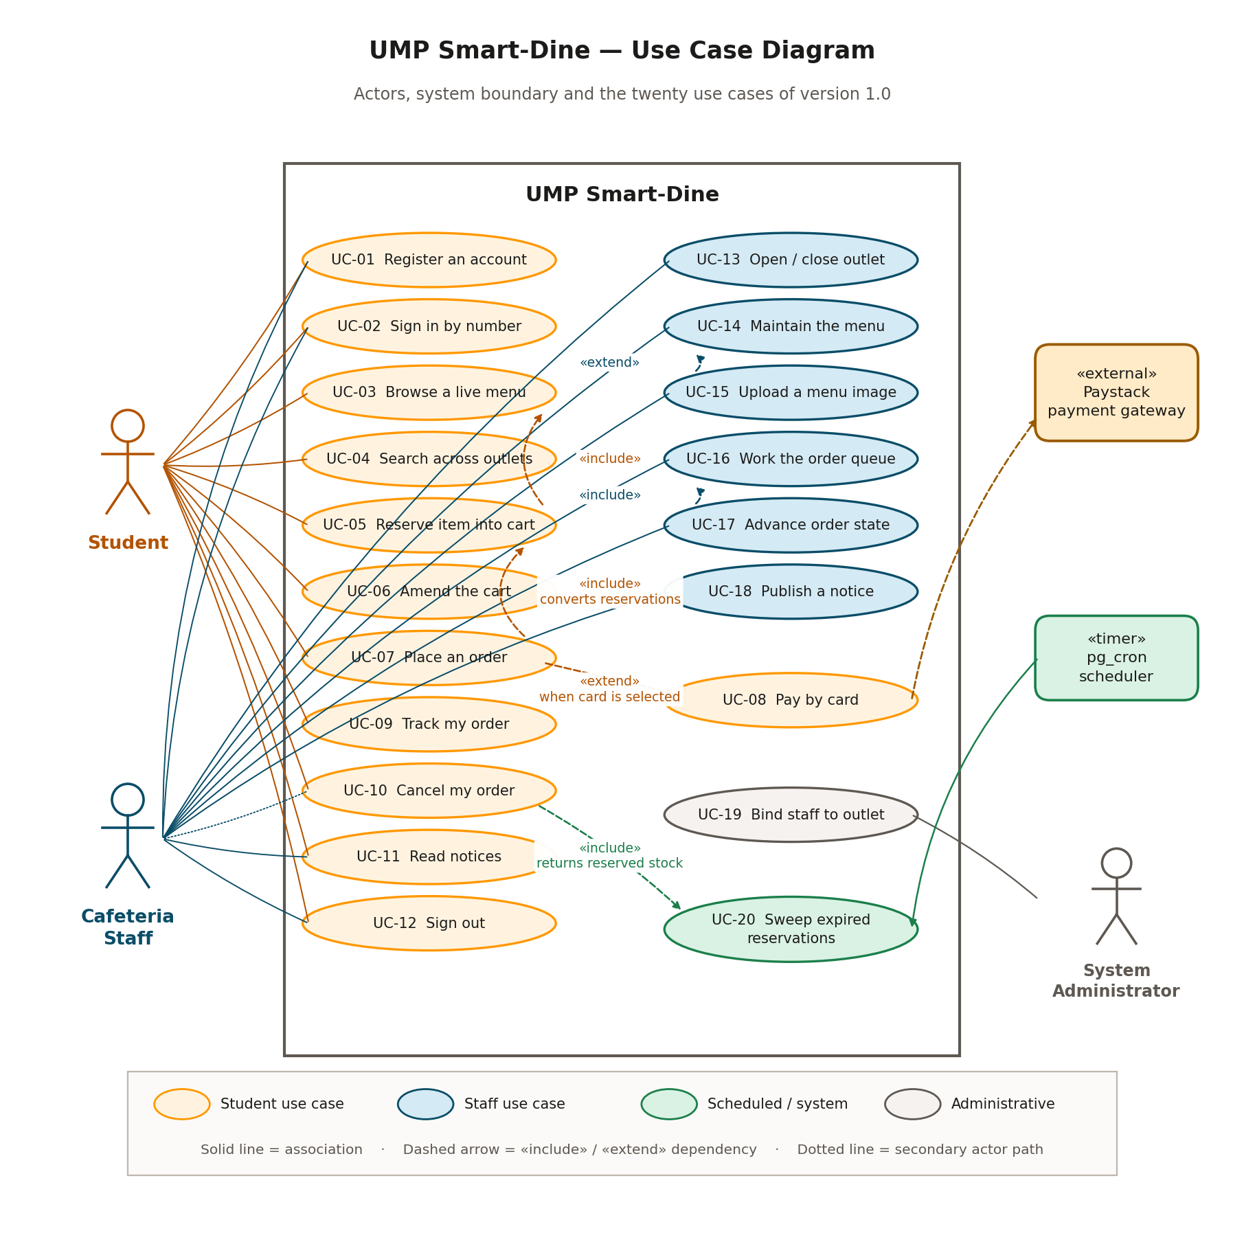
Figure 1. Use case diagram. Four actors, twenty use cases and the system boundary of version 1.0.
Figure 1 gives the full set of use cases. In plain terms, a student can register, sign in with a student number rather than an e-mail address, pick an outlet, browse its live menu, search every outlet's menu by item name, hold items in a cart, pay by card through a hosted checkout page or choose to pay cash at the counter, receive a collection reference, watch the order move through preparation, cancel it while that is still allowed, read notices and sign out.
A staff member can sign in and be routed to a different interface without choosing it, select which of the outlets they are assigned to they are managing, open and close that outlet for orders, create and edit and delete menu items including a photograph, publish a notice to students or to other staff, watch a live queue of orders split by state with a count for each, move an order forward through preparing and ready and collected, and cancel an order with a reason.
A system administrator, who has no interface in version 1.0, binds staff accounts to cafeterias in the Supabase dashboard and seeds the cafeteria rows. That binding is the authorisation boundary for every staff write in the system, so it is an administrative act by design rather than an oversight.

2.3 Operating context
The client is one Flutter code base compiled for Android and iOS, with a web build maintained on a best effort basis because a browser suits a counter-side dashboard. There is no server written by the team in the usual sense. The backend is a hosted Supabase project supplying PostgreSQL 15, the GoTrue authentication service, a Realtime engine that reads the write-ahead log and pushes changes over a WebSocket, an object store for menu photographs, and a Deno runtime for the three payment functions.
Everything the system does needs connectivity. There is no offline mode, no cached menu and no queue of pending writes. That is a real limitation and it is recorded as such in clause 8.3 rather than presented as a design choice.
The target device is a mid-range Android handset with 2 GB to 4 GB of memory and limited free storage, because that is what most students carry. The compiled application is required to stay under 150 MB installed and 250 MB resident. Two decisions follow from that: menu photographs are fetched over the network and cached by the framework rather than bundled, and the notification subscription is capped at fifty rows so the panel cannot grow without bound.

2.4 Changes since the Software Requirements Specification
The Software Requirements Specification was issued on 10 August 2026 and marked a large part of the system as not implemented. Substantial work has happened since. This clause records every place where the design in this document supersedes that specification, so that a reader comparing the two finds an explanation rather than a contradiction.
Table 2. Changes since UMPSD-SRS-001 version 1.0.
Area | Specification said | Design now | Effect on requirements
Order persistence | No orders table existed. A confirmed cart was written nowhere and the staff queue rendered five hardcoded placeholder rows. Recorded as item TBD-02, the largest gap in the project. | Four new tables (orders, order_items, payments, stock_reservations) plus staff_cafeterias. The queue reads real rows. Migration 0003. | REQ-62 to REQ-69 move from not implemented to implemented.
Payment | Card details were collected into Flutter text fields, validated, and then discarded. No gateway was contacted. Recorded as item TBD-01. | Paystack, reached through three Edge Functions. The application never sees a card number; the hosted page collects it. Verification and a signed webhook both settle the order idempotently. | REQ-60 becomes implemented. REQ-56 and REQ-57, which specified card field validation, are superseded because the field no longer exists. REQ-58 is satisfied more completely than before.
Stock control | The client read stock_count, subtracted one and wrote the result back. Two students who both read 5 both wrote 4, so two units sold and one was consumed. Recorded as REQ-50 not implemented. | Seven SECURITY DEFINER functions. Every stock movement is a single predicated UPDATE evaluated under a row lock. Migration 0004. | REQ-50, REQ-48 and REQ-51 become implemented.
The cart | A list held in the home screen's widget state, shallow-copied by the cart screen and never resynchronised. Pressing minus on a stale row credited stock back to the database indefinitely. | The stock_reservations table is the cart. CartController holds one in-memory view of it and reloads after every mutation. | REQ-52 becomes implemented. The stock inflation defect is closed.
Authorisation | Row level security was off on every table. Any authenticated user could edit any menu item at any outlet, including its price, using the publishable key that ships inside the APK. | Row level security on all nine tables and on the storage bucket, twenty policies in total. Staff writes are gated on membership of staff_cafeterias. Migrations 0006 and 0007. | REQ-110, REQ-76, REQ-113 and REQ-36 become implemented. BR-2 and BR-3 are now enforced.
Sign-in lookup | The client read the profiles table while unauthenticated to exchange a student number for an e-mail address, and reported 'ID not found' when there was no row. That is an enumeration oracle. | lookup_login_email(), a SECURITY DEFINER function that returns a deliberately unusable address for an unknown number, so an unregistered number and a wrong password fail identically. | REQ-111 and REQ-30 become implemented.
Money | price was a numeric column read into a Dart double and multiplied by quantity to form a total. | Integer cents throughout, with price_cents on menu_items and total_cents on orders. A trigger keeps the deprecated price column in step during the transition. Migration 0002. | REQ-2 and REQ-54 are unaffected in wording but no longer depend on floating point.
Schema control | The schema existed only in the hosted project and was not captured anywhere. Recorded as TBD-10. | Seven idempotent migration files under supabase/migrations, runnable against a fresh or an existing database. | REQ-127 becomes implemented.
Placeholder screens | My Orders, Profile and the staff Settings tab each rendered a single centred string, two of them in white on a white background. | All three are built. Settings also carries the notice composer, which closes REQ-89 and TBD-11. | REQ-68, REQ-89 and REQ-114 move forward. TBD-12 is closed.

Five status tags in the specification were also wrong when it was issued, and are corrected here rather than left to be discovered. REQ-17 and REQ-21 were marked implemented and partial, but the sign-up form held a form key and called validate() without ever attaching a validator to a field, so validate() always returned true and a completely empty form went to the network. REQ-91 was marked implemented but only the staff path called signOut(); the student path navigated back to the login screen and left the session alive and refreshing. REQ-66 was marked partial but the three queue counters were the literals 2, 4 and 3. REQ-15 was marked partial but no session check existed anywhere in the code base, so a returning user always had to sign in again. REQ-83 was the one understatement: it was marked partial but the control did already revert on failure.

3.0 SYSTEM ARCHITECTURE

3.1 Architectural Design
The system is partitioned into five subsystems. The split follows one rule: anything that must hold true no matter what the client does lives in the platform subsystem, and everything above it is there to present that truth to a person. A client running on a student's phone is not trusted, because the publishable key needed to reach the API is compiled into the binary and can be read out of it. Any rule enforced only in Dart is therefore a suggestion.
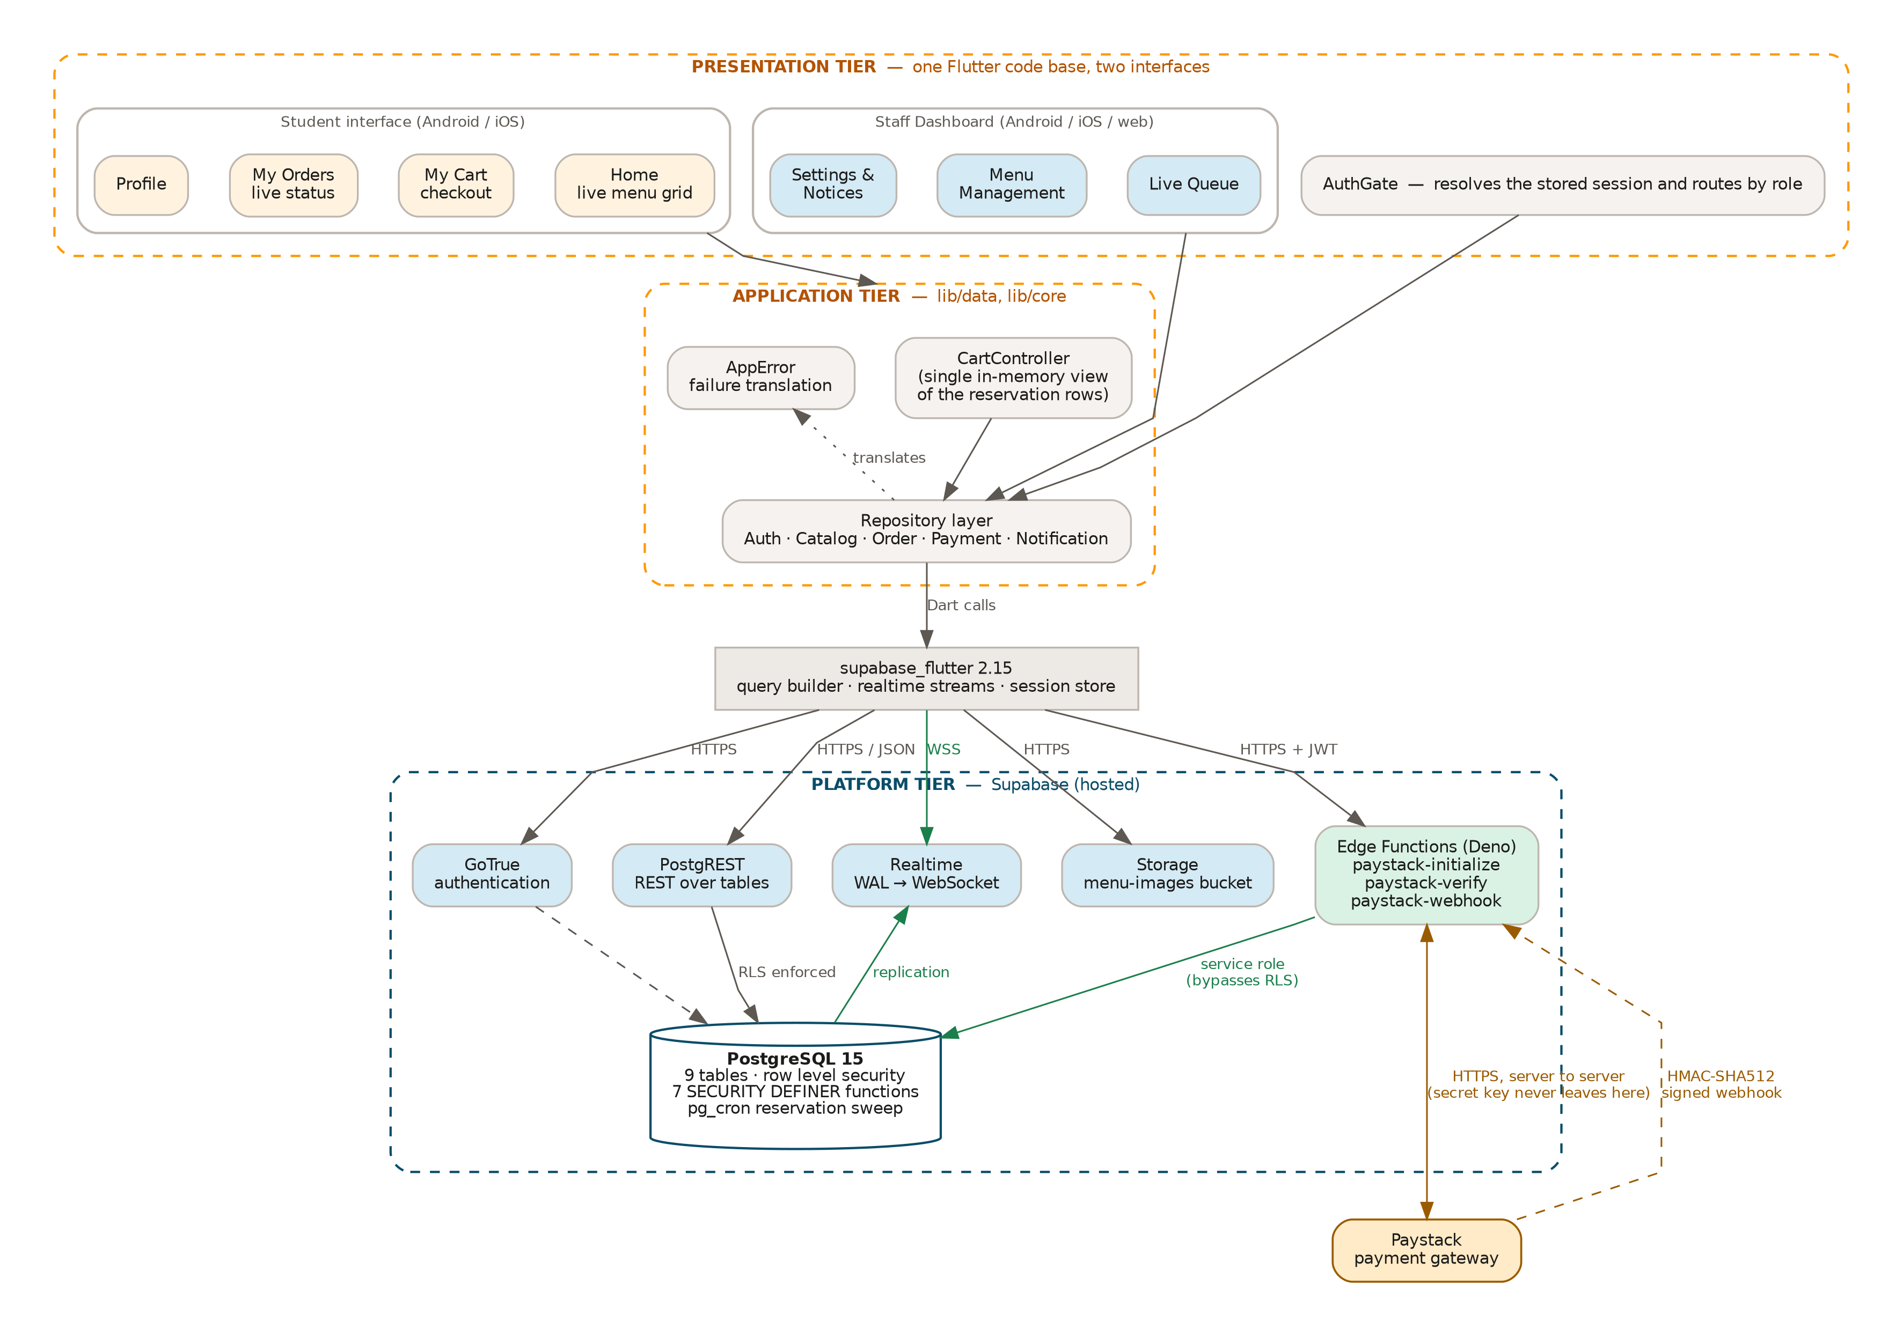
Figure 2. System architecture. Two Flutter interfaces compiled from one code base, a repository layer, and the hosted Supabase platform with its five services. The Paystack secret key never leaves the Edge Function environment.
Table 3 states what each subsystem is responsible for and what it may not do. The 'may not' column is the more useful half: it is what keeps responsibilities from leaking back across the boundary during maintenance.
Table 3. Subsystem responsibilities.
Subsystem | Responsibility | May not
S1 Presentation  lib/features, lib/widgets | Render state, collect input, validate a form before any network call, report failure in a transient banner, and disable a control while its operation is in flight. Holds no business rule beyond what is needed to decide whether a control is enabled. | Call Supabase directly. Every screen goes through the repository layer, so a change of backend touches five files rather than twenty-five.
S2 Application state  lib/features/student/cart_controller.dart | Hold exactly one in-memory view of the cart, expose derived values (item count, total, whether the cart spans outlets) and notify listeners when any of them change. | Compute a stock figure of its own. After every mutation it reloads from the database rather than adjusting a local number, because a local number is what produced the original stock inflation defect.
S3 Data access  lib/data | Translate between Dart objects and the wire format, choose between a stream and a one-off fetch, and call the correct database function. Owns the five repositories and the ten model types. | Build a widget, show a snackbar, or decide what a user is allowed to do. It reports failure upward and lets the screen decide how to say it.
S4 Cross-cutting core  lib/core | Configuration read at build time, the colour and spacing tokens, currency and time formatting, field validators, and the single translation from a thrown object to a sentence a student can read. | Depend on any other subsystem. Nothing in lib/core imports from lib/data or lib/features, which is what makes it safe to import everywhere.
S5 Platform  supabase/ | Store the data, enforce every invariant that must survive a hostile client, push changes to subscribers, hold the menu images, and talk to the payment gateway with a secret the client never sees. | Assume the caller is the application. Every policy and every function is written as though the caller were curl with a stolen publishable key, because that is a realistic caller.

3.1.1 How the subsystems collaborate
A typical interaction runs downward and returns upward. A student taps Add on a menu card. The card calls CartController.add(), which calls OrderRepository.reserve(), which issues a PostgREST RPC to reserve_stock(). That function takes a row lock on the menu item, decrements the count if and only if enough remains, writes a reservation row, and returns the new count. The controller then reloads the cart from stock_reservations and notifies its listeners, so the badge on the navigation bar and the cart screen update from the same source at the same moment.
Two things happen in parallel and are worth stating. The UPDATE to menu_items lands in the write-ahead log, the Realtime engine reads it and pushes the new row to every device subscribed to that cafeteria's menu, so a second student watching the same screen sees the count fall without having done anything. Meanwhile the staff dashboard, subscribed to the same table, sees the same change. No component pushes anything to any other component; they all subscribe to the database.
That is the shape of the whole system. The database is the only place two parties meet. There is no message bus, no socket between clients and no server-held session state beyond the JWT. It keeps the number of ways two views can disagree down to one, which is the propagation delay measured in REQ-97.

3.2 Decomposition Description
The decomposition is object oriented. This clause gives the package structure, the domain object model, the message sequences for the two interactions that carry the most design weight, the order state machine, and the data flow view.

3.2.1 Package structure
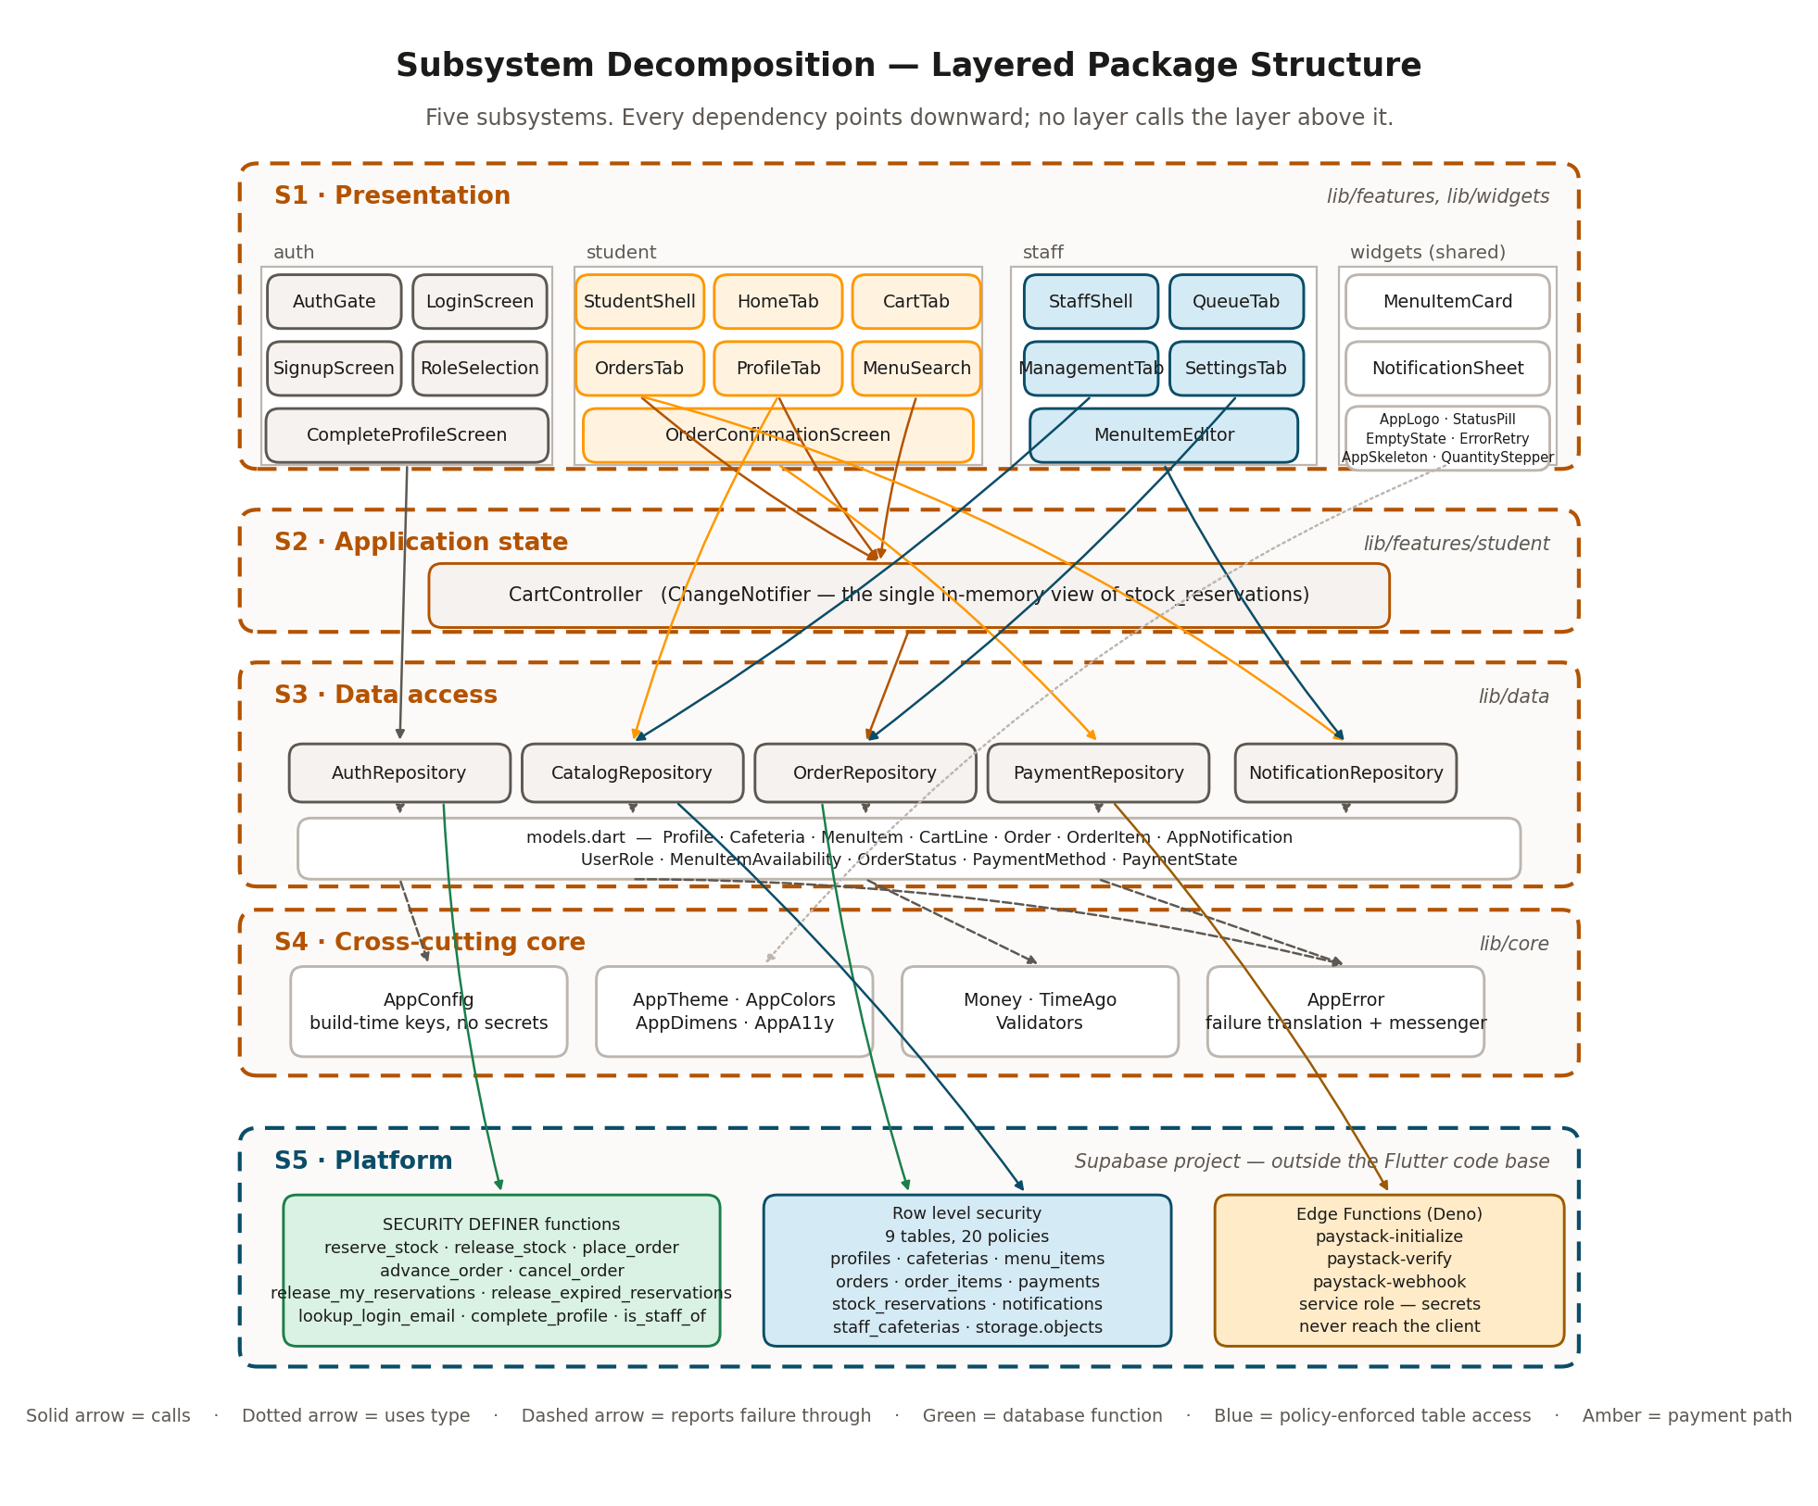
Figure 3. Subsystem decomposition into packages and their dependencies. Every arrow points downward; no layer calls the layer above it.
There are four rules that hold across the whole tree and that a reviewer can check mechanically. Nothing in lib/core imports from lib/data or lib/features. Nothing in lib/features imports supabase_flutter. Every repository can be constructed with an injected SupabaseClient, which is what makes the sixty unit tests in test/ possible without a live project. No source file exceeds 800 lines; the largest is queue_tab.dart at 422, down from a single 2,123 line screen file in the earlier build.

3.2.2 Object model
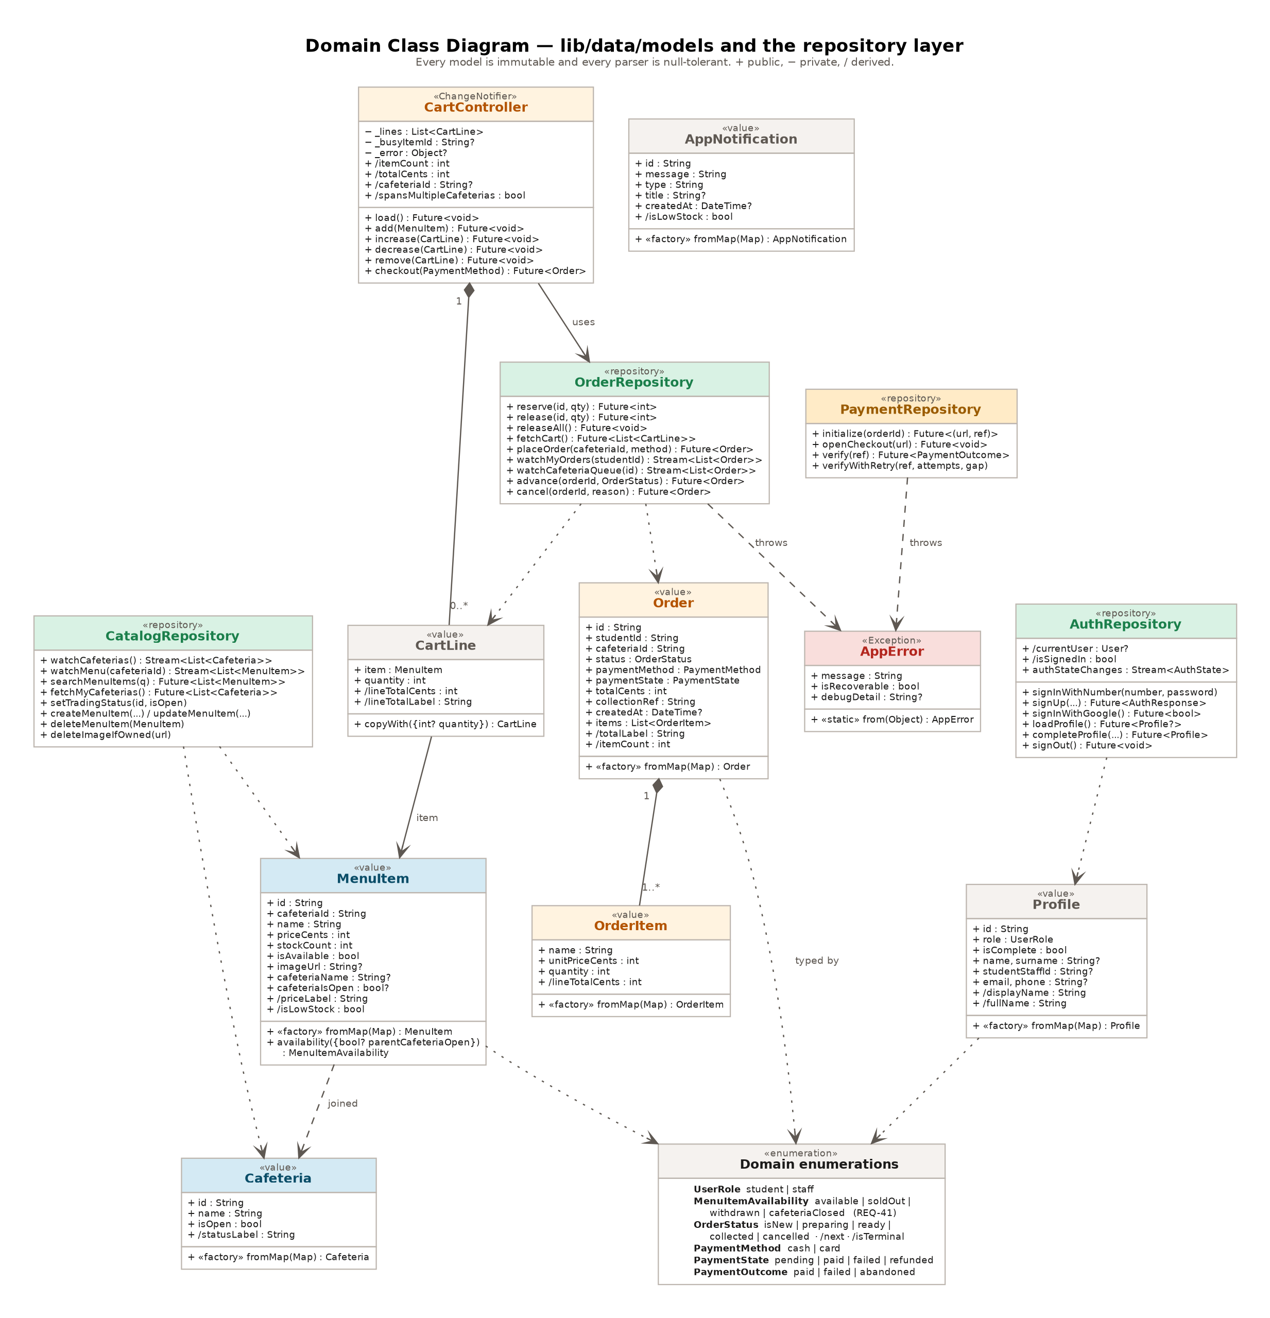
Figure 4. Domain class diagram. Ten model types, five repositories, one controller and the enumerations that type them.
Every model is immutable and every constructor is const. There is no setter anywhere in lib/data. A screen that needs a changed object builds a new one, which removes a class of defect where two widgets hold the same instance and one of them mutates it.
Every parser is null tolerant, and that is a direct response to a real failure. The earlier code did hard casts such as item['stock_count'] as int at the top of a method, outside the try block, so a null column threw past the error handler and took the screen down. The helpers _asInt, _asString, _asBool and _asDate each take a fallback and never throw. MenuItem.fromMap goes further: it reads price_cents when the column is present and falls back to converting the legacy price column when it is not, so the application works on either side of migration 0002.
MenuItemAvailability is worth singling out because it is a type doing the work that a comment used to do. An item can be unavailable for three different reasons, and a student needs to tell them apart: sold out means come back tomorrow, withdrawn from sale means it is not coming back today, and cafeteria closed means try a different outlet. The old card printed the single word 'Unavailable' for all three. MenuItem.availability() collapses the three inputs into one enumeration value with its own label, and the card renders the label rather than deciding for itself.

3.2.3 Interface specifications
Table 4 gives the public surface of each repository. These are the only methods that reach the network, so this table is also the complete list of places the system can fail for a network reason.
Table 4. Repository interface specifications.
Repository | Operation | Returns or raises
AuthRepository | signInWithNumber(number, password) | AuthResponse. Raises AppError with one message for both an unknown number and a wrong password.
 | signUp(email, password, name, surname, number, phone, role) | AuthResponse. Raises if the number is already registered, before contacting GoTrue.
 | signInWithGoogle() | bool. Opens the OAuth redirect; the session arrives on authStateChanges.
 | loadProfile() | Profile or null.
 | completeProfile(role, number, name, surname, phone) | Profile. Raises PROFILE_ALREADY_COMPLETE or IDENTIFIER_ALREADY_REGISTERED.
 | signOut() | void. Releases reserved stock first, then ends the session.
CatalogRepository | watchCafeterias() | Stream of Cafeteria, name ascending.
 | watchMenu(cafeteriaId) | Stream of MenuItem for one outlet, name ascending.
 | searchMenuItems(query) | Up to 50 MenuItem across all outlets, filtered in the database with ILIKE, each carrying its parent cafeteria name and trading status.
 | fetchMyCafeterias() | The outlets this staff account is bound to. Empty list is a valid answer.
 | setTradingStatus(cafeteriaId, isOpen) | void. Refused by policy unless the caller is bound to that outlet.
 | createMenuItem / updateMenuItem / deleteMenuItem | void. Refused by policy for another outlet's items.
 | deleteImageIfOwned(publicUrl) | void. Silently ignores a URL that is not one of ours.
OrderRepository | reserve(menuItemId, quantity) | int, the remaining stock. Raises INSUFFICIENT_STOCK, CAFETERIA_CLOSED or ITEM_NOT_FOUND.
 | release(menuItemId, quantity) | int, the remaining stock. Returns at most what the caller actually holds. Raises NO_RESERVATION.
 | releaseAll() | void. Called on sign-out.
 | fetchCart() | List of CartLine, read back from stock_reservations. This is the authoritative cart.
 | placeOrder(cafeteriaId, method) | Order. Raises CART_EMPTY, CART_SPANS_CAFETERIAS or CAFETERIA_CLOSED.
 | watchMyOrders(studentId) | Stream of Order, newest first.
 | watchCafeteriaQueue(cafeteriaId) | Stream of Order for one outlet, terminal states filtered out.
 | fetchQueueWithItems(cafeteriaId) | Orders with their line items and the student's name, for the queue cards.
 | advance(orderId, to) | Order. Raises ILLEGAL_TRANSITION or NOT_AUTHORISED_FOR_CAFETERIA.
 | cancel(orderId, reason) | Order. Returns reserved stock. Raises ILLEGAL_TRANSITION or NOT_AUTHORISED.
PaymentRepository | initialize(orderId) | A record carrying the authorisation URL and the transaction reference.
 | openCheckout(url) | void. Launches the external browser. Raises if no browser is installed.
 | verify(reference) | PaymentOutcome of paid, failed or abandoned.
 | verifyWithRetry(reference, attempts, gap) | PaymentOutcome. Three attempts two seconds apart, because the webhook may land first.
NotificationRepository | watch(role) | Stream of AppNotification for that audience, newest first, capped at 50.
 | publish(cafeteriaId, audience, title, message) | void. Refused by policy for another outlet.
 | lastSeen() / markSeen() | The timestamp behind the unread indicator, held in shared preferences.
 | hasUnread(notices, lastSeen) | bool. A pure function, unit tested.

3.2.4 Sequence: concurrent stock reservation
This is the interaction the whole system is built around, so it is given in full. Two students are looking at the same item. One unit remains. Both tap Add within the same few milliseconds.
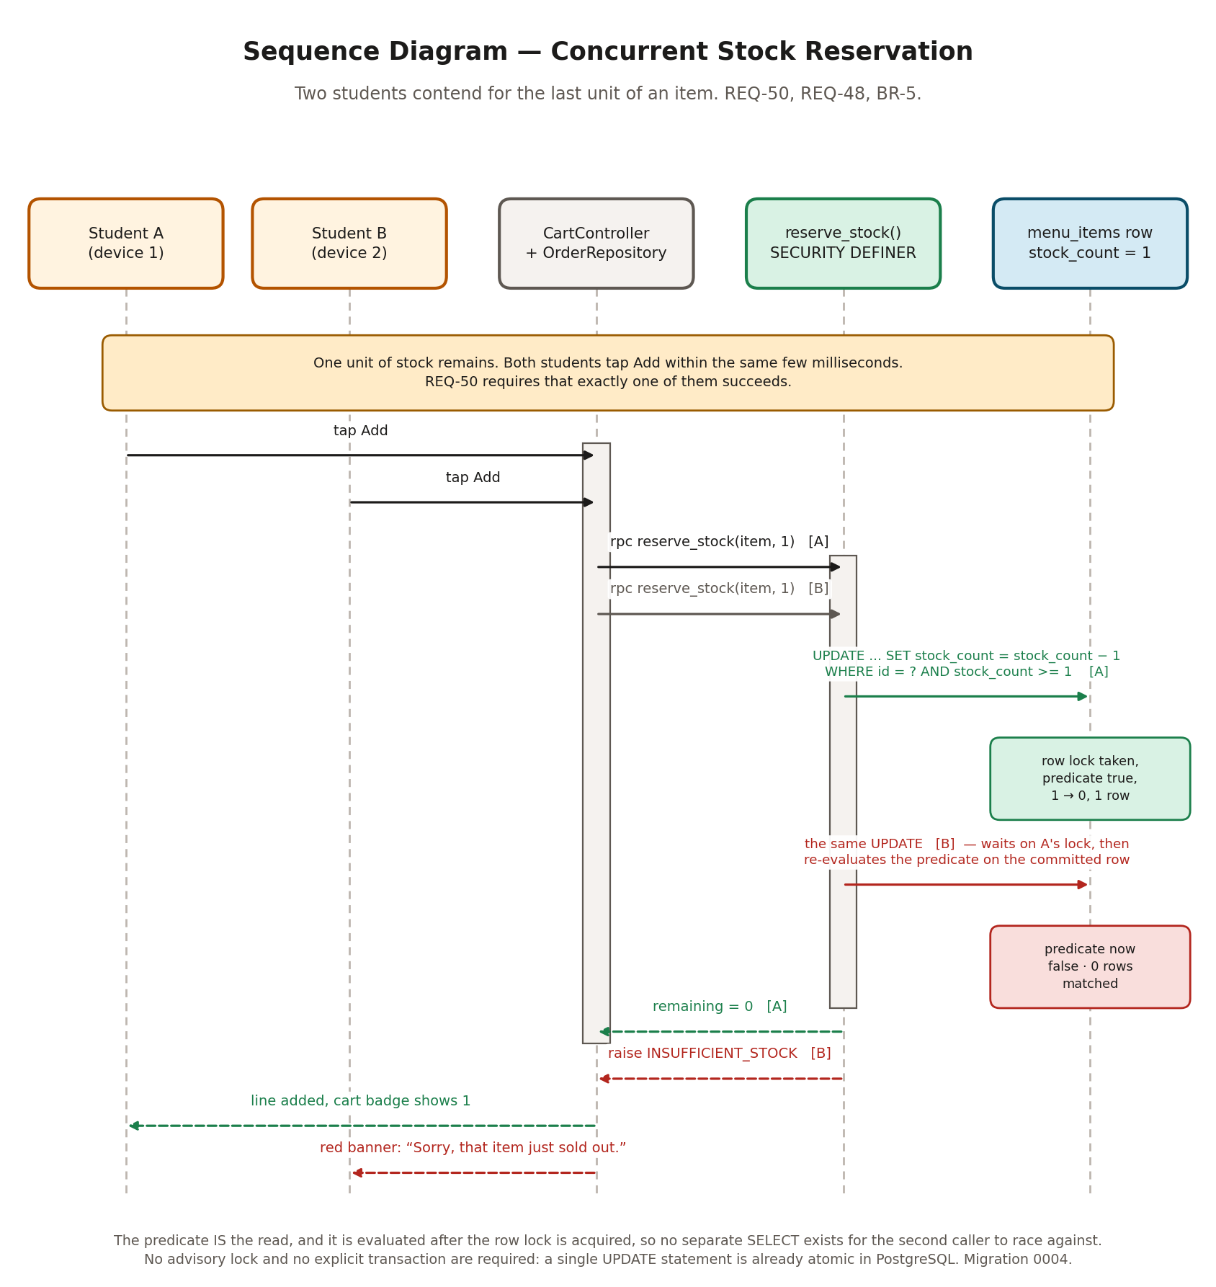
Figure 5. Two students contend for the last unit of an item. Exactly one succeeds, and the other is told why.
The important detail is that there is no separate read. The old code did a SELECT, got 5, then did an UPDATE setting the value to 4. Between those two statements anything can happen, and with two callers it reliably does. The replacement is one statement whose WHERE clause carries the condition:
update public.menu_items
set stock_count = stock_count - p_qty
where id = p_menu_item_id
and is_available = true
and stock_count >= p_qty
returning stock_count into v_remaining;

if not found then
raise exception 'INSUFFICIENT_STOCK';
end if;

PostgreSQL takes a row lock before evaluating the predicate. The second caller blocks on that lock, and when it is released it re-evaluates stock_count >= p_qty against the committed row, finds zero, matches nothing and raises. No advisory lock is needed and no explicit transaction block is needed, because a single UPDATE statement is already atomic. This is why clause 3.3 argues that the choice of a relational database was the decision the rest of the project hangs from.

3.2.5 Sequence: card checkout and settlement
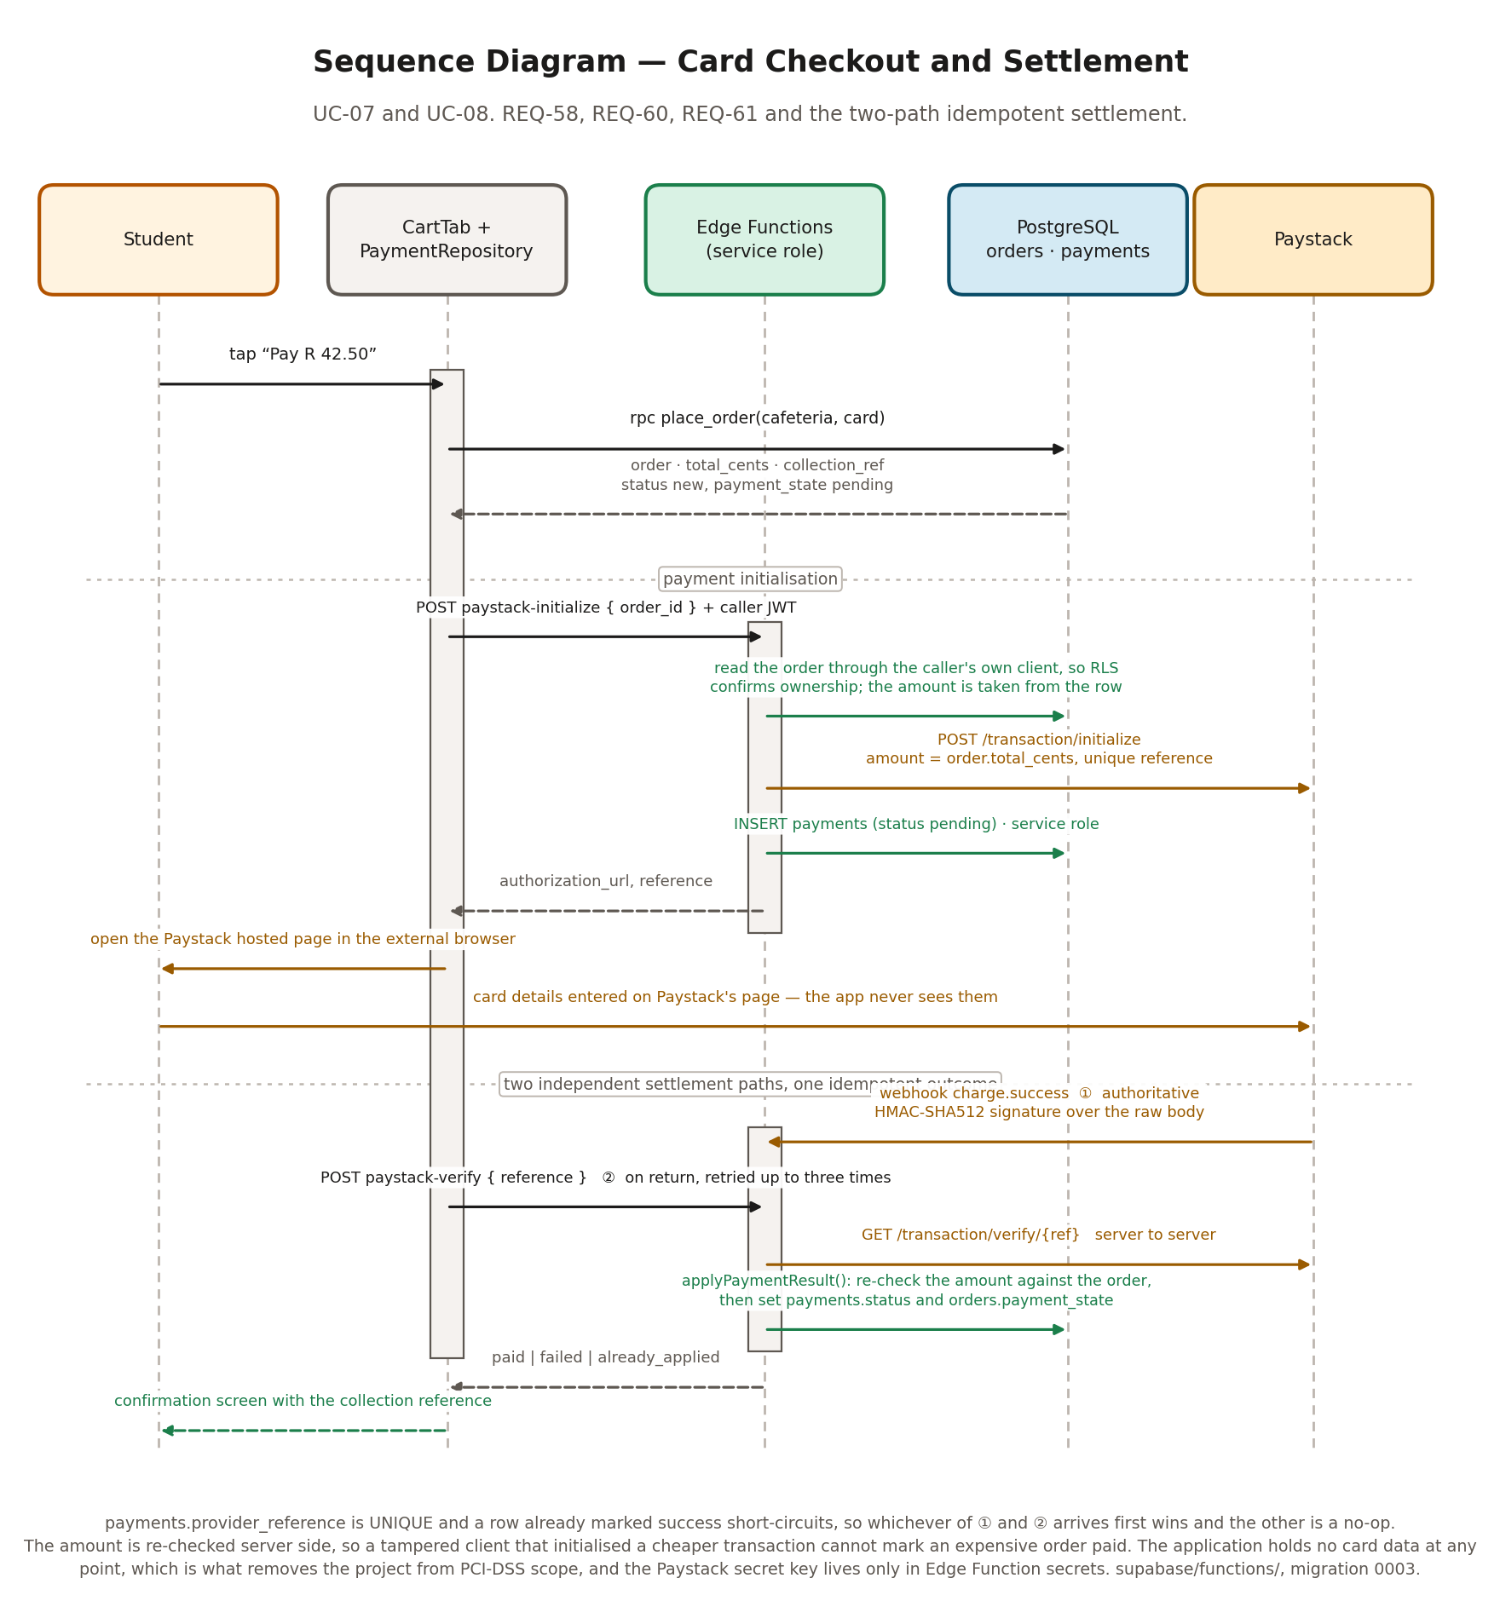
Figure 6. Card checkout. The order is created first so an amount exists server side, then the gateway is initialised, and the outcome arrives by either of two paths that share one idempotent handler.
Three properties of this flow were designed for deliberately. The amount charged is read from the orders row inside the Edge Function and never taken from the request body, so a modified client cannot initialise a cheaper transaction. The result is confirmed by asking Paystack directly, server to server, rather than by trusting the redirect the student came back on. And the webhook is the authoritative path: if the student pays and then closes the application before returning, the order still becomes paid, because Paystack calls the webhook regardless.
Both paths call the same function, applyPaymentResult(). It short-circuits when the payments row is already marked success, and payments.provider_reference carries a unique constraint, so whichever path arrives first wins and the second is a no-op. It also re-checks the amount Paystack reports against the amount stored on the payments row, and marks the payment failed rather than successful if they disagree.

3.2.6 Order state machine
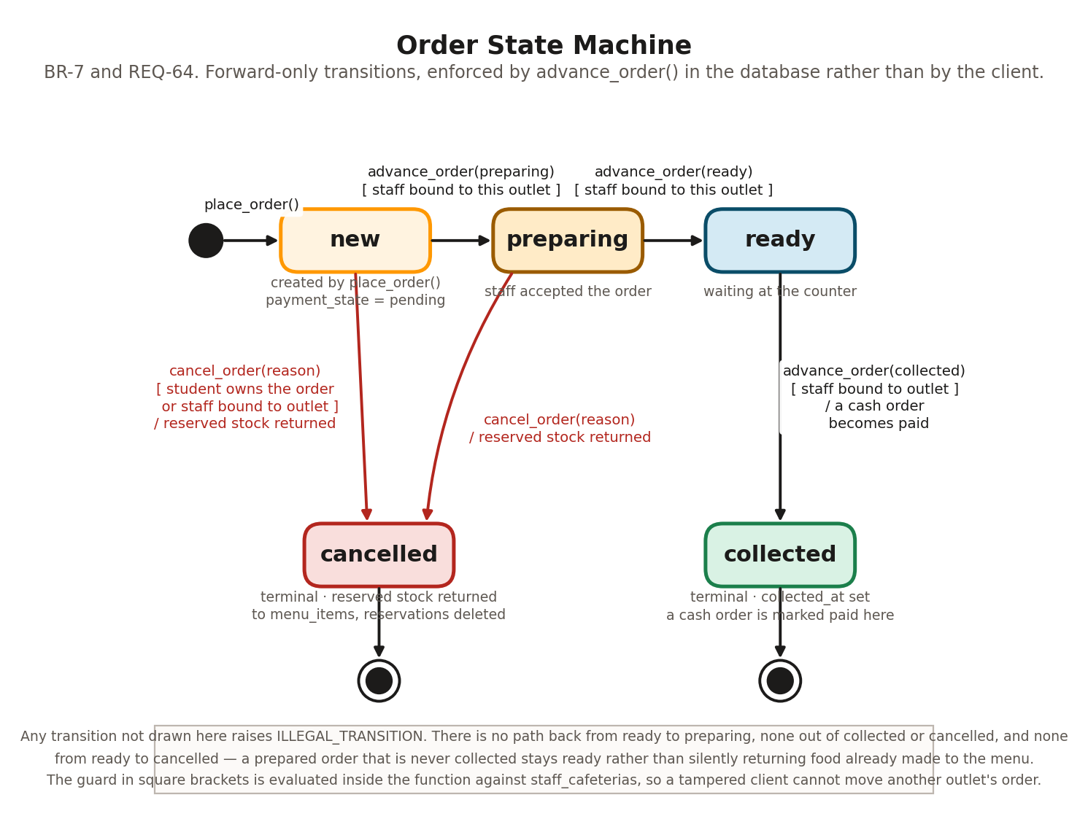
Figure 7. The order lifecycle. Forward-only, with cancellation permitted from two states and a guard on every transition.
BR-7 says an order moves forward and never backwards. That rule is enforced inside advance_order() rather than by hiding a button, because hiding a button only stops a user who is using the application. The function takes a row lock on the order, checks that the caller is bound to that order's cafeteria, checks that the requested transition is one of the three legal ones, and raises ILLEGAL_TRANSITION otherwise.
One piece of business logic rides on the collected transition: a cash order whose payment_state is still pending becomes paid at that moment, because cash is settled at the counter when the food changes hands. A card order is already paid by then, so the case does not arise.
There is deliberately no transition from ready to cancelled. An order that reached ready has been made, and returning its stock to the menu would tell a student that food exists which has already been cooked and is sitting on a counter. An uncollected ready order stays ready and is dealt with by a person, not by the system.

3.2.7 Data flow
The data flow view is included because the marking rubric asks for it and because it says something the object model does not: which processes touch which stores, and therefore what the blast radius of a change to a table is.
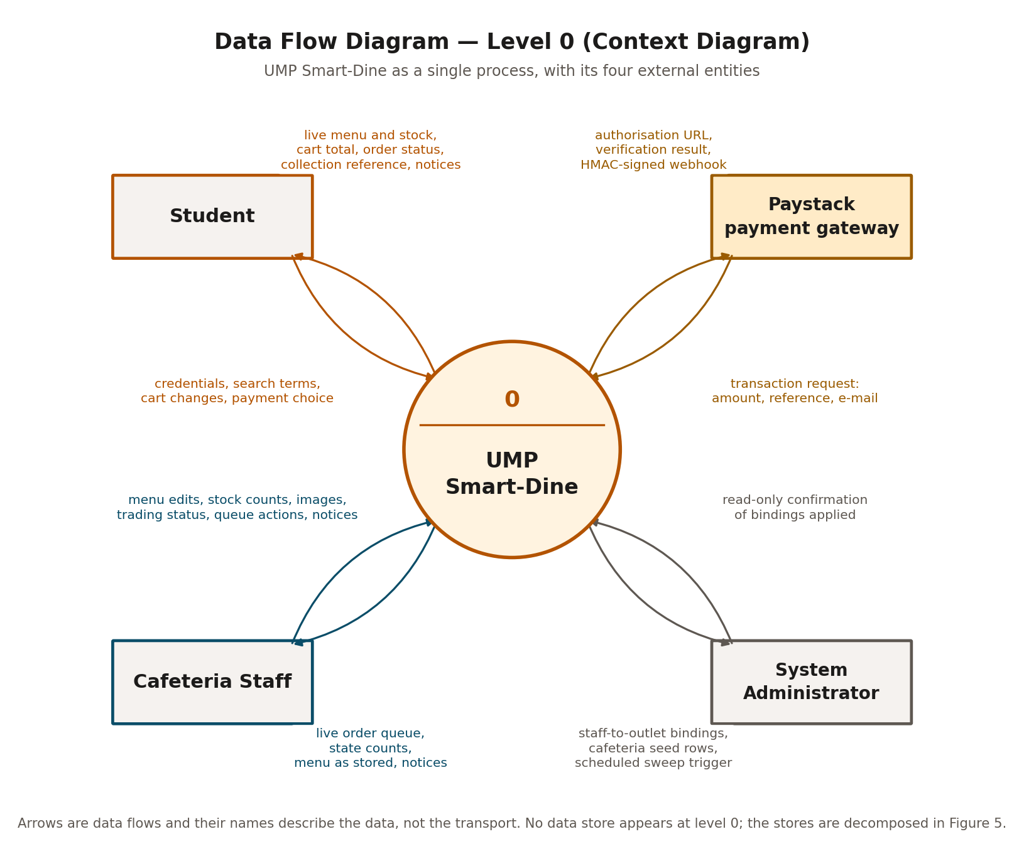
Figure 8. Data flow diagram, level 0. The system as one process with its four external entities.
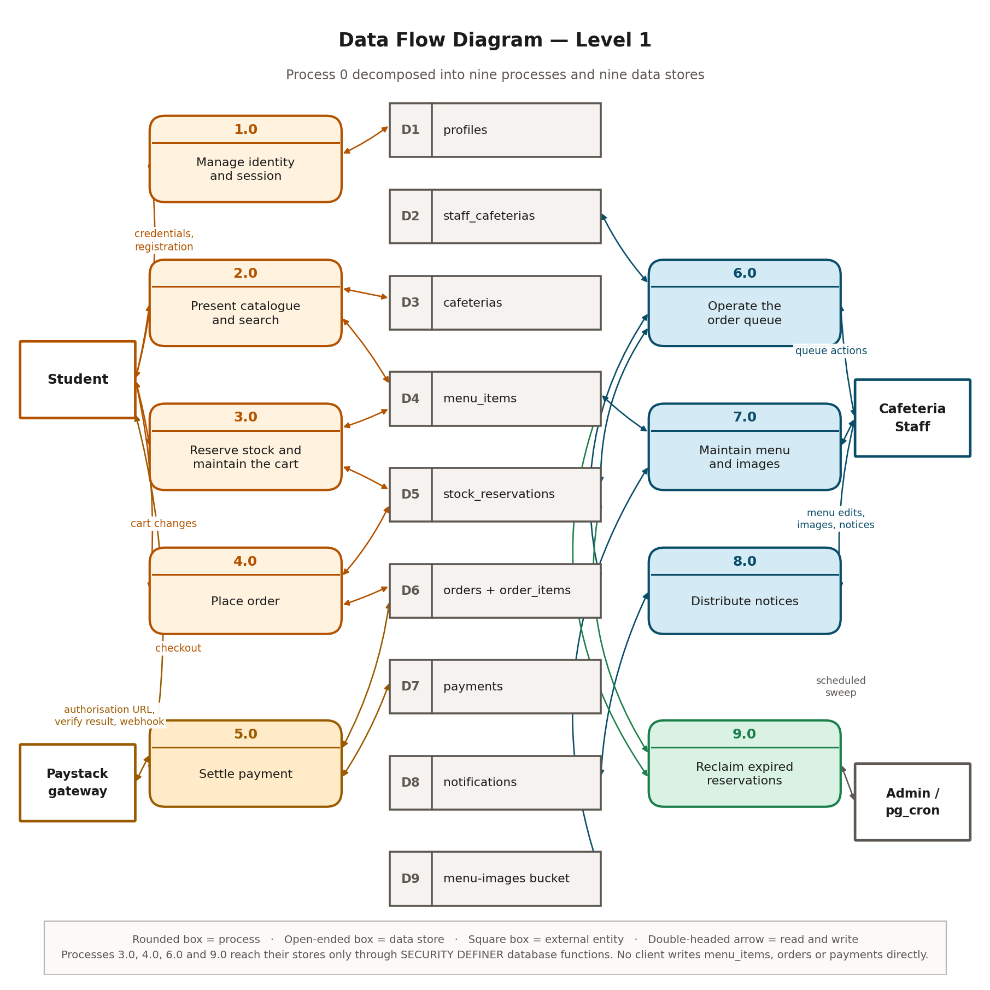
Figure 9. Data flow diagram, level 1. Nine processes and nine data stores. Processes 3.0, 4.0, 6.0 and 9.0 reach their stores only through database functions.

3.3 Design Rationale
This clause records the six decisions that shaped the architecture, what the alternatives were, and why they were not taken. Where a decision has a cost, the cost is stated.

3.3.1 A relational database rather than a document store
The Software Project Plan approved in March 2026 specified Google Firebase with Firestore, structured as nested documents with order items embedded inside order documents. The delivered system uses Supabase with PostgreSQL 15 and a normalised relational schema. This is the largest departure from the plan and it deserves the fullest answer.
Stock control is the product. A stock count is a single integer that several users contend for at the same instant, and getting that wrong is not a cosmetic defect: it is two students paying for one pie. PostgreSQL answers that problem directly. A predicated UPDATE under a row lock is about eight lines of SQL and is correct by construction. Firestore's optimistic concurrency model would have required a transaction with a read, a comparison and a retry loop, written in the client, with the retry behaviour and the failure path both in the developer's hands.
Three further consequences followed. Row level security gave a way to enforce authorisation in the database rather than in the client, which matters because the key that reaches the API is inside the compiled binary. Foreign keys gave referential integrity for free, so an order line cannot point at a menu item that never existed. And CHECK constraints let the non-negative stock rule hold against a direct API call rather than only against the form.
The cost is real and is stated here rather than glossed. The team had no PostgreSQL experience at the start and lost time to it. Nested reads need an explicit join syntax where Firestore would have returned the document whole. And the Project Plan, the pitch presentation and the earlier documentation all describe an architecture that no longer exists, which is why clause 2.4 exists.

3.3.2 The database enforces the rules, not the client
The publishable key is compiled into the APK. Anyone with the application can extract it and call the REST API directly with curl. Any rule enforced only in Dart is therefore advisory. The design treats the client as a convenience for honest users and puts every rule that matters into the database in one of three forms.
- A constraint, where the rule is about a single value. stock_count >= 0 and price_cents >= 0 are CHECK constraints in migration 0001, so no caller can write a negative price.
- A policy, where the rule is about who may touch which row. Twenty row level security policies across nine tables plus the storage bucket. Staff writes are gated on membership of staff_cafeterias, which only an administrator can populate.
- A SECURITY DEFINER function, where the rule is a sequence of steps that must happen together. Stock reservation, checkout and the order lifecycle are all functions, and orders has no client-facing write policy at all, so the only way to create an order is to call place_order().
One consequence of that looks like a hole and is not. The sign-up form lets a user choose the staff role, and that role is written to their profile. It grants nothing. Every staff write policy checks staff_cafeterias, not profiles.role, so a user who self-asserts staff gets the staff interface, sees an explanation that no cafeteria has been assigned to them, and can do nothing. That is a dead end rather than a privilege escalation, and it was chosen over blocking the role at sign-up because a real staff member has to be able to register before an administrator can assign them.

3.3.3 The cart is a database table
The earlier cart was a List of maps in the home screen's widget state. The cart screen took a shallow copy in initState and never resynchronised. That produced a reproducible defect: when the parent removed a line at quantity one, the cart screen kept a phantom row, and pressing minus on it credited stock back to the database while changing nothing locally. It could be repeated without limit.
The fix was to stop keeping two copies. stock_reservations is the cart. CartController holds one view of it and reloads after every mutation rather than adjusting a local number. Three things fall out of that. The cart survives an application restart, which closes REQ-52 without any extra code. A reservation has an owner and an expiry, so an abandoned cart can be swept. And the quantity shown to the student is the quantity the database will act on at checkout, because it is the same row.
The cost is a network round trip after every plus and minus. That is accepted because the alternative is a number in memory that can disagree with the database, which is exactly the defect being closed. The interface hides the latency by disabling only the line being changed rather than the whole screen.

3.3.4 Money is integer cents
price was a numeric column read into a Dart double and multiplied by a quantity to form a total. That is a rounding defect waiting to be found by whoever reconciles the till. Migration 0002 introduced price_cents as an integer and Money.format() is the single place a cent value becomes a string. Paystack also expects the amount in the minor unit, so cents is the natural representation end to end and nothing has to convert at the boundary.
The old price column is kept and a BEFORE trigger holds the two in step whichever one a writer sets, so a client built before the migration and one built after can both run against the same database. The column is marked deprecated in a COMMENT and should be dropped once no client reads it.

3.3.5 The application never touches a card number
The earlier checkout collected the card number, expiry and CVV into Flutter text fields. That puts the project inside PCI-DSS scope for no benefit, and it was broken anyway: the length limit of 16 counted the separators its own formatter inserted, so a real 16-digit card could not be typed.
Paystack's hosted page collects the card instead. The application opens a browser at an authorisation URL and never sees a digit of it. The secret key lives in Edge Function secrets and is never sent to a device; the public key in the build configuration can only initialise a transaction, never verify or refund one. This satisfies REQ-58 more completely than a validated but inert form did, and it removes the compliance exposure rather than managing it.
The cost is that the student leaves the application and comes back, which is a worse experience than an in-application sheet would be. A native Paystack SDK integration would close that gap and is recorded in clause 8.3 as future work.

3.3.6 Alternatives considered and not taken
Table 5. Design alternatives and why they were rejected.
Decision point | Alternative considered | Why it was not taken
Concurrency control on stock | A PostgreSQL advisory lock taken around a read then a write. | More code and a lock that must be released on every path, including the error paths. The predicated UPDATE gives the same guarantee in one statement with nothing to release.
 | SELECT ... FOR UPDATE followed by a separate UPDATE. | Correct, but two statements inside an explicit transaction where one statement does. Also needs the transaction to be managed from Dart, which the PostgREST client does not expose cleanly.
Where authorisation lives | A role claim on the JWT, checked in policies. | The role on the profile is written from sign-up metadata and is therefore user-controlled. A separate table an administrator populates cannot be self-asserted.
Cart storage | A carts table separate from stock_reservations. | Two tables holding the same fact would need to be kept in step, which is the class of defect being removed. A reservation with a null order_id already is a cart line.
 | Local storage on the device with reconciliation at checkout. | Stock could not then be held before checkout, so the pre-order flow would guarantee nothing, and the product's central claim would be false.
Stock release for abandoned carts | An Edge Function invoked on a schedule. | The sweep is pure SQL with no external call. pg_cron runs it inside the database every five minutes at no cost, where a function invocation would be billed for nothing.
Payment confirmation | Trusting the callback URL the browser returns to. | A redirect is client-controlled and can be forged. Asking Paystack server to server cannot be.
 | The webhook alone, with no verify call. | The student would stare at a spinner until the webhook landed. The verify call gives a fast answer and the webhook covers the case where the student closes the application first.
Google sign-in | The native google_sign_in package. | It needs per-platform client IDs and more setup than the OAuth redirect flow, which reuses what the Supabase dashboard already holds. The native flow is a later polish step, not a requirement.
Tab navigation | Rebuilding the active screen on each tab change, as the earlier build did. | It re-ran initState, re-subscribed all three realtime streams, lost scroll position and wiped a half-typed form on every tap. IndexedStack keeps all four alive at the cost of their memory.

4.0 DATA DESIGN

4.1 Data Description
The information domain of the system is five things: who a person is, which outlets exist and whether they are trading, what each outlet sells and how much of it is left, what a student has reserved or ordered, and what has been said to whom. Each maps to a group of tables in one PostgreSQL 15 database inside the hosted Supabase project. There is no second store, no cache layer and no data held on the device apart from one timestamp behind the unread notification indicator.

4.1.1 Entity relationships
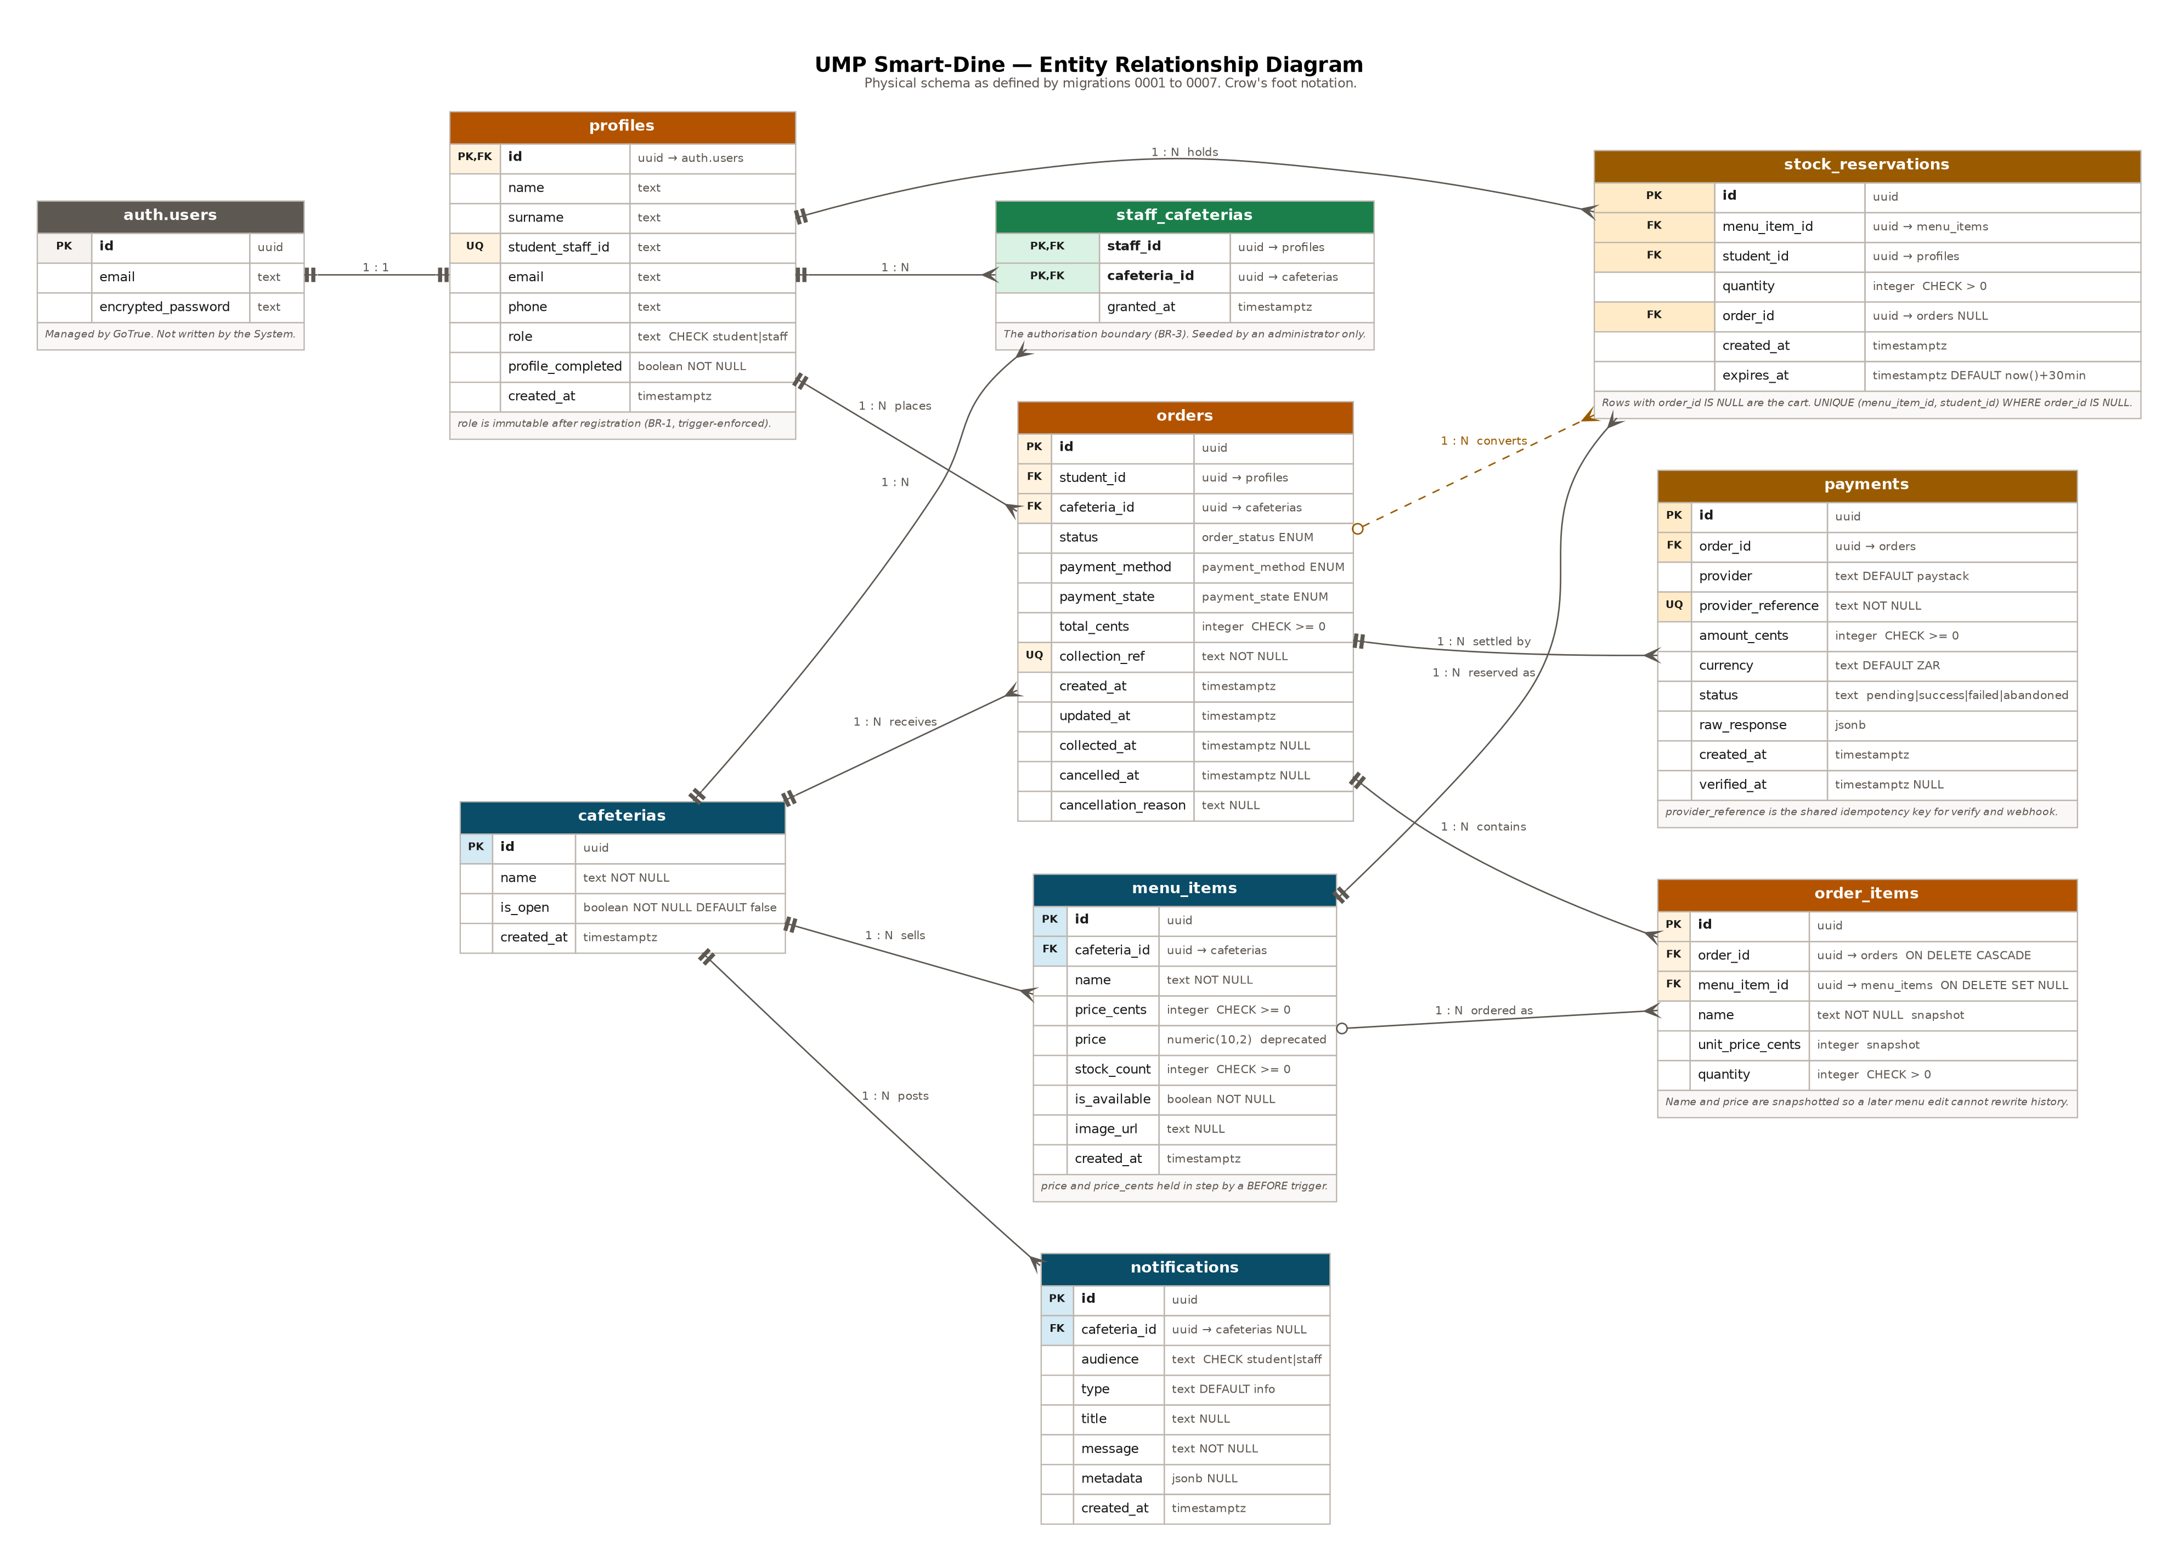
Figure 10. Entity relationship diagram. Nine tables plus the authentication service's own user table, in crow's foot notation, as defined by migrations 0001 to 0007.
Five relationships carry design weight and are worth reading off the diagram deliberately.
- profiles to auth.users is one to one, with profiles.id being a foreign key to the authentication service's user identifier. The row is created by the handle_new_user trigger from sign-up metadata, not by the application, so a profile cannot exist without an account behind it.
- staff_cafeterias is a pure junction table with a composite primary key. It is small, it is administrator-populated, and it is the authorisation boundary for every staff write in the system. Nothing else in the schema is load-bearing in the same way.
- stock_reservations sits between menu_items and profiles and optionally points at an order. A row with a null order_id is a cart line. Setting order_id converts it into part of an order and takes it out of reach of the expiry sweep. One table serves both purposes, which is why the cart and the order can never disagree.
- order_items carries name and unit_price_cents as its own columns rather than reading them through menu_item_id. A menu price changes; an order is a record of what was actually charged. The foreign key is ON DELETE SET NULL for the same reason: deleting a menu item must not rewrite last week's orders.
- payments is one to many from orders rather than one to one, because a student can abandon a checkout and try again, and each attempt gets its own reference. The unique constraint is on provider_reference, not on order_id.

4.1.2 Storage design
Table 6 records the physical design decisions that are not visible in the entity diagram.
Table 6. Physical storage design.
Decision | Detail | Reason
Primary keys | uuid with gen_random_uuid() as the default on eight of the nine tables. staff_cafeterias uses a composite key of its two foreign keys. | A uuid can be generated client side if that is ever needed, and it does not leak how many rows exist the way a serial does.
Money | integer cents. price_cents on menu_items, total_cents on orders, unit_price_cents on order_items, amount_cents on payments. All carry CHECK >= 0. | Exact arithmetic, and the same unit Paystack expects, so nothing converts at the boundary.
Enumerated types | Three PostgreSQL enums: order_status, payment_method and payment_state. | An enum rejects a bad value at insert rather than relying on a CHECK the next developer might drop. The Dart side mirrors them with sealed-in-practice enums that parse defensively.
Indexes | orders(cafeteria_id, status, created_at desc) for the staff queue. orders(student_id, created_at desc) for My Orders. menu_items(cafeteria_id). order_items(order_id). payments(order_id). notifications(audience, created_at desc). Two partial indexes on stock_reservations. | Each index matches a query the application actually issues. The composite ones are ordered to match the WHERE then ORDER BY of the query that uses them.
Partial unique index | stock_reservations(menu_item_id, student_id) WHERE order_id IS NULL. | One open reservation per student per item, so repeat additions combine into one line with a quantity (REQ-49). Converted rows are excluded so a student can order the same item again.
Expiry index | stock_reservations(expires_at) WHERE order_id IS NULL. | The five-minute sweep scans only open reservations, so it stays cheap as order history grows.
Collection reference | Six characters from the 31-character alphabet ACDEFGHJKLMNPQRSTUVWXYZ23456789. Random, not sequential. Unique constraint, with place_order retrying up to five times on collision. | No 0 or O and no 1 or I, because the code is read aloud at a counter. Random rather than sequential so one reference does not reveal another. About 887 million combinations.
Image object keys | menu-images/<cafeteria_id>/<uuid>.<ext> | Namespacing by cafeteria is what lets the storage policy scope a write to one outlet. The earlier code wrote to the bucket root under a name containing colons, which is not a legal key on some platforms and made cleanup impossible.
Replication | Enabled on cafeterias, menu_items, notifications and orders. | These four are what the four realtime subscriptions watch. Without replication the subscriptions connect and deliver nothing, and screens appear frozen after their first load.
Backup | Daily, by the platform. The system performs none of its own. | Nothing of value is held on the device, so there is nothing local to back up.

4.2 Data Dictionary
Tables are listed alphabetically. Every column is given with its type, its constraints and what it is for. Where a column is written by something other than the application, that is stated.

4.2.1 cafeterias
Table 7. cafeterias.
Column | Type | Constraints | Description
id | uuid | PK, default gen_random_uuid() | Primary key.
name | text | NOT NULL | Display name of the outlet, shown in the selector and on search results.
is_open | boolean | NOT NULL, default false | Trading status. Controls whether students may reserve or check out. Defaults to closed so a newly seeded outlet cannot take orders by accident.
created_at | timestamptz | NOT NULL, default now() | Row creation time.

4.2.2 menu_items
Table 8. menu_items.
Column | Type | Constraints | Description
id | uuid | PK | Primary key.
cafeteria_id | uuid | FK to cafeterias, ON DELETE CASCADE, indexed | The owning outlet. An item belongs to exactly one outlet (BR-4).
name | text | NOT NULL | Item name. Searched case-insensitively by clause 5.10.
price_cents | integer | NOT NULL, default 0, CHECK >= 0 | Unit price in cents. The value the application reads.
price | numeric(10,2) | NOT NULL, default 0, CHECK >= 0 | Deprecated. Held in step with price_cents by the menu_items_sync_price trigger so a pre-migration client still works. To be dropped once nothing reads it.
stock_count | integer | NOT NULL, default 0, CHECK >= 0 | Units available for sale. Decremented by reserve_stock, restored by release_stock, the sweep and cancel_order. Never written directly by a client.
is_available | boolean | NOT NULL, default true | The staff withdrawal switch. False means withdrawn from sale. This is not the sold-out signal; stock_count = 0 is.
image_url | text | NULL | Public URL of the object in the menu-images bucket. Null renders a placeholder rather than a broken frame (REQ-11).
created_at | timestamptz | NOT NULL, default now() | Row creation time.

4.2.3 notifications
Table 9. notifications.
Column | Type | Constraints | Description
id | uuid | PK | Primary key.
cafeteria_id | uuid | FK to cafeterias, ON DELETE CASCADE, NULL | The outlet the notice is scoped to. Null is permitted for a system-wide notice, but the insert policy requires a value, so only an administrator can create one.
audience | text | NOT NULL, default 'student', CHECK IN ('student','staff') | Who the notice is for. The select policy compares this against the caller's own role.
type | text | NOT NULL, default 'info' | Notice kind. 'announcement' for a staff-composed notice; 'low_stock' and 'new_item' are reserved for automatic notices.
title | text | NULL | Short heading.
message | text | NOT NULL | Body text.
metadata | jsonb | NULL | Unstructured payload for automatic notices. Unused in version 1.0.
created_at | timestamptz | NOT NULL, default now(), indexed with audience | Publication time. Orders the list and drives the unread indicator.

4.2.4 order_items
Table 10. order_items.
Column | Type | Constraints | Description
id | uuid | PK | Primary key.
order_id | uuid | FK to orders, ON DELETE CASCADE, NOT NULL, indexed | The parent order.
menu_item_id | uuid | FK to menu_items, ON DELETE SET NULL | The item ordered. Nullable, so deleting a menu item does not delete history.
name | text | NOT NULL | The item's name at the moment of ordering. Snapshotted.
unit_price_cents | integer | NOT NULL, CHECK >= 0 | The price charged. Snapshotted, so a later price change cannot rewrite what a student paid.
quantity | integer | NOT NULL, CHECK > 0 | Units of this item on the order.

4.2.5 orders
Table 11. orders.
Column | Type | Constraints | Description
id | uuid | PK | Primary key.
student_id | uuid | FK to profiles, ON DELETE RESTRICT, NOT NULL, indexed | The student who placed it. RESTRICT rather than CASCADE, so a profile carrying orders cannot be removed without a decision about them.
cafeteria_id | uuid | FK to cafeterias, ON DELETE RESTRICT, NOT NULL, indexed | The outlet.
status | order_status | NOT NULL, default 'new' | One of new, preparing, ready, collected, cancelled. Moved only by advance_order or cancel_order.
payment_method | payment_method | NOT NULL | cash or card. Fixed at checkout.
payment_state | payment_state | NOT NULL, default 'pending' | pending, paid, failed or refunded. Written by the Edge Functions for a card order and by advance_order on collection for a cash one.
total_cents | integer | NOT NULL, CHECK >= 0 | Order total in cents, computed inside place_order from the reservations. Never sent by the client.
collection_ref | text | NOT NULL, UNIQUE | The six-character code the student shows at the counter.
created_at | timestamptz | NOT NULL, default now() | Confirmation time.
updated_at | timestamptz | NOT NULL, default now() | Maintained by the orders_touch_updated_at trigger on every update.
collected_at | timestamptz | NULL | Set when the order reaches collected.
cancelled_at | timestamptz | NULL | Set when the order is cancelled.
cancellation_reason | text | NULL | Free text supplied by whoever cancelled.

4.2.6 payments
Table 12. payments.
Column | Type | Constraints | Description
id | uuid | PK | Primary key.
order_id | uuid | FK to orders, ON DELETE CASCADE, NOT NULL, indexed | The order being settled.
provider | text | NOT NULL, default 'paystack' | Gateway name, so a second provider can be added without a schema change.
provider_reference | text | NOT NULL, UNIQUE | The transaction reference, formed as ump_<collection_ref>_<8 hex>. This is the idempotency key shared by the verify call and the webhook.
amount_cents | integer | NOT NULL, CHECK >= 0 | The amount the transaction was initialised for. Re-checked against what Paystack reports before the order is marked paid.
currency | text | NOT NULL, default 'ZAR' | ISO currency code.
status | text | NOT NULL, default 'pending', CHECK IN ('pending','success','failed','abandoned') | Transaction outcome.
raw_response | jsonb | NULL | The verification payload as received, kept for reconciliation.
created_at | timestamptz | NOT NULL, default now() | Initialisation time.
verified_at | timestamptz | NULL | When the outcome was applied.

4.2.7 profiles
Table 13. profiles.
Column | Type | Constraints | Description
id | uuid | PK, FK to auth.users, ON DELETE CASCADE | The authentication service's user identifier. The row is created by the handle_new_user trigger.
name | text | NULL | Given name, captured at registration.
surname | text | NULL | Family name.
student_staff_id | text | Partial UNIQUE index WHERE NOT NULL | The number printed on the University card, used as the sign-in identifier. Partial because a Google account has none until the profile is completed.
email | text | NULL | The address the account was registered with. Read by lookup_login_email.
phone | text | NULL | Contact number.
role | text | NOT NULL, default 'student', CHECK IN ('student','staff') | Decides which interface the account sees. Immutable after registration, enforced by the guard_profile_immutables trigger (BR-1). Grants no permission on its own.
profile_completed | boolean | NOT NULL, default false | False for a Google account that has not yet supplied a number, which routes it to the completion screen. Set once by complete_profile().
created_at | timestamptz | NOT NULL, default now() | Row creation time.

4.2.8 staff_cafeterias
Table 14. staff_cafeterias.
Column | Type | Constraints | Description
staff_id | uuid | PK part, FK to profiles, ON DELETE CASCADE | The staff account.
cafeteria_id | uuid | PK part, FK to cafeterias, ON DELETE CASCADE | The outlet they may manage.
granted_at | timestamptz | NOT NULL, default now() | When the binding was created.

This table has a select policy limited to the caller's own rows and no insert, update or delete policy for any client role. Granting a binding is an administrative act performed in the Supabase dashboard, and there is deliberately no path to it from either interface.

4.2.9 stock_reservations
Table 15. stock_reservations.
Column | Type | Constraints | Description
id | uuid | PK | Primary key.
menu_item_id | uuid | FK to menu_items, ON DELETE CASCADE, NOT NULL | The item being held.
student_id | uuid | FK to profiles, ON DELETE CASCADE, NOT NULL | Who holds it.
quantity | integer | NOT NULL, CHECK > 0 | Units held. Increased by repeat additions through an ON CONFLICT clause rather than by a second row.
order_id | uuid | FK to orders, ON DELETE SET NULL, NULL | Null means this is a cart line. Non-null means it has been converted into part of an order and is out of reach of the sweep.
created_at | timestamptz | NOT NULL, default now() | When the hold started.
expires_at | timestamptz | NOT NULL, default now() + interval '30 minutes' | When the hold lapses. The sweep in clause 5.3 runs every five minutes and returns anything past this.

4.2.10 Enumerated types
Table 16. PostgreSQL enumerated types and their Dart counterparts.
Type | Values | Dart counterpart
order_status | new, preparing, ready, collected, cancelled | OrderStatus. The Dart value for 'new' is isNew because new is a reserved word; the wire getter maps it back.
payment_method | cash, card | PaymentMethod, with a label getter for display.
payment_state | pending, paid, failed, refunded | PaymentState. The label for pending is 'Pay at counter', which is what the state means to a student.
(client only) | student, staff | UserRole. Mirrors the CHECK on profiles.role.
(client only) | available, soldOut, withdrawn, cafeteriaClosed | MenuItemAvailability. Derived by MenuItem.availability(), not stored. Exists so REQ-41 can be satisfied by a type rather than by a comment.
(client only) | paid, failed, abandoned | PaymentOutcome. What PaymentRepository.verify() returns to the checkout screen.

4.2.11 Database functions
Ten functions carry logic. Seven are callable by an authenticated client; the rest are internal or service-role only. Their algorithms are in clause 5.
Table 17. Database functions.
Function | Parameters and return | Granted to | Raises
reserve_stock | (p_menu_item_id uuid, p_qty integer default 1) returns integer | authenticated | AUTH_REQUIRED, INVALID_QUANTITY, ITEM_NOT_FOUND, CAFETERIA_CLOSED, INSUFFICIENT_STOCK
release_stock | (p_menu_item_id uuid, p_qty integer default 1) returns integer | authenticated | AUTH_REQUIRED, INVALID_QUANTITY, NO_RESERVATION
release_my_reservations | () returns integer | authenticated | AUTH_REQUIRED
release_expired_reservations | () returns integer | service_role only | none; returns the number of items restored
place_order | (p_cafeteria_id uuid, p_payment_method payment_method) returns orders | authenticated | AUTH_REQUIRED, CAFETERIA_NOT_FOUND, CAFETERIA_CLOSED, CART_SPANS_CAFETERIAS, CART_EMPTY, COLLECTION_REF_COLLISION
advance_order | (p_order_id uuid, p_to order_status) returns orders | authenticated | AUTH_REQUIRED, ORDER_NOT_FOUND, NOT_AUTHORISED_FOR_CAFETERIA, ILLEGAL_TRANSITION
cancel_order | (p_order_id uuid, p_reason text default null) returns orders | authenticated | AUTH_REQUIRED, ORDER_NOT_FOUND, NOT_AUTHORISED, ILLEGAL_TRANSITION
lookup_login_email | (p_number text) returns text | anon, authenticated | INVALID_IDENTIFIER
is_identifier_available | (p_number text) returns boolean | anon, authenticated | none
complete_profile | (p_role, p_number, p_name, p_surname, p_phone) returns profiles | authenticated | AUTH_REQUIRED, INVALID_ROLE, INVALID_IDENTIFIER, PROFILE_ALREADY_COMPLETE, IDENTIFIER_ALREADY_REGISTERED
is_staff_of | (p_cafeteria_id uuid) returns boolean | authenticated | none; used inside policies
gen_collection_ref | () returns text | internal | none
menu_image_cafeteria | (object_name text) returns uuid | internal | none; returns null for an object that does not follow the naming convention
handle_new_user | trigger on auth.users | internal | none
guard_profile_immutables | trigger on profiles | internal | ROLE_IS_IMMUTABLE, IDENTIFIER_IS_IMMUTABLE
sync_menu_item_price | trigger on menu_items | internal | none
touch_updated_at | trigger on orders | internal | none

4.2.12 Row level security policies
Table 18 gives every policy. The pattern is that reads are broad and writes are narrow, and that the tables which must not be written directly have no write policy at all rather than a restrictive one, so a direct REST write is refused outright.
Table 18. Row level security policies.
Table | Operation | Policy
profiles | select | Own row. Plus any student whose order this staff member is serving, so the queue card can show a name.
 | update | Own row only, and the guard trigger refuses a change to role or student_staff_id.
 | insert / delete | No policy. Rows come from the handle_new_user trigger.
cafeterias | select | All rows, to any authenticated user.
 | update | Only an outlet the caller is bound to through staff_cafeterias.
 | insert / delete | No policy. Seeding is administrative.
menu_items | select | All rows, to any authenticated user.
 | insert / update / delete | Only for an outlet the caller is bound to. Students never write here; stock moves through the definer functions, which bypass these policies by design.
notifications | select | Rows whose audience matches the caller's own role.
 | insert / delete | Only for an outlet the caller is bound to, and cafeteria_id must not be null.
orders | select | Own orders, or any order at an outlet the caller is bound to.
 | insert / update / delete | No policy. place_order, advance_order and cancel_order are the only ways in.
order_items | select | Through the parent order, using the same test.
 | write | No policy.
payments | select | Through the parent order. Readable by the paying student and the serving staff.
 | write | No policy. Written by the Edge Functions with the service role, which bypasses RLS.
stock_reservations | select | Own rows only.
 | write | No policy. reserve_stock and release_stock are the only ways in.
staff_cafeterias | select | Own bindings only.
 | write | No policy for any client role.
storage.objects | select | Public. Menu photographs load without a session.
 | insert / update / delete | Only inside the folder named for a cafeteria the caller is bound to, tested through menu_image_cafeteria(name).

5.0 COMPONENT DESIGN
This clause gives the algorithm of every component that does more than move data between a widget and a row. Algorithms are written in program design language: structured pseudocode with the real identifiers, so a reader can put this clause beside the source file and follow it line for line. Local variables are declared where they matter.
The components are grouped by where they run. Clause 5.1 to 5.8 run inside PostgreSQL. Clause 5.9 and 5.10 run in the Deno environment on Supabase infrastructure. Clause 5.11 onward run on the device.

5.1 reserve_stock
Called when a student adds an item to the cart or increases a line. Returns the remaining stock. This is the component the correctness of the product rests on. Satisfies REQ-46, REQ-48, REQ-49, REQ-50 and REQ-35, and enforces BR-5 and BR-6.
function reserve_stock(p_menu_item_id, p_qty default 1) returns integer
local v_uid := auth.uid() -- the caller, from the JWT
local v_remaining integer
local v_is_open boolean

if v_uid is null then
raise AUTH_REQUIRED
if p_qty is null or p_qty <= 0 then
raise INVALID_QUANTITY

-- BR-6 and REQ-35: no hold against a closed outlet.
select c.is_open into v_is_open
from menu_items m join cafeterias c on c.id = m.cafeteria_id
where m.id = p_menu_item_id

if v_is_open is null then raise ITEM_NOT_FOUND
if v_is_open = false then raise CAFETERIA_CLOSED

-- The atomic decrement. The predicate IS the read, and it is
-- evaluated after the row lock is taken, so a second caller
-- re-tests it against the committed row and matches nothing.
update menu_items
set stock_count = stock_count - p_qty
where id = p_menu_item_id
and is_available = true
and stock_count >= p_qty
returning stock_count into v_remaining

if no row was updated then
raise INSUFFICIENT_STOCK

-- REQ-49: a repeat addition becomes a quantity, not a second line.
insert into stock_reservations (menu_item_id, student_id, quantity)
values (p_menu_item_id, v_uid, p_qty)
on conflict (menu_item_id, student_id) where order_id is null
do update set quantity = stock_reservations.quantity + excluded.quantity,
expires_at = now() + interval '30 minutes'

return v_remaining
end

Two details are easy to miss. The trading status is read before the UPDATE rather than folded into its predicate, because a closed outlet and an item that just sold out need different messages, and a single predicate cannot tell the caller which condition failed. And the ON CONFLICT clause refreshes expires_at, so a student who is actively adding to their cart is not swept out from under while they are still shopping.

5.2 release_stock
Called when a student reduces a line or removes it. Satisfies REQ-47.
function release_stock(p_menu_item_id, p_qty default 1) returns integer
local v_uid := auth.uid()
local v_held, v_release, v_remaining integer

if v_uid is null then raise AUTH_REQUIRED
if p_qty is null or p_qty <= 0 then raise INVALID_QUANTITY

select quantity into v_held
from stock_reservations
where menu_item_id = p_menu_item_id
and student_id = v_uid
and order_id is null
for update -- lock the reservation row

if v_held is null then raise NO_RESERVATION

-- Return at most what the caller actually holds. This is the line
-- that closes the stock inflation defect: pressing minus on a stale
-- row can no longer credit stock the caller never reserved.
v_release := least(p_qty, v_held)

if v_held - v_release = 0 then
delete the reservation row
else
update the reservation row set quantity = quantity - v_release

update menu_items set stock_count = stock_count + v_release
where id = p_menu_item_id
returning stock_count into v_remaining

return v_remaining
end

5.3 release_expired_reservations
The scheduled sweep. Registered with pg_cron to run every five minutes and granted to the service role only, so no client can call it. Satisfies REQ-51.
function release_expired_reservations() returns integer
with freed as (
delete from stock_reservations
where order_id is null
and expires_at < now()
returning menu_item_id, quantity
),
totals as (
-- MUST aggregate before the update. Several students can hold
-- expired reservations against the same item, and UPDATE ... FROM
-- applies only one matching source row per target row. Without the
-- GROUP BY, stock is silently under-restored.
select menu_item_id, sum(quantity) as qty
from freed group by menu_item_id
),
restored as (
update menu_items m
set stock_count = m.stock_count + t.qty
from totals t
where m.id = t.menu_item_id
returning 1
)
return count(*) from restored
end

release_my_reservations() is the same shape without the expiry test, filtered to the calling user. It runs on sign-out (REQ-93), and AuthRepository.signOut() wraps it in a try so a failure there never blocks the sign-out. The five-minute sweep is the backstop.

5.4 place_order
Converts a student's open reservations for one outlet into an order and its line items. Satisfies REQ-53, REQ-59, REQ-62 and REQ-63, and enforces BR-6.
function place_order(p_cafeteria_id, p_payment_method) returns orders
local v_uid := auth.uid()
local v_is_open boolean; v_total, v_lines, v_other integer
local v_order orders; v_ref text; v_attempts := 0

if v_uid is null then raise AUTH_REQUIRED

select is_open into v_is_open from cafeterias where id = p_cafeteria_id
if v_is_open is null then raise CAFETERIA_NOT_FOUND
if v_is_open = false then raise CAFETERIA_CLOSED -- BR-6

-- REQ-53: refuse a cart that spans outlets.
count open reservations of this student whose item belongs to a
different cafeteria, into v_other
if v_other > 0 then raise CART_SPANS_CAFETERIAS

select sum(m.price_cents * r.quantity), count(*)
into v_total, v_lines
from stock_reservations r join menu_items m on m.id = r.menu_item_id
where r.student_id = v_uid and r.order_id is null
and m.cafeteria_id = p_cafeteria_id

-- REQ-59. Tested on the line count, not the total: a cart holding
-- only free items also totals zero, and refusing that as empty
-- would be wrong.
if v_lines = 0 then raise CART_EMPTY

loop
v_attempts := v_attempts + 1
v_ref := gen_collection_ref()
try
insert into orders (student_id, cafeteria_id, payment_method,
total_cents, collection_ref)
values (v_uid, p_cafeteria_id, p_payment_method, v_total, v_ref)
returning * into v_order
exit loop
catch unique_violation
if v_attempts >= 5 then raise COLLECTION_REF_COLLISION
end loop

-- Snapshot name and unit price at order time.
insert into order_items (order_id, menu_item_id, name,
unit_price_cents, quantity)
select v_order.id, m.id, m.name, m.price_cents, r.quantity
from stock_reservations r join menu_items m on m.id = r.menu_item_id
where r.student_id = v_uid and r.order_id is null
and m.cafeteria_id = p_cafeteria_id

-- The reservations now belong to the order, so the sweep must not
-- touch them.
update those same reservations set order_id = v_order.id

return v_order
end

The function never touches menu_items. Stock was already decremented when each item entered the cart, so checkout is a conversion rather than a second deduction. That is what makes the pre-order flow mean something: the hold exists from the first tap, not from the moment of payment.
The total is computed inside the function from the reservation rows and the current menu price. The client sends only a cafeteria and a payment method. There is no amount in the request for anyone to tamper with.

5.5 advance_order
Moves an order one step forward. Satisfies REQ-64 and enforces BR-3 and BR-7.
function advance_order(p_order_id, p_to) returns orders
local v_uid := auth.uid(); v_order orders

if v_uid is null then raise AUTH_REQUIRED

select * into v_order from orders where id = p_order_id for update
if v_order.id is null then raise ORDER_NOT_FOUND

-- BR-3: only staff bound to this order's outlet may move it.
if not exists (select 1 from staff_cafeterias
where staff_id = v_uid
and cafeteria_id = v_order.cafeteria_id) then
raise NOT_AUTHORISED_FOR_CAFETERIA

-- BR-7: exactly three legal transitions, forward only.
if not ( (v_order.status = 'new' and p_to = 'preparing')
or (v_order.status = 'preparing' and p_to = 'ready')
or (v_order.status = 'ready' and p_to = 'collected') ) then
raise ILLEGAL_TRANSITION

update orders
set status = p_to,
collected_at = case when p_to = 'collected'
then now() else collected_at end,
-- a cash order settles at the counter on collection
payment_state = case when p_to = 'collected'
and payment_method = 'cash'
and payment_state = 'pending'
then 'paid' else payment_state end
where id = p_order_id
returning * into v_order

return v_order
end

5.6 cancel_order
Cancels an order and returns its reserved stock to the menu. Satisfies REQ-64 and REQ-69.
function cancel_order(p_order_id, p_reason default null) returns orders
local v_uid := auth.uid(); v_order orders; v_is_staff boolean

if v_uid is null then raise AUTH_REQUIRED

select * into v_order from orders where id = p_order_id for update
if v_order.id is null then raise ORDER_NOT_FOUND

v_is_staff := caller is bound to v_order.cafeteria_id

-- The owning student or bound staff, nobody else.
if v_order.student_id <> v_uid and not v_is_staff then
raise NOT_AUTHORISED

if v_order.status not in ('new', 'preparing') then
raise ILLEGAL_TRANSITION

-- REQ-69. Aggregated per item for the same reason as the sweep.
update menu_items m
set stock_count = m.stock_count + t.qty
from (select menu_item_id, sum(quantity) as qty
from stock_reservations
where order_id = p_order_id
group by menu_item_id) t
where m.id = t.menu_item_id

delete from stock_reservations where order_id = p_order_id

update orders set status = 'cancelled',
cancelled_at = now(),
cancellation_reason = p_reason
where id = p_order_id
returning * into v_order

return v_order
end

5.7 lookup_login_email
Exchanges a student or staff number for the e-mail address the authentication service needs. Satisfies REQ-7, REQ-30 and REQ-111.
function lookup_login_email(p_number) returns text
local v_email text

if p_number is null or trim(p_number) = '' then
raise INVALID_IDENTIFIER

select email into v_email from profiles
where student_staff_id = trim(p_number) limit 1

-- REQ-30. Returning null here would tell an unauthenticated caller
-- which numbers are registered. Instead return an address that
-- cannot authenticate, so an unknown number and a wrong password
-- fail identically at the next step and the caller cannot tell
-- them apart. md5 is used only to make the address stable per
-- input; it is not doing security work.
if v_email is null then
return 'unknown-' || md5(trim(p_number)) || '@invalid.local'

return v_email
end

This function is the reason profiles no longer needs to be readable by the anonymous role, which is in turn what made the row level security work in migration 0006 possible. It runs as definer and returns one column, so it exposes nothing beyond what authentication needs.

5.8 complete_profile and the immutability guard
A Google account arrives with an e-mail address and possibly a name, but no role and no student number, and the whole system signs in by number. complete_profile() collects the missing pieces once. BR-1 says the role is fixed at registration, and a trigger enforces that rather than the interface, so complete_profile has to opt out of its own guard for the one legitimate change.
function guard_profile_immutables() returns trigger
if current_setting('app.allow_profile_role_change', true) = 'on' then
return new -- definer functions opt out here
if new.role is distinct from old.role then
raise ROLE_IS_IMMUTABLE
if old.student_staff_id is not null
and new.student_staff_id is distinct from old.student_staff_id then
raise IDENTIFIER_IS_IMMUTABLE
return new
end

function complete_profile(p_role, p_number, p_name, p_surname, p_phone)
if auth.uid() is null then raise AUTH_REQUIRED
if p_role not in ('student','staff') then raise INVALID_ROLE
if p_number is blank then raise INVALID_IDENTIFIER
if this profile is already complete then raise PROFILE_ALREADY_COMPLETE
if the number belongs to another profile then
raise IDENTIFIER_ALREADY_REGISTERED

set_config('app.allow_profile_role_change', 'on', local := true)
update profiles set role, student_staff_id, name, surname, phone,
profile_completed := true
where id = auth.uid()
set_config('app.allow_profile_role_change', 'off', local := true)

return the updated row
end

The setting is set with local := true, so it is scoped to the transaction and cannot leak into another session even if the function fails between the two calls.

5.9 applyPaymentResult
The shared settlement handler in supabase/functions/_shared/paystack.ts. Both the verify call and the webhook funnel through it, which is what makes the two paths safe to run in either order.
async function applyPaymentResult(admin, data) returns {applied, reason, orderId}
payment := admin.from('payments')
.select('id, order_id, amount_cents, status')
.eq('provider_reference', data.reference)
.maybeSingle()

if payment is null then
return { applied: false, reason: 'unknown_reference' }

-- Idempotency. Whichever path arrived first already did the work.
if payment.status = 'success' then
return { applied: false, reason: 'already_applied',
orderId: payment.order_id }

succeeded := (data.status = 'success')
amountMatches := (data.amount = payment.amount_cents)

-- A tampered client that initialised a cheaper transaction must not
-- be able to mark an expensive order paid.
if succeeded and not amountMatches then
mark the payment failed, record the raw response
return { applied: false, reason: 'amount_mismatch',
orderId: payment.order_id }

set payments.status := succeeded ? 'success' : 'failed'
set payments.raw_response := data, payments.verified_at := now()
set orders.payment_state := succeeded ? 'paid' : 'failed'

return { applied: true, reason: succeeded ? 'paid' : 'failed',
orderId: payment.order_id }
end

5.10 Webhook signature verification
The webhook endpoint is public, because Paystack calls it rather than the application, so there is no JWT to check. Authenticity comes from an HMAC-SHA512 signature computed over the raw request body with the secret key.
serve(request):
if request.method <> 'POST' then return 405

-- Must read the body as raw text. Re-serialising parsed JSON would
-- change the bytes and the signature would never match.
rawBody := await request.text()
signature := request.headers['x-paystack-signature'] or ''
expected := hmacSha512Hex(PAYSTACK_SECRET_KEY, rawBody)

-- Constant-time comparison, so the number of matching leading bytes
-- cannot be recovered from how long the comparison took.
if signature is empty or not safeEqual(signature, expected) then
log the rejection without the body
return 401 INVALID_SIGNATURE

event := JSON.parse(rawBody)

-- Acknowledge uninteresting events so Paystack stops retrying them.
if event.event <> 'charge.success' then
return 200 { ignored: event.event }

result := await applyPaymentResult(adminClient(), event.data)

-- Always 200 once the signature is valid. A non-2xx makes Paystack
-- retry, and there is nothing to retry for an unknown or
-- already-applied reference. A thrown error is different: that IS
-- worth retrying, because it means a real payment went unrecorded.
return 200 { ok: true, reason: result.reason }

on exception:
return 500 INTERNAL_ERROR

function safeEqual(a, b):
if length(a) <> length(b) then return false
diff := 0
for i in 0 .. length(a) - 1:
diff := diff OR (charCode(a, i) XOR charCode(b, i))
return diff = 0

5.11 CartController
The single in-memory view of the cart. A ChangeNotifier, so the navigation badge and the cart screen rebuild from one source.
class CartController extends ChangeNotifier
private _lines : List<CartLine> := []
private _loading : bool := false
private _busyItemId : String? := null -- which line is mid-flight
private _error : Object? := null

derived itemCount := sum of line.quantity
derived totalCents := sum of line.lineTotalCents

derived cafeteriaId:
if _lines is empty then return null
first := _lines[0].item.cafeteriaId
if every line has that cafeteriaId then return first else return null

derived spansMultipleCafeterias := _lines not empty and cafeteriaId is null

async load():
_loading := true; _error := null; notifyListeners()
try _lines := await repository.fetchCart()
catch e: _error := e
finally _loading := false; notifyListeners()

async _mutate(itemId, action):
_busyItemId := itemId; notifyListeners() -- spin only this row
try
await action()
_lines := await repository.fetchCart() -- reload, never adjust
finally
_busyItemId := null; notifyListeners()
-- rethrows, because 'sold out' is information the student needs

add(item) := _mutate(item.id, () => repository.reserve(item.id))
increase(line) := _mutate(line.item.id, () => repository.reserve(line.item.id))
decrease(line) := _mutate(line.item.id, () => repository.release(line.item.id))
remove(line) := _mutate(line.item.id,
() => repository.release(line.item.id,
quantity: line.quantity))

async checkout(method) returns Order:
id := cafeteriaId
if id is null then throw AppError('Your cart has items from more
than one cafeteria.')
order := await repository.placeOrder(id, method)
_lines := [] -- the reservations now belong to the order
notifyListeners()
return order

The line worth defending is the reload inside _mutate. Adjusting a local number after a successful call would be faster and would look identical almost all the time. It is exactly what produced the stock inflation defect described in clause 3.3.3, so the controller reloads from the database instead and accepts the round trip.

5.12 AuthGate
The entry point, and the component that makes automatic sign-in work. Satisfies REQ-1, REQ-15 and REQ-27.
class AuthGate extends StatefulWidget
state : {resolving, signedOut, needsProfile, student, staff}
MINIMUM_SPLASH := 1200 ms

initState():
subscribe to authRepository.authStateChanges, calling resolve()
resolve(withMinimumSplash: true)

async resolve(withMinimumSplash):
-- The splash runs in PARALLEL with resolution, so it is a brand
-- moment rather than an added delay. The earlier build ran a flat
-- 2.5 s timer and then navigated, checking nothing.
splash := withMinimumSplash ? delay(MINIMUM_SPLASH) : completed

if not signedIn then
next := signedOut
else
try
profile := await loadProfile()
if profile is null then
-- A live session with no profile row would trap the user in a
-- loop: sign in, land back here, sign in again. End the
-- session so the next attempt starts clean.
await signOut(); next := signedOut
else if not profile.isComplete then
next := needsProfile
else
next := profile.role.isStaff ? staff : student -- REQ-27
catch
-- Offline, or RLS refusing. Treat as signed out rather than
-- crashing the splash.
next := signedOut

await splash
if still mounted then setState(state := next)

build():
switch state:
resolving -> Splash(logo, 'Eat smart, study more', spinner)
signedOut -> LoginScreen()
needsProfile -> CompleteProfileScreen(onCompleted: resolve)
student -> StudentShell(profile)
staff -> StaffShell(profile)

Staying subscribed to authStateChanges is what lets the Google sign-in redirect work. The session arrives by deep link at za.ac.ump.smartdine://login-callback, the stream fires, resolve runs again and the user lands in the application without another tap.

5.13 AppError.from
The single translation from any thrown object to a sentence a student can read. Satisfies REQ-14 and REQ-115.
static AppError from(Object error):
if error is AppError then return error

if error is PostgrestException:
-- The RPCs raise bare uppercase tokens; PostgREST wraps them in
-- prose, so pull the token back out with \b([A-Z][A-Z_]{3,})\b.
code := firstMatch of that pattern in error.message
if _postgrestMessages contains code then
return AppError(_postgrestMessages[code], debugDetail: error.message)
if error.code = '42501' or message mentions row-level security then
return AppError('You do not have permission to do that.',
isRecoverable: false)
return AppError('Something went wrong on our side. Please try again.')

if error is AuthException:
-- REQ-30: identical wording whether or not the number is registered.
invalid login -> 'Incorrect student/staff number or password.'
email not confirmed -> 'Please verify your email address first.'
already registered -> 'An account with that email already exists.'
rate limit -> 'Too many attempts. Please wait a minute.'
weak password -> 'That password is too weak. Use at least 8
characters.'
otherwise -> 'Sign-in failed. Please try again.'

if error is StorageException:
return AppError('That image could not be uploaded. Please try again.')

if error text mentions socket, network, failed host lookup or
connection then
return AppError('No internet connection. Check your network and
try again.')

return AppError('Something went wrong. Please try again.')

extension on BuildContext:
showAppError(error):
appError := AppError.from(error)
if kDebugMode then debugPrint(appError.debugDetail)
-- REQ-115: never in a release build. A Postgres error can carry a
-- row's contents, such as an email address inside a unique-violation
-- message, and that must not reach the device log.
show a red banner with an error icon and appError.message

Twenty-one database error codes are mapped by name. The full mapping is in Appendix B. Nine call sites in the earlier build interpolated the raw exception into the message, which once row level security was enabled would have printed policy violation text onto a student's phone.

5.14 Money.format
The single place a cent value becomes a string. Satisfies REQ-2 and REQ-54.
static String format(int cents):
negative := cents < 0
abs := |cents|
rands := abs div 100
remainder := abs mod 100
grouped := groupThousands(rands) -- 1234567 -> '1 234 567'
return (negative ? '-' : '') + 'R ' + grouped + '.'
+ padLeft(remainder, 2, '0')

Thousands are separated with a space rather than a comma, which is the South African convention and avoids any ambiguity with a decimal comma. The function is covered by the unit tests in test/money_test.dart, including zero, a negative value, an exact rand amount and a value above one million.

5.15 MenuSearchDelegate
Search across every outlet's menu. Satisfies REQ-43, REQ-44 and REQ-45.
class MenuSearchDelegate extends SearchDelegate
private _cache : Map<String, Future<List<MenuItem>>> := {}

_results(context):
term := query.trim()
if term is empty then return a prompt to type something

-- buildSuggestions runs on every keystroke AND on every unrelated
-- rebuild. Handing FutureBuilder a freshly created future each time
-- would fire a round trip per frame and flash the spinner
-- constantly, so the future is cached per query string.
future := _cache.putIfAbsent(term,
() => repository.searchMenuItems(term))

return FutureBuilder(future):
waiting -> skeleton placeholders
error -> ErrorRetry(message, onRetry)
empty -> EmptyState('No items match "term"') -- REQ-45
data -> list of MenuItemCard, each showing its owning
cafeteria and that outlet's trading status -- REQ-44

The filtering happens in the database with ILIKE and a limit of 50. The earlier delegate fetched the whole menu_items table with no limit and filtered it in Dart, which is a full table transfer on every keystroke.

6.0 HUMAN INTERFACE DESIGN

6.1 Overview of User Interface
Two interfaces are compiled from one code base, and the user never chooses between them. The role held on the signed-in profile decides which one opens, which means a student cannot reach the dashboard by any route and a staff member is never asked a question they should not have to answer.
They share one visual language and are told apart by colour. Orange is the student accent, taken from the application logo. A deep blue is the staff accent, chosen so that a staff member who also uses the student application never confuses the two at a glance. Quicksand is the typeface throughout, retrieved through google_fonts, with a system fallback if the request fails.

6.1.1 What a student does
The student interface is four tabs behind a floating translucent bar that sits above the content rather than occupying a fixed strip at the bottom. Home carries the greeting, a search action, the notification bell, a horizontal strip of cafeterias with their trading status, and the live menu grid for whichever outlet is selected. My Cart carries the line items, the payment choice and the total. My Orders shows the student's own orders newest first, each expandable to its line items. Profile shows the stored details, an explanation of what data is held and why, and sign-out.
The four tabs live in an IndexedStack rather than being rebuilt on each tap. That is a user-visible decision, not an implementation detail: switching tabs keeps scroll position, keeps a half-typed search, and does not tear down and re-establish the three realtime subscriptions. The earlier build rebuilt the active tab from scratch every time, and the flicker was noticeable.
A student completes an order in five actions. Pick an outlet, tap Add on what they want, open the cart, choose cash or card, confirm. The confirmation screen gives them a six-character code, and that is the whole transaction.

6.1.2 What a staff member does
The staff interface is three tabs under a conventional top bar, with the cafeteria selector in the bar itself and a trading status control pinned below it so it is visible from every tab. Live Queue shows three count cards above a filter row and the order cards. Menu shows the outlet's items as a grid with an add action and per-item edit and delete. Settings carries the account details, the notice composer and sign-out.
The selector lists only the outlets this account is bound to. With one binding, which is the common case, it renders as plain text rather than a dropdown, because a dropdown with one entry is noise. An account with no binding at all sees an explanation and a Check again button rather than an empty control, because that is the expected state until an administrator grants access, not an error.
The Live Queue is designed to be left on screen for hours during trading. It updates from a subscription, so it stays correct without anyone touching it, and it does not accumulate memory because the subscription is cancelled and re-established when the selected cafeteria changes rather than being stacked.

6.1.3 Rules that hold on every screen
- A control that starts a network operation is disabled for the duration and its label is replaced by a progress indicator, so a user cannot submit the same form twice by tapping again (REQ-3).
- Failure is reported in a transient banner at the foot of the screen, red with an error icon for failure and green with a tick for success. No failure is ever reported by a modal dialogue the user must dismiss before continuing (REQ-14).
- Colour never carries meaning on its own. Every colour-coded state also carries a text label saying the same thing, so a colour-blind user loses nothing (REQ-4).
- Every screen scrolls rather than clipping, so content stays reachable on a small display and when the on-screen keyboard is raised.
- Currency is written as R, a space, then the amount to two decimal places, with a space between thousands. R 42.50 and R 1 250.00 (REQ-2).
- A back control on any screen that is not a tab root is drawn as a filled circular button rather than a bare chevron, so it stays visible against a photograph.

6.2 Screen Images
The following are design views rendered from the widget code, the colour tokens in lib/core/theme/app_colors.dart and the spacing scale in app_dimens.dart. Dimensions, colours and label text are taken from the source rather than sketched.
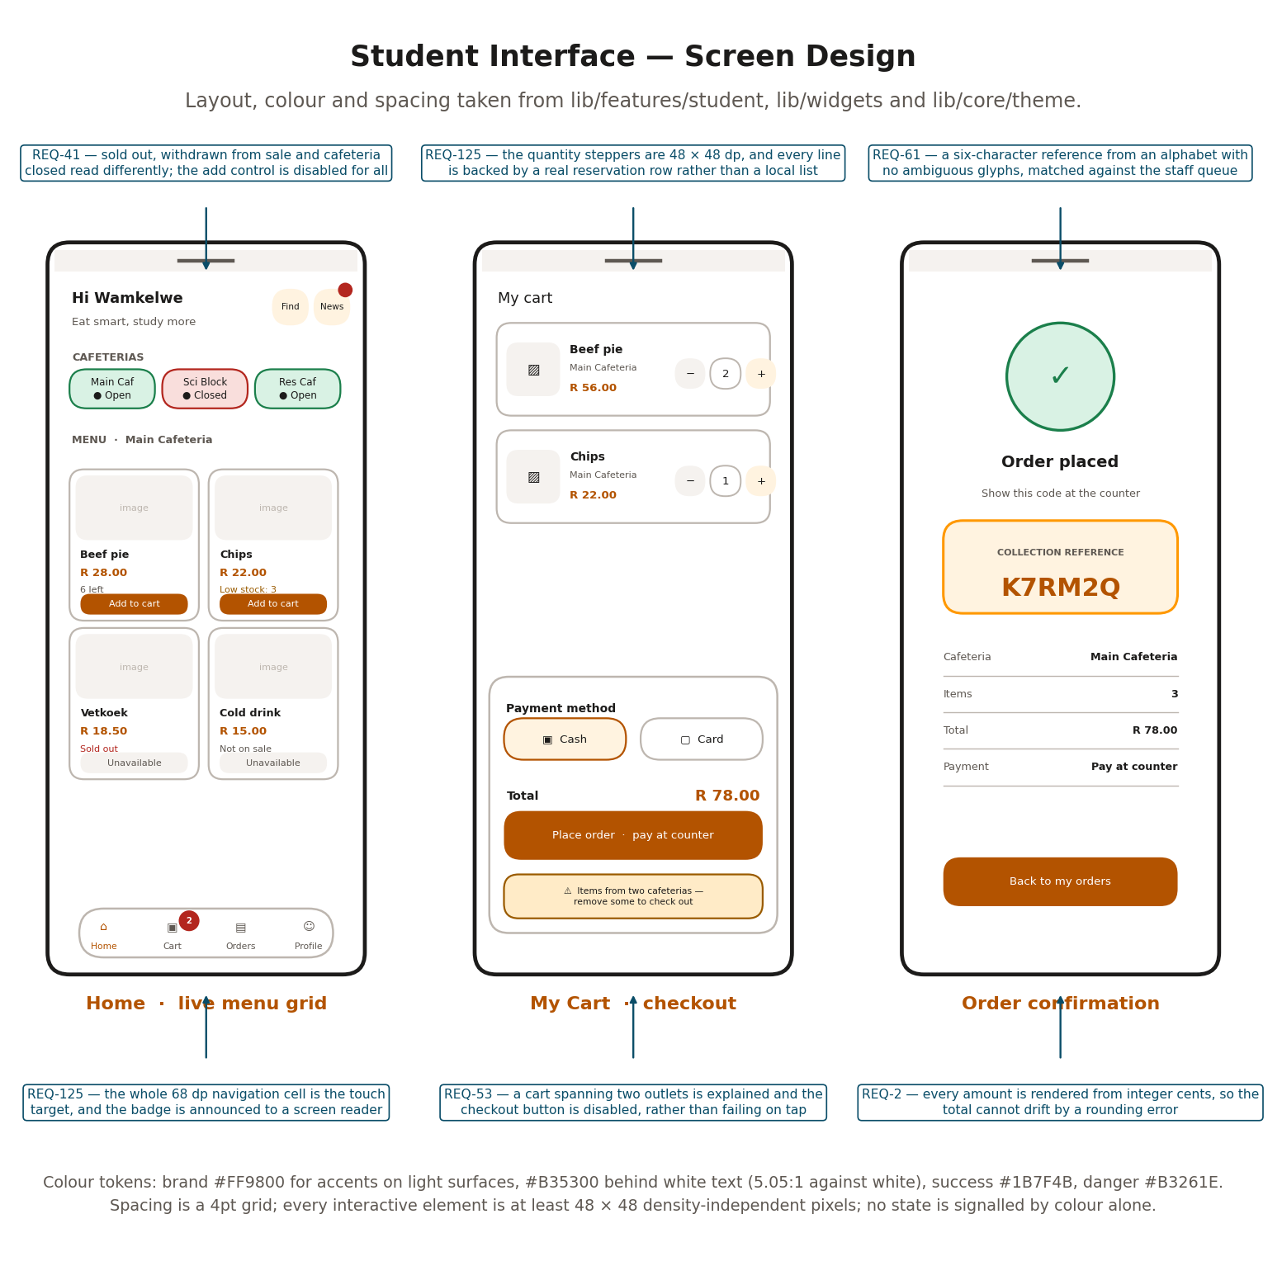
Figure 11. Student interface: Home with the live menu grid, My Cart with checkout, and the order confirmation screen.
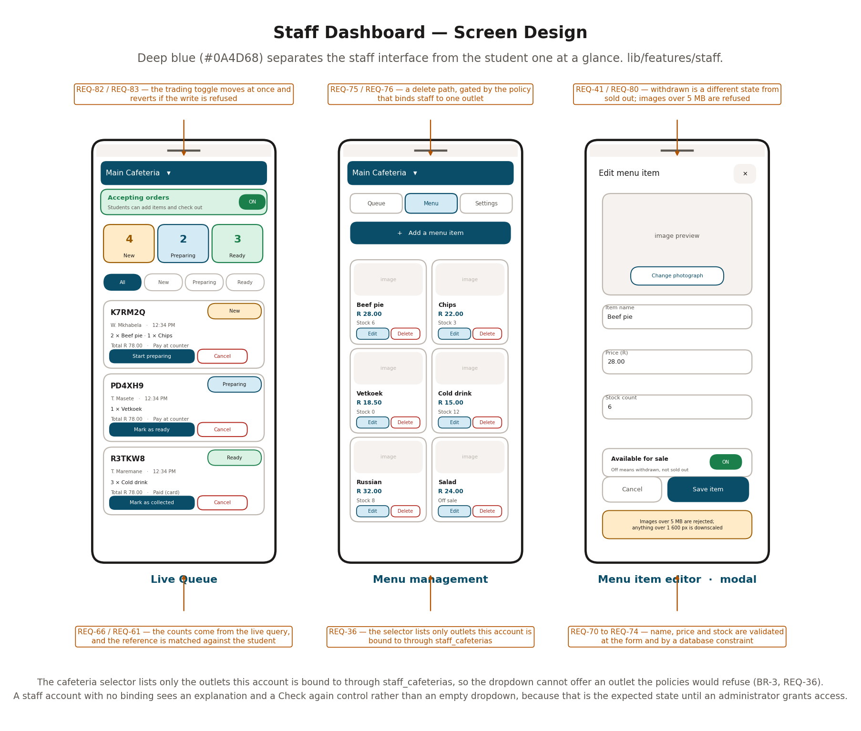
Figure 12. Staff Dashboard: the Live Queue, menu management, and the menu item editor.
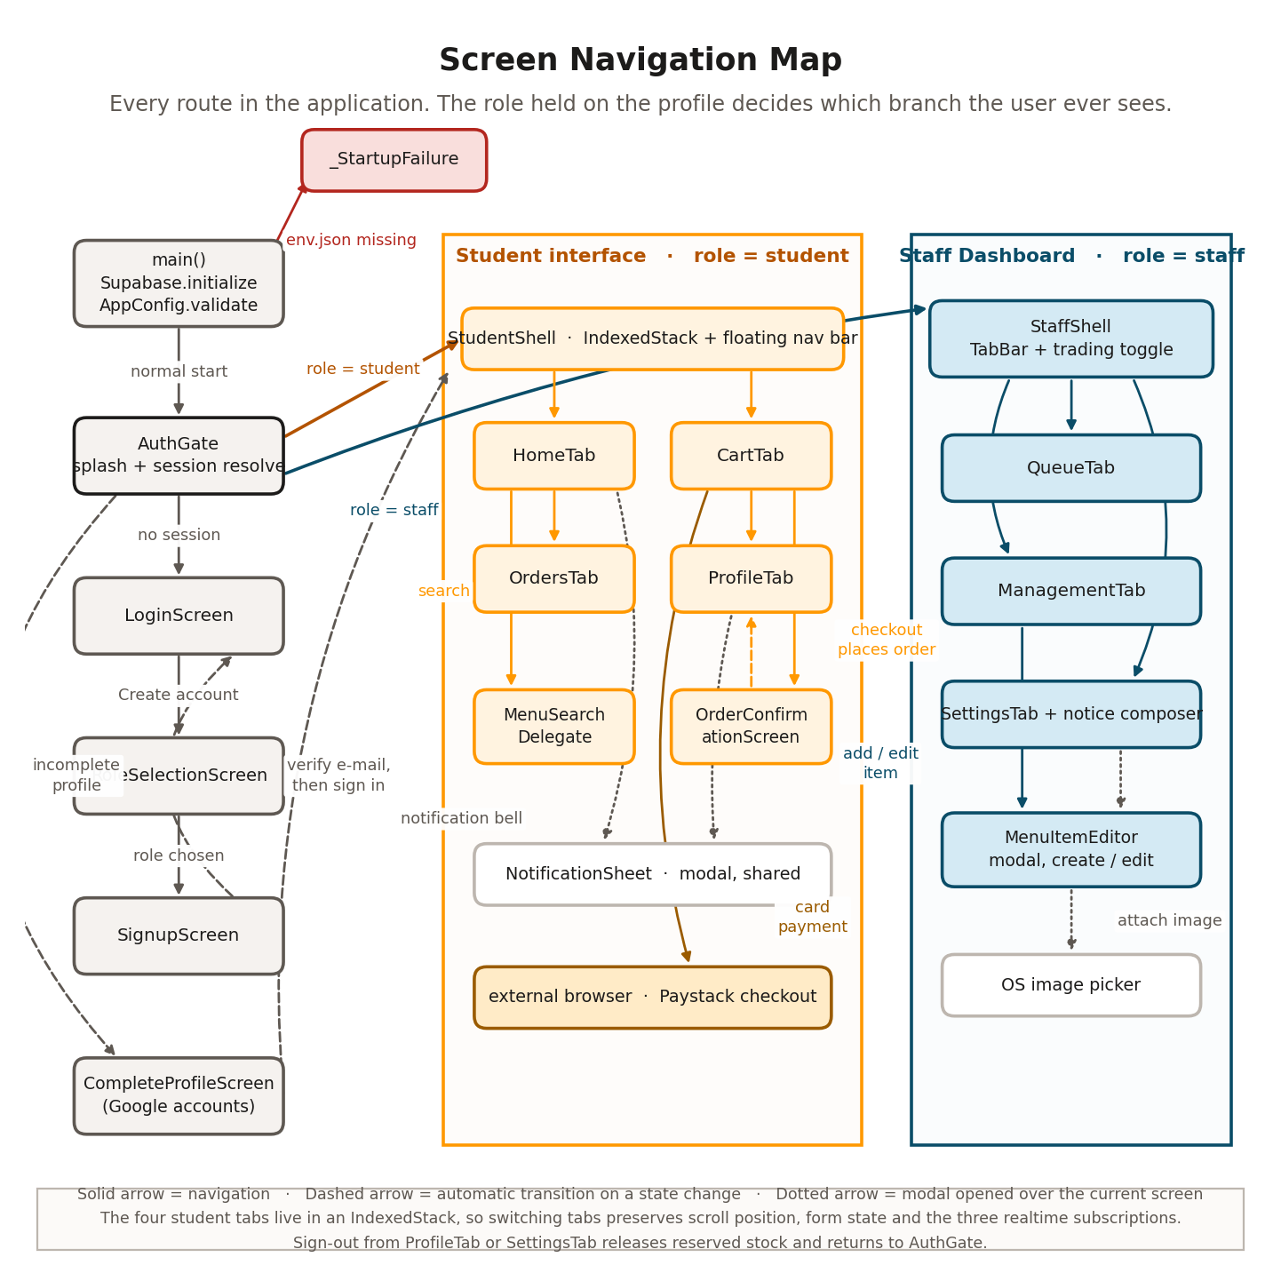
Figure 13. Screen navigation map. Every route in the application, with the role branch that decides which half a user ever sees.

6.3 Screen Objects and Actions
Table 19 lists every interactive object, what it does, and what happens when it cannot.
Table 19. Screen objects and their actions.
Screen | Object | Action and response
Login | Number field | Accepts letters, digits and hyphens. Rejected before any network call if empty or shorter than four.
 | Password field | Obscured as typed. Rejected if empty.
 | Sign in | Disabled while in flight, label replaced by a spinner. On failure, one message for a wrong password and for an unregistered number alike.
 | Continue with Google | Hidden entirely when GOOGLE_WEB_CLIENT_ID is not set for this build, rather than shown and broken.
 | Create account | Opens role selection. The role must be chosen before the form is shown (REQ-16).
Sign-up | Six fields | Each validated on submit. See Table 20 for the limits.
 | Identity field label | Reads Student Number or Staff Number according to the role chosen (REQ-18).
 | Create account | Checks the number is free before calling the authentication service, so a duplicate gets a specific message instead of a generic failure.
Home | Cafeteria chip | Selects the outlet and swaps the menu subscription. Shows Open or Closed as text beside a coloured dot.
 | Search action | Opens the search overlay. Results are filtered in the database, capped at 50.
 | Notification bell | Opens the notices sheet and marks them seen. Carries a dot when unread notices exist, and the dot survives a restart.
 | Menu card | Shows name, price, image or placeholder, and stock position.
 | Add to cart | Reserves one unit. Disabled and relabelled when the item is sold out, withdrawn from sale, or its outlet is closed.
My Cart | Quantity stepper | Plus reserves one more, minus releases one. Both are 48 by 48 dp. Only the line being changed shows a spinner; the rest of the cart stays usable.
 | Remove | Releases the whole line.
 | Cash or Card | A two-segment control defaulting to cash. The card segment is disabled when PAYSTACK_PUBLIC_KEY is not set, with a line of text saying so.
 | Place order | Disabled when the cart spans two outlets, with the reason shown above it rather than only on failure.
Confirmation | Collection reference | Six characters at display size in a bordered panel. The screen is reached by a push, so the device back gesture returns to My Orders.
My Orders | Order card | Tap expands to load and show the line items. Status is a pill carrying both a colour and a word.
 | Cancel order | Offered only while the order is new or preparing. Asks for confirmation, then returns the stock.
Profile | Sign out | Releases reserved stock, ends the session, and returns to the gate. Navigation history is cleared.
Staff: header | Cafeteria selector | Lists only bound outlets. Plain text when there is one.
 | Trading toggle | Moves at once and reverts if the write is refused, with the failure reported.
Staff: Queue | Count cards | New, Preparing and Ready, read from the live query.
 | Filter chips | Narrow the list. Replaces the nested swipeable tab view, which made horizontal drags ambiguous against the outer tabs.
 | Advance button | Label states the next state: Start preparing, Mark as ready, Mark as collected. Refused by the database if another device moved the order first.
 | Cancel | Available from new and preparing. Asks for a reason.
Staff: Menu | Add a menu item | Opens the editor with empty fields.
 | Edit / Delete | Delete asks for confirmation and removes the stored image with the item.
Staff: Editor | Change photograph | Opens the operating system picker. Permission is requested at the point of use, not at install.
 | Available for sale | A switch, labelled so it cannot be read as the sold-out signal.
 | Save item | Disabled while uploading, so the form cannot be dismissed mid-upload.
Staff: Settings | Notice composer | Title, message and an audience choice. Publishes to the selected outlet only.

6.4 Data entry design and field limits
Every field the user can type into is listed in Table 20 with its limit, where the limit is enforced and what the user is told when it is broken. Two principles run through it. A limit is enforced at the form so the user gets an immediate answer, and again in the database so it holds against a caller that is not the application. And the message says what to do, not what went wrong.
Table 20. Data entry limits and validation.
Field | Type and limit | Enforced at | Message on failure
Name, Surname | Free text, must not be blank after trimming. | Form (Validators.required) | "Please enter your name."
Student / Staff number | Letters, digits and hyphens only. At least 4 characters. Must be unique across all profiles. | Form (Validators.identifier), then is_identifier_available(), then a partial unique index on profiles.student_staff_id | "A student number may only contain letters, numbers and hyphens." / "That student/staff number is already registered. Try signing in instead."
E-mail address | Must match a local part, an at sign, and a dotted domain. | Form (Validators.email), before any network call (REQ-21) | "Please enter a valid email address."
Phone number | 9 to 15 digits after stripping every non-digit, so spaces, brackets and a country code are all accepted. | Form (Validators.phone) | "Please enter a valid phone number."
Password | At least 8 characters. Obscured as typed. | Form (Validators.password), then GoTrue's own policy | "Password must be at least 8 characters." The requirement is stated at the point of failure rather than only in help text.
Confirm password | Must equal the password field exactly. | Form | "Passwords do not match."
Menu item name | Must not be blank after trimming. | Form, and NOT NULL on the column | "Please enter an item name."
Price | A number, at least 0 and at most 100000. Parsed with tryParse, so a letter is caught rather than thrown on. | Form (Validators.price), then CHECK price_cents >= 0 | "Please enter a valid amount." / "Price cannot be negative." / "That price looks too high."
Stock count | A whole number, at least 0. | Form (Validators.stock), then CHECK stock_count >= 0 | "Please enter a whole number." / "Stock cannot be negative."
Menu image | At most 5 MB. Longest edge downscaled above 1600 pixels before upload. | The editor, before the object is sent (REQ-80) | "That image is too large. Please choose one under 5 MB."
Notice title and body | Both must be non-blank after trimming. Body is NOT NULL on the column. | Form, and the column | "Please enter a message."
Cancellation reason | Free text, optional. | Not constrained | Not applicable.
Search query | Trimmed. An empty query returns nothing rather than the whole menu. Results capped at 50. | CatalogRepository.searchMenuItems | An empty result is reported in words (REQ-45).
Card number, expiry, CVV | Not collected by this application at any point. | Not applicable. | Collected by Paystack's hosted page. This is why REQ-56 and REQ-57 are superseded.

There is one field type the design deliberately does not use. No free-text field anywhere in the application is passed into a query as a string. Every database call goes through the PostgREST client, which parameterises its arguments, and the two RPCs that take text take it as a typed parameter rather than as interpolated SQL.

6.5 Error prevention, trapping and recovery
The design treats a user doing something unexpected as normal rather than exceptional. Figure 14 shows the approach: four independent barriers, where the point of the independence is that skipping one still leaves the other three.
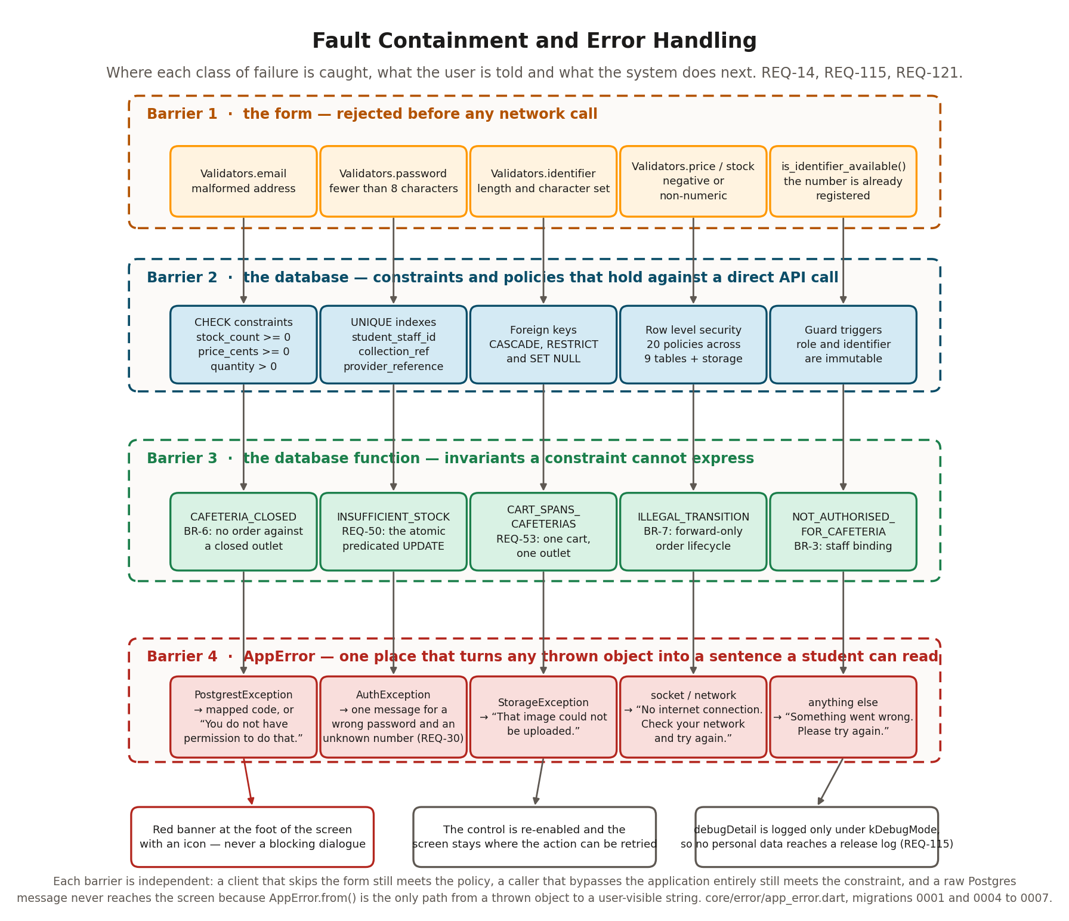
Figure 14. Fault containment. Four independent barriers, where each class of failure is caught, and what the user is told.

6.5.1 Prevention before the user acts
The cheapest failure is the one that cannot be started. A control whose action would fail is disabled and relabelled with the reason, rather than left enabled to produce an error message.
- Add to cart is disabled and reads Sold out, Not on sale or Cafeteria closed, so the student learns the reason from the control itself.
- Place order is disabled while the cart spans two outlets, with the explanation shown above the button rather than surfacing only after the tap.
- The Card segment is disabled, with a line of text, when the build has no Paystack key. Cash checkout still works.
- The Google button is hidden entirely rather than shown broken when no client ID is configured.
- The cafeteria selector cannot offer an outlet the policies would refuse, because it is built from the bindings rather than from the full list.
- The advance button on a queue card is labelled with the next state, so there is no state to guess and no backwards move to attempt.

6.5.2 What happens when the user does something unexpected
Table 21 walks through the cases that a tester should try, and says what the system does in each.
Table 21. Unexpected user actions and the system response.
The user does this | What happens
Submits a completely empty registration form. | Every field reports its own message under itself, the form does not submit, and no network call is made. The earlier build sent the empty form to the server.
Taps Add twice very quickly on an item with one unit left. | The first call succeeds and the second raises INSUFFICIENT_STOCK. The line does not double and the count does not go negative. The student sees "Sorry, that item just sold out."
Taps Sign in repeatedly while the request is in flight. | The button is disabled for the duration and shows a spinner, so only one request exists.
Turns on airplane mode halfway through checkout. | The call fails with a socket error, which AppError maps to "No internet connection. Check your network and try again." Nothing is half-written: place_order either created the order and its lines or created neither. The cart is reloaded rather than guessed at.
Closes the application with items in the cart and does not come back. | The reservations expire after 30 minutes and the sweep returns the stock within five minutes of that. No stock is stranded.
Signs out with items in the cart. | release_my_reservations returns the stock first, then the session ends. If that call fails, sign-out proceeds anyway and the sweep collects it.
Presses the device back gesture after signing in. | The gate replaces the login screen rather than stacking on top of it, so back does not return to the form (REQ-29). After sign-out the history is cleared, so back does not re-enter an authenticated screen (REQ-92).
Two staff members tap Start preparing on the same order at the same moment. | The first succeeds. The second finds the status is already preparing, fails the transition test and raises ILLEGAL_TRANSITION, which is shown as "That order cannot be moved to that stage." The queue then refreshes from the subscription.
A staff member tries to edit an item belonging to another outlet, by any means. | The policy refuses the write. The interface never offers it, and a caller using the API directly gets a policy violation, which AppError renders as "You do not have permission to do that."
Pays on Paystack, then kills the application before returning. | The signed webhook arrives independently and marks the order paid. When the student next opens My Orders they see the correct state.
Returns from Paystack having abandoned the payment. | verifyWithRetry reports abandoned after three attempts. The order exists with payment_state pending, and the student can retry payment or cancel.
A modified client initialises a transaction for a smaller amount. | applyPaymentResult compares the amount Paystack reports against the amount on the payments row, marks the payment failed on a mismatch, and does not mark the order paid.
Sends an unsigned request to the webhook endpoint. | Rejected with 401 before the body is parsed. The rejection is logged without the body.
Enters a student number that is not registered. | The same message as a wrong password, and the same failure at the same step, so the interface cannot be used to discover which numbers exist.
Tries to change their own role from student to staff. | The guard trigger raises ROLE_IS_IMMUTABLE, shown as "Your role cannot be changed from the app." There is no control for this; it is reachable only through the API.
Registers as staff to get the dashboard. | They get the dashboard and an explanation that no cafeteria has been assigned. Every write is refused because the binding does not exist. A dead end, not an escalation.
Uploads a 20 MB photograph of a pie. | Refused at the picker with a message before any upload starts.
Scrolls to the bottom of a list on a small screen with the keyboard open. | Every scrollable reserves the navigation bar height plus the safe-area inset, so the last row is not trapped behind the floating bar.
Increases the system font size to the largest setting. | Layouts scroll rather than clip. The earlier header used a fixed 210 pixel SliverAppBar whose column overflowed at larger text scale; it was replaced by a compact bar with search as an action.

6.5.3 Recovery
Every failure leaves the interface somewhere the user can act from. A failed network call re-enables the control it came from. A failed list load renders an ErrorRetry state with a Retry button rather than an empty screen. A failed cart mutation triggers a reload, so the displayed cart matches the database even when the mutation did not do what the user asked. A failed optimistic write reverts the control to its previous position and reports why.
One failure is deliberately not recoverable in the interface. A policy violation returns isRecoverable: false, because retrying the same call as the same user will fail the same way. The message says so rather than inviting a retry that cannot succeed.

6.6 User interface checklist compliance
The marking rubric attaches a user interface testing checklist. This clause answers every item on it. Where an item does not apply to a mobile application, that is stated with the reason rather than left blank.

6.6.1 Colours
Table 22. Checklist section 1.1, colours.
Item | Status | How the design satisfies it
1.1.1 Hyperlink colours standard | Met | The only tappable text outside a button is the Create account and Sign in links, drawn in the primary accent at 5.05:1 against the surface. There is no underlined web-style link, so no visited and unvisited pair is needed.
1.1.2 Field backgrounds the correct colour | Met | Every input uses the same filled surface from the theme's InputDecorationTheme. No screen sets a field background of its own.
1.1.3 Field prompts the correct colour | Met | Labels and helper text resolve to AppColors.textSecondary at 5.9:1 on the surface. The earlier screens used Colors.grey at 2.8:1, which fails AA.
1.1.4 Colours adjusted for non-editable mode | Met | A disabled control drops to AppColors.textDisabled for its icon and border, and its label changes text as well, so the state does not rely on the colour shift.
1.1.5 Approximately standard link colours | Met | The brand orange is used for anything actionable and nothing else, which is the convention users already read.
1.1.6 Buttons in standard format and size | Met | Three button types exist in the theme: FilledButton for the primary action, OutlinedButton for the secondary and TextButton for the tertiary. Each has one height, one radius and one padding set in AppTheme. No screen builds a button of its own.
1.1.7 General screen background correct | Met | AppColors.background, a warm off-white, on every scaffold. Set once in the theme.
1.1.8 Page background distraction free | Met | A flat colour. There is no wallpaper, gradient or pattern behind content anywhere in the application.

6.6.2 Content
Table 23. Checklist section 1.2, content.
Item | Status | How the design satisfies it
1.2.1 All fonts to be the same | Met | Quicksand throughout both interfaces, applied once through google_fonts in AppTheme. Weight and size vary; the family does not.
1.2.2 Screen prompts in the correct font | Met | Every prompt resolves through the theme's text styles. No widget sets a TextStyle with a family of its own.
1.2.3 Content remains when moving back or forward | Met | The four student tabs live in an IndexedStack, so scroll position, a half-typed search and form state all survive a tab change. The cart itself survives a full application restart, because it is database rows rather than widget state.
1.2.4 All text properly aligned | Met | Text is left aligned by default. Centre alignment is used only for empty states and the confirmation screen. Amounts are right aligned in the cart summary and the confirmation table so the decimal points line up.
1.2.5 Field text in the correct font | Met | As 1.2.2. Input text uses bodyLarge from the theme.
1.2.6 Headings left aligned | Met | Every section heading uses SectionHeader, which is left aligned. The only centred headings are on the confirmation screen and inside empty states, where the block itself is centred.
1.2.7 First letter of the second word lowercase | Met | Sentence case throughout. Labels read Add to cart, Place order, Start preparing and Mark as ready, not Add To Cart. The only exception is the small-caps section label CAFETERIAS, which is a styling choice rather than title case.

6.6.3 Images
Table 24. Checklist section 1.3, images.
Item | Status | How the design satisfies it
1.3.1 Graphics properly aligned | Met | Every menu image sits in a fixed-ratio container at the top of its card with a uniform inset, so a row of cards lines up whatever the source image's shape.
1.3.2 Efficient use of file size | Met | An image whose longest edge exceeds 1600 pixels is downscaled before upload, and anything over 5 MB is refused outright (REQ-80).
1.3.3 Optimised for quick downloads | Met | Images are fetched over the network and cached by the framework rather than bundled in the binary, so installed size does not grow with the menu. A skeleton placeholder is shown while one loads.
1.3.4 Command buttons similar in size, shape, font | Met | As 1.1.6. All button geometry comes from AppTheme.
1.3.5 Banner style and size consistent | Met | One AppLogo widget is used everywhere. There were previously four copies, one of which differed enough to break the shared Hero animation between the splash and the login screen.
1.3.6 Text wraps properly around graphics | Met | Text and image never share a line. Cards stack the image above the text block, so there is no float to wrap around and no overlap at any text scale.
1.3.7 Visually consistent without graphics | Met | An item with no image, or one whose image fails to load, renders a labelled placeholder of the same size, so the grid does not reflow and no frame appears broken (REQ-11).

6.6.4 Instructions
Table 25. Checklist section 1.4, instructions.
Item | Status | How the design satisfies it
1.4.1 Error message text spelt correctly | Met | All 21 mapped messages are defined in one map in core/error/app_error.dart and were proofread as a set. They are listed in Appendix B so a reviewer can check them without reading the code.
1.4.2 Micro-help text spelt correctly | Met | Helper text sits under the field it belongs to and is defined beside it. The same proofread applies.
1.4.3 Micro-help for every enabled field and button | Met, with a note | Every icon-only control carries a tooltip, which is also its screen reader label: the notification bell reads Notices or Notices, unread. Text-labelled buttons carry no tooltip, because a tooltip repeating a visible label is noise on a touch device.
1.4.4 Progress messages on load of active screens | Met | Every loading state is a skeleton placeholder shaped like the content that is coming, not a bare centred spinner. In-flight controls show an inline spinner in place of their label.

6.6.5 Navigation
Table 26. Checklist section 1.5, navigation.
Item | Status | How the design satisfies it
1.5.1 Disabled fields avoided in the tab sequence | Met | A disabled Flutter control is excluded from the focus traversal automatically, and no screen overrides that.
1.5.2 Read-only fields avoided in the tab sequence | Met | There are no read-only inputs. Values the user cannot edit are rendered as text, which is not focusable as a field.
1.5.3 Every screen reachable by its button is reachable | Met | Figure 13 maps every route. Each was walked during the interface review; there is no orphan screen and no control leading to a dead route.
1.5.4 Scrollbar appears if required | Met | Flutter shows a scroll indicator on an overflowing list on the platforms that expect one. Every screen is scrollable rather than clipped.
1.5.5 Tab order top left to bottom right | Met | Forms are single-column, so the default traversal is top to bottom, which is what the convention reduces to in one column. No screen sets a custom FocusTraversalPolicy.
1.5.6 Link to home on every page | Met | The floating navigation bar is present on all four student tabs, so Home is one tap from anywhere in the student interface. Pushed screens carry a back control at the top left. The staff interface keeps its tab bar visible on all three tabs.
1.5.7 Focus on the first editable field when a tab opens | Met, with a note | The menu item editor focuses its name field when it opens. Tab roots do not auto-focus, because raising the keyboard over a menu grid the user came to browse would be wrong.
1.5.8 Focus returns to the field in error | Met | Flutter's form validation scrolls to and focuses the first failing field on submit. A failure that comes back from the server is shown in the banner and leaves focus where the user left it.

6.6.6 Usability
Table 27. Checklist section 1.6, usability.
Item | Status | How the design satisfies it
1.6.1 Field prompts spelt correctly | Met | As 1.4.1 and 1.4.2.
1.6.2 Fonts not too large or too small | Met | Body text is 14 to 16 logical pixels, labels 12, headings 20 to 28. Sizes were chosen to stay legible in direct sunlight, because students order outdoors.
1.6.3 Button and option names are not abbreviations | Met | Every label is a full phrase: Add to cart, Place order, Start preparing, Mark as collected, Change photograph. No abbreviation appears on any control.
1.6.4 Related controls logically grouped in demarcated areas | Met | The cart summary is one raised panel holding the payment choice, the total and the action. The staff queue counts are one row of three cards. The editor groups image, then details, then the availability switch, then the actions.
1.6.5 A typical user can run the system without frustration | Specified, not yet verified | REQ-117 requires eight of ten first-time users to complete an order unaided. The usability test has not yet been run; it is item 3 in Appendix D.
1.6.6 Pages print legibly without cutting off text | Not applicable, with a note | There is no print path in a mobile application. The one artefact a user may want on paper is the collection reference, which is six characters at display size on a white panel and photographs or screenshots cleanly.
1.6.7 Clear sense of the intended audience | Met | The greeting names the student, the copy is written for a student in a hurry, and the staff interface is a different colour with denser information. Nobody opening either one is unsure who it is for.
1.6.8 Consistent, recognisable look and feel | Met | One theme file, one colour token set, one spacing scale, one radius scale and one set of shared widgets. The earlier build carried roughly 200 hardcoded colour literals including three different oranges for the same element and a deepPurple theme seed that nothing used except, visibly, the login hover state.
1.6.9 Login with either username or e-mail | Met by design decision | Sign-in is by student or staff number only, deliberately. The number is on the card in the student's pocket and is what the University already uses to identify them. The e-mail address is held, but a student does not have to remember which one they registered with (REQ-7).
1.6.9b Looks good at 640x480, 800x600 and other sizes | Met | The grid column count is computed from the available width: one column under 360 logical pixels, two on a phone, three on a tablet and four above 900. The earlier build hardcoded two columns, which gives about 136 pixels per card on a 320 pixel phone and two absurdly wide cards on a tablet.
1.6.10 The system provides or facilitates customer service | Met | The notice board is the channel: staff compose a notice to students from the Settings tab and it appears on every student device within the propagation latency. The Profile tab explains what data is held and how to request its deletion.
1.6.11 Terminology understandable to all intended users | Met | No technical vocabulary appears anywhere a user can see. The interface says Sold out, Not on sale, Cafeteria closed, Pay at counter, Ready for collection. It never says reservation, RPC, policy, token or row.

6.6.7 Accessibility, beyond the checklist
The checklist does not cover accessibility, so these are recorded separately. REQ-125 requires WCAG 2.1 Level AA contrast, touch targets of at least 48 by 48 density-independent pixels, and a label on every interactive element.
- The brand orange #FF9800 measures 2.16:1 against white and cannot carry white text, so the palette splits in two. #FF9800 is used for accents, icons and borders on light surfaces. A deepened #B35300 measures 5.05:1 and is used for any filled surface carrying white text. Side by side they read as the same brand and only one of them is safe behind text.
- Body text is #1C1B1A at 12.6:1 on the surface. Secondary text is #5E5852 at 5.9:1, which is the floor for body copy. A lighter grey is used only for dividers and disabled iconography, never for text.
- Touch targets are at least 48 dp everywhere. The earlier cart steppers set constraints: BoxConstraints(), which removes IconButton's built-in 48 dp floor, giving an effective target of about 16 by 16 dp. That was the worst accessibility defect in the application.
- Every icon-only control has a Semantics label. The navigation bar announces the cart tab as "Cart, 2 items" rather than as an unlabelled icon.
- On dark surfaces the split reverses: the bright orange becomes the readable one and is used for accents, with a deep brown behind text. Both themes are defined in AppTheme and follow the system setting.

7.0 REQUIREMENTS MATRIX
Table 28 traces every requirement in UMPSD-SRS-001 to the component that satisfies it and the clause of this document that describes that component. Where a requirement is not satisfied by the current design, the entry says so and points to the appendix that records why.
Two requirements are marked superseded. REQ-56 and REQ-57 specified validation of a card number, an expiry date and a CVV. The application no longer collects any of the three, so the requirements have nothing left to apply to. The change is explained in clause 3.3.5.
Table 28. Requirements traceability matrix.
Req | Requirement in brief | Component that satisfies it | Clause
REQ-1 | Route by role on sign-in without asking | AuthGate, Profile.role | 5.12
REQ-2 | Rand to two decimal places | Money.format | 5.14
REQ-3 | Disable a control while its operation runs | AppTheme button states, every screen's in-flight flag | 6.1.3
REQ-4 | Never convey status by colour alone | StatusPill, MenuItemAvailability.label | 3.2.2
REQ-5 | Image through the OS picker, permission at point of use | MenuItemEditor, image_picker | 6.3
REQ-6 | Work on a device with no camera | MenuItemEditor disables only the attach control | 6.3
REQ-7 | Exchange a number for an e-mail before authenticating | lookup_login_email | 5.7
REQ-8 | Subscribe to changes and update without user action | watchCafeterias, watchMenu, watch, watchMyOrders, watchCafeteriaQueue | 3.2.3
REQ-9 | Cap a notification subscription at fifty rows | NotificationRepository.watch | 3.2.3
REQ-10 | Store images under a non-colliding name and record the URL | MenuItemEditor, storage key convention | 4.1.2
REQ-11 | Placeholder for a missing or failed image | MenuItemCard._image | 6.6.3
REQ-12 | TLS 1.2 or later, no unencrypted fallback | supabase_flutter over HTTPS and WSS | 2.3
REQ-13 | Attach and refresh the session token without user involvement | supabase_flutter session store | 2.3
REQ-14 | Plain-language network failure, retryable | AppError.from, ErrorRetry | 5.13
REQ-15 | Session survives an application restart | AuthGate.resolve | 5.12
REQ-16 | Role chosen before the registration form | RoleSelectionScreen | 6.3
REQ-17 | Reject a registration with any empty field | Validators.required and the sign-up form | 6.4
REQ-18 | Label the identity field by role | SignupScreen | 6.3
REQ-19 | Obscure the password as typed | SignupScreen, LoginScreen | 6.4
REQ-20 | Store role, name, surname, number and phone on the profile | AuthRepository.signUp metadata, handle_new_user | 5.8
REQ-21 | Reject a malformed e-mail before the network | Validators.email | 6.4
REQ-22 | Reject a password under eight characters, state the rule | Validators.password | 6.4
REQ-23 | Reject a duplicate number specifically | is_identifier_available, partial unique index | 4.2.7
REQ-24 | Require e-mail verification and say so | GoTrue, AuthRepository.signUp | 6.3
REQ-25 | Authenticate from a number and a password | AuthRepository.signInWithNumber | 5.7
REQ-26 | Reject an empty sign-in without contacting the network | LoginScreen form validation | 6.4
REQ-27 | Staff dashboard for staff, student home otherwise | AuthGate.resolve | 5.12
REQ-28 | Greet by name, falling back to the number | Profile.displayName | 3.2.2
REQ-29 | Replace the sign-in screen rather than stacking on it | AuthGate state machine | 5.12
REQ-30 | Never disclose whether a number is registered | lookup_login_email, AppError._authMessage | 5.7
REQ-31 | Limit repeated failed sign-ins | Delegated to GoTrue. See Appendix C. | 8.3
REQ-32 | No diagnostic controls in a production build | Debug button and print calls removed | 2.4
REQ-33 | List cafeterias by name with trading status | CatalogRepository.watchCafeterias, _CafeteriaStrip | 6.3
REQ-34 | Reflect a trading status change without refresh | Realtime subscription on cafeterias | 3.1.1
REQ-35 | Prevent adding while the outlet is closed | reserve_stock CAFETERIA_CLOSED, disabled add control | 5.1
REQ-36 | Staff change status only of their own outlet | cafeterias_update_own policy, fetchMyCafeterias | 4.2.12
REQ-37 | Show name, price, stock position and image | MenuItemCard | 6.3
REQ-38 | Order menu items by name ascending | watchMenu order clause | 3.2.3
REQ-39 | Update a displayed item when its row changes | Realtime subscription on menu_items | 3.1.1
REQ-40 | Disable the add control for an unavailable item | MenuItemAvailability.canOrder | 3.2.2
REQ-41 | Distinguish sold out from withdrawn from sale | MenuItemAvailability enumeration | 3.2.2
REQ-42 | Explain an empty menu rather than showing an empty grid | EmptyState | 6.3
REQ-43 | Search item names across all outlets, ignoring case | searchMenuItems with ILIKE | 5.15
REQ-44 | Show each result's outlet and its trading status | MenuItem.cafeteriaName and cafeteriaIsOpen from the join | 5.15
REQ-45 | Report an empty result set in words | MenuSearchDelegate EmptyState | 5.15
REQ-46 | Decrement stock when an item enters the cart | reserve_stock | 5.1
REQ-47 | Return stock when a line is reduced or removed | release_stock | 5.2
REQ-48 | Re-read the count before an increase and refuse if none remains | The predicate inside reserve_stock | 5.1
REQ-49 | Combine repeat additions into one line with a quantity | ON CONFLICT clause, partial unique index | 5.1
REQ-50 | Read and decrement atomically | The predicated UPDATE under a row lock | 5.1
REQ-51 | Release stock reserved by an abandoned cart | release_expired_reservations, pg_cron every five minutes | 5.3
REQ-52 | Cart survives an application restart | stock_reservations is the cart | 3.3.3
REQ-53 | One cart, one cafeteria | place_order CART_SPANS_CAFETERIAS, CartController.cafeteriaId | 5.4
REQ-54 | Cart total as the sum of line totals in rand | CartController.totalCents, Money.format | 5.11
REQ-55 | Exactly two payment methods, defaulting to cash | CartTab SegmentedButton | 6.3
REQ-56 | Validate card number, expiry and CVV | Superseded. The application no longer collects a card. | 2.4
REQ-57 | Obscure the CVV | Superseded, for the same reason. | 2.4
REQ-58 | Never persist, log or transmit card data | Paystack hosted page. No card field exists. | 3.3.5
REQ-59 | Prevent checkout of an empty cart | place_order CART_EMPTY on the line count | 5.4
REQ-60 | Authorise through a gateway and confirm on approval | paystack-initialize, paystack-verify, paystack-webhook | 3.2.5
REQ-61 | Issue a collection reference staff can match | gen_collection_ref, OrderConfirmationScreen | 4.1.2
REQ-62 | Persist a confirmed order with its line items | place_order, orders, order_items | 5.4
REQ-63 | Assign status new on creation | orders.status default | 4.2.5
REQ-64 | Forward-only lifecycle, cancel from new or preparing | advance_order, cancel_order | 5.5, 5.6
REQ-65 | Show staff only their own outlet's orders | orders_select_own_or_staff policy, watchCafeteriaQueue | 4.2.12
REQ-66 | Live counts of new, preparing and ready | QueueTab._countOf over the live query | 6.3
REQ-67 | Update the queue without the staff member refreshing | Realtime subscription on orders | 3.1.1
REQ-68 | Show a student their own orders and each state | watchMyOrders, OrdersTab | 3.2.3
REQ-69 | Return reserved stock when an order is cancelled | cancel_order | 5.6
REQ-70 | Create a menu item with name, price, stock, availability, image | createMenuItem, MenuItemEditor | 6.3
REQ-71 | Edit any of those values | updateMenuItem | 6.3
REQ-72 | Require name, price and stock on save | Validators plus NOT NULL columns | 6.4
REQ-73 | Associate a created item with the selected cafeteria | createMenuItem cafeteria_id | 6.3
REQ-74 | Reject a negative price or stock | Validators.price and .stock, CHECK constraints | 6.4
REQ-75 | Delete a menu item | deleteMenuItem, ManagementTab | 6.3
REQ-76 | Prevent modifying another outlet's item | menu_items write policies | 4.2.12
REQ-77 | Upload under a non-colliding name | Storage key convention with a uuid | 4.1.2
REQ-78 | Preview the image before saving | MenuItemEditor._imagePicker | 6.3
REQ-79 | Prevent dismissal during an upload | MenuItemEditor disables its actions while uploading | 6.3
REQ-80 | Reject over 5 MB, downscale over 1600 pixels | MenuItemEditor._maxImageBytes and the resize step | 6.4
REQ-81 | Delete the stored object when the item or image goes | deleteImageIfOwned | 6.3
REQ-82 | Open or close the selected cafeteria | setTradingStatus, _TradingToggle | 6.3
REQ-83 | Restore the control and report if the write fails | StaffShell._toggleTrading optimistic revert | 6.3
REQ-84 | Show the current trading status from the stored value | Cafeteria.isOpen, default false | 4.2.1
REQ-85 | Show notices matching the signed-in role | notifications_select_audience policy | 4.2.12
REQ-86 | Newest first, no more than fifty | NotificationRepository.watch | 3.2.3
REQ-87 | Indicate notices created since the panel was last opened | NotificationRepository.hasUnread | 3.2.3
REQ-88 | Retain the last-viewed time across a restart | shared_preferences | 3.2.3
REQ-89 | Staff can compose and publish a notice | SettingsTab notice composer, publish | 6.3
REQ-90 | Push notification when backgrounded | Not built. See Appendix C. | 8.3
REQ-91 | End the session with the authentication service on sign-out | AuthRepository.signOut | 5.11
REQ-92 | Clear navigation history on sign-out | AuthGate replaces the tree | 5.12
REQ-93 | Discard the cart and return stock on sign-out | release_my_reservations | 5.3
REQ-94 | Cold start under 3 seconds | AuthGate parallel splash. Untested. Appendix D. | 8.4
REQ-95 | Sign-in under 2 seconds at the 90th percentile | Untested. Appendix D. | 8.4
REQ-96 | Menu first paint under 1.5 seconds | Skeleton placeholders while loading. Untested. | 8.4
REQ-97 | Propagation under 2 seconds at the 90th percentile | Realtime over WSS. Untested. | 8.4
REQ-98 | Cart operation under 500 milliseconds | Per-line spinner hides the round trip. Untested. | 8.4
REQ-99 | Menu image under 2 seconds with a placeholder | AppSkeleton while loading | 6.6.3
REQ-100 | 60 frames per second while scrolling | IndexedStack, const constructors. Untested. | 8.4
REQ-101 | 300 concurrent student sessions | Platform capacity. Untested. | 8.4
REQ-102 | 310 concurrent realtime subscriptions | Four subscriptions per device. Untested. | 8.4
REQ-103 | Never imply allergen or nutritional information | No such field exists in menu_items or the card | 1.2
REQ-104 | Usable one-handed | Bottom navigation, 48 dp targets. Unverified. Appendix D. | 8.4
REQ-105 | No need to be at the cafeteria to order | No location check anywhere in the system | 1.2
REQ-106 | Authenticate before any screen but sign-in and registration | AuthGate | 5.12
REQ-107 | All traffic over TLS 1.2 or later | supabase_flutter | 2.3
REQ-108 | Passwords only through the authentication service | GoTrue. No password is held by the system. | 3.3.2
REQ-109 | No card data stored, logged or transmitted | No card field exists | 3.3.5
REQ-110 | Row level security on every table | Migration 0006, twenty policies | 4.2.12
REQ-111 | Sign-in lookup through a database function | lookup_login_email | 5.7
REQ-112 | Keys in build configuration rather than source | AppConfig, env.json, gitignored | 3.3.2
REQ-113 | Storage writes restricted to bound staff | Migration 0007 storage policies | 4.2.12
REQ-114 | POPIA minimisation and a deletion path | ProfileTab explains what is held. Deletion is a manual request. Appendix C. | 8.3
REQ-115 | No personal data in a release log | kDebugMode guard in showAppError | 5.13
REQ-116 | Stock shown always agrees with the stored value | Atomic reservation plus realtime. Test in Appendix D. | 8.4
REQ-117 | A first-time student completes an order unaided | Design goal. Usability test outstanding. | 8.4
REQ-118 | A staff member adds an item with an image in five minutes | Design goal. Timed observation outstanding. | 8.4
REQ-119 | Available whenever the platform is | No scheduled downtime of the system's own | 2.3
REQ-120 | No unexpected termination during acceptance flows | Null-tolerant parsers, no hard casts outside try | 3.2.2
REQ-121 | Survive a network failure without losing input | ErrorRetry, cart reload, per-line failure | 6.5.3
REQ-122 | Same features and visual language on both platforms | One code base, one theme | 2.3
REQ-123 | Lints clean, no file over 800 lines, screens separate from data | flutter analyze reports 0 issues; largest file 422 lines | 3.2.1
REQ-124 | Tests for cart, reservation and validation logic | 60 tests across four files in test/ | 8.4
REQ-125 | AA contrast, 48 dp targets, labelled elements | AppColors, AppA11y, Semantics wrappers | 6.6.7
REQ-126 | No platform feature unavailable on Android 8 or iOS 12 | Flutter 3.11 floor. Build and smoke test outstanding. | 8.4
REQ-127 | Schema held as versioned migrations | Seven idempotent files under supabase/migrations | 2.4
REQ-128 | Referential integrity by foreign key | Nine foreign keys with explicit delete behaviour | 4.1.1
REQ-129 | Stock and price constrained at the database | CHECK constraints in migration 0001 | 4.2.2
REQ-130 | User-facing text separable for translation | Partial. Strings are still inline. Appendix C. | 8.3
REQ-131 | South African locale for dates, times and currency | Money.format and TimeAgo. Dates are dd/mm/yyyy. | 5.14

Table 29 does the same for the twelve business rules. A business rule differs from a requirement in that it describes something the University's operation requires rather than something the software does, so the interesting column is where the rule is enforced rather than which screen shows it.
Table 29. Business rule traceability.
Rule | Business rule in brief | Where it is enforced | Clause
BR-1 | An account is student or staff, fixed at registration | profiles.role CHECK plus guard_profile_immutables | 4.2.7
BR-2 | Only staff amend menu items; students never write to one | menu_items write policies; stock moves only through definer functions | 4.2.12
BR-3 | A staff member manages only the cafeteria they are responsible for | staff_cafeterias plus is_staff_of in every staff policy | 3.3.2
BR-4 | An item belongs to exactly one cafeteria | menu_items.cafeteria_id NOT NULL foreign key | 4.2.2
BR-5 | Stock is reserved on entering the cart and returned on leaving | reserve_stock and release_stock | 5.1, 5.2
BR-6 | An order may only be placed against an open outlet | place_order CAFETERIA_CLOSED | 5.4
BR-7 | Forward-only lifecycle; cancel only from new or preparing | advance_order transition test, cancel_order status test | 5.5, 5.6
BR-8 | Prices are in rand and include VAT; no tax is itemised | No tax column exists anywhere in the schema | 4.2
BR-9 | Payment is cash at the counter or card at confirmation | payment_method enum, two code paths in CartTab | 3.2.5
BR-10 | The system records orders; it is not a point of sale | No till, reconciliation or reporting component exists | 1.2
BR-11 | A notice has one audience and one cafeteria | notifications.audience CHECK, insert policy requires cafeteria_id | 4.2.3
BR-12 | Personal data is used only to operate the system | Five fields collected. No analytics, no third party. | 8.3

8.0 APPENDICES

Appendix A. Fault-proof plan
This appendix takes each way the system can fail, says how likely it is, what the user experiences, what the system does about it, and what is left for a person to do. It is written for whoever operates the system during the pilot, not for a developer.
Table 30. Failure modes and responses.
Failure | Likelihood | What the user sees | What the system does | What a person must do
Campus Wi-Fi drops mid-order | High at the lunch peak | "No internet connection. Check your network and try again." The control they tapped is re-enabled. | Nothing is half-written. place_order is one transaction, so either the order and all its lines exist or none do. The cart is reloaded from the database rather than assumed. | Nothing. The student retries.
Two students take the last unit | Certain, several times a day | One gets the item. The other gets "Sorry, that item just sold out." | The predicated UPDATE matches one caller and no rows for the other. | Nothing. This is the system working.
A student abandons a full cart | High | Nothing. They closed the application. | The reservations expire after 30 minutes. pg_cron sweeps every five minutes and returns the stock, aggregated per item so nothing is under-restored. | Nothing, provided the pg_cron job is registered. Appendix D item 1.
Two staff advance the same order at once | Occasional at a busy counter | One succeeds. The other sees "That order cannot be moved to that stage." | The row lock in advance_order serialises them and the second fails the transition test. The queue then refreshes from its subscription. | Nothing.
Student pays, then kills the application | Occasional | When they reopen My Orders the order is paid. | The signed webhook arrives independently of the client and settles the order. | Nothing, provided the webhook URL is registered with Paystack. Appendix D item 2.
Paystack is unreachable | Low | "Could not start the payment. Please try again." Cash checkout still works. | The Edge Function returns 502 and no payments row is created, so nothing is left half-open. | Advise students to pay cash until it returns.
A payment is reported for the wrong amount | Very low, but high impact | The order stays unpaid. | applyPaymentResult compares the reported amount against the stored amount and marks the payment failed rather than marking the order paid. | Reconcile against the raw_response column, which holds the payload as received.
Someone calls the API directly with the publishable key | Plausible; the key is in the APK | Not applicable. | Row level security refuses every write they are not entitled to. orders, payments and stock_reservations have no client write policy at all. | Nothing. This is the threat the design was built against.
A staff account self-asserts the staff role at sign-up | Plausible | They see the dashboard and "No cafeteria assigned yet." | Every staff policy tests staff_cafeterias, not profiles.role, so nothing is writable. | Assign the binding if they are genuine staff. Otherwise ignore it.
Replication is not enabled on a table | Likely on a fresh deployment | Screens load once and then never change. Nothing errors. | Nothing. The subscription connects and delivers no rows. | Enable replication on cafeterias, menu_items, notifications and orders. Appendix D item 1. This is the most common deployment mistake.
Stock in the database has drifted from the shelf | Likely over a trading day | A student reserves an item that is not physically there. | Nothing. The system has no way to detect it. | Staff correct the count in Menu management. This is an accepted limitation, recorded in the specification as an assumption.
An order reaches ready and is never collected | Occasional | The order sits in Ready on the queue. | Nothing automatic. There is deliberately no ready to cancelled transition, because the food has already been made. | Staff decide: hand it over late, or cancel from an earlier state next time. A timeout policy is future work.
The Supabase project is down | Low | Every screen shows the network message and a Retry. | Nothing works. There is no offline mode and no cached menu. | Wait. This is the single point of failure and it is stated as such in clause 2.3.
A menu image fails to load | Occasional on a weak connection | A labelled placeholder of the same size. | The grid does not reflow and no frame appears broken. | Nothing.
A student enters a number that is not registered | Common | The same message as a wrong password. | lookup_login_email returns an address that cannot authenticate, so both cases fail identically. | Nothing.
The build is run without env.json | Likely during setup | A full-screen message naming the missing variables and pointing at SETUP.md step 3. | AppConfig.validate throws before Supabase.initialize, and main catches it and runs a failure application rather than dying at a grey crash. | Copy env.example.json to env.json and fill it in.

Appendix B. Error message reference
Every message the system can show a user, and what produced it. A tester can use this as the expected-output column.
Table 31. Error codes and the messages they produce.
Raised by | Code | Message shown
reserve_stock, release_stock, place_order, advance_order, cancel_order, complete_profile | AUTH_REQUIRED | Please sign in again.
reserve_stock, release_stock | INVALID_QUANTITY | That quantity is not valid.
reserve_stock | ITEM_NOT_FOUND | That item is no longer on the menu.
reserve_stock, place_order | CAFETERIA_CLOSED | That cafeteria has just closed and is not taking orders.
place_order | CAFETERIA_NOT_FOUND | That cafeteria is no longer available.
reserve_stock | INSUFFICIENT_STOCK | Sorry, that item just sold out.
release_stock | NO_RESERVATION | That item is no longer in your cart.
place_order | CART_EMPTY | Your cart is empty.
place_order | CART_SPANS_CAFETERIAS | Your cart has items from more than one cafeteria. Please order from one at a time.
advance_order, cancel_order | ILLEGAL_TRANSITION | That order cannot be moved to that stage.
advance_order, cancel_order | ORDER_NOT_FOUND | That order could not be found.
cancel_order | NOT_AUTHORISED | You do not have permission to do that.
advance_order | NOT_AUTHORISED_FOR_CAFETERIA | You are not assigned to that cafeteria. Ask an administrator for access.
complete_profile | IDENTIFIER_ALREADY_REGISTERED | That student/staff number is already registered.
complete_profile | PROFILE_ALREADY_COMPLETE | Your profile has already been set up.
lookup_login_email, complete_profile | INVALID_IDENTIFIER | Please enter a valid student or staff number.
complete_profile | INVALID_ROLE | Please choose either student or staff.
guard_profile_immutables | ROLE_IS_IMMUTABLE | Your role cannot be changed from the app.
guard_profile_immutables | IDENTIFIER_IS_IMMUTABLE | Your student/staff number cannot be changed from the app.
place_order | COLLECTION_REF_COLLISION | Could not create your order just now. Please try again.
PostgreSQL | 42501 or any row-level-security violation | You do not have permission to do that. (Not offered as retryable.)
GoTrue | invalid login credentials | Incorrect student/staff number or password.
GoTrue | email not confirmed | Please verify your email address first. Check your inbox for the link.
GoTrue | already registered | An account with that email address already exists.
GoTrue | rate limit exceeded | Too many attempts. Please wait a minute and try again.
GoTrue | weak password | That password is too weak. Use at least 8 characters.
Supabase Storage | any | That image could not be uploaded. Please try again.
Dart runtime | socket, network, failed host lookup, connection | No internet connection. Check your network and try again.
paystack-initialize | PAYSTACK_INIT_FAILED | Could not start the payment. Please try again.
Anything unmapped | any | Something went wrong. Please try again.

Appendix C. Outstanding design items
Items that are specified but not yet designed for, or designed but deliberately deferred. Each says what would have to happen for it to close.
Table 32. Outstanding items.
Item | Requirement | State and what would close it
Sign-in rate limiting | REQ-31 | Delegated rather than built. A client-side limit is bypassed by calling the API directly, so the constraint belongs on the server. GoTrue enforces one and AppError surfaces it as "Too many attempts." Closing this means confirming the dashboard's rate-limit settings before the pilot, and recording the figure here.
Push notifications | REQ-90 | Not built. Notices are read in the application. Closing this means adding Firebase Cloud Messaging or an equivalent, a device token table, and a trigger on notifications. It was left out of version 1.0 on a scope decision.
Account deletion | REQ-114 | Partial. Collection is minimised to five fields and the Profile tab explains what is held and why. Deletion is a documented manual request. Doing it properly needs an authenticated administrative endpoint, because a client cannot be trusted to cascade its own removal.
Localisation | REQ-130 | Not designed for. User-facing strings are inline in the widgets. Closing this means extracting them to an ARB file and adding flutter_localizations. The formatting side of REQ-131 is already isolated in Money and TimeAgo, so only the strings remain.
Native payment sheet | REQ-60, quality | The hosted page works and is the safer design, but the student leaves the application and comes back. A native Paystack SDK integration would keep them in it. Not a correctness issue.
Ready timeout policy | BR-7 | There is no automatic handling of an order that reaches ready and is never collected. Deciding what should happen is a business question for cafeteria management before it is a design question.
Management reporting | User class 3 | Cafeteria management is named as a user class in the specification and no interface serves it. The data to build sales and demand reports now exists in orders and order_items, which it did not before, so this is now a reporting layer rather than a schema change.
Offline mode | REQ-58 note, clause 2.3 | No cached menu and no queue of pending writes. Every function needs connectivity. Closing this means a local store and a reconciliation strategy for reservations made offline, which is a substantial piece of design and is not attempted.

Appendix D. Deployment prerequisites and verification
The design assumes several things about the environment it is deployed into. If any of them is not true, the system fails in a way that looks like a defect. They are listed here so whoever deploys it can check them.
- Run the seven migration files in order against the Supabase project. They are written to be idempotent, so they are safe against a fresh database or an existing one. Then register the pg_cron job for release_expired_reservations, which is the one step the migrations cannot do for themselves because it needs a superuser. The SQL block is in a comment at the end of migration 0004.
- Deploy the three Edge Functions, set PAYSTACK_SECRET_KEY in the function secrets, and register the webhook URL with Paystack. Deploy paystack-webhook with --no-verify-jwt, because Paystack calls it and has no JWT. Card checkout fails until this is done; cash checkout does not depend on it.
- Enable replication on cafeterias, menu_items, notifications and orders in the Supabase dashboard under Database, then Replication. Without it, every subscription connects and delivers nothing, and screens appear frozen after their first load. This is the most likely deployment mistake and it produces no error message.
- Create the menu-images storage bucket as public, then run migration 0007 to attach its policies.
- Insert one cafeterias row per catering outlet before any staff member signs in, and insert the staff_cafeterias bindings. A staff account with no binding can do nothing, by design.
- Copy env.example.json to env.json and fill in the Supabase URL, the publishable key and the Paystack public key. env.json is gitignored. The application refuses to start without the first two and says which are missing.
Verification that has been carried out on the code base as it stands: flutter analyze reports zero issues under the flutter_lints rule set; flutter test runs 60 tests covering the cart arithmetic, the money formatting, the field validators and the model parsers, all passing; and flutter build web succeeds, which proves the code compiles end to end.
Verification that has not been carried out, stated plainly because it matters for the demonstration. The migrations have not been applied to a live database. The Edge Functions have not been deployed and Paystack has not been exercised end to end. Google sign-in has not been exercised. No Android or iOS binary has been produced on the development machine used for this work, because no Android SDK is installed on it. And the concurrency test matters more than any of the others: the atomic reservation is the central correctness claim of this design, and it deserves to be demonstrated with two real devices reaching for the same last unit.

Appendix E. Document control
Table 33. Version history.
Version | Date | Editor | Description
0.1 | 2 September 2026 | W. Mkhabela | Skeleton drawn from the IEEE 1016 template. Clause 1 and clause 2 drafted.
0.2 | 9 September 2026 | T. Maremane | Architecture and decomposition written against the migrations added in the August work.
0.3 | 14 September 2026 | T. Masete | Data dictionary completed. Component pseudocode written for the seven database functions.
1.0 | 18 September 2026 | Development team | First complete issue. Human interface design, checklist compliance, traceability matrix and appendices added. Reconciled against the code base at the date of issue.

