AZURA WORLD RESIDENCE & HOTEL
User Manual
The property management system, explained in plain language

Property: Azura World Residence & Hotel — Türkler, Alanya, Antalya
Developer: Cebeci Group
System built by: Wamocon
Document version: 1.0 — August 2026

Who this manual is for
Anyone who uses the system, whatever their job. You do not need any technical background to read it. Every term is explained the first time it appears, and there is a glossary at the end. If you only read one section, read “The big idea” on page 2 — everything else follows from it.

Contents

1. What this system is
One place to run a 656-apartment residence and a 188-room hotel — and to prove that every number it shows you is real.
Azura World Residence & Hotel is a large property in Türkler, near Alanya on the Turkish coast. Seven blocks of apartments, a hotel, an aquapark, gardens and pools, all on one 76,000 square metre site.
Running something that size means keeping track of a great many things at once: who lives where, what is broken, who is fixing it, what money has come in and gone out, which documents are on file, which safety checks are due. Most of that work is done today across spreadsheets, message groups and email, in several languages, by people who each see only their own corner.
This system puts all of it in one place, and gives each person their own view of it.
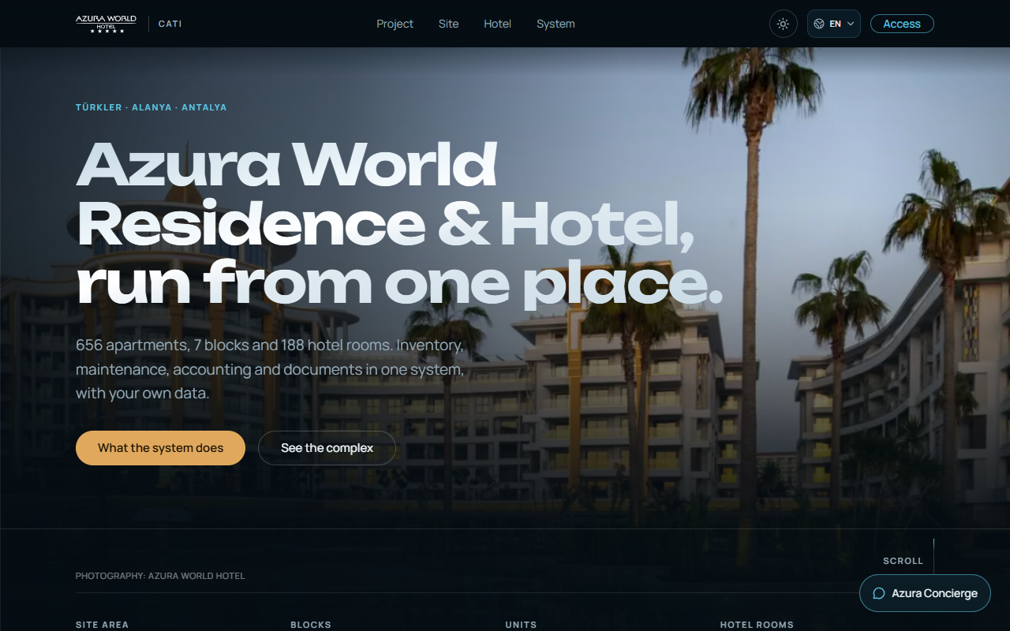
Figure 1 — The public page. This is what a visitor sees before signing in.

The big idea
Most software will happily show you a number. This one will not show you a number without telling you where it came from.
That sounds like a small thing. It is the whole point of the system, so it is worth explaining properly.
When you look at a figure here — the price of an apartment, how many rooms the hotel has, how far the sea is — the system also knows which web page, document or record that figure came from, and when it was read. If two sources disagree, it shows you both and says so. If nothing anywhere states a figure, it says “not stated” rather than guessing.
The rule the system follows
A number with no source is never shown as if it were a fact. It is shown as a gap. The system would rather tell you it does not know than tell you something that might be wrong.

2. The problem this solves
Four ordinary situations that cost real money and real trust.

Nobody agrees what an apartment costs
The same apartments in this project are advertised on several property websites at the same time. Those websites do not agree. One lists a one-bedroom apartment at 112,000 euros; another lists what looks like the same thing at 310,000 euros. One website even advertises this project twice, as two different properties, with two different prices.
If you are selling, that is embarrassing. If you are buying, it is alarming. And if you try to fix it by picking an average, you have invented a number that nobody published — which is worse than the confusion you started with.

The same question gets four different answers
How many rooms does the hotel have? The hotel's own website says 188. A travel site says 112. Both are written down somewhere. Without a system that keeps track, whichever number the last person happened to read becomes “the” number, and it changes depending on who you ask.

Work gets lost between people
A resident reports a leaking tap in a message group. Someone forwards it. A technician may or may not see it. There is no record of when it was reported, who took it on, whether it was fixed, or what it cost. When the same tap leaks again in three months, nobody can tell whether it was ever properly repaired.

Everyone speaks a different language
The residents include Turkish, Russian, German and English speakers. The staff do too. A system that works in only one language pushes everyone else back to messaging apps and telephone calls, and the record disappears again.

3. How the system solves it
Four answers, matching the four problems.

It keeps the disagreement instead of hiding it
When sources conflict, the system shows every version it found, names who published each one, and marks the fact as “disputed”. It never averages them, and it never quietly picks a winner.
You will see this on the public page: it states that thirteen facts about the project are disputed, and then lists exactly which thirteen. That is unusual. Most marketing pages would simply show one confident number.

Every figure carries its receipt
Behind each number is the web page it came from — and a stored copy of that page, saved on the day it was read. If the website changes its price next week, the copy the system kept does not change. You can always go back and check.
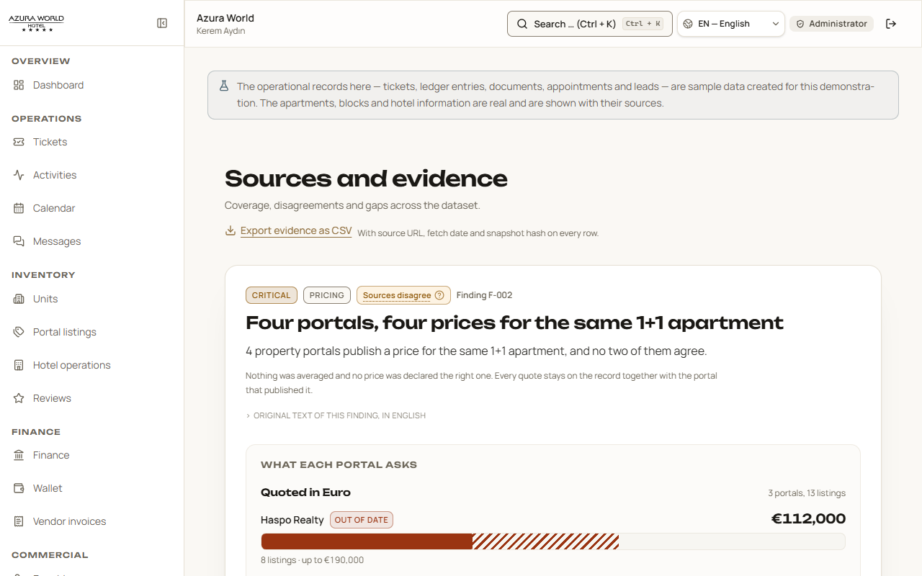
Figure 2 — The evidence screen. Every source is listed with the date it was read and a link to the stored copy.

Work becomes a record, not a message
A reported problem becomes a numbered ticket with a status, an owner, a deadline and a history. Nothing is lost between people, because the ticket is the thing everyone is looking at.

Four languages, Turkish first
The whole system exists in Turkish, English, Russian and German. Turkish is the main language, because the property and the people running it are Turkish. You switch language from the menu at the top of any screen, and nothing else changes — the same data, in your words.

4. Getting started
Two minutes, from opening the page to seeing your own screen.

Signing in
- Open the address your administrator gave you in any web browser.
- Choose your language from the menu at the top right, if it is not already right.
- Select “Access”, then type the email address and password you were given.
- You arrive at your Dashboard — your own home screen. What is on it depends on your job.
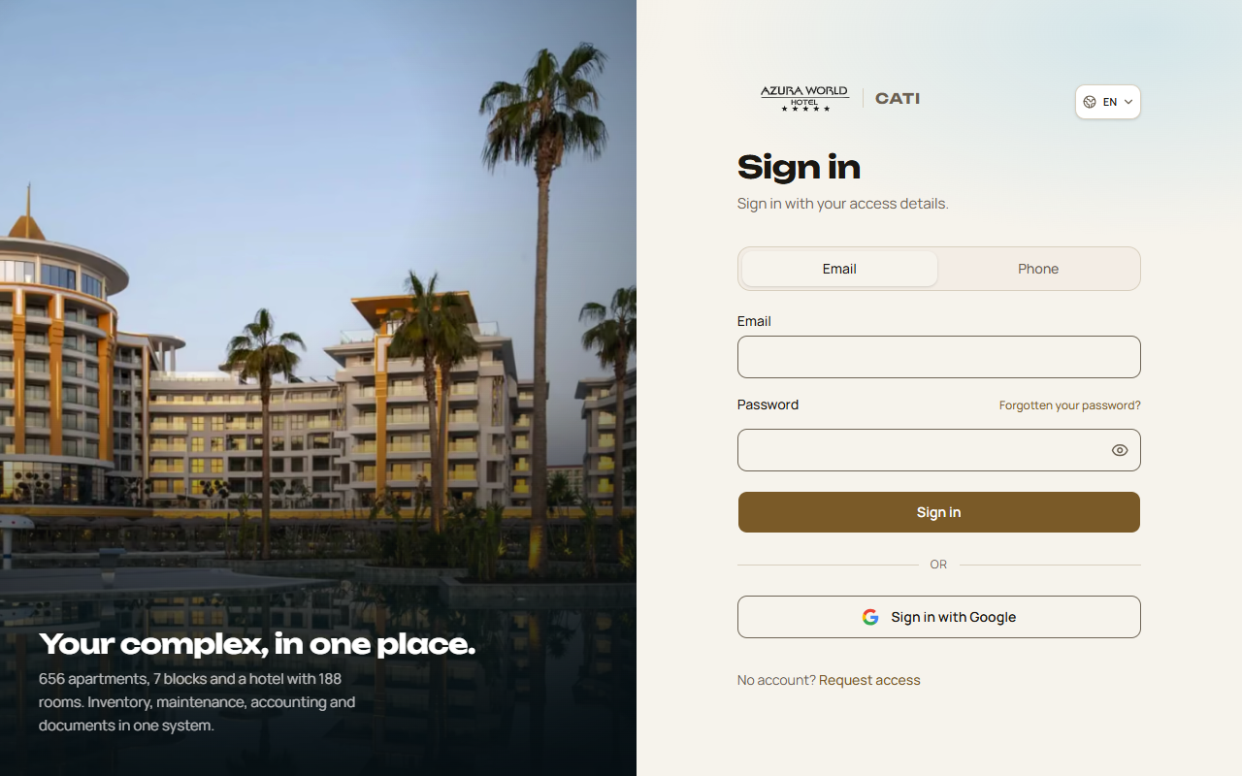
Figure 3 — The sign-in screen.
If you do not have an account
Accounts are created by the site management, not by signing up yourself. There is a “Request access” page, and it is honest with you: it tells you before you fill anything in that it cannot yet store your request, and asks you to contact site management directly instead. That is deliberate — a form that pretends to send something and does not is worse than no form.

Finding your way around
Every screen has the same three parts.
- The sidebar, on the left — Your menu. It only lists the sections your job gives you access to, so it is shorter for some people than others. It is grouped by the kind of work: Operations, Inventory, Finance, Sales, Governance.
- The bar across the top — Search (you can also press Ctrl and K together), your language, your name and role, and the way out.
- The main area — The screen you are on. It always starts with a title and one line saying what the screen is for.

One notice you will see on every screen
A line at the top explains that the day-to-day records in this demonstration — tickets, accounting entries, documents, appointments and sales enquiries — are sample data created to show how the system works. The apartments, blocks and hotel information are real, and are shown with their sources. The system tells you which is which rather than letting you assume.

5. The eleven kinds of login
The same system looks different to each person, because each person needs different things.
There are eleven roles. Your role decides which sections appear in your sidebar, and what you can do once you are in them. Nobody sees a button they are not allowed to press: the system removes it rather than showing it and refusing.
The table below is the short version. Each role is then explained in its own right.

Role | Sees
Administrator | Everything — all 21 sections, including system health and the audit log
Site manager | 20 sections — everything except the administration screen
Accountant | 11 sections — the money, the documents, the people
Technical staff | 11 sections — the work, the buildings, the suppliers
Owner | 12 sections — their apartment, their money, the building around it
Tenant | 10 sections — their apartment, their requests, their balance
Guest | 6 sections — the hotel, the reviews, their balance, messages
Service provider | 9 sections — their assigned work and their invoices
Owner's child account | 7 sections — a supervised, read-mostly view
Tenant's child account | 7 sections — the same
Guest's child account | 5 sections — the smallest view

5.1 Administrator
The person who looks after the system itself. They see all 21 sections, and two things nobody else does: the health of the connected services, and the audit log — a permanent record of every change anyone has made, who made it, and when.
An administrator can change what role somebody has, and can block an account. They cannot delete an account, and that is on purpose: deleting a person would take the record of their past actions with them.
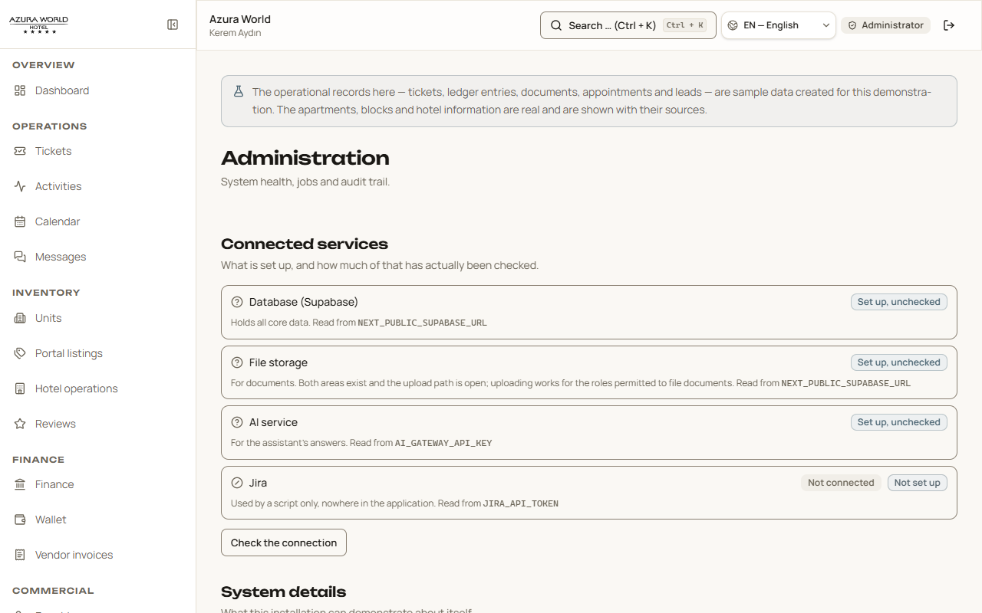
Figure 4 — The administration screen: connected services and the audit log.

5.2 Site manager
The person who runs the property day to day. This is the fullest working view: the ticket queue, the apartments, the money, the sales enquiries, the documents, the compliance checks and the staff directory.
Their home screen opens with “What needs you now” — a short list of the things that are actually waiting: a ticket past its promised date, a request nobody has picked up, this week's events, open conversations. It is not decoration; every line is a link to the thing itself.
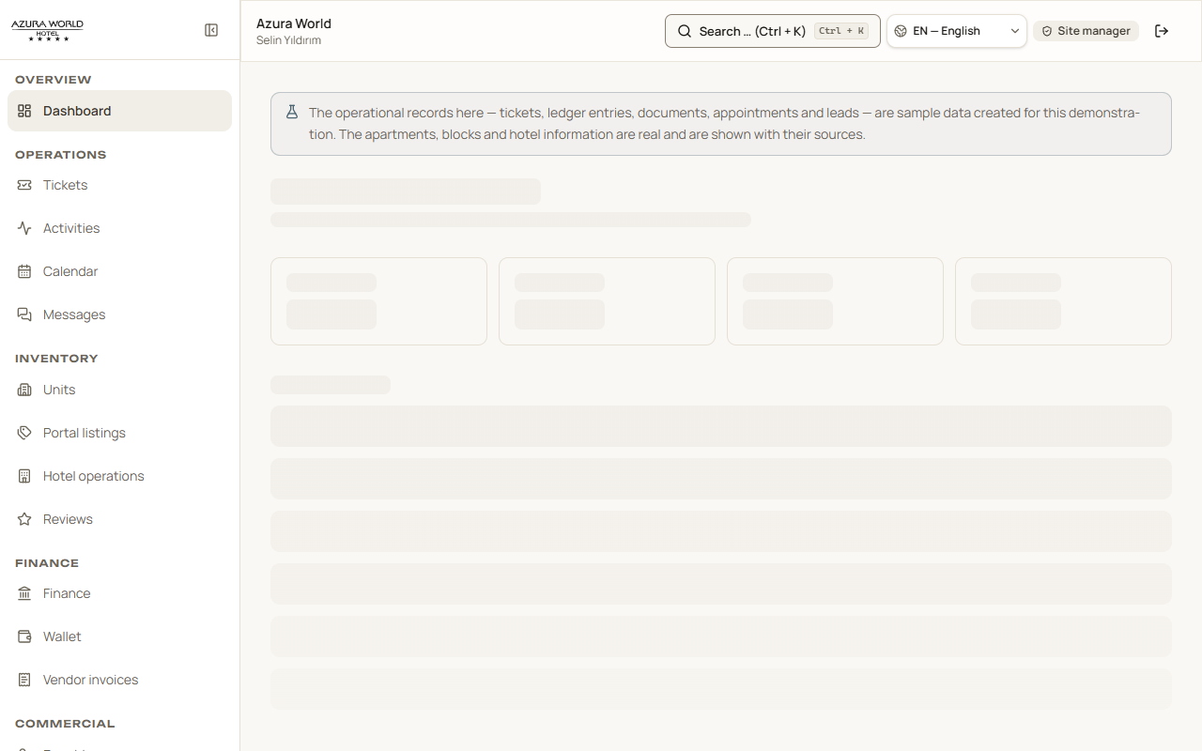
Figure 5 — The site manager's home screen.

5.3 Accountant
Looks after the money. They are the only role that can post an accounting entry, and they can see every balance, every payment and every supplier invoice.
They can also see the resident directory. That is a deliberate decision made in August 2026: before it, an accountant could see that a balance existed but not whose it was, which makes reconciling payments impossible. They can read who people are; they cannot change anyone's role or block an account.
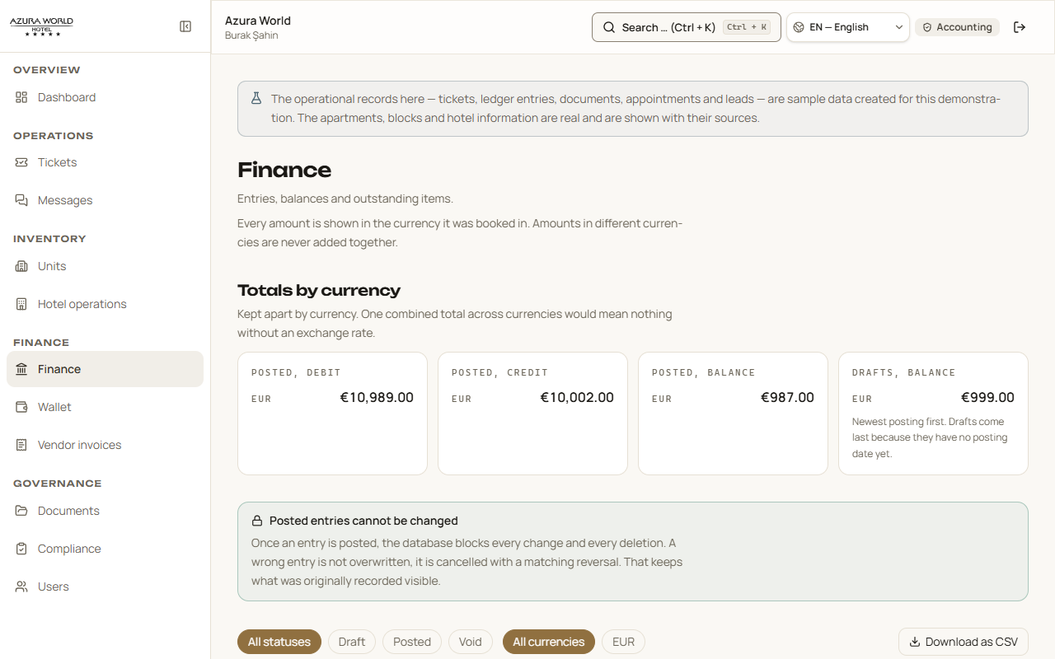
Figure 6 — The accounting screen.

5.4 Technical staff
The people who fix things. They see the ticket queue, the buildings, the documents, the calendar and the supplier invoices. They do not see the sales pipeline, the accounting entries or the competitor price research — none of which helps them repair a lift.

5.5 Owner
Somebody who owns an apartment. Their sidebar says “My apartment”, not “Units”, because they have one, not 656.
They see their own place, the work outstanding on it, their balance, the building's events and calendar, their documents, and the property market listings — the last of those because what comparable apartments are advertised at genuinely matters to an owner.

5.6 Tenant
Somebody who rents. Almost the same as an owner, minus the things that belong to ownership: no accounting view and no market listings. They can report a problem, follow it, read their documents and see their balance.
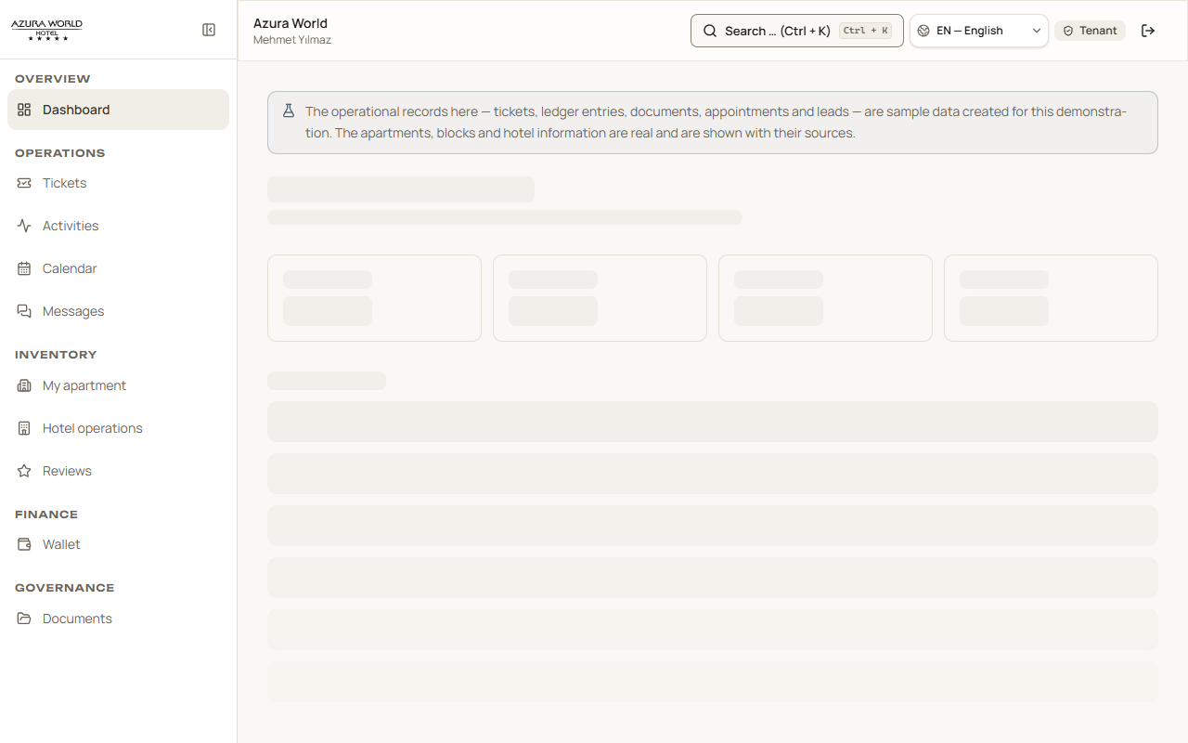
Figure 7 — A tenant's home screen.

5.7 Guest
A hotel guest, or a visitor. The smallest full view: the hotel, the reviews, their balance and messages. They cannot see other people's apartments, the accounts, or any internal record.
One detail worth knowing
“Guest” is also what the system treats an unidentified visitor as. That means the guest role is the one that must be safe by construction, and it is: it holds no permission to create, change, delete or approve anything at all.

5.8 Service provider
An outside contractor — the lift company, the pool company, the security firm. They see the work assigned to them, the calendar, the documents they need and their own invoices. They do not see residents' details, the accounts, or any part of the property that is not their job.
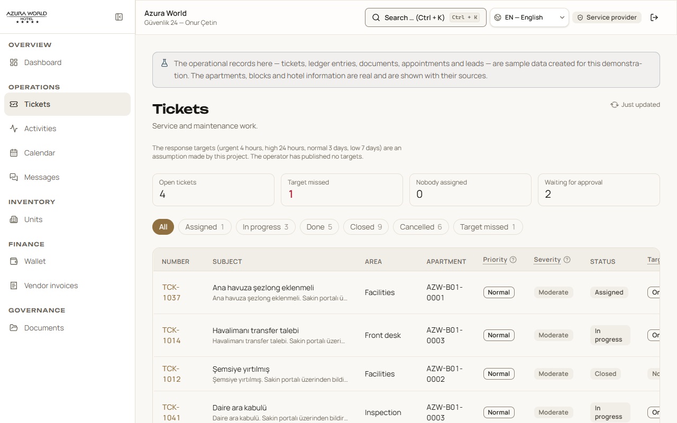
Figure 8 — A contractor's view of the work queue: their jobs, not everybody's.

5.9–5.11 The three child accounts
A supervised account for a young family member of an owner, a tenant or a guest. They can see the apartment, the hotel information, the events and the calendar, and read messages. They cannot see money, contracts or title documents.
The owner's and tenant's child accounts see exactly the same things as each other, and that is intentional rather than an oversight. What separates their guardians is whether they own or rent the apartment — a fact about the adult, not about what a young person living there should be able to look at.

6. The features, one by one
Twenty-one sections, grouped the way the working day is. Each one is described by what it is for first.

6.1 Operations — the daily work

Tickets
The heart of the system. Anything that needs doing becomes a ticket: a leaking tap, a broken lift, a complaint about noise, a request for an airport transfer.
Each ticket carries:
- A number, like TCK-1043, so people can refer to it in conversation.
- A short title and a description of the problem.
- Where it is — which block and which apartment.
- Two separate judgements, which are easy to confuse. Severity is how bad the problem is. Priority is how soon we will get to it. A small leak is minor, but if it is over an electrical box its priority becomes urgent. Each column heading has a (?) that explains this on the screen.
- Its status: open, assigned, in progress, resolved, closed.
- A deadline. The system uses four response times — 4 hours for emergencies, 24 hours for high priority, 3 days for normal, 7 days for low — and tells you plainly that these are the project's own assumptions, not something the operator has published.
- A full history: who did what, and when.
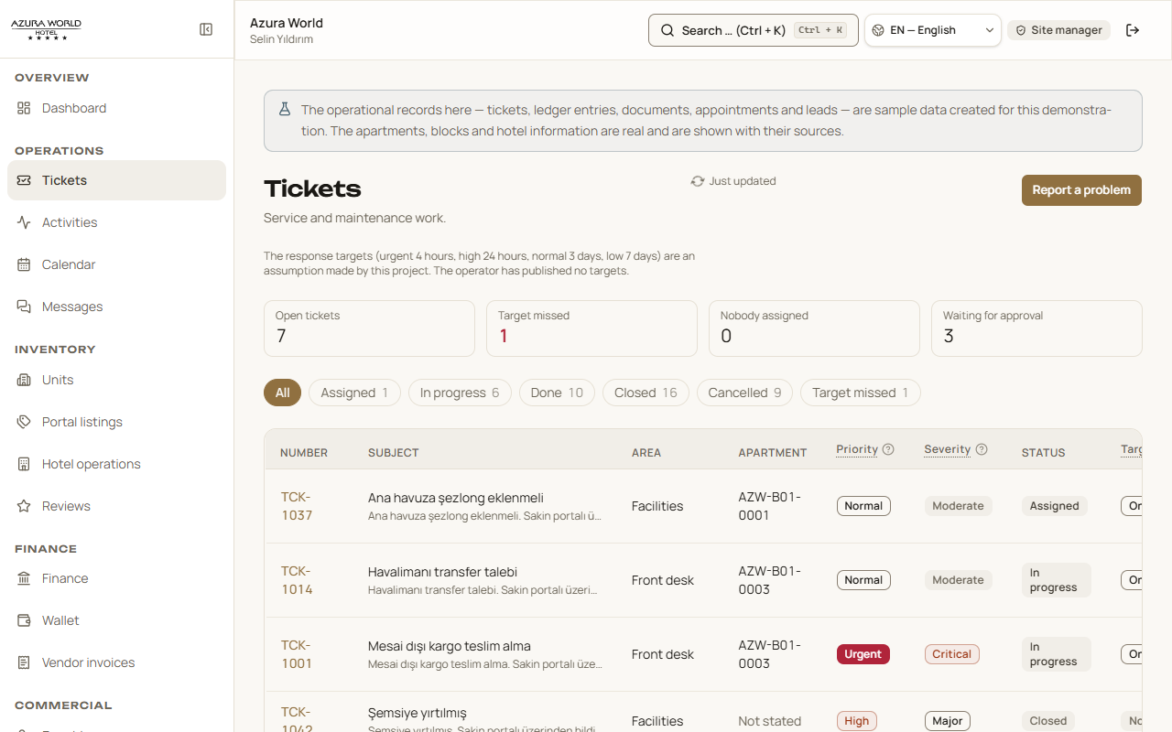
Figure 9 — The ticket queue.
The counts across the top are live filters. Select “Overdue” and the list narrows to the overdue ones. The screen also updates by itself when someone else changes something, so two people looking at the queue see the same thing.

Activities and Calendar
What is happening on the site: yoga by the pool, aqua fitness, a Turkish evening, a treasure hunt in the garden, and the maintenance work behind them. The calendar is the same information arranged by date.
The Calendar screen also offers a link you can add to Outlook, Apple Calendar or Google Calendar, so site events appear in your own diary and keep themselves up to date. There is a Copy button beside it.
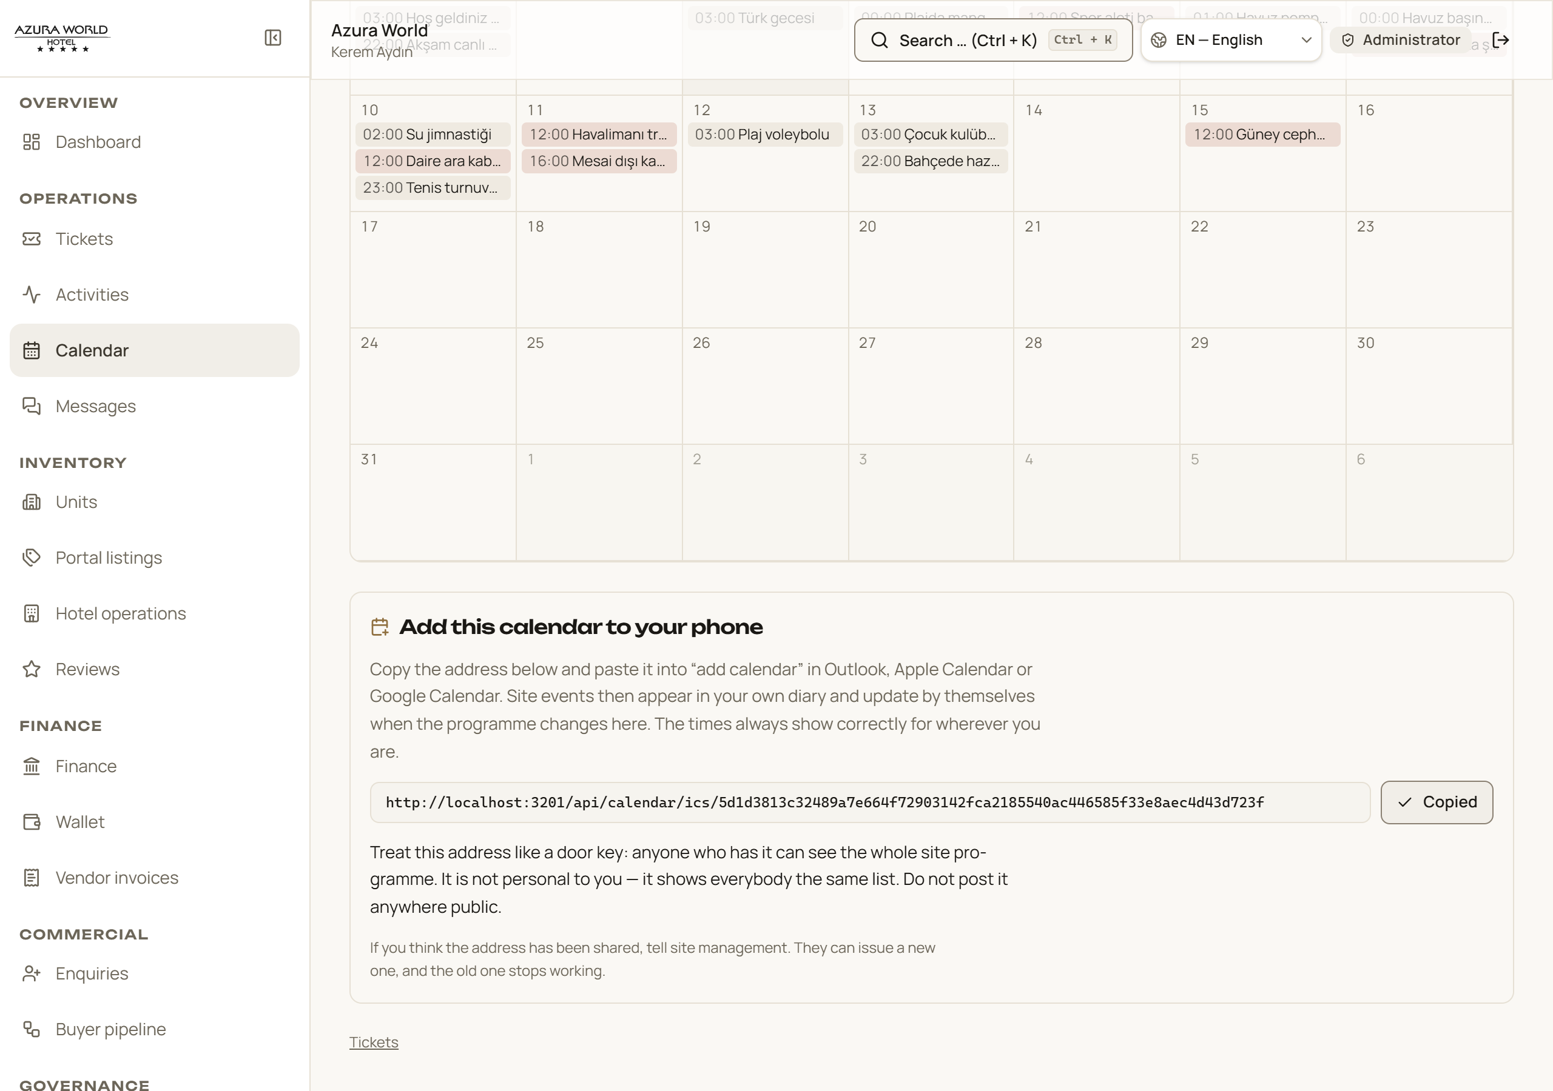
Figure 10 — Adding the site calendar to your own phone or computer.
One thing to know about that link
It is not personal to you. Anyone who has the link sees the same list of site events, so treat it like a door key and do not post it anywhere public. If it does get shared, tell site management — they can issue a new one, and the old link stops working.

Messages
Conversations between residents and site management, organised by subject rather than by person — so a question about a service charge stays with that question.
Staff can attach an internal note to a conversation. Residents never see those notes: the system enforces that in two independent places, so a mistake in one is caught by the other.

6.2 Inventory — the property itself

Units
All 656 apartments, arranged by block. Each one has its floor, its size, its layout — 1+1, 2+1, 3+1 in the Turkish way of counting rooms — and its status.
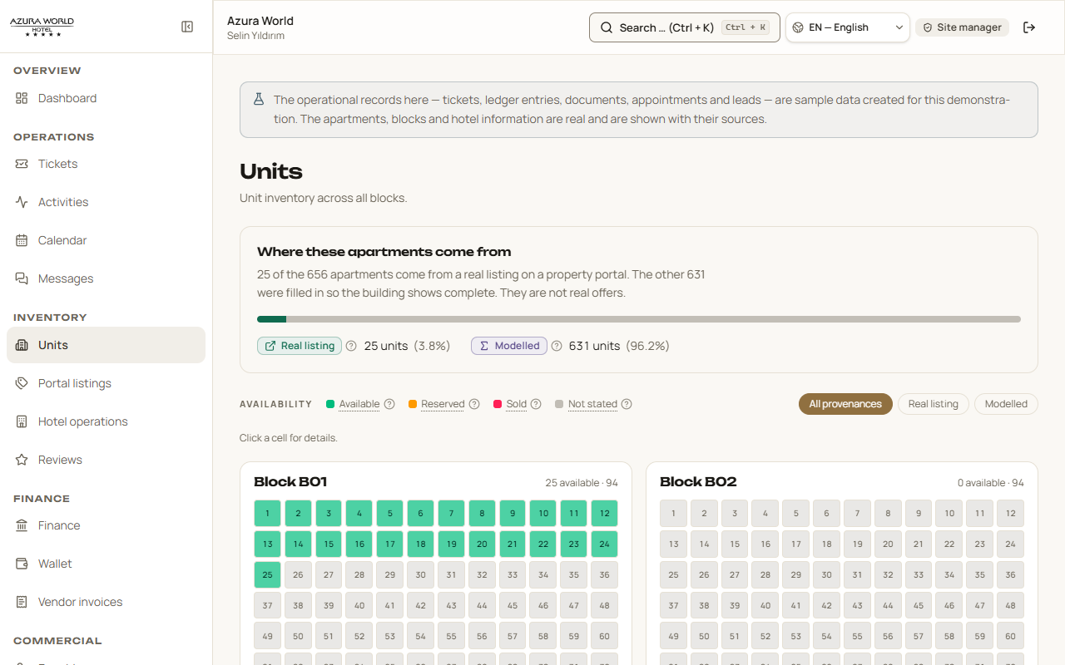
Figure 11 — The apartments, by block.
An honest detail about prices
Only 25 of the 656 apartments appear on a property website with a published price. For the other 631, the system has no published price — so it does not invent one. It shows a “modelled value”, clearly labelled as such, and prints the working underneath: the typical price per square metre for that layout, multiplied by the typical size. It also states plainly that this figure must never be used as an asking price.

Portal listings
The 47 advertisements for this project that the system found on property websites, and where they disagree with each other. This is a research screen for the people selling the building — it is not shown to residents, who have no use for what a competing agent is asking.

Hotel operations
What the sources state about the hotel: how many rooms, check-in and check-out times, board arrangements, the aquapark. Where the sources disagree — and for the room count they do, 188 against 112 — the screen shows both figures rather than choosing.

Reviews
What guests say about the hotel, and on which site. The system notices that two of the three review scores it found are the same Tripadvisor score shown on two different websites, so it counts two independent platforms rather than three. A duplicate is not a second opinion.

6.3 Finance — the money

Accounting entries
Every amount in and out: service charges, rent, deposits, utilities, supplier payments. Two rules govern this screen and both are unusual enough to explain.
The first: amounts in different currencies are never added together. The system holds euros, dollars, lira and pounds, and it shows a separate total for each. A single combined figure would need an exchange rate that nobody published, and that would be an invented number.
The second: once an entry is posted it can never be edited or deleted, by anyone, including the system's own administrators. A mistake is corrected by posting a reversing entry, so the original stays visible. This is how real accounting works, and it means the record cannot be quietly rewritten.

Wallet
Balances and movements for each resident and contractor. Owners, tenants, guests and service providers each have one and can see their own; management can see them all.

Supplier invoices
Invoices from contractors — the pool company, the cleaners, the security firm — with what has been paid and what is still owed. The system flags likely duplicates by matching the supplier, the invoice number and the amount all three together, and it marks both copies rather than deciding which is real. Deciding is a person's job.

6.4 Sales

Enquiries
People who have asked about buying, where they came from — website, portal, referral, walk-in, exhibition — what they are looking for, what they said they could spend, and who is looking after them. Budgets are shown per currency, never summed.

Buyer pipeline
Where each interested buyer has got to, from first contact through to a completed sale.

6.5 Governance — the paperwork

Documents
Contracts, handover records, insurance policies, inspection reports, correspondence. Each document says who uploaded it, whether it has been reviewed, and how long it must be kept.
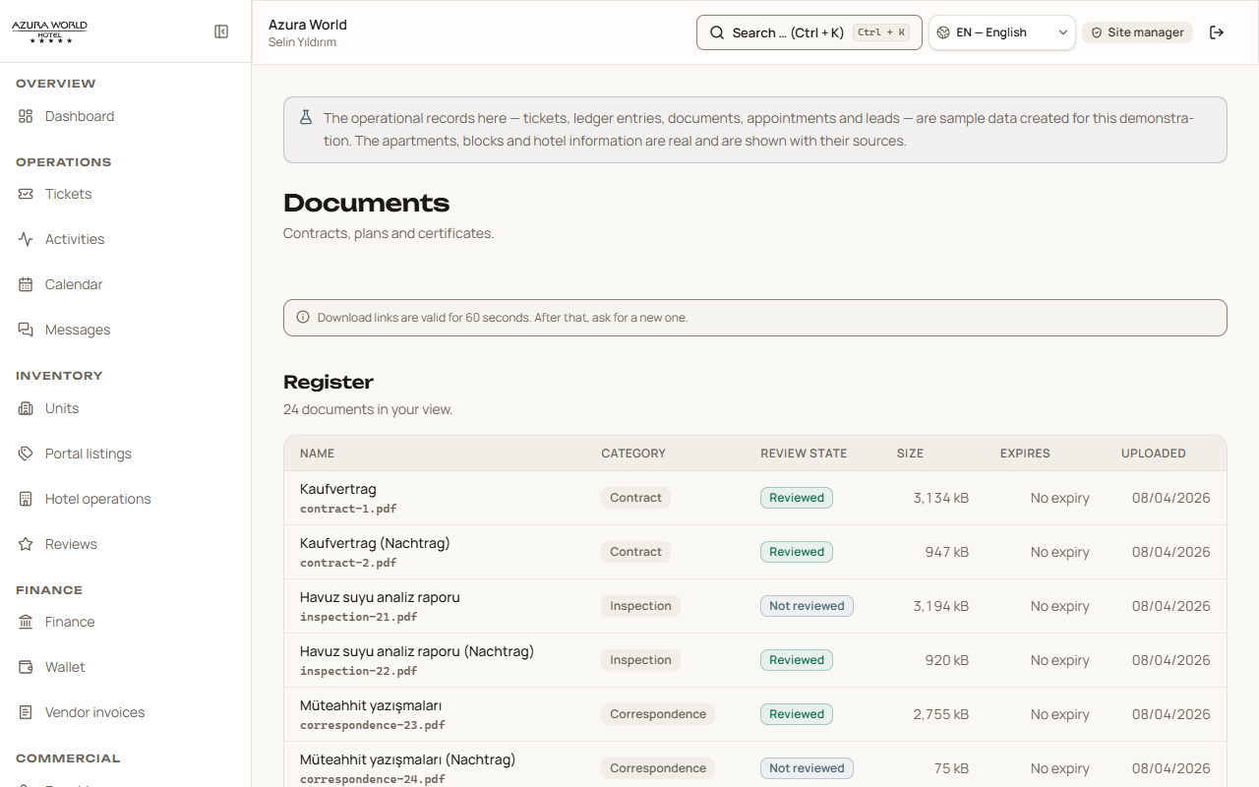
Figure 12 — The document register.
Files are stored privately. When you ask to download one, the system creates a link that works for sixty seconds and then stops working, so a link that leaks is not a way in.

Compliance
The safety and legal checks a building must pass: fire safety inspections, contract reviews, supplier checks, identity verification. Each has a due date, a risk level and a result.
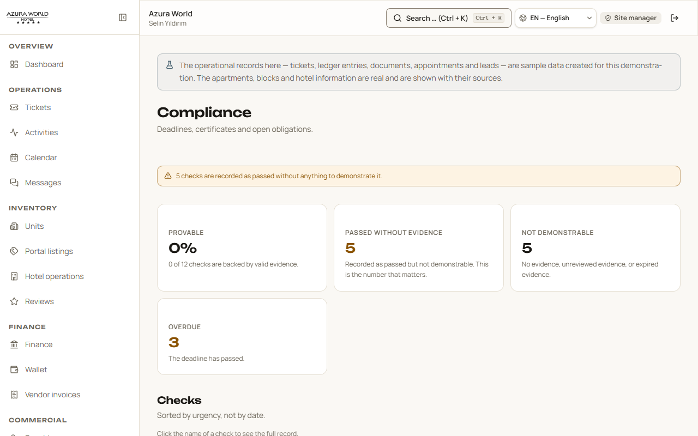
Figure 13 — The compliance register.
Why this screen shows two numbers instead of one
It shows how many checks can be proved, and separately how many claim to have passed but have no evidence attached. Combining those into a single “compliance score” would average away the difference — and the difference is the entire point. A check that passed and cannot prove it is not the same as one that passed.

Users
The people with accounts, their roles and whether each account is active. Administrators can change a role or block an account here. Every such change is written to the audit log, including the ones that are refused.

Settings
Your own details: your name, your language, your contact information.

6.6 Intelligence — the evidence

Sources and evidence
The research behind every figure in the system. Sixty sources were checked; forty-five returned a readable page and were verified. The screen lists each one, when it was read, and links to the stored copy of it.
It also lists 24 findings — the specific contradictions the research turned up, ranked by how serious they are. The most serious is that the entry price for a one-bedroom apartment cannot be established: nineteen observations from six publishers, spanning more than double from lowest to highest, deliberately left unresolved.

Reports
Downloadable versions of the evidence: a coverage report and a source register, both as spreadsheets that carry their citations with them. Two further reports are listed and marked as not yet built, rather than being hidden — so you can see what is coming.

7. The assistant
A question box that answers only from what the system can prove.
The system includes an assistant called Azura Concierge. You can ask it questions in ordinary language and it answers from the collected evidence.
There are two versions of it, and the difference matters.

The public assistant
Available to anyone, without signing in, at the Concierge page. It answers questions about the project: what an apartment costs, how many units and blocks there are, whether the hotel is a Wyndham, where the numbers come from.
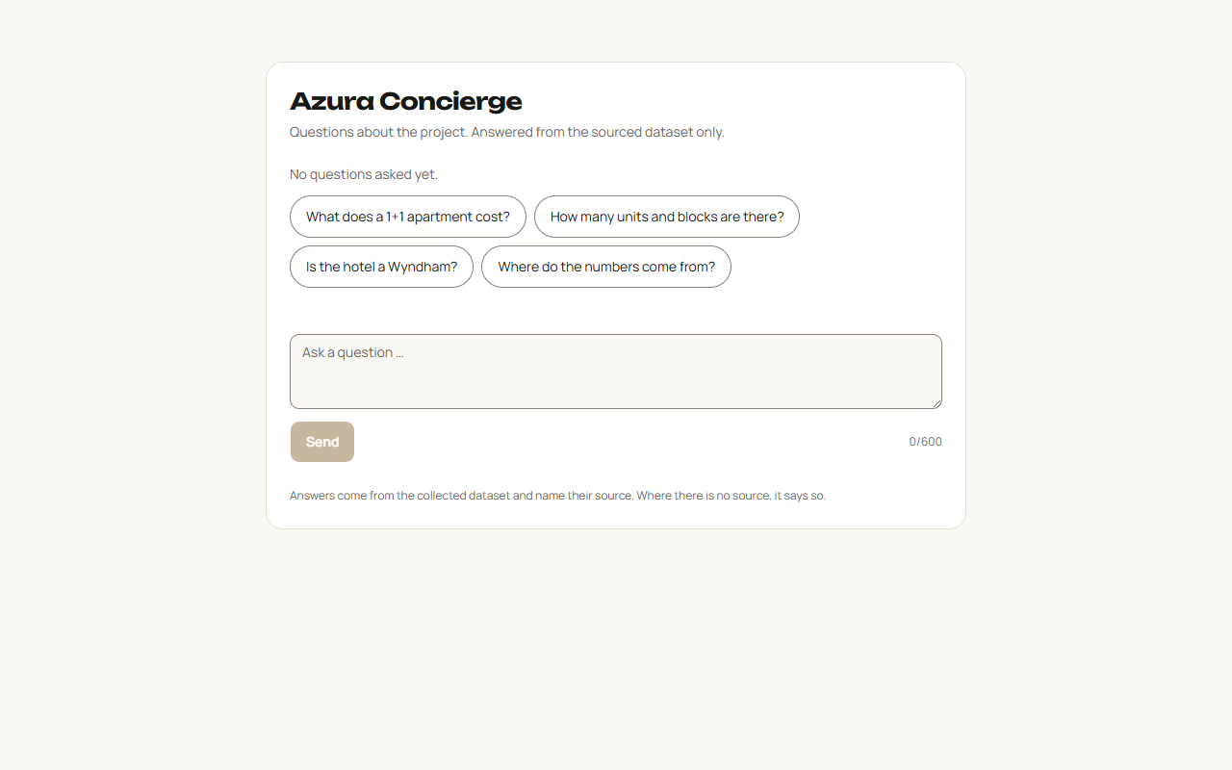
Figure 14 — The public assistant, with suggested questions.

The signed-in assistant
The same assistant, but aware of who you are. It answers within your permissions — so it will not tell a tenant something only management may see. It is the same rule as the rest of the system, applied to a conversation.

What makes it unusual
Most assistants of this kind will give you a confident answer whether or not they have grounds for one. This one will not.
Asked what a one-bedroom apartment costs — the single most obvious question anyone would ask — it replies, in part:
The assistant's actual answer
“The sources disagree. Asking prices observed on different portals for the same project: Haspo Realty: 112,000–190,000 EUR, 80–89 m² (8 listings) — stale? · Seaside Alanya: 185,000–210,000 EUR, 85–92 m² (2 listings) · Capital Estate: 230,000–310,000 EUR, 58–68 m² (3 listings) · Housearch: 238,967–239,171 USD, 75 m² (2 listings). The amounts are in different currencies and are not converted; an average would be an invented number.”
It then names the recorded conflicts behind that answer, and finishes by stating how many sources it used.
It would have been far easier to write an assistant that says “around 200,000 euros”. That answer would be friendlier, and it would be made up. This one tells you the truth, which is that nobody knows, and shows you why.
What the assistant will not do
It does not guess. If the evidence does not answer your question, it says so. It also never sees the evidence cockpit on behalf of somebody who is not allowed to see it — the same permission rules apply to the conversation as to the screens.

8. How the system keeps things safe
Four protections, explained without jargon.

You cannot reach what is not yours
Permission is enforced twice, in two independent places. The screen hides what you may not see, and the database refuses to hand it over even if somebody got past the screen. The second one is the real protection: it does not depend on the website behaving correctly.

Web addresses do not reveal anything
When you open a ticket or a document, the address in your browser does not contain the system's internal reference for it. It contains a scrambled code that means nothing outside the system. That stops anybody guessing their way to somebody else's records by changing a number in the address bar.

Every change is recorded
Who did it, what changed, when, and from which request. The record cannot be edited or deleted by anyone. Attempts that were refused are recorded too, because a refused attempt is often the more interesting one.

Accounting entries are permanent
As described in section 6.3: once posted, an entry cannot be altered. Corrections are made by adding a reversing entry, never by changing history.

9. What is deliberately not finished
A short, honest list. The system tells you these things on screen too — this section simply gathers them.
Software is rarely finished. What is unusual here is that the system says so where it matters, rather than showing you a control that quietly fails.

What | Where it stands
Email, SMS and WhatsApp | Not connected. Notifications appear inside the system only. Nothing is sent to your phone or inbox, and the system does not pretend otherwise.
Payment gateway | Not connected. Payments are recorded in the system; taking money online is not part of it yet.
Public damage report form | The page exists and states clearly, above the form, that it cannot yet store a report, and asks you to telephone site management instead.
Request an account | The same: it says so before you fill anything in, rather than after.
Two of the four reports | Listed in the Reports section and marked as not yet built.
Sample data | The day-to-day records in this version are demonstration data. Every screen says so. The apartments, blocks and hotel information are real.

10. Glossary
Every term in this manual that is not everyday English.

Term | What it means
1+1, 2+1, 3+1 | The Turkish way of describing an apartment: living rooms plus bedrooms. A 1+1 is one living room and one bedroom.
Aidat | The regular service charge every resident of a Turkish site pays towards shared costs.
Audit log | A permanent list of every change made in the system, who made it and when. Cannot be edited.
Block | One of the seven apartment buildings on the site, numbered B01 to B07.
Compliance check | A safety or legal inspection the building has to pass, with a due date.
Conflicted | Two or more sources state different things and the system is showing you both rather than choosing.
Dashboard | Your home screen after signing in.
Deposit (depozito) | Money held against damage, returned at the end of a tenancy.
Evidence | The web page, document or record a figure came from, kept with a copy and a date.
Gap | The system has no source for something, and says so rather than guessing.
Modelled value | A figure the system worked out rather than read somewhere. Always labelled, always shown with its working, never to be used as an asking price.
Permission | What your role allows you to see and do.
Reversing entry | A correcting accounting entry that cancels an earlier one, used because entries can never be edited.
Role | Your kind of account — one of the eleven in section 5.
Source | Where a piece of information came from.
Ticket | A numbered record of something that needs doing.

Getting help
If something in the system looks wrong, the most useful thing you can send is the reference on the screen — a ticket number like TCK-1043, or the reference code shown on an error message. Those let the record be found immediately.
For anything else, contact the site management directly.

Azura World CATI — User Manual, version 1.0, August 2026. Prepared by Wamocon.

