STRICTLY CONFIDENTIAL
DATA MIGRATION PLAN
AI-Powered Residential Site Management CRM
Source inventory, data quality rules, import workflow, reconciliation and cutover plan
Data quality
Reconciliation
Cutover
Prepared for: Ataberk Estate digital transformation planning
Prepared by: 1Cati / Product and Engineering
Design refresh: 25 June 2026
Status: Consulting-ready v0.2

Table of Contents
Executive review map generated from the main document structure.
1. Executive Summary
2. Migration Workflow
3. Source Inventory
4. Data Quality Rules
5. Reconciliation Reports
6. Migration Cutover Plan
7. Migration Risks
8. Acceptance Criteria

Executive At-A-Glance
- Day-one trust depends on accurate flats, relationships, opening balances, deposits, active bookings, open tickets and essential documents.
- Migration must use preview, validation, staging import, reconciliation and client sign-off before production cutover.
- Historical data should be migrated only when it is useful, legally appropriate and clean enough to avoid production confusion.

Reader Guide
Document type | Data Migration Plan
Primary audience | Data migration, product, engineering, finance and client operations
Status | Consulting-ready v0.2
Confidentiality | STRICTLY CONFIDENTIAL
Design preset | Arial Narrow consulting report; black text; light-grey table and diagram system

Visual Navigation
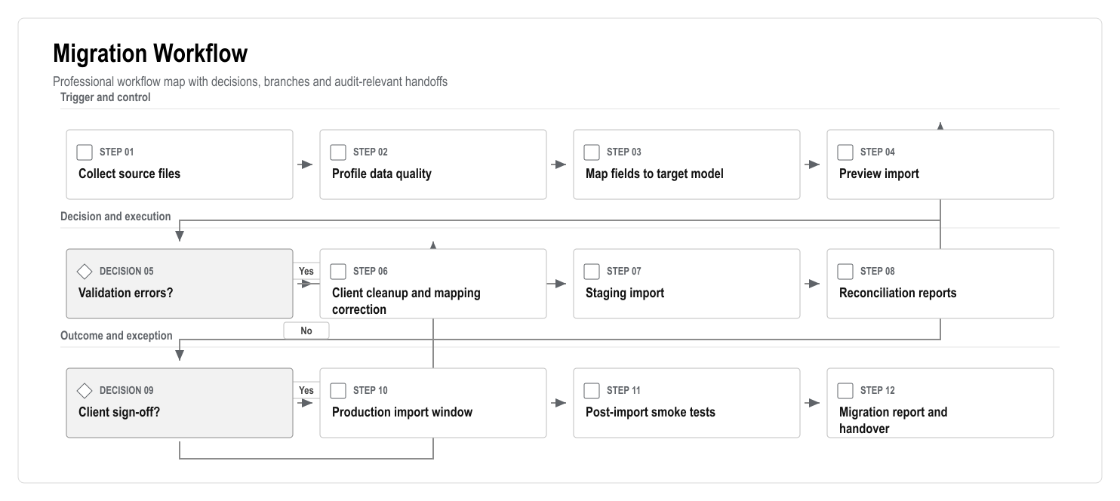
Figure: Migration Workflow

1. Executive Summary
Data migration will decide whether the platform feels trustworthy on day one. The first production migration should focus on correct active records: flats, owner/tenant relationships, user contacts, staff, account opening balances, current debts, deposits, active bookings, open service requests and essential documents.
Historical data should be migrated only where it has business value and acceptable quality. Poor history should not be imported blindly into the production ledger or audit trail.

2. Migration Workflow

Figure: Migration Workflow

3. Source Inventory
Source | Expected Content | Migration Priority
Flat list | Site, block, floor, number, type, status | Critical
Owner list | Owner identity, contact, linked flats | Critical
Tenant list | Tenant identity, contact, occupancy dates, permissions | Critical
Staff list | Staff role, team, contact, employment status | Critical
Accounting export | Opening balances, debts, payments, deposits | Critical
Service history | Open requests, recent completed work, categories | High if available
Booking history | Active/future bookings, deposits, checkout status | High if available
Documents | Contracts, statements, identity files, rules, notices | High, with legal review
Communication history | Emails/SMS/chat | Optional unless required
Access list | Cards, access IDs, active/inactive status | Integration-dependent

4. Data Quality Rules
Data Area | Validation Rule
Flats | Block/floor/flat combination must be unique
Users | Duplicate email/phone/identity candidates must be flagged
Relationships | Owner/tenant must link to an existing flat
Occupancy | Dates must not overlap without approved reason
Finance | Opening balance must map to an account and source file row
Deposits | Deposit must link to booking/flat/user where possible
Documents | Document owner, type and visibility must be defined
Access | External card/access IDs must not be stored as user IDs

5. Reconciliation Reports
The migration cannot be accepted by file count alone. It needs reconciliation reports:
- Total flats imported vs expected 769.
- Flats by block/floor/status.
- Owners imported and linked to flats.
- Tenants imported and linked to flats.
- Duplicate people candidates.
- Accounts created.
- Opening balances by account and total.
- Debts by age bucket.
- Deposits imported and linked.
- Documents imported by type and visibility.
- Open bookings and open tickets imported.
- Rejected rows with clear reasons.

6. Migration Cutover Plan
Step | Action | Owner
1 | Freeze source spreadsheets/exports | Client operations
2 | Run final validation import in staging | Data lead
3 | Review reconciliation report | Client and finance lead
4 | Approve production import window | Steering group
5 | Backup production database before import | Engineering lead
6 | Run production import | Data/engineering lead
7 | Run smoke tests and reconciliation | QA/data lead
8 | Client signs migration acceptance | Client owner

7. Migration Risks
Risk | Mitigation
Duplicate users | Candidate matching, manual merge queue, no silent overwrite
Wrong opening balances | Finance reconciliation and accountant sign-off
Missing flat relationships | Import preview errors and client correction file
Bad encoding/language | UTF-8 normalization and sample import review
Sensitive document overexposure | Default private visibility and permission mapping
Historical data inconsistency | Import active records first; migrate history only by approved scope

8. Acceptance Criteria
- 100% of expected flats imported or explained.
- Owner/tenant/staff records have accepted duplicate handling.
- Opening balances reconcile to approved source totals.
- Import errors are visible and resolved or accepted.
- Sensitive documents are not publicly accessible.
- Migration report is stored with source file versions and sign-off.

