STRICTLY CONFIDENTIAL
IMPLEMENTATION DELIVERY PLAN
AI-Powered Residential Site Management CRM
Phased delivery model, governance cadence, workstreams, decision gates and handover plan
Phased execution
Governance
Launch handover
Prepared for: Ataberk Estate digital transformation planning
Prepared by: 1Cati / Product and Engineering
Design refresh: 25 June 2026
Status: Consulting-ready v0.2

Table of Contents
Executive review map generated from the main document structure.
1. Executive Summary
2. Delivery Principles
3. Delivery Workflow
4. Phase Plan
5. Workstreams
6. Governance Cadence
7. Decision Log
8. Delivery Risks And Mitigations
9. Delivery Definition Of Done
10. Handover Package

Executive At-A-Glance
- Delivery should proceed through controlled phases because finance, restrictions, services, bookings, access and audit are tightly connected.
- Each phase should produce a usable business capability with evidence, not only static screens or isolated backend tables.
- The delivery model includes governance cadence, decision log, workstream ownership, risks and launch handover assets.

Reader Guide
Document type | Implementation Delivery Plan
Primary audience | Delivery leadership, product, engineering, client operations and steering group
Status | Consulting-ready v0.2
Confidentiality | STRICTLY CONFIDENTIAL
Design preset | Arial Narrow consulting report; black text; light-grey table and diagram system

Visual Navigation
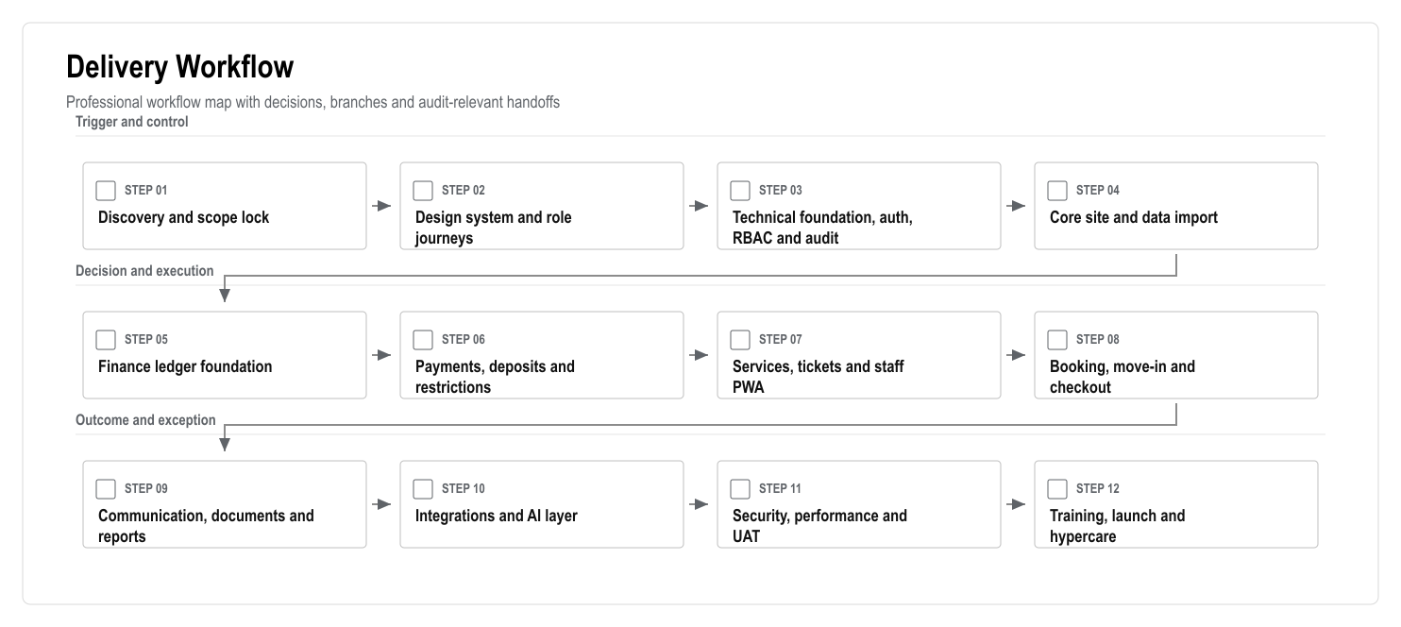
Figure: Delivery Workflow

1. Executive Summary
This plan converts the requirements package into a practical delivery model. The product should be delivered in controlled phases because the domains are highly connected: user relationships affect finance, finance affects restrictions, restrictions affect services and bookings, bookings affect deposits and access, and all sensitive actions must be auditable.
The recommended delivery approach is a phased modular monolith. Each phase should produce a usable business capability, not only backend tables or static screens. The first client-facing milestone should be a realistic demo that proves the operating model. Production work should then move through foundation, finance, services, bookings, communication, integrations, AI, QA and launch.

2. Delivery Principles
- Deliver business workflows, not isolated pages.
- Make finance and audit foundations early.
- Keep PWA mobile workflows in scope from the first usable release.
- Gate sensitive domains with legal/accounting review.
- Build integrations through adapters and test mode first.
- Treat data migration as a workstream, not a final task.
- Keep AI behind source links, role checks and human approval.
- Use UAT evidence before each major phase is accepted.

3. Delivery Workflow

Figure: Delivery Workflow

4. Phase Plan
Phase | Business Outcome | Key Deliverables | Acceptance Gate
1. Discovery and lock | Shared decision baseline | Final questions, data inventory, legal assumptions, integration inventory | Scope and assumptions signed
2. UX and navigation | Role journeys are clear | Design system, route map, mobile PWA patterns, clickable workflows | Manager/resident/staff/accountant journeys approved
3. Platform foundation | Secure access foundation | Auth, RBAC, RLS, audit log, protected route shell | Unauthorized access blocked and logged
4. Site data | 769-flat model is usable | Site/block/floor/flat schema, import preview, flat matrix | 769 flats load and filter correctly
5. People and roles | Owners, tenants and staff are mapped | Profiles, relationships, staff groups, identity status | Users link to flats with correct permissions
6. Ledger | Finance has a reliable base | Accounts, journal entries, balances, reversals, statements | Balances reconcile to ledger lines
7. Payments and restrictions | Debt affects operations safely | Payment intents, deposits, reconciliation, restriction engine | Restrictions enforced by backend rules
8. Services and tickets | Requests become managed work | Catalogue, service order, ticket creation, SLA, assignment | Accepted service always creates trackable task
9. Staff execution | Field work is visible | Staff PWA, media upload, completion report, tour control | Staff completes task from mobile with proof
10. Booking and checkout | Move-in/out is controlled | Availability, booking, deposit, inspection, settlement, access actions | Mandatory booking/check-in/checkout scenario passes
11. Communication/docs | Official communication is centralized | Chat, announcements, notifications, document vault | Messages and documents respect permissions
12. PWA hardening | Mobile usage is production-ready | Manifest, mobile navigation, performance optimization, push plan | Mobile E2E workflows pass
13. Integrations | External systems are connected safely | Payment/bank/SMS/access adapters, retry queue, health dashboard | No silent integration failure path
14. AI and analytics | Management workload is reduced | AI briefing, recommendations, source links, evaluation set | AI cannot execute restricted actions
15. Launch | Users can adopt safely | UAT, training, runbook, monitoring, hypercare | Go-live checklist accepted

5. Workstreams
Workstream | Owner | Main Responsibility
Product and scope | Product lead | Scope lock, acceptance criteria, roadmap decisions
UX and content | Design lead | Role journeys, Turkish-first UX, resident/staff simplicity
Engineering | Engineering lead | Architecture, implementation, code quality, technical gates
Data and migration | Data lead | Source inventory, import validation, reconciliation
Finance domain | Finance analyst / accountant | Ledger rules, deposits, statements, reconciliation
Security and compliance | Security/compliance lead | RBAC/RLS, KVKK, ASVS, audit, retention
QA and UAT | QA lead | Test strategy, UAT scripts, release evidence
Client operations | Client owner | Business rules, staff processes, training attendance

6. Governance Cadence
- Weekly delivery steering: scope, risks, decisions, timeline.
- Twice-weekly product/engineering working session during build phases.
- Weekly data migration checkpoint once source files are available.
- Security/compliance review before finance, access and document features go live.
- UAT readiness review before each major release candidate.
- Daily launch standup during final go-live week and first hypercare week.

7. Decision Log
Decision Area | Required Decision | Recommended Default
Mobile launch scope | Native app or PWA-first | PWA-first, native wrapper later only if approved
Payment launch scope | Online provider or manual/bank first | Provider adapter if vendor confirmed; manual/bank fallback
Access restriction | Legal and operational boundaries | Human-approved access action queue
AI autonomy | What AI can execute | Recommendation only for sensitive actions
Hosting and data residency | Supabase/Vercel region choice | Confirm with client/legal before production
Data migration | Historical depth | Opening balances plus active users/flats first; history by priority

8. Delivery Risks And Mitigations
Risk | Impact | Mitigation
Data quality is poor | Setup delay and trust issues | Import preview, error report, reconciliation sign-off
Finance rules are unclear | Wrong balances or disputes | Accountant workshops and ledger acceptance tests
Access blocking creates legal risk | Operational and legal escalation | Legal review, human approval and manual fallback
Integration vendor is not ready | Delay to payments/access/meter features | Adapter pattern and manual/import fallback
Native app expectation returns | Scope and budget expansion | Written PWA-first decision and optional later phase
AI overreach | Unsafe recommendations | Guardrails, source links, evaluation and approval queue

9. Delivery Definition Of Done
- Feature is connected to the relevant domain data, not mocked in production.
- Role permissions are enforced server-side.
- Sensitive writes create audit logs.
- Acceptance criteria have test evidence.
- Mobile behavior is checked for resident/staff workflows.
- Turkish copy is reviewed for clarity and tone.
- Documentation and training notes are updated.
- Open risks are documented with an owner.

10. Handover Package
The final launch handover should include:
- Production architecture summary.
- Environment and deployment notes.
- Admin and support playbook.
- Data migration report.
- UAT evidence.
- Security/compliance checklist.
- Backup/restore procedure.
- Role-based training material.
- Post-launch adoption report template.

