STRICTLY CONFIDENTIAL
MARKET RESEARCH ANNEX
AI-Powered Residential Site Management CRM
Benchmark summary, market signals, phase implications and differentiation
Market baseline
Competitive gaps
Turkish adaptation
Prepared for: Ataberk Estate digital transformation planning
Prepared by: 1Cati / Product and Engineering
Design refresh: 25 June 2026
Status: Consulting-ready v0.2

Table of Contents
Executive review map generated from the main document structure.
1. Research Position
2. Competitor And Best-Practice Sources
3. Phase-By-Phase Market Research Matrix
4. Market Gap Opportunities
5. Top Five Turkey Player Deep-Dive
6. Edge-Case Coverage Summary
7. Recommended Differentiators For Proposal
8. Research Caveats

Executive At-A-Glance
- Turkish benchmarks show that aidat, payments, resident access, communication, reservations, reporting and support are baseline expectations.
- The strongest proposal angle is not another basic CRM; it is a finance-first operating system with real service desk workflows.
- AI should be positioned as a controlled assistant for triage, briefing, anomaly detection and reporting, not as an autonomous decision-maker.

Reader Guide
Document type | Market Research Annex
Primary audience | Strategy, sales, product and delivery leadership
Status | Consulting-ready v0.2
Confidentiality | STRICTLY CONFIDENTIAL
Design preset | Arial Narrow consulting report; black text; light-grey table and diagram system

Visual Navigation
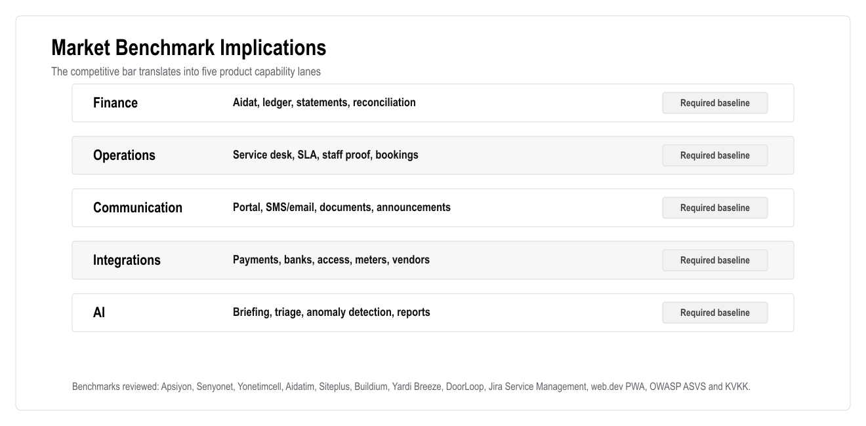
Figure: Market Benchmark Implications

1. Research Position
The client request should be treated as a full residential operations platform, not a simple CRM. Market research shows that serious competitors already provide property accounting, payments, resident/owner portals, service requests, maintenance workflows, mobile access, communication, reporting, integrations, onboarding and increasingly AI assistance.
The correct business response is to match the client's mandatory scope and add AI, workflow clarity, premium web/PWA UX, stronger reporting, and Turkish-localized service delivery.

2. Competitor And Best-Practice Sources
Source | Relevant Findings
Apsiyon | Turkish baseline for aidat tracking, bank integrations, card collection, reservation, manager/resident mobile, access control, meter/billing, email/SMS and AI assistant positioning
Senyonet | Turkish site/facility software benchmark for communication/public relations, finance, accounting, security, reservations, document management, support and training
Yönetimcell | Turkish usability benchmark for aidat tracking, bank integration, credit card/Masterpass collection, resident payment access, reporting/Excel export and staff job tracking
Aidatım | Turkish hybrid benchmark combining management software, private assistant, accounting/legal support, migration/setup, bank matching, reports, meter billing and e-mail/SMS
Siteplus | Adjacent integrated facility management benchmark for professional site management, security, cleaning, technical maintenance and field operations
Buildium | Global property management baseline: accounting, payments, maintenance requests, resident center, owner portal, leasing, marketplace, open API, automation and AI
Yardi Breeze | Global baseline: online balances/payments, automated rent/fee posting, maintenance requests, smartphone photos/videos, accounting and owner reports
DoorLoop | Global baseline: accounting, bank sync, financial reports, leasing, CRM, maintenance, mobile app, owner portal, file storage, rent collection, tenant management, communication and AI
Atlassian Jira Service Management | Ticketing/service desk baseline: request intake, incident/request workflows, SLA, assignment, automation, reporting and AI
web.dev PWA | PWA baseline: installable mobile web experience, one codebase, service worker/caching capabilities and app-like web behavior
OWASP ASVS | Security baseline for authentication, access control, validation, logging, API security and data protection
KVKK | Turkish data protection baseline for personal data processing, purpose limitation, proportionate processing and protection obligations

3. Phase-By-Phase Market Research Matrix
Phase | What The Market Does | Best Practice For Our Product | AI / Time-Saving Add-On | Turkish Adaptation
1. Discovery and benchmark | Competitors sell onboarding, migration and training, not only software | Start with operating model, finance rules, integration inventory and data migration plan | AI meeting summaries, gap analysis and scope checklist | Turkish examples, clear business language, visible implementation confidence
2. UX/UI design system | Market leaders emphasize simple portals, dashboards and guided workflows | Role-based navigation, calm dashboard, clear statuses and mobile-first resident/staff flows | AI briefing cards and next-best-action prompts | Turkish-first wording, respectful tone, low clutter, visible support
3. Platform foundation, auth, RBAC, audit | Mature platforms restrict owner/resident/staff access and preserve operational logs | Auth, RBAC, RLS, audit logs and secure admin settings from day one | AI audit summary and unusual action detection | Trust depends on "who did what and when" clarity
4. Site/block/flat/import | Competitors support migration from Excel and structured property setup | 769-flat matrix, import preview, validation and data quality dashboard | AI duplicate/missing-data detection | Managers commonly rely on spreadsheets; import must be simple
5. User/owner/tenant/staff management | Owner portals, resident centers and tenant management are standard | Profile, documents, relationships, identity status, staff groups | AI duplicate contacts and missing document alerts | Strong privacy and clear contact/SMS support
6. Financial ledger | Accounting is a core market feature | Ledger-based balances, accruals, statements, reversals and exports | AI balance explanation and anomaly detection | Financial disputes require official, traceable records
7. Payments/deposits/restrictions | Online bank/card collection and automated payments are standard | Payment provider, bank import, reconciliation, deposit lifecycle, debt rules | AI unmatched payment suggestions and debt-risk ranking | Debt language must be firm, clear and respectful
8. Service catalogue/order flow | Maintenance and service requests are expected | Service catalogue, debt check, payment/debit, order, ticket, notification | AI category, urgency and SLA suggestions | Show price/SLA before confirmation; explain blocked requests
9. Tasks/workforce/SLA/media | Global tools support maintenance photos/videos, notes and progress | Ticket board, staff PWA, SLA, media report, tour control | AI routing, duplicate ticket detection and workload balancing | Staff need simple mobile screens and managers need proof
10. Booking/move-in/checkout | Reservation/leasing workflows are common | Availability, payment, deposit, move-in tasks, access, checkout settlement | AI booking conflict and checkout risk summaries | Deposits and access changes need clear documentation
11. Communication/documents | Portals, email/SMS, files and chat are standard | Linked chat, announcements, delivery logs, document vault | AI reply drafts, summaries and announcement drafts | SMS/email still important; official communication should stay in system
12. Web/PWA mobile experience | Mobile apps are common; PWA can satisfy mobile access faster | Responsive web app, installable PWA, mobile staff/resident workflows | Mobile AI help and voice-ready Turkish commands | Works for users who do not want app store installation
13. Integrations | Market differentiators include payment, banks, access, meters and APIs | Adapter layer, webhooks, retries, integration health and manual fallback | AI integration failure summaries and anomaly alerts | Local vendors vary; fallback process must be planned
14. AI and analytics | AI assistants are increasingly promoted by competitors | Manager/accountant/resident/staff AI, recommendations, approval workflow | Daily briefing, anomaly detection, predictive maintenance, report generation | Turkish quality and human approval are critical for trust
15. QA/security/UAT/training/launch | Competitors sell support and implementation services | UAT scripts, security review, training, launch runbook, monitoring | AI test assistance and support triage | Hands-on launch support and role-specific training are essential

4. Market Gap Opportunities
The strongest competitive opportunities are:
- Combine Turkish site management needs with a modern global SaaS UX.
- Replace vague "service management" with a real service desk/ticketing system.
- Build a true finance ledger, not a simple balance table.
- Make debt restrictions configurable, auditable and transparent.
- Use PWA to deliver mobile access faster than native development.
- Add AI, but keep AI controlled with human approval.
- Make the dashboard action-oriented, not only informational.
- Treat support, migration and training as part of the product offer.
- Make access integrations auditable and failure-aware.
- Make Turkish copy, SMS/email, receipts and official-looking statements central to trust.

5. Top Five Turkey Player Deep-Dive
These five players are included because they are publicly visible and relevant to the client's requested scope. They should be treated as benchmarks, not as a legally ranked market-share list.

5.1 Apsiyon
Observed capabilities:
- Aidat tracking.
- Online bank integrations.
- Card collection.
- Reservation.
- Free website.
- Manager mobile.
- E-mail and SMS.
- Access control products.
- Meter reading and billing.
- AI assistants and digital-assistant positioning.
Implications:
- Our product must include finance, payments, communication and reservation as baseline.
- Access and meter integrations should be planned even if not launched in phase one.
- AI should be useful in real operational scenarios: debt, request triage, reporting and anomaly detection.

5.2 Senyonet
Observed capabilities:
- Site, apartment, facility, hotel, office, AVM and management-company positioning.
- Public relations/communication module.
- Finance module.
- Accounting module.
- Security module.
- Requests, announcements, events, reservations and document management.
- Bank, cash and current account visibility.
- Collections, invoicing, budgeting and reporting.
- Visitor, personnel, cargo and vehicle tracking.
- Support and training.
Implications:
- Our platform must support connected operations, not only CRM records.
- Security/visitor workflows should be considered in access/integration planning.
- Support/training should be part of the delivery model.

5.3 Yönetimcell
Observed capabilities:
- Aidat tracking.
- Online bank integration.
- Credit card and Masterpass collection.
- Resident account/payment access.
- Reports and Excel exports.
- Multi-site/apartment management.
- Manager mobile app.
- Resident aidat tracking app.
- Staff job-tracking app.
Implications:
- Simplicity and learnability are competitive advantages in Turkey.
- Export and reporting are mandatory for managers and management companies.
- Staff job tracking validates the need for a proper ticket/task module.
- PWA must cover the core value of mobile apps without delaying launch.

5.4 Aidatım
Observed capabilities:
- Private assistant.
- Management software.
- Accounting support.
- Legal support.
- Setup and transition help.
- Credit card collection.
- Bank account tracking with smart matching.
- Leave and payroll.
- Monthly/yearly analysis and reports.
- Current account tracking and expense sharing.
- Meter reading and billing.
- E-mail and SMS.
- Account sharing.
Implications:
- Migration, setup and support must be part of the offer.
- Smart reconciliation should be included in finance roadmap.
- Payroll/leave can remain non-goal for launch but should be extensible later.
- Legal review is required for debt, access and collection workflows.

5.5 Siteplus
Observed capabilities:
- Integrated facility management.
- Professional site management.
- Private security.
- Cleaning.
- Alarm monitoring.
- Landscaping.
- Pest control and disinfection.
- Technical maintenance and repair.
Implications:
- Our service module must support real field operations.
- Work queues should cover cleaning, security, repair and technical maintenance.
- Media evidence, SLA, staff/contractor assignment and incident tracking are critical.
- The system should work for a professional facility management company, not only resident self-service.

6. Edge-Case Coverage Summary
The expanded BRD/TRD now includes edge cases across:
- Multiple owners and multi-flat ownership.
- Tenant permission limits.
- Vacant flats with owner debt.
- Duplicate imports.
- Partial payments and overpayments.
- Delayed/duplicate payment webhooks.
- Deposit shortfall and refund failure.
- Debt threshold changes.
- Emergency maintenance override.
- Service ticket duplicates.
- Media upload failures.
- Booking overlaps.
- Access integration failure.
- SMS/email delivery failure.
- Staff internal notes leaking to residents.
- AI hallucination, role leakage and unauthorized action.
- Document retention and KVKK privacy risks.
The key product rule is that risky cases must be handled by state machines, audit logs and approval workflows, not by informal manual edits.

7. Recommended Differentiators For Proposal

7.1 Business Differentiators
- Full 769-flat operating model.
- Finance-first architecture.
- Service desk/ticketing module.
- Web/PWA launch instead of slow native app dependency.
- AI manager assistant.
- AI debt-risk and anomaly detection.
- Turkish-first onboarding and support.
- Audit and accountability at every critical action.

7.2 UX Differentiators
- Flat matrix by block/floor.
- One-click view of debt status per flat.
- Resident self-service with simple mobile web.
- Staff task mobile view with photo/video reports.
- Manager daily briefing.
- Accountant ledger and export tools.

7.3 Technical Differentiators
- API-first modular architecture.
- PostgreSQL ledger.
- RLS/RBAC security.
- Integration adapter layer.
- AI recommendations with human approval.
- PWA-first delivery.
- End-to-end test coverage for mandatory scenarios.

8. Research Caveats
This annex uses public competitor and best-practice information available on 24 June 2026. It is suitable for product planning and proposal positioning. It is not a legal compliance opinion and should be reviewed by legal/accounting specialists before finalizing debt restriction, access blocking, identity verification, camera processing, retention and payment compliance rules.

