STRICTLY CONFIDENTIAL
PRODUCT REQUIREMENTS DOCUMENT
AI-Powered Residential Site Management CRM
Product scope, personas, modules, UX requirements, roadmap and risks
User outcomes
Launch scope
Roadmap
Prepared for: Ataberk Estate digital transformation planning
Prepared by: 1Cati / Product and Engineering
Design refresh: 25 June 2026
Status: Consulting-ready v0.2

Table of Contents
Executive review map generated from the main document structure.
1. Executive Summary
2. Market And Competitive Context
3. User Personas
4. Product Scope
5. Functional Requirements By Module
6. UX Requirements
7. AI System Requirements
8. Edge Cases
9. Technical Specifications Summary
10. Roadmap
11. Product Operating Model
12. Product Module Interaction Model
13. Screen And Workflow Inventory
14. MVP Acceptance Matrix
15. Risks
16. PRD Approval Checklist

Executive At-A-Glance
- The MVP should prove the operating model: 769 flats, role access, ledger basics, service desk and PWA workflows.
- V1 adds payments, deposits, restrictions, bookings, communication, documents, reports and AI assistant v1.
- V2 expands integrations, meter/billing, advanced reconciliation, predictive AI and optional native wrappers.

Reader Guide
Document type | Product Requirements Document
Primary audience | Product, design, engineering, QA and delivery teams
Status | Consulting-ready v0.2
Confidentiality | STRICTLY CONFIDENTIAL
Design preset | Arial Narrow consulting report; black text; light-grey table and diagram system

Visual Navigation
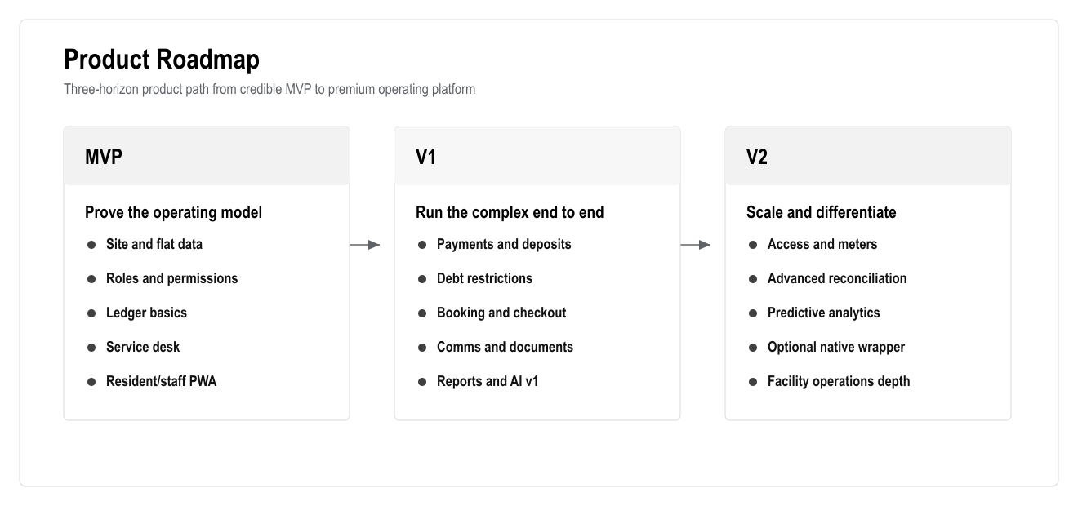
Figure: Product Roadmap
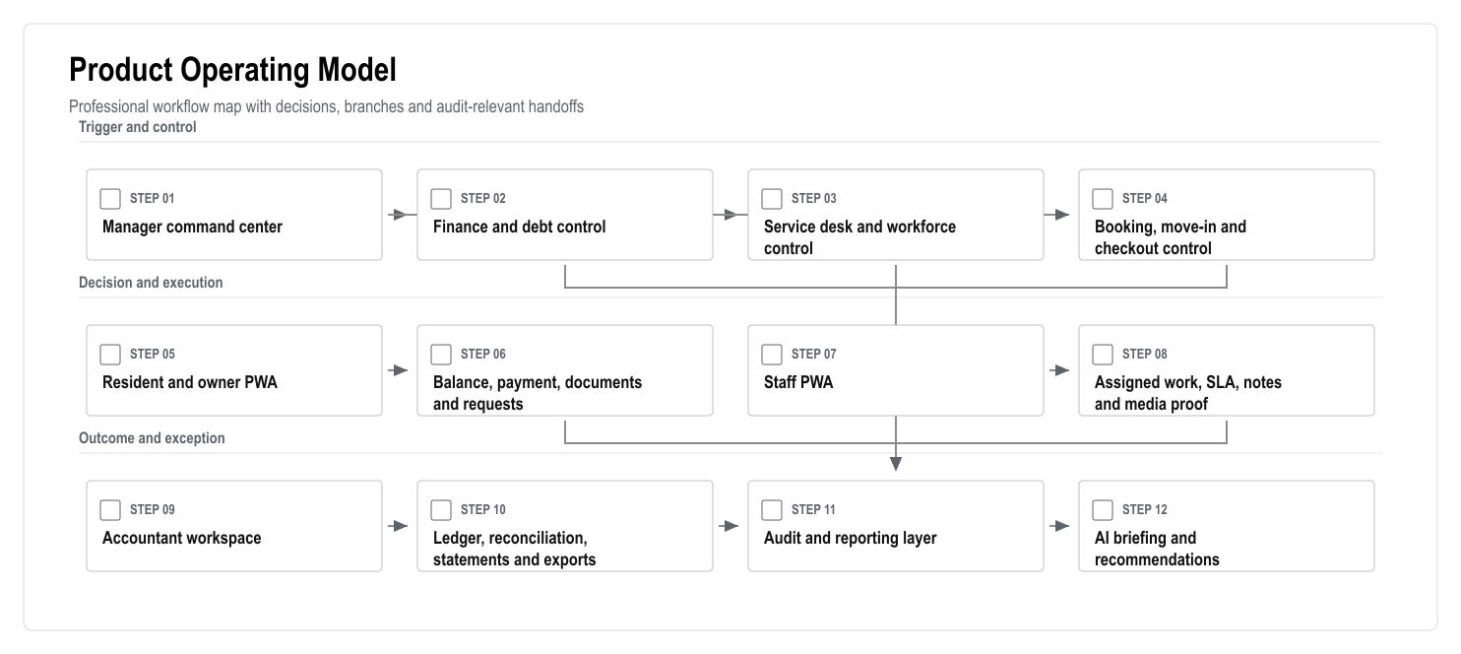
Figure: Product Operating Model
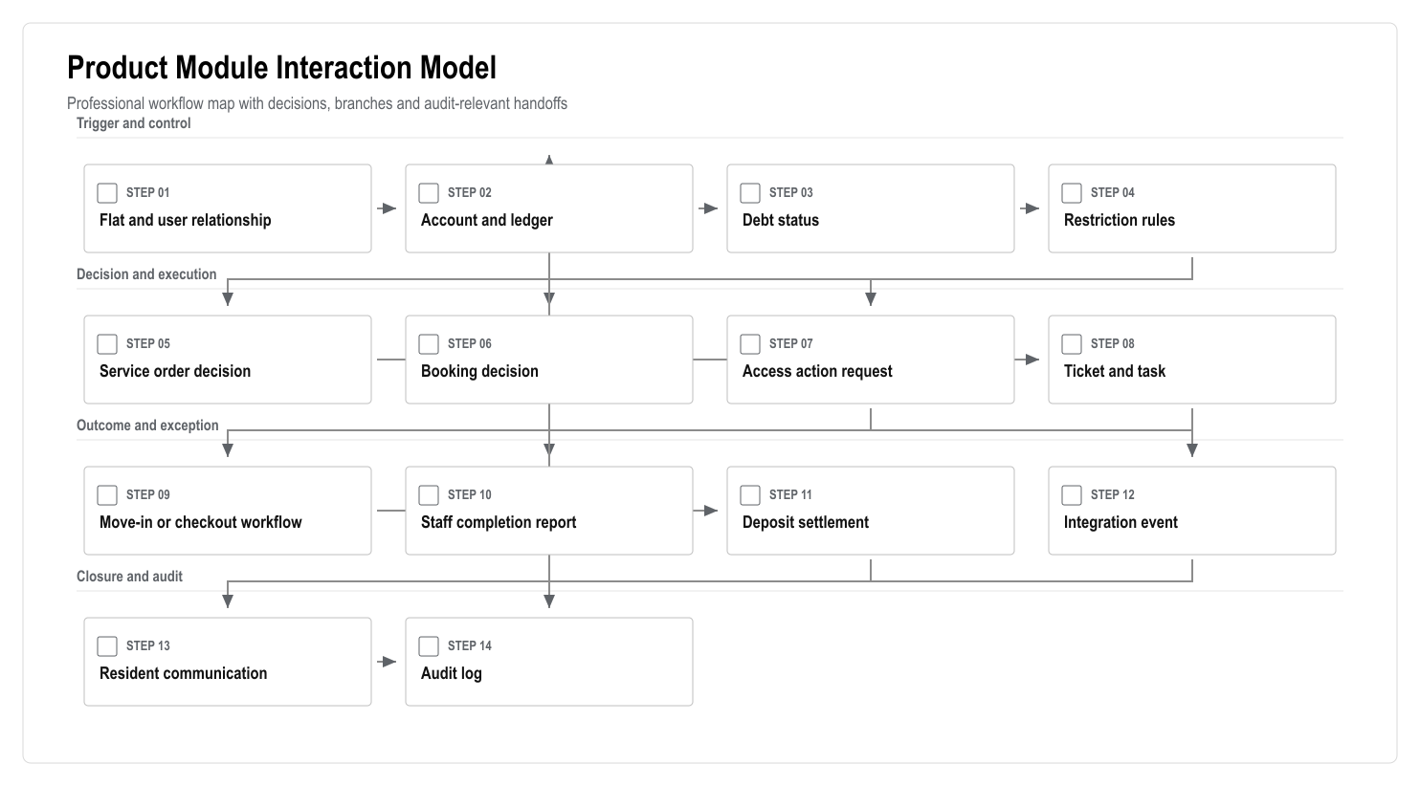
Figure: Product Module Interaction Model

1. Executive Summary

Problem Statement
The client needs to manage a 769-flat residential complex with owners, tenants, staff, accounting, payments, services, bookings, deposits, debt restrictions, access rules, communication, reporting and audit history. The current implemented concept is a useful foundation, but the required product is a full site management operating platform.

Proposed Solution
Build a Turkish-first AI-powered residential site management CRM as a responsive web application and installable PWA. The product will cover the client's mandatory requirements and add premium capabilities such as AI manager briefing, AI service triage, debt-risk insights, anomaly detection, workflow automation, modern dashboards and auditable operations.

Success Criteria
- 100% of 769 flats can be represented with block, floor, status, owner/tenant relationship and account state.
- 100% of financial activity is recorded through an auditable ledger.
- 100% of accepted service requests create trackable tickets/tasks.
- Mandatory scenarios pass UAT: service order, tenant move-in, checkout and late-payment/debt restriction.
- Resident, staff and manager PWA workflows pass mobile viewport E2E tests.
- AI suggestions are source-linked, permission-aware and blocked from direct finance/access execution.

2. Market And Competitive Context

2.1 Turkish Top-Five Benchmark
The product must compete against or at least be credible beside the following Turkish market benchmarks:
- Apsiyon: broad site/apartment management suite with aidat, bank integration, card collection, reservation, access control, meter/billing, e-mail/SMS, mobile and AI positioning.
- Senyonet: site/facility management platform with public relations, finance, accounting, security, requests, announcements, events, reservations, document management, support and training.
- Yönetimcell: simple site/apartment program with aidat tracking, bank integration, credit card/Masterpass collection, resident payments, reports, Excel export, manager/resident apps and staff job tracking.
- Aidatım: hybrid software/service model with private assistant, accounting/legal support, setup/migration, smart bank matching, reports, meter reading, e-mail/SMS and account sharing.
- Siteplus: adjacent integrated-facility-management benchmark with professional site management, security, cleaning, alarm monitoring, landscaping and technical maintenance/repair.

2.2 Product Positioning
The product should be positioned as:
A premium AI-powered residential site operating system for Turkish complexes, combining finance, services, bookings, access, communication, reporting and management intelligence in one secure web platform.

2.3 Differentiation
The strongest differentiators are:
- PWA-first delivery for fast launch without native app delay.
- True service desk/ticketing module.
- Ledger-based finance engine.
- Debt restriction workflows with audit and human override.
- AI manager/accountant/resident/staff assistants.
- Turkish-first service psychology.
- Support for professional facility operations, not only resident payments.

3. User Personas

3.1 Administrator
As an administrator, I need full configuration access so that the system can be safely operated, secured and maintained.

3.2 Site Manager
As a site manager, I need one dashboard for debts, tasks, bookings, access issues, resident communication and AI recommendations so that I can control daily operations.

3.3 Accountant
As an accountant, I need accurate ledgers, accruals, payments, deposits, refunds, reconciliation and reports so that financial records are correct and auditable.

3.4 Owner
As an owner, I need to see my balance, payments, statements, tenant/rental information, documents and service requests so that I can manage my flat transparently.

3.5 Tenant
As a tenant, I need to pay allowed balances, request services, receive notifications, chat with management and access permitted documents so that I can handle daily needs without calling management.

3.6 Staff / Technician / Security
As staff, I need assigned tasks, SLA, location details, notes, photo/video upload and completion controls so that I can complete work correctly from my phone.

4. Product Scope

4.1 In Scope For Launch
- Web admin app.
- Installable PWA for manager, resident, owner, tenant and staff workflows.
- Site/block/floor/flat data model.
- User, role and permission management.
- Owner/tenant/staff profiles.
- Finance ledger.
- Accruals, payments, deposits, refunds and statements.
- Debt restriction rules.
- Service catalogue.
- Service order workflow.
- Ticket/task management.
- SLA and media reports.
- Booking, move-in and checkout workflows.
- Chat, announcements, notifications and documents.
- Reporting dashboard.
- Integration-ready architecture.
- AI assistant and recommendation layer with human approval.
- Audit logs.
- QA, UAT, security and launch support.

4.2 Out Of Scope For Launch
- Native iOS app.
- Native Android app.
- Full offline-first operation.
- Fully autonomous AI financial actions.
- Fully autonomous AI access actions.
- Full camera video storage unless legally and technically approved.
- Payroll/leave as a first-launch module.
- Complex ERP integration unless separately scoped.

5. Functional Requirements By Module

5.1 Core Site Data
User stories:
- As a manager, I want to view all 769 flats by block/floor so that I can understand the site at a glance.
- As an admin, I want to import flats from Excel so that setup is faster.
- As a manager, I want to filter flats by debt, status, owner and tenant so that I can find operational problems quickly.
Acceptance criteria:
- Flat records include site, block, floor, number, type and status.
- Import preview validates duplicates and missing fields before commit.
- Flat matrix supports all 769 flats.
- Flat history is not overwritten when owner/tenant changes.

5.2 User And Role Management
User stories:
- As an admin, I want to assign users to roles so that permissions are controlled.
- As a manager, I want to link owners and tenants to flats so that communication and finance are correct.
- As an owner, I want tenant permissions to be controlled so that private owner data is protected.
Acceptance criteria:
- Roles include owner, tenant, staff, manager, accountant and admin.
- Users can be linked to one or more flats.
- Tenant permissions can be limited.
- Document visibility follows role and relationship rules.

5.3 Finance Ledger
User stories:
- As an accountant, I want balances calculated from ledger entries so that records are reliable.
- As an owner, I want to see transaction history so that I understand my balance.
- As a manager, I want debt reports so that collection can be managed.
Acceptance criteria:
- Financial entries cannot be deleted after posting.
- Reversals reference original entries.
- Balance equals ledger total.
- Statements can be exported.

5.4 Payments, Deposits And Restrictions
User stories:
- As a resident, I want to pay online so that I can clear my balance quickly.
- As an accountant, I want payment reconciliation so that bank/provider records match accounts.
- As a manager, I want debt restrictions so that unpaid balances affect services/bookings/access according to policy.
Acceptance criteria:
- Duplicate payment webhooks do not double-post.
- Deposits can be blocked, used and refunded with audit history.
- Debt restrictions are enforced by backend APIs.
- Users see clear payment guidance when blocked.

5.5 Service Catalogue And Tickets
User stories:
- As a tenant, I want to request cleaning, transfer, repair or tour services so that I can get help.
- As a manager, I want every service request to create a ticket so that work is trackable.
- As staff, I want clear assigned tasks so that I know what to do next.
Acceptance criteria:
- Service order checks debt before acceptance.
- Paid service requires payment/debit before task creation.
- Every accepted service order creates a ticket/task.
- Ticket includes status, priority, SLA and assignee.

5.6 Workforce, SLA And Media Reports
User stories:
- As staff, I want to upload photo/video completion evidence so that work can be verified.
- As a manager, I want overdue tasks highlighted so that service quality is controlled.
- As a resident, I want to track service progress so that I know what is happening.
Acceptance criteria:
- Staff can complete a ticket from mobile web.
- Required media categories enforce upload before completion.
- SLA breach is visible on dashboard.
- Internal notes are not exposed to residents.

5.7 Booking, Move-In And Checkout
User stories:
- As a manager, I want availability calendar so that bookings do not overlap.
- As an accountant, I want deposits linked to booking so that checkout settlement is accurate.
- As a manager, I want checkout workflow so that debts, damages, refunds and access are handled correctly.
Acceptance criteria:
- Overlapping bookings are blocked.
- Move-in creates preparation tasks.
- Checkout requires inspection and settlement.
- Access activation/deactivation creates auditable request.

5.8 Communication And Documents
User stories:
- As a resident, I want to chat with management so that issues stay in one place.
- As a manager, I want announcements so that I can communicate with the right audience.
- As an owner, I want documents and statements so that records are accessible.
Acceptance criteria:
- Threads can link to flat, ticket, booking or account.
- Notification delivery status is logged.
- Documents have permission controls.
- Sensitive document access is auditable where required.

5.9 Reporting And Dashboard
User stories:
- As a manager, I want a dashboard showing income, debt, tasks and bookings so that I can prioritize.
- As an accountant, I want exportable financial reports so that I can work with external records.
- As management, I want staff and SLA reports so that service quality can be measured.
Acceptance criteria:
- Dashboard data comes from backend views/services.
- Reports support filters and date ranges.
- Reports export to Excel/CSV and PDF where required.
- Metrics drill down to source records.

5.10 AI Layer
User stories:
- As a manager, I want an AI daily briefing so that I know what needs attention.
- As an accountant, I want AI to explain balance anomalies so that I can investigate faster.
- As staff, I want AI to prioritize tasks so that urgent work is not missed.
- As a resident, I want AI help for simple questions so that I get answers faster.
Acceptance criteria:
- AI output is logged.
- AI recommendations include source/context.
- AI cannot post payments, refund deposits or change access directly.
- AI respects RBAC and data permissions.
- AI Turkish tone is professional and respectful.

6. UX Requirements
- Turkish-first interface.
- Clear navigation for each role.
- Calm, professional visual system.
- Dashboard optimized for scanning.
- Resident flows must be short and simple.
- Staff flows must be mobile-first.
- Accountant screens must prioritize precision, filters and exports.
- Debt and restriction messages must be clear and respectful.
- Critical workflows must use guided wizards.
- Mobile PWA must support common Android and iOS browsers.

7. AI System Requirements

7.1 AI Tools Required
- Natural language assistant.
- Retrieval over authorized system data.
- Prompt templates per role.
- AI recommendation queue.
- Approval/decline workflow.
- AI event log.
- AI evaluation set.

7.2 AI Evaluation Strategy
AI must be evaluated against:
- Service category classification.
- Urgency detection.
- Debt summary accuracy.
- Ledger explanation accuracy.
- Turkish language quality.
- Permission boundary safety.
- Refusal behavior for restricted actions.

7.3 AI Non-Goals
- No autonomous payments.
- No autonomous refunds.
- No autonomous access changes.
- No final legal advice.
- No hidden data access across roles.

8. Edge Cases
The product must handle:
- Multiple owners for one flat.
- One owner with multiple flats.
- Tenant permission restrictions.
- Duplicate imports.
- Partial payments.
- Overpayments.
- Duplicate/delayed payment webhooks.
- Deposit shortfall.
- Emergency service override.
- Debt threshold changes.
- Booking overlap.
- Checkout without tenant cooperation.
- Failed access integration.
- Failed SMS/email delivery.
- Media upload failure.
- Staff internal-note privacy.
- AI hallucination.
- AI unauthorized action attempt.
- KVKK-sensitive document and media handling.

9. Technical Specifications Summary
Architecture:
- Next.js 16 App Router.
- React 19.
- TypeScript.
- Tailwind CSS v4.
- Supabase Auth.
- Supabase PostgreSQL.
- Row Level Security.
- Supabase Storage/S3-compatible storage.
- Supabase Realtime where suitable.
- PostgreSQL full-text search.
- pgvector for AI retrieval.
- Optional FastAPI/LangGraph worker for advanced AI orchestration.
Security:
- RBAC.
- RLS.
- Audit logs.
- Idempotency keys.
- Validation.
- KVKK-aware data handling.
- OWASP ASVS-aligned security checks.
Testing:
- Unit tests for finance, restrictions, deposits and permissions.
- Integration tests for payments, access, notifications and RLS.
- Playwright E2E for mandatory scenarios.
- AI evaluation tests.

10. Roadmap

MVP
- Core site/flat data.
- User/role model.
- Finance ledger basics.
- Service/ticket workflow.
- Basic PWA resident/staff screens.
- Dashboard.

V1
- Payments.
- Deposits.
- Debt restrictions.
- Booking/move-in/checkout.
- Communication/documents.
- Reports.
- AI manager/accountant assistant v1.

V2
- Access integrations.
- Meter/billing integration.
- Advanced reconciliation.
- Advanced AI anomaly detection.
- Native app wrapper only if explicitly approved.
- Expanded professional facility management workflows.

11. Product Operating Model
The product should be understood as four connected experiences, not one generic CRM screen. Each experience has a different job and therefore a different product standard.

Figure: Product Operating Model
Product implication:
- Manager screens should prioritize control, exceptions and approvals.
- Resident screens should prioritize simplicity, trust and fast completion.
- Staff screens should prioritize mobile task execution and proof of work.
- Accountant screens should prioritize accuracy, filters, exports and audit trail.

12. Product Module Interaction Model
The main product risk is treating modules as separate pages. The platform only works if finance, restrictions, tickets, bookings, access and communications share one operational state.

Figure: Product Module Interaction Model
Design rule:
- A user should never need to understand the internal module boundaries.
- Every module should show the current state, the next action and the reason behind any block.
- Critical actions must explain the source record: debt amount, booking, ticket, deposit, access request or approval.

13. Screen And Workflow Inventory
Area | Primary Screens | Must Support | Product Quality Bar
Manager command center | Dashboard, debt list, task board, booking calendar, approvals, AI briefing | Exception review, assignment, approval, communication | Clear priorities and no hidden operational risk
Resident/owner PWA | Home, balance, payment, service request, booking status, documents, chat | Fast mobile completion and simple language | Fewer steps, clear receipts, respectful debt messaging
Staff PWA | Task list, task detail, route/checkpoint, media upload, completion form | Mobile execution, SLA visibility, offline draft where feasible | No administrative clutter during field work
Accountant workspace | Ledger, accruals, payments, deposits, reconciliation, reports, exports | Accuracy, reversals, audit trail, statement generation | Finance actions are traceable and hard to misuse
Admin workspace | Roles, permissions, site setup, integrations, rules, audit logs | Safe configuration and controlled overrides | Dangerous settings are explicit and logged
AI command center | Briefing, recommendations, approval queue, evaluation results | Source-linked recommendations and human approval | AI is useful but never silently authoritative

14. MVP Acceptance Matrix
Capability | MVP Acceptance Standard | Evidence Required
769-flat model | Blocks, floors, flats, status and relationships load correctly | Seed/import result and flat matrix review
Role model | Admin, manager, accountant, owner, tenant and staff permissions work | Role-based navigation and blocked access tests
Ledger basics | Balances are derived from ledger lines, not editable totals | Unit tests and accountant review scenario
Service desk | Accepted service request always creates a ticket/task | E2E test and audit log record
Staff mobile flow | Staff can open, update and complete a task with media | Mobile viewport Playwright test
Resident PWA flow | Resident can view balance, submit request and see status | Mobile viewport Playwright test
Dashboard | Manager sees debt, tickets, bookings and risk priorities | Dashboard source-data drill-down
AI guardrails | AI cannot execute payment, refund, ledger or access changes | AI safety test cases
Audit log | Critical writes create actor, timestamp and entity history | Audit log inspection

15. Risks
- Finance logic errors could create trust and legal issues.
- Access restriction rules need legal review.
- Payment/bank integrations depend on vendor selection.
- Native mobile demand could expand scope if not controlled.
- AI must be guarded to prevent unsafe decisions.
- Data migration quality may affect launch timeline.
- Turkish copy and support quality will heavily affect adoption.

16. PRD Approval Checklist
- Problem and solution approved.
- PWA-first scope approved.
- Native mobile launch exclusion approved.
- Turkish top-five benchmark reviewed.
- Functional requirements approved.
- Product operating model approved.
- Module interaction model approved.
- MVP acceptance matrix approved.
- Edge cases reviewed.
- AI guardrails approved.
- Technical architecture accepted.
- MVP/V1/V2 roadmap approved.

