STRICTLY CONFIDENTIAL
QA, UAT AND LAUNCH PLAN
AI-Powered Residential Site Management CRM
Test strategy, mandatory UAT scenarios, release gates, launch runbook and hypercare checklist
Business correctness
UAT evidence
Launch readiness
Prepared for: Ataberk Estate digital transformation planning
Prepared by: 1Cati / Product and Engineering
Design refresh: 25 June 2026
Status: Consulting-ready v0.2

Table of Contents
Executive review map generated from the main document structure.
1. Executive Summary
2. Test Strategy
3. UAT Workflow
4. Mandatory UAT Scenarios
5. Defect Severity Model
6. Release Gates
7. Launch Runbook
8. QA Exit Checklist

Executive At-A-Glance
- QA must prove business correctness across finance, service tickets, bookings, access, documents, reports, AI and role permissions.
- Mandatory UAT scenarios should block launch when critical or high defects remain unresolved.
- Launch readiness requires test evidence, security checks, migration reconciliation, training and support ownership.

Reader Guide
Document type | QA, UAT And Launch Plan
Primary audience | QA, product, engineering, delivery leadership and client operations
Status | Consulting-ready v0.2
Confidentiality | STRICTLY CONFIDENTIAL
Design preset | Arial Narrow consulting report; black text; light-grey table and diagram system

Visual Navigation
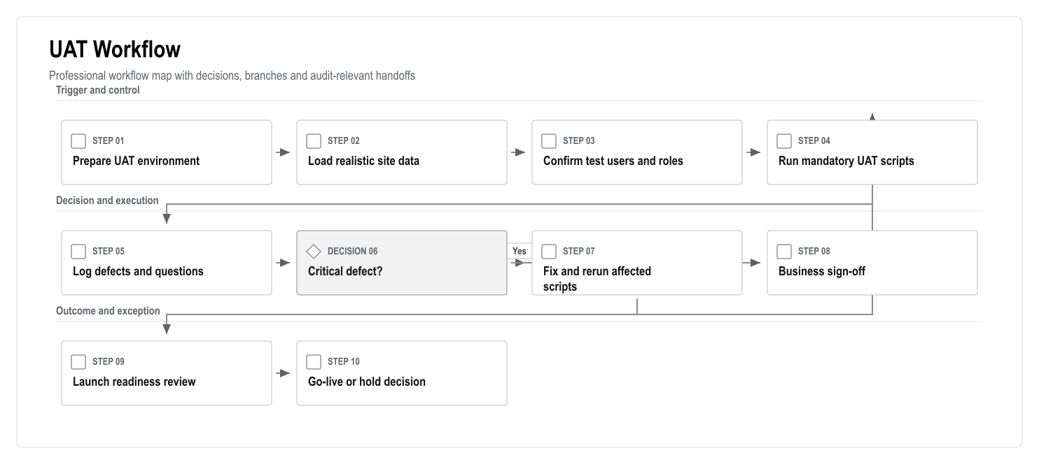
Figure: UAT Workflow

1. Executive Summary
The platform handles finance, deposits, resident data, service requests, documents, access actions, AI recommendations and audit history. QA must therefore focus on business correctness and operational trust, not only UI behavior.
The launch should not proceed until the mandatory client scenarios pass: role login, flat lookup, ledger balance, payment/restriction behavior, service ticket, staff completion, booking, move-in, checkout, document permission, reporting and AI guardrail behavior.

2. Test Strategy
Layer | Purpose | Example Coverage
Unit tests | Prove domain rules | Ledger posting, balance calculation, restrictions, deposit settlement, permissions, AI guardrails
Integration tests | Prove services work together | Payment webhook idempotency, access action queue, notification delivery, storage permissions, RLS
E2E tests | Prove user workflows | Resident service request, debt block, staff completion, manager dashboard, booking and checkout
UAT scripts | Prove business acceptance | Client validates scenarios using realistic data
Security checks | Prove safe controls | RBAC/RLS, file access, audit logs, ASVS checklist, secrets
Performance checks | Prove usability at expected scale | 769-flat dashboard, search, reports, mobile staff/resident flows

3. UAT Workflow

Figure: UAT Workflow

4. Mandatory UAT Scenarios
Scenario | Roles | Acceptance Standard
Role login and navigation | Admin, manager, accountant, owner, tenant, staff | Each role sees only permitted modules
769-flat lookup | Manager | Flats filter by block, floor, status, owner/tenant and debt
Owner balance and statement | Owner, accountant | Balance matches ledger and statement export
Tenant service request | Tenant, manager, staff | Request creates service order, ticket and status trail
Debt blocks service | Tenant, manager | User sees clear reason and payment path
Payment clears restriction | Tenant, accountant | Payment posts once and restriction status updates
Staff task completion | Staff, manager | Staff completes task with notes and media proof
Booking creation | Manager, accountant | Availability prevents overlap and links deposit
Move-in | Manager, staff, tenant | Preparation tasks, access request and welcome notification are created
Checkout | Manager, accountant | Inspection, debt check, settlement and access action are complete
Document access | Owner, tenant, staff | Users cannot view unauthorized documents
AI recommendation | Manager, accountant | AI shows sources and cannot execute restricted action
Reporting | Manager, accountant | Dashboard and exports match source records

5. Defect Severity Model
Severity | Definition | Launch Impact
Critical | Finance corruption, role data leak, broken login, lost payment/access event | Blocks launch
High | Mandatory workflow blocked or incorrect audit/restriction behavior | Blocks launch unless formal waiver
Medium | Workaround exists but workflow is inefficient or confusing | Fix before launch if in core flow
Low | Cosmetic or low-impact content issue | Can move to launch backlog

6. Release Gates
Gate | Required Evidence | Owner
Feature complete | Scope checklist and demo | Product lead
Test complete | Unit/integration/E2E/UAT evidence | QA lead
Security ready | RBAC/RLS, ASVS-aligned checklist, secret check | Security lead
Data ready | Migration report and reconciliation sign-off | Data lead
Operations ready | Support runbook, monitoring, backup/restore evidence | Delivery lead
Training ready | Role-based training delivered or scheduled | Client operations
Launch decision | Open risks accepted and go-live approved | Steering group

7. Launch Runbook

Pre-Launch
- Freeze scope for launch release.
- Confirm environment variables and secrets.
- Run database migrations in staging.
- Load or verify production seed/migration data.
- Complete backup/restore drill.
- Complete smoke tests in production-like environment.
- Prepare rollback plan.
- Prepare client support contacts.

Launch Day
- Confirm production deployment.
- Run smoke test: login, dashboard, flat lookup, service request, ledger read, document access.
- Monitor logs, errors, payments/integrations and notification delivery.
- Keep launch bridge open for decision-makers and support.
- Record issues in one launch tracker.

Hypercare
- Daily issue review for first week.
- Track adoption by role.
- Review support themes.
- Review finance and ticket correctness.
- Produce first-month adoption and stability report.

8. QA Exit Checklist
- No unresolved critical defects.
- High defects resolved or formally accepted.
- Mandatory UAT scenarios passed.
- Role permissions tested.
- Finance ledger tested.
- Debt and restriction behavior tested.
- Mobile PWA workflows tested.
- AI guardrail tests passed.
- Backup/restore evidence exists.
- Launch runbook approved.

