STRICTLY CONFIDENTIAL
REQUIREMENTS TRACEABILITY MATRIX
AI-Powered Residential Site Management CRM
Business-to-product-to-technical-to-test traceability for scope control and launch sign-off
Scope control
Test coverage
Sign-off evidence
Prepared for: Ataberk Estate digital transformation planning
Prepared by: 1Cati / Product and Engineering
Design refresh: 25 June 2026
Status: Consulting-ready v0.2

Table of Contents
Executive review map generated from the main document structure.
1. Executive Summary
2. Traceability Flow
3. Core Traceability Matrix
4. Release Traceability Gates
5. Open Traceability Items
6. Traceability Acceptance Checklist

Executive At-A-Glance
- Traceability prevents business requirements from disappearing between BRD, PRD, TRD, QA and launch planning.
- Every launch requirement should have product coverage, technical coverage, security/compliance controls and acceptance evidence.
- Open traceability items should be resolved or formally accepted before scope lock and launch readiness approval.

Reader Guide
Document type | Requirements Traceability Matrix
Primary audience | Product, QA, delivery leadership, engineering and client stakeholders
Status | Consulting-ready v0.2
Confidentiality | STRICTLY CONFIDENTIAL
Design preset | Arial Narrow consulting report; black text; light-grey table and diagram system

Visual Navigation
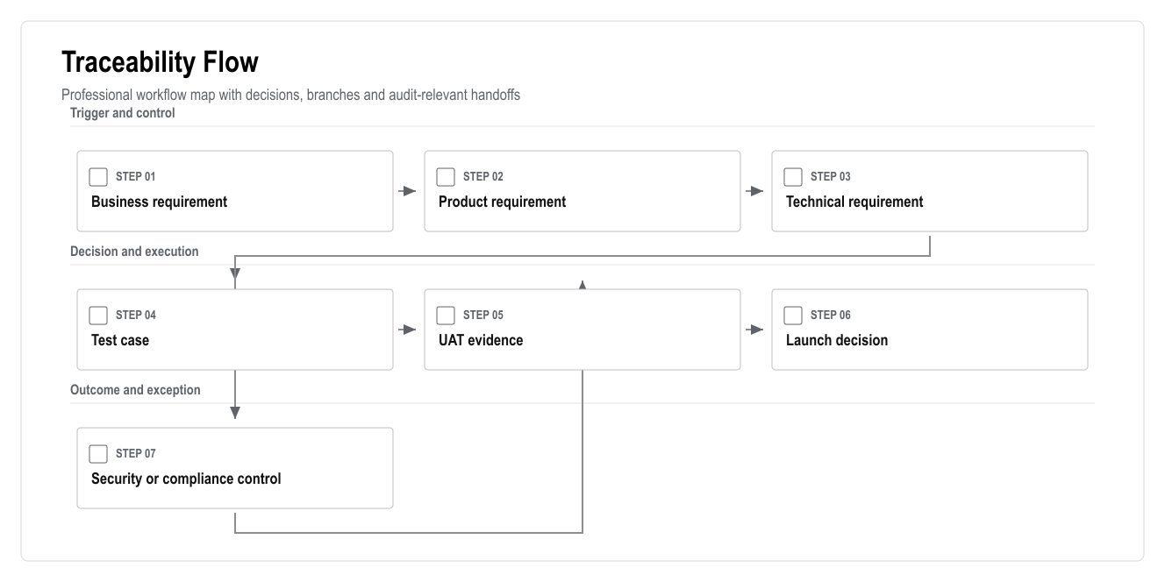
Figure: Traceability Flow

1. Executive Summary
This matrix keeps the documentation package connected. It prevents a common delivery failure: a business requirement appears in the BRD, but the PRD, TRD, test plan or launch checklist does not carry it through.
Each major requirement must have a product owner, a technical owner, acceptance evidence and a release gate. Items without traceability should not be treated as launch-ready.

2. Traceability Flow

Figure: Traceability Flow

3. Core Traceability Matrix
ID | Business Requirement | Product Coverage | Technical Coverage | Acceptance Evidence
BR-001 | Represent all 769 flats | Core site data, flat matrix | Site/block/flat schema, import APIs | Import report and flat matrix UAT
BR-002 | Role-based access for all users | User and role management | Supabase Auth, RBAC, RLS | Role navigation and blocked access tests
BR-003 | Reliable finance balances | Finance ledger | Journal entries, balances, reversals | Ledger unit tests and accountant UAT
BR-004 | Payments and reconciliation | Payments/deposits module | Payment intents, webhooks, idempotency | Payment integration tests
BR-005 | Debt restrictions | Restriction rules | Restriction engine, backend checks | Debt-block E2E and legal approval
BR-006 | Service requests become work | Service catalogue and tickets | Service orders, tickets, SLA events | Service request E2E
BR-007 | Staff completion evidence | Workforce and media reports | Storage, media reports, ticket events | Mobile staff E2E
BR-008 | Booking, move-in and checkout | Booking workflows | Availability, deposits, settlement, access queue | Booking/check-in/checkout UAT
BR-009 | Communication and documents | Chat, announcements, vault | Message threads, notifications, document permissions | Permission and delivery tests
BR-010 | Reporting dashboard | Reporting module | Views/materialized views, exports | Dashboard source-data review
BR-011 | AI assistance with guardrails | AI layer | AI events, recommendations, approvals, retrieval | AI eval and restricted-action tests
BR-012 | Auditability | Audit module | Immutable audit logs | Audit inspection for critical actions
BR-013 | PWA mobile access | Resident/staff/manager PWA | Manifest, mobile shells, responsive routes | Mobile viewport tests
BR-014 | Integrations | Integration layer | Adapters, webhooks, retry queue | Integration health and failure tests
BR-015 | Security and privacy | Security requirements | RBAC/RLS, storage policies, ASVS checklist | Security launch checklist

4. Release Traceability Gates
Release | Minimum Traceability Evidence
Demo | Clickable role journeys, sample data, workflow demonstration
MVP | BR-001, BR-002, BR-003, BR-006, BR-007, BR-010, BR-012, BR-013
V1 | MVP plus BR-004, BR-005, BR-008, BR-009, BR-011
V2 | V1 plus BR-014 and advanced AI/analytics
Launch | All launch-scoped requirements have UAT evidence and accepted risks

5. Open Traceability Items
Topic | Why It Is Open | Required Decision
Payment provider | Vendor not confirmed | Choose provider or approve manual/bank-first flow
Access vendor | API capability unknown | Confirm vendor, API/export/manual fallback
Legal access restriction boundary | Debt-based access action is sensitive | Legal review and client policy approval
Data retention | Retention periods not confirmed | Legal/accounting retention policy
Native app | Excluded from launch but may return | Written PWA-first approval
Meter/camera integrations | Vendor and legal basis unknown | Confirm roadmap vs launch requirement

6. Traceability Acceptance Checklist
- Every launch requirement has a product owner.
- Every launch requirement has technical coverage.
- Every sensitive requirement has a security/compliance control.
- Every mandatory scenario has a test case.
- Every UAT result is linked to the requirement it validates.
- Open decisions are tracked before scope lock.

