STRICTLY CONFIDENTIAL
SECURITY AND COMPLIANCE PLAN
AI-Powered Residential Site Management CRM
KVKK-aware processing, OWASP ASVS-aligned controls, data classification and sensitive workflow rules
RBAC/RLS
Audit and privacy
Sensitive workflows
Prepared for: Ataberk Estate digital transformation planning
Prepared by: 1Cati / Product and Engineering
Design refresh: 25 June 2026
Status: Consulting-ready v0.2

Table of Contents
Executive review map generated from the main document structure.
1. Executive Summary
2. Reference Baseline
3. Security Control Model
4. Data Classification
5. Control Matrix
6. Sensitive Workflow Rules
7. Compliance Open Questions
8. Security Launch Checklist

Executive At-A-Glance
- The system will process personal, financial, document, media, access and AI-event data, so security must be designed into launch scope.
- Controls should combine authentication, RBAC, RLS, domain validation, audit logs, monitoring and approval workflows.
- Debt-based access restriction, identity data, camera/media handling, payment compliance and retention require legal/accounting review.

Reader Guide
Document type | Security And Compliance Plan
Primary audience | Security, compliance, engineering, product and client leadership
Status | Consulting-ready v0.2
Confidentiality | STRICTLY CONFIDENTIAL
Design preset | Arial Narrow consulting report; black text; light-grey table and diagram system

Visual Navigation
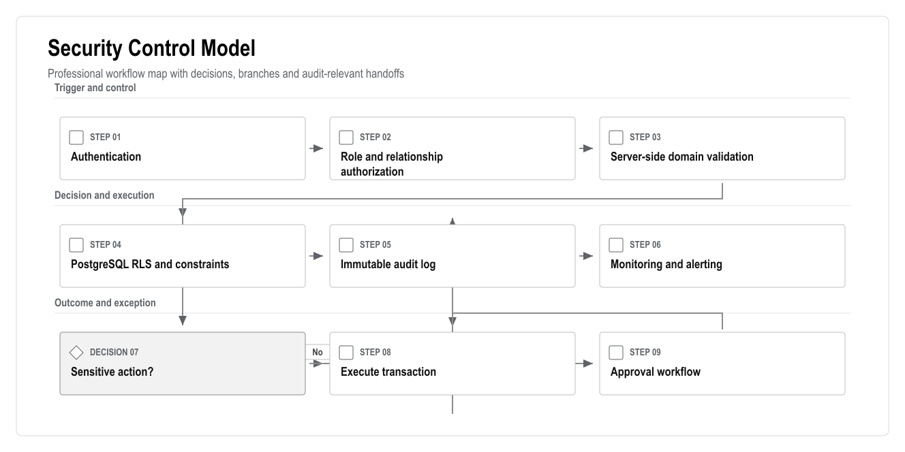
Figure: Security Control Model

1. Executive Summary
The platform will process personal data, owner/tenant relationships, financial records, documents, media uploads, service communications, access actions and AI events. Security and compliance must be designed into the product from the first production release.
This plan is not a legal opinion. It is a delivery checklist for engineering, product and operations. Debt restriction, access blocking, identity verification, camera data, document retention and payment compliance must still be reviewed by legal/accounting specialists before production launch.

2. Reference Baseline
Source | How It Applies
KVKK Personal Data Protection Law: https://www.kvkk.gov.tr/Icerik/6649/Personal-Data-Protection-Law | Personal data must be processed lawfully, fairly, purposefully and proportionately
OWASP ASVS: https://owasp.org/www-project-application-security-verification-standard/ | Provides a structured baseline for testing web application security controls; current official page references ASVS 5.0.0
web.dev PWA guidance: https://web.dev/learn/pwa/ | PWA should be treated as a modern installable web app with responsive design, service worker and secure delivery practices

3. Security Control Model

Figure: Security Control Model

4. Data Classification
Data Class | Examples | Required Controls
Public/marketing | Public landing page content | Normal web publishing controls
Operational | Tickets, bookings, service categories, staff assignments | RBAC, audit for status changes, role-specific visibility
Personal | Names, contact data, owner/tenant relationships | Purpose limitation, role access, export caution
Financial | Ledger, balances, payments, deposits, refunds | Immutable postings, approval, idempotency, audit, restricted exports
Sensitive documents | Identity files, contracts, statements, legal notices | Storage permissions, download audit, retention review
Media | Task photos/videos, possible access/camera references | Role limits, retention policy, avoid unnecessary storage
Access control | Card/barrier IDs, activation/deactivation events | High privilege, approval, manual fallback, audit
AI events | Prompts, context, outputs, accepted/declined suggestions | Source links, role filtering, prompt/output logs, retention policy

5. Control Matrix
Area | Required Control | Acceptance Evidence
Authentication | Supabase Auth, secure session refresh, password reset | Login/logout/session tests
Authorization | App-level RBAC plus database RLS | Role-based E2E and RLS tests
Finance | Immutable ledger, reversals, idempotency keys | Unit and integration tests
Files | Private buckets, signed URLs where needed, permission checks | Unauthorized file access test
Audit | Actor, timestamp, entity, action and sensitive before/after context | Audit log inspection
Integrations | Signature verification, retry queue, health dashboard | Webhook and failure-mode tests
AI | Source-linked, role-filtered, no direct sensitive mutations | AI safety/evaluation tests
Secrets | No secrets in client code or repository | Secret scan and env review
Logging | Structured logs without unnecessary personal data | Log review
Backup | Backup and restore drill | Restore evidence

6. Sensitive Workflow Rules

Finance
- Posted records cannot be edited directly.
- Corrections must use reversal or adjustment entries.
- Refunds require explicit permission and audit.
- Duplicate provider events must not double-post.

Access
- Access activation/deactivation must be recorded as an action request.
- Manual override requires high privilege, reason and audit.
- Debt-based access restriction requires legal review and client policy approval.
- Failed access integrations must create visible alerts.

Documents
- Sensitive documents need role and relationship checks.
- Downloads of sensitive documents should be auditable where required.
- Retention and deletion rules require legal/accounting review.

AI
- AI cannot post payments.
- AI cannot refund deposits.
- AI cannot mutate ledger records.
- AI cannot activate or disable access.
- AI recommendations must show source data and be logged.

7. Compliance Open Questions
- Which data residency requirements apply?
- Which user consent and privacy notices are required?
- What retention periods apply to financial records, identity documents, media and chat?
- What is the legal basis for access restriction due to debt?
- Are camera references or video storage required?
- Which payment provider compliance rules apply?
- Who approves refunds, access changes and sensitive exports?
- Which reports are legally required for site management?

8. Security Launch Checklist
- RBAC and RLS tests pass.
- Finance integrity tests pass.
- File permission tests pass.
- Integration webhook tests pass.
- Secrets are not committed.
- Audit logs are created for sensitive actions.
- Backup/restore drill is complete.
- AI guardrail tests pass.
- Legal/accounting review is complete for access, debt, payments, identity and retention.

