**C Sc 335 Analysis and Design Artifacts for Final Project**

**1. Team Name:**  _______Pokemon_Go_JWMS_________

**2. Project: ________Pokemon Safari_______**

**3. Team Members**: _ _______Zelin Wan___________ ____Jeremiah Hanson__________

________Mutian Yan__________ ____Songzhe Zhu________________

**4. Candidate Objects or Class Hierarchies**

List the most important objects, or an inheritance hierarchy name, and the single responsibility of each.

|  |  |
| --- | --- |
| **Candidate Object** | **Single Responsibility in 1 or 2 sentences** |
| Trainer | the trainer position and what trainer has, health, steps. |
| MAP | all elements in map |
| Pokemon | stores information on the individual Pokemon types. |
| Items | Stores item names and uses and prices |
| Battle | a GUI view for battle. |
| main GUI | calls different views based on in-game context, menu |
| sounds | background-music, and sound effects. |
| backpack | contain trainer's items. |
| Collected Pokemon | keeps track of the Pokemon the trainer has collected |
| Random encounter | use random to determine if the trainer encounter Pokemon. |

**5. Sequence Diagram 1:** Your team UML Sequence Diagram should show the most important scenario you can think of. Your sequence diagram should show most of your objects from above and how they communicate with each other.

*This Sequence Diagram must be created with the sequence diagram editor* [https://www.websequencediagrams.com/#](https://www.websequencediagrams.com/)

*Export and Image and copy and paste it here*

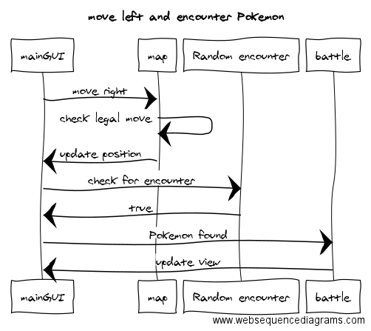

**6. Sequence Diagram 2:** Your team UML Sequence Diagram should show the seconf most important scenario you can think of. Your sequence diagram should show most of your objects from above and how they communicate with each other.

*This Sequence Diagram must be created with the sequence diagram editor* [https://www.websequencediagrams.com/#](https://www.websequencediagrams.com/)

*Export and Image and copy and paste it here*

