FPT UNIVERSITY
DEPARTMENT OF SOFTWARE ENGINEERING
CAPSTONE PROJECT REPORT
REPORT 4 – SOFTWARE DESIGN DOCUMENT (SDD)
Project: Motel Management System (MMS)
Role in Project | Member Name | Assigned Module
Team Leader | Quang | Room & Search Management
Member 2 | Phạm Văn Khánh | User Auth & Tenant KYC
Member 3 | Đức | Rental Contract Management
Member 4 | Nguyễn Văn Mạnh | Utility, Billing & VNPay Payment
Hanoi, Academic Year 2026

I. Record of ChangesI. Record of Changes
This document records all architectural revisions, design specifications, and review checkpoints throughout the Capstone software design phase.
Date | Ver. | Description | Author | Approved
2026-10-25 | 0.1 | Initial System Architecture & Layered Package Draft | Quang (Lead) | Mentor
2026-10-31 | 0.5 | Full Domain Class Diagram & Mongoose Schemas design | Team | Mentor
2026-11-04 | 0.8 | Module-level Controller/Service/Model APIs synchronization | All Members | Instructor
2026-11-10 | 1.0 | Final SDD: High-resolution Architecture diagrams, 4 Module Class Diagrams, 14 Sequence Diagrams | Quang (Lead) | Instructor

II. Table of ContentsII. Table of Contents
1. System Design
1.1 System Architecture: 1.1.1 Front-end Architecture, 1.1.2 Back-end Architecture
1.2 Package Diagram: 1.2.1 Front-end Package Diagram, 1.2.2 Back-end Package Diagram
2. Detailed Design
2.1 Module 1: Authentication & Tenant Management (Phạm Văn Khánh)
2.2 Module 2: Room & Search Management (Quang - Team Leader)
2.3 Module 3: Rental Contract Management (Đức)
2.4 Module 4: Utility, Invoice & VNPay Payment (Nguyễn Văn Mạnh)
3. Database Design
3.1 System Domain Model / Class Diagram
3.2 Collection Schemas & Data Dictionary (users, rooms, contracts, invoices...)

1. System Design1. System Design

1.1 System Architecture1.1 System Architecture
The Motel Management System (MMS) adopts an enterprise 3-tier distributed architecture, separating Presentation (Client), Application Logic (NodeJS RESTful API), and Persistent Data Storage (MongoDB cluster & VNPay payment gateway).

1.1.1 Front-end Architecture1.1.1 Front-end Architecture
The front-end client architecture features two main client targets: React Admin Web for landlords/staff and React Native (Expo) for mobile tenants. The presentation layer delegates navigation through React Router DOM and React Navigation, modularizes UI into Pages, Components, and Contexts, and communicates asynchronously via an Axios Service Layer.
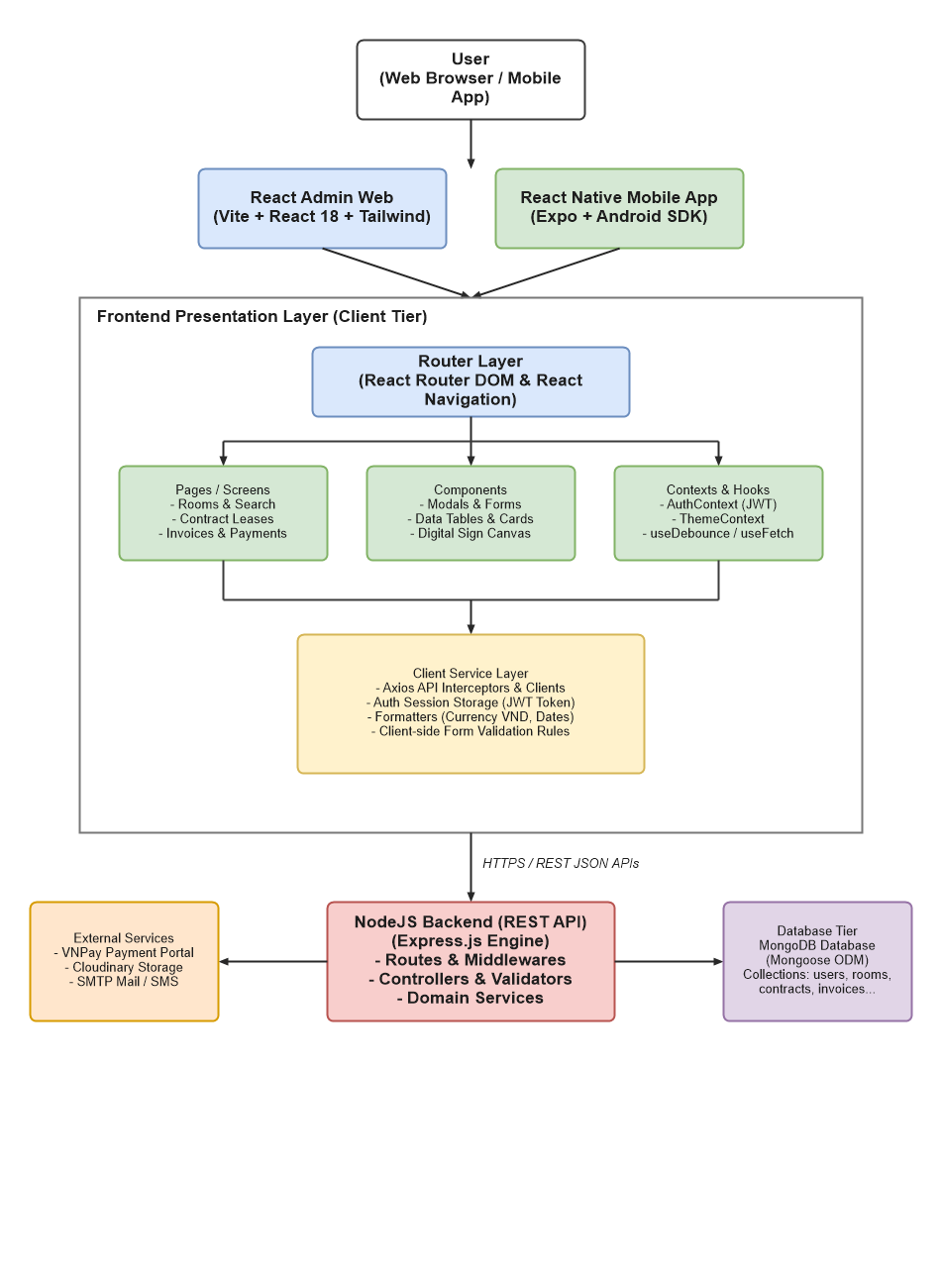
Figure 1.1.1. Front-end Architecture

1.1.2 Back-end Architecture1.1.2 Back-end Architecture
The backend architecture strictly enforces a layered pipeline matching the SAMS Capstone standard: API Layer (Routes) -> Request Processing Layer (Middlewares, Validators) -> Application Layer (Controllers) -> Business Logic Layer (Services) -> Data Access Layer (Mongoose Models) -> MongoDB Database. Auxiliary logic (Jobs, Utils, Constants, Configs) is encapsulated in dedicated packages.
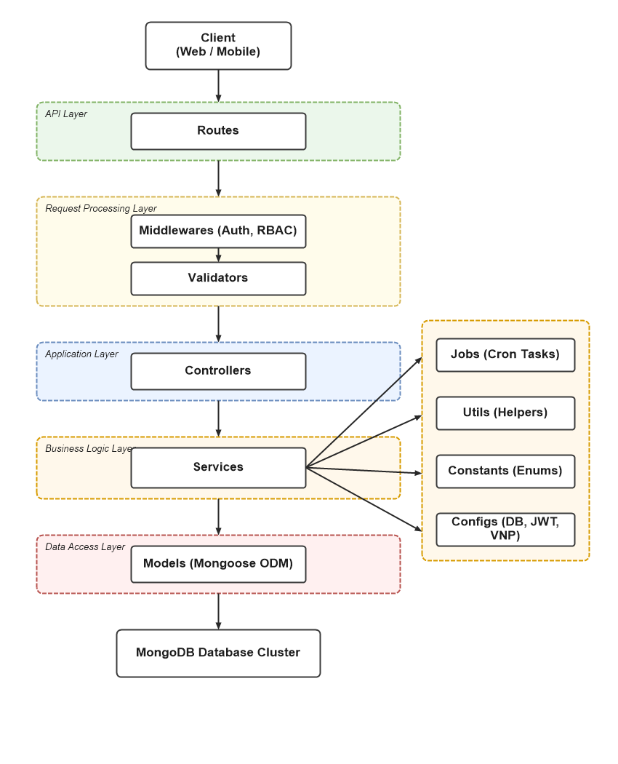
Figure 1.1.2. Back-end Architecture

1.2 Package Diagram1.2 Package Diagram

1.2.1 Front-end package diagram1.2.1 Front-end package diagram
The front-end package diagram defines the structural organization of both the Admin Web and Tenant Mobile clients, connected through shared Services, Context providers, and utility formatters:
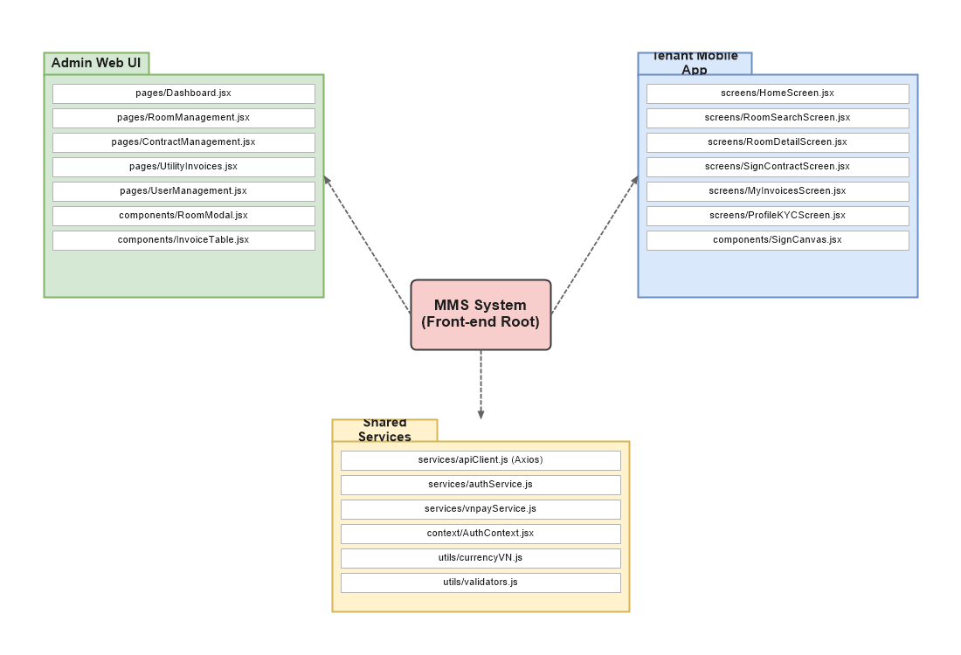
Figure 1.2.1. Front-end package diagram

1.2.2 Back-end package diagram1.2.2 Back-end package diagram
The back-end package structure organizes components into 10 decoupled directories to optimize reusability, testability, and maintainability:
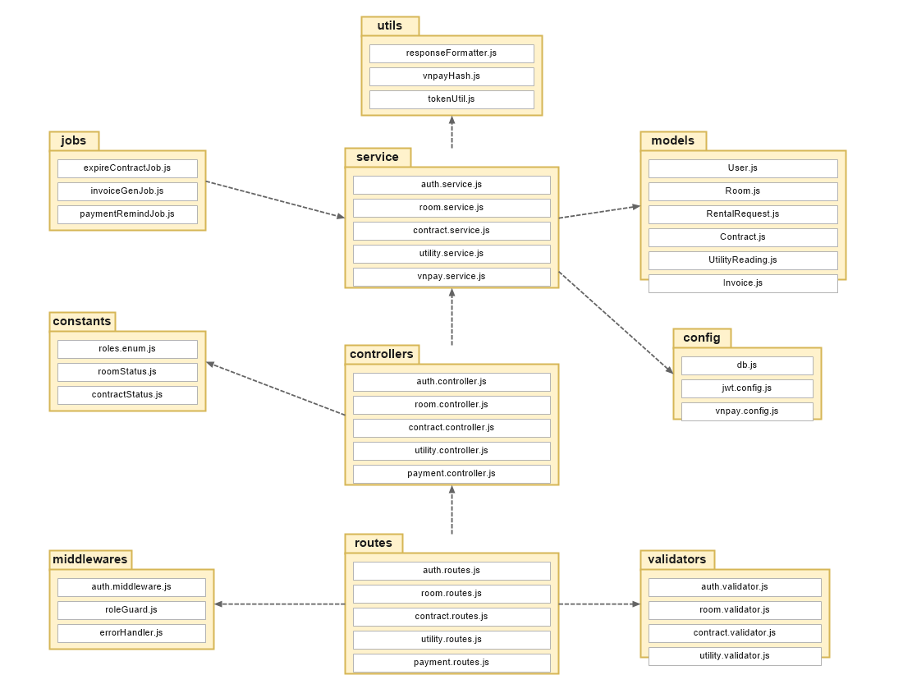
Figure 1.2.2. Back-end package diagram
Package descriptions:
No | Package | Description
01 | /config | Contains configuration settings for the backend system such as environment variables, database connection setup, and VNPay merchant credentials.
02 | /constants | Stores constant values and enumerations (User roles, Room status, Contract status, Invoice status) to avoid hardcoding values and improve maintainability.
03 | /controllers | Handles incoming HTTP requests and responses. Controllers receive requests from routes, extract parameters, call services, and return unified JSON responses to the client.
04 | /jobs | Contains scheduled background tasks (cron jobs) that run automatically at specified intervals to handle time-sensitive operations (expiring unpaid bookings, monthly invoice generation, payment reminders).
05 | /middlewares | Contains middleware functions used in the request processing pipeline, such as JWT authentication, Role-Based Access Control (RBAC), error handling, and request logging.
06 | /models | Defines data models and database schemas used in the application. These models represent collections stored in MongoDB and enforce data integrity constraints.
07 | /routes | Defines API endpoints and maps incoming HTTP requests to corresponding controller functions.
08 | /service | Implements the core business logic of the application. Services process data, interact with models, and provide reusable business operations for controllers.
09 | /utils | Provides helper functions and reusable utilities that support different parts of the application (response formatters, cryptographic HMAC hashing, token utilities).
10 | /validators | Contains validation logic to verify request data (phone format, price bounds, citizen ID length) before requests are processed by controllers.

2. Detailed Design2. Detailed Design

2.1 Module 1: Authentication & Tenant Management (Phạm Văn Khánh)2.1 Module 1: Authentication & Tenant Management (Phạm Văn Khánh)
This module manages user identity, secure authentication using JSON Web Tokens, tenant KYC compliance (citizen ID verification), and staff account management.

2.1.1 Class Diagram - User & Tenant Module2.1.1 Class Diagram - User & Tenant Module
[ DIAGRAM: ClassDiagram_User_Module.drawio ]
Available in draw.io format at: docs/diagrams/ClassDiagram_User_Module.drawio
Figure 2.1.1. Class Diagram - User & Tenant Module

2.1.2 Sign Up (Register) Sequence Diagram2.1.2 Sign Up (Register) Sequence Diagram
[ DIAGRAM: UC-M01_1_Register_SequenceDiagram.drawio ]
Available in draw.io format at: docs/diagrams/UC-M01_1_Register_SequenceDiagram.drawio
Figure 2.1.2. Sign Up Sequence Diagram
Flow Description: The user inputs name, phone, email, and password. The system queries MongoDB to ensure uniqueness of phone/email. If unique, password is encrypted with Bcrypt (salt round = 10), new User document is persisted, and a signed JWT is returned for seamless login.

2.1.3 Sign In (Login) Sequence Diagram2.1.3 Sign In (Login) Sequence Diagram
[ DIAGRAM: UC-M01_2_Login_SequenceDiagram.drawio ]
Available in draw.io format at: docs/diagrams/UC-M01_2_Login_SequenceDiagram.drawio
Figure 2.1.3. Sign In Sequence Diagram
Flow Description: The client sends credentials to POST /api/auth/login. The service compares bcrypt hash and verifies account is not locked. Upon validation, a JWT session token containing user ID and role is issued.

2.1.4 Update Tenant Profile (KYC) Sequence Diagram2.1.4 Update Tenant Profile (KYC) Sequence Diagram
[ DIAGRAM: UC-M06_Update_Tenant_Profile_SequenceDiagram.drawio ]
Available in draw.io format at: docs/diagrams/UC-M06_Update_Tenant_Profile_SequenceDiagram.drawio
Figure 2.1.4. Update Tenant Profile Sequence Diagram
Flow Description: The tenant submits 12-digit Citizen ID (CCCD), hometown, and identity card photographs. Upon validation, isKycDone is flagged true, allowing instant 1-click room rental requests.

2.2 Module 2: Room & Search Management (Quang - Team Leader)2.2 Module 2: Room & Search Management (Quang - Team Leader)
Responsible for room inventory management, multi-criteria search algorithms, rental request processing, and operational room state transitions.

2.2.1 Class Diagram - Room Module2.2.1 Class Diagram - Room Module
[ DIAGRAM: ClassDiagram_Room_Module.drawio ]
Available in draw.io format at: docs/diagrams/ClassDiagram_Room_Module.drawio
Figure 2.2.1. Class Diagram - Room Module

2.2.2 Search & Filter Rooms Sequence Diagram2.2.2 Search & Filter Rooms Sequence Diagram
[ DIAGRAM: UC-M02_Search_Room_SequenceDiagram.drawio ]
Available in draw.io format at: docs/diagrams/UC-M02_Search_Room_SequenceDiagram.drawio
Figure 2.2.2. Search & Filter Rooms Sequence Diagram
Flow Description: The client provides keyword, minPrice, maxPrice, and amenities. The backend executes a MongoDB query with regex and range operators. If matched, room array is returned; otherwise, an empty array triggers the UI Empty State.

2.2.3 Request Rental / Hold Room Sequence Diagram2.2.3 Request Rental / Hold Room Sequence Diagram
[ DIAGRAM: UC-M03_Request_Rental_SequenceDiagram.drawio ]
Available in draw.io format at: docs/diagrams/UC-M03_Request_Rental_SequenceDiagram.drawio
Figure 2.2.3. Request Rental Sequence Diagram
Flow Description: Tenant requests reservation on a selected room. Service checks room.status === 'AVAILABLE'. If available, a RentalRequest document with status PENDING is created for landlord approval.

2.2.4 Create Room Sequence Diagram2.2.4 Create Room Sequence Diagram
[ DIAGRAM: UC-M04_1_Create_Room_SequenceDiagram.drawio ]
Available in draw.io format at: docs/diagrams/UC-M04_1_Create_Room_SequenceDiagram.drawio
Figure 2.2.4. Create Room Sequence Diagram
Flow Description: Landlord inputs room number, type, price, and amenities. System verifies room number uniqueness, validates positive price, and stores room as AVAILABLE.

2.2.5 Update Room Info Sequence Diagram2.2.5 Update Room Info Sequence Diagram
[ DIAGRAM: UC-M04_2_Update_Room_SequenceDiagram.drawio ]
Available in draw.io format at: docs/diagrams/UC-M04_2_Update_Room_SequenceDiagram.drawio
Figure 2.2.5. Update Room Info Sequence Diagram
Flow Description: Fully synchronized with instructor-approved UC-M09 specification: updates pricing, amenities, and media with atomic persistence.

2.2.6 Delete Room Sequence Diagram2.2.6 Delete Room Sequence Diagram
[ DIAGRAM: UC-M04_3_Delete_Room_SequenceDiagram.drawio ]
Available in draw.io format at: docs/diagrams/UC-M04_3_Delete_Room_SequenceDiagram.drawio
Figure 2.2.6. Delete Room Sequence Diagram
Flow Description: Critical business rule guard: System queries active contracts. If room status is RENTED or has active contracts, deletion is strictly aborted with 400 Bad Request to guarantee data integrity.

2.3 Module 3: Rental Contract Management (Đức)2.3 Module 3: Rental Contract Management (Đức)
Manages electronic lease contracts, legally binding terms, online digital signatures, contract extensions, and security deposit liquidations.

2.3.1 Class Diagram - Contract Module2.3.1 Class Diagram - Contract Module
[ DIAGRAM: ClassDiagram_Contract_Module.drawio ]
Available in draw.io format at: docs/diagrams/ClassDiagram_Contract_Module.drawio
Figure 2.3.1. Class Diagram - Contract Module

2.3.2 Create Contract Sequence Diagram2.3.2 Create Contract Sequence Diagram
[ DIAGRAM: UC-M05_1_Create_Contract_SequenceDiagram.drawio ]
Available in draw.io format at: docs/diagrams/UC-M05_1_Create_Contract_SequenceDiagram.drawio
Figure 2.3.2. Create Contract Sequence Diagram
Flow Description: Landlord converts an approved RentalRequest into an official lease. Room status automatically switches to RENTED, and the contract is staged in PENDING_SIGN.

2.3.3 Tenant Sign Contract Online Sequence Diagram2.3.3 Tenant Sign Contract Online Sequence Diagram
[ DIAGRAM: UC-M05_2_Sign_Contract_SequenceDiagram.drawio ]
Available in draw.io format at: docs/diagrams/UC-M05_2_Sign_Contract_SequenceDiagram.drawio
Figure 2.3.3. Sign Contract Sequence Diagram
Flow Description: Tenant inspects legal terms on mobile, draws signature on touch canvas, and clicks confirm. System verifies user identity, saves digital signature image, and activates contract (status: ACTIVE).

2.4 Module 4: Utility, Invoice & VNPay Payment (Nguyễn Văn Mạnh)2.4 Module 4: Utility, Invoice & VNPay Payment (Nguyễn Văn Mạnh)
Manages monthly utility meter readings, automated billing generation, and direct payment integration with the VNPay Payment Gateway.

2.4.1 Class Diagram - Billing & Payment Module2.4.1 Class Diagram - Billing & Payment Module
[ DIAGRAM: ClassDiagram_Billing_Module.drawio ]
Available in draw.io format at: docs/diagrams/ClassDiagram_Billing_Module.drawio
Figure 2.4.1. Class Diagram - Billing & Payment Module

2.4.2 Record Utility Readings Sequence Diagram2.4.2 Record Utility Readings Sequence Diagram
[ DIAGRAM: UC-M07_Record_Utility_SequenceDiagram.drawio ]
Available in draw.io format at: docs/diagrams/UC-M07_Record_Utility_SequenceDiagram.drawio
Figure 2.4.2. Record Utility Readings Sequence Diagram
Flow Description: Staff inputs new electricity and water readings. Guard condition asserts newReading >= oldReading, computes net consumption, and records utility data for monthly invoicing.

2.4.3 Pay Invoice via VNPay Gateway Sequence Diagram2.4.3 Pay Invoice via VNPay Gateway Sequence Diagram
[ DIAGRAM: UC-M09_1_VNPay_Payment_SequenceDiagram.drawio ]
Available in draw.io format at: docs/diagrams/UC-M09_1_VNPay_Payment_SequenceDiagram.drawio
Figure 2.4.3. Pay Invoice via VNPay Sequence Diagram
Flow Description: Tenant initiates invoice payment. Service constructs VNPay query parameters, generates cryptographic HMAC-SHA512 checksum, and returns redirect URL to VNPay Sandbox.

2.4.4 VNPay IPN Callback & Webhook Sequence Diagram2.4.4 VNPay IPN Callback & Webhook Sequence Diagram
[ DIAGRAM: UC-M09_2_VNPay_IPN_Callback_SequenceDiagram.drawio ]
Available in draw.io format at: docs/diagrams/UC-M09_2_VNPay_IPN_Callback_SequenceDiagram.drawio
Figure 2.4.4. VNPay IPN Webhook Sequence Diagram
Flow Description: Asynchronous server-to-server webhook from VNPay. System validates secure checksum. If response code is '00', payment record is created, invoice is set to PAID, and confirmation code 00 is returned.

3. Database Design3. Database Design

3.1 System Domain Model / Class Diagram3.1 System Domain Model / Class Diagram
The domain model captures the complete entity-relationship graph, cardinalities, foreign key mappings, and schema attributes across the Motel Management System:
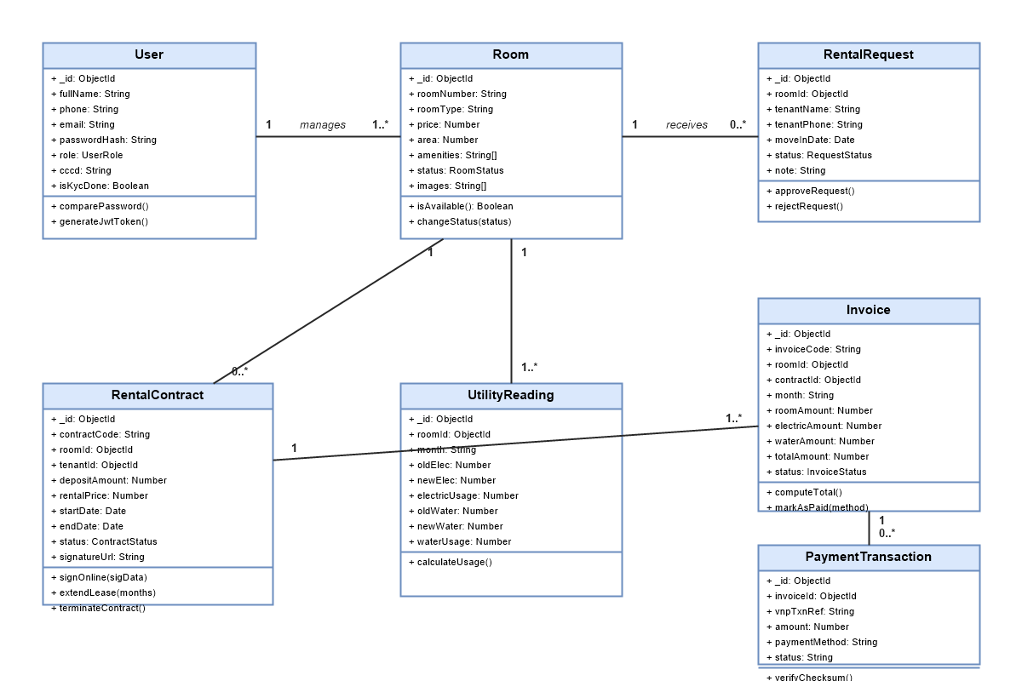
Figure 3.1. System Domain Class Diagram

3.2 Collection Schemas & Data Dictionary3.2 Collection Schemas & Data Dictionary

3.2.1 Collection: users3.2.1 Collection: users
Field Name | Type | Nullable | Key / Index | Description & Rules
_id | ObjectId | No | PK | Primary unique identifier
fullName | String | No | - | Full legal name
phone | String | No | Unique Index | 10 digits phone, login credential
email | String | No | Unique Index | Valid email address format
passwordHash | String | No | - | Bcrypt hash (salt round 10)
role | String | No | - | ADMIN, LANDLORD, STAFF, TENANT
cccd | String | Yes | Index | 12-digit Citizen ID for KYC
isKycDone | Boolean | No | - | Default false; true when verified
isLocked | Boolean | No | - | Default false; true locks login

3.2.2 Collection: rooms3.2.2 Collection: rooms
Field Name | Type | Nullable | Key / Index | Description & Rules
_id | ObjectId | No | PK | Primary room key
roomNumber | String | No | Unique Index | Room code (e.g., P101, P202)
roomType | String | No | Index | SINGLE, DOUBLE, STUDIO, MEZZANINE
price | Number | No | Index | Monthly rent in VND (price > 0)
area | Number | No | - | Surface area in square meters
status | String | No | Index | AVAILABLE, RENTED, MAINTENANCE
amenities | Array[String] | No | - | AC, HEATER, WIFI, BALCONY

3.2.3 Collection: contracts3.2.3 Collection: contracts
Field Name | Type | Nullable | Key / Index | Description & Rules
_id | ObjectId | No | PK | Primary contract ID
contractCode | String | No | Unique Index | Format: HD-YYYY-XXXX
roomId | ObjectId | No | FK (rooms) | Associated leased room
tenantId | ObjectId | No | FK (users) | Tenant signee ID
rentalPrice | Number | No | - | Monthly rental fee in VND
depositAmount | Number | No | - | Security deposit in VND
status | String | No | Index | DRAFT, PENDING_SIGN, ACTIVE, TERMINATED
signatureUrl | String | Yes | - | Digital signature image path

3.2.4 Collection: invoices3.2.4 Collection: invoices
Field Name | Type | Nullable | Key / Index | Description & Rules
_id | ObjectId | No | PK | Invoice identifier
invoiceCode | String | No | Unique Index | Format: INV-YYYYMM-XXXX
roomId | ObjectId | No | FK (rooms) | Billed room
month | String | No | Index | Billing cycle (YYYY-MM)
totalAmount | Number | No | - | Rent + Electric + Water + Service
status | String | No | Index | UNPAID, PAID, OVERDUE
paidAt | Date | Yes | - | Timestamp payment confirmed

4. Conclusion4. Conclusion
This Software Design Document constitutes the official technical architecture and detailed specifications of the Motel Management System (MMS). All system-level diagrams and module-specific sequence diagrams are fully realized and ready for academic grading and individual defense.

