**How to use the Jupyter Notebook? 1**

**How to download the Jupyter Notebook ? 2**

**How to open the tutorial notebook? 3**

**How to use the Jupyter Notebook?**

**Description: Frequently used functions in the interface and official web links.**

**Time:10mins.**

When you open the notebook, you can start by clicking on the buttons (don’t click Logout).

Here only shows the frequently used buttons, and you can get more information through the Jupyter Notebook official website.

1. **Name**

Let’s start from the notebook Interface:

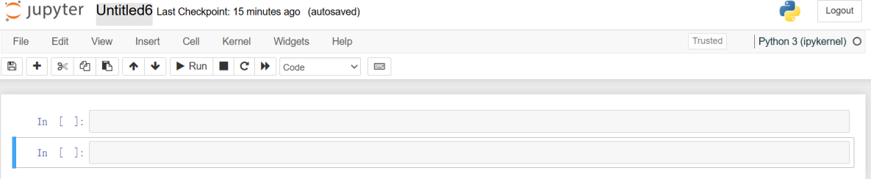

If you click on the name(‘Untitled6’), you can change the name of your notebook.

We can change it to ‘CHANGENAMES ’.:



1. **Code or Markdown**

The pictures below show the differences between a Markdown and a Code cell.

You can see the different usages of ‘#’ in the two cells:

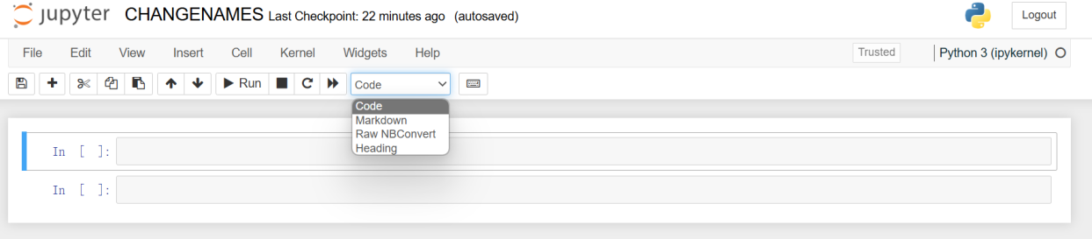 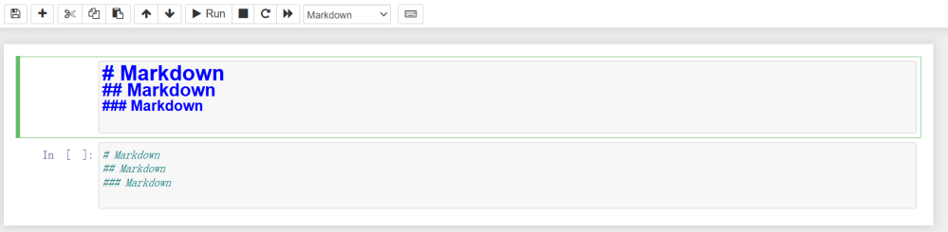

We usually use the ‘#’ symbol in the Markdown cell to change the font size.

1. **Others**

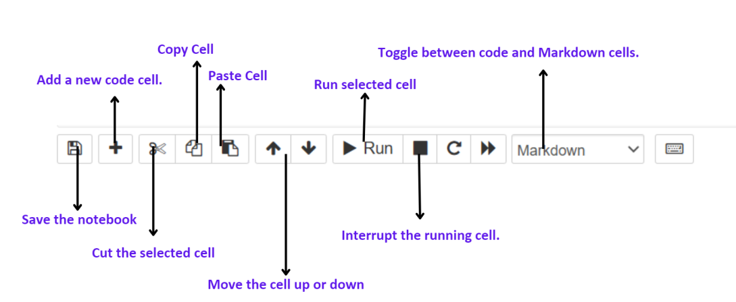

* **Notes:** **Save** your notebook when you complete parts of your project; if you accidentally delete something, press **Ctrl+Z** to withdraw, and conversely, press **Ctrl+Y** .

You can also select Edit -> Undo Delete Cells to undo the accidental deletion of a cell.

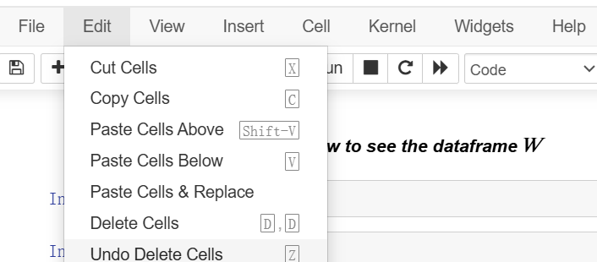

* **For more information**, please refer to the official Jupyter Notebook website:
* <https://jupyter-notebook.readthedocs.io/en/stable/>
* <https://jupyter-notebook.readthedocs.io/en/stable/notebook.html>

**How to download the Jupyter Notebook ?**

**Description:** From ANACONDA, Python to Jupyter Notebook.

**Time:** 5mins.

1. **STEP1: Dwonload ANACONDA** You can download from the links:

<https://www.anaconda.com/download/success> or <https://www.anaconda.com/download> or <https://www.anaconda.com/>

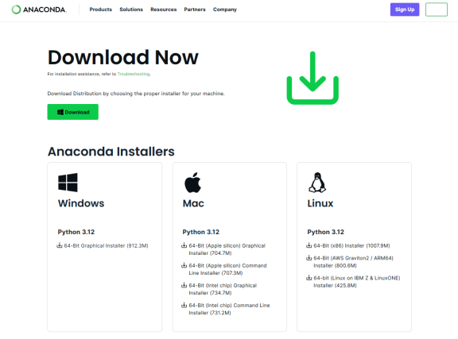

1. **STEP2: Download the Python** You can use the version after Python3.0:<https://www.python.org/downloads/>

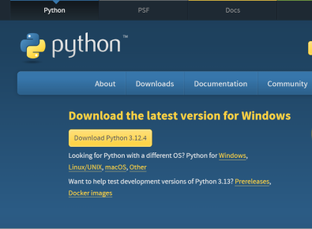

1. **STEP3: Launch Jupyter Notebook** File **Search** ‘**ANACONDA.NAVIGATOR**’

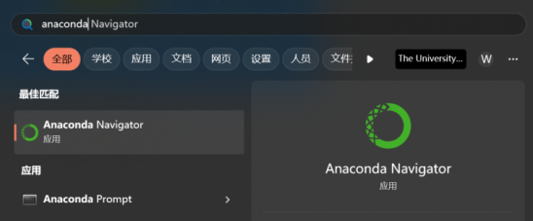

Click “**Launch**” to open the Jupyter Notebook:

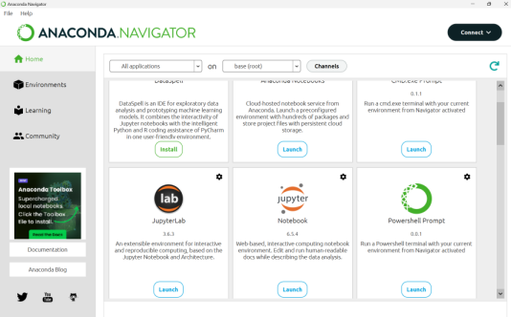

**How to open the tutorial notebook?**

**Description:** 3 methods to download the notebook Tutorial.ipynb

**Time:** 2 mins.

1. **Option 1: [Upload]**

Download the Tutorial.ipynb through the github link:[OMINEX/Tutorial.ipynb at main · WanbingZeng/OMINEX (github.com)](https://github.com/WanbingZeng/OMINEX/blob/main/Tutorial.ipynb)

Click **upload** at the top right to open the **Tutorial.ipynb** files.

1. **Option 2: Terminal**

Open your **terminal** or click **new→terminal** and Enter the following command:

wget https://raw.githubusercontent.com/WanbingZeng/OMINEX/main/Tutorial.ipynb

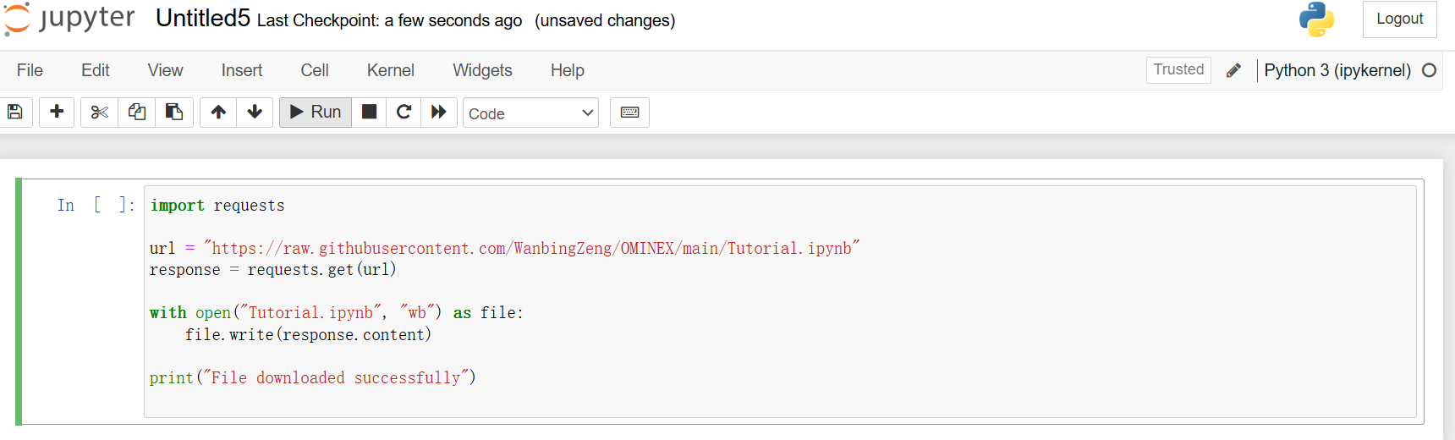

* Then you can see the Tutorial.ipynb.

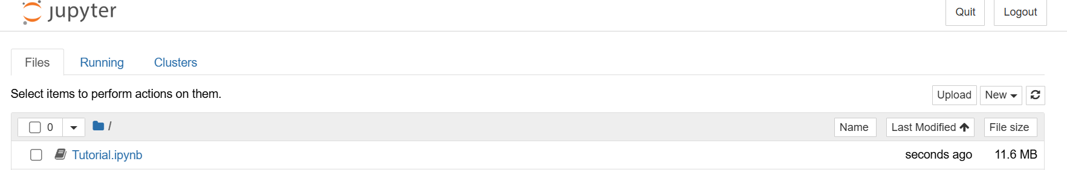

1. **Binder**

Click the 'Launch Binder' button on my GitHub page. It may take a little time to run.

