1. **Latihan Melengkapi Script**

/*

* To change this license header, choose License Headers in Project Properties.

* To change this template file, choose Tools | Templates

* and open the template in the editor.

*/

package kelassmif;

import java.util.Scanner;

/**

*

* @author wanda

*/

public class StrukturKondisi {

public static void main(String[] args) {

// scanner

Scanner inp = new Scanner(System.in);

// input nama

System.out.print("masukkan nama anda : ");

String nama = inp.nextLine();

// input nim

System.out.print("masukkan nim anda : ");

String nim = inp.nextLine();

// input nilai

System.out.print("masukkan nilai anda : ");

int nilai = inp.nextInt();

if (nilai > 70 ) {

System.out.println("Selamat Anda LULUS");

}else {

System.out.println("Anda TIDAK LULUS");

}

}

}

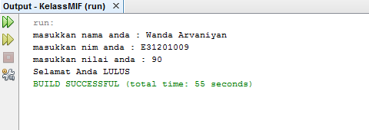

1. **Latihan membuat script program yang menerima input data integer dan outputnya berupa nilai huruf**

/*

* To change this license header, choose License Headers in Project Properties.

* To change this template file, choose Tools | Templates

* and open the template in the editor.

*/

package kelassmif;

import java.util.Scanner;

/**

*

* @author wanda

*/

public class StrukturKondisi {

public static void main(String[] args) {

// scanner

Scanner inp = new Scanner(System.in);

// input nama

System.out.print("masukkan nama anda : ");

String nama = inp.nextLine();

// input nim

System.out.print("masukkan nim anda : ");

String nim = inp.nextLine();

// input nilai

System.out.print("masukkan nilai anda : ");

int nilai = inp.nextInt();

if (nilai <= 100 ) {

System.out.println("A");

}else if (nilai <= 90) {

System.out.println("B");

}else if (nilai <= 80) {

System.out.println("C");

}else if (nilai <= 70) {

System.out.println("D");

}

}

}

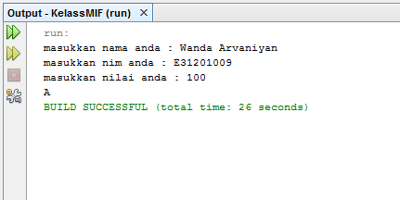

1. **Latihan membuat Script program yang menerima input nama , jenis kelamin, tinggi badan. Outputnya harus “Selamat Anda LULUS” atau “Anda GAGAL”**

/*

* To change this license header, choose License Headers in Project Properties.

* To change this template file, choose Tools | Templates

* and open the template in the editor.

*/

package kelassmif;

import java.util.Scanner;

/**

*

* @author wanda

*/

public class IfInIf {

public static void main (String[] args) {

// scanner

Scanner input = new Scanner(System.in);

// input nama

System.out.println("Nama : ");

String nama = input.nextLine();

// input nim

System.out.println("NIM : ");

String nim = input.nextLine();

// input jenis kelamin

System.out.println("Jenis Kelamin : ");

String jenis = input.nextLine();

// input nilai

System.out.println("Tinggi Badan : ");

int tinggi = input.nextInt();

if (jenis == "Laki-Laki") {

if (tinggi > 170 && tinggi <= 250 ) {

System.out.println("Selamat Anda LULUS");

}else {

System.out.println("Anda GAGAL");

}

} else{

if (tinggi > 160 && tinggi <= 250) {

System.out.println("Selamat Anda LULUS");

}else {

System.out.println("Anda GAGAL");

}

}

}

}

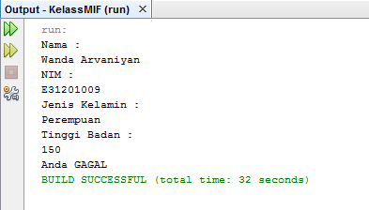

1. Latihan Percabangan *Switch/Case*

/*

* To change this license header, choose License Headers in Project Properties.

* To change this template file, choose Tools | Templates

* and open the template in the editor.

*/

package kelassmif;

import java.util.Scanner;

/**

*

* @author wanda

*/

public class Switch {

public static void main(String[] args){

// scanner

Scanner input = new Scanner(System.in);

// input nama

System.out.print("Masukkan Nama : ");

String nama = input.nextLine();

// input nim

System.out.print("Masukkan NIM : ");

String nim = input.nextLine();

// input nilai

System.out.print("Masukkan Nilai : ");

String huruf = input.nextLine();

switch (huruf){

case "A":

System.out.println("4");

break;

case "B":

System.out.println("3");

break;

case "C":

System.out.println("2");

break;

case "D":

System.out.println("1");

break;

case "E":

System.out.println("0");

break;

default :

System.out.println("Huruf Tidak Terdaftar");

break;

}

}

}

