Test suite
Test routine 1
Test suite
Test routine 1
Test routine 2
Test case
Test case 1
Test case 2
Test check 1
Test check 2
Test check 3
Test routine 2
Test routine 3
Test routines ...
19 function routine1( test )
20 {
21
22 test.case = 'trivial';
23 var got = Join.join( 'a', 'b' );
24 var expected = 'ab';
25 test.identical( got, expected );
26
27 test.case = 'empty';
28 test.identical( Join.join( '', '' ), '' );
29
30 }
test routine
'routine1'
opening of test case 'trivial'
test check
opening of test case 'empty'
it closes the test case 'trivial'
test check

19 function routine2( test )
20 {
21
22 test.open( 'trivial' );
23 var got = Join.join( 'a','b' );
24 var expected = 'ab';
25 test.identical( got,expected );
26 test.close( 'trivial' );
27
28 test.open( 'empty' );
29 test.identical( Join.join( '', '' ), '' );
30 test.close( 'empty' );
31
32 }
test routine
'routine2'
opening of test case 'trivial'
test check
closing of test case 'trivial'
opening of test case 'trivial'
test check
closing of test case 'trivial'

19 function routine3( test )
20 {
21
22 test.open( 'string' );
23
24 test.case = 'trivial';
25 test.identical( Join.join( 'a', 'b' ), 'ab' );
26
27 test.case = 'empty';
28 test.identical( Join.join( '', '' ), '' );
29
30 test.close( 'string' );
31 test.open( 'number' );
32
33 test.case = 'trivial';
34 test.identical( Join.join( 1, 2 ), '12' );
35
36 test.case = 'zeroes';
37 test.identical( Join.join( 0, 0 ), '00' );
38
39 test.close( 'number' );
40
41 }
test routine
'routine3'
opening of test case 'string'
closing of test case 'string'
inner test case 'trivial'
inner test case 'empty'
opening of test case 'number'
closing of test case 'number'
inner test case 'trivial'
inner test case 'zeroes'

19 function joinTwo( test )
20 {
21
22 test.open( 'join strings' );
23 var got = Join.join( 'a','b' );
24 var expected = 'ab';
25 test.open( 'anotherValues' );
26test.identical( Join.join( 1,2 ), '12' );
27 test.close( 'anotherValues' );
28 test.identical( got,expected );
29 test.close( 'join strings' );
30 }
31
closing of test cases
test check
opening of test cases
test routine
'joinTwo'
19 function joinTwo( test )
20 {
21
22 test.case = 'join strings';
23 test.identical( Join.join( 'a','b' ),'ab' );
24 test.identical( Join.join( 1,2 ),'12' );
25 test.notIdentical( Join.join( 1,2 ),12 );
26
27 }
28
test routine
'joinTwo'
test case 'join strings'
test checks
19 function joinTwo( test )
20 {
21
22 test.open( 'string' );
23 test.case = 'trivial';
24 test.identical( Hello.join( 'a', 'b' ), 'ab' );
25 test.case = 'empty';
26 test.identical( Hello.join( '', '' ), '' );
27 test.close( 'string' );
28
29 test.open( 'number' );
30 test.case = 'trivial';
31 test.identical( Hello.join( 1, 3 ), '13' );
32 test.case = 'zeroes';
33 test.identical( Hello.join( 0, 0 ), '00' );
34 test.close( 'number' );
35 }
test routine
'joinTwo'
opening of test case 'string'
closing of test case 'string'
inner test cases
opening of test case 'number'
closing of test case 'number'
inner test cases
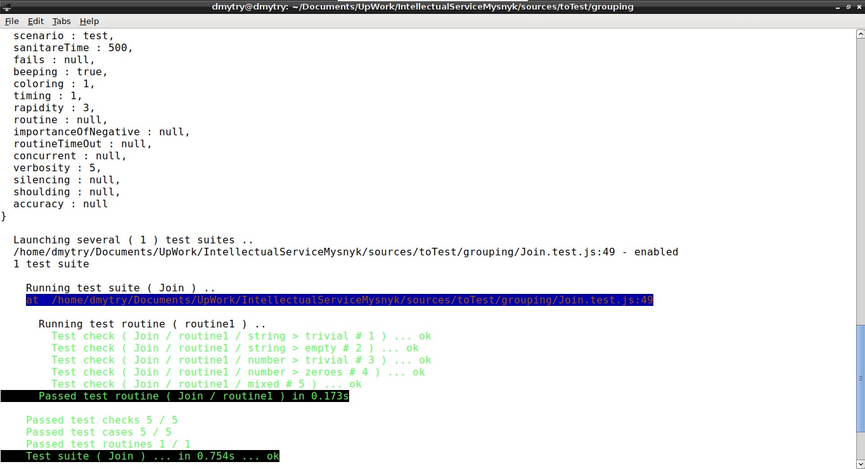
1 let _ = require( 'wTesting' );
2 let Join = require( './Join.js' );
3
4 //
5
6 function routine1( test )
7 {
8
9 test.open( 'string' );
10
11 test.case = 'trivial';
12 test.identical( Join.join( 'a', 'b' ), 'ab' );
13
14 test.case = 'empty';
15 test.identical( Join.join( '', '' ), '' );
16
17 test.close( 'string' );
18 test.open( 'number' );
19
20 test.case = 'trivial';
21 test.identical( Join.join( 1, 2 ), '12' );
22
23 test.case = 'zeroes';
24 test.identical( Join.join( 0, 0 ), '00' );
25
26 test.close( 'number' );
27 test.open( 'mixed' );
28
29 test.identical( Join.join( 'a', 1 ), 'a1' );
30
31 test.close( 'mixed' );
32
33 }
34
35 //
36
37 var Self =
38 {
39 name : 'Join',
40 tests :
41 {
42 routine1,
43 }
44 }
45
46 //
47
48 Self = wTestSuite( Self );
49 if( typeof module !== 'undefined' && !module.parent )
50 wTester.test( Self.name );
[user@user ~]$ tst Join.test.js v:5
Includes tests from : /……………………………………………………………./Join.test.js

Tester Settings :
{
scenario : test,
sanitareTime : 500,
fails : null,
beeping : true,
coloring : 1,
timing : 1,
rapidity : 3,
routine : null,
importanceOfNegative : null,
routineTimeOut : null,
concurrent : null,
verbosity : 5,
silencing : null,
shoulding : null,
accuracy : null
}

Launching several ( 1 ) test suites ..
/……………………………………………………………./Join.test.js:49 - enabled
1 test suite

Running test suite ( Join ) ..
at /……………………………………………………………./Join.test.js:49

Running test routine ( routine1 ) ..
Test check ( Join / routine1 / string > trivial # 1 ) ... ok
Test check ( Join / routine1 / string > empty # 2 ) ... ok
Test check ( Join / routine1 / number > trivial # 3 ) ... ok
Test check ( Join / routine1 / number > zeroes # 4 ) ... ok
Test check ( Join / routine1 / mixed # 5 ) ... ok
Passed test routine ( Join / routine1 ) in 0.173s

Passed test checks 5 / 5
Passed test cases 5 / 5
Passed test routines 1 / 1
Test suite ( Join ) ... in 0.754s ... ok

Passed test checks 5 / 5
Passed test cases 5 / 5
Passed test routines 1 / 1
Passed test suites 1 / 1
Testing ... in 1.358s ... ok
[user@user ~]$
test
options
report of separate test routines
report of one test suite
general report of all test suites
#1 string > trivial
#3 number > trivial
#2 string > empty
#4 number > zeroes
#5 mixed
#1 trivial
#2 empty
#3 trivial
#4 zeroes
#5 mixed
test suite 'Join' runs
test suite 'Join' stops
test suite 'Join'
test routine
test case 'strings'
test case 'number'
test case 'mixed'

