drwxr-xr-x 2 user user 4096 Мар 22 14:38 .
drwxr-xr-x 8 user user 4096 Мар 22 14:38 ..
-rw-r--r-- 1 user user 5 Мар 22 14:38 fileToExport
-rw-r--r-- 1 user user 1261 Мар 22 14:38 .will.yml
about :
name : exportModule
description : 'To export single file'
version : 0.0.1

path :
in : '.'
out : 'out'
fileToExport : 'fileToExport'

step :
export.single :
inherit : predefined.export
export : path::fileToExport

build :
export :
criterion :
default : 1
export : 1
steps :
- export.single

1
2
3
4

step :
export.single :
inherit : predefined.export
export : path::fileToExport.*=1
criterion :
debug : 1

export.multi :
inherit : predefined.export
export : path::fileToExport.*=1

build :
export :
criterion :
debug : 1
steps :
- step::export.*=1

step :
export.single :
inherit : predefined.export
export : path::fileToExport.*=1
criterion :
debug : 1

export.multi :
inherit : predefined.export
export : path::fileToExport.*=1
criterion :
debug : 0

build :
export :
criterion :
debug : 1
steps :
- step::export.*=1

path :
in : '.'
out : 'out'
fileToExport.single :
path : 'fileToExport'
criterion :
debug : 1
fileToExport.multi :
path : 'fileTo*'
criterion :
debug : 0

step :
export.single :
inherit : predefined.export
export : path::fileToExport.*
criterion :
debug : 1

export.multi :
inherit : predefined.export
export : path::fileToExport.*
criterion :
debug : 0

delete.out :
inherit : predefined.delete
filePath : path::out

build :
export :
criterion :
debug : 0
steps :
- step::export.*
- step::delete.out

Found : step::export.single, step::export.multi
Select constraint "export.*=1" failed, got 2 elements using selector "step::export.*=1"

CRITERIONS IS EQUAL?
ASSERTS IS EQUAL?
NEXT STEPS OF
ALGORITHM
NEXT RESOURCE
YES
NO
NO
YES
WRITE RESOURCE IN
MEMORY
ERROR MESSAGE
END
ALL RESOURCES
CHECKED?
NO
YES

step :
export.single :
inherit : predefined.export
export : path::fileToExport.*=1
criterion :
debug : 1

export.multi :
inherit : predefined.export
export : path::fileToExport.*=1
criterion :
debug : 0
build :
export.direct :
criterion :
debug : 1
steps :
step::export.multi

build :
release :
criterion :
default : 1
steps :
- step::reflect.proto
- step::reflect.out

export :
criterion :
default : 1
export : 1
steps :
- step::export.release
- step::clean.proto

step :
proto.release :
inherit : predefined.reflect
reflector : reflector::predefined.*=1

build :
release :
criterion :
debug : 1
steps :
- step::proto.*=1

about :

name : aboutSection
description : "Example of about section"
version : 0.0.1
keyword :
- willbe

path :

in : '.'
out : 'out'
toDelete :
path : './fileToDelete'
description : 'To delete ...'

reflector :

reflect.project:
inherit: predefined.debug
src:
filePath:
proto : 1
dst:
filePath: path::out.*=1
criterion :
debug : [ 0,1 ]

step :

export.proto :
inherit : predefined.export
export : path::proto
tar : 0
criterion :
export : 1

proto.release :
inherit : predefined.reflect
reflector : reflector::predefined.*=1
criterion :
export : 0

build :

export :
criterion :
default : 1
export : 1
steps :
- export.proto

exported:
export.:
version: 0.0.1
criterion:
default: 1
export: 1
debug: 0
exportedReflector: 'reflector::exported.export.'
exportedFilesReflector: 'reflector::exportedFiles.export.'
exportedDirPath: 'path::exportedDir.export.'
exportedFilesPath: 'path::exportedFiles.export.'

reflector :
name of reflector resource
reflector1 :
src : 'path::proto' source of files
criterions field
steps of build scenario
dst : 'path::out' destination directory

build :
name of build resource
copy.files :
criterion :
default : 1
steps :
- copy.proto

reflector :
.
├── proto
│ ├── files
│ │ ├── one.will.yml
│ │ └── two.will.yml
│ └── some_file.will.yml
│
└── .will.yml

reflect.project:
recursive : 0
filePath : './proto'

reflector :
.
├── proto
│ ├── files
│ │ ├── one.will.yml
│ │ └── two.will.yml
│ └── some_file.will.yml
│
└── .will.yml

reflect.project:
recursive : 1
filePath : './proto'

reflector :
.
├── proto
│ ├── files
│ │ ├── one.will.yml
│ │ └── two.will.yml
│ └── some_file.will.yml
│
└── .will.yml

reflect.project:
recursive : 2
filePath : './proto'

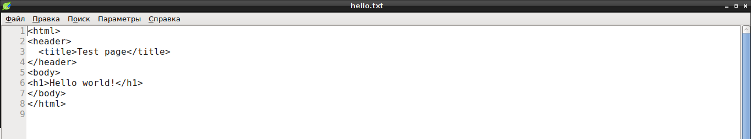

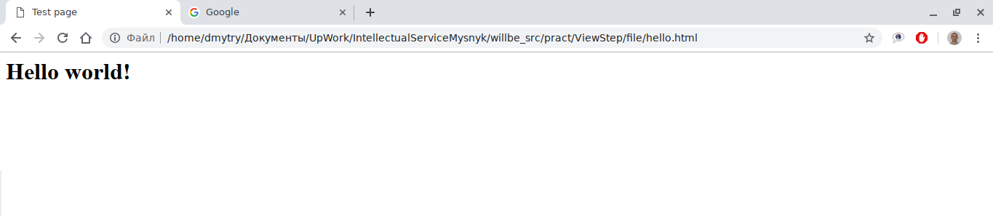
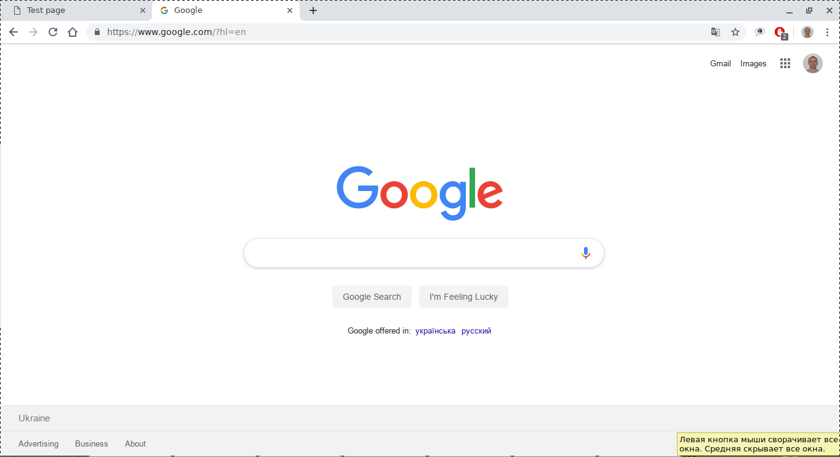
Remote resource (submodule) built without WILLBE

Download
Local submodule files
Exported
WILL-file
Export
Module with informal submodule
Import
Informal submodule WILL-file
Module WILL-file

Parent
resource
Child
resource
about :
supermodule
name : superModule
description : 'Supermodule'

submodule :
submodule
Tools : git+https:///github.com/Wandalen/wTools.git/out/wTools#master

about :
name : local
description : 'Module with local submodule'

submodule :
relative path
ModuleOne : ./ModuleOne
LocalModule : /home/user/localModule/
absolute path

unnamed will-file
named will-files
[user@user ~]$ ls -al
drwxr-xr-x 3 user user 4096 Mar 12 08:41 .
drwxr-xr-x 19 user user 4096 Feb 28 12:35 ..
-rw-r--r-- 1 user user 384 Feb 28 12:35 .will.yml
-rw-r--r-- 1 user user 989 Feb 28 12:35 all.will.yml
drwxr-xr-x 2 user user 4096 Feb 28 12:35 proto
-rw-r--r-- 1 user user 915 Feb 28 12:35 release.will.yml
-rw-r--r-- 1 user user 344 Feb 28 12:35 super.will.yml

[user@user ~]$ ls -al
drwxr-xr-x 3 user user 4096 Mar 12 08:41 .
drwxr-xr-x 19 user user 4096 Feb 28 12:35 ..
-rw-r--r-- 1 user user 384 Feb 28 12:35 .ex.will.yml
-rw-r--r-- 1 user user 989 Feb 28 12:35 .im.will.yml
drwxr-xr-x 2 user user 4096 Feb 28 12:35 proto
-rw-r--r-- 1 user user 344 Feb 28 12:35 super.ex.will.yml
-rw-r--r-- 1 user user 915 Feb 28 12:35 super.im.will.yml

unnamed split
will-file
named split
will-file

submodule :

Tools : git+https:///github.com/Wandalen/wTools.git/out/wTools#master

step :

npm.install :
currentPath : '.'
shell : npm install
resource value
resource fields
(value)
resource name

section name

resource
submodule :

Tools : git+https:///github.com/Wandalen/wTools.git/out/wTools#master

about :

name : 'first'
description : 'Will-file'
version : 0.0.1
keywords :
- willbe

submodule :

Tools : git+https:///github.com/Wandalen/wTools.git/out/wTools#master

step :

npm.install :
currentPath : '.'
shell : npm install

build :
export :
criterion :
default : 1
steps :
-npm.install
section
resource step
resource submodule
section name

