ANA 515 Week 5

Jiawei Zhao

2024-06-23

knitr::opts_chunk$set(echo = TRUE)  
library(ggplot2)

drinks <- read.csv ("https://raw.githubusercontent.com/fivethirtyeight/data/master/alcohol-consumption/drinks.csv")

# Calculate average consumption per continent  
# Bar plot  
ggplot(drinks, aes(x = country, y = beer_servings)) +  
 geom_bar(stat = "identity", fill = "skyblue") +  
 labs(title = "Beer Servings by Country", x = "Country", y = "Beer Servings") +  
 theme_minimal()

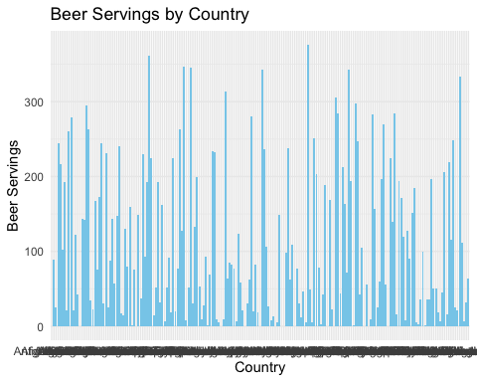

# Scatter plot  
ggplot(drinks, aes(x = wine_servings, y = total_litres_of_pure_alcohol)) +  
 geom_point(color = "darkred") +  
 labs(title = "Wine Servings vs Total Alcohol Consumption", x = "Wine Servings", y = "Total Alcohol Consumption") +  
 theme_minimal()

