1. Using the scipy stats module:

P(x<1|N(0,1)): probability x<1 given a normal distribution of x with μ=0, σ=1

P(x>μ+2σ|N(175, 3))

Specifically, you should import as: from scipy import stats

Within stats you should explore the functions stats.norm().pdf and stats.norm().cdf , which refer to the probability density function and cumulative distribution functions, respectively.

Rather than printing your findings to the console, we will use matplotlib.pyplot to produce nicely formatted, stacked plots such as shown below. Additional requirements are:

* You should use numpy arrays for all of your work on this problem where arrays are needed.

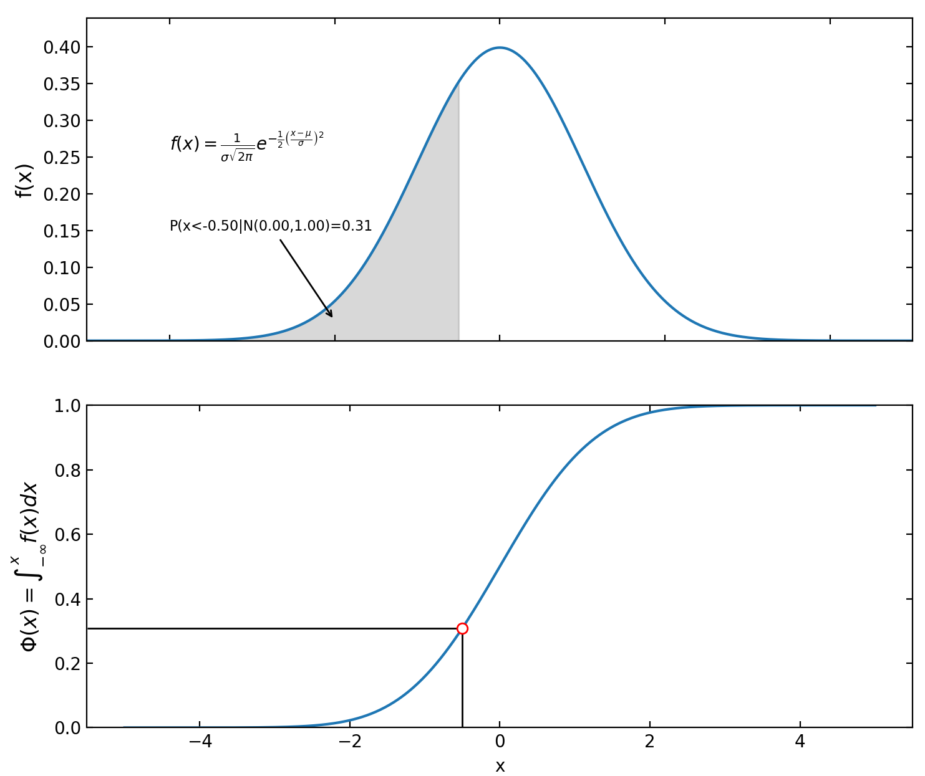 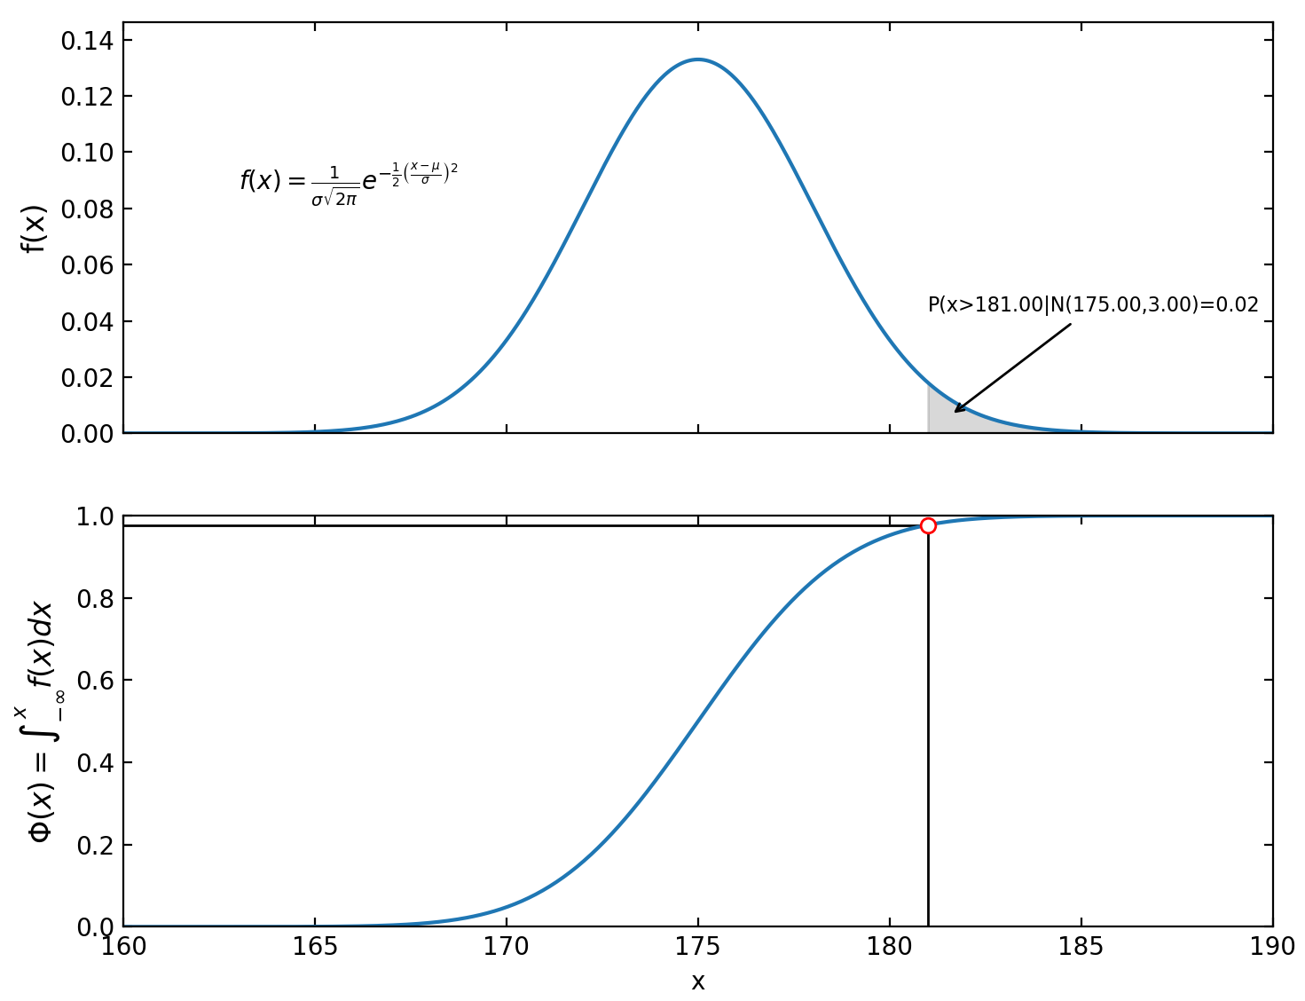

1. Find the roots of the following equations using fsolve from scipy.optimize. Do these functions intersect? If so, where?





1. Solve the following matrix problems using scipy and numpy. Provide nice output.



