Xiaoxuan Wang 1205269243
Visaul studio 2010
.net Framework 4.0

Q5
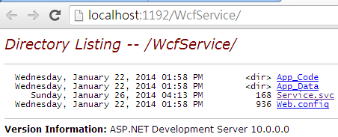
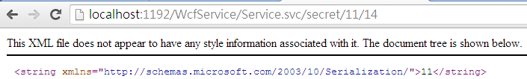
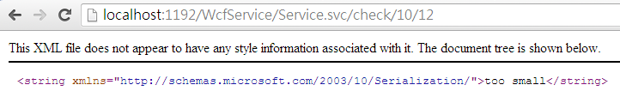

Q6
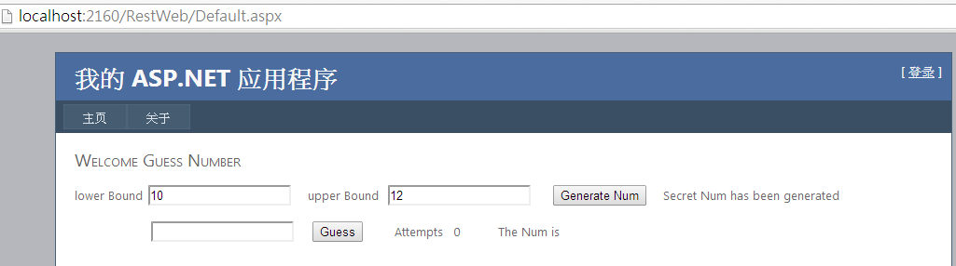
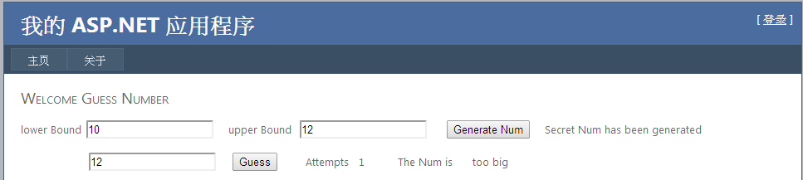
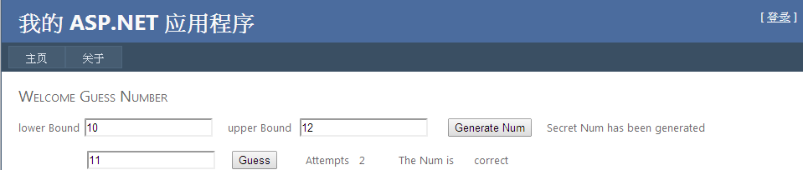

Q7
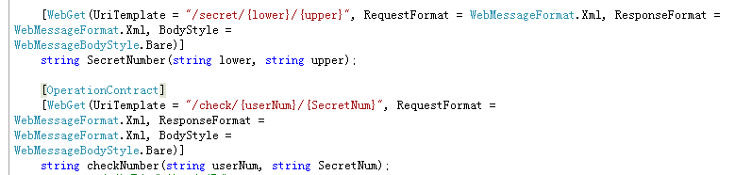

Q8
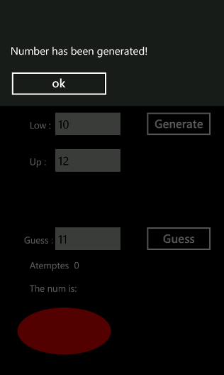

When guess is not correct the ellipse will stop.
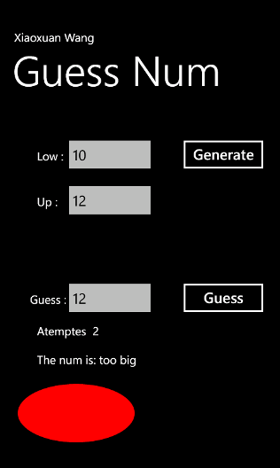

When guess correct the ellipse will move.
