Xiaoxuan Wang
1205269243
Visual studio 2012 .net framework 4.5

User Manul:

- I developed the guess number game with workflow using one service I developed and one from the external internet. The app can let the player input lower and upper bound can generate a secret number. Then he needs to guess the number, only he guess right can he quit.

2. “secret” to genrate the secret number. “checkNum” to check the answer .The main “sequence” flow
3. 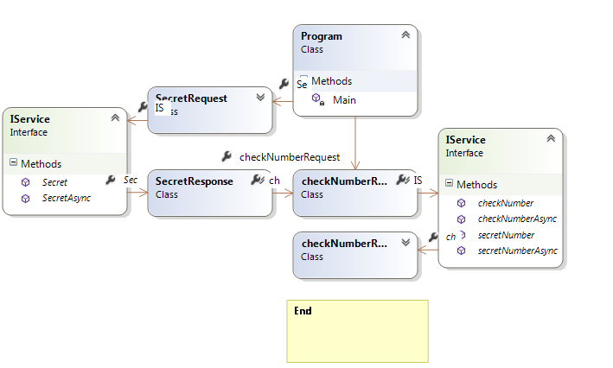

4
