Git List Remote Branches (freecodecamp.org)

Git List Remote Branches
Quincy Larson

There are 4 different Git commands you can enter into your command line to list all of the remote branches of a repo. I will show you command line code examples of each of these.
For all of these examples, I will use freeCodeCamp's open source repository.

Command #1: git branch -r
This Git command will show you remote branches. The -r flag here is short for --remotes.
freecodecamp➜~/web/freeCodeCamp(main)» git branch -r

Output:
origin/HEAD -> origin/main
origin/i18n-sync-client
origin/main
origin/prod-current
origin/prod-staging
origin/renovate/react-i18next-11.x
origin/renovate/typescript-eslint-monorepo
This is the command I use personally. So if you want, you can just stop reading here and use git branch -r whenever you want to list remote git branches.
But for completeness, I've included 3 other commands you can use, that return different lists.

Command #2: git ls-remote --heads
This Git command returns the same information, but also includes the hash for these remotes.
freecodecamp➜~/web/freeCodeCamp(main)» git ls-remote --heads

Output:
From git@github.com:freeCodeCamp/freeCodeCamp
12d742a4f0dfdcfae25d1b71aa738b4e91bfcb61 refs/heads/i18n-sync-client
f05262b823f5a578787e5387357383f09df9c5c1 refs/heads/main
6d89576b6c588e3e3daa90bdaf226a6f5cc3d9c5 refs/heads/prod-current
6d89576b6c588e3e3daa90bdaf226a6f5cc3d9c5 refs/heads/prod-staging
750af5a018008c9a7eac683b064adc016b990659 refs/heads/renovate/react-i18next-11.x
08e06f10363ab1d33156b83b2b01cad005c3a2cf refs/heads/renovate/typescript-eslint-monorepo

Command #3: git ls-remote
This Git command displays not only the names of remote repositories, but their reference information, including Git commit hash.
freecodecamp➜~/web/freeCodeCamp(main)» git ls-remote

Output:

! [origin/HEAD] chore(deps): update dependency @types/validator to v13.7.3
! [origin/i18n-sync-client] fix(client): prevent lower jaw breaking on code evaluation (#46154)
! [origin/main] chore(deps): update dependency @types/validator to v13.7.3
! [origin/prod-current] fix(curriculum): don't block fragment links (#46246)
! [origin/prod-staging] fix(curriculum): don't block fragment links (#46246)
! [origin/renovate/react-i18next-11.x] fix(deps): update dependency react-i18next to v11.17.0
! [origin/renovate/typescript-eslint-monorepo] chore(deps): update typescript-eslint monorepo to v5.27.0
-------
There is a lot of specially formatted output, so I'll just include a screenshot to give you an idea:
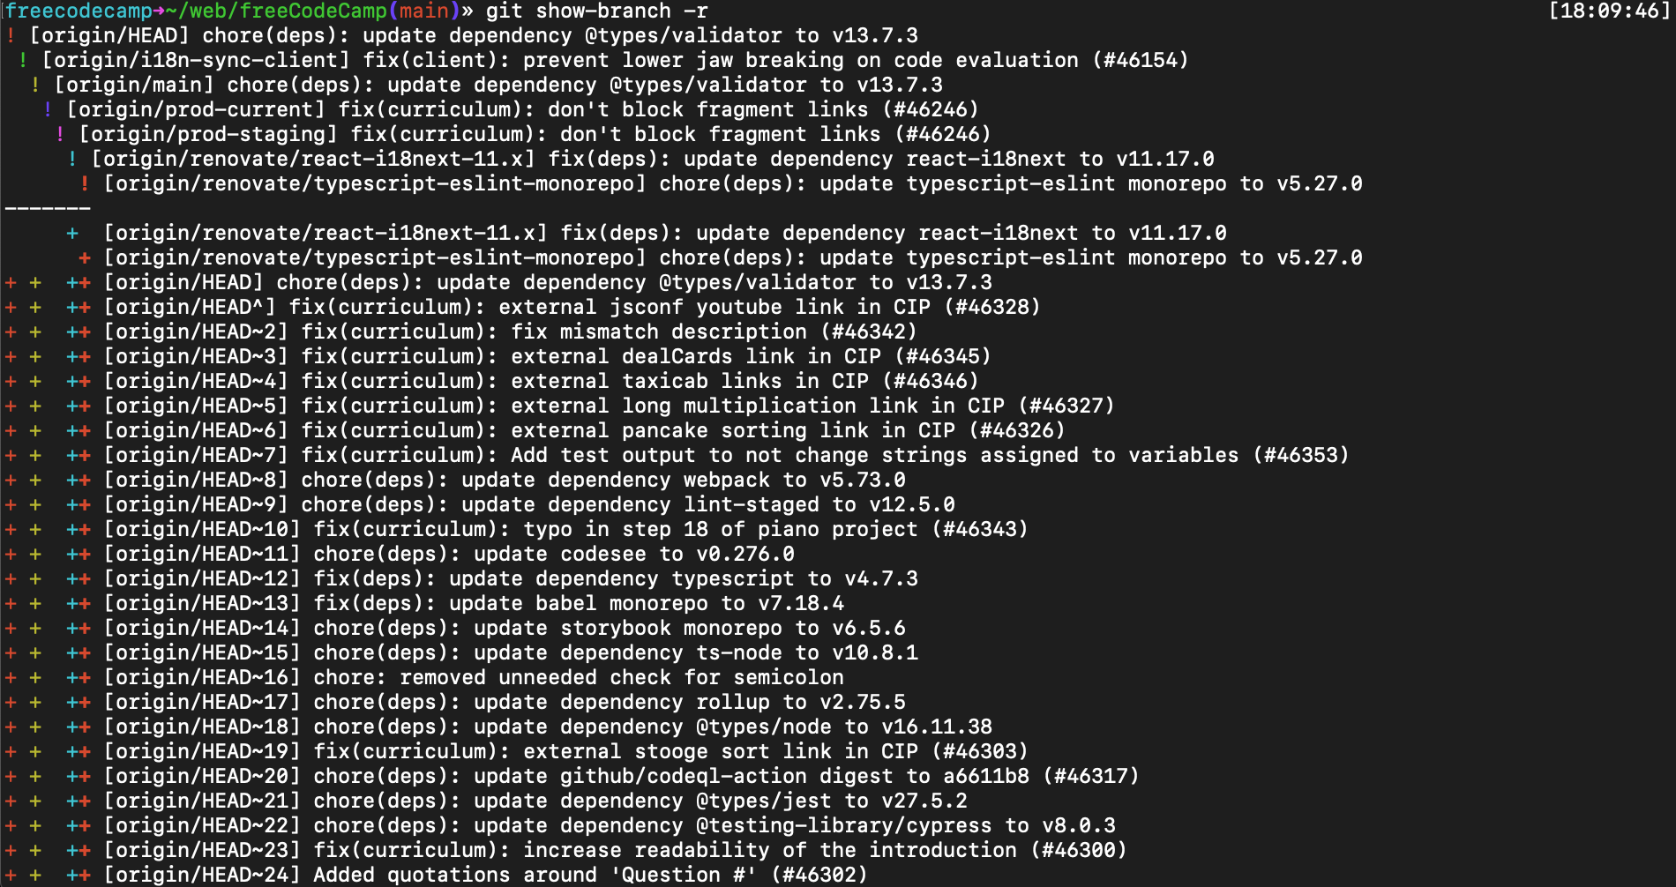If you want color coding and timestamps in your terminal here, I recommend using OhMyZSH.

Command #4: git show-branch -r
The main reason you would use this Git command is because it displays almost everything, so you can control+f through to find a particular hash.
I don't remember ever using this before myself.
freecodecamp➜~/web/freeCodeCamp(main)» git show-branch -r

Output:

From git@github.com:freeCodeCamp/freeCodeCamp
f05262b823f5a578787e5387357383f09df9c5c1 HEAD
12d742a4f0dfdcfae25d1b71aa738b4e91bfcb61 refs/heads/i18n-sync-client
f05262b823f5a578787e5387357383f09df9c5c1 refs/heads/main
6d89576b6c588e3e3daa90bdaf226a6f5cc3d9c5 refs/heads/prod-current
6d89576b6c588e3e3daa90bdaf226a6f5cc3d9c5 refs/heads/prod-staging
750af5a018008c9a7eac683b064adc016b990659 refs/heads/renovate/react-i18next-11.x
08e06f10363ab1d33156b83b2b01cad005c3a2cf refs/heads/renovate/typescript-eslint-monorepo
36380c5a67938de35d7011e33855d45bb545300b refs/pull/10/head
d12e25f250b91afc01a43af0067d7026c39473fa refs/pull/100/head
56ff814f24385e5f76dc29bc4276c84e38ca9c5f refs/pull/10006/head
f84bb9a94ea33e0994e2d40c779416f3caa3aa04 refs/pull/10007/head
7193b9c725ed97cd8cc99aba72ceffa40a79c8f8 refs/pull/10008/head

[30,000 more lines]

9656d9030eb472341eebf5e0fb46a3538740701b refs/pull/9991/head
0545010ab9e1dac4aedca071669b6a86b35cabdc refs/pull/9995/head
b5365d3106e188fa6782388221b1184dfb2ffc88 refs/pull/9995/merge
0545010ab9e1dac4aedca071669b6a86b35cabdc refs/pull/9996/head
b5365d3106e188fa6782388221b1184dfb2ffc88 refs/pull/9996/merge
7e35af7b67c22b502cdfdf4663fafc788e75eeec refs/pull/9997/head
d8f3a9cb2e6d41a95f610ac72efae30ca9952d6f refs/remotes/origin/pr-39112-with-my-additional-commits-for-tests
d3aaa5a11e09f5996cfd5eb2f8b55f63785b4947 refs/remotes/upstream/master
56d78a11198a0d244bd131a8b9386b247212c5a1 refs/remotes/upstream/production-current
b73c7eac62d30fdc5e533f617dcd1b5e95306984 refs/remotes/upstream/staging
For the freeCodeCamp repo, this command returned more than 30,000 lines of branches. So I would not recommend using this command unless you absolutely need to see everything. 😅
That's all. I hope you have a fantastic day, and happy coding.

Git List Branches – How to Show All Remote and Local Branch Names (freecodecamp.org)
MARCH 29, 2022/#GIT

Git List Branches – How to Show All Remote and Local Branch Names
Kolade Chris

Git is a version control system used by software developers to track changes in applications and collaborate on projects.
One feature that makes Git more dynamic is branches. Developers working on a project can work in different branches before merging their changes with the original code or the main branch.
Sometimes, you might want to see the branches you and other collaborators have created. And that’s what I’m going to show you how to do in this article.

How to Show All Remote and Local Branch Names
To see local branch names, open your terminal and run git branch:
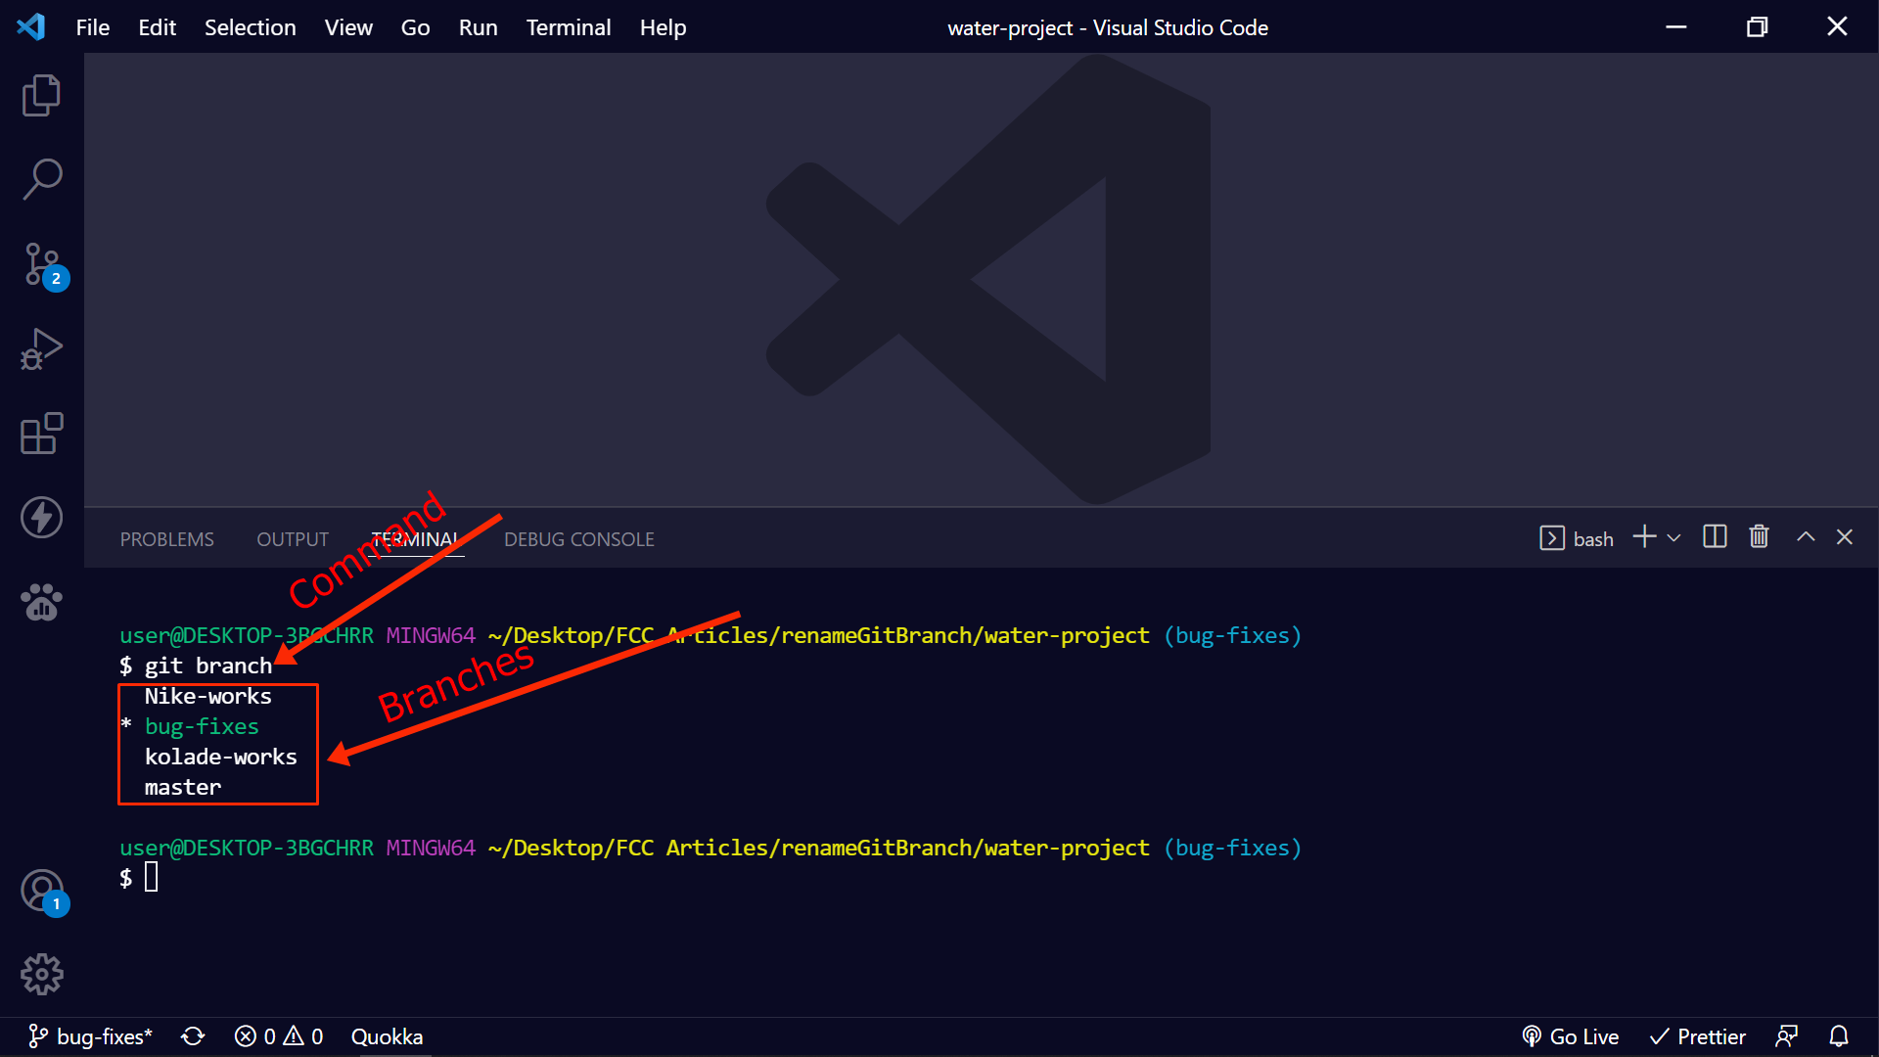
N.B the current local branch will be marked with an asterisk. In addition, if you’re using Git bash or WSL’s Ubuntu as your terminal, the current local branch will be highlighted in green.
To see all remote branch names, run git branch -r:
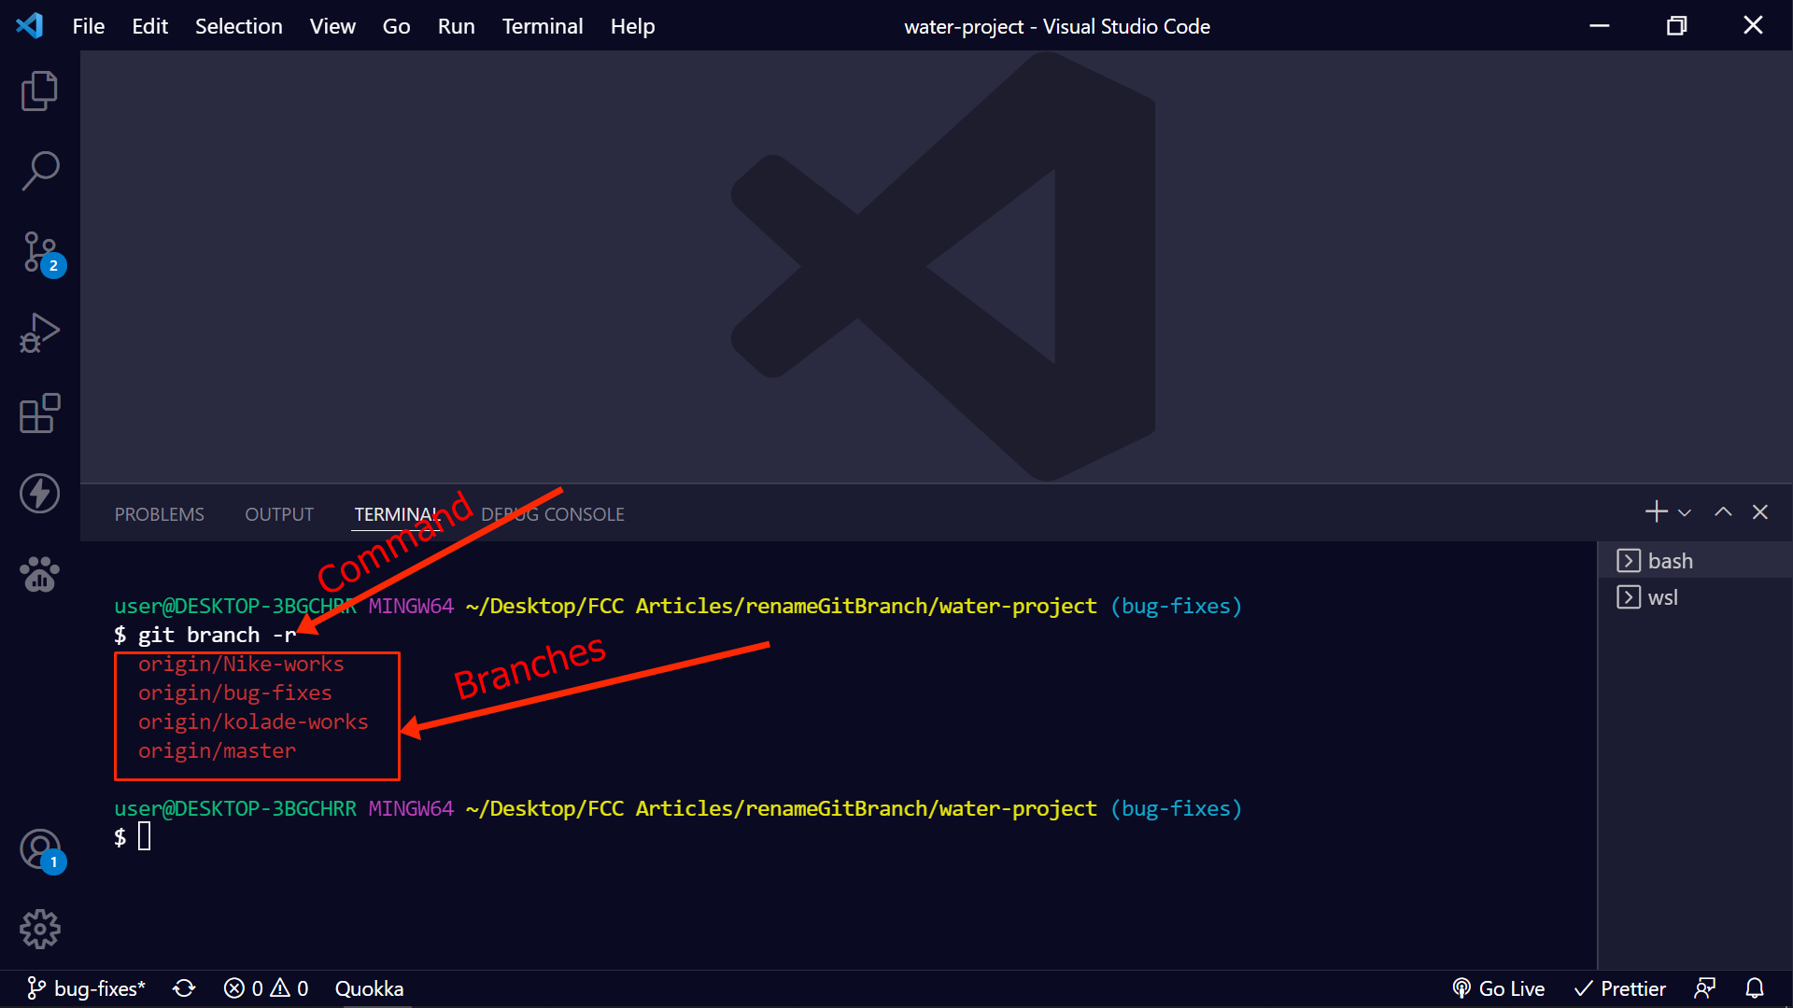
To see all local and remote branches, run git branch -a:
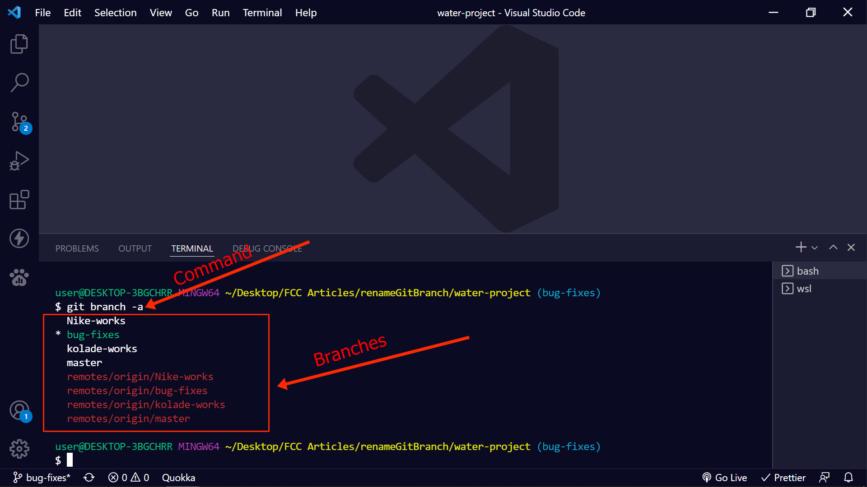
You can see detailed information such as the local or remote branches in use, commit ids, and commit messages by running git branch -vv or git branch -vva:
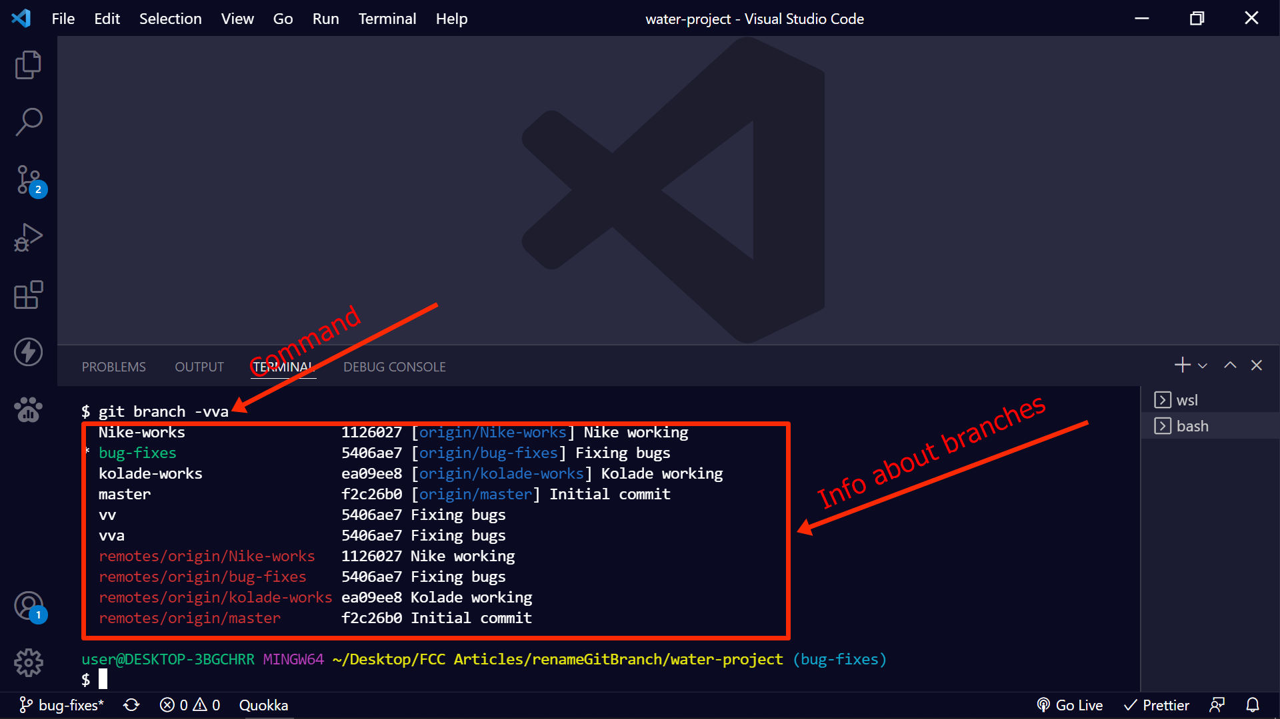

Conclusion
This article showed you how to list branches while working with Git.
Being able to list the Git branches of a project can help you learn more about the project and get to know what your team members are working on.
If you find this article helpful, don’t hesitate to share it with others who might need it.
Thank you for reading.

