mv src_folder target_folder/ → move

unzip file.zip -d destination_folder

rm file fiel2 → rename

Use the rmdir or rm -d command to remove empty directories.
- Use the rm -r command to remove non-empty directories.

cp -avr /home/vivek/letters /usb/backup
Where,
-a : Preserve the specified attributes such as directory an file mode, ownership, timestamps, if possible additional attributes: context, links, xattr, all.
-v : Explain what is being done.
-r : Copy directories recursively. Example
Copy a folder called /tmp/conf to /tmp/backup:
$ cp -avr /tmp/conf/ /tmp/backup

Create a New File
touch sample.txt
cat >sample.txt

ls -lat → ordena pela data desc

ls -l | grep 'yyyy-mm-dd'

ls -l | grep "Feb"

Processos → top ou htop

Uso de memória → free ou vmstat p

How to install .NET Core SDK on Ubuntu 22.04

install-net-core-sdk-on-ubuntu-22-04.sh

wget https://packages.microsoft.com/config/ubuntu/22.04/packages-microsoft-prod.deb -O packages-microsoft-prod.deb

sudo dpkg -i packages-microsoft-prod.deb

rm packages-microsoft-prod.deb

sudo apt-get update && sudo apt-get install -y dotnet-sdk-7.0

How To Install PostgreSQL on Ubuntu 22.04
sudo apt update
sudo apt install postgresql postgresql-contrib

sudo -i -u postgres
psql

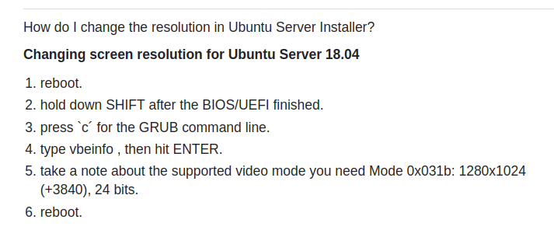
Depois seguir
https://

www.youtube.com/watch?v=QTgHrEy2B4w

Edit the GRUB configuration file:
sudo {editor of choice} /etc/default/grub
Note: Be sure to replace {editor of choice} with your editor of choice.
- Add a GRUB_GFXPAYLOAD_LINUX definition to the bottom of the file:
GRUB_CMDLINE_LINUX_DEFAULT=nomodeset”
GRUB_GFXPAYLOAD_LINUX=1280x1024
Note: You cannot set the refresh rate. This will be limited to 30fps.
- Save the file and exit.
- Update GRUB:
sudo update-grub
- Restart the server.

How to Disable auto capture keyboard and mouse from oracle virtual box
https://www.youtube.com/watch?v=-oEN8rnfRa8

Mostrar os pacotes instalados

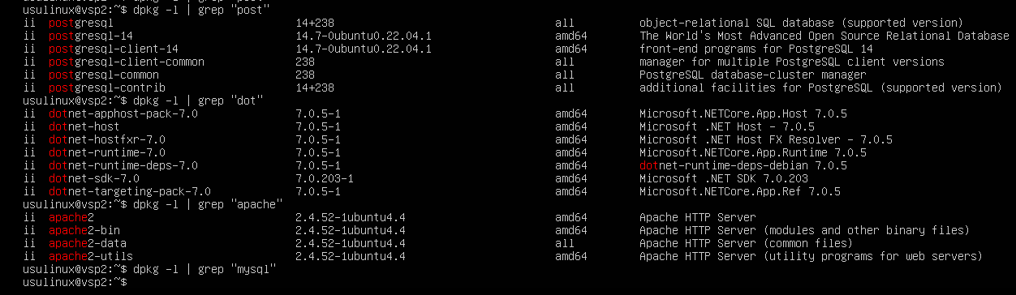

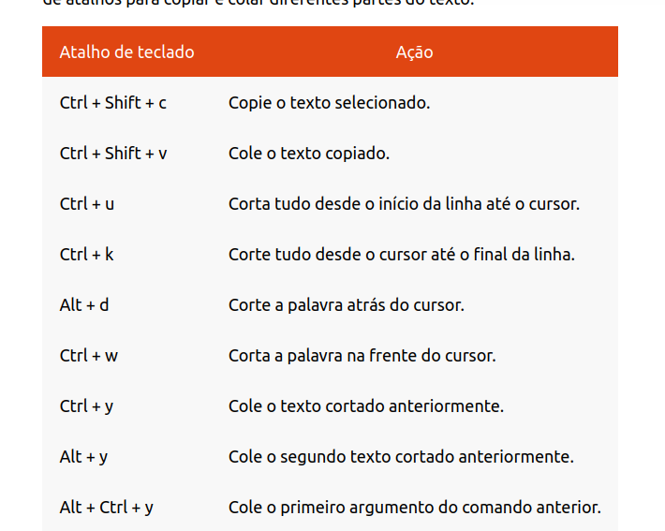

listar usuários linux → cat /etc/passwd

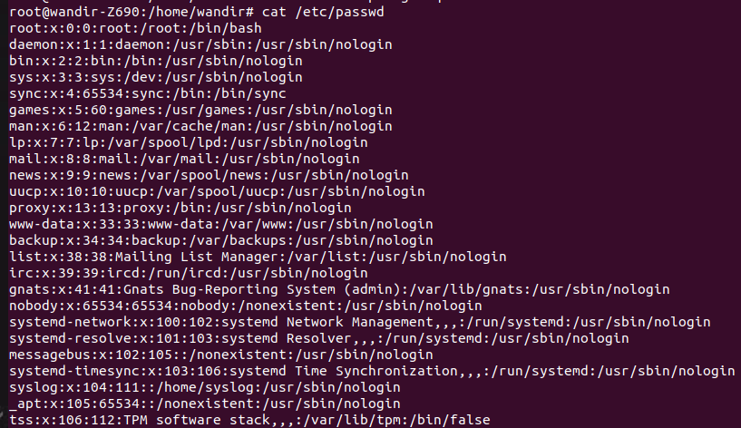
remover usuário linux → deluser <nameUser>

