git remote add origin git@github.com:WandirPereira/PostgresqlReview.git
pslql –-version
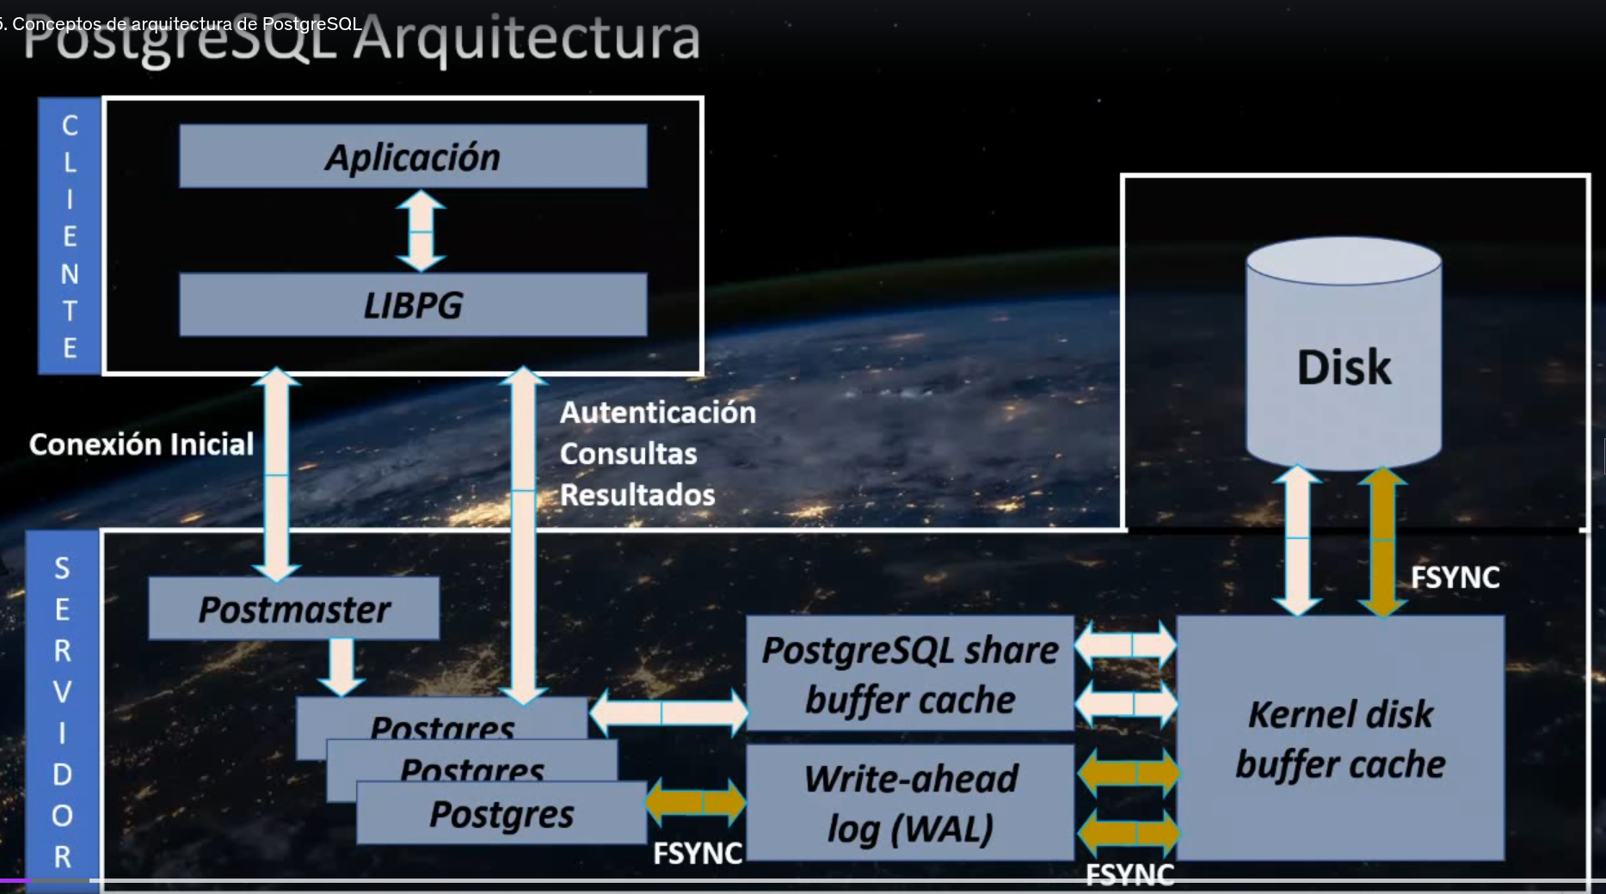

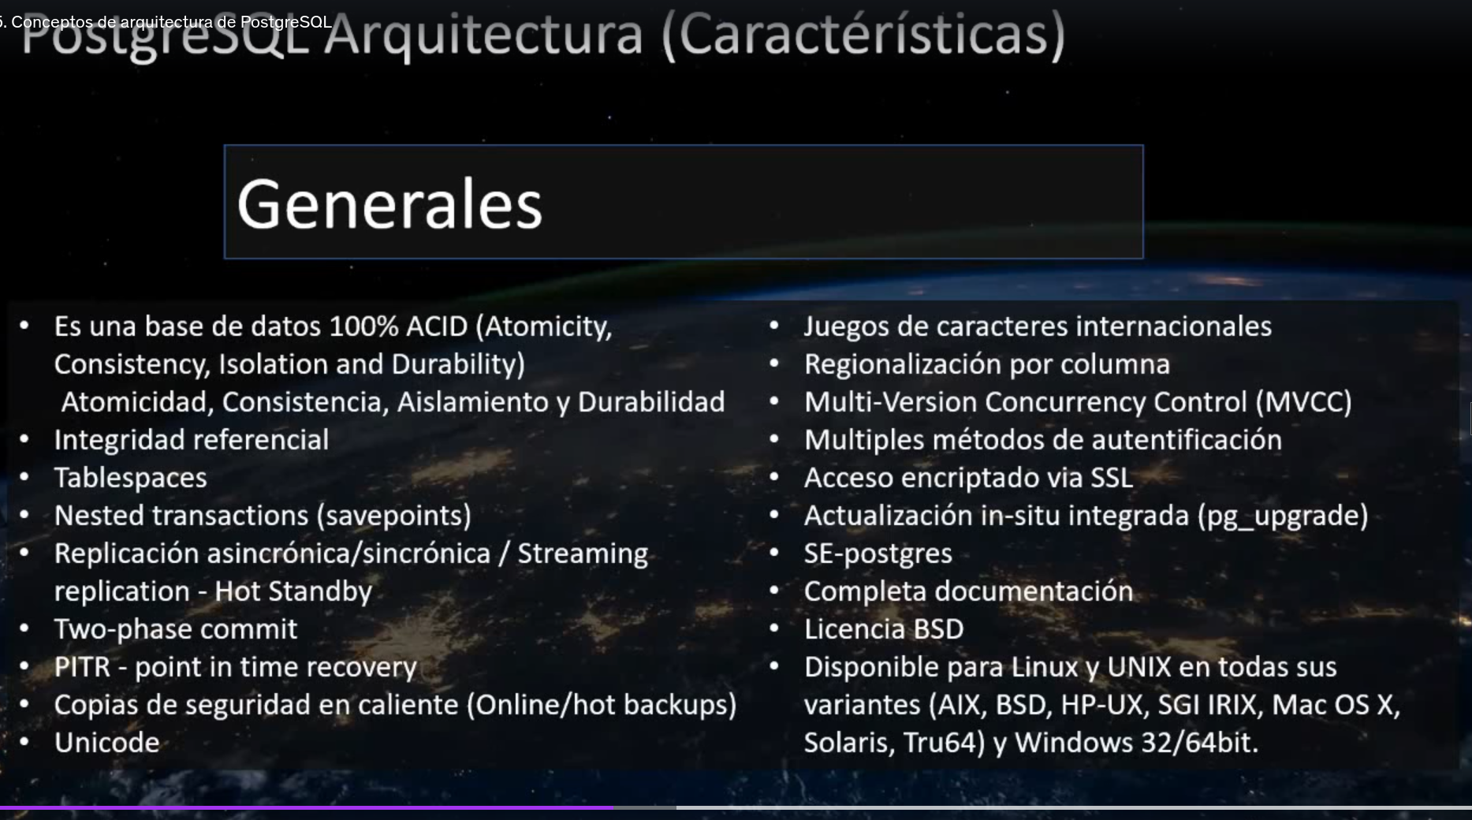

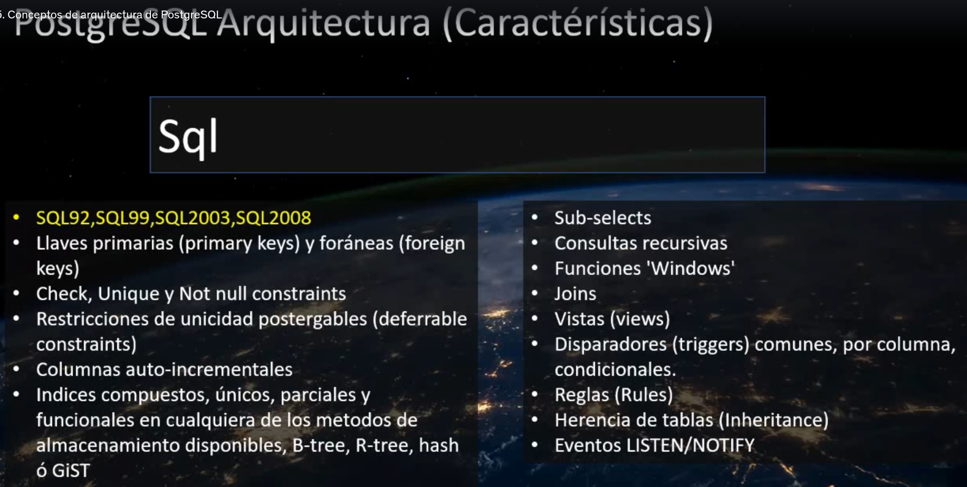
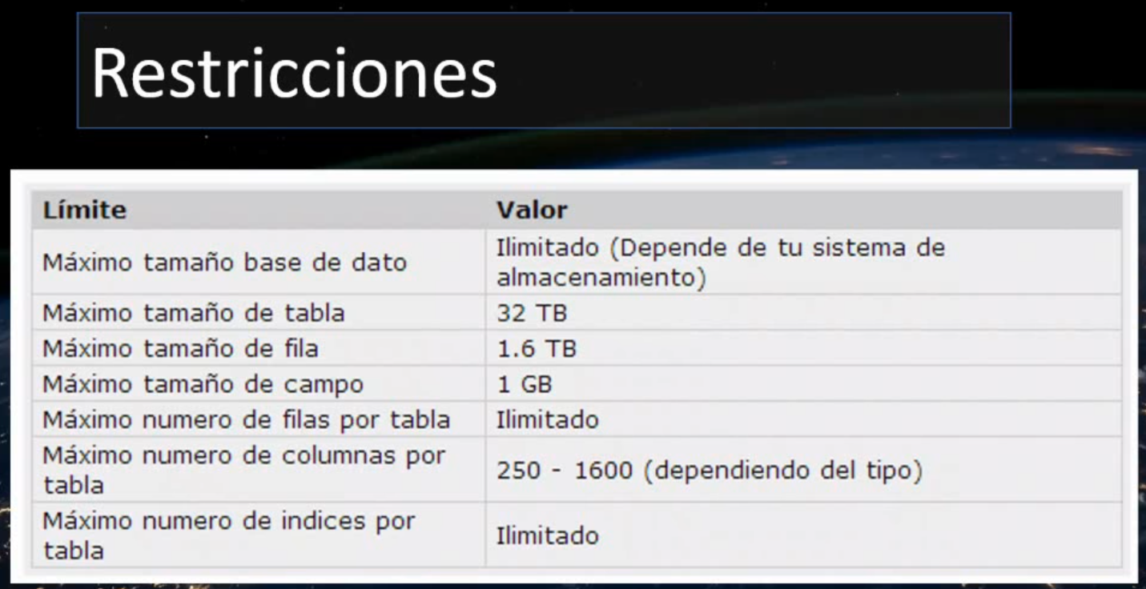

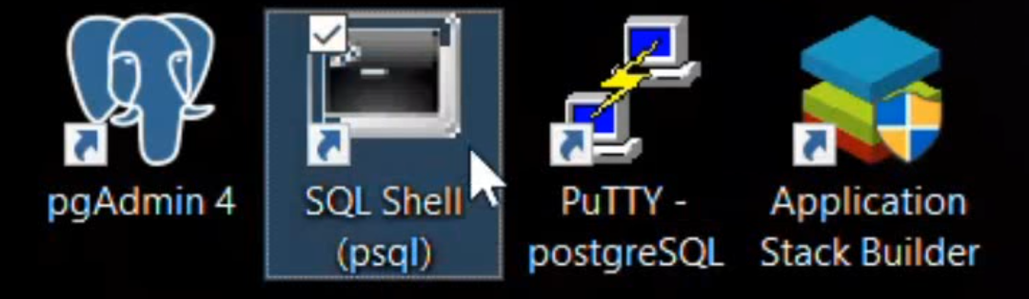

Acessars o postgresql:
1. sudo -i -u postgres (ou sudo su - postgres)
2. psql
Para sair: /q e em seguida → exit
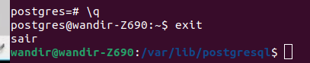

Listar bases de dados: \l
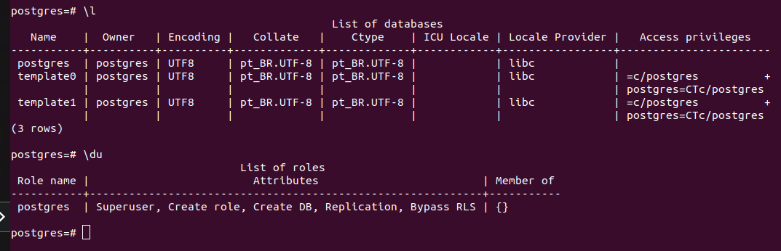
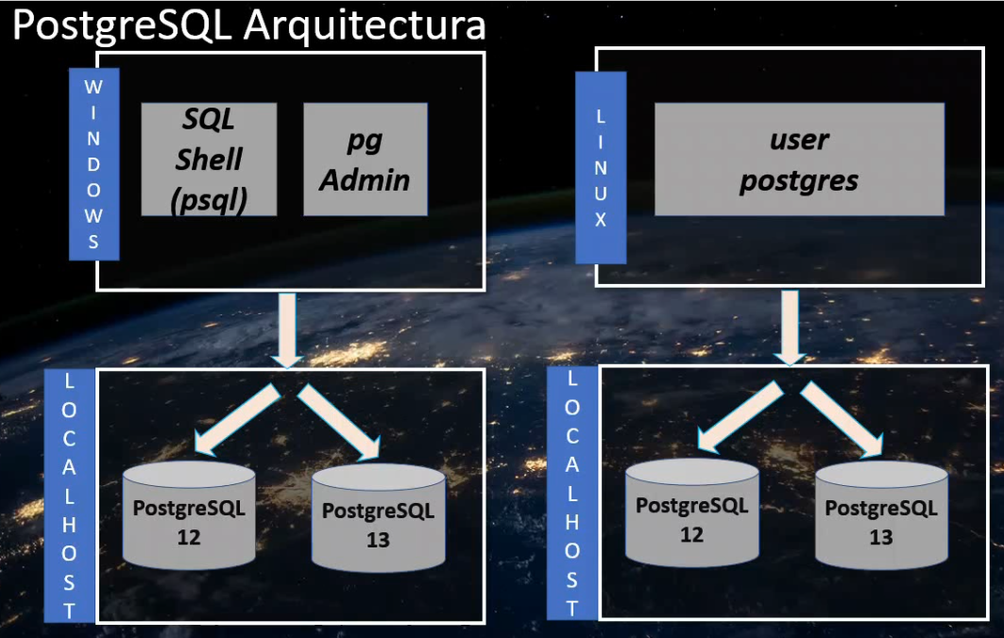
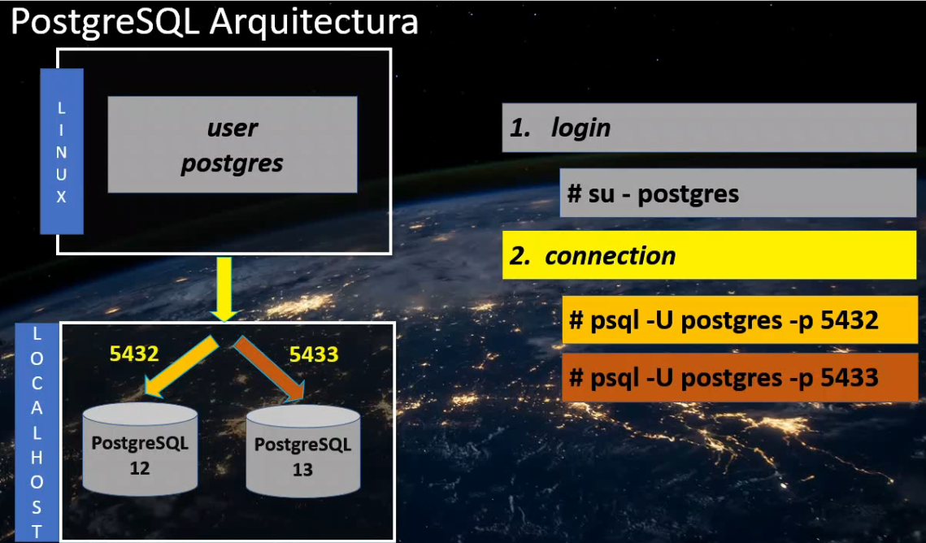
Primeira instãncia 5432 segunda instância 5433 terceira instância 5434 ...
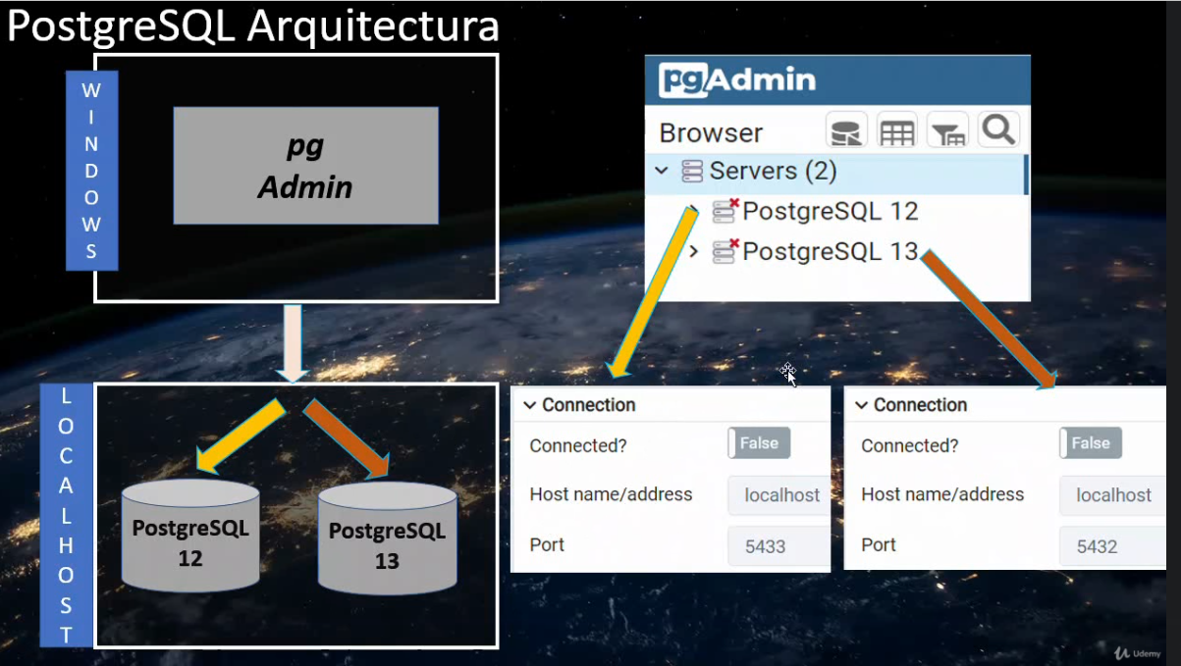

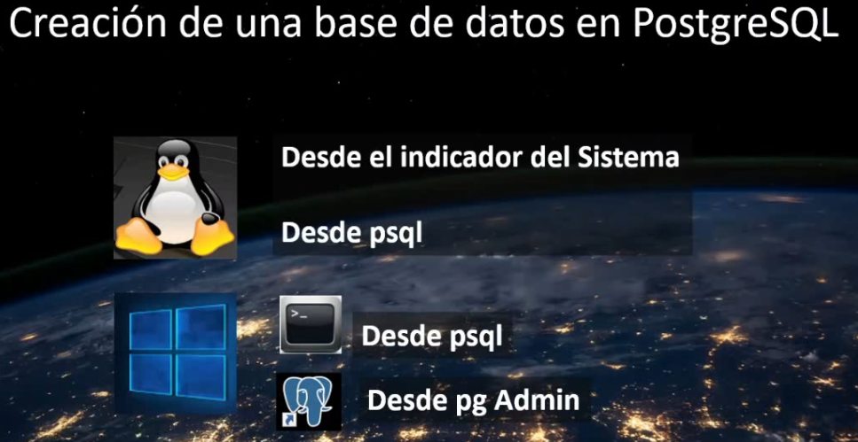

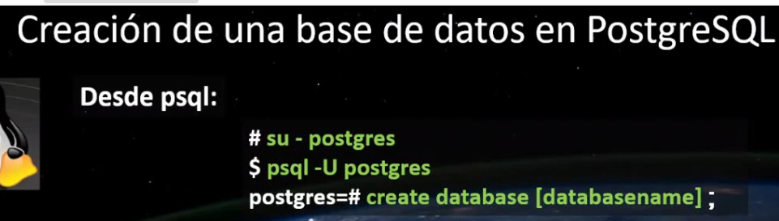
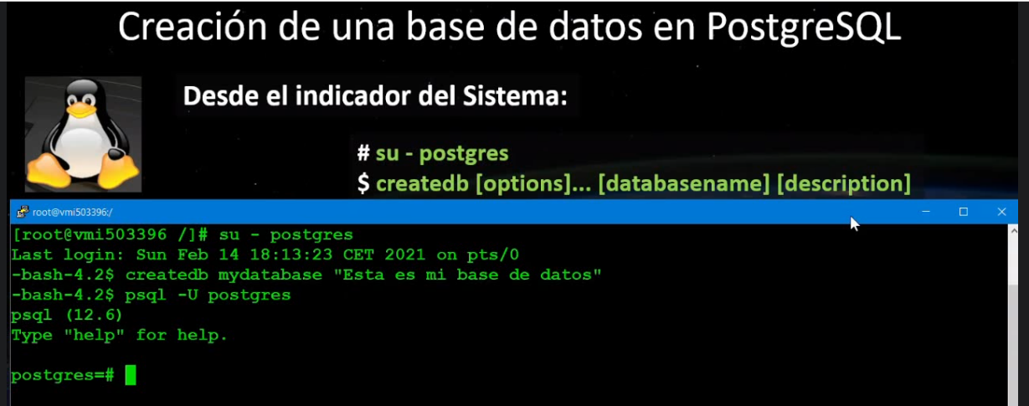
A base de dados foi criada fora do Postgresql, apenas logando com o usuário postgres
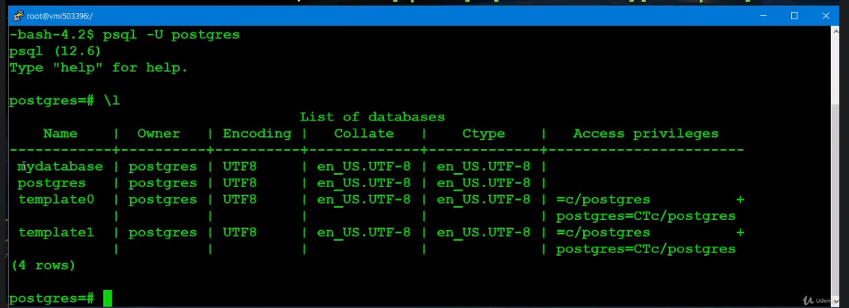
Listar bancos de dados: \l+
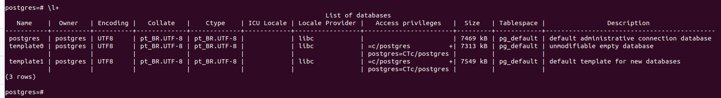
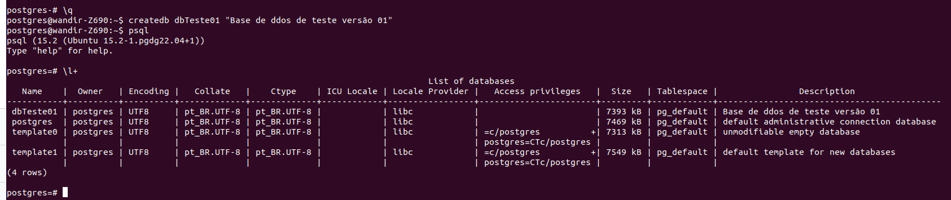
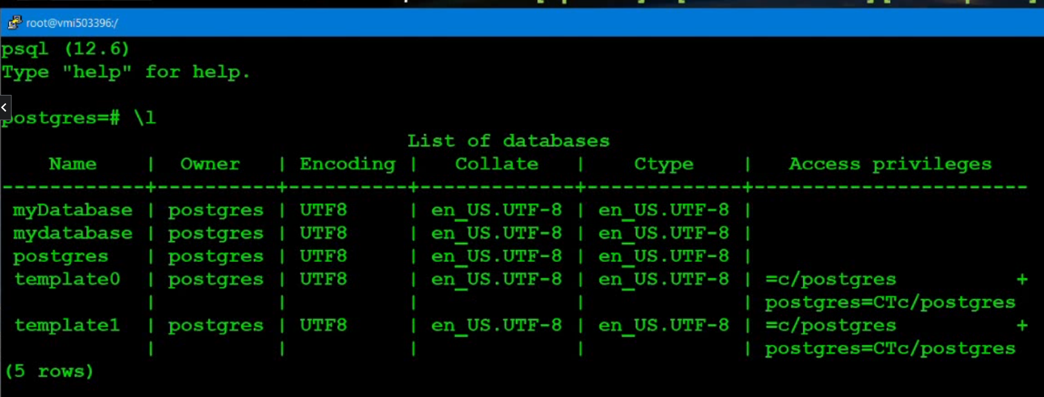

Nome dos bancos são case sensitive
Excluir database:
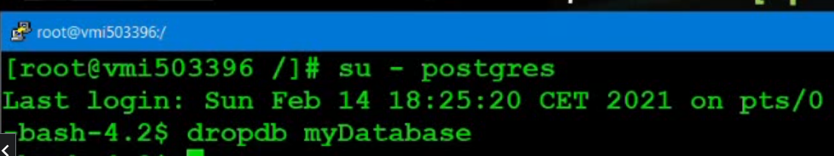
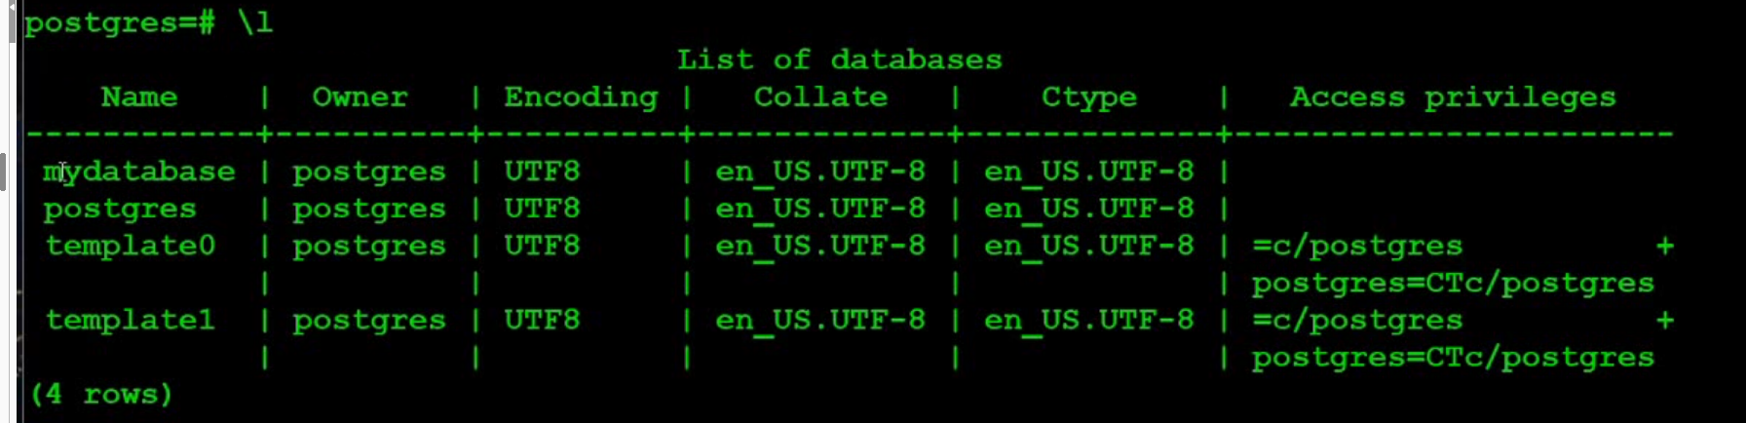

Criar database usando psql:
Dentro do psql, se quisermos distinguir os nome dos bancos , entre maiúsculas e mínúsculas, o nome deve ser colocado entre aspas.
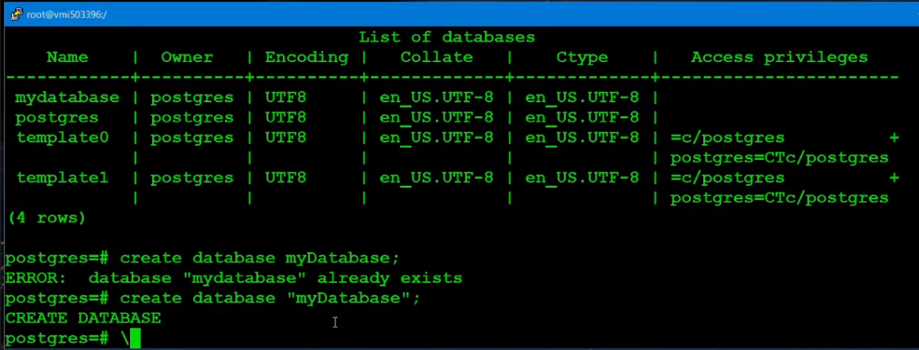
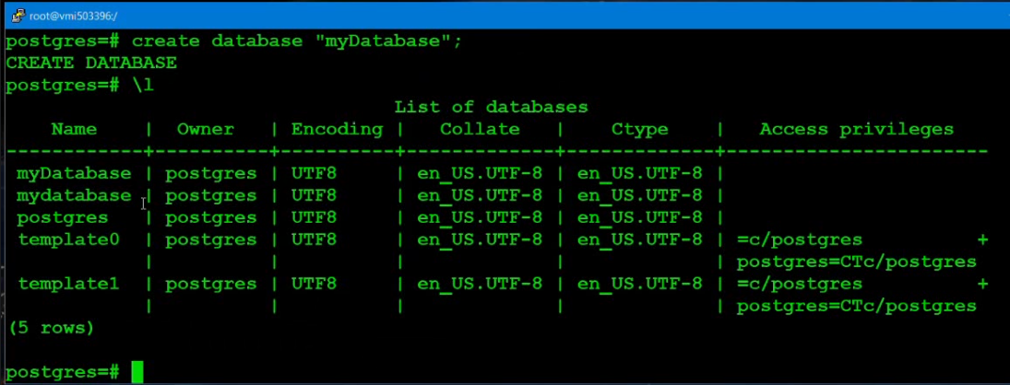
Para excluir o banco com letra maiúscula, temos que colocar o nome entre aspas
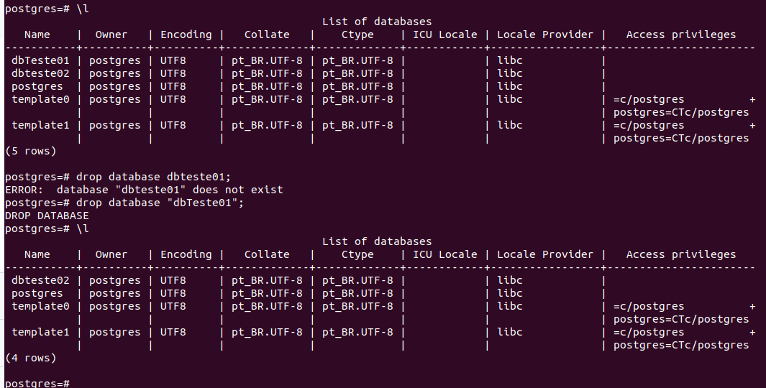

Conexão remota:
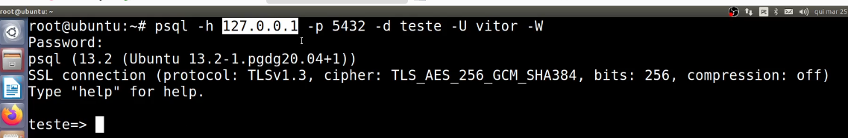
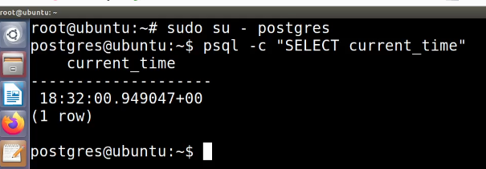
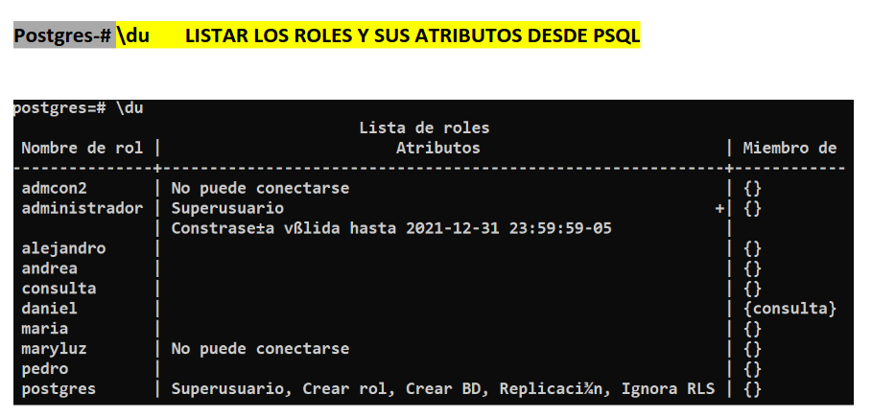
Criar um database fora do psql:
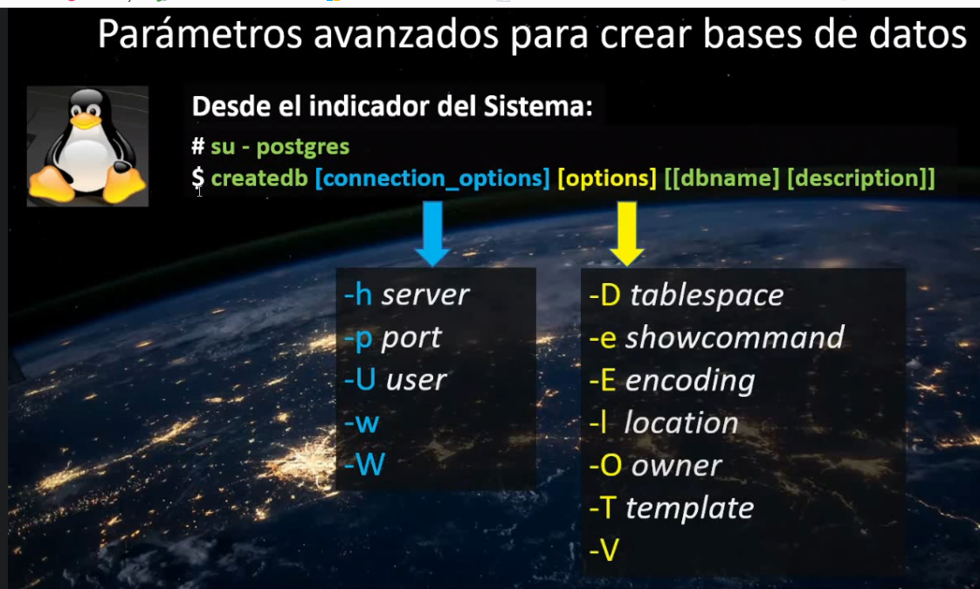
-W → pergunte o password
-w → não pergunte o password
-V versão
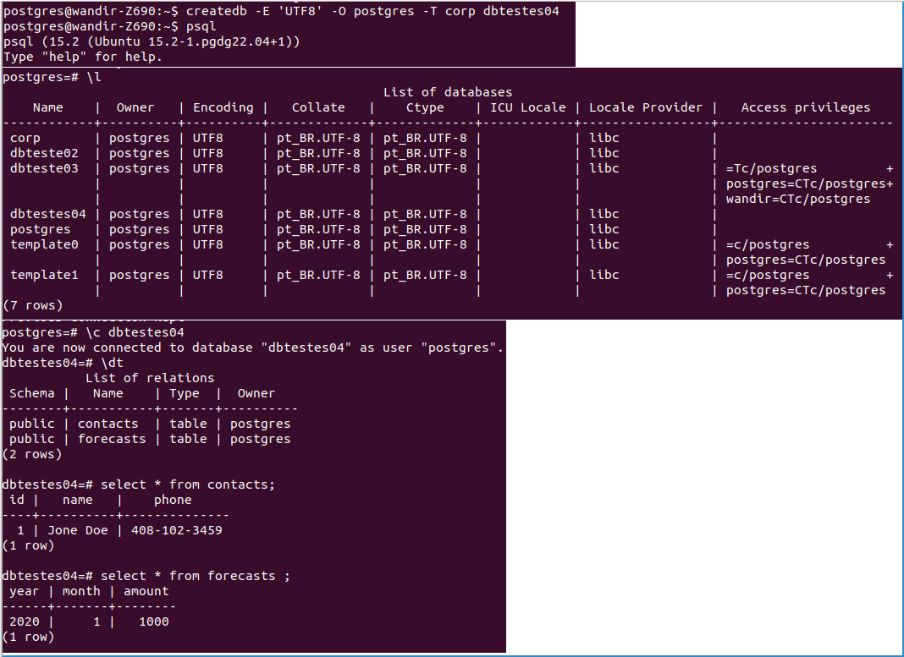
Criar um database dentro do psql:
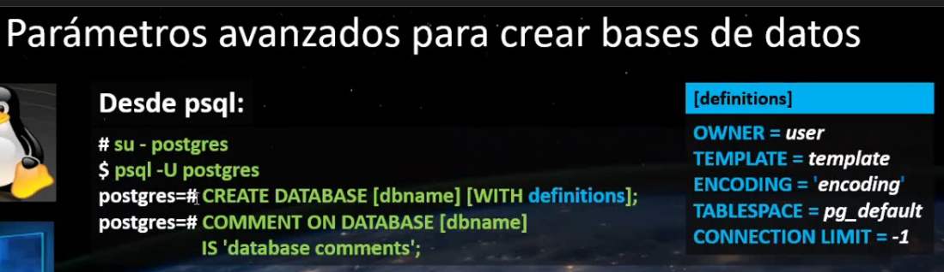
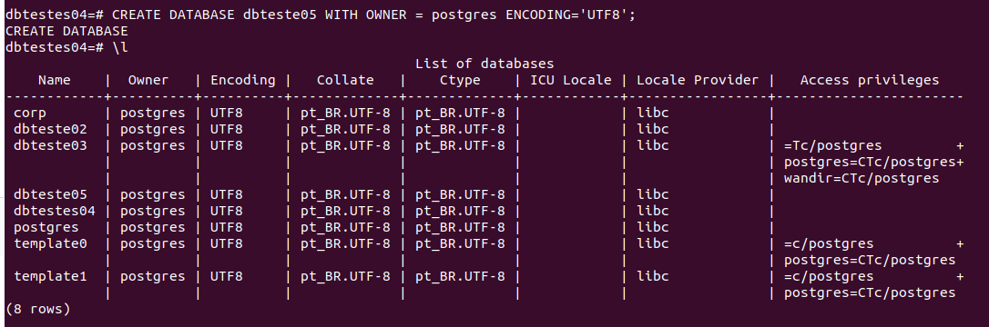
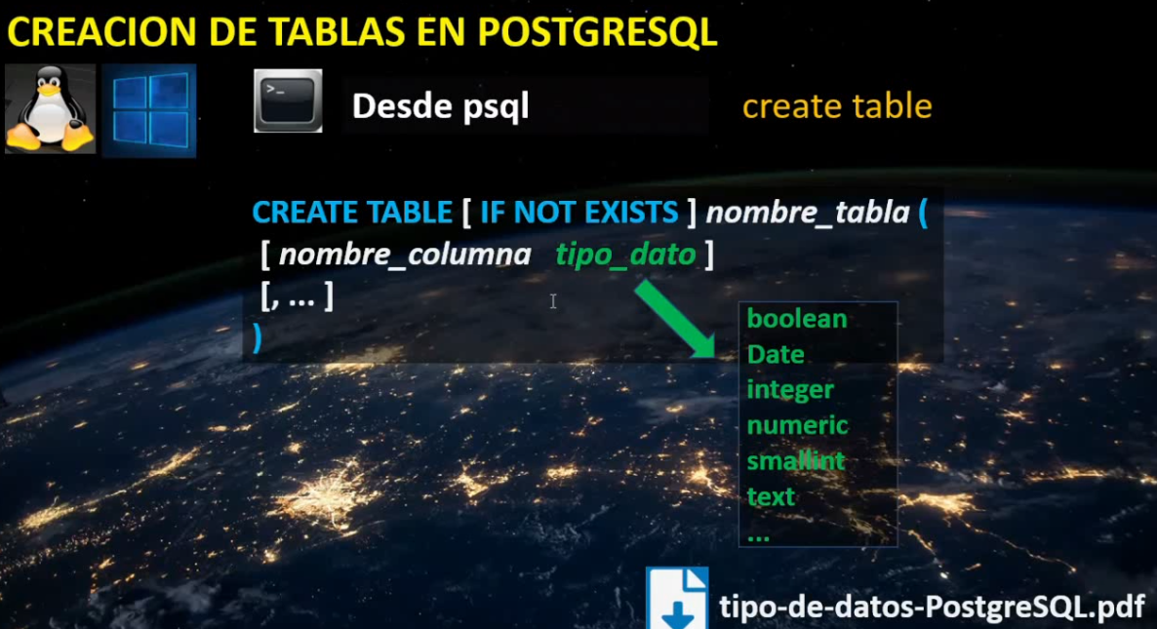
CREATE TABLE
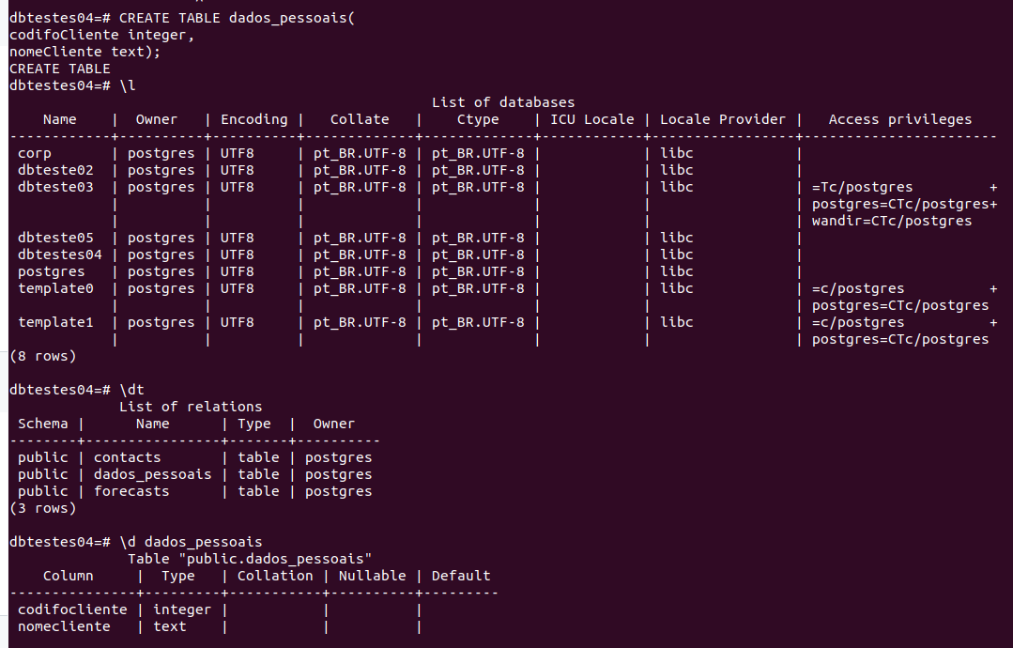
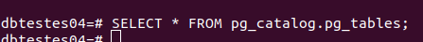
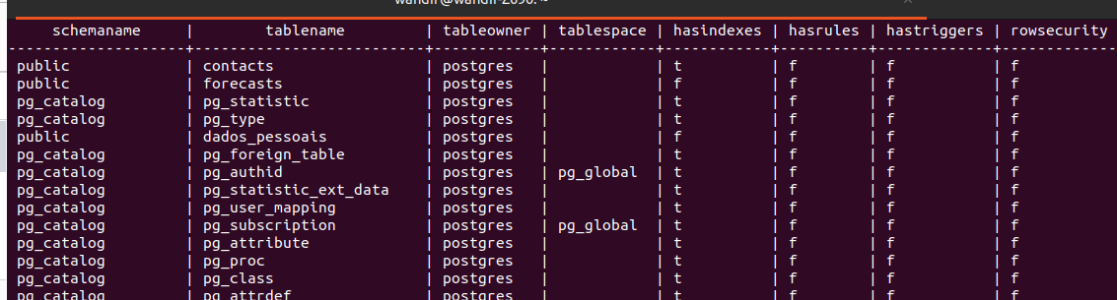

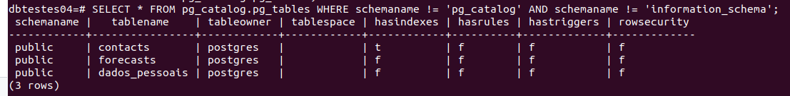
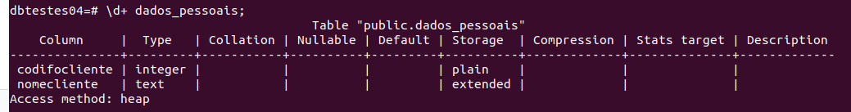
DROP TABLE
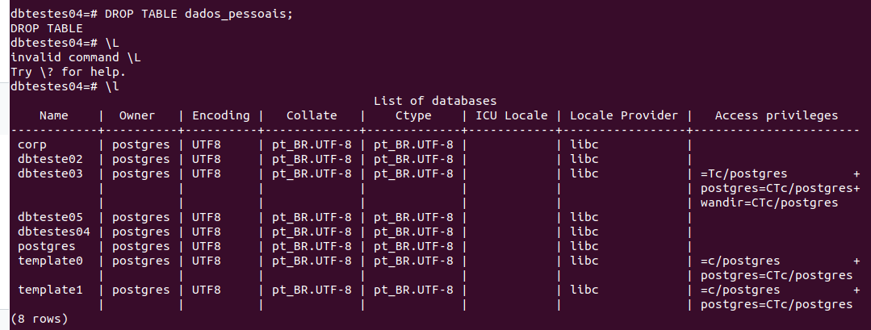
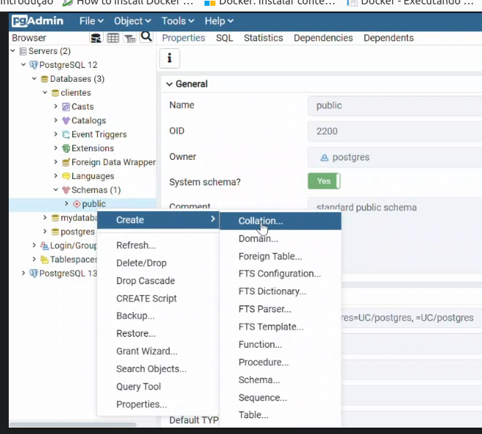

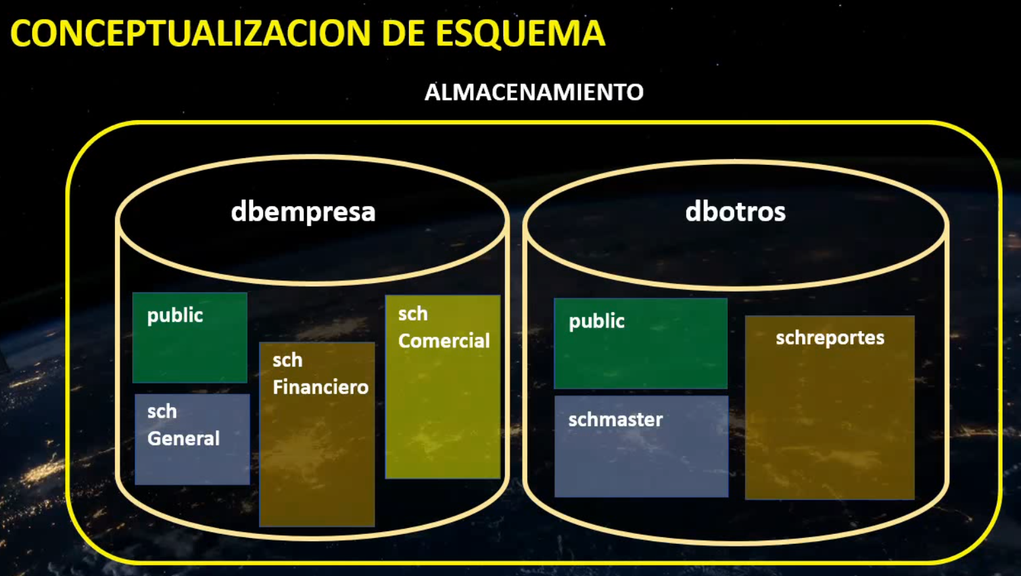
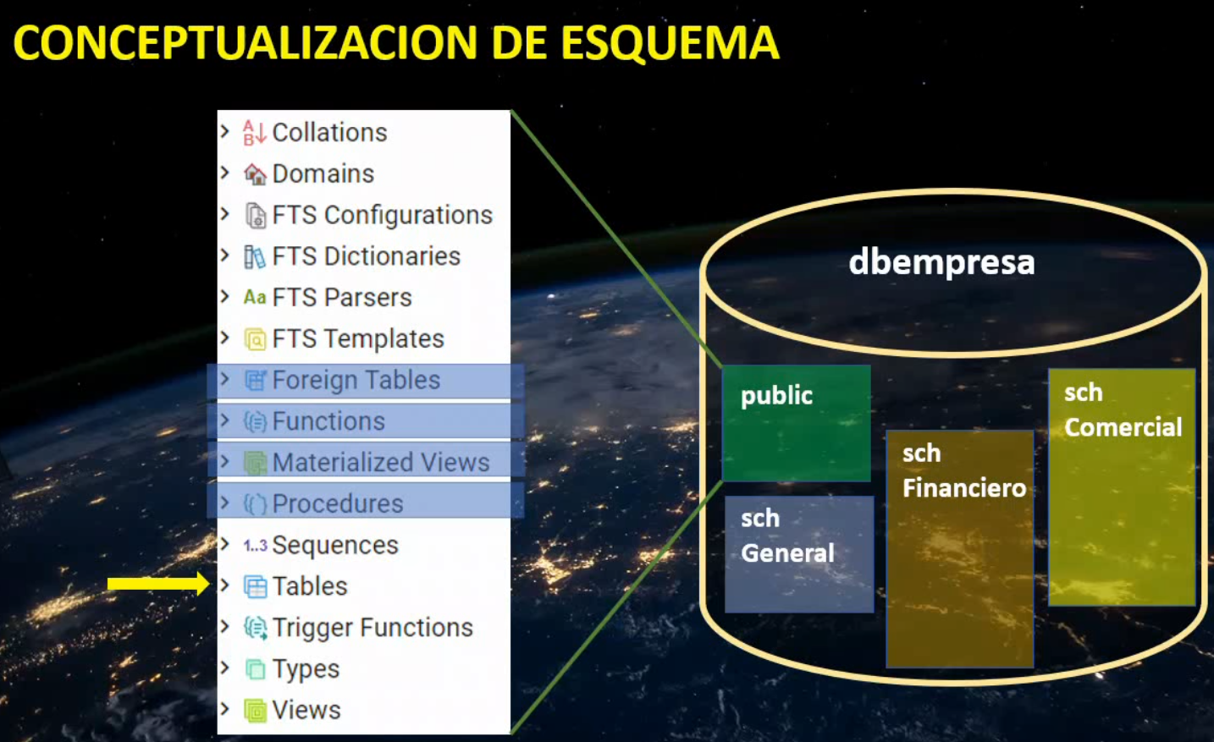
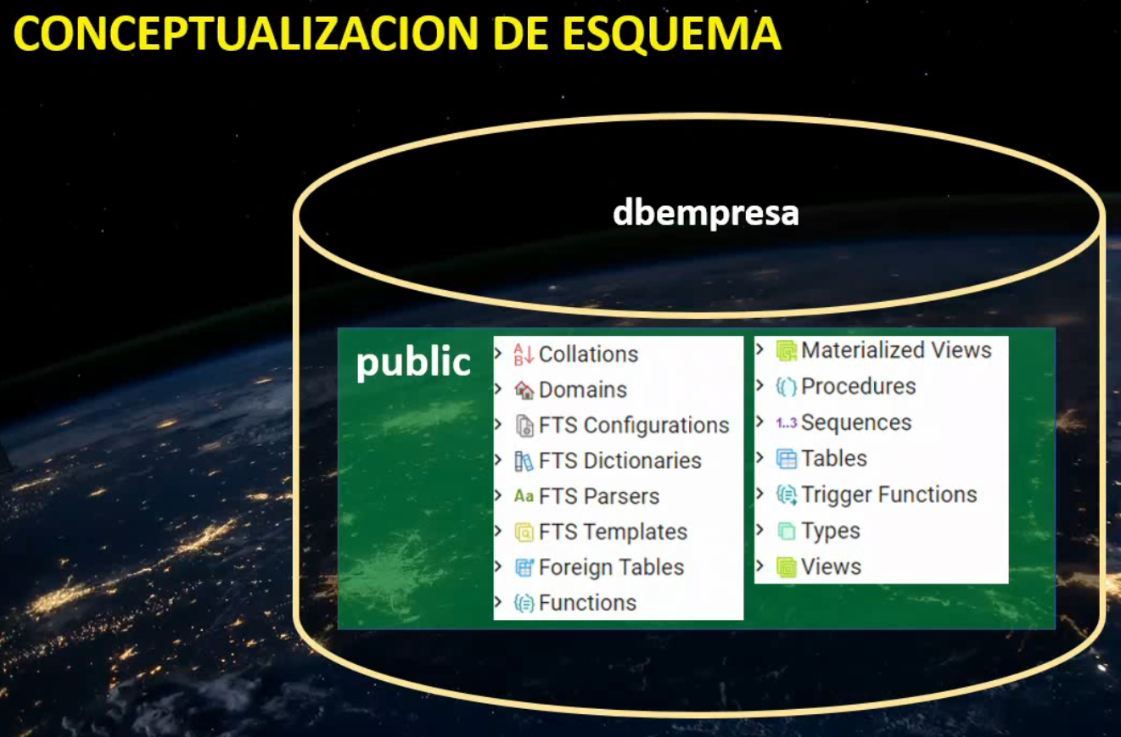

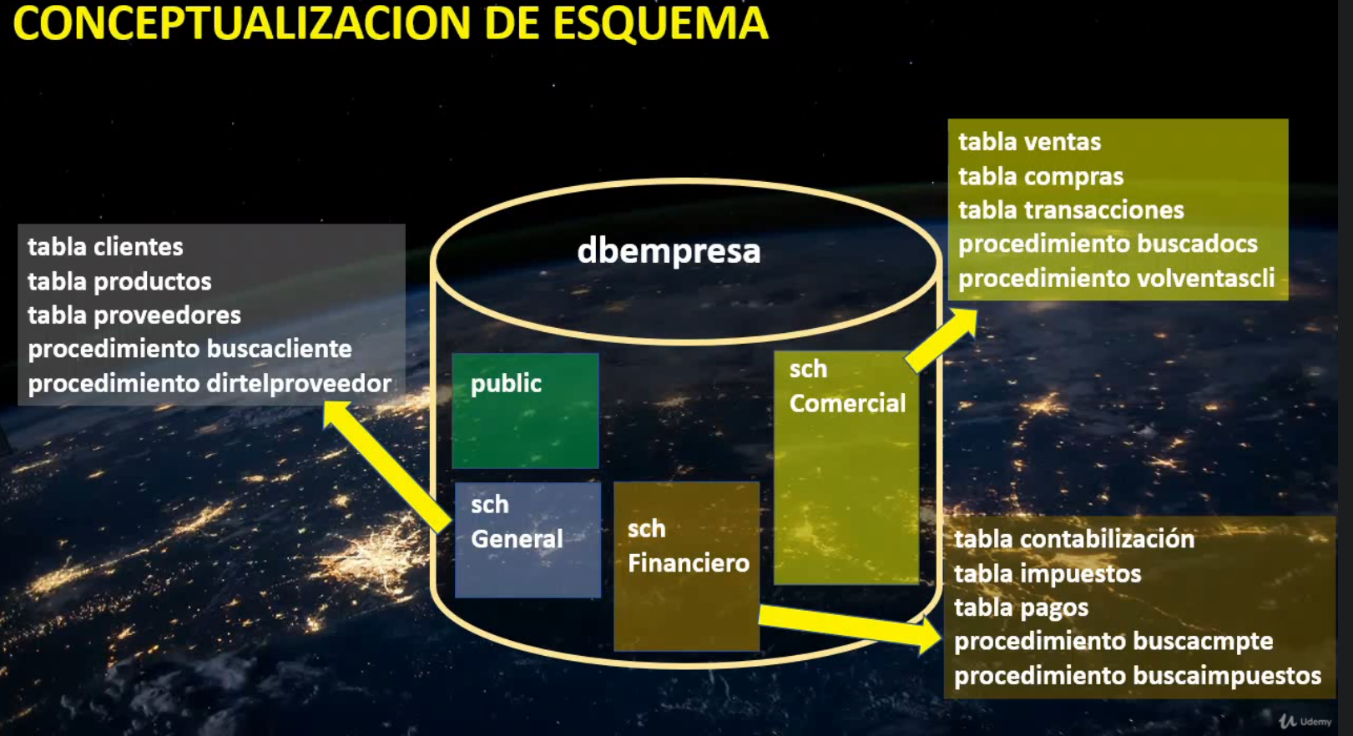
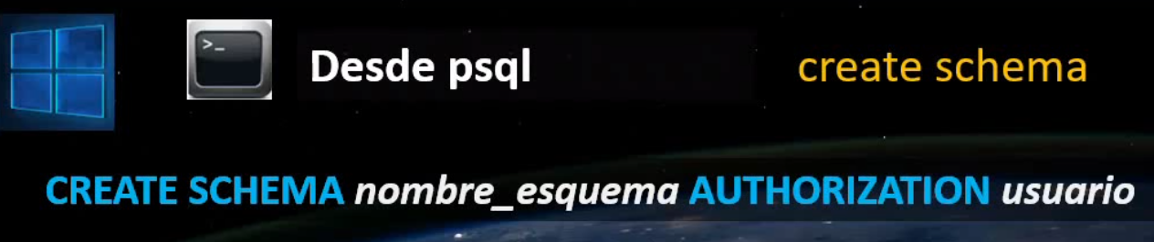
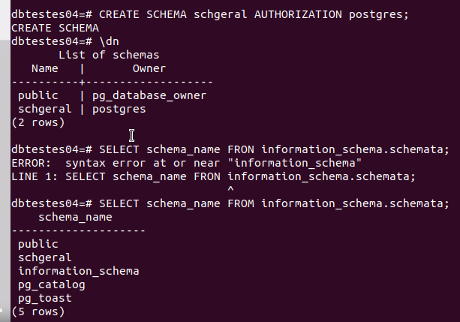
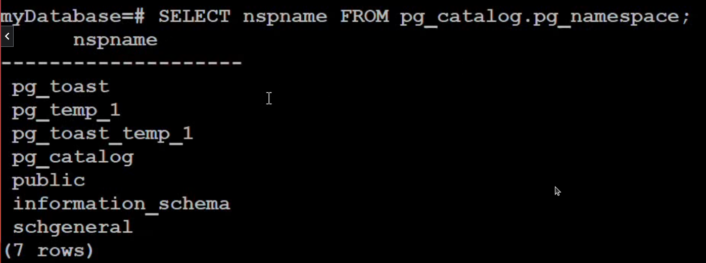
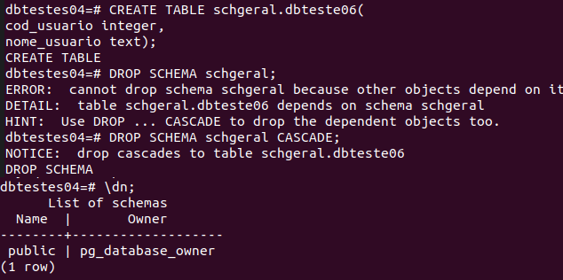
Para deletar schema que já possui objetos, usar CASCADE.
Índices
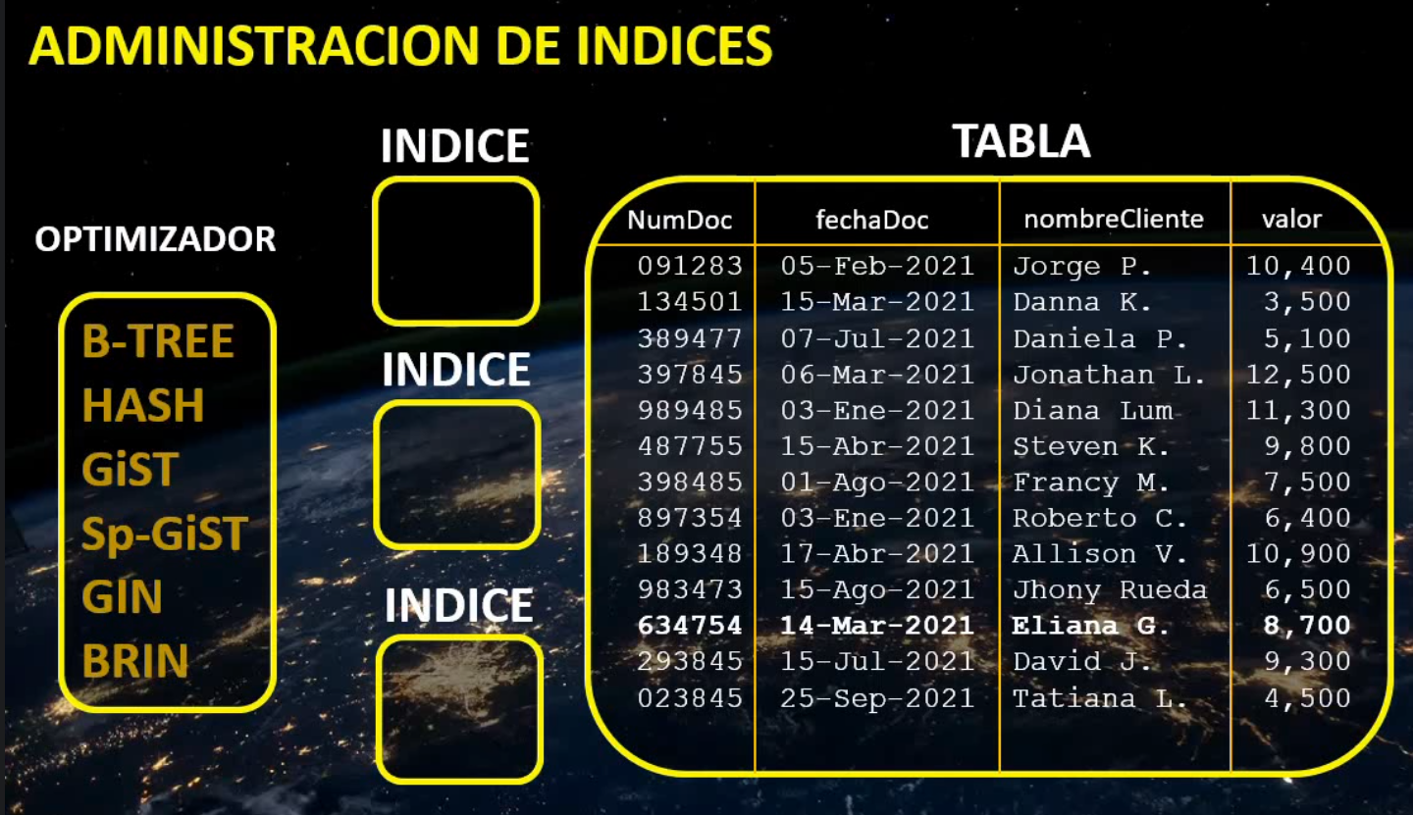
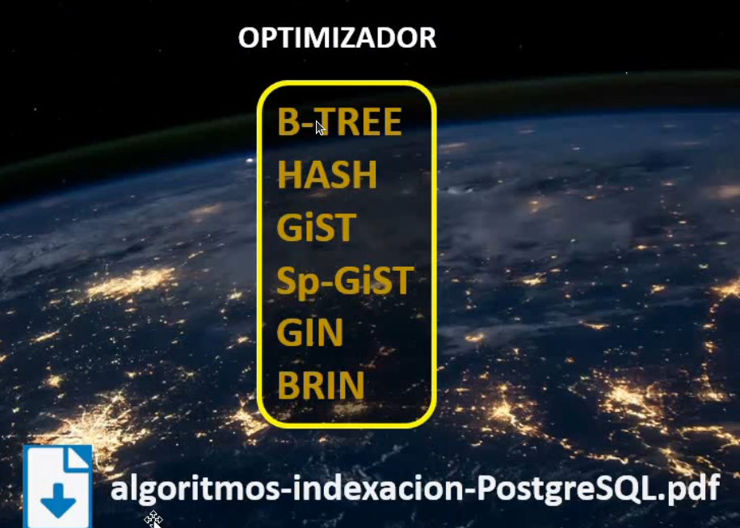
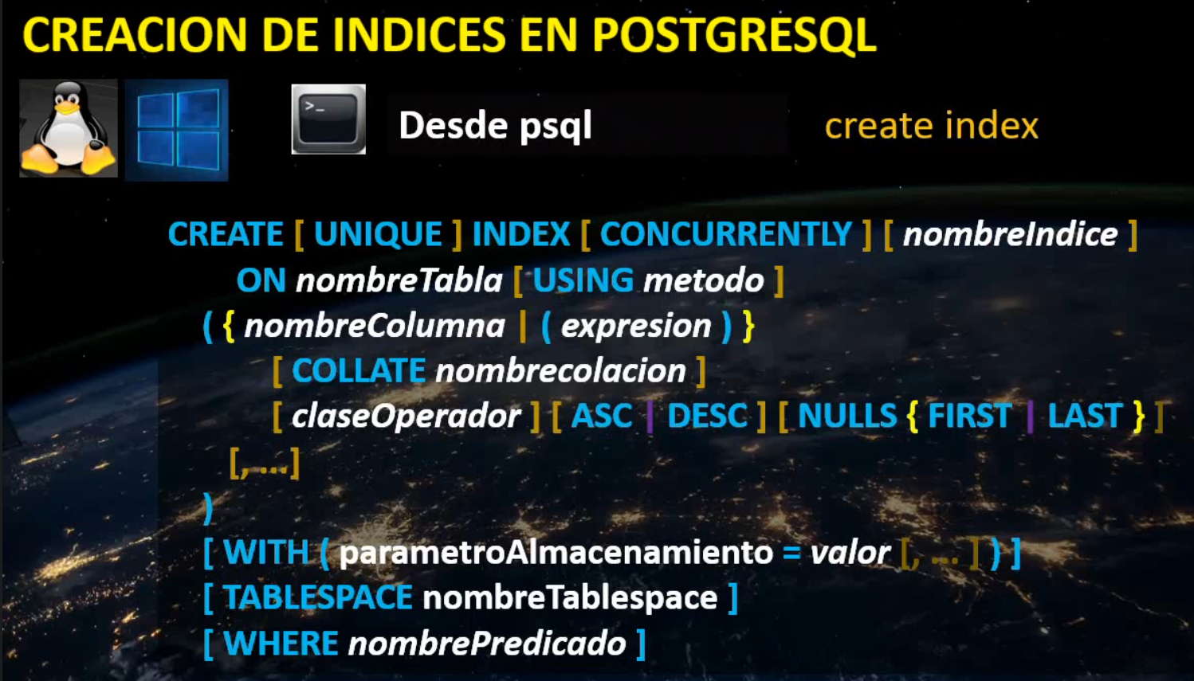
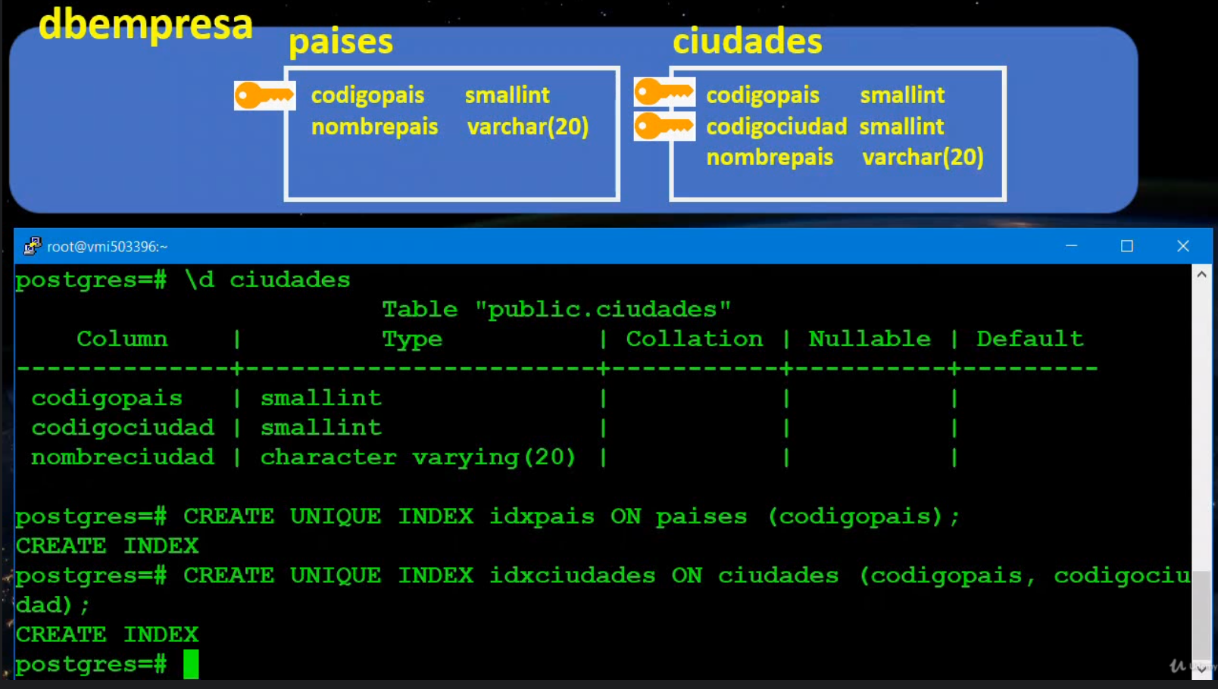
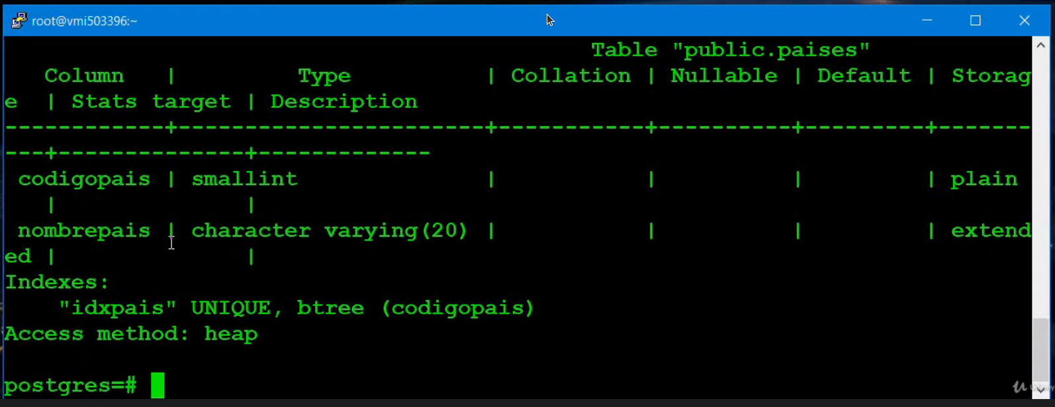
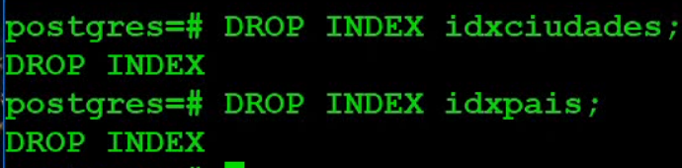
Listando os database de um schema
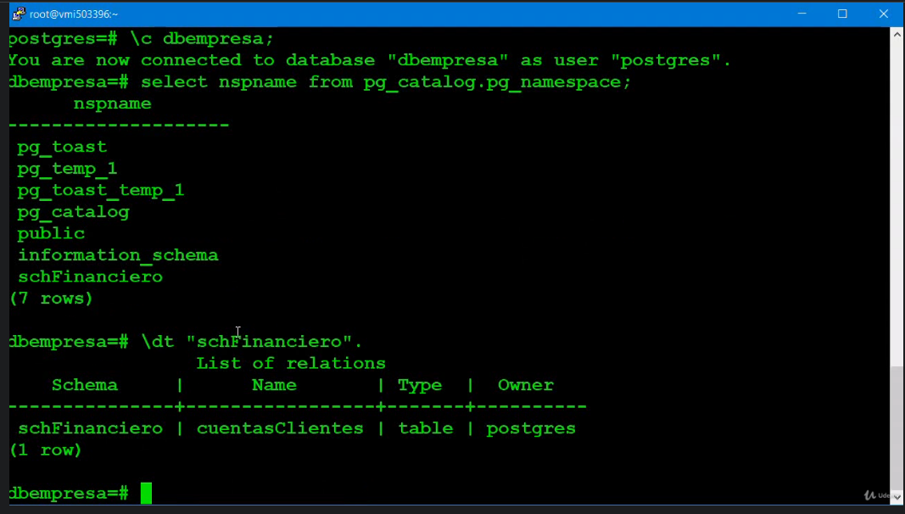
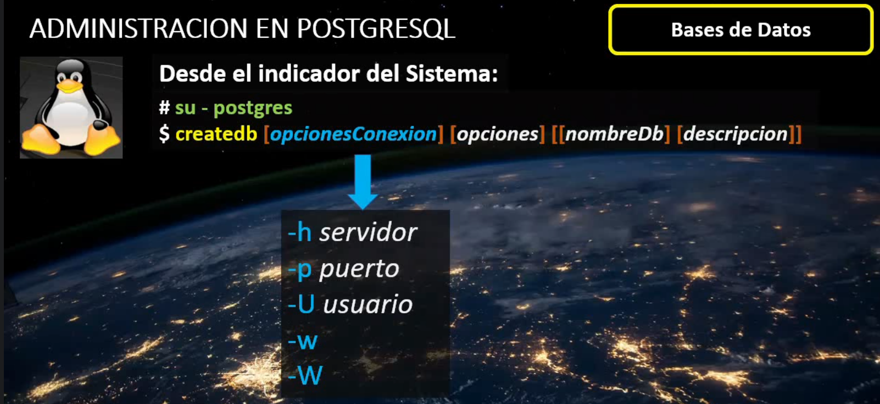

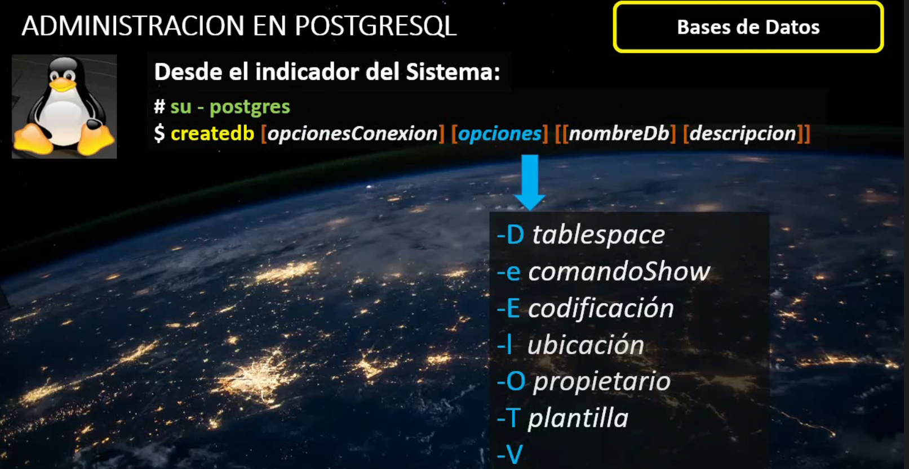
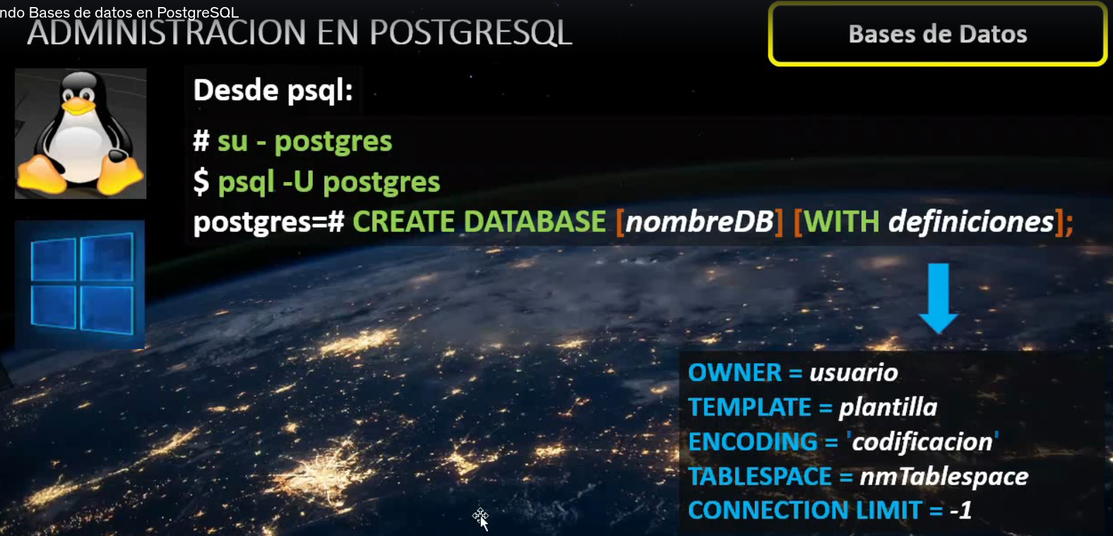
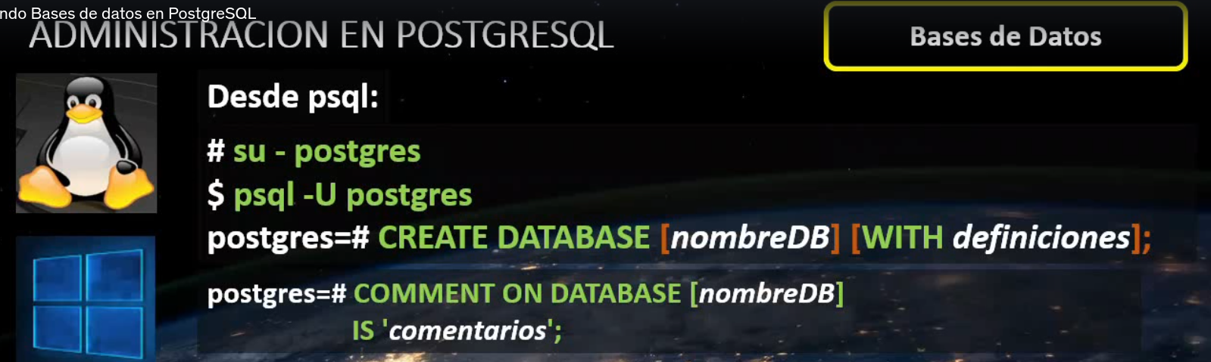
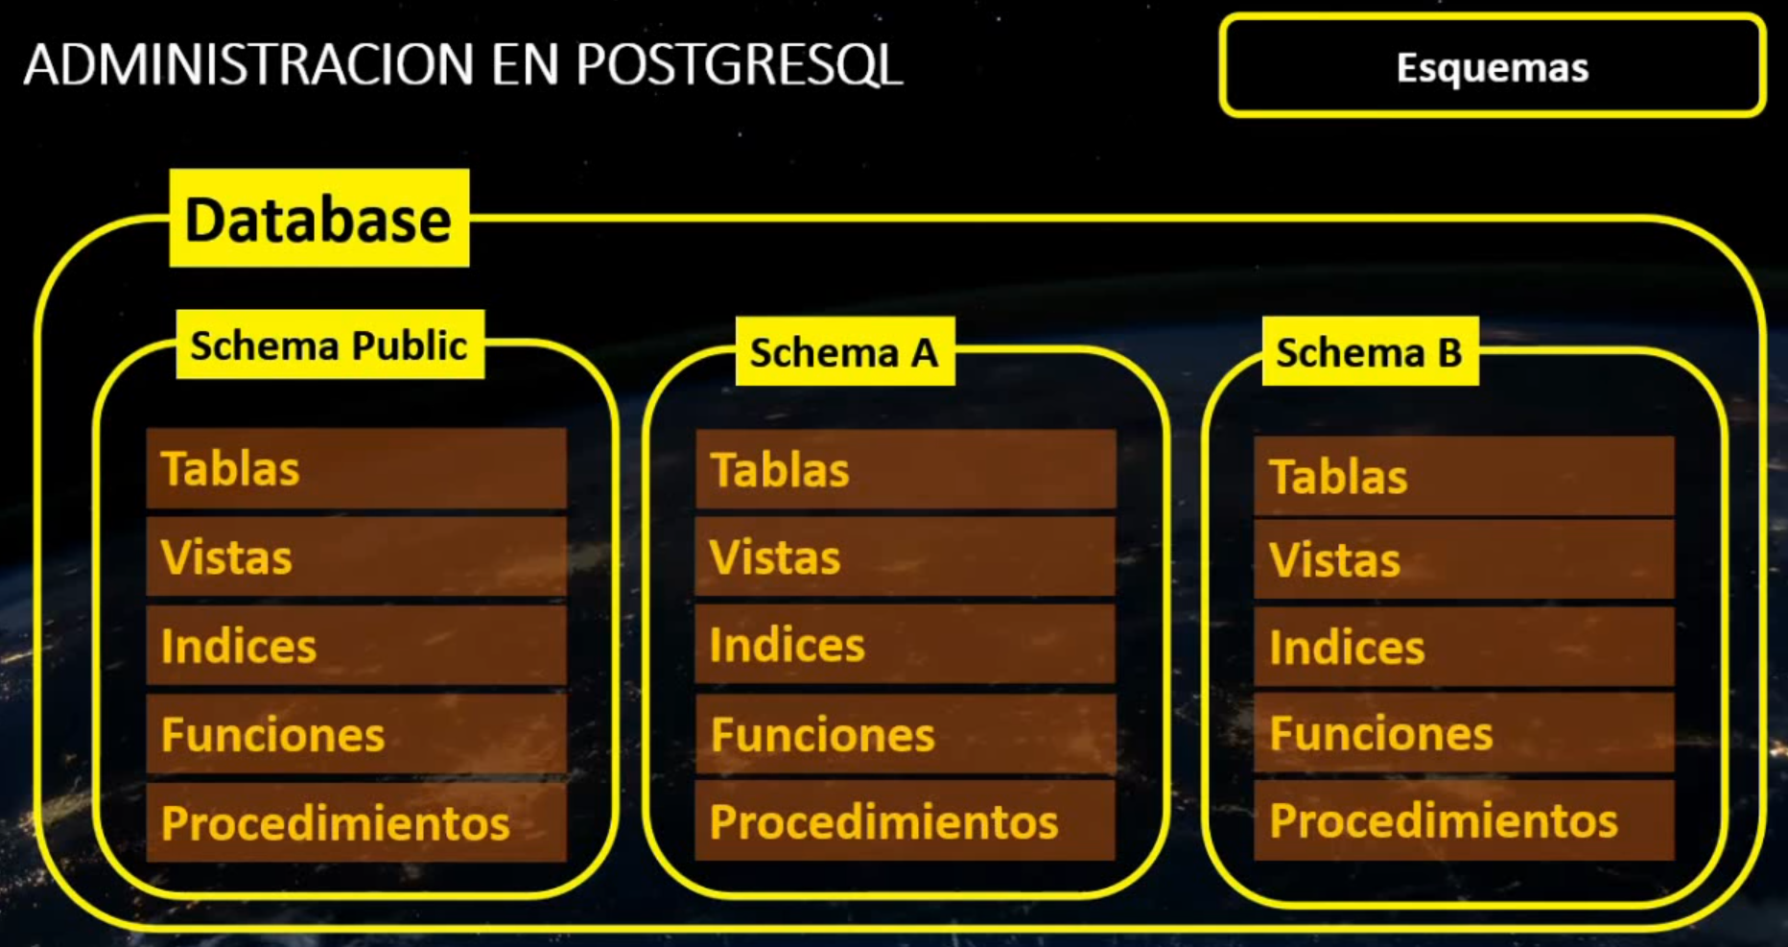

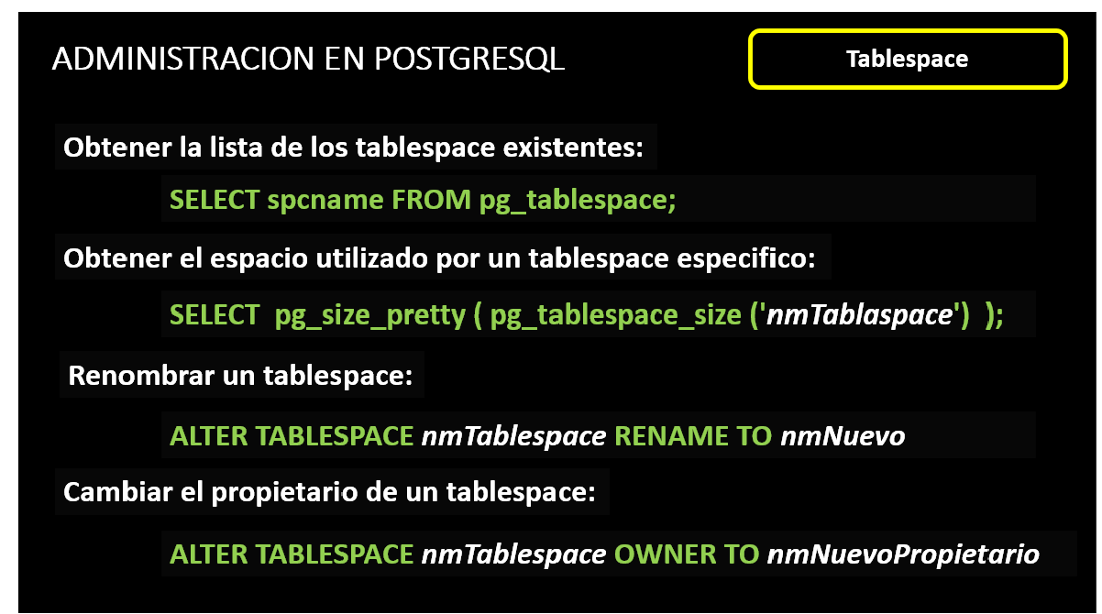

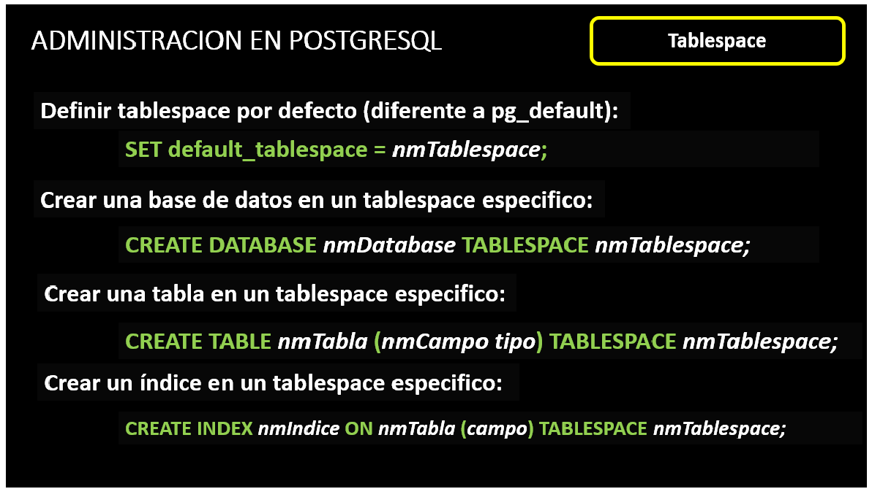

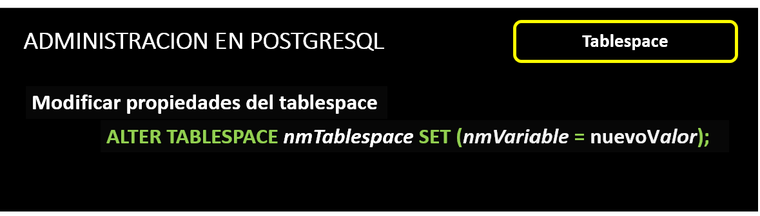

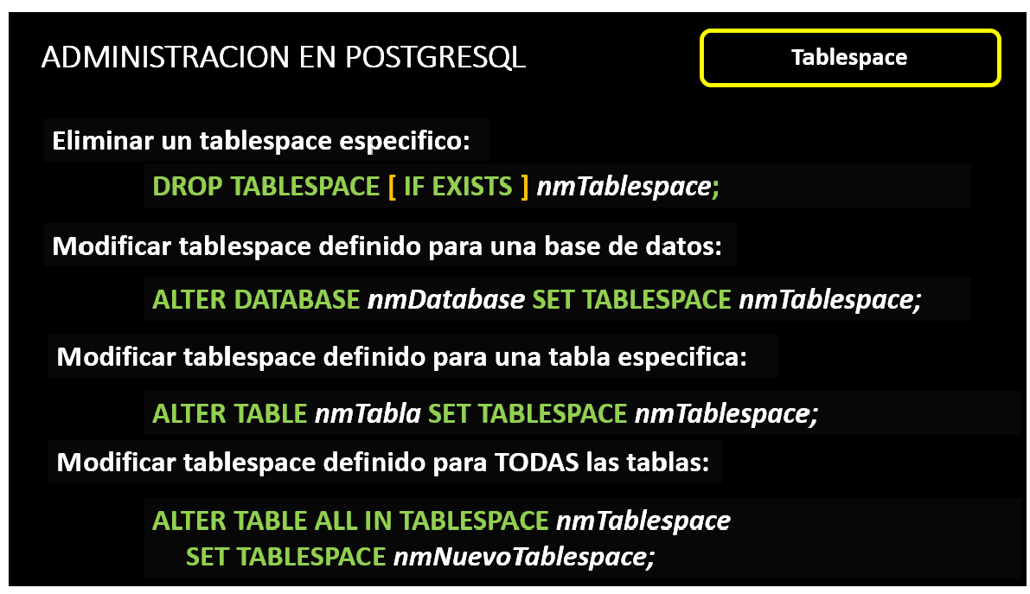

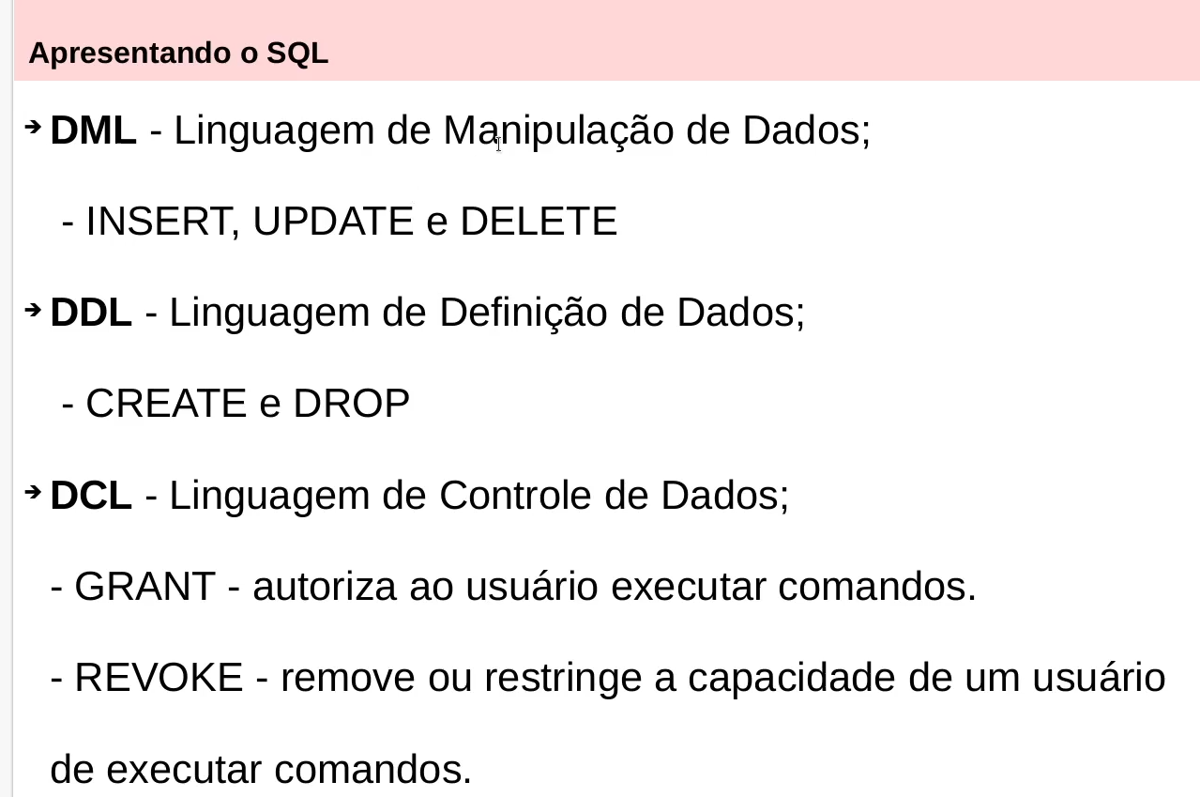

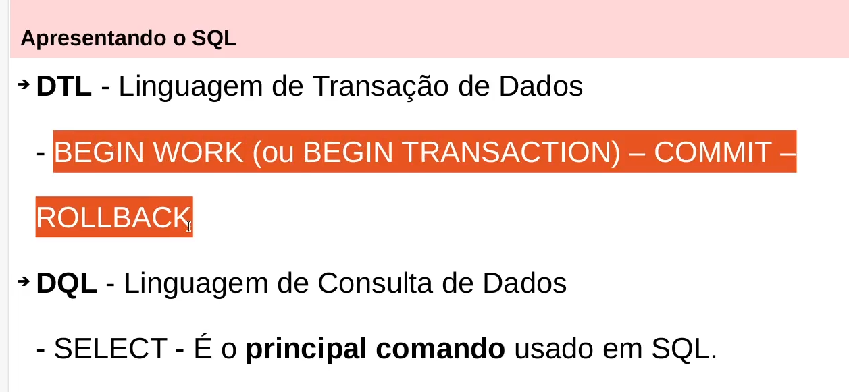

Instalando o PostgreSQL

https://www.postgresql.org/support/versioning/

sudo apt -y install vim bash-completion wget
sudo apt -y upgrade

# wget --quiet -O - https://www.postgresql.org/media/keys/ACCC4CF8.asc | sudo apt-key add -

# echo "deb http://apt.postgresql.org/pub/repos/apt/ `lsb_release -cs`-pgdg main" |sudo tee /etc/apt/sources.list.d/pgdg.list

# sudo apt update
# sudo apt -y install postgresql-13 postgresql-client-13

# systemctl status postgresql.service

# sudo su - postgres

# psql -c "alter user postgres with password '123456'"

# psql

=# \conninfo

=# \q

Configurações de usuários e de conexões

$ sudo su - postgres
$ psql

postgres=# select current_user;

postgres=# SELECT current_database();

postgres=# SELECT version();

# adduser vitor adiciona usuário no linux
# passwd vitor
# su - postgres
$ psql template1

template1=# CREATE USER vitor WITH PASSWORD '123456';
template1=# CREATE DATABASE teste;
template1=# GRANT ALL PRIVILEGES ON DATABASE teste to vitor;
template1=# \q

$ su - vitor
$ psql -d teste -U vitor -d → database -U usuário

=> select current_user;

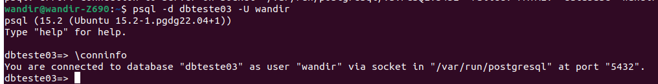
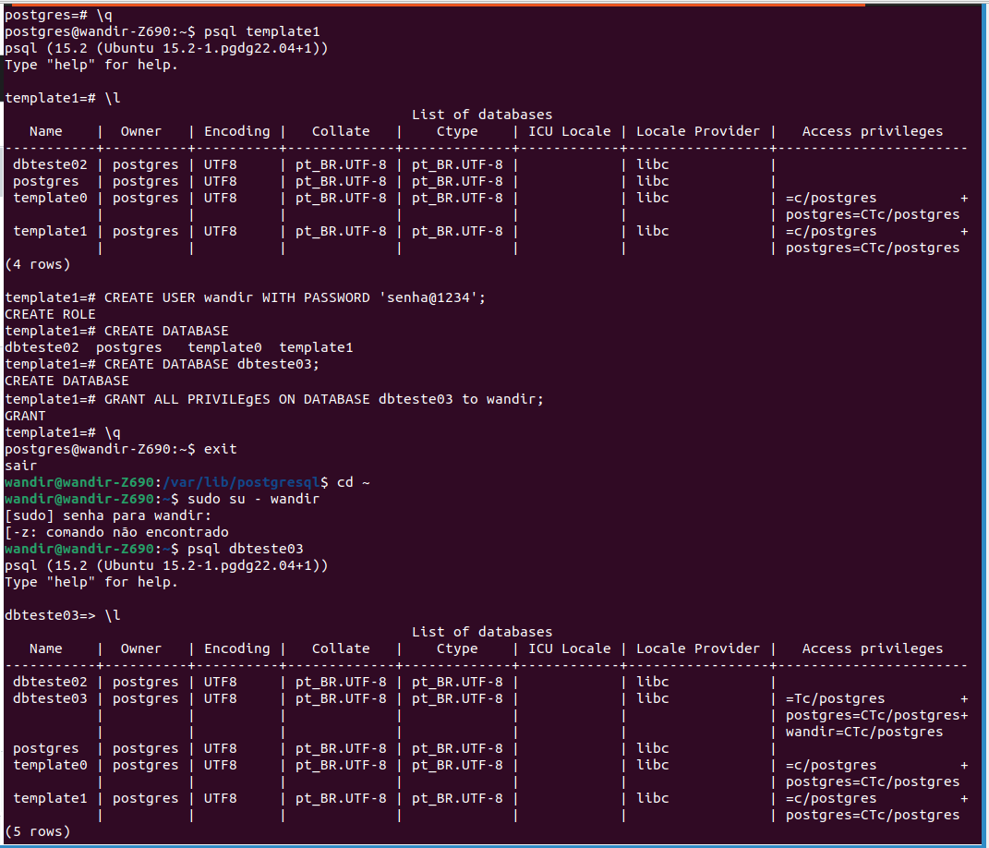

Instalando interfces gráficas

https://www.pgadmin.org

# sudo curl https://www.pgadmin.org/static/packages_pgadmin_org.pub | sudo apt-key add

# sudo sh -c 'echo "deb https://ftp.postgresql.org/pub/pgadmin/pgadmin4/apt/$(lsb_release -cs) pgadmin4 main" > /etc/apt/sources.list.d/pgadmin4.list && apt update'

# sudo apt install pgadmin4

# sudo /usr/pgadmin4/bin/setup-web.sh

Para CentOS:

# sudo rpm -i https://ftp.postgresql.org/pub/pgadmin/pgadmin4/yum/pgadmin4-redhat-repo-1-1.noarch.rpm

# sudo yum install pgadmin4

# sudo /usr/pgadmin4/bin/setup-web.sh

O comando psql

# psql --help

# psql -h hostname -p 5432 -d dbname -U username -W acesso remoto

# psql -h 127.0.0.1 -p 5432 -d teste -U vitor -W

# sudo su - postgres
# psql -c "SELECT current_time" executa uma consulta sem logar no banco

# sudo su - postgres
$ psql

postgres=# \h DELETE \h → help \h delete → help para o comando delete

# ALTER USER usuario PASSWORD 'suasenhaaqui'

Principais comandos do psql

# psql -h host -d database -U user -W conexão remota -h → host -d → database -U → user
-W → password -p → port

# psql -d postgres -h localhost -U postgres -W

# psql -h localhost -U postgres -W "dbname=postgres sslmode=require"

=# \l lista os databases

=# \c teste conecta no database <nome database>
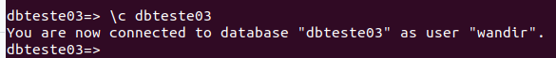

=# \dt lista as tabelas

=# \d alunos detalha a tabela \d <nome tabela>

=# \dn lista os schemas
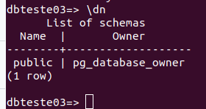

=# \df lista as funções
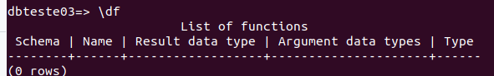

=# \dv lista as views

=# \du lista os usuários, roles, grupos

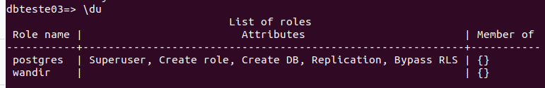

=# \s lista o histórico de comandos

=# \s historico.txt salva o histórico de comando em um arquivo
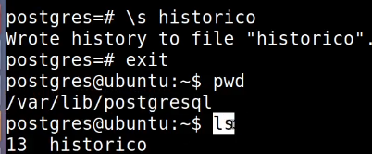

=# \e abre um editor de texto
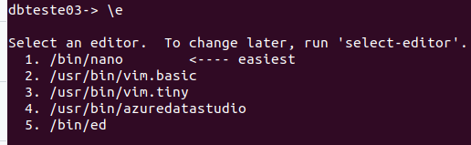

SELECT version();

=# \q sair do psql
=# exit sair do postgresql

Arquivos de Configuração
Principais:
- postgresql.conf
- pg_ident.conf
- pg_hba.conf

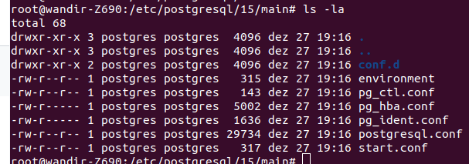

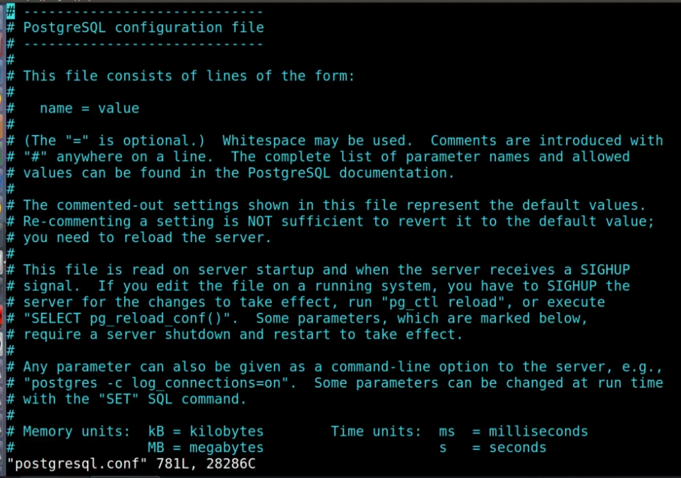

configuração postgresql.config
SELECT name, context, unit, setting, boot_val, reset_val FROM pg_settings WHERE name IN ( 'listen_addresses', 'max_connections', 'shared_buffers', 'effective_cache_size', 'work_mem', 'maintenance_work_mem') ORDER BY context, name;
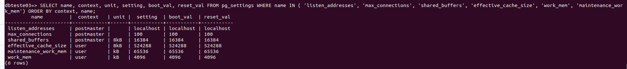

Caminhos arquivos de configuração
SELECT name, setting FROM pg_settings WHERE category = 'File Locations';
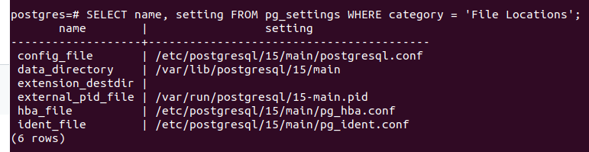

psql –help
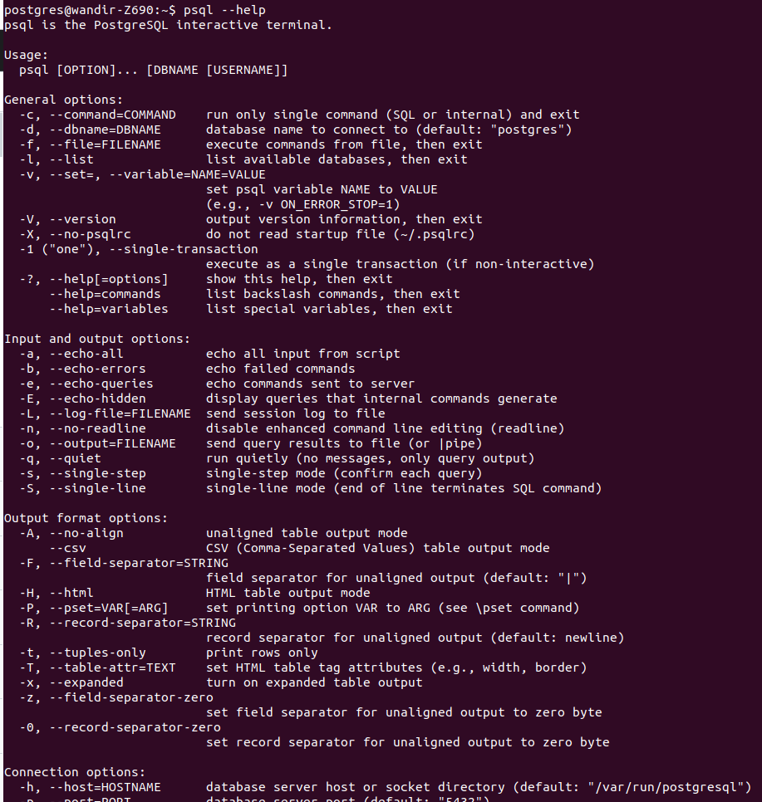

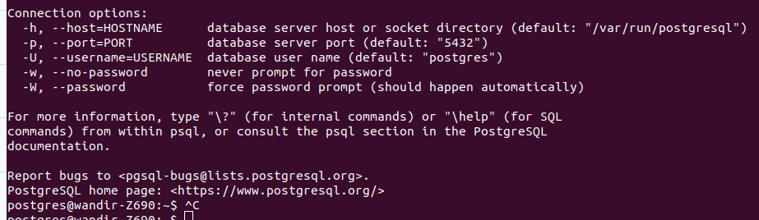

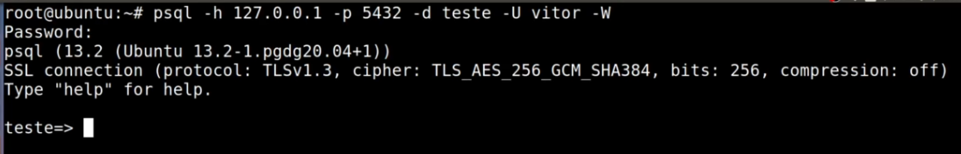

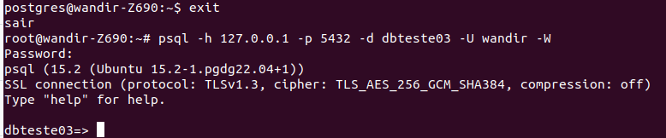

Gerenciando conexões

SELECT * FROM pg_stat_activity;
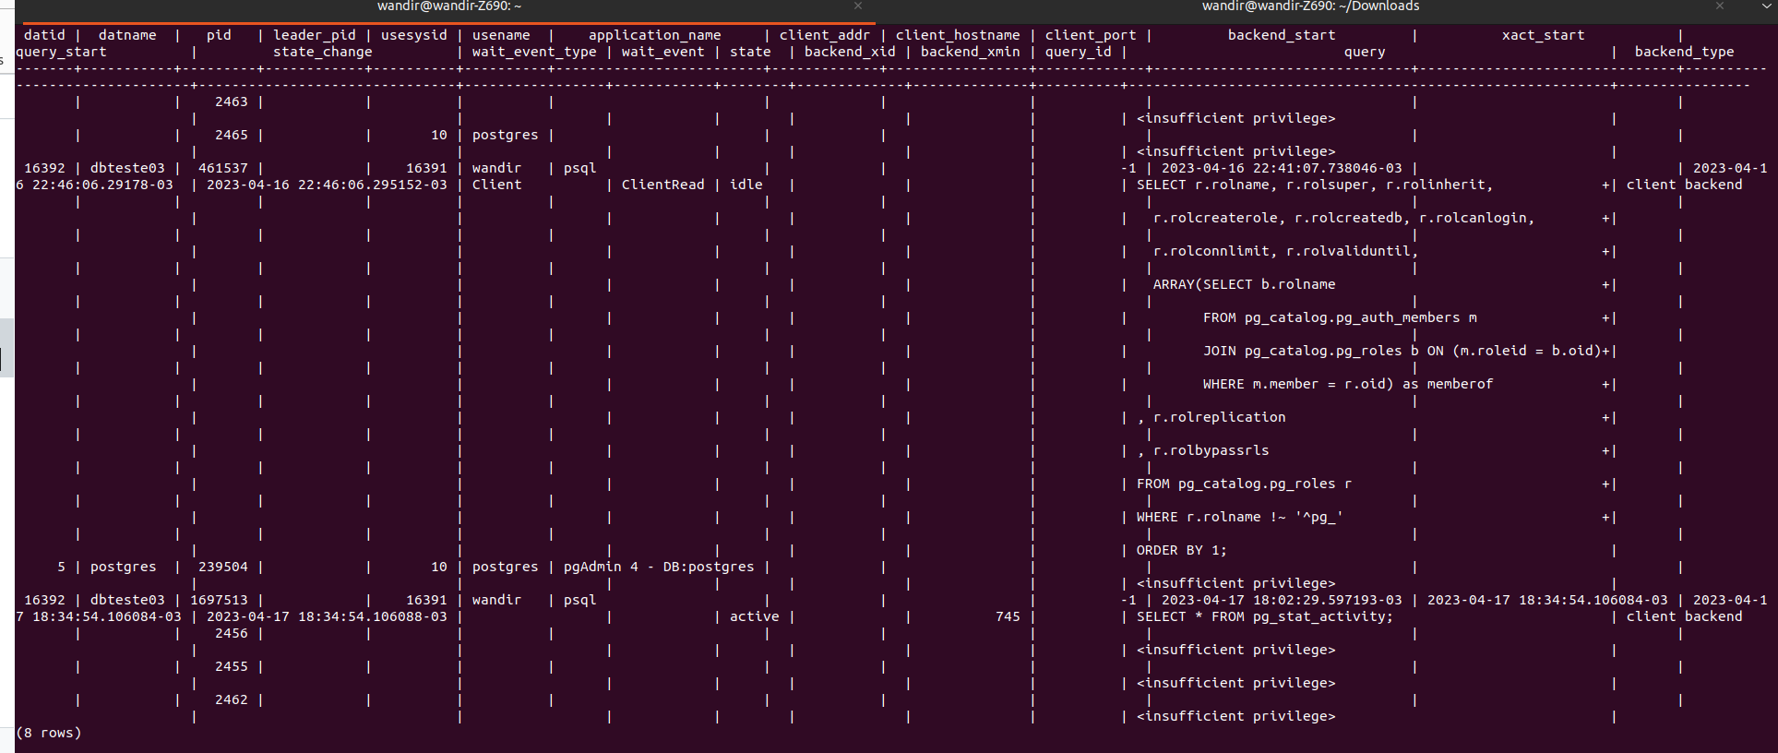

permite cancelar ou terminar um PID
SELECT pg_cancel_backend(pid);
SELECT pg_terminate_backend(pid);
SELECT pg_terminate_backend(pid) FROM pg_stat_activity WHERE usename = 'algum_role';

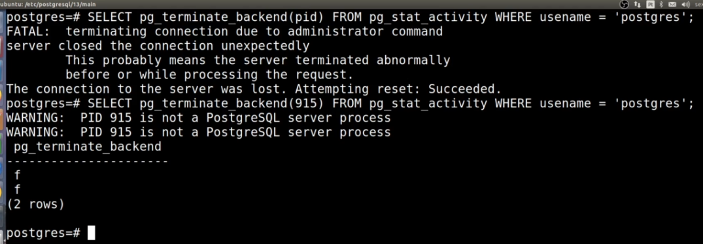

Roles (não se usa user ou grupo no Postgresql)

- PostgreSQL manages database access permissions using the concept of roles.
- A role can be thought of as either a database user, or a group of database users, depending on how the role is set up.
- Roles can own database objects (for example, tables and functions) and can assign privileges on those objects toother roles to control who has access to which objects.
- Furthermore, it is possible to grant membership in a role to another role, thus allowing the member role to use privileges assigned to another role.
- The concept of roles subsumes the concepts of “users” and “groups”.
- In PostgreSQL versions before 8.1, users and groups were distinct kinds of entities, but now there are only roles.
- Any role can act as a user, a group, or both.

CREATE ROLE joao LOGIN PASSWORD '123456' CREATEDB VALID UNTIL 'infinity';

CREATE ROLE regina LOGIN PASSWORD '123456' SUPERUSER VALID UNTIL '2022-1-1 00:00';

DROP ROLE maria;
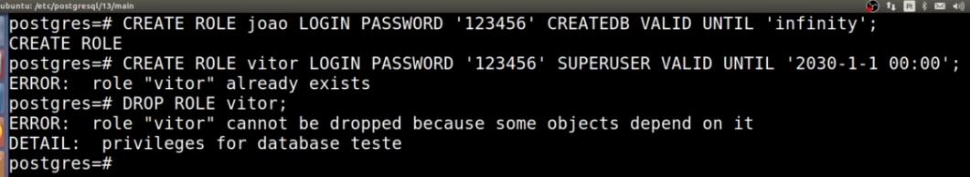
Se role estiver sendo usada por algum objeto do banco não deixa remover. Tem que remover a role do objeto primeiro.

CREATE ROLE grupo1 INHERIT;

GRANT grupo1 TO joao;

GRANT grupo1 TO regina;

Ver artigo PostgresSQL Role Membership.odt ou https://www.postgresqltutorial.com/postgresql-administration/postgresql-role-membership/

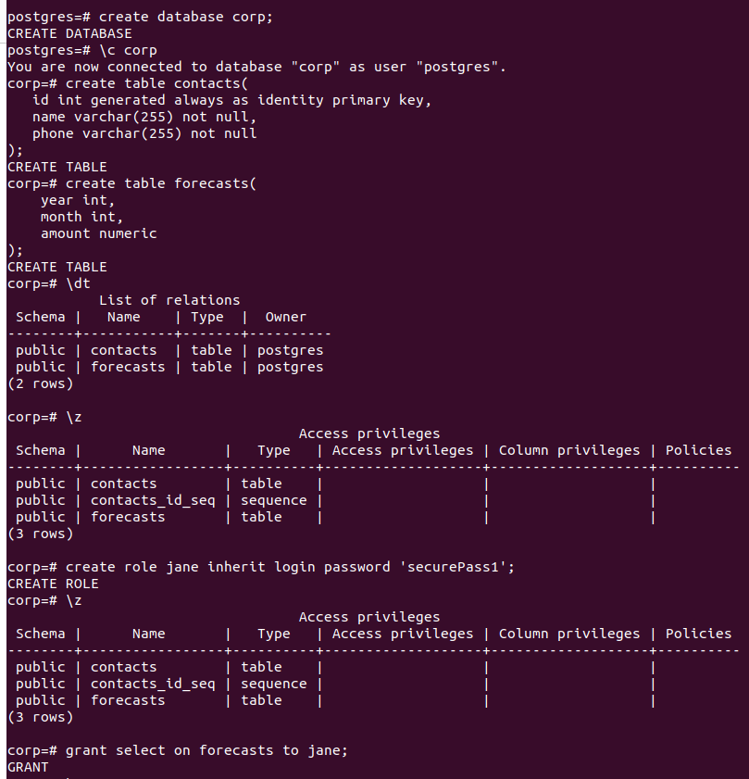
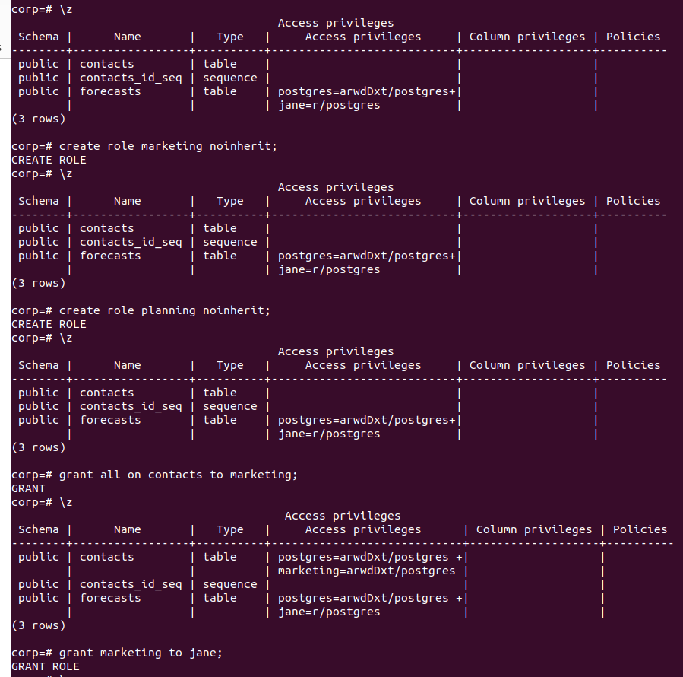
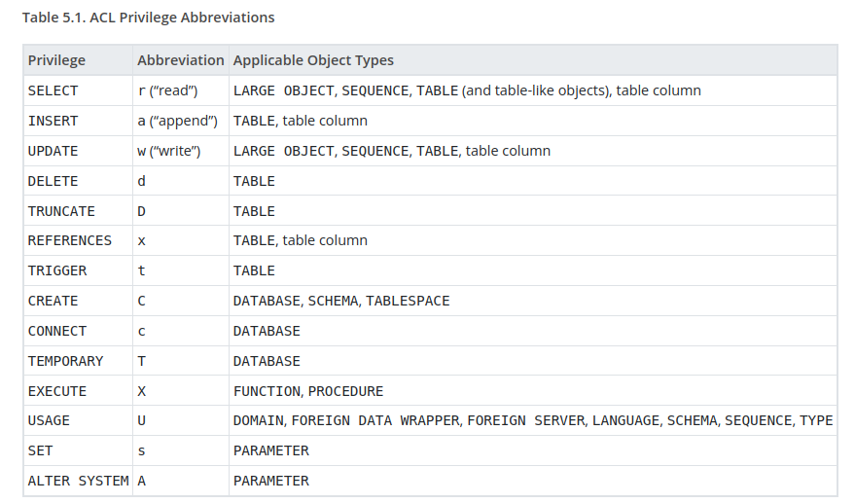

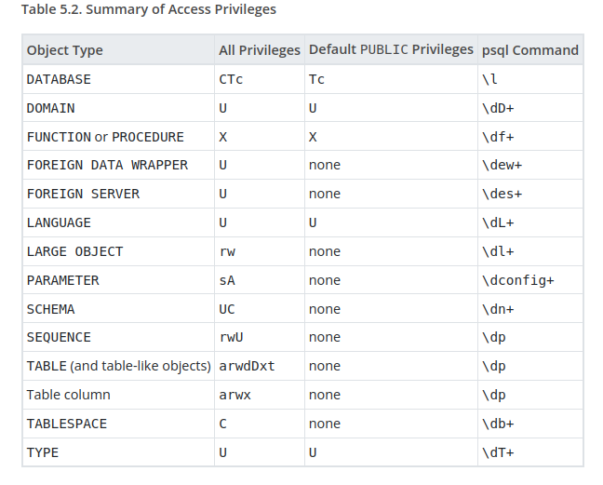
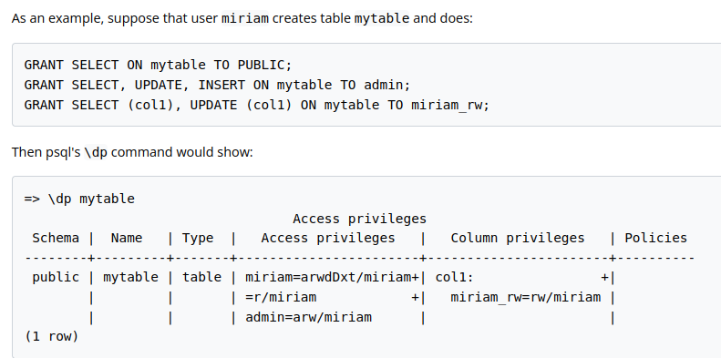

Criação de banco de dados

# \list ou \l

CREATE DATABASE meubd;

CREATE DATABASE meubd TEMPLATE meu_template_db;

UPDATE pg_database SET datistemplate = TRUE WHERE datname = 'meubd';

UPDATE pg_database SET datistemplate = FALSE WHERE datname = 'meubd';

Usando Esquemas

\c teste;
CREATE SCHEMA minha_extensão;

CREATE DATABASE taxi_aereo;
\c taxi_aereo;
CREATE SCHEMA Plano;
CREATE SCHEMA Dados Pessoais;
CREATE SCHEMA Clientes;

# adduser spadogs
# adduser cuidadoscao
# su - postgres
$ psql template1
=# CREATE ROLE spadogs WITH PASSWORD '123456';
=# ALTER ROLE spadogs WITH LOGIN;
=# CREATE ROLE cuidadoscao WITH PASSWORD '123456';
=# ALTER ROLE cuidadoscao WITH LOGIN;
=# \q
=# psql

=# CREATE DATABASE spadogs WITH owner = spadogs;
=# CREATE DATABASE cuidadoscao WITH owner = cuidadoscao;
=# \c spadogs;
=# CREATE SCHEMA spadogs;
=# ALTER SCHEMA spadogs OWNER TO spadogs;
=# \q
=# \c cuidadoscao;
=# CREATE SCHEMA cuidadoscao;
=# ALTER SCHEMA cuidadoscao OWNER TO cuidadoscao;

=# ALTER DATABASE cuidadoscao SET search_path='"$user", public, cuidadoscao';

#= select user;

Privilégios

CREATE ROLE admin LOGIN PASSWORD '123456';
CREATE DATABASE meudb_admin WITH owner = admin;
\c meudb_admin;
CREATE SCHEMA meu_esquema;

-- Sintaxe

GRANT algum_privilegio TO algum_role;

GRANT ALL ON ALL TABLES IN SCHEMA public TO admin WITH GRANT OPTION;

GRANT SELECT, REFERENCES, TRIGGER ON ALL TABLES IN SCHEMA meu_esquema TO PUBLIC;

GRANT SELECT, UPDATE ON ALL SEQUENCES IN SCHEMA meu_esquema TO PUBLIC;

GRANT USAGE ON SCHEMA meu_esquema TO PUBLIC;

REVOKE EXECUTE ON ALL FUNCTIONS IN SCHEMA meu_esquema FROM PUBLIC;

Privilégios Padrão

GRANT USAGE ON SCHEMA meu_esquema TO PUBLIC;
ALTER DEFAULT PRIVILEGES IN SCHEMA meu_esquema GRANT SELECT, REFERENCES ON TABLES TO PUBLIC;

ALTER DEFAULT PRIVILEGES IN SCHEMA meu_esquema GRANT ALL ON TABLES TO vitor WITH GRANT OPTION;

ALTER DEFAULT PRIVILEGES IN SCHEMA meu_esquema GRANT SELECT, UPDATE ON SEQUENCES TO public;

ALTER DEFAULT PRIVILEGES IN SCHEMA meu_esquema GRANT ALL ON FUNCTIONS TO vitor WITH GRANT OPTION;

-- Links: https://www.postgresql.org/docs/current/static/sql-alterdefaultprivileges.html

Extensões.sql

SELECT name, default_version, installed_version, left(comment,30) As comment FROM pg_available_extensions WHERE installed_version IS NOT NULL ORDER BY name;

SELECT pg_catalog.pg_describe_object(d.classid, d.objid, 0) AS description FROM pg_catalog.pg_depend AS D INNER JOIN pg_catalog.pg_extension AS E ON D.refobjid = E.oid WHERE D.refclassid = 'pg_catalog.pg_extension'::pg_catalog.regclass AND deptype= 'e' AND E.extname = 'plpgsql';

SELECT * FROM pg_available_extensions;

psql -p 5432 -d meubanco_de_dados -c "CREATE EXTENSION fuzzystrmatch;"

CREATE EXTENSION fuzzystrmatch SCHEMA meu_esquema;

-- Links: https://pgxn.org/

Extensões populares

Links:

https://pt.wikipedia.org/wiki/%C3%81rvore_B

https://www.postgresql.org/docs/9.1/static/btree-gist.html

web.archive.org/web/20170226030932/http://franciscosumma.blogspot.com.br/2016/02/indices-no-postgresql.html

http://web.archive.org/web/20170503200607/https://www.postgresql.org/docs/9.1/static/fuzzystrmatch.html

http://web.archive.org/web/20170606170100/http://postgresguide.com/cool/hstore.html

http://www.postgresonline.com/journal/archives/165-Encrypting-data-with-pgcrypto.html

Gerenciando armazenamento em disco com Tablespaces

- CREATE TABLESPACE - Criação de tablespaces
- DROP TABLESPACE - Exclusão de tablespaces sem conteúdo

-- Para você criar nos sistemas do tipo Unix, rode esse comando:

CREATE TABLESPACE secondary LOCATION '/var/lib/postgresql/9.5/';

-- Para no Windows rode:

CREATE TABLESPACE secondary LOCATION 'C:/pgdata95_secondary';

--

CREATE TABLESPACE secondary LOCATION '/var/lib/postgresql/9.5/';

CREATE TABLESPACE secondary LOCATION 'C:/pgdata95_secondary';

ALTER DATABASE meudb_admin SET TABLESPACE secondary;

ALTER TABLE tabela1 SET TABLESPACE secondary;

ALTER TABLESPACE pg_default MOVE ALL TO secondary;

